|  |  |  |  |  |
| --- | --- | --- | --- | --- |
| ER Component | Type | Primary key | Related entity and their primary key | Corresponding relation schema |
| Screenshot (124).png | Strong entity | Email ID,Name | Laptop Router(User_ID), Block List | create table Administrator(  Name varchar(10),  Email_ID varchar(15),  Department char(5),  Residential_details varchar(20),  Primary key(Email_ID,Name)  ); |
| Screenshot (124).png | Strong entity | User_ID | Administrator(Name,Email_ID), Devices(IP address),  Register(r_id) | create table Laptop_Router(  limit_of_devices varchar(3),  data_usage varchar(6),  User_ID varchar(10),  MAC_address varchar(15),  Serial_Number char(10),  Name varchar(10),  Email_ID varchar(15),  Primary key(User_ID),  Foreign key (Email_ID,Name) references Administrator); |
| Screenshot (124).png | Strong entity | r_id | Laptop_Router(User_ID),  Devices(IP address),  Routing_Table(Network_ID) | create table Register(  r_id varchar(10),  IST_time timestamp,  User_ID varchar(10),  ConnectionStatus char(12),  Network_ID varchar(15),  Primary key (r_id),  Foreign key (Network_ID) references Routing_Table,  Foreign key(User_ID) references Laptop_Router  ); |
| Screenshot (124).png | Weak entity | null | Devices(Device_ID), Administrator(Name,Email_ID) | create table Block_List(  blocked_Device_ID varchar(10),  blocked_IP_address varchar(15),  User_ID varchar(10),  Foreign key(User_ID) references Laptop_Router  ); |
| Screenshot (124).png | Strong entity | IP address | Block list,  Laptop_Router(Network_ID),  Register(r_id),  Routing_Table(Network_ID) | create table Devices(  Device_ID varchar(10),  IP_address varchar(15),  Frequency char(5),  User_ID varchar(10),  list_id varchar(5),  Network_ID varchar(15),  Primary key(IP_address),  Foreign key(Network_ID) references Routing_Table,  Foreign key(User_ID) references Laptop_Router  ) |
| Screenshot (124).png | Strong entity | Network_ID | Devices(Device_ID),  Register | create table Routing_Table(  Network_ID varchar(15),  Subnet_Mask varchar(15),  Interface char(3),  Primary key(Network_ID)  ) |

I have included snapshots of SQL:

SNAPSHOT 1:

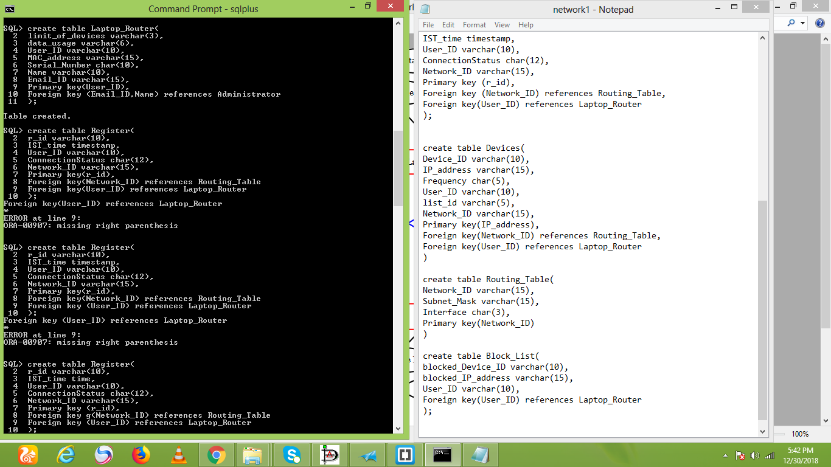

SNAPSHOT 2:



SNAPSHOT 3:

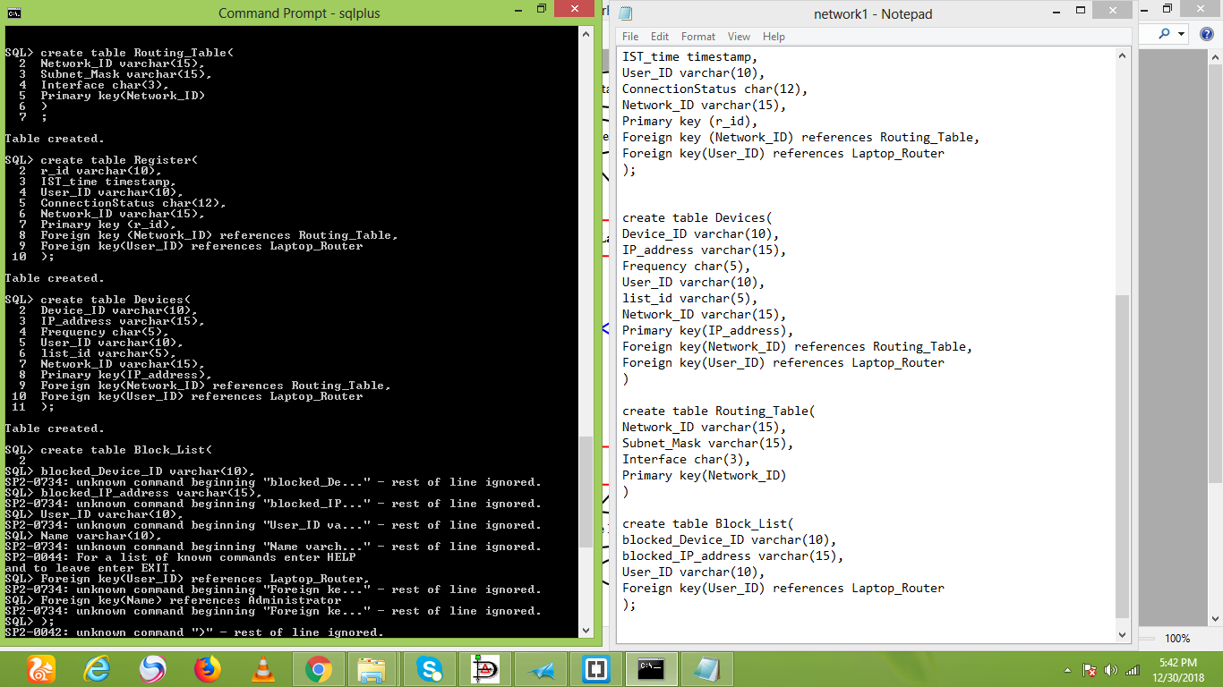

SNAPSHOT 4:

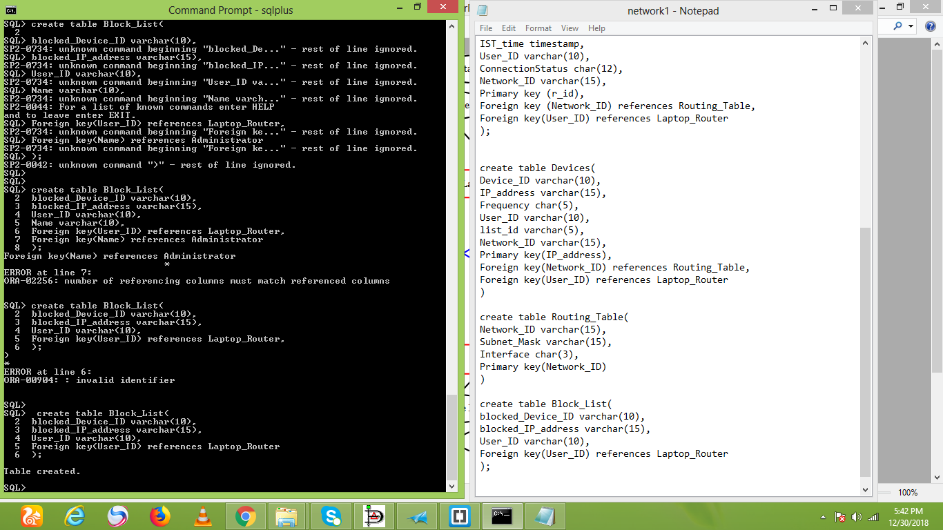

**REGISTER:**

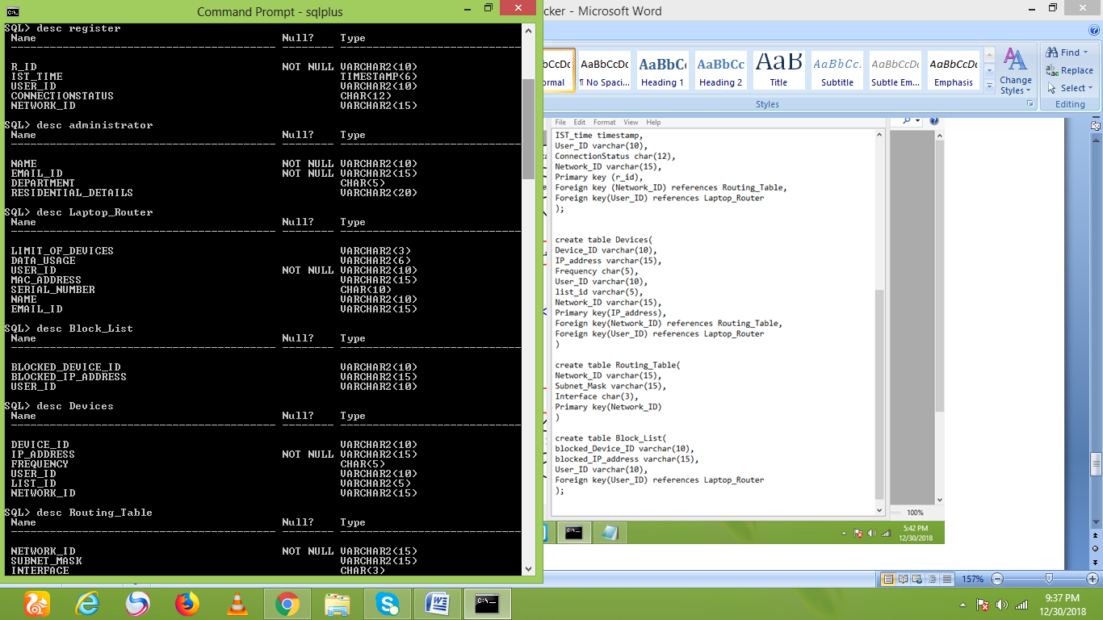

The primary key of register is r_id.

The network ID is the foreign key.

Cardinality:

1:n with devices.

1:1 with routing table.

1:1 with laptop router.

**ADMINISTRATOR:**



The primary key is name,email-id.

Cardinality:

1:1 Laptop Router.

1:1 with Block List.

**LAPTOP ROUTER:**



The primary key is User ID.

The Foreign key is Name, Email ID.

Cardinality:

1:1 with administrator.

1:n with devices.

1:1 with register.

**BLOCK LIST:**



The foreign key is user ID.

Cardinality:

1:n with devices.

1:1 with administrator.

**ROUTING TABLE:**



The primary key is Network ID.

Cardinality:

1:1 with register.

1:n with devices.

**DEVICES:**



The primary key is Device ID.

The foreign key is Network ID, User ID, List ID.

Cardinality:

n:1 with block list.

n:1 with Routing table.

n:1 with Laptop Router.

N:1 with Register.