Automation Project
By
Deva Bharathi

Project Title | Decathlon E-Commerce Website Automation Testing
URL | https://www.decathlon.in/
Project Name | Decathlon India
Programming Language | Java
Automation Tool | Selenium WebDriver
Testing Framework | TestNG
Build Tool | Apache Maven
IDE | Eclipse
Browser | Google Chrome
Version Control | GitHub

Total No. of Test Cases: 3

Test Modules Overview

The following three automation modules have been implemented for the Decathlon India e-commerce website:

- Login Automation (login.java)
- Add to Cart Automation (addToCart.java)
- Search Product Automation (searchTheProduct.java)

Script – Java

Module / Class | Status
Login | Working
Add to Cart | Working
Search Product | Working

Test Cases – TestNG

Module / Class | Status
decathlon.login.main | PASSED
decathlon.addToCart.main | PASSED
decathlon.searchTheProduct.main | PASSED

Module 1 – Login Automation

The Login module validates the user authentication mechanism of the Decathlon India website. It verifies the home page title, navigates to the Sign In modal, captures a screenshot, enters email and phone number credentials, and validates error messages returned by the application.

Script:
package decathlon;

import java.io.File;
import java.io.IOException;
import java.util.concurrent.TimeUnit;
import org.apache.commons.io.FileUtils;
import org.openqa.selenium.By;
import org.openqa.selenium.OutputType;
import org.openqa.selenium.TakesScreenshot;
import org.openqa.selenium.WebDriver;
import org.openqa.selenium.WebElement;
import org.openqa.selenium.chrome.ChromeDriver;
import org.testng.annotations.AfterMethod;
import org.testng.annotations.BeforeMethod;
import org.testng.annotations.Test;

public class login {
WebDriver driver;
@BeforeMethod
public void setup() {
System.setProperty("webdriver.chrome.driver","./Driver/chromedriver.exe");
driver = new ChromeDriver();
driver.get("https://www.decathlon.in");
driver.manage().window().maximize();
driver.manage().timeouts().implicitlyWait(15, TimeUnit.SECONDS);
}

@Test
public void main() throws InterruptedException, IOException {
// Checking we are on actual Home page or not
String actualTitle = "Buy Sporting Goods, Sportswear and Equipments | Download App";
String title = driver.getTitle();
System.out.println(title);
if (actualTitle.equals(title)) {
System.out.println("We are in Home page");
} else {
System.out.println("we are not in home page");
}
// Checking Login Page
wait(3000);
driver.findElement(By.xpath("//span[normalize-space()='Sign In']")).click();
String actualLoginText = "Login";
WebElement loginTextWE = driver.findElement(By.xpath("//h3[text()='Login']"));
String expLoginText = loginTextWE.getText();
System.out.println(expLoginText);
if (actualLoginText.equals(expLoginText)) {
System.out.println("It's Sign In page");
} else {
System.out.println("It's not Sign In page");
}
// Take a Screenshot
TakesScreenshot screenShot = (TakesScreenshot) driver;
File source = screenShot.getScreenshotAs(OutputType.FILE);
File destination = new File("D:\\eclipse\\myProject1\\screenShot\\img2.png");
FileUtils.copyFile(source, destination);
// Automate Login Page
WebElement mail = driver.findElement(By.xpath("//input[@id='input-email']"));
mail.sendKeys("deva.bharathi013@gmail.com");
System.out.println("Enterd Mail : " + mail.getAttribute("value"));
WebElement emailErrMsg = driver.findElement(
By.xpath("(//p[starts-with(@Class,'vtmn-typo_font-weight')])[1]"));
if (emailErrMsg.isDisplayed()) {
String emailErrMsgText = emailErrMsg.getText();
System.out.println(emailErrMsgText);
}
driver.findElement(By.xpath("//div[text()='Phone number']")).click();
WebElement phoneNum = driver.findElement(By.xpath("//input[@id='input-mobile']"));
phoneNum.sendKeys("0000000002");
System.out.println("Phone Number value : " + phoneNum.getAttribute("value"));
driver.findElement(By.xpath("//button[@type='submit']")).click();
WebElement phoneNumErrMsg = driver.findElement(
By.xpath("(//p[starts-with(@class,'vtmn-typo_font-weight')])[1]"));
if (phoneNumErrMsg.isDisplayed()) {
String numErrMsgText = phoneNumErrMsg.getText();
System.out.println(numErrMsgText);
}
}
@AfterMethod
public void after() {
driver.quit();
}
}

Output:
Console output from Eclipse IDE – TestNG execution result for login.java
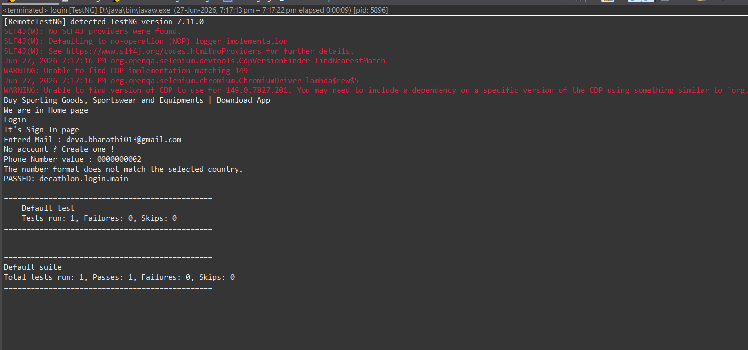
Figure 1: Login Module – Console Output (PASSED) – TestNG run: 1 test, 0 Failures

Login.java – Source Code (Eclipse IDE)
Screenshots of the complete login.java source code as viewed in Eclipse IDE:
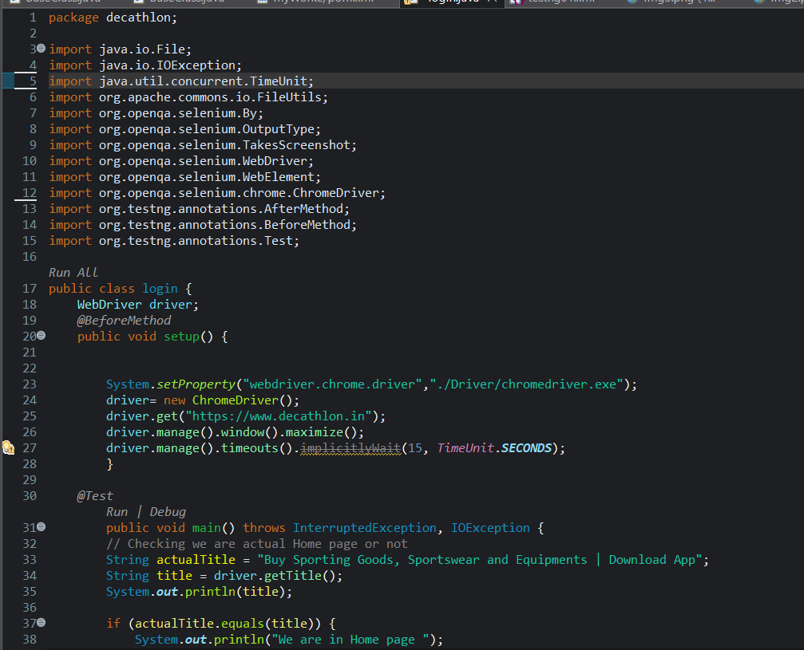
Figure 2: login.java – Lines 1–38 (Package, Imports, Class Declaration, @BeforeMethod setup())
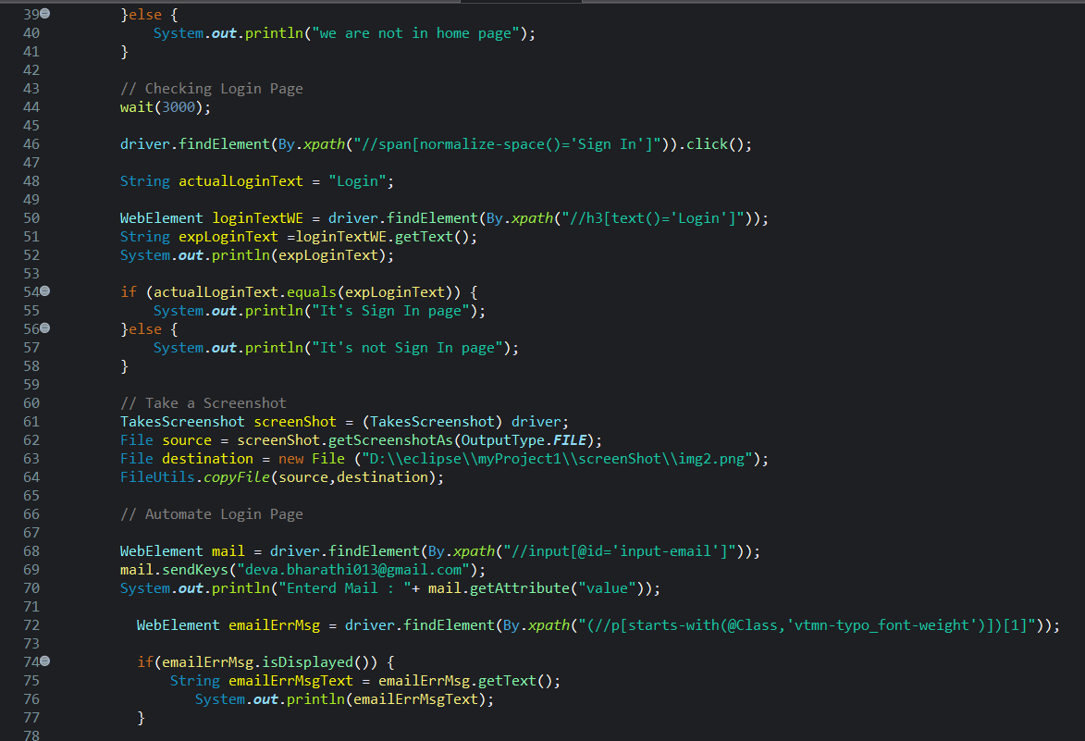
Figure 3: login.java – Lines 39–77 (Home Page Check, Sign In click, Login verification, Screenshot)
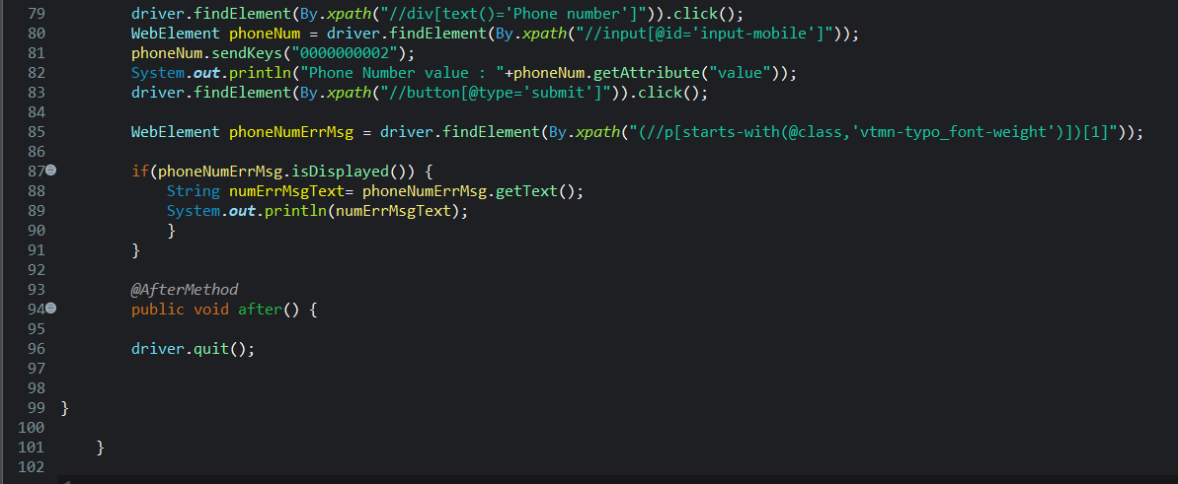
Figure 4: login.java – Lines 79–102 (Phone number entry, Submit, Error capture, @AfterMethod)

Module 2 – Add to Cart Automation

The Add to Cart module validates the complete product selection and cart management workflow. It sets the delivery pincode to 625001 (Madurai), navigates through Fishing and Football Shoes categories, adds two products to the cart, verifies the cart count badge after each addition, captures a screenshot, performs a mouse-based slider action, prints the breadcrumb location, and validates actual price, discount value, and total cart value.

Script:
package decathlon;

import java.io.File;
import java.io.IOException;
import java.util.concurrent.TimeUnit;
import org.apache.commons.io.FileUtils;
import org.openqa.selenium.By;
import org.openqa.selenium.OutputType;
import org.openqa.selenium.TakesScreenshot;
import org.openqa.selenium.WebDriver;
import org.openqa.selenium.WebElement;
import org.openqa.selenium.chrome.ChromeDriver;
import org.openqa.selenium.interactions.Actions;
import org.testng.annotations.AfterMethod;
import org.testng.annotations.BeforeMethod;
import org.testng.annotations.Test;

public class addToCart {
WebDriver driver;
@BeforeMethod
public void setup() {
System.setProperty("webdriver.chrome.driver", "./Driver/chromedriver.exe");
driver = new ChromeDriver();
driver.get("https://www.decathlon.in");
driver.manage().window().maximize();
driver.manage().timeouts().implicitlyWait(10, TimeUnit.SECONDS);
}

@Test
public void main() throws InterruptedException, IOException {
// Pin Code
driver.findElement(
By.xpath("//span[@class='truncate text-xs font-medium text-cobalt-500']")).click();
WebElement pinCode = driver.findElement(By.xpath("//input[@type='text']"));
pinCode.sendKeys("625001");
driver.findElement(By.xpath("//button[@aria-label='Submit pincode']")).click();
Thread.sleep(3000);
WebElement cityName = driver.findElement(
By.xpath("//span[@data-test-id='header-desktop:delivery-address']"));
String nameOfTheCity = cityName.getText();
System.out.println("pin code City Name : " + nameOfTheCity);
// Search The Product
driver.findElement(By.xpath("//span[@data-test-id='All Sports:text']")).click();
driver.findElement(By.xpath("//a[text()='Fishing']")).click();
driver.findElement(By.xpath(
"(//img[@src='https://contents.mediadecathlon.com/p1997697/...' ])[1]")).click();
driver.findElement(By.xpath("//span[text()='Add to cart']")).click();
// Cart count check
WebElement addRoCartUpdating = driver.findElement(
By.xpath("//span[@data-test-id='header-desktop:cart-count-badge']"));
String cartNum = addRoCartUpdating.getText();
System.out.println("Add To Cart is Working : " + cartNum);
// Second product – Football Shoes
driver.findElement(By.xpath("//span[text()='Men']")).click();
driver.findElement(By.xpath("//a[text()='Football Shoes']")).click();
driver.findElement(By.xpath("//img[@src='https://contents.mediadecathlon.com/p2380445/...']")).click();
driver.findElement(By.xpath("//span[text()='10.5']")).click();
driver.findElement(By.xpath("//span[text()='Add to cart']")).click();
driver.findElement(By.xpath("//span[text()='Select products']")).click();
driver.findElement(By.xpath("//img[@src='https://contents.mediadecathlon.com/p2970303/...']")).click();
driver.navigate().back();
WebElement addRoCartUpdating1 = driver.findElement(
By.xpath("//span[@data-test-id='header-desktop:cart-count-badge']"));
String cartNum1 = addRoCartUpdating1.getText();
System.out.println("Add to cart value : " + cartNum1);
// Take a Screenshot
TakesScreenshot screenShot = (TakesScreenshot) driver;
File source = screenShot.getScreenshotAs(OutputType.FILE);
File destination = new File("D:\\eclipse\\myProject1\\screenShot\\img1.png");
FileUtils.copyFile(source, destination);
Thread.sleep(2000);
// Mouse Actions on slider
WebElement mouseFunction = driver.findElement(
By.xpath("//div[@class='absolute top-1/2 h-2 -translate-y-1/2 rounded-full bg-cobalt-500']"));
Actions act = new Actions(driver);
act.clickAndHold(mouseFunction).moveByOffset(1000,0).release().perform();
// Breadcrumb address
WebElement locetingAddress = driver.findElement(
By.xpath("//ol[@data-test-id='breadcrumbs-list']"));
String locetingAdd = locetingAddress.getText();
System.out.println("Addressing locetion : ");
System.out.println(locetingAdd);
System.out.println("**************************");
// Cart price validation
driver.findElement(By.xpath("//span[text()='Cart']")).click();
WebElement actualProductvalue = driver.findElement(
By.xpath("//div[@data-test-id='cart:cart-checkout-total-price']"));
System.out.println("Actual product values : " + actualProductvalue.getText());
WebElement discountValue = driver.findElement(
By.xpath("//div[@data-test-id='cart:cart-checkout-discount']"));
System.out.println("Discount value : " + discountValue.getText());
WebElement totalValue = driver.findElement(
By.xpath("(//p[@classname='font-semibold'])[2]"));
System.out.println("Total Value : " + totalValue.getText());
}
@AfterMethod
public void tearDown() {
driver.quit();
}
}

Output:
Console output from Eclipse IDE – TestNG execution result for addToCart.java
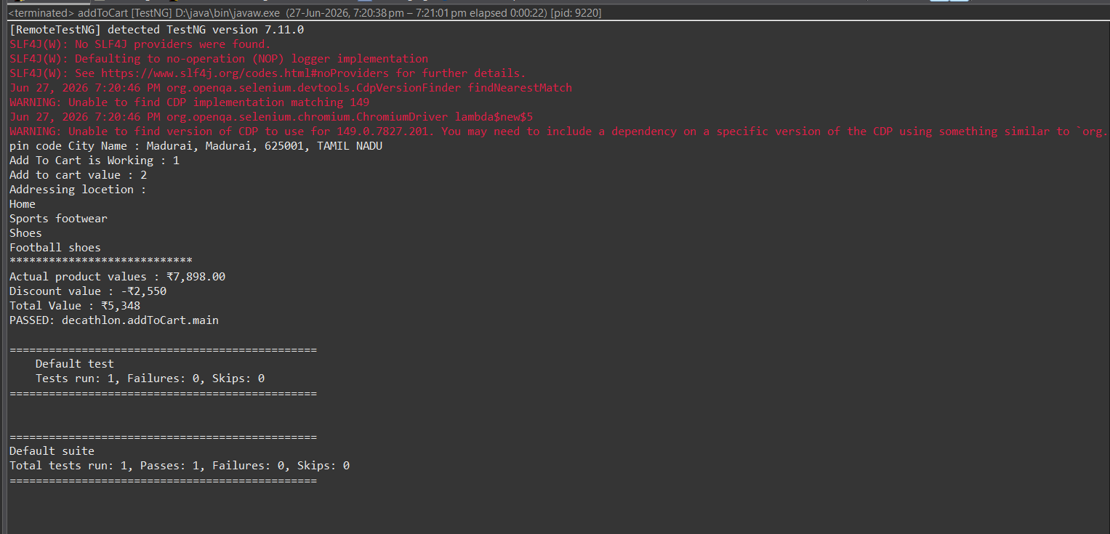
Figure 5: addToCart Module – Console Output (PASSED) – Cart value ₹5,348, Discount -₹2,550

addToCart.java – Source Code (Eclipse IDE)
Screenshots of the complete addToCart.java source code as viewed in Eclipse IDE:

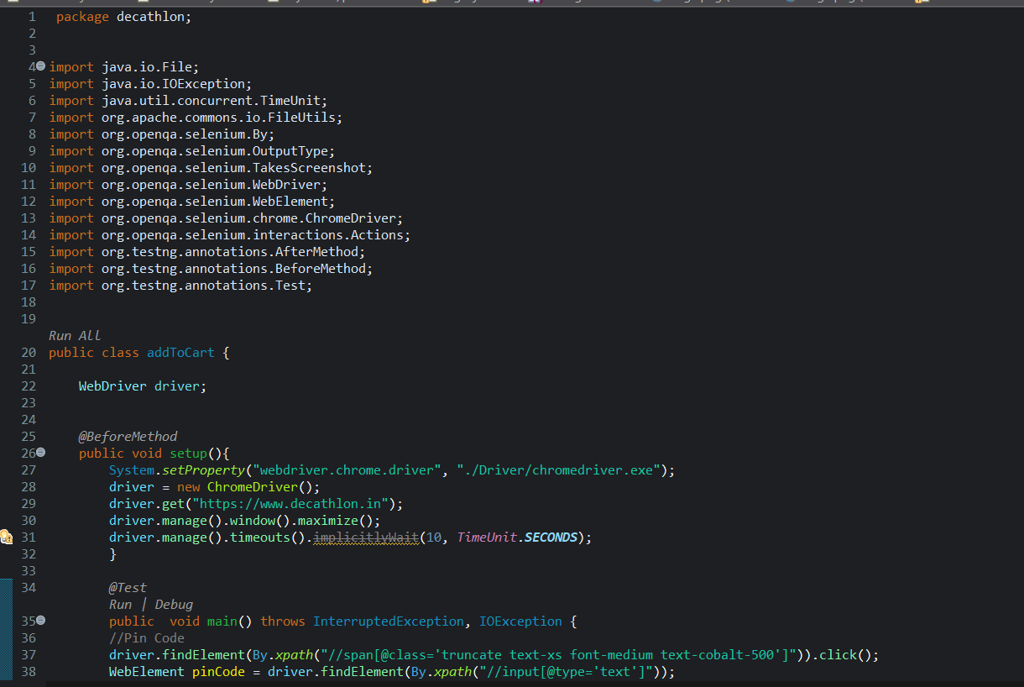
Figure 6: addToCart.java – Lines 1–38 (Package, Imports, Class, @BeforeMethod setup())
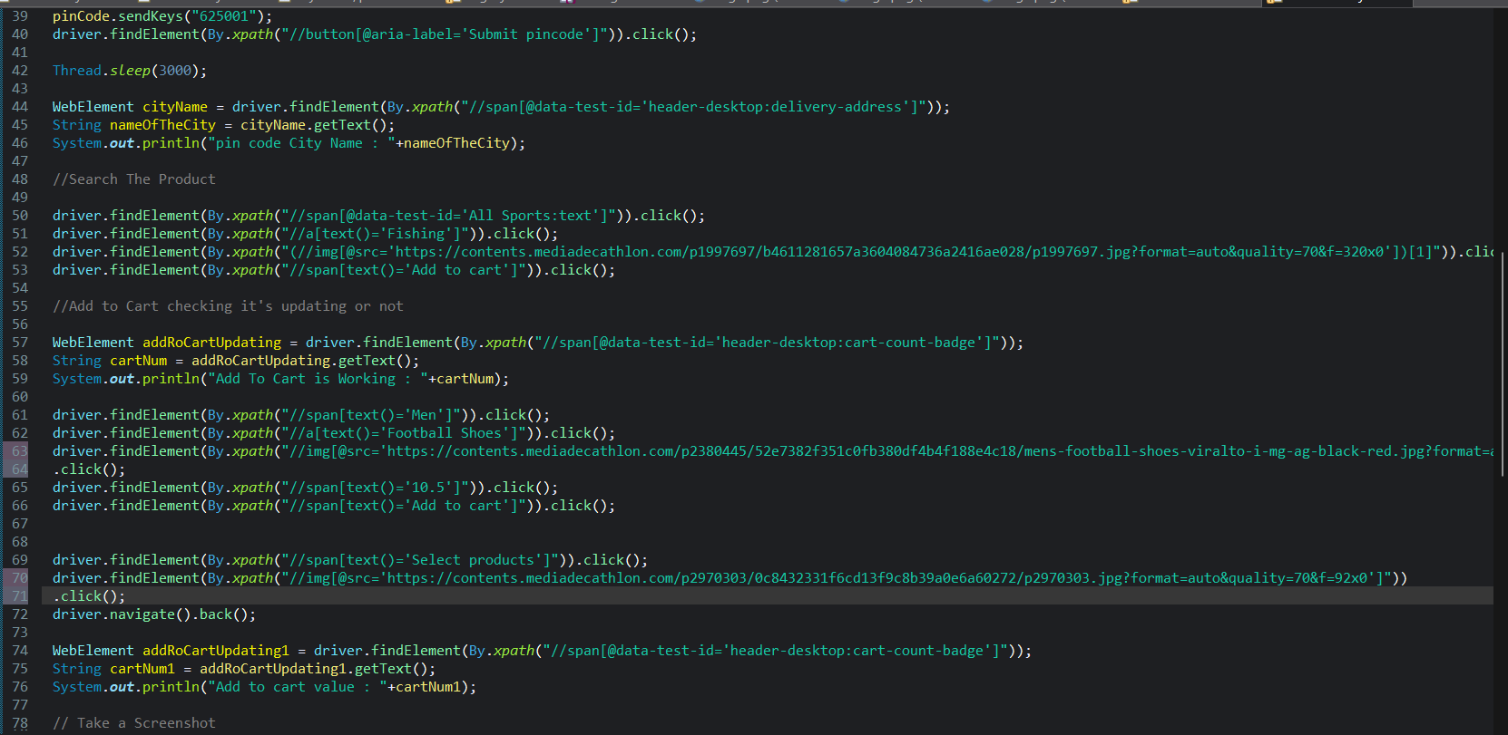
Figure 7: addToCart.java – Lines 39–77 (Pincode entry, Fishing product, Cart count verification)
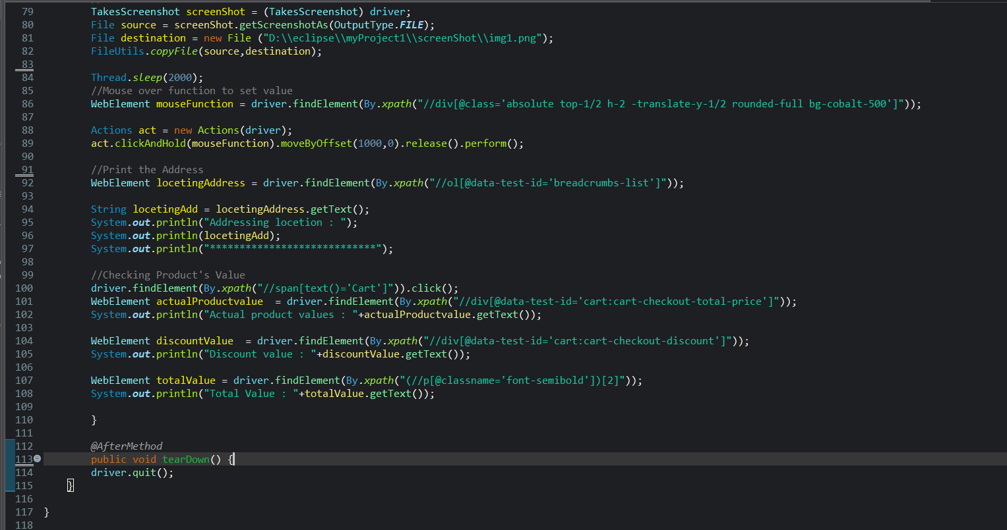
Figure 8: addToCart.java – Lines 79–118 (Screenshot, Mouse action, Breadcrumb, Price validation, @AfterMethod)

Module 3 – Search Product Automation

The Search Product module validates the complete product discovery workflow. It selects a product from the promotional EMI section, changes the delivery pincode to 636701 (Dharmapuri), verifies the city name, captures delivery date and time, takes a screenshot, checks store availability, performs a keyword search for 'football shoes', and applies four sequential filters: Gender (Men), Category (Football boots), Size (11), and Colour (Black).

Script:
package decathlon;

import java.io.File;
import java.io.IOException;
import java.util.concurrent.TimeUnit;
import org.apache.commons.io.FileUtils;
import org.openqa.selenium.By;
import org.openqa.selenium.Keys;
import org.openqa.selenium.OutputType;
import org.openqa.selenium.TakesScreenshot;
import org.openqa.selenium.WebDriver;
import org.openqa.selenium.WebElement;
import org.openqa.selenium.chrome.ChromeDriver;
import org.testng.annotations.AfterMethod;
import org.testng.annotations.BeforeMethod;
import org.testng.annotations.Test;

public class searchTheProduct {
WebDriver driver;
@BeforeMethod
public void setup() {
System.setProperty("webdriver.chrome.driver","./Driver/chromedriver.exe");
driver = new ChromeDriver();
driver.get("https://www.decathlon.in");
driver.manage().window().maximize();
driver.manage().timeouts().implicitlyWait(15, TimeUnit.SECONDS);
}

@Test
public void main() throws InterruptedException, IOException {
// Select the product in EMI Page
driver.findElement(
By.xpath("(//span[@class='text-base font-medium text-white'])[3]")).click();
driver.findElement(By.xpath(
"//img[@src='https://contents.mediadecathlon.com/p2571076/...white.jpg...']")).click();
// Change the product Delivery address
driver.findElement(By.xpath("//button[@aria-label='Change delivery pincode']")).click();
driver.findElement(By.xpath("//input[@id='pincode-input-login']")).sendKeys("636701");
driver.findElement(By.xpath("//button[@aria-label='Submit pincode']")).click();
Thread.sleep(2000);
// Print the address
WebElement cityName = driver.findElement(
By.xpath("//span[@class='truncate text-xs font-medium text-cobalt-500']"));
String pinCodeCity = cityName.getText();
System.out.println("Name Of The City : " + pinCodeCity);
// Delivery date and time
WebElement getDate = driver.findElement(
By.xpath("(//span[@class='text-sm text-rock-900'])[1]"));
String date = getDate.getText();
System.out.println("Delivery Date : " + date);
WebElement getTime = driver.findElement(
By.xpath("//button[@class='cursor-pointer border-none bg-transparent p-0 text-green-600']"));
String time = getTime.getText();
System.out.println("Delivery Timing : " + time);
// Take a Screenshot
TakesScreenshot screenShot = (TakesScreenshot) driver;
File source = screenShot.getScreenshotAs(OutputType.FILE);
File destination = new File("D:\\eclipse\\myProject1\\screenShot\\img3.png");
FileUtils.copyFile(source, destination);
// Store availability check
WebElement viewAvailableStores = driver.findElement(
By.xpath("//span[@class='pl-7 text-xs text-red-400']"));
String viewStores = viewAvailableStores.getText();
String store = "View stores";
if (store.equals(viewStores)) {
System.out.println("Stores are available");
} else {
System.out.println("Stores are not available");
}
// Search Particular Product
WebElement search = driver.findElement(By.xpath("//input[@type='search']"));
search.sendKeys("football shoes", Keys.ENTER);
// Apply filters
driver.findElement(By.xpath("//span[text()='Gender']")).click();
WebElement gender = driver.findElement(By.xpath("(//span[text()='Men'])[2]"));
gender.click();
driver.findElement(By.xpath("//span[text()='Category']")).click();
WebElement product = driver.findElement(By.xpath("//span[text()='Football boots']"));
product.click();
driver.findElement(By.xpath("//span[text()='Size']")).click();
WebElement size = driver.findElement(By.xpath("//span[text()='11']"));
size.click();
driver.findElement(By.xpath("//span[text()='Color']")).click();
WebElement color = driver.findElement(By.xpath("(//span[text()='Black'])[1]"));
color.click();
}
@AfterMethod
public void after() {
driver.quit();
}
}

Output:
Console output from Eclipse IDE – TestNG execution result for searchTheProduct.java
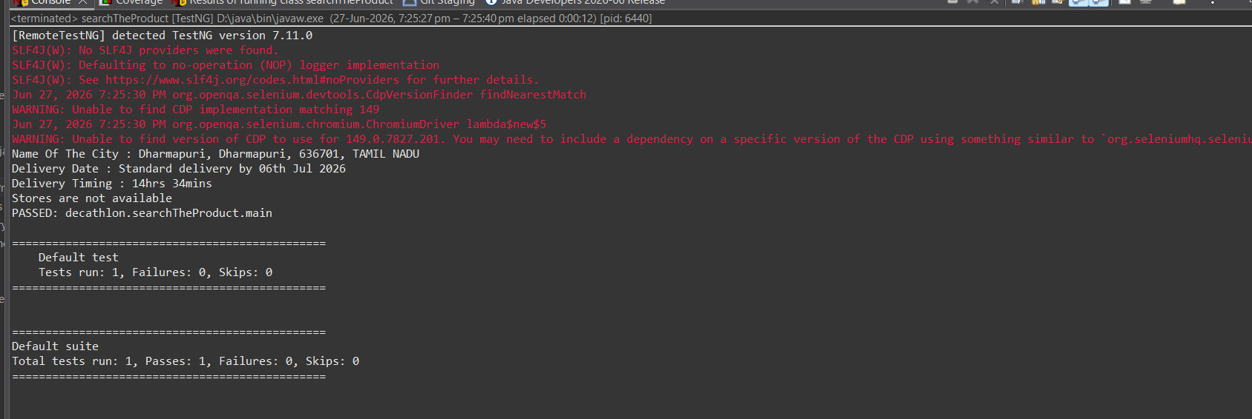
Figure 9: searchTheProduct Module – Console Output (PASSED) – City: Dharmapuri, Delivery: 06 Jul 2026

searchTheProduct.java – Source Code (Eclipse IDE)
Screenshots of the complete searchTheProduct.java source code as viewed in Eclipse IDE:
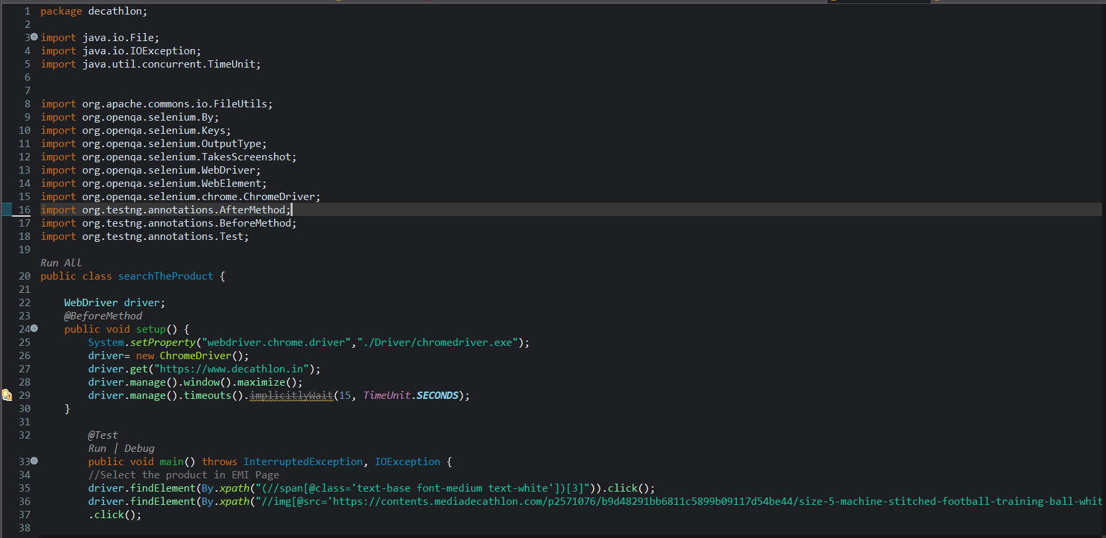
Figure 10: searchTheProduct.java – Lines 1–37 (Package, Imports, Class, @BeforeMethod setup())
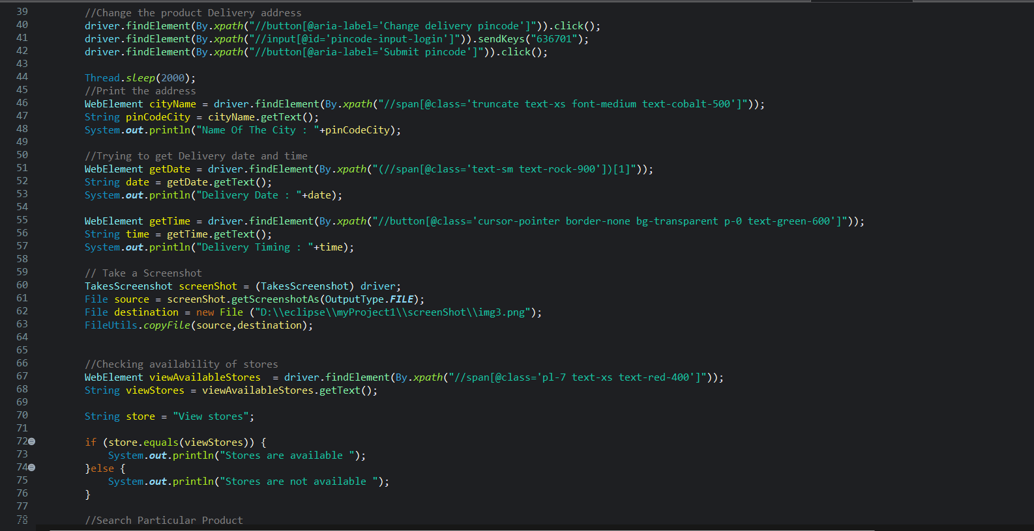
Figure 11: searchTheProduct.java – Lines 39–77 (Pincode change, City name, Delivery date/time, Screenshot, Store check)
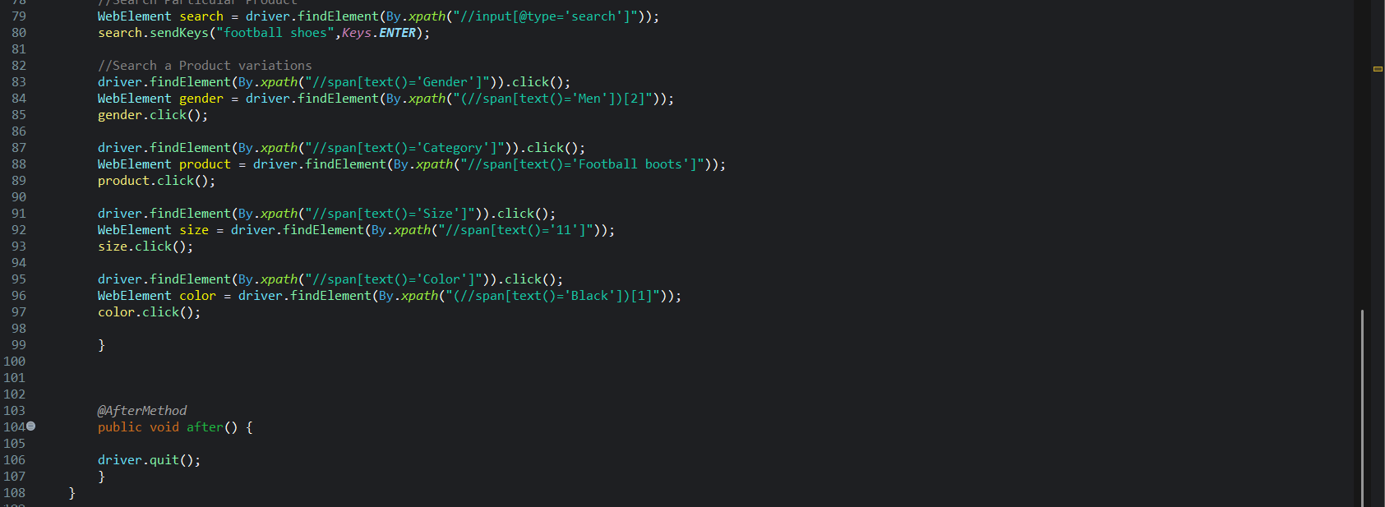
Figure 12: searchTheProduct.java – Lines 79–108 (Search, Gender/Category/Size/Colour filters, @AfterMethod)

Test Execution Summary

All three automation modules executed successfully. The TestNG runner reported 1 test per class with 0 Failures and 0 Skips across all three suite executions.

Module | Test Class | Result | Tests Run
Login Automation | decathlon.login.main | PASSED | 1
Add to Cart Automation | decathlon.addToCart.main | PASSED | 1
Search Product Automation | decathlon.searchTheProduct.main | PASSED | 1

Total tests run: 3 | Passes: 3 | Failures: 0 | Skips: 0
— End of Automation Project Report —

