- First name  Please provide only the first name of the student/team member. Do not include middle or last names. | Devadit
- CREST Award Level | Gold
- Project title | MangoGuard: A market-conditioned pesticide recommender for Indian mango orchards
  - Mentor name
(if you had one)
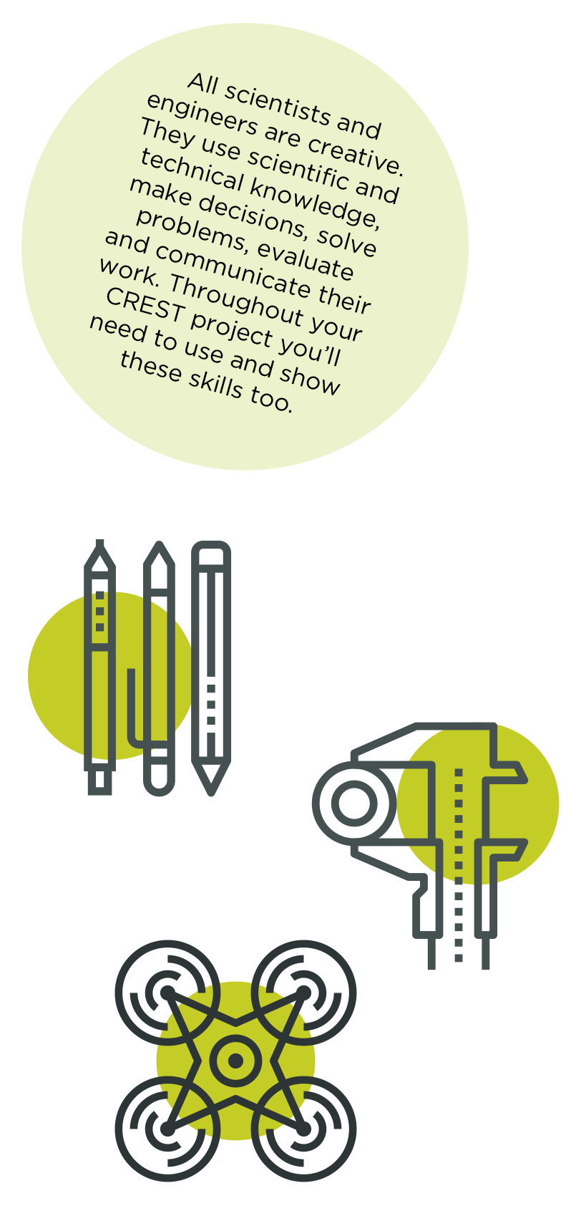

This Profile form is suitable for Bronze, Silver and Gold CREST Awards. Always use in conjunction with corresponding Student Guide Documents.

Please fill in this profile form and submit it along with your project work or report. This a requirement for your application and an opportunity for you to present clearly to the assessor how you have met the CREST criteria and reflected on your project.

If you are working in a group, make sure that you fill in and submit a separate Student Profile Form for each individual.

Criteria | Where do you show this in your report or project record? | Your notes to the assessor (optional)

1 – Planning your project

1.1 You have set a clear aim for the project and have broken it down into smaller objectives | §1.1 Aim; §1.2 success conditions ('I will have achieved my aim if' S1–S4); §1.3 six numbered objectives. | Broad aim, then measurable success conditions, then a numbered objective list — one per module.
1.2 You have explained a wider purpose for the project | §2 Wider purpose & affected populations (§2.1 problem; §2.2 stakeholder table). | Quantifies affected Konkan smallholder population and the export-rejection / domestic over-spray problem.
1.3 You have identified a range of approaches to the project | §3.1 three project architectures compared (positives/negatives); §3.2 hardware vs interoperability. | Method-comparison tables; chosen hybrid approach justified against the alternatives.
1.4 You have described your plan for the project and why you chose that approach | §4 Plan and rationale (six-stage plan + 'Our rationale for this approach is…'). | High-level plan with reasons tied to the access, no-hardware and 12-week constraints.
1.5 You have planned and organised your time well | §4; Appendix A Gantt chart (planned vs actual, with a 2-week contingency buffer). | Timeline covers planning → build → evaluation → write-up; buffer weeks named.

2 – Throughout your project

2.1 You have made good use of the materials and people available | §6.2 connector layer (data sources used); §7 (consent/data); §2.2 stakeholders. | Used free public data (IMD, CROPSAP, AGMARKNET, Sentinel-2), public MangoLeafBD, and Pessl FieldClimate demo data; live farm/FPO engagement is documented future work (§8.4).
2.2 You have researched the background to the project and acknowledged your sources appropriately | §5 Background & literature review; §12 References. | (Author, Year) citations; primary sources — Akem 2006, NHB, ICAR-CISH, EU RASFF, FSSAI, CIB&RC, Sentinel-2.

3 – Finalising your project

3.1 You have made logical conclusions and explained the implications for the wider world | §10 Conclusions & wider-world implications; §2.2 affected population. | Conclusions tied back to each success condition; implications for growers, exporters, FSSAI/APEDA and consumers.
3.2 You have explained how your actions and decisions affected the project’s outcome | §3.2; §9 problems & decisions; §8.2/§9.4 (retired invalid metric; calibration gap). | Each key decision stated with its effect and the rejected alternative — e.g. MobileNetV3 over DenseNet201, interoperability over new hardware, and retiring a biased metric after seeing real output.
3.3 You have explained what you have learnt and reflected on what you could improve | §11 Reflection & future work (five-part) and §11.1. | Skills gained; what went well/badly with root causes; what I would repeat; concrete next iterations.

4- Project-wide criteria

4.1 You have shown understanding of the science behind your project, appropriate to the Award level | §5 derivations (Akem logistic regression & HTR; Gaussian/triangular pathogen models; NDRE biophysics; ROC-AUC; Beta-prior conjugacy); §6 methodology. | Mathematics derived, not merely cited — the depth-of-understanding evidence.
4.2 You have made decisions to direct the project, taking account of ethical and safety issues | §7 Ethics, safety & AI use; Appendix B (risk-assessment matrix + consent form); Appendix E (AI use statement). | Risk assessment, farmer consent (English/Marathi), DPDP Act 2023, advisory-not-prescriptive disclaimer, full AI-use disclosure.
4.3 You have shown creative thinking | §6.4 market-conditioned recommender (focal contribution); §8.2–§8.3 interoperability finding. | Original synthesis — no commercial mango tool conditions the spray on the destination market's residue rules; quantified that one integrated system lifts disease-risk AUC from chance (0.48) to 0.78.
4.4 You have identified and overcome problems successfully | §9 Problems encountered (six, each problem → workaround → root-cause fix). | Includes problems the real evaluation exposed — the invalid prevention-rate metric and the chlorpyrifos/carbendazim calibration gap — found, named and addressed.
4.5 You have explained your project clearly, in writing or conversation | Whole report: §0 abstract, numbered sections, Appendix D glossary, six captioned figures. | Abbreviations expanded on first use; intended audience stated; figures and tables throughout; proofread.

Personal reflections
Now that you’ve finished your project, use this space to add further thoughts on what you did and evaluate each stage of the project process. The CREST Award student guide gives an example of what to include. You can continue on a separate sheet if necessary and use diagrams or pictures if you want to.
- How my project was successful/not successful
- What I learned
- What impact the results of my project might have on other people/the wider world
- What I would have done to improve my work
- What I’d do to develop the project in the future

How my project was successful / not successful: The software succeeded — all five modules and the market-conditioned recommender were built and pass 554 automated tests, and the evaluation runs end-to-end and is fully reproducible. The disease-pressure index clearly beat the calendar baseline (ROC-AUC 0.75 vs 0.50), and integrating one existing commercial monitoring system lifted accuracy from chance (0.48) to 0.78, which is the core interoperability result. It was less successful in two honest ways: I could not secure repeated farm access, so the field pilot and stakeholder interviews became future work; and running the real evaluation showed that my recommender does not yet catch two high-frequency residue offenders (chlorpyrifos, carbendazim) without real inspection-volume data.
What I learned: how to build an interoperability layer across genuinely different data sources; the agronomic epidemiology behind anthracnose, powdery mildew and hopper risk; the statistics of evaluation (ROC-AUC, Brier calibration, and why a Beta prior is the right tool for a sparse rejection rate); and — most importantly — that running a real evaluation, rather than assuming the design works, is what exposes the real problems (it caught a biased metric and a calibration gap I would otherwise have missed).
Impact on others / the wider world: because the tool works with whatever monitoring system a farm already runs, a single cooperative field officer could apply it across many member farms, reaching the tens of thousands of Konkan smallholders served by the Devgad and Ratnagiri cooperatives — lowering both export-rejection risk and unnecessary domestic spraying, which reduces grower cost, worker exposure and consumer residue.
What I would improve: curate the regulatory tables from live portals first (they are the rate-limiting input), secure the field visit before the build rather than during it, and calibrate the residue filter against real inspection-volume data so the strict-limit offenders are caught.
How I would develop it: a multi-farm 2026-season pilot to replace simulation with real outcomes; Sentinel-1 radar fusion to close the monsoon satellite gap; multi-cultivar support (Kesar, Dasheri); and an exporter-buyer matching feature.

My mentor or supervisor
If you had a project mentor or placement supervisor (such as a teacher, relative, industry expert, etc.) how did they help with your project? (Please leave blank if you did not have one.)
Ask your mentor to confirm that this project is your work by signing below.
  - Signature of mentor or supervisor
  - Date

  - Space for further notes/ drawings/ reflections (optional)

