Be My Professional
BMP
UX / UI FLOW DIAGRAMS
Authentication · Signup · Role Flows · Screen Navigation
6 flows | 4 roles | OTP states | All screens | Edge cases | Navigation

Version 1.0 | May 2026 | Bengaluru, India | Confidential

Diagram Index
This document contains 6 UX flow diagrams covering the complete authentication, signup, and navigation flows for all roles in the BMP platform. Each diagram is presented with a description, key decision points, and design notes.

Flow | Name | What it covers | Roles
Flow 1 | App launch and auth routing | Splash screen → JWT check → token valid (auto-login) or expired (phone entry) → fork screen for new users | All roles
Flow 2 | Role routing after OTP | After OTP verified → single role goes direct → multiple roles hit role picker → 4 destination screens | All roles
Flow 3 | New user signup paths | All 4 parallel onboarding paths side by side: customer (3 steps), salon owner (5 steps + 24h review), stylist (3 steps), employee (invite only) | All roles
Flow 4 | OTP screen — all states | Entering → auto-submit → API response → correct (verified) or wrong (error, lockout) → WhatsApp fallback path | All roles
Flow 5 | Complete screen ID map | Every screen from S1 Splash to T3/M3, with screen IDs and navigation connections across all 4 role paths | All roles
Flow 6 | Returning user login | JWT valid (auto-login) → known device vs new device → previous device alert → role routing (single or multi-role) | All roles

Flow 1
App launch and authentication routing

Flow 1 — App launch and authentication routing
This is the very first thing that happens every time a user opens the BMP app. The app silently checks for a stored JWT token. If found and valid, the user is auto-logged in. If not, they see the login/signup screen. New users are routed to the fork screen.

Flow 1: App launch → JWT check → Login or Auto-login

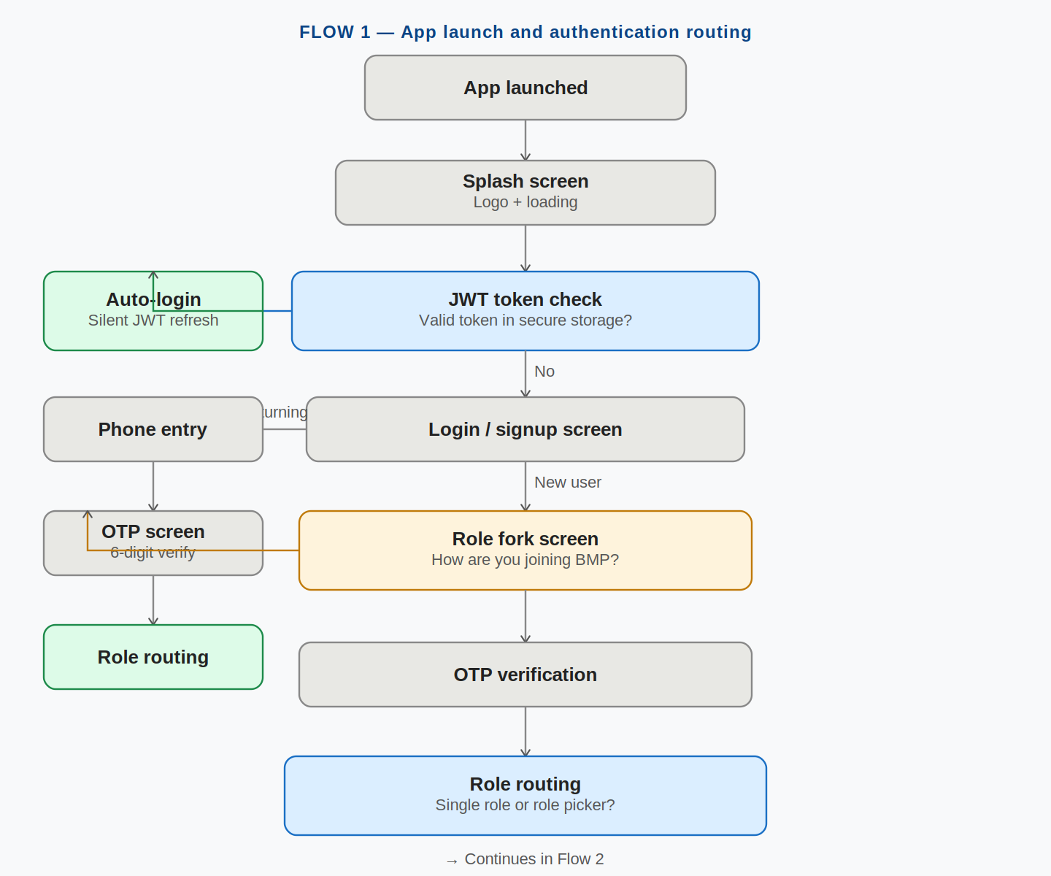

Note: Blue boxes = decision or action nodes. Green boxes = success outcomes. Grey = neutral steps.
Note: The JWT check happens silently on the splash screen — user never sees a loading indicator.
Note: New users always arrive at the Fork screen (Flow 3). Returning users skip the fork.

Key decision points in Flow 1
Decision | YES path | NO path
JWT token found? | Check if device is known. If yes: auto-login silently. | Show login/signup screen. User must authenticate.
JWT valid and not expired? | Silent refresh if near expiry. Route to home screen. | Force re-login. Phone entry shown.
Returning or new user? | Returning: phone entry → OTP → role routing. | New: phone entry → OTP → fork screen.

Flow 2
Role routing after OTP

Flow 2 — Role routing after OTP verification
After the user successfully verifies their OTP, the backend checks how many roles this phone number has. A single-role user goes directly to their home screen. A multi-role user sees the role picker to choose which context they want to use.

Flow 2: OTP verified → single role or role picker → 4 destination screens

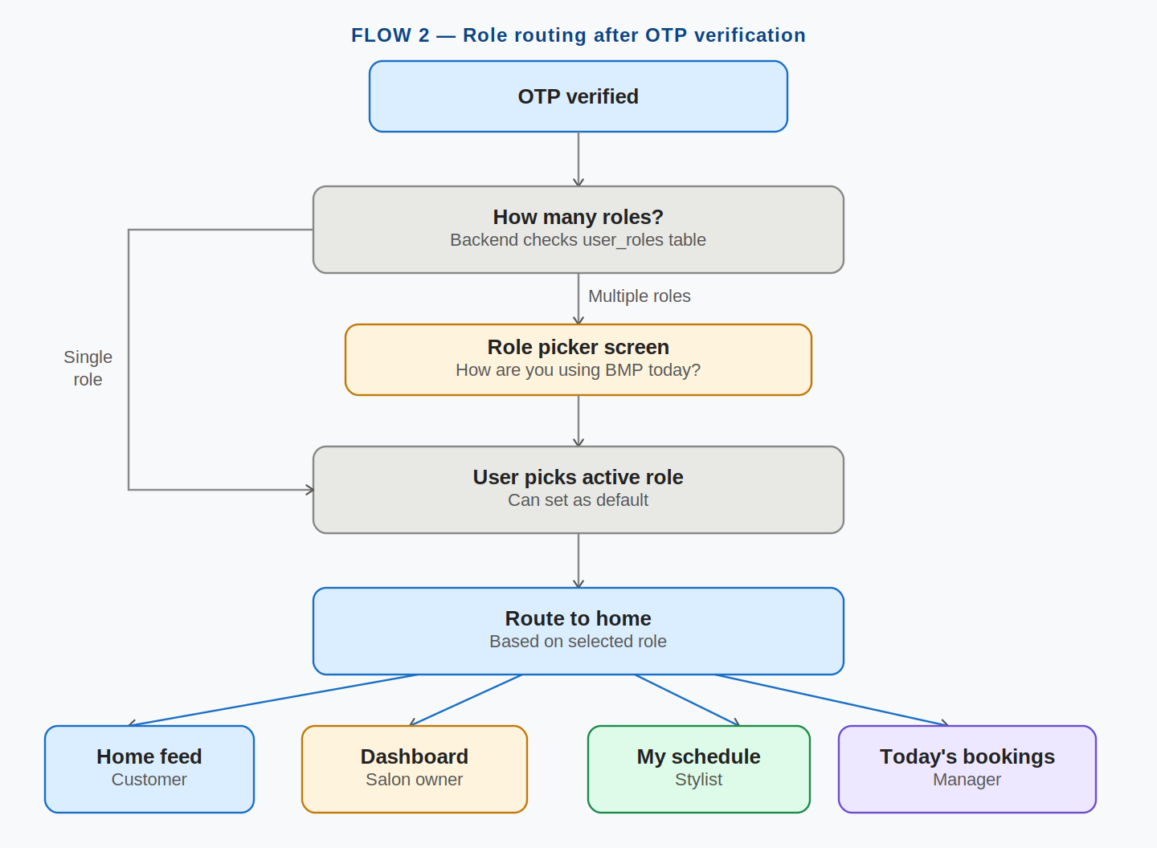

Note: Four destination screens: Home feed (customer), Dashboard (salon owner), My schedule (stylist), Today bookings (manager).
Note: Role picker allows setting a default role to skip this screen on future logins.
Note: Multi-role users can switch roles any time from the Profile tab without logging out.

Role | Destination screen | First thing they see | Default role?
Customer | Home feed | Nearby salon cards, search bar, category filters | Yes, for most users
Salon owner | Salon dashboard | Today bookings summary + pending actions | If only salon role
Stylist | My schedule | Today appointments list + availability toggle | If only stylist role
Manager | Today's bookings | All salon bookings for today, mark arrived/done | If only manager role

Flow 3
New user signup — all 4 role paths

Flow 3 — New user signup paths (all 4 roles)
After a new user verifies OTP, they hit the Fork screen and choose their role. This diagram shows all four signup paths in parallel columns. The employee path has no Fork option — employees only join via an invite link sent by their salon owner.

Flow 3: Fork → 4 parallel onboarding paths → 4 home screens

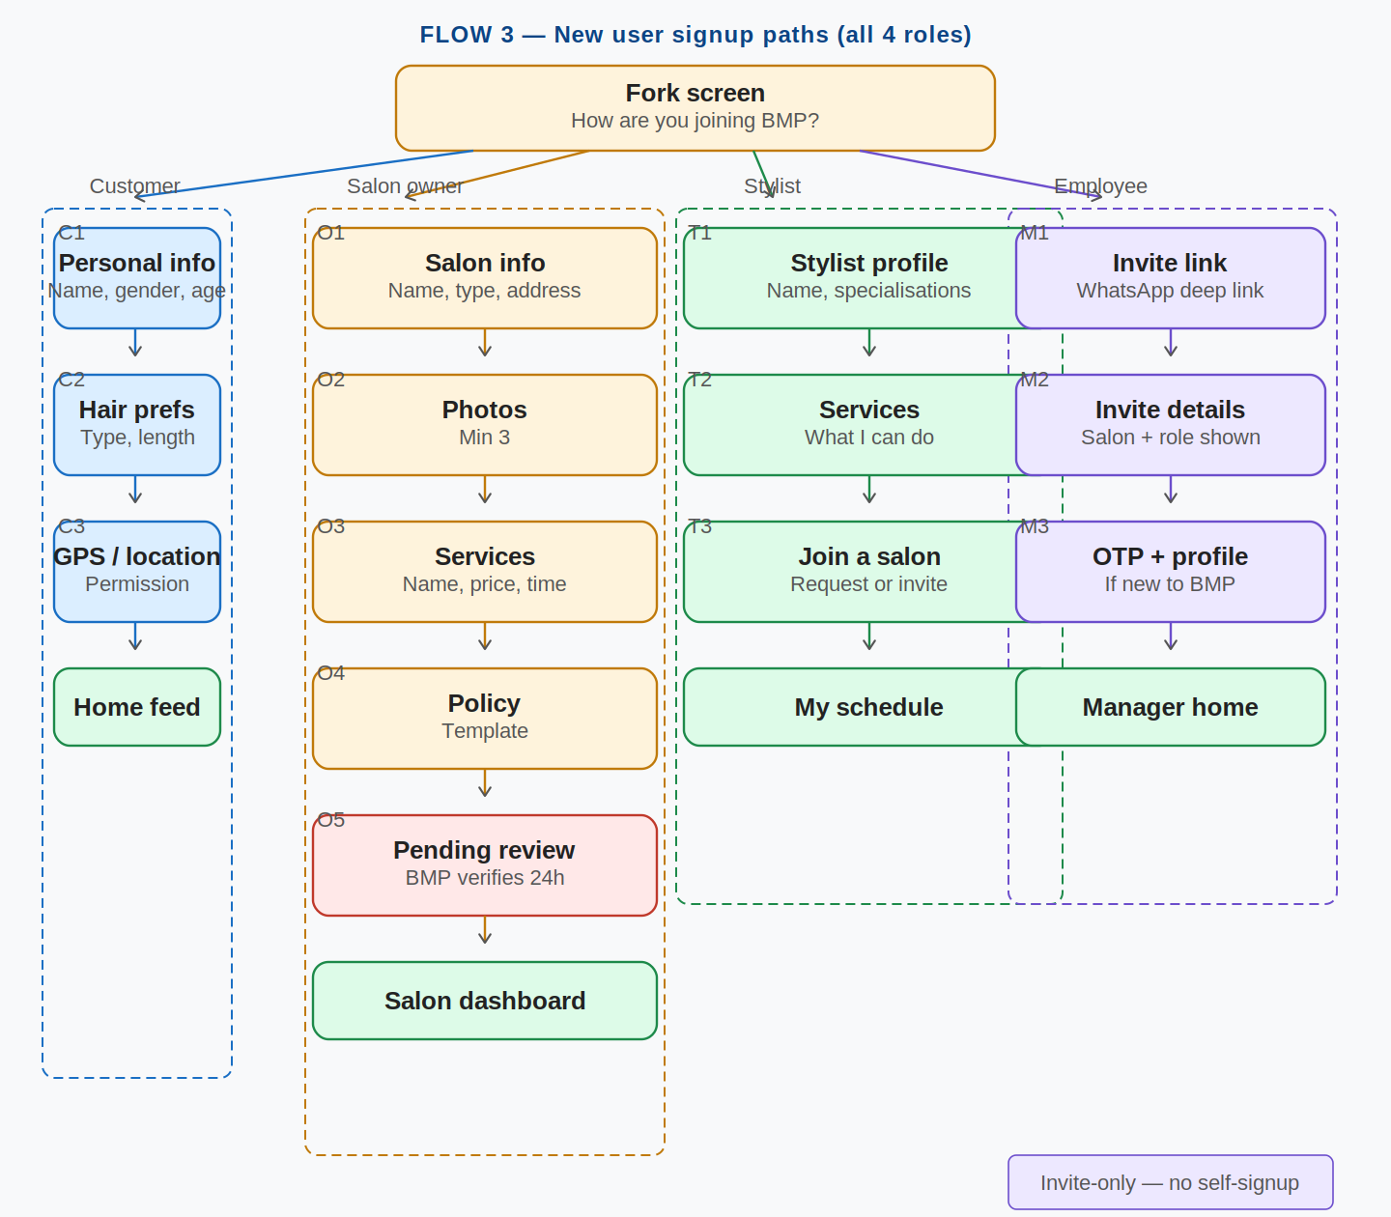

Note: Blue = Customer path (C1–C3). Amber = Salon owner path (O1–O6). Green = Stylist path (T1–T3). Purple = Employee/Manager path (M1–M3).
Note: Salon owner O6 (Pending review) is shown in red because it is a wait state — salon cannot go live until BMP approves.
Note: Employee path has NO fork option — this column is only reachable via a WhatsApp invite link.

Step details — all paths
Step | Customer | Salon owner | Stylist | Manager
1 | C1: Name, gender, age, email | O1: Salon name, type, address, hours | T1: Name, photo, specialisations, experience | M1: Invite link — salon name + role shown
2 | C2: Hair type, length, services | O2: Photos (min 3 required) | T2: Services I can perform | M2: OTP verification if new to BMP
3 | C3: GPS permission request | O3: Add services with price + duration | T3: Join a salon — invite or request | M3: Complete profile, land on manager home
4 | Done: Home feed | O4: Add stylists (optional) | Done: My schedule | —
5 | — | O5: Set cancellation policy | — | —
6 | — | O6: Pending BMP review (24h) | — | —

Flow 4
OTP screen — all states and transitions

Flow 4 — OTP screen: all states and transitions
The OTP screen has 8 distinct states. This flow maps every transition including the lockout path after 3 failed attempts, the WhatsApp fallback when SMS is delayed, and the success state that triggers JWT issuance.

Flow 4: OTP screen state machine — entering, error, lockout, WhatsApp fallback, verified

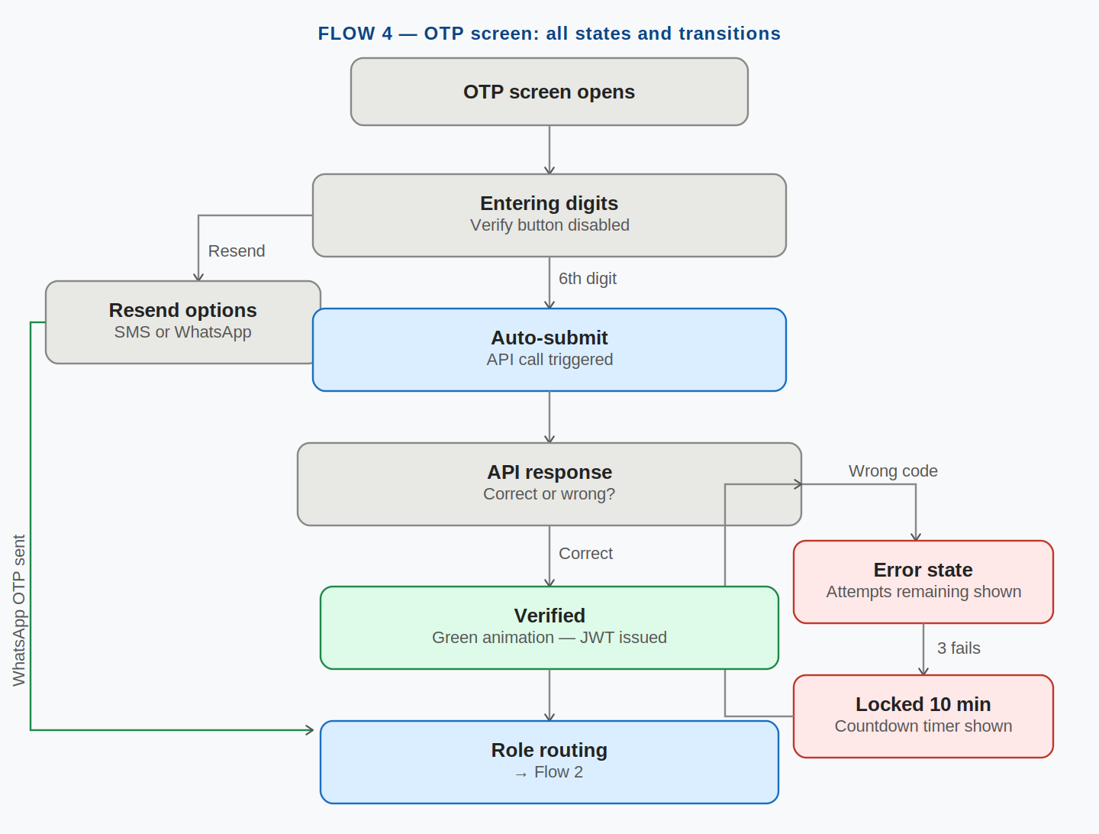

Note: Auto-submit triggers the API call the moment the 6th digit is entered — no tap needed.
Note: Lockout is 10 minutes after 3 failed attempts. The countdown timer is visible on screen.
Note: WhatsApp fallback (green path on the left) re-enters at the API response stage — same flow from there.

State | What user sees | System behaviour
Entering (partial) | Filled boxes show digits. Empty boxes grey. Verify button disabled. | No API call yet. Waiting for all 6 digits.
Complete (auto-submit) | All 6 boxes filled. Button activates. Spinner appears. | API call triggered automatically after 300ms.
Wrong code | All boxes turn red. "Incorrect code. X attempts remaining." | Attempt counter decremented. Boxes cleared for re-entry.
Locked out | "Too many attempts. Try again in 10 minutes." Countdown shown. | Account locked for 10 minutes. Prevents brute force attacks.
OTP expired | Timer at 0:00. "Code expired. Request a new one." Resend highlighted. | Old OTP invalidated. Fresh OTP sent on resend tap.
WhatsApp fallback | "Try via WhatsApp" option shown after first resend. | MSG91 WhatsApp API sends OTP via WhatsApp message.
Verified | All boxes turn green. Checkmark animation. Auto-navigate. | JWT issued. Role routing triggered. User never sees loading.

Flow 5
Complete screen ID navigation map

Flow 5 — Complete screen ID navigation map
This is the master screen map. Every screen in the authentication and onboarding flows is assigned a unique ID. Screens are grouped by role path. This map is the reference for frontend developers when wiring up navigation.

Flow 5: All screen IDs and navigation connections across all 4 role paths

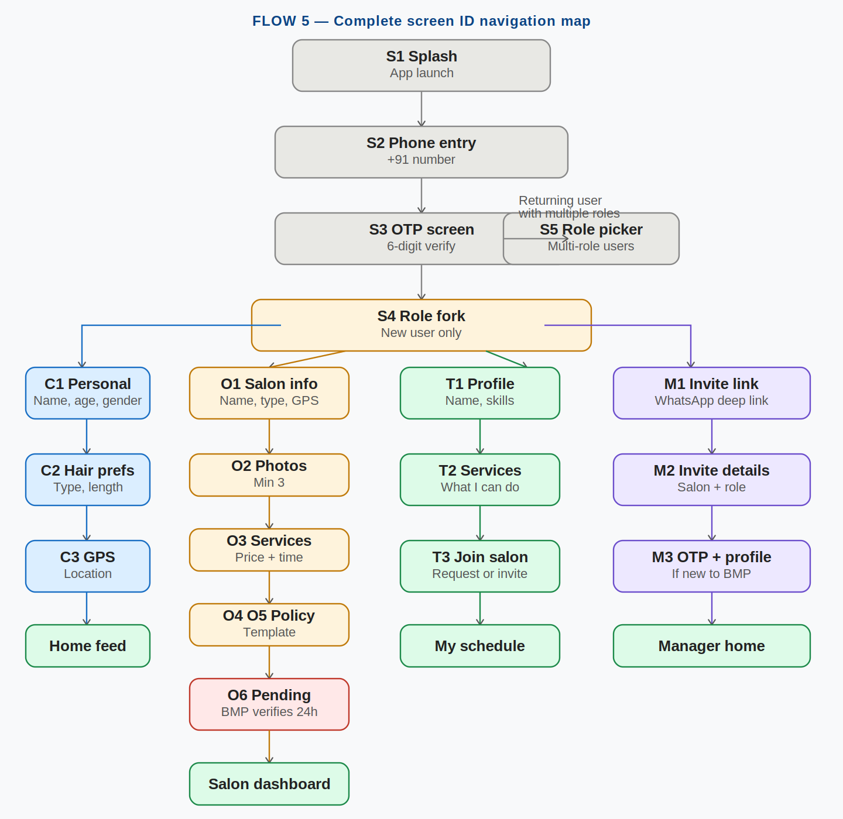

Note: S-prefixed screens are shared across all roles (S1 Splash, S2 Phone, S3 OTP, S4 Fork, S5 Role picker).
Note: C-prefixed = Customer. O-prefixed = Salon Owner. T-prefixed = Stylist. M-prefixed = Manager.
Note: Green terminal boxes = final destination home screens for each role.

Screen ID reference
ID | Screen name | Purpose | Role
S1 | Splash screen | Brand moment. Background JWT check. | All
S2 | Phone entry | +91 number input. Country code picker. Google sign-in below. | All
S3 | OTP screen | 6-digit OTP. 8 states. WhatsApp fallback. Auto-submit. | All
S4 | Role fork | New users only. 3 options: Customer / Salon owner / Stylist. Employee note. | New users
S5 | Role picker | Multi-role users. Choose active role. Set default option. | Multi-role
C1 | Personal info | Name (required). Gender pills. Age slider 18–65. Email (optional). | Customer
C2 | Hair prefs | Hair type, length, services usually needed. Personalises feed. | Customer
C3 | GPS / location | Location permission request. Skip allowed. Framed as a benefit. | Customer
O1 | Salon info | Name, type, address with Maps pin, working hours. | Salon owner
O2 | Salon photos | Min 3, max 15. First = cover image. Real photos required. | Salon owner
O3 | Services | Add services: name, price (INR), duration (minutes). Min 1. | Salon owner
O4 | Stylists | Add stylists: name, photo, services. Optional at onboarding. | Salon owner
O5 | Policy | Cancellation template, booking window, late grace period. | Salon owner
O6 | Pending review | Checklist screen. BMP verifies within 24h. Add bank account here. | Salon owner
T1 | Stylist profile | Name, photo, specialisations, years of experience. | Stylist
T2 | Services | Which services can this stylist perform? Selected from list. | Stylist
T3 | Join salon | Two paths: wait for invite OR search and request to join a salon. | Stylist
M1 | Invite link landing | Shows: which salon, role assigned, what they can/cannot do. Accept or Decline. | Manager
M2 | Invite OTP | Phone OTP verification. Skipped if already logged in as BMP user. | Manager
M3 | Profile completion | Name and photo. Role and salon pre-filled from invite token. | Manager

Flow 6
Returning user login — all scenarios

Flow 6 — Returning user login (all scenarios)
Returning users have three possible login scenarios: auto-login from known device, OTP from new device, or forced re-login after token expiry. New device logins also trigger a security notification to the user's previous device.

Flow 6: JWT check → auto-login vs new device vs expired token → role routing

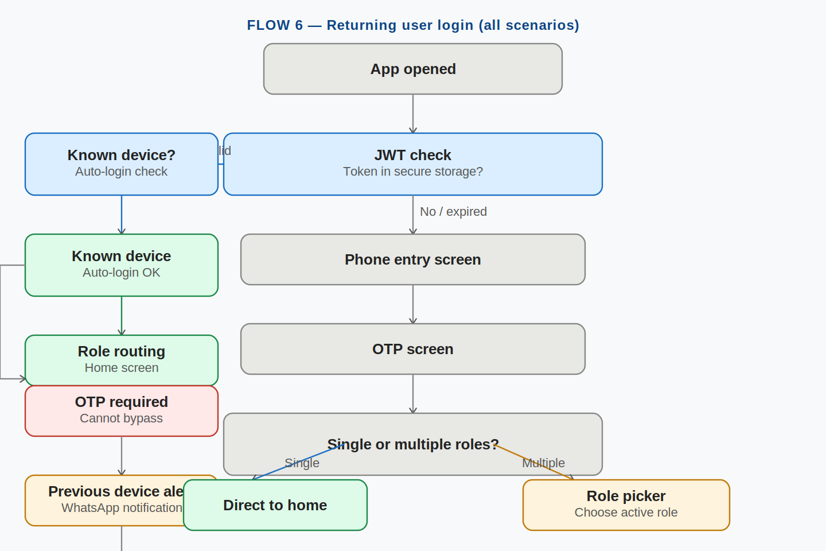

Note: New device logins require OTP even if a valid JWT exists — device fingerprint binding prevents token theft.
Note: Previous device receives a WhatsApp alert for every new device login — security notification.
Note: Multi-role returning users see the role picker. Single-role users land directly on their home screen.

Scenario | What happens | Security measure
Known device, valid JWT | Silent JWT refresh if near expiry. Auto-login. No interaction needed. | Device fingerprint match. No extra step.
Known device, expired JWT | Phone entry + OTP required. | Fresh JWT issued. Device re-confirmed.
New device, valid JWT | OTP required even though JWT is valid. | Previous device gets WhatsApp alert: "New login detected."
Multiple roles detected | Role picker shown after login. | JWT scoped to chosen role only.
Default role set | Role picker skipped. Goes directly to home. | default_role field in user profile.

Edge Cases — Auth Flows
The following edge cases must be handled in the authentication flows. Each has a defined UX response and system behaviour.

Edge case | User sees | System behaviour
OTP SMS not received | Resend available after 30s. WhatsApp option shown. | MSG91 retry. WhatsApp channel as fallback.
Wrong OTP 3 times | "Too many attempts. Try again in 10 min." Countdown shown. | Account locked 10 minutes. Prevents brute force.
OTP expires (5 min) | "Code expired. Request a new one." | Old OTP invalidated. Fresh on resend.
Phone already registered | Normal login flow proceeds. No special message. | Prevents account enumeration attacks.
Invite link expired (48h) | "Invite expired. Ask owner to resend." | invite_token invalidated. Owner generates new.
Invite already used | "Invite already accepted." Link to login. | One-time token. Cannot be reused.
Salon rejected by BMP | Specific feedback: what needs to change. | Owner can fix and resubmit. Not a permanent ban.
App crash mid-onboarding | Returns to where they left off. | Onboarding state saved locally + partial server record.
Google sign-in used | Google OAuth flow. Same fork screen after. | Phone still required for OTP on bookings.

BMP — UX / UI Flow Diagrams | Authentication and Role Flows | May 2026 | Confidential

