BMP — Internal Admin Panel
SCREEN DESIGNS | CONFIDENTIAL — INTERNAL ONLY
dashboard.bemyprofessional.in/admin | 5 roles | TOTP mandatory | Full audit trail
AP1 Overview | AP2 Salons | AP3 Tickets | AP4 Ticket detail | AP5 Finance | AP6 Staff | AP7 Audit log | AP8 Salon detail

Admin roles — who uses which screen
Screen | Super Admin | Admin | Cust Support | Salon Support | Finance | Notes
AP1 Platform overview | Full | Full | Read only | Read only | Revenue only | All roles land here. Financial KPIs hidden for CS and Salon Support.
AP2 Salon management | Full + ban | Approve/suspend | No access | Approve/edit | No access | CS cannot see salon management. Salon Support can approve but not ban.
AP3/AP4 Support tickets | Full | Full + escalate | Customer tickets | Salon tickets | Finance tickets | Routed by type. CS sees customer tickets only. SS sees salon tickets only.
AP5 Finance | Full | View only | No access | No access | Full | CS and Salon Support have zero access to financial data. Finance can trigger payouts.
AP6 Internal staff | Full | No SA access | No access | No access | No access | Only Super Admin can create or remove other Super Admins.
AP7 Audit log | Full | Full | No access | No access | No access | Only Super Admin and Admin can see the audit log. CS and Support cannot.
AP8 Salon detail | Full | Edit/suspend | No access | Edit info only | Payout view | CS cannot drill into salon data. Salon Support can edit profile but not financial.

Screens AP1 · AP2
Platform overview · Salon management

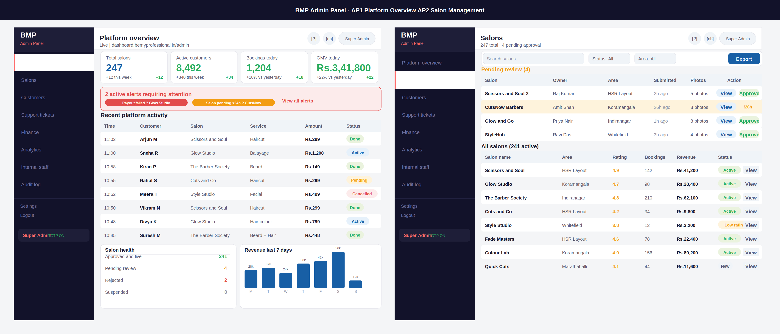

Annotations — AP1 · AP2
ID | Screen | UI elements | UX reasoning | Dev note
AP1 | Platform overview | Very dark sidebar (almost black) with BMP logo in red accent, 8 nav items, role badge with TOTP status at bottom. Main area: 4 KPI cards (total salons, customers, bookings today, GMV). Red alert banner with 2 active issues. Scrollable recent activity table with time, customer, salon, service, amount, status. Bottom: salon health panel + 7-day revenue bar chart. | Dark sidebar distinguishes the admin panel completely from the salon dashboard and customer app — anyone who sees it knows they are in a sensitive internal tool. Red accent on "Admin Panel" is a constant visual reminder of elevated access. Alert banner at the top before the table means critical issues cannot be missed by scrolling past them. | Admin panel at internal.bemyprofessional.in/admin — completely separate subdomain from the public app. TOTP status shown in sidebar for every session. All API calls require admin JWT with role claim. Recent activity table auto-refreshes every 60 seconds. Salon health counts from salon.status aggregation.
AP2 | Salon management | Search + filter row (status, area, export). Amber pending section at top with 4 pending salons. Each pending row has View and Approve buttons. Amber highlight on CutsNow (submitted 26h ago — SLA breach). All salons table below: name, area, rating, bookings, revenue, status badge, View link. | Pending salons are physically separated at the top of the page because they require action. The 26h amber warning on CutsNow is automatic — the system knows verification should take under 24h. Rating shown in gold to immediately flag low-rated salons (Style Studio at 3.8 is visually distinct). Export button for finance reconciliation. | Pending sort: oldest first. SLA breach = submitted >24h ago, highlighted amber automatically. Approve button triggers salon.status=approved + WhatsApp notification to owner. Reject navigates to a rejection reason form. All approval actions logged in audit_log with actor and timestamp.

Screens AP3 · AP4
Support tickets · Ticket detail

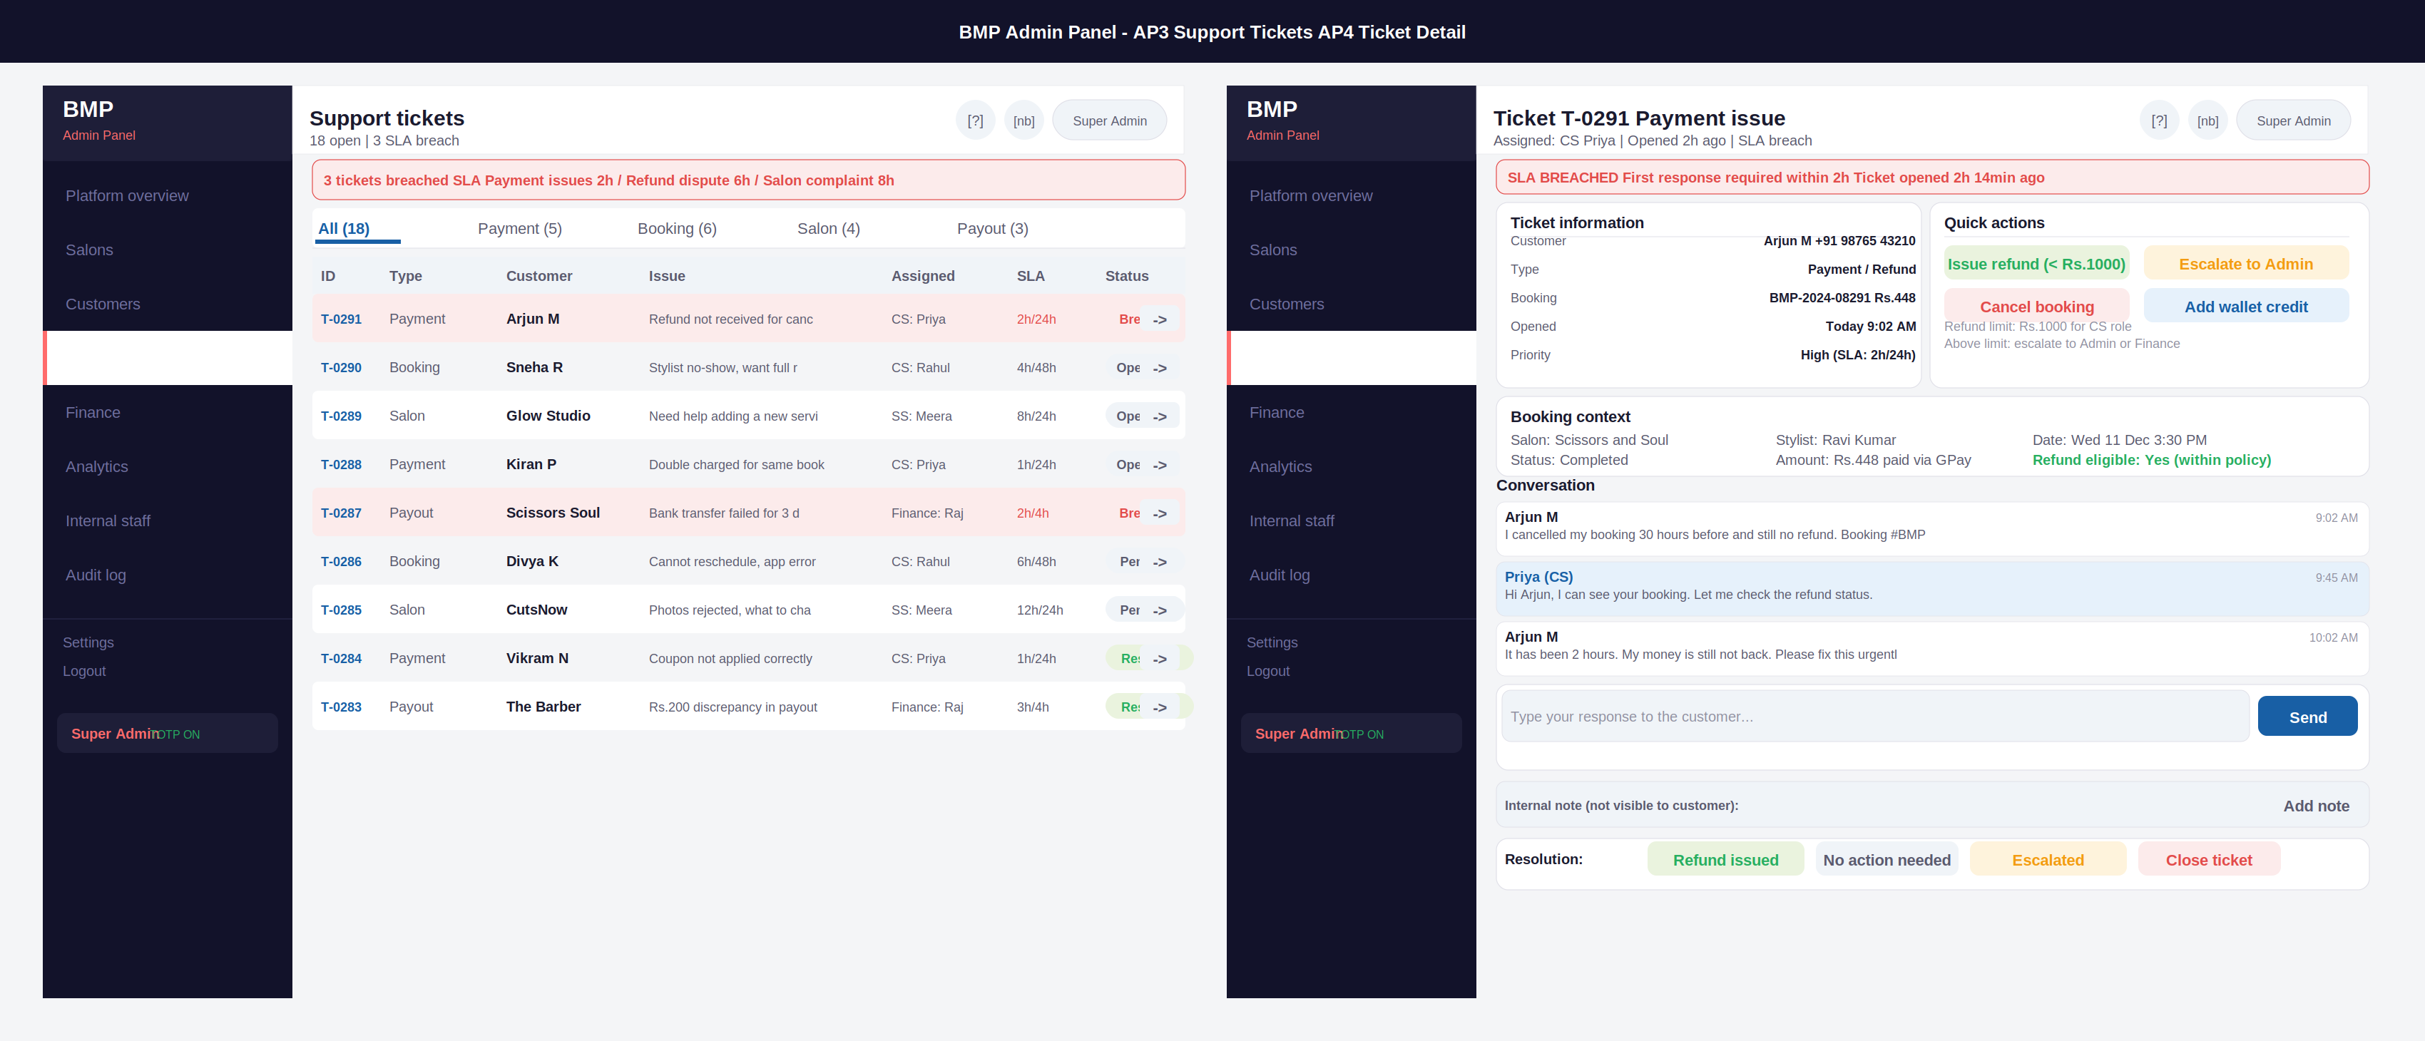

Annotations — AP3 · AP4
ID | Screen | UI elements | UX reasoning | Dev note
AP3 | Support tickets | Red alert at top: 3 SLA breach count with specific tickets named. Filter tabs: All (18), Payment (5), Booking (6), Salon (4), Payout (3). Ticket table: ID in blue link, type, customer, truncated issue, assigned agent, SLA timer (red when breached), status badge. Arrow link on each row. Breached rows have red background tint. | SLA breach tickets named in the alert so agent knows immediately which 3 to handle. Tabs show counts so agent can pick their queue. SLA timer shows both first-response and resolution times (2h/24h) — agent knows which metric they are measured on. Red background on breached rows is impossible to miss when scanning. | SLA calculated server-side: first_response_sla from ticket type config table. Breach flag set by background job every 5 minutes. Tab counts from ticket.status and ticket.type aggregations. Assignments auto-routed on creation: payment/booking -> CS queue, salon -> SS queue, payout -> Finance queue.
AP4 | Ticket detail | Red SLA breach banner at top. Two-column layout: left = ticket info (customer, type, booking, priority), right = quick actions (Issue refund, Escalate, Cancel, Add wallet credit). Below: booking context card. Conversation thread (customer messages grey, agent messages blue). Reply text box + Send. Internal note row. Resolution buttons (Refund issued / No action / Escalated / Close). | Quick actions are the most-used controls — placed prominently in a dedicated column. Refund limit (Rs.1000 for CS) shown as a note below the action buttons — agent always knows their limit without checking elsewhere. Booking context auto-loaded with refund eligibility in green — reduces back-and-forth. Internal notes never shown to customer (important for legal notes). | Issue refund button: if amount <= Rs.1000 and role is CS, allow directly. Else: show escalation required message. Refund calls Razorpay refund API and updates payment.refund_amount. All actions create audit_log entry. Conversation thread from support_messages table. Send creates new message and sends WhatsApp/email to customer.

Screens AP5 · AP6
Finance dashboard · Internal staff management

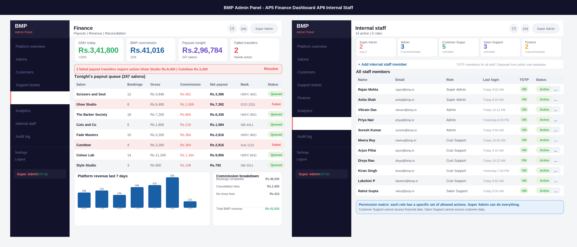

Annotations — AP5 · AP6
ID | Screen | UI elements | UX reasoning | Dev note
AP5 | Finance dashboard | KPI strip: GMV, BMP commission (12%), tonight payouts (247 salons), failed transfers (2, red). Red alert: 2 failed payout transfers named. Payout queue table: salon, bookings, gross, commission in red, net payout, bank last 4, status badge. Failed rows in red tint. Platform revenue bar chart. Commission breakdown panel: booking fees + cancellation fees + no-show fees = total. | Failed transfers are named immediately in the alert — not just a count. Finance agent knows which 2 to call before reading the table. Commission column in red in the payout table makes the deduction visible — this prevents confusion when salons call about their payout amount. Commission breakdown shows exactly how BMP revenue is composed. | Payout queue from payment_service aggregation for tonight batch. Failed = payout_records.status=failed. Resolve action opens a modal to enter correct bank details and retry. Manual payout requires 2FA and creates audit_log entry. All finance actions: actor, amount, target, IP logged. Commission calculated at 12% of completed booking values.
AP6 | Internal staff | Role summary row: 5 cards showing count vs recommended max per role. Super Admin 2/max 2 shown. Add staff link with TOTP note. Staff table: name, email, role, last login, TOTP status (ON/OFF badge), active status. 3-dot menu on each row for edit/deactivate. Blue permission matrix note at bottom. | Role count cards make capacity visible at a glance — if Customer Support shows 5/unlimited it is fine, if Super Admin shows 2/max 2 it means at capacity. TOTP badge on every row because TOTP is mandatory for all staff — OFF would be a security red flag and needs immediate action. Last login column for dormant account detection. | bmp_staff table completely separate from public users table. Invite creates an invite token sent to the new staff member email. TOTP secret generated on first login. Deactivate immediately revokes JWT and refresh token. All staff changes: create, deactivate, role change — logged in audit_log. Cannot create Super Admin from Admin role — Super Admin only.

Screens AP7 · AP8
Audit log · Salon detail (admin view)

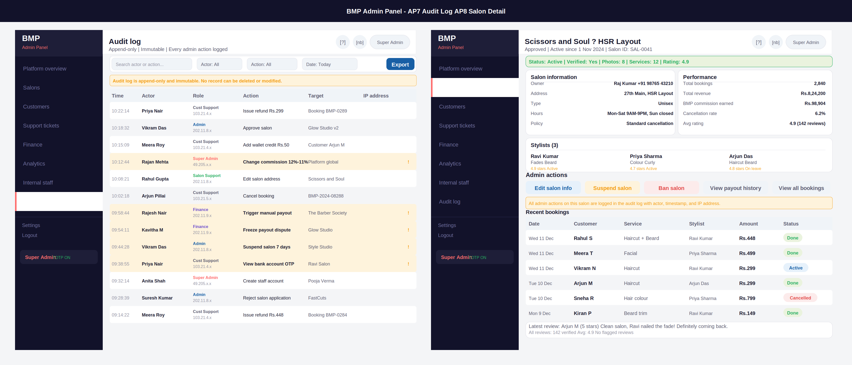

Annotations — AP7 · AP8
ID | Screen | UI elements | UX reasoning | Dev note
AP7 | Audit log | Filter row: search, actor, action type, date, export. Amber immutability banner. Table: time, actor name, role (colour-coded), action, target, IP address. Sensitive actions highlighted amber with ! badge: commission change, suspend salon, view bank account OTP, trigger payout, freeze dispute. Roles colour-coded: Super Admin in red accent, Admin in blue, Finance in purple, CS in grey. | The immutability banner must be visible on every scroll position — it sets the legal context for the entire screen. Sensitive actions highlighted amber because these are the ones that get disputed or investigated — they need to stand out when a manager is reviewing. Role colour coding lets a reviewer immediately see if the right role took the right action. | audit_log table: id, actor_id, actor_role, action_type enum, action_detail JSON, target_type, target_id, ip_address, created_at. Append-only at database level: no DELETE or UPDATE permissions on this table for any role including Super Admin. Export generates a signed PDF with timestamp. Retention: 7 years minimum.
AP8 | Salon detail (admin) | Green status strip with all key facts in one line. Two-column: salon info card (owner + phone, address, type, hours, policy) and performance card (total bookings, revenue, BMP commission earned, cancellation rate, rating). Stylists section with 3 profiles. Admin action buttons (Edit/Suspend/Ban/Payout history/All bookings). Amber logged-actions note. Recent bookings table. Reviews summary. | BMP commission earned is shown prominently in the performance card — this is what the admin needs when a salon disputes their earnings. Phone number visible because admin needs to call the owner. Admin action buttons ordered by severity: Edit (safe) -> Suspend (temporary) -> Ban (permanent). The amber note reminds the admin that every action is logged — a deterrent for careless actions. | Ban salon: requires confirmation + reason. Creates salon_ban record. All future bookings cancelled with full refund. Customers notified via WhatsApp. Suspend: sets salon.status=suspended with reactivation_date. BMP commission earned: sum of payment.commission_amount for this salon. Admin view has no refund limit — full access.

Security — Admin panel access controls
The admin panel is the most sensitive part of the BMP platform. The following security measures are non-negotiable.

Security measure | Implementation detail
Separate subdomain | Admin panel runs at dashboard.bemyprofessional.in/admin — completely separate from the public app and salon dashboard. Cannot be accessed from the same session.
TOTP mandatory | All internal staff must use Google Authenticator TOTP on every login. No exceptions. TOTP status shown in the sidebar for the current session. If TOTP is not set up, access is denied.
Separate user table | bmp_staff table is completely separate from the public users table. A customer or salon owner can never accidentally gain admin access. Admin accounts use email + password + TOTP, not phone OTP.
Role-scoped JWT | Admin JWT contains role claim. API gateway validates this on every request. A Customer Support JWT cannot call Finance APIs. Scope checked server-side on every endpoint.
Append-only audit log | Every admin action is logged. No admin can delete or modify audit log entries. Database-level constraint: no DELETE or UPDATE on audit_log for any role. 7-year retention. Legal evidence trail.
IP logging | Every audit log entry records the IP address of the actor. Unusual IP (outside Bengaluru) triggers an alert to Super Admin. VPN usage is logged.
Session timeout | Admin sessions expire after 4 hours of inactivity (shorter than the public app). Re-TOTP required after session expiry. No auto-refresh tokens for admin accounts.
Max 2 Super Admins | Hard limit of 2 Super Admin accounts. Enforced at application and database level. Founders only. Cannot be overridden from the admin panel itself.

BMP — Internal Admin Panel Screen Designs | CONFIDENTIAL | June 2026

