BMP — Booking and Payment
UX / UI SCREEN DESIGNS
B1-B7 Booking Flow | P1-P5 Payment Flow | All States | All Edge Cases
B1 Stylist pick | B2 Services | B3 Date/Time | B4 Summary | B5 Policy | B6 Reschedule

B7 Slot conflict | P1 Checkout | P2 Coupons | P3 Razorpay | P4+P5 Confirm/Fail

Version 1.0 | June 2026 | Bengaluru, India | Confidential

Screens B1 · B2 · B3
Choose Stylist · Select Services · Date and Time

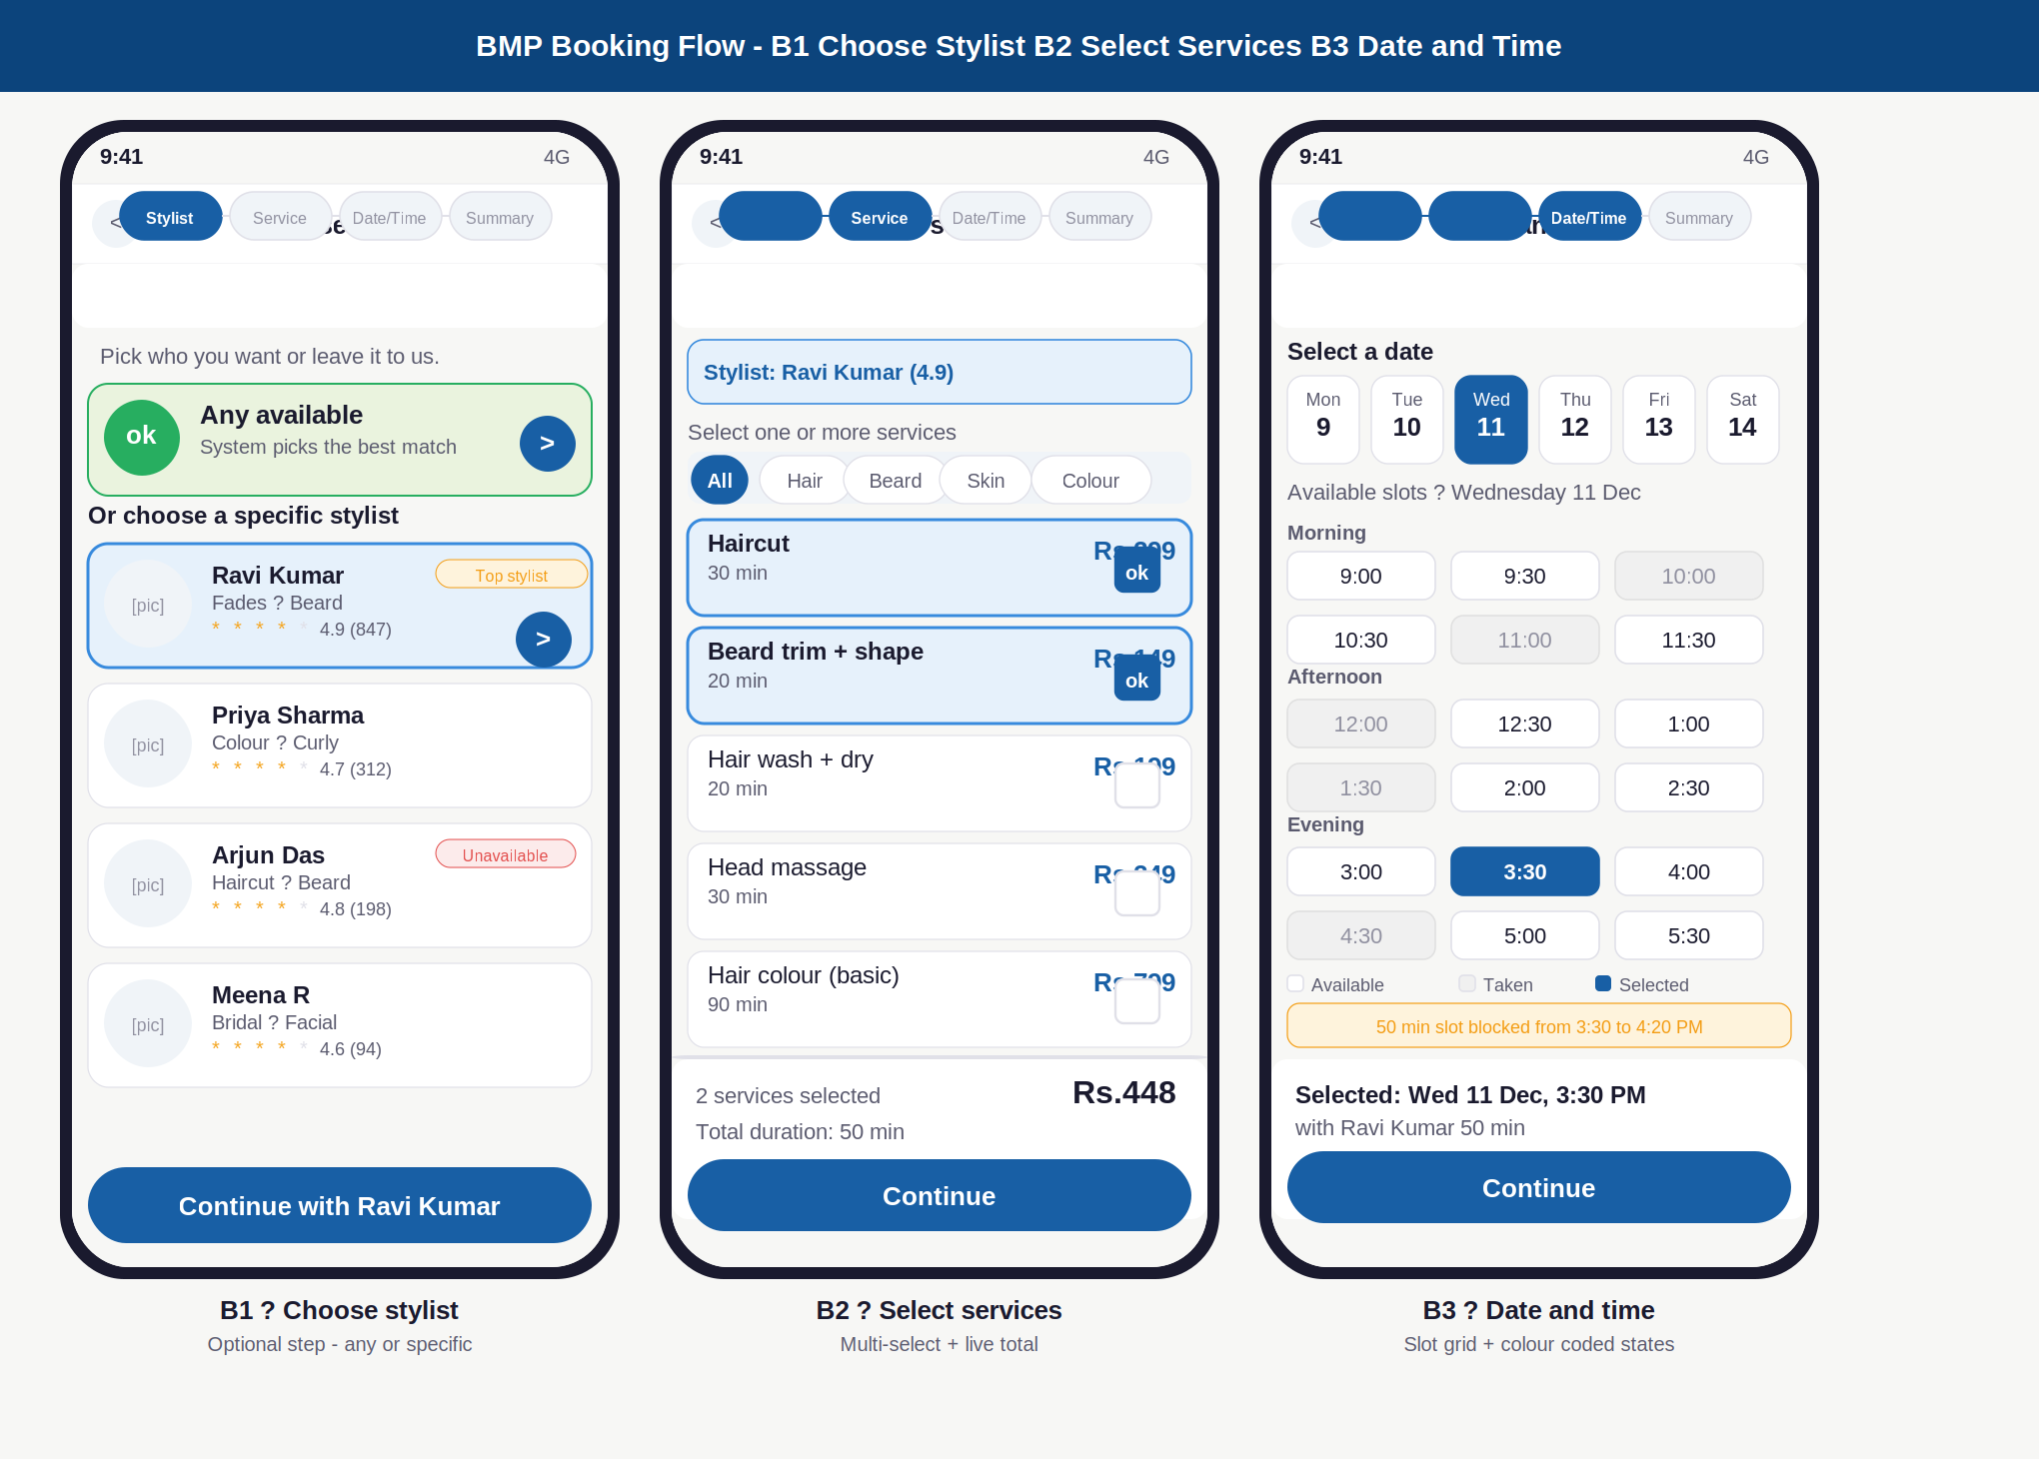

Annotations — B1 · B2 · B3
ID | Screen | UI elements | UX reasoning | Dev note
B1 | Choose stylist | 4-step progress bar (Stylist active). Any available green card at top. 4 stylist cards: photo, name, specialisation, star rating. Unavailable in red badge. Top stylist in amber badge. Selected card has blue border + arrow button. | Any available is the first option because 40% of bookings work with any stylist. Unavailable stylists shown (not hidden) so customer can see their profile and wait for them to be free. Selection filters B3 slot grid to only that stylist. | Optional step. If skipped, system auto-assigns on booking creation. Stylist selection sets stylist_id on pending booking. Unavailable = stylist_salon.available=false for today.
B2 | Select services | Stylist selected strip at top confirms previous step. Category tabs: All, Hair, Beard, Skin, Colour. Service list: name, duration, price each row. Selected rows have blue border + checkbox tick. Sticky bottom bar: count, total duration, total price. | Multi-select chips remove back-and-forth navigation. Price shown on every row, no checkout surprise. Live total in bottom bar updates immediately on each tap. Duration stacking shown so customer knows the full time block upfront. | Multi-select stores service_ids array. Duration sum sets slot_duration. Prices from salon_service table at selection time. Filter services to stylist specialisations if stylist was selected in B1.
B3 | Date and time | 6-day horizontal date strip, today + booking window. Slot grid: 3 columns, white=free, grey=busy, blue=selected. Section headers: Morning, Afternoon, Evening. Duration note in amber. Summary bar: selected slot + stylist + duration. | Colour coding lets customer scan instantly without reading. Grey slots visible (not hidden) so customer understands demand pattern. Duration note prevents surprise when slot blocks 50 minutes not just 30. Selected slot confirmed at bottom. | Slots generated dynamically: salon hours minus existing bookings minus selected duration. Redis lock triggered on slot selection. Lock released if payment not completed in 10 min. Grid refreshes every 30 seconds.

Screens B4 · B5 · B6
Booking Summary · Cancellation Policy · Reschedule

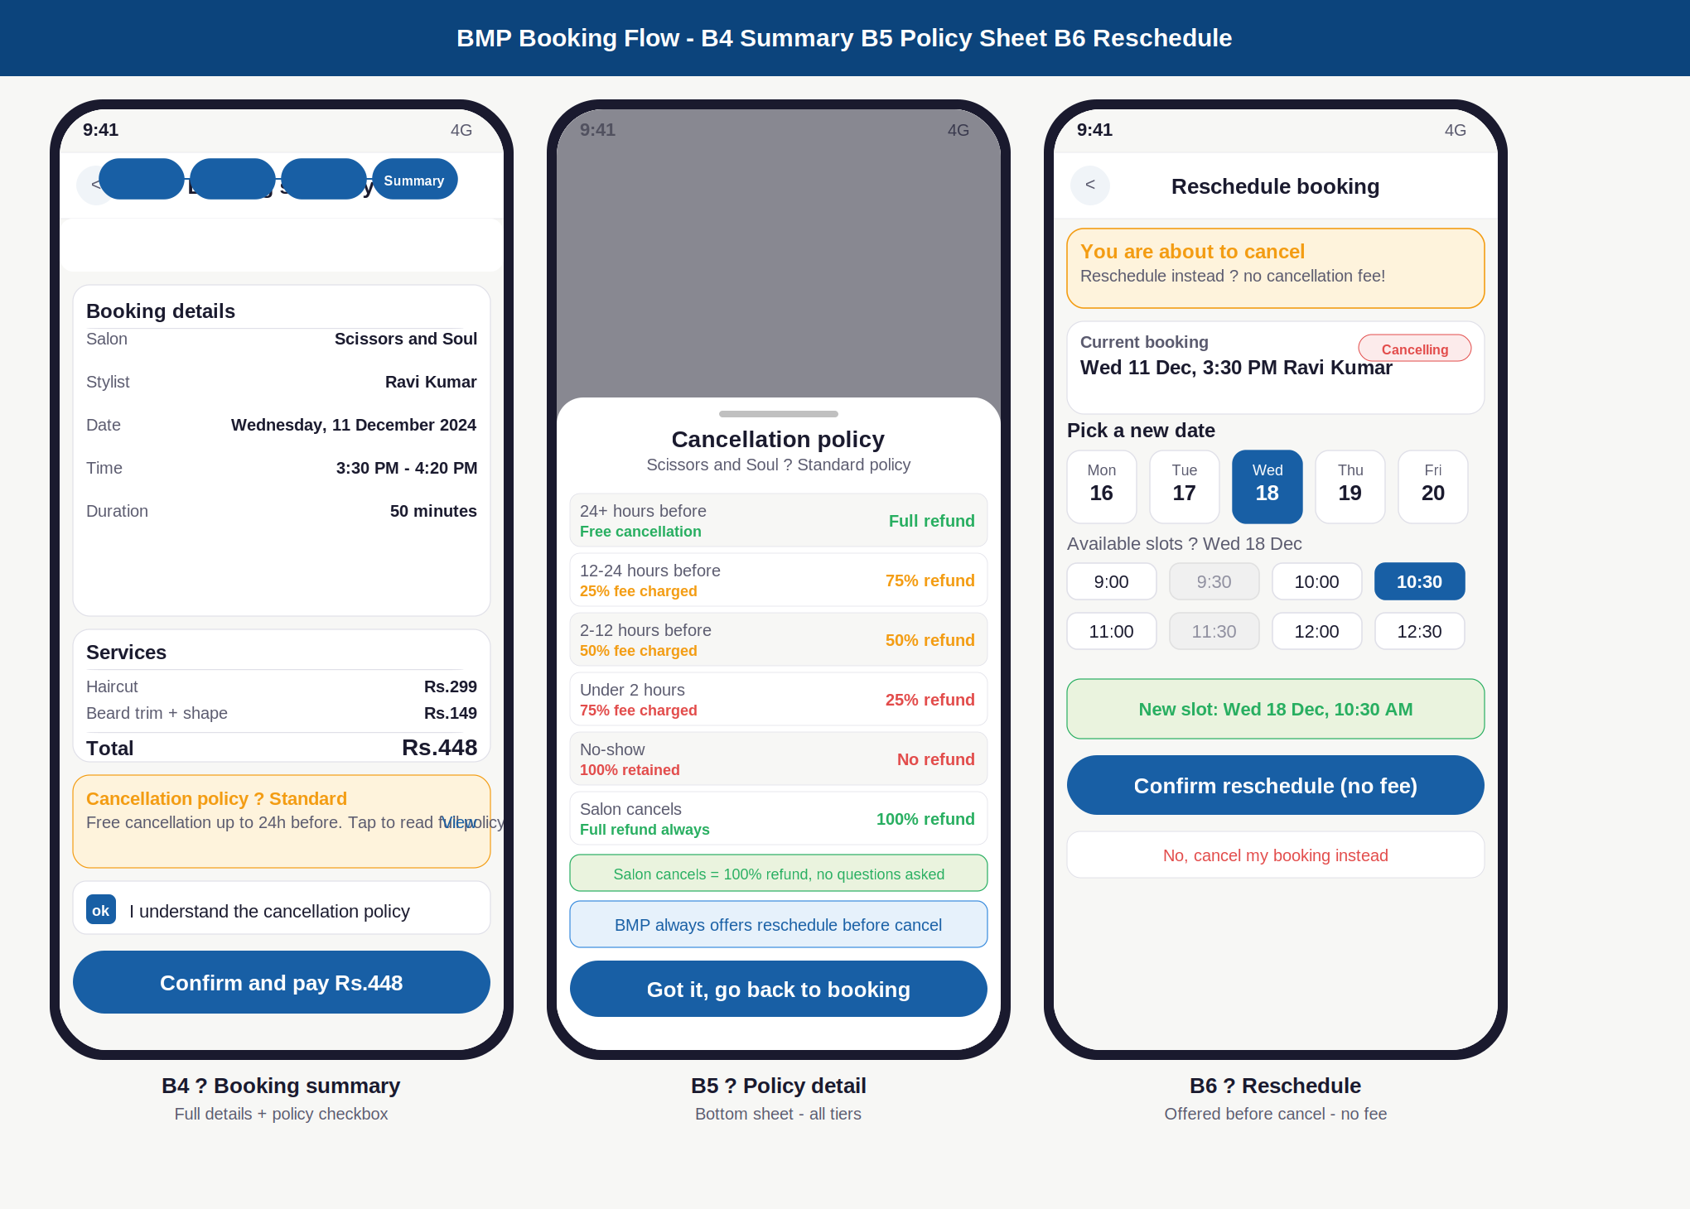

Annotations — B4 · B5 · B6
ID | Screen | UI elements | UX reasoning | Dev note
B4 | Booking summary | All 4 progress steps filled. Summary card: salon, stylist, date, time, duration. Services card: each service + total. Amber policy card with View link. Pre-ticked I-understand checkbox. Confirm and pay button with Rs. total. | Checkbox creates a mini-contract moment — customer actively confirms they have read the policy, not just scrolled past. Policy card is compact (not full text) with a view link. All details on one screen before payment removes last-second surprises. | Policy snapshotted into booking.policy_snapshot JSON at this point. Snapshot is immutable after booking created. Server-side validation of all prices before payment order created.
B5 | Policy detail | Bottom sheet with drag handle. 6-tier table: time window, fee, refund amount. Colour coded: green=free, amber=partial fee, red=high fee. Salon cancels row always green. Reschedule note in blue. Got it button. | Bottom sheet keeps B4 context visible behind. All 6 tiers at once, no scrolling. Colour coding lets customer see the gradient of risk instantly. Salon cancels always green builds trust. Reschedule note prompts alternative before customer decides. | Policy loaded from salon_policy table. If salon uses custom rates they are shown here. This sheet is also accessible from booking detail after booking.
B6 | Reschedule | Warning amber banner: You are about to cancel. Current booking with red Cancelling badge. 5-day new date strip. New slot grid. Confirmed new slot shown in green. Confirm reschedule (no fee) primary. No cancel instead secondary in red. | Reschedule always offered before confirm-cancel. The phrase no fee in the button is the most important text on the screen. Cancel option is de-emphasised: smaller, red, secondary position. This flow reduces cancellations by 30-40% in similar apps. | Reschedule = new slot locked, old slot freed, payment retained. No fee if within free window. Fee applies if rescheduling past free window. Old booking marked rescheduled, new booking created.

Screens B7 · P1 · P2
Slot Conflict · Checkout · Coupon Picker

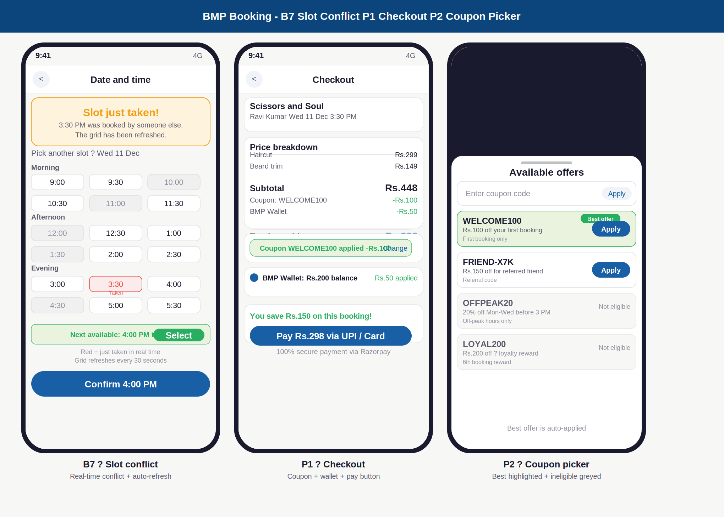

Annotations — B7 · P1 · P2
ID | Screen | UI elements | UX reasoning | Dev note
B7 | Slot conflict | Amber alert card: Slot just taken. Updated slot grid with red Taken marker on conflicting slot. All other slots still shown. Green suggestion: Next available today. Select button inline. Auto-refresh note at bottom. | Amber not red because this is not a user error. Customer did nothing wrong. The next available suggestion removes need to manually scan grid. Auto-refresh note builds trust that availability is live data. | Redis lock detects conflict at booking confirmation. Slot grid re-fetched from server. Conflict slot marked taken but still visible. Suggested next slot computed server-side.
P1 | Checkout | Booking mini recap strip. Price breakdown: line items, coupon deduction green, wallet deduction green, final total. Coupon applied banner with change link. Wallet row with balance shown. You save banner. Pay button with final Rs. amount. | Full breakdown eliminates checkout surprise. Coupon and wallet in green, saving feels rewarding. You save banner creates positive momentum before payment. Pay button shows exact final amount, not just Pay now. | Razorpay order created server-side on Pay tap. Payment amount validated server-side, never from client. Coupon and wallet deduction applied atomically on payment success via webhook.
P2 | Coupon picker | Bottom sheet. Manual code entry field at top. Coupon cards: green = best and auto-applied, white = eligible with Apply button, grey = ineligible with Not eligible label. Best offer auto-suggested note at bottom. | Auto-applying the best offer removes decision fatigue. Showing ineligible coupons greyed (not hidden) builds trust: customer understands why their code does not work. One coupon per booking enforced visually and server-side. | Coupon eligibility evaluated server-side. Best offer = max discount among eligible coupons. If manually entered code is ineligible: specific reason shown. Coupon applied as pending until payment success.

Screens P3 · P4 · P5
Razorpay Sheet · Booking Confirmed · Payment Failed

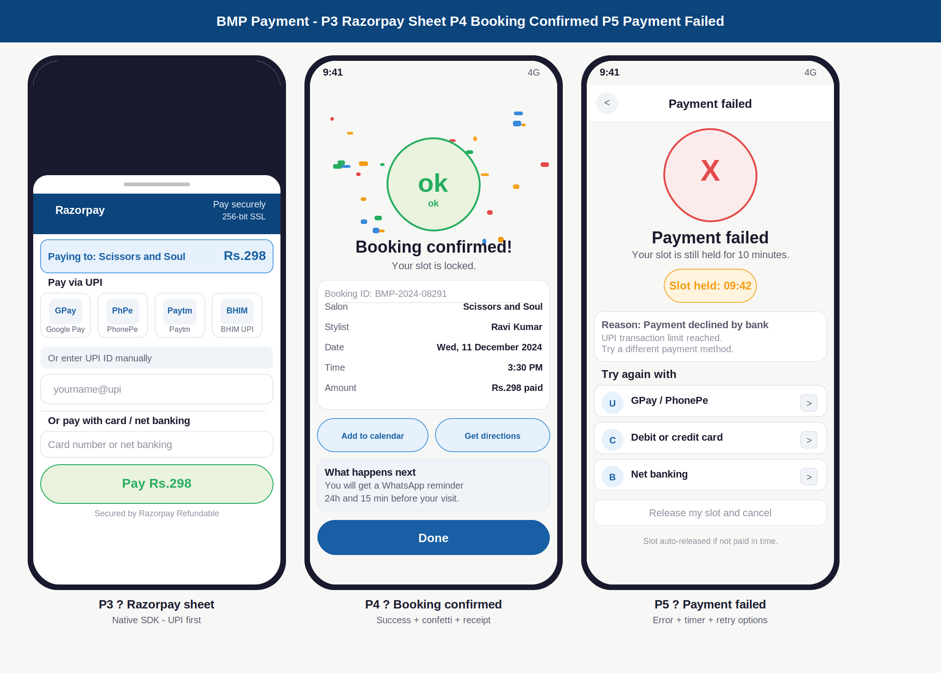

Annotations — P3 · P4 · P5
ID | Screen | UI elements | UX reasoning | Dev note
P3 | Razorpay sheet | Bottom sheet. Navy Razorpay header. Amount displayed prominently. 4 UPI app tiles: GPay, PhonePe, Paytm, BHIM. Manual UPI ID field. Divider. Card and net banking option below. Green Pay button. Secured by Razorpay note. | UPI first because 80%+ of Indian mobile payments are UPI. 4 tiles cover the most popular apps. Amount shown at the top of sheet, not only on the CTA, so customer never second-guesses what they are paying. Native SDK: BMP never touches payment credentials. | Razorpay SDK initialised with order_id from server. Webhook is source of truth for payment status. BMP never confirms booking based on SDK callback alone. Duplicate webhook protection via idempotency key.
P4 | Booking confirmed | Coloured confetti dots scattered across hero area. Large green circle with checkmark. Booking confirmed heading. Booking ID. Full receipt card: salon, stylist, date, time, amount. Add to calendar + Get directions buttons. What happens next card. Done button. | Confetti creates a positive dopamine moment. All details on one screen so customer can screenshot as a receipt. What happens next sets expectations proactively about WhatsApp reminders. No navigation trap, Done returns to Home. | Screen shown only after Razorpay webhook confirmed server-side. Booking ID generated: BMP-YYYY-NNNNN. WhatsApp and FCM push triggered via Kafka event booking.confirmed. Calendar deep link uses platform native calendar.
P5 | Payment failed | Red X icon in red circle. Payment failed heading. Amber countdown timer: Slot held for 10 minutes. Error reason card with specific text from Razorpay. Three retry rows: UPI, Card, Net banking. Release slot secondary link. | Amber timer creates urgency without alarm. Specific failure reason guides next action rather than generic Try again. Three concrete alternatives shown so customer knows exactly what to do. Slot held 10 min gives real time to try again with a different method. | Failure code from Razorpay mapped to human-readable reasons. Slot lock extended by 10 minutes on payment failure. On second failure: re-extend. On third failure: auto-release slot. Release slot link triggers immediate slot_lock.release.

Design system — Booking and Payment screens

Component states reference
Component | State | Visual treatment
Progress step | Active | Blue filled pill, white bold text, 1.5px blue border
Progress step | Completed | Blue filled pill, lighter white text
Progress step | Upcoming | Grey background, grey text, 0.8px grey border
Stylist card | Default | White bg, 0.6px grey border, photo placeholder, name/spec/rating
Stylist card | Selected | Light blue bg, 1.5px blue border, blue arrow button on right
Stylist card | Unavailable | White bg, red Unavailable badge top-right, content still visible
Service row | Default | Grey background card, name bold, duration muted, price blue right
Service row | Selected | Light blue background, 1.5px blue border, blue checkbox with tick
Time slot | Available | White bg, 0.8px grey border, 6px radius, time in dark text
Time slot | Busy (taken) | Light grey bg, grey border and text — visible but not tappable
Time slot | Selected | Blue filled, white bold text
Time slot | Just taken | Light red bg, red border, Taken label in 7px red below time
Policy tier | Free cancel | Light green row, green bold text, Full refund right-aligned
Policy tier | Partial fee | Amber text, fee percentage, partial refund right-aligned
Policy tier | High fee | Red text, high fee, no refund right-aligned
Coupon card | Best / applied | Light green bg, green border, Best offer badge top-right
Coupon card | Eligible | White bg, grey border, blue Apply button on right
Coupon card | Ineligible | Grey background, no Apply button, Not eligible in muted text
Pay button | Active | Blue filled, white bold text, pill shape, shows exact Rs. amount
Pay button | Processing | Spinner replaces text, button stays blue, disabled state
Success screen | Confirmed | Green circle icon, confetti dots, full receipt card below
Error screen | Failed | Red circle X icon, amber timer pill, specific reason card, retry rows

BMP — Booking and Payment Screen Designs | June 2026 | Confidential

