BMP — Community
UX / UI SCREEN DESIGNS
C1 Community feed | C2 Post detail | C3 Write review | C4 Before/After upload
C1 Community feed | C2 Post detail | C3 Write review | C4 Before/After upload

Version 1.0 | June 2026 | Bengaluru, India | Confidential

Screens C1 · C2
Community feed · Post detail

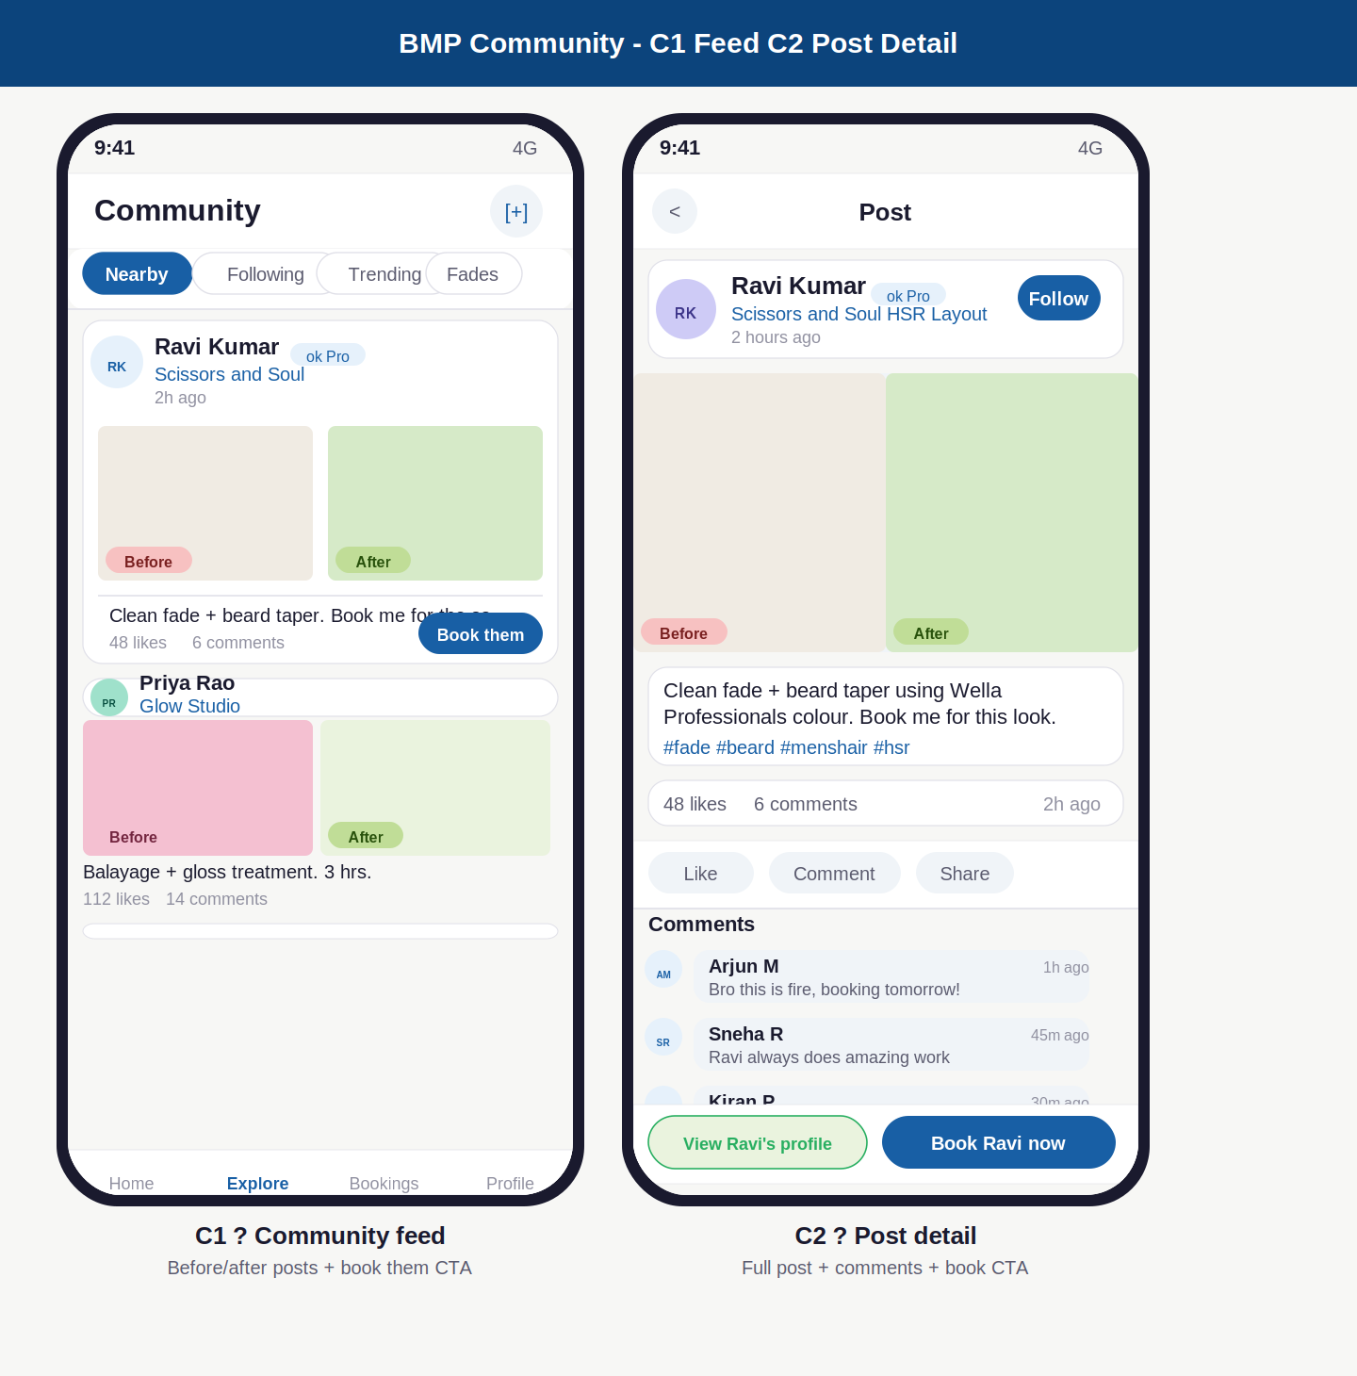

Annotations — C1 · C2
ID | Screen | UI elements | UX reasoning | Dev note
C1 | Community feed | Community heading with [+] post button top-right. Filter tab row: Nearby (active), Following, Trending, topic chips (Fades, Colour etc). Post cards: stylist avatar + name + Pro badge + salon name + time. Side-by-side Before/After image pair. Caption. Likes/comments. Book them button on each post. | Before/after is the most compelling content format for a salon app. A customer sees the transformation and the booking intent is immediate. Book them on every post card is not spammy because every post is already an implicit advertisement. Filter tabs let customers narrow to their area or the stylists they follow. Nearby default ensures relevance from the first screen. | Feed loaded by location or following list based on active filter tab. Post content from community_post table linked to stylist_id and salon_id. Pro badge shown when stylist has 50+ verified reviews. Infinite scroll with 10 posts per page. [+] button opens C4 photo upload flow.
C2 | Post detail | Back button. Stylist card: avatar, name, Pro badge, salon + area, time. Follow button. Full-width Before/After split image (larger than feed card). Caption with hashtags (blue). Stats row: likes, comments, time. Actions row: Like / Comment / Share. Comments list. Sticky bottom: View profile (green outline) + Book now (blue filled). | Full-width before/after gives the transformation full justice on a larger canvas. Hashtags in blue are tappable for exploration. Comments create social proof and community. Two CTAs in sticky footer: view profile gives context, book now is immediate. Green outline for profile (softer) vs blue filled for booking (primary action) creates clear hierarchy. | Post detail loaded by post_id. Follow action updates stylist_follower table. Like updates post_likes count. Comments from post_comment table. Book now navigates to B2 services screen with stylist pre-selected and salon context. View profile navigates to D5 stylist profile.

Screens C3 · C4
Write review · Before/After upload

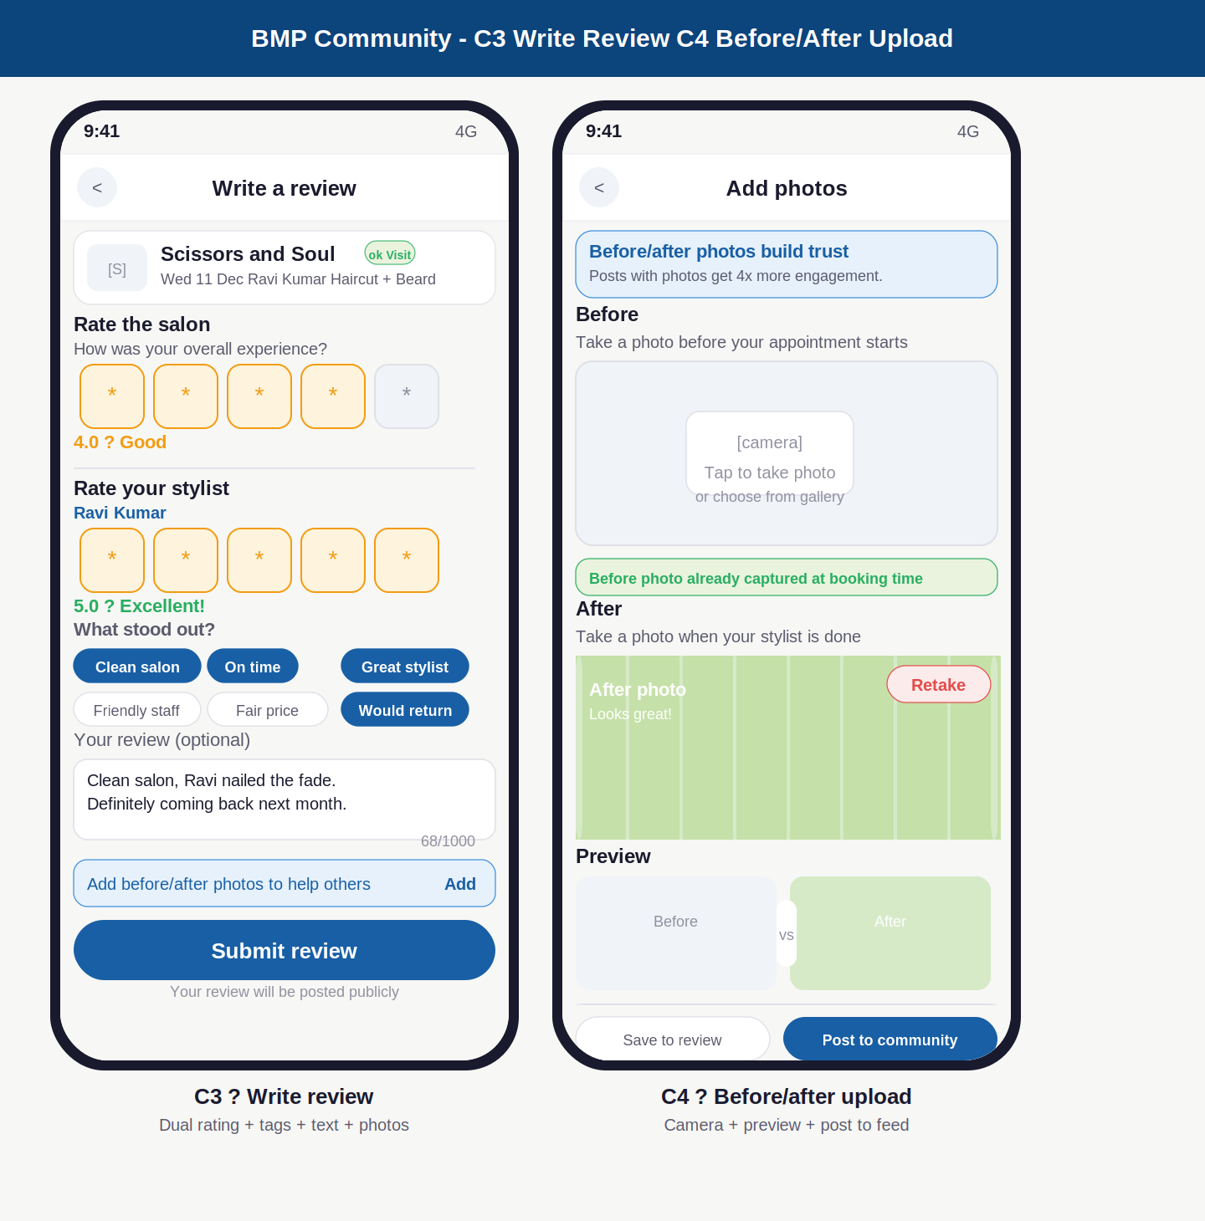

Annotations — C3 · C4
ID | Screen | UI elements | UX reasoning | Dev note
C3 | Write review | Visit recap card at top with verified visit badge. Salon rating: 5 large tappable star boxes, current rating label below. Stylist rating: separate section, 5 stars all filled, green Excellent label. Tags: 6 chips, selected ones blue. Optional text area with char count. Blue photo prompt strip. Submit button. Public notice. | Large star boxes (38px) are easy to tap accurately on mobile — small stars get mis-tapped. Two separate rating sections (not one combined) are both visible simultaneously to encourage both ratings. Tag chips remove thinking — customer can submit a complete review in under 20 seconds without typing anything. Character count manages expectations. Public notice at the bottom is a gentle reminder without being a warning. | review.salon_rating and review.stylist_rating stored as separate integers 1-5. review.tags stored as string array. review.text max 1000 chars. review.booking_id required (verified visit). On submit: Kafka event triggers aggregate rating recalculation for both salon and stylist. Photo URLs stored in review.photo_urls[].
C4 | Before/After upload | Blue info card: photos get 4x more engagement. Before section: empty camera slot with instructions. Green notice: before photo already captured at booking time. After section: photo filled state with green tint (taken), Retake button. Preview section: side-by-side mini thumbnails with vs divider. Two buttons: Save to review (outline) + Post to community (blue filled). | The engagement stat (4x) is shown as a motivator at the top. Before photo is auto-captured at booking confirmation — the customer already has it without doing anything extra. After slot is empty and waiting, prompting action right when the customer is happiest (just had a great haircut). Preview gives confidence before posting. Two distinct options: save privately to the review, or share publicly to the community feed. | Before photo prompted at booking confirmed (P4) screen. Stored as pre_photo_url on booking record. After photo uploaded to Cloudflare R2. Post to community creates community_post record. Save to review attaches photo_urls to the pending review. Both paths converge on the same photo assets — not duplicated.

Complete customer app — all screens summary
All 32 customer-facing screens have now been designed. This is the complete inventory across all 6 sections.

Section | Screens | Screen IDs | Key screens and purpose
Auth | A1-A10 | 10 screens | Splash, phone entry, OTP (3 states), role fork, customer profile (2 steps), salon onboarding, pending verification, stylist onboarding, manager invite, role picker
Discovery | D1-D6 | 7 screens | Home feed, explore map, search results, salon detail services tab, salon detail stylists tab, stylist profile, all reviews
Booking | B1-B7 | 7 screens | Choose stylist, select services, date and time slot grid, booking summary, cancellation policy sheet, reschedule, slot conflict
Payment | P1-P5 | 5 screens | Checkout with coupon and wallet, coupon picker sheet, Razorpay payment sheet, booking confirmed with confetti, payment failed with retry
My Account | M1-M6 | 7 screens | Booking history upcoming, booking history past, booking detail, cancel with fee calculation, rate and review, BMP wallet, profile settings
Community | C1-C4 | 4 screens | Community feed with before/after posts, post detail with comments, write review with dual rating, before/after photo upload
Total | 32+ screens | All designed | Complete customer app UI/UX designed, annotated, and documented

What is still to be designed
Platform | Screens | Description
Salon owner dashboard | 10-12 web screens | Today bookings, booking detail, manage stylists, add service, analytics, payout history, salon settings, cancellation policy editor, pending verification view
Stylist app | 6-8 screens | My schedule, today bookings, booking detail, availability toggle, my profile (public view), earnings summary, join salon flow
Admin panel | 8-10 web screens | Platform overview dashboard, support ticket queue, salon approval queue, payout management, analytics, internal staff management, audit log

BMP — Community Screen Designs | June 2026 | Confidential

