BMP — My Account
UX / UI SCREEN DESIGNS
M1 Booking history | M2 Booking detail | M3 Cancel | M4 Review | M5 Wallet | M6 Profile
M1 History | M2 Detail | M3 Cancel | M4 Review | M5 Wallet | M6 Profile

Version 1.0 | June 2026 | Bengaluru, India | Confidential

Screens M1 · M2 · M3
Booking history · Booking detail · Cancel booking

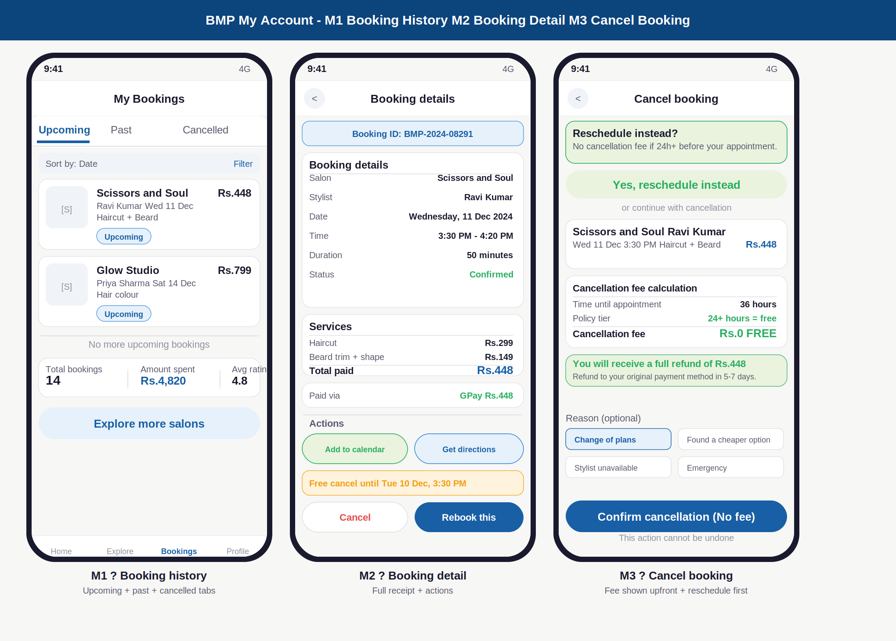

Annotations — M1 · M2 · M3
ID | Screen | UI elements | UX reasoning | Dev note
M1 | Booking history | Bookings tab in bottom nav (active). Three sub-tabs: Upcoming (active, blue underline), Past, Cancelled. Sort and Filter row. Booking cards: salon photo, name, stylist, date, service, price, status badge. Stats strip: total bookings, amount spent, avg rating. Explore CTA. | Three sub-tabs cover the full lifecycle. Upcoming is default because that is what customers check most often. Stats strip gives a sense of loyalty and history without needing to open a report. Explore CTA at the end converts idle browsing into new bookings. | Bookings fetched by customer_id filtered by status. Upcoming = status IN (confirmed, pending). Past = status = completed. Cancelled = status IN (cancelled, refunded). Rebook button creates a new booking pre-filled with same salon, stylist, and services.
M2 | Booking detail | Back button. Booking ID strip (blue bg). Two cards: Booking details (salon, stylist, date, time, duration, status) and Services (line items, total, payment method). Actions: Add to calendar, Get directions. Amber free-cancel deadline. Cancel and Rebook buttons. | Booking ID is shown prominently because customers need it when contacting support. Payment method shown so customer knows where the refund goes if they cancel. Free-cancel deadline in amber creates appropriate urgency without alarm. Both actions equal-sized to prevent accidental cancellation. | Booking detail loaded by booking_id. Add to calendar uses platform native calendar via deep link. Get directions opens Google Maps with salon address. Cancel checks time until appointment and pre-calculates fee before showing cancel screen.
M3 | Cancel booking | Reschedule nudge at top (green, prominent). "Or continue with cancellation" divider. Booking recap card. Fee calculation card: time until appointment, policy tier, fee in large text (Rs.0 FREE in this case). Full refund green banner. Reason chips (optional). Confirm button. Warning note. | Reschedule nudge is the first thing visible because 40% of customers who see it choose reschedule instead. The fee calculation card makes the policy transparent and specific to this booking. Rs.0 FREE in large green text removes anxiety. Reason chips are optional and collect valuable data without friction. | Fee calculated server-side based on booking time and salon policy snapshot. Never calculated on client. Reason stored as cancellation_reason enum on booking record. Reschedule button navigates to B6 with current booking context. Confirm triggers refund via Razorpay based on fee calculation.

Screens M1b · M4 · M5
Past bookings · Rate and review · BMP Wallet

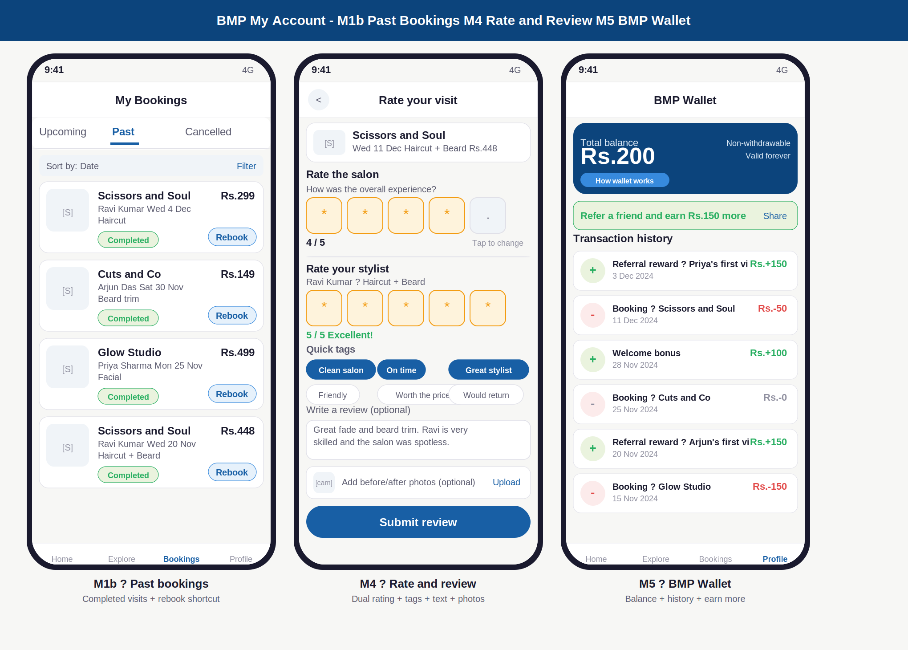

Annotations — M1b · M4 · M5
ID | Screen | UI elements | UX reasoning | Dev note
M1b | Past bookings | Past tab active (blue underline). Completed booking cards with green Completed badge and Rebook shortcut on each card. Chronological, most recent first. Same stats strip as upcoming tab. | Rebook on every past card is the highest-converting CTA in the app. A customer who completed a visit and loved it is the highest-intent user. One tap rebook removes all friction from repeat business. Completed badge in green reinforces the positive experience. | Past bookings sorted by visit_date DESC. Rebook pre-fills a new booking_wizard context with salon_id, stylist_id (if still working there), and service_ids from the original booking. If stylist left salon: defaults to Any available.
M4 | Rate and review | Visit recap card at top. Salon star rating: 5 large tappable star boxes (4 filled amber, 1 empty). Stylist star rating: separate section below (5/5 all filled, green "Excellent!" label). Quick tags: 6 chips, 3 selected blue, 3 unselected. Text area with typed review. Photo upload row. Submit button. | Two separate star ratings (salon + stylist) are both visible at once — not on separate screens. This is critical: customer rates both in one flow. 5 large star boxes (not small icons) make tapping easy on mobile. Quick tags surface the most useful feedback without requiring the customer to think. Text area is pre-scrolled-to with cursor waiting. | Review record requires booking_id (verified booking). Rating submitted as two integers: salon_rating and stylist_rating. Tags stored as string array. Text max 1000 chars. Photos uploaded to Cloudflare R2, URLs stored in review.photo_urls array. Rating triggers Kafka event to recalculate salon and stylist aggregate ratings.
M5 | BMP Wallet | Navy wallet card: Rs.200 balance large, Non-withdrawable + Valid forever labels, How wallet works button. Refer a friend green strip (earn Rs.150, Share link). Transaction history: each row has + or - circle icon, description, date, amount in green (credit) or red (debit). | Non-withdrawable is shown clearly on the balance card itself (not buried in FAQ) to manage expectations upfront. Valid forever removes urgency and pressure. Green/red colours on transactions make the ledger scannable without reading. Refer a friend strip is placed immediately after the balance because that is when wallet value is most salient. | Wallet.balance updated atomically on each credit or debit. wallet_transaction table records every movement with type: referral_earned, booking_deducted, welcome_bonus, coupon_refund, manual_credit. Non-withdrawable enforced at payout-service level: no withdrawal API exists.

Screen M6
Profile settings · Account management

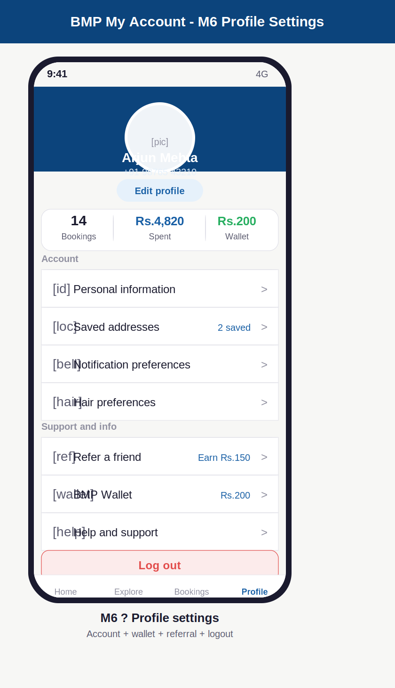

Annotations — M6 Profile settings
ID | Screen | UI elements | UX reasoning | Dev note
M6 | Profile settings | Navy hero section: circular avatar, name, phone number. Edit profile button below avatar. Stats strip: 14 bookings, Rs.4,820 spent, Rs.200 wallet. Two menu sections: Account (Personal info, Saved addresses, Notifications, Hair preferences) and Support (Refer a friend + Rs.150 label, BMP Wallet + balance, Help). Red logout button at bottom. | Navy hero matches the app brand and gives the profile screen a distinct identity. Stats strip makes the customer feel valued (14 bookings!) and shows loyalty at a glance. Refer a friend has the Rs.150 incentive shown inline in the menu row because showing the reward alongside the action dramatically increases taps. Wallet shows current balance so it never feels forgotten. Logout is red and at the bottom — clearly destructive, clearly findable. | Edit profile navigates to a form pre-filled from users table. Saved addresses stores up to 5 locations. Hair preferences links to onboarding A5b screen reused as an edit form. Refer a friend generates a unique referral code from referral_codes table. Logout: revoke refresh_token, clear local JWT, navigate to A1 splash.

My Account — screen navigation map
From screen | Trigger | Navigates to | Data passed | Back behaviour
M1 Booking history | Tap booking card | M2 Booking detail | booking_id | Back to M1, scroll position restored
M2 Booking detail | Tap Cancel | M3 Cancel booking | booking_id, fee pre-calculated | Back to M2
M2 Booking detail | Tap Rebook | B1 Booking wizard (pre-filled) | salon_id, stylist_id, service_ids | Back to M2
M3 Cancel | Tap Reschedule instead | B6 Reschedule screen | booking_id | Back to M3
M1 Past bookings | Tap Rate (post-visit prompt) | M4 Rate and review | booking_id, salon_id, stylist_id | Back to M1 (review submitted or dismissed)
M6 Profile | Tap BMP Wallet | M5 BMP Wallet | user_id (wallet loaded) | Back to M6
M6 Profile | Tap Refer a friend | Referral share sheet | referral_code pre-filled | Dismisses back to M6
Booking confirmed P4 | 30 min after visit completed | M4 Review (push notification) | booking_id triggered by notification | Notification dismissed or review submitted

Design decisions — My Account section
Decision | Reasoning
Reschedule shown before cancel on M3 | A customer who sees the reschedule option converts 40% of the time. This single design decision can save significant cancellation revenue across the platform. The reschedule nudge must be the very first thing visible, not buried below the fee.
Fee shown before confirmation on M3 | Customers are more likely to proceed with cancellation if the fee is transparent from the start. A surprise fee at the end of a cancellation flow causes anger and support tickets. Showing Rs.0 FREE for in-window cancellations removes anxiety completely.
Dual star rating on M4 (not one rating) | Salon ratings and stylist ratings measure different things. A customer can love the stylist but find the salon dirty, or vice versa. Splitting them gives far more useful data. Both sections visible simultaneously (not separate screens) reduces review abandonment.
Wallet non-withdrawable stated on M5 balance card | This avoids RBI regulation complexity. More importantly, it must be stated clearly at the point where customers might expect withdrawal — the balance card itself, not in terms and conditions. Showing it clearly upfront prevents support tickets and disappointment.
Rebook on every past booking card M1b | Past-customers-who-loved-it are the highest-intent users in the app. Making rebook one tap (not four steps) dramatically increases repeat booking rate. Pre-filling the full booking context (salon, stylist, services) means they only need to pick a new date and time.

BMP — My Account Screen Designs | June 2026 | Confidential

