BMP — Salon Owner Dashboard
WEB APP | UX / UI SCREEN DESIGNS
SO1 Today | SO2 Booking detail | SO3 Stylists | SO4 Analytics | SO5 Payouts | SO6 Settings
SO1 Today | SO2 Booking | SO3 Stylists | SO4 Analytics | SO5 Payouts | SO6 Settings

Version 1.0 | June 2026 | Web app (Next.js) | Bengaluru, India | Confidential

Screens SO1 · SO2
Today overview · Booking detail

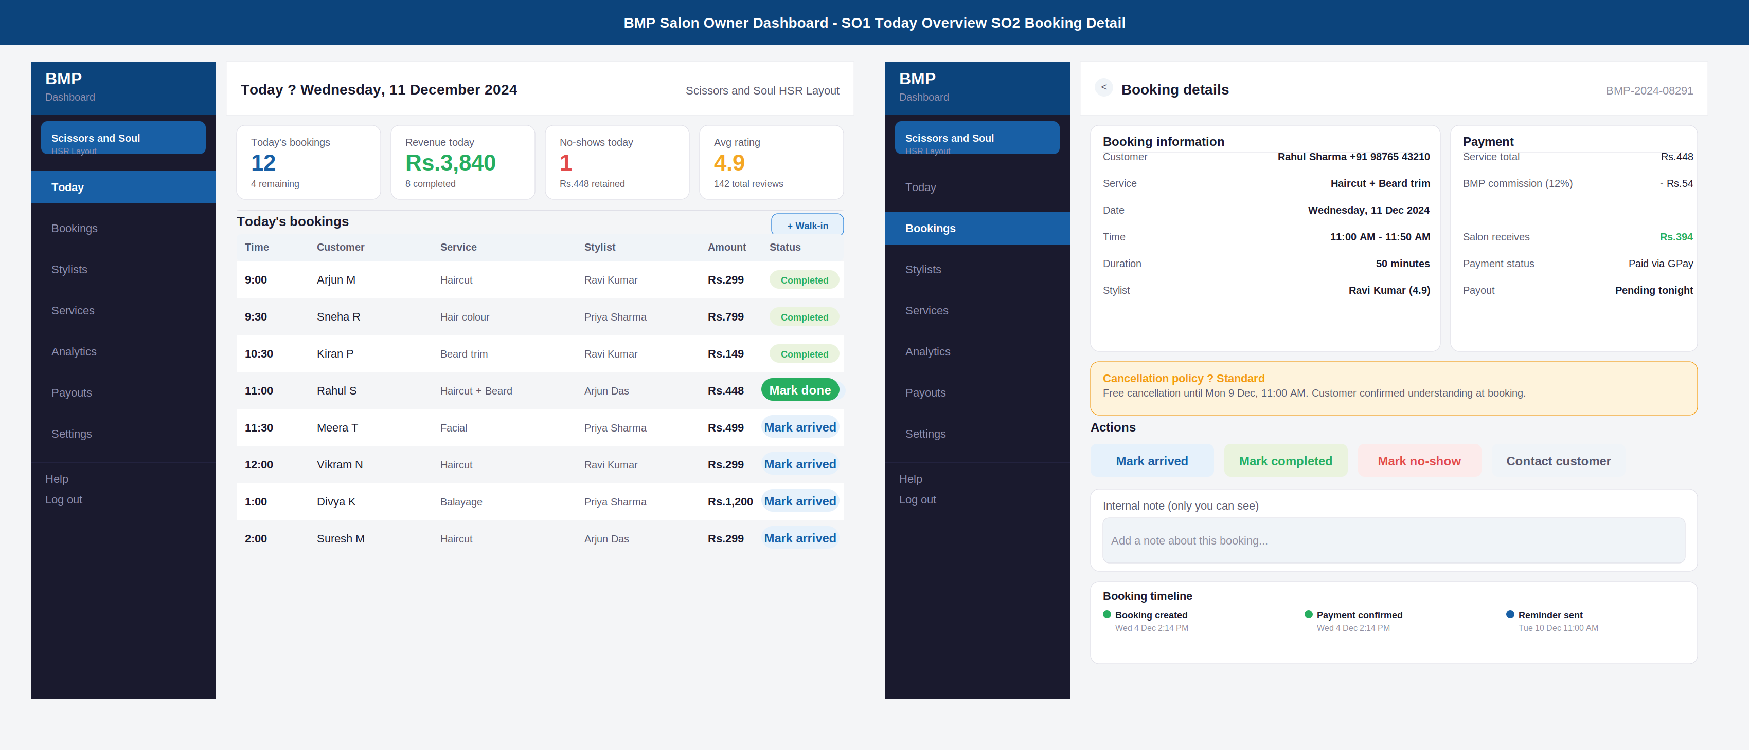

Annotations — SO1 · SO2
ID | Screen | UI elements | UX reasoning | Dev note
SO1 | Today overview | Dark sidebar: BMP logo, salon name + area, 7 nav items (Today active). Main area: date header + salon name top-right. 4 stat cards: bookings, revenue, no-shows, avg rating. Bookings table: time, customer, service, stylist, amount, status badge. Action buttons: Mark arrived (blue) on upcoming, Mark done (green) on in-service. Walk-in button top-right. | Today is the default landing page because the owner opens the dashboard to manage right now, not to review history. 4 stat cards give the complete day picture in 2 seconds. The booking table rows alternate background for easy scanning. Action buttons are on the row itself — no drilling in to mark a simple arrival. Walk-in button is always visible because walk-ins are common. | Bookings loaded for today filtered by salon_id and date. Status transitions: upcoming -> arrived -> in_service -> completed. Mark done triggers payout_queue insert and review prompt Kafka event. Mark no-show triggers cancellation_fee calculation. Walk-in creates a manual booking bypassing the customer app flow.
SO2 | Booking detail | Back button + booking ID in header. Two-column layout: left = booking information card (customer + phone, service, date/time, duration, stylist), right = payment card (service total, commission, salon receives, payment status, payout timing). Amber policy card. Four action buttons. Internal note text area. Booking timeline at bottom. | Two-column layout uses web screen space efficiently. Customer phone number visible so owner can call if needed. Salon receives shown in green and prominent because that is what owners care about most. Payment card shows commission deducted transparently — removes confusion. Timeline at the bottom gives the full lifecycle without needing to open a separate log. | Booking detail loaded by booking_id from bookings table joined with payments. Actions are permission-gated: mark_no_show requires confirmation modal. Internal notes stored in booking_notes table. Timeline events from booking_events table. Contact customer opens WhatsApp deep link with pre-filled message.

Screens SO3 · SO4
Manage stylists · Analytics

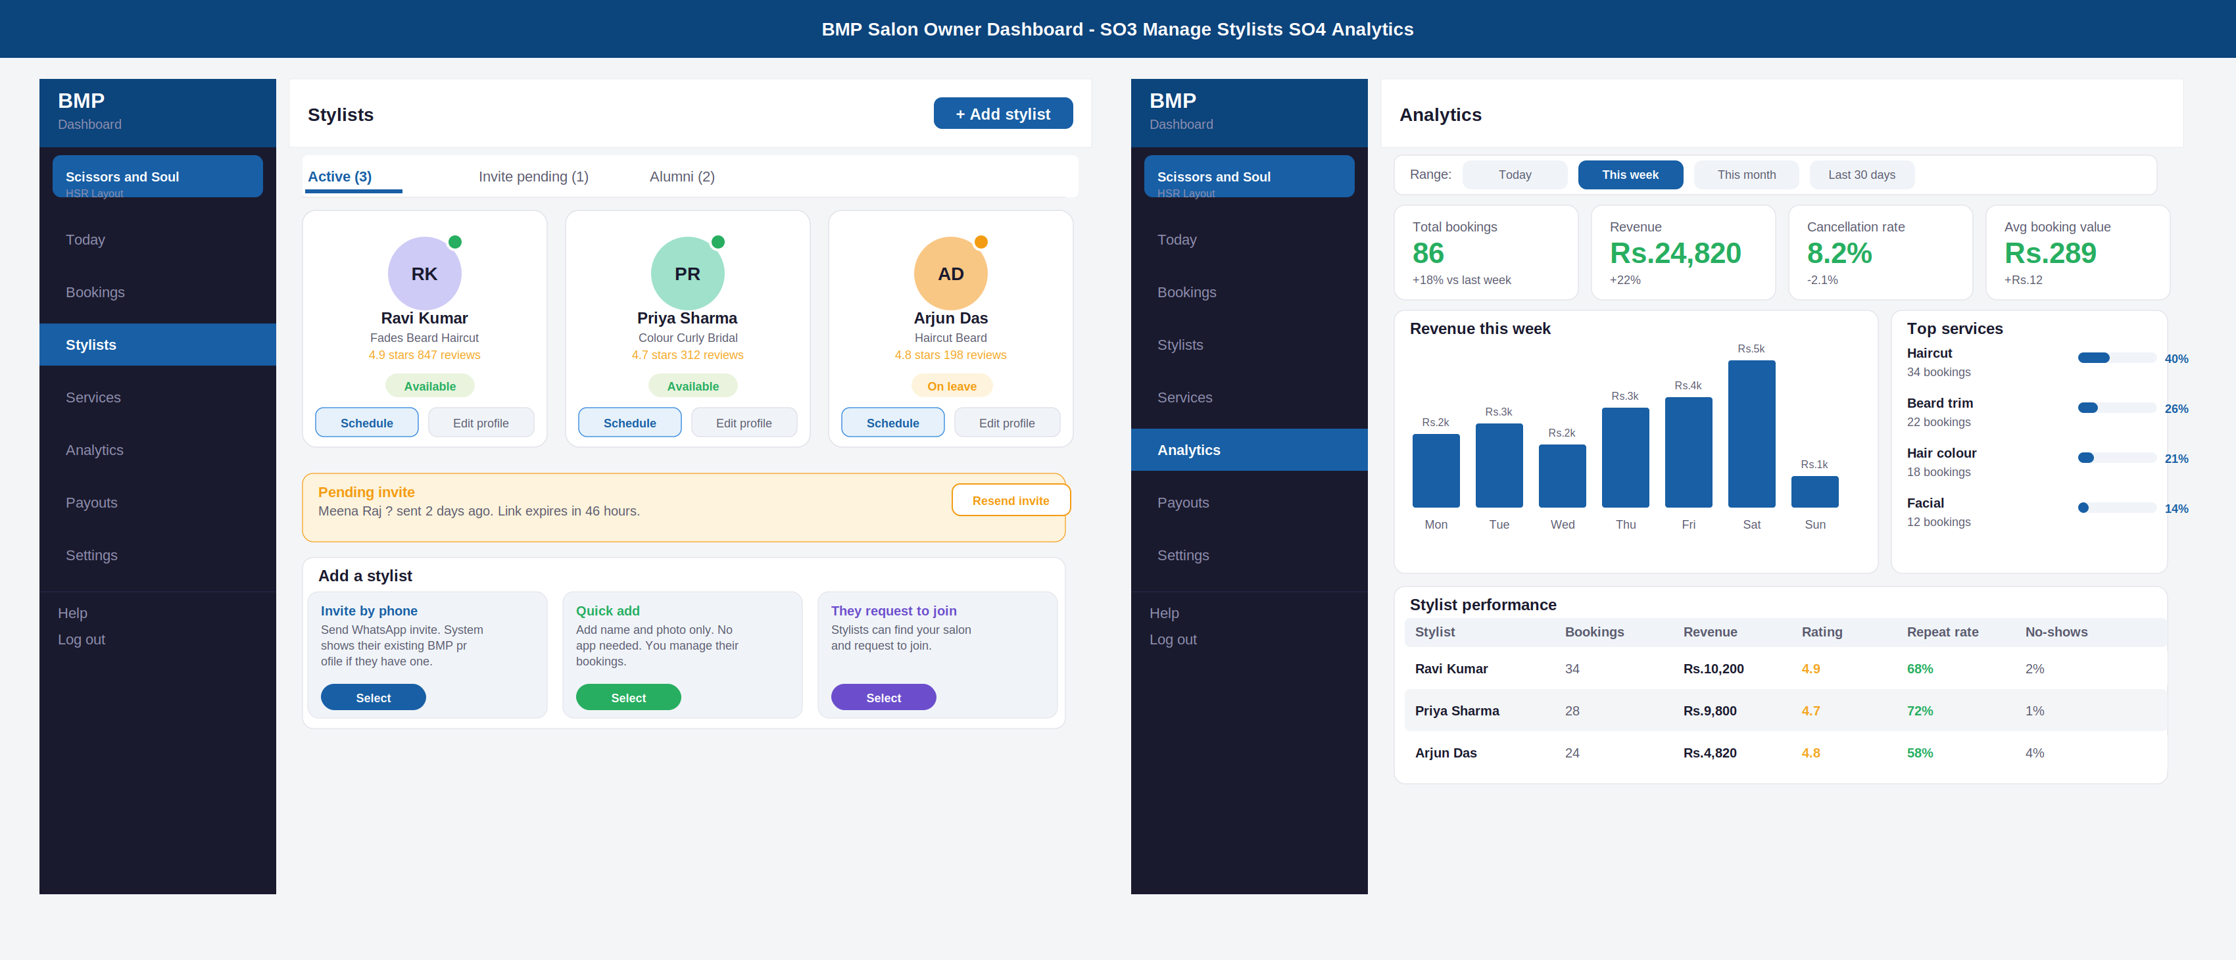

Annotations — SO3 · SO4
ID | Screen | UI elements | UX reasoning | Dev note
SO3 | Manage stylists | Tab row: Active (3), Invite pending (1), Alumni (2). Stylist cards in grid: avatar with availability dot (green=available, amber=leave), name, specialisations, rating, status badge, Schedule + Edit profile buttons. Pending invite amber card with Resend. Add a stylist section: 3 method cards (Invite by phone, Quick add, They request to join) with colour-coded Select buttons. | Three tabs cover the full lifecycle. Availability dot on the avatar card is immediately visible — no need to read text. Alumni tab is important: owners review former stylists when considering rehiring or when customers ask about them. The three add-methods are shown simultaneously so the owner picks the right one for their context. Quick add is fastest for onboarding day. | Stylists loaded from stylist_salon table filtered by salon_id and status. Availability dot from stylist_availability table. Schedule button opens a day-view calendar for that stylist. Invite by phone calls POST /staff-invites. Quick add creates a profile-only stylist record with no user_id. Alumni status set when stylist_salon.status=alumni.
SO4 | Analytics | Date range selector: Today / This week (active) / This month / Last 30 days. 4 KPI cards: total bookings, revenue, cancellation rate, avg booking value with delta vs previous period. Revenue bar chart with day labels and Rs values. Top services panel: service name, booking count, horizontal progress bar, percentage. Stylist performance table: bookings, revenue, rating, repeat rate, no-shows. | Date range selector is the most used control on this page — placed at the top. KPI deltas show trend direction immediately. Bar chart requires no interaction — the shape tells the story. Top services reveals what to stock and what to promote. Stylist performance table is the key retention tool — an owner who sees Priya has a 72% repeat rate knows Priya is valuable and should be treated accordingly. | Analytics data from bookings + payments aggregated by date range. Revenue chart from booking_completions grouped by day. Stylist performance calculated: repeat_rate = customers who booked the same stylist more than once / total unique customers. All analytics are read-only, no writes. Consider caching with 1-hour TTL for performance.

Screens SO5 · SO6
Payouts · Salon settings

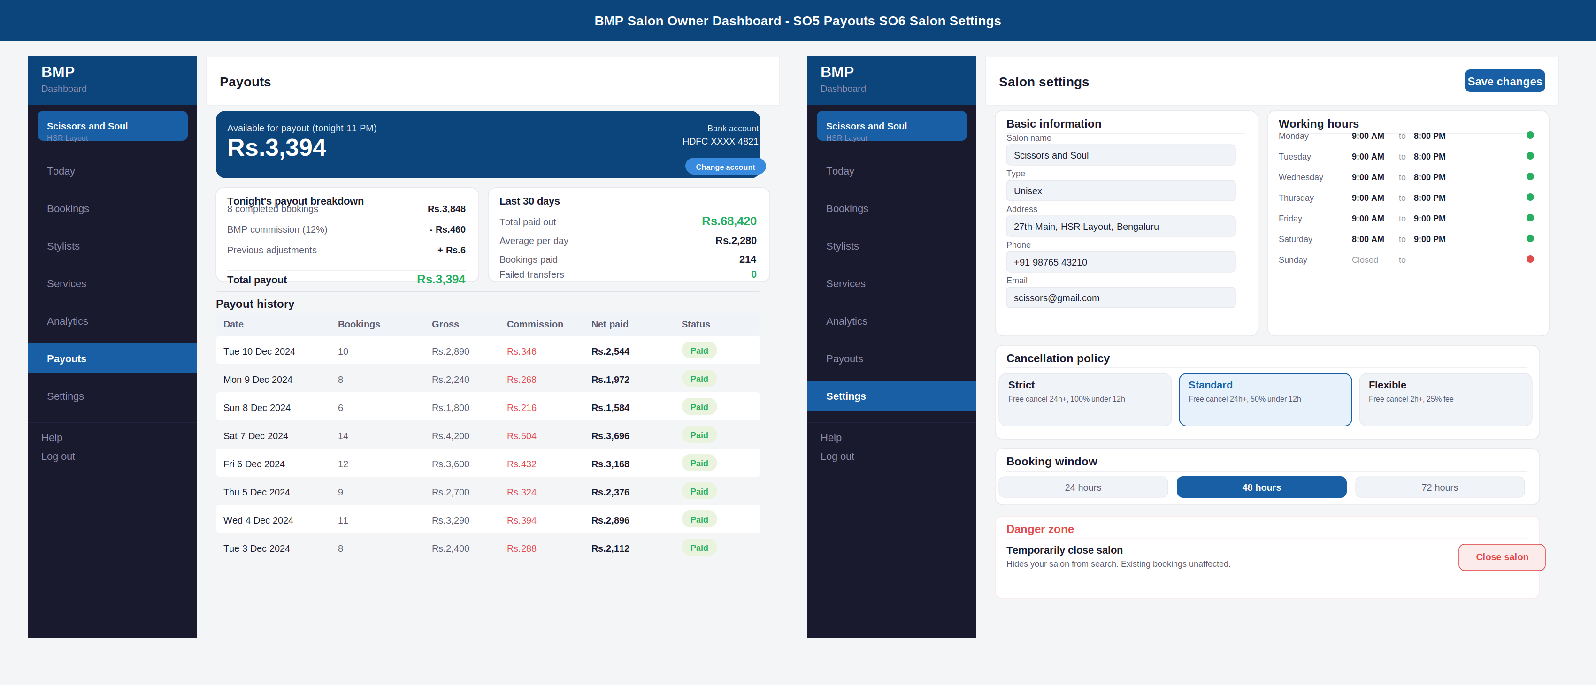

Annotations — SO5 · SO6
ID | Screen | UI elements | UX reasoning | Dev note
SO5 | Payouts | Navy balance card: tonight payout amount (large), bank account last 4 digits, Change account button. Two summary cards: Tonight breakdown (gross - commission + adjustments = total) and Last 30 days (total paid, daily avg, bookings, failed transfers). Payout history table: date, bookings, gross, commission (red), net paid, status badge. | Balance shown large and navy because payouts are the primary financial concern. Commission shown in red in the table — owners want to see this number clearly, not have it hidden. Change account has 2FA protection. Failed transfers = 0 in green is a positive signal. History table lets owners reconcile with their bank statement row by row. | Balance = sum of pending payouts for tonight. Change account triggers 2FA OTP and 24h cooling period. Payout history from payout_records table. Commission deducted at payment_service level on Razorpay Route. Net paid = gross - commission - any adjustments. Failed transfers shown separately with reason.
SO6 | Salon settings | Basic information: form fields for name, type, address, phone, email (all pre-filled, editable). Working hours: day-by-day grid with open/close times and green/red availability dot. Cancellation policy: 3 cards (Strict, Standard, Flexible) — selected one has blue border. Booking window: 3-segment picker (24h, 48h, 72h). Danger zone: Close salon button in red outline. | Settings are split into logical sections with clear visual grouping. Working hours as a grid is more scannable than a list. Policy selection as cards shows the full description of each option simultaneously — owner does not have to remember what Strict means. Booking window as a segmented control removes ambiguity. Danger zone is separated visually and the action is clearly labelled (not a vague disable). | Policy changes save to salon_policy table but only affect future bookings. Existing bookings retain their snapshotted policy. Working hours saved to salon_hours table per day. Close salon sets salon.status = temporarily_closed. Reopening requires explicit action. All settings changes logged to audit_log table.

Sidebar navigation — complete reference
The dark sidebar is persistent across all 6 dashboard screens. It contains the 7 main navigation sections plus the salon name and quick-access links.

Nav item | Screen ID | Default view | What the owner manages here
Today | SO1 | Today's bookings list | All bookings for today. Mark arrived / in service / completed / no-show. Walk-in booking. At-a-glance stats.
Bookings | SO2 | Full booking list with filters | All bookings across all dates. Filter by date, status, stylist. Booking detail with receipt, actions, and timeline.
Stylists | SO3 | Active stylists grid | Add, edit, invite stylists. View schedule. Mark availability. Manage pending invites. View alumni.
Services | SO-S | Services list with prices | Add, edit, pause services. Set price and duration. Assign services to stylists. (Not shown in this set — standard CRUD form.)
Analytics | SO4 | This week KPIs | Revenue trends, booking counts, cancellation rate, top services, stylist performance. Date range selector.
Payouts | SO5 | Tonight payout balance | Payout history, breakdown per day, commission deductions, bank account management.
Settings | SO6 | Salon information form | Basic info, working hours, cancellation policy template, booking window, danger zone (close salon).

BMP — Salon Owner Dashboard Screen Designs | June 2026 | Confidential

