BMP — Salon Owner
ANDROID APP | UX / UI SCREEN DESIGNS
Mobile-optimised version of the salon dashboard | React Native | Same codebase as customer app
SM1 Today | SM2 Detail | SM3 Stylists | SM4 Analytics | SM5 Payouts | SM6 Settings | SM7 Notifs | SM8 No-show

Web vs Mobile — Design principles
Aspect | Web dashboard (Next.js) | Android app (React Native)
Primary use case | Seated at a computer. Morning setup, end-of-day review, analytics. | On the salon floor. Mark arrived, mark done, check who is next, respond to alerts.
Layout | Wide 2-column layouts. Dense tables. Sidebar navigation. Mouse-friendly. | Single column. Large tap targets (min 44px). Bottom tab bar. Thumb-reachable.
Stats display | 4 stat cards across full width. More data visible at once. | 4 stat cards in 2x2 grid. Same data, mobile-proportioned.
Action buttons | Small buttons inline on table rows. | Large pill buttons (38-44px tall) easily tapped with thumb while standing.
Unique to mobile | — | SM7 Notifications feed. SM8 No-show confirmation modal. Push notifications from FCM.
Navigation | Left sidebar always visible. 7 items. | Bottom tab bar: Today / Bookings / Stylists / More. Clean and thumb-friendly.
Shared codebase | Next.js web app. Separate from mobile. | React Native — same app as customer app. Salon owner role shows this dashboard after login.

Screens SM1 · SM2 · SM3
Today overview · Booking detail · Manage stylists

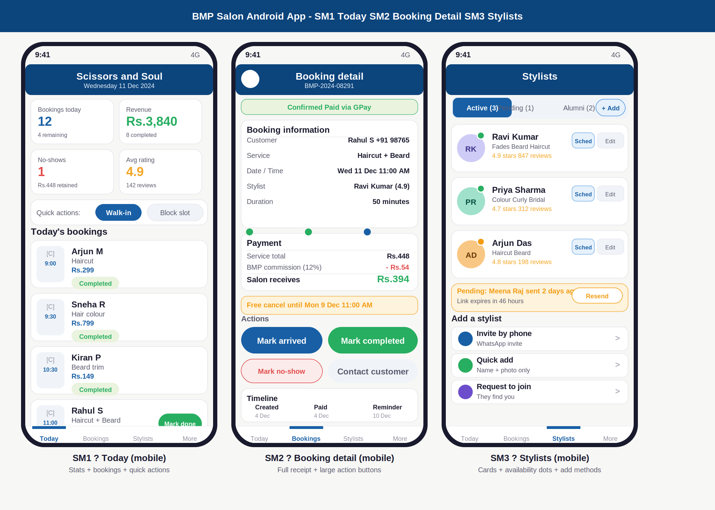

Annotations — SM1 · SM2 · SM3
ID | Screen | UI elements | UX reasoning | Dev note
SM1 | Today (mobile) | Navy top bar: salon name + date. 2x2 stat grid: bookings (blue), revenue (green), no-shows (red), rating (gold). Quick action strip: Walk-in (blue), Block slot (grey). Booking list: each card shows time badge, customer name, service, amount, status badge, and action button (Mark done / Arrived) inline on card. | Salon name in the top bar — owners sometimes manage multiple salons and need instant context. 2x2 grid makes all 4 KPIs visible without scrolling on a phone. Quick actions strip covers the two most common floor actions. Action button on the card itself means no drill-in needed for the most common workflow: mark arrived, mark done. | Role = salon_owner or manager. Both see this screen. Same booking_service API as web. Bottom tab: Today = today filter. Walk-in button opens a quick booking sheet. Mark done triggers the same payout_queue insert as web. Push notification badge on Today tab if there are new bookings.
SM2 | Booking detail (mobile) | Large green status strip at top. Booking info card (customer + phone, service, date/time, stylist, duration). Payment card (total, commission in red, salon receives in large green). Amber free-cancel deadline. Four large action buttons (Mark arrived, Mark completed, Mark no-show, Contact customer). Timeline at bottom. | Large action buttons (38px tall, full half-width) are safe to tap while standing on the salon floor. Commission in red and salon receives in large green — the owner knows at a glance what they earn from this booking. Contact customer opens WhatsApp deep link because that is how salon owners communicate in India. | Mark no-show button navigates to SM8 confirmation flow — never marks directly. Contact customer: wa.me/91PHONENUMBER?text=pre-filled message. Timeline rendered from booking_events. All same data as SO2 web, adapted layout.
SM3 | Stylists (mobile) | Tab row: Active (3), Pending (1), Alumni (2) with inline + Add button. Stylist list cards: coloured avatar with availability dot (green/amber), name, specialisations, rating/reviews in gold, Schedule and Edit buttons. Amber pending invite card with Resend. Three add-method rows: Invite by phone, Quick add, Request to join. | Availability dot on the avatar is visible immediately — no reading required. Schedule button on each card is the second most used action on mobile (after today bookings). Three add methods as tappable rows (not cards like web) use space efficiently on mobile and are still clearly differentiated. | Same stylist_salon data as web SO3. Schedule opens a date picker then navigates to a day view for that stylist. Edit profile navigates to a form. Resend invite calls POST /staff-invites with existing invite_id to refresh token and expiry.

Screens SM4 · SM5 · SM6
Analytics · Payouts · Settings

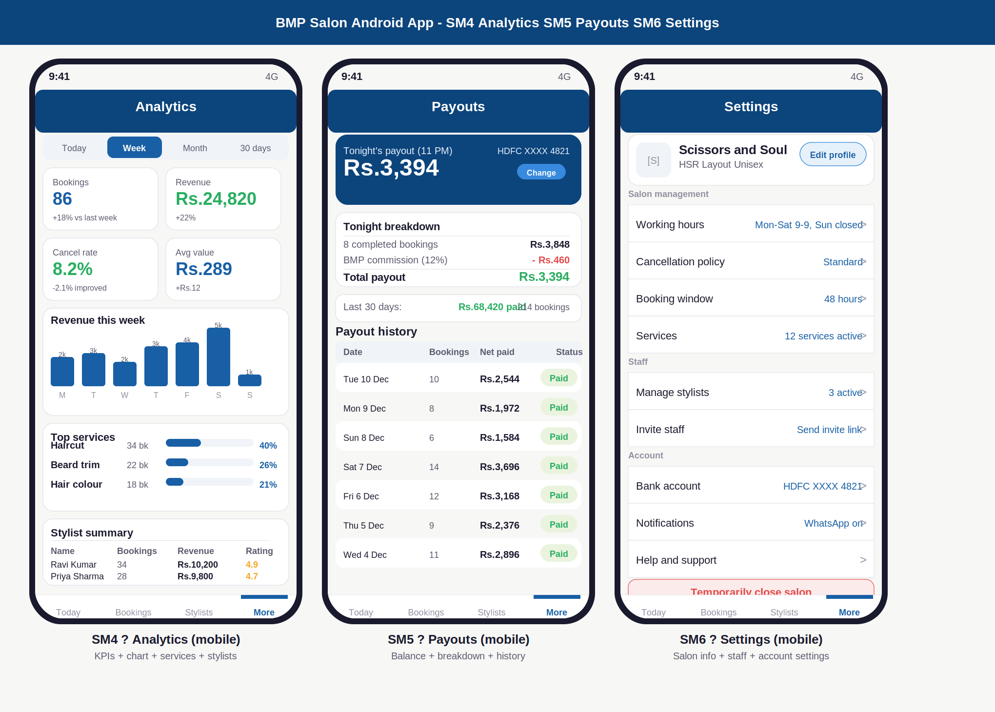

Annotations — SM4 · SM5 · SM6
ID | Screen | UI elements | UX reasoning | Dev note
SM4 | Analytics (mobile) | Compact date range selector (4 pill options). 2x2 KPI grid with delta labels. Revenue bar chart (compact, day labels at bottom, value labels above bars). Top services: name, count, horizontal progress bar, percentage inline. Stylist summary table: name, bookings, revenue, rating. | Analytics on mobile is read-only and primarily used to answer one question: how is this week going? 2x2 grid answers that in under 3 seconds. Chart is compact but readable. Top services and stylist table give enough detail for a floor check without needing a desktop. | All analytics from same endpoints as web SO4. Chart rendered with react-native-svg bar chart. Date range selection updates all 4 KPI cards, chart, services, and stylist table simultaneously. Cached with 1-hour TTL.
SM5 | Payouts (mobile) | Navy payout balance card: amount large, bank last 4 digits, Change button. Tonight breakdown card: gross, commission in red, total in green. Last 30 days strip: total + bookings count. Payout history table: date, bookings, net paid, status badge. Scrollable. | Balance card is navy — same visual weight as the web version. The most important number (Rs.3,394) is the largest text on the screen. Commission in red is deliberate: owners need to understand the deduction. Change account on mobile has the same 2FA + 24h cooling as web. | Payouts data from payout_records. Change account triggers OTP modal (using the same auth flow). Payout history limited to last 30 rows on mobile for performance. Pull to refresh.
SM6 | Settings (mobile) | Salon header card: logo, name, area, Edit profile button. Settings list divided into three sections (Salon management, Staff, Account) with current value shown inline on each row. Danger zone: red Temporarily close salon at the bottom. | Settings on mobile use the iOS/Android standard list pattern — label on left, current value or chevron on right. This is familiar to every smartphone user and requires no learning. Current values (Standard, 48 hours, 3 active) shown inline so owner can see current state without tapping in. | Tapping each row navigates to a dedicated edit screen. Working hours opens a day-by-day toggle grid. Policy opens the 3-card selection (same as SO6 web, stacked vertically). Bank account requires 2FA. Close salon shows a confirmation modal with 24h re-open note.

Screens SM7 · SM8
Notifications · No-show confirmation

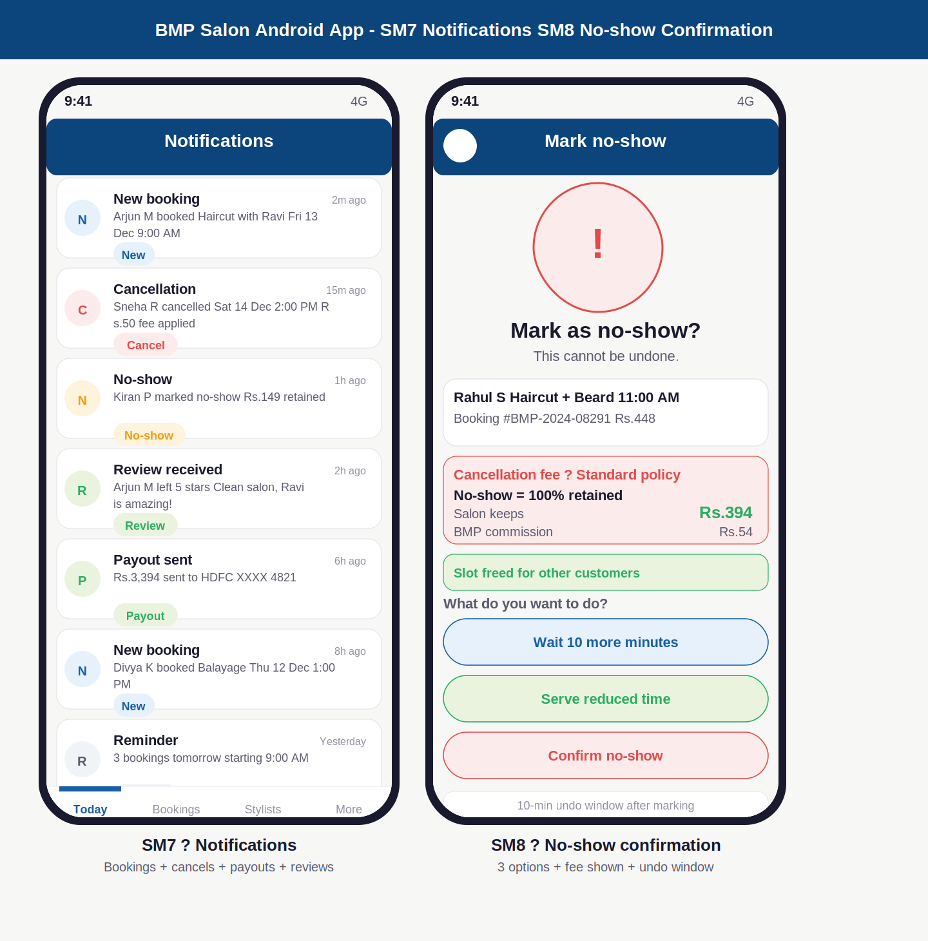

Annotations — SM7 · SM8
ID | Screen | UI elements | UX reasoning | Dev note
SM7 | Notifications (mobile) | Notification list. Each row: coloured circle icon (N=new booking blue, C=cancel red, No-show amber, R=review green, P=payout green, Remind grey), title, description, time ago, colour-coded badge. Types covered: New booking, Cancellation, No-show, Review received, Payout sent, Reminder. | Notifications are mobile-only — on web the owner sees real-time data in tables. On mobile, a notification feed is essential because owners are not watching the screen. Colour-coded icons let the owner scan the type instantly without reading. Most important (new booking, cancellation) are blue and red respectively. | Notifications stored in notification_log table with type enum. FCM push on every event. In-app notification feed loaded on pull-to-refresh. Unread count shown as badge on Today tab in bottom nav. Mark all read on swipe or after 5 seconds of viewing.
SM8 | No-show confirmation (mobile) | Large red warning circle with ! icon. "Mark as no-show?" heading, "This cannot be undone" warning. Booking recap card. Red fee card: policy name, fee calculation, salon keeps in green, commission in grey. Green strip: Slot freed for other customers. Three large action buttons: Wait 10 min (blue outline), Serve reduced time (green outline), Confirm no-show (red outline). 10-min undo note at bottom. | This is the most consequential action a salon owner takes. The flow is deliberately slowed down with a confirmation screen. Three options shown simultaneously — the owner might not know they can serve reduced time. "Slot freed" note in green turns a bad situation into a positive (someone else gets the slot). Large buttons are safe to tap when frustrated. | SM8 reached from booking detail "Mark no-show" button only — never directly. Wait 10 min extends the arrival grace period, resets the timer, and shows a wait screen. Serve reduced: marks booking as in_service with reduced duration. Confirm no-show: sets booking.status=no_show, triggers cancellation_fee logic, frees slot, sends customer WhatsApp.

Responsive design — screen mapping
Every screen on web has a direct mobile equivalent. The data shown is identical. The layout is different. The actions are the same. A salon owner can switch between web and mobile seamlessly.

Feature | Web screen | Mobile screen | Key layout difference
Today overview | SO1 | SM1 | Web: wide table with 6 columns. Mobile: cards with inline action buttons.
Booking detail | SO2 | SM2 | Web: 2-column layout. Mobile: single column, stacked cards, larger action buttons.
Manage stylists | SO3 | SM3 | Web: stylist cards grid. Mobile: vertical list with Schedule/Edit on each row.
Analytics | SO4 | SM4 | Web: wide chart + performance table. Mobile: compact chart + summary table.
Payouts | SO5 | SM5 | Web: full history with gross/commission columns. Mobile: simplified with net paid only.
Settings | SO6 | SM6 | Web: inline forms and card selectors. Mobile: settings list rows (iOS/Android pattern).
Notifications | Not needed (real-time tables) | SM7 (mobile only) | Mobile-only screen. Web owners see data update in real time. Mobile owners need a feed.
No-show confirm | Inline modal on SO2 | SM8 (dedicated screen) | Web: modal overlay. Mobile: full screen confirmation because modal is harder to interact with accurately.

BMP — Salon Owner Android App Screen Designs | June 2026 | Confidential

