Be My Professional
BMP
UX / UI SCREEN DESIGNS
Authentication · Signup · Role Onboarding · All Screens with Annotations
10 screens | 5 roles | All states | Full flow | UX notes | Dev specs

Version 1.0 | May 2026 | Bengaluru, India | Confidential

Screen Index — Authentication and Onboarding
This document contains actual UI screen designs for all 10 authentication and onboarding screens in the BMP app. Each screen is shown in a phone frame with annotations explaining every element, the UX reasoning, and key development notes.

Screen ID | Screen name | What it shows | Role
A1 | Splash screen | Full navy brand screen. Logo, tagline, loading dots. JWT check happens here. | All roles — first thing every user sees
A2 | Phone entry | Mobile number input with +91 selector. Google sign-in fallback. OTP trigger button. | All roles — new and returning users
A3a | OTP entering | 6-box OTP entry. Partial fill state. Disabled verify button. Timer. WhatsApp fallback. | All roles
A3b | OTP wrong code | All boxes red. Error message with attempts remaining. Clear messaging. | All roles
A3c | OTP verified | Green success animation. JWT issued. Auto-navigates in 1 second. | All roles
A4 | Role fork screen | 3 role cards: Customer / Salon owner / Stylist. Employee notice at bottom. | New users only
A5a | Customer profile step 1 | Name, gender pills, age slider, email, GPS permission card. | Customer only
A5b | Customer hair prefs | Hair type, length, services. Chip-based multi-select. All optional. | Customer only
A6 | Salon onboarding step 1 | Salon name, type chips, address with Maps pin, verification notice. | Salon owner only
A7 | Pending verification | Clock icon, checklist with status badges, bank account CTA. | Salon owner only
A8 | Stylist onboarding | Universal profile: name, photo, specialisations, experience picker. | Stylist only
A9 | Manager invite screen | Invite banner, role summary, permissions list, accept/decline. | Manager only (invite)
A10 | Role picker | Multi-role card list. Set default role. Session scoping. | Multi-role users

Screens A1 · A2 · A3a
Splash · Phone entry · OTP entering

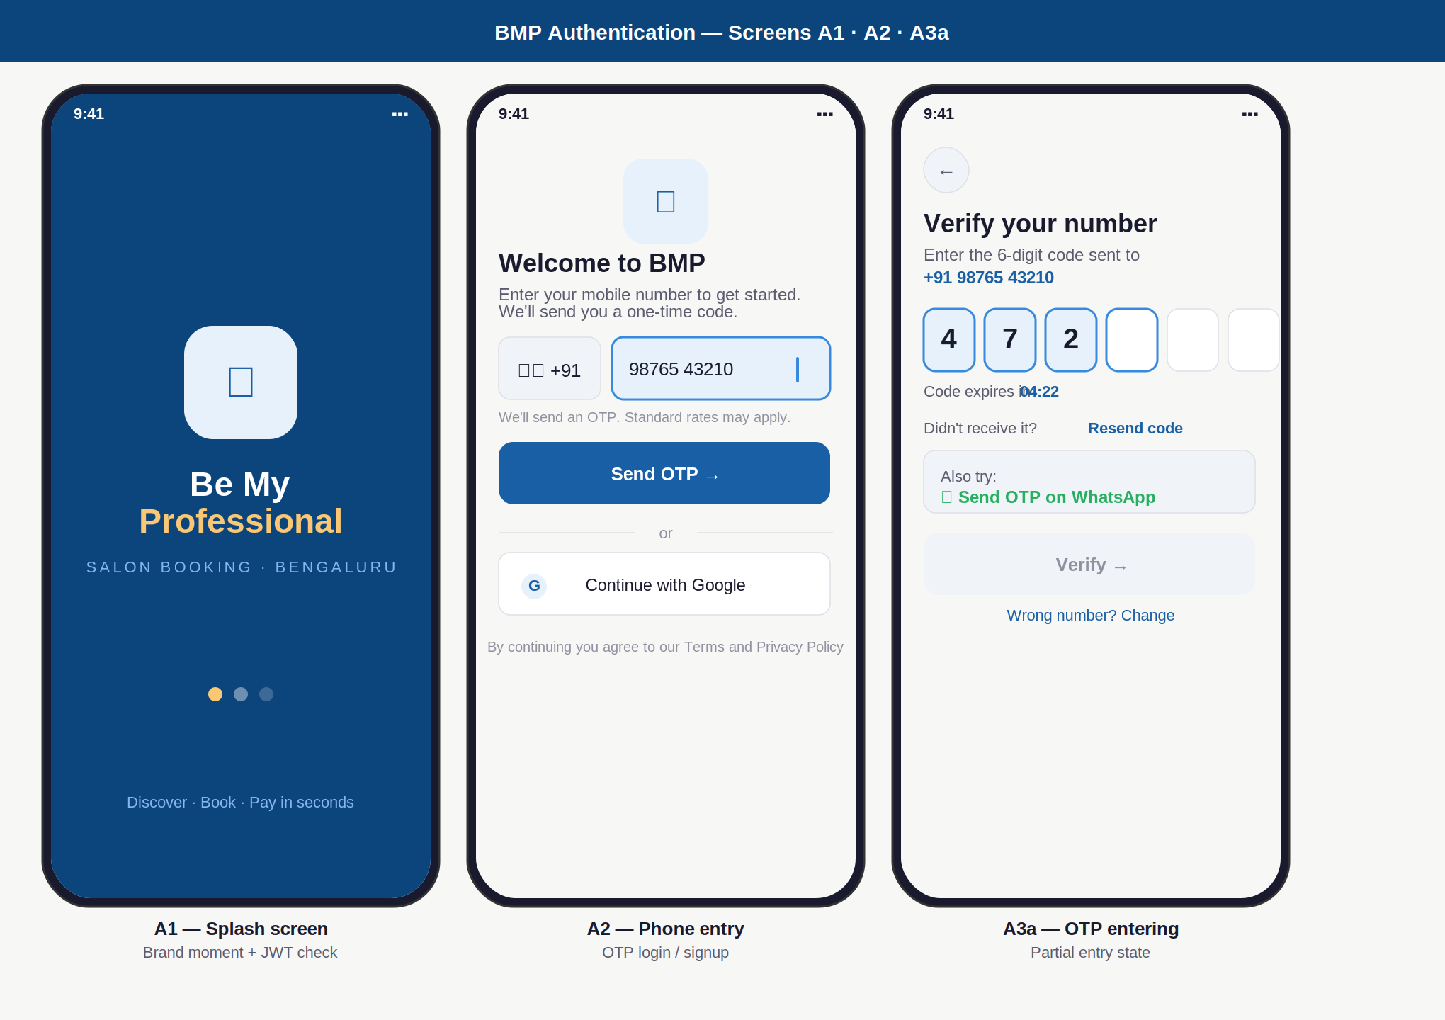

Screen annotations — A1, A2, A3a
Screen | Elements shown | UX reasoning | Dev note
A1 Splash | Navy background. BMP logo in light blue card. "Be My Professional" + amber accent on "Pro". Tagline in muted blue. 3 loading dots: first amber (active), rest faded. | Dark background creates a distinct brand moment — the only screen with a coloured background, making it memorable. Amber accent on "Pro" is a subtle premium cue. Dots signal something is happening without showing a spinner. | JWT check fires during the 1.5s splash. If token valid: auto-navigate to home. If invalid: navigate to A2. Never show splash for more than 2 seconds.
A2 Phone | Small logo at top. +91 country selector (left) + phone input (right, active blue border). Send OTP primary button. "or" divider. Google sign-in secondary. Terms micro-text. | Country selector is left-fixed — Indian users expect +91 always visible. Active state (blue border + light blue background) makes the focused field immediately clear. Google is secondary because phone OTP has higher trust in India. | Phone number formatted as user types (auto-spaces). Validate 10 digits before enabling Send OTP. Google OAuth uses existing BMP backend for JWT — same flow after auth.
A3a OTP | 6 individual OTP boxes. First 3 filled (blue bg, blue border). 4th box active (blue border only). Last 2 empty (grey). Timer running. WhatsApp alternative card. Verify button disabled. | Individual boxes instead of a single input field: forces one digit per box, removes ambiguity, visually shows progress. Verify button stays disabled until all 6 filled — eliminates premature submit errors. WhatsApp card is visible immediately, not hidden behind a link. | Auto-submit triggers API call 300ms after 6th digit entered. OTP is 6 digits, valid 5 minutes. Max 3 resends. After 3 failed attempts: lock account 10 minutes.

Screens A3b · A3c · A4
OTP error · OTP verified · Role fork

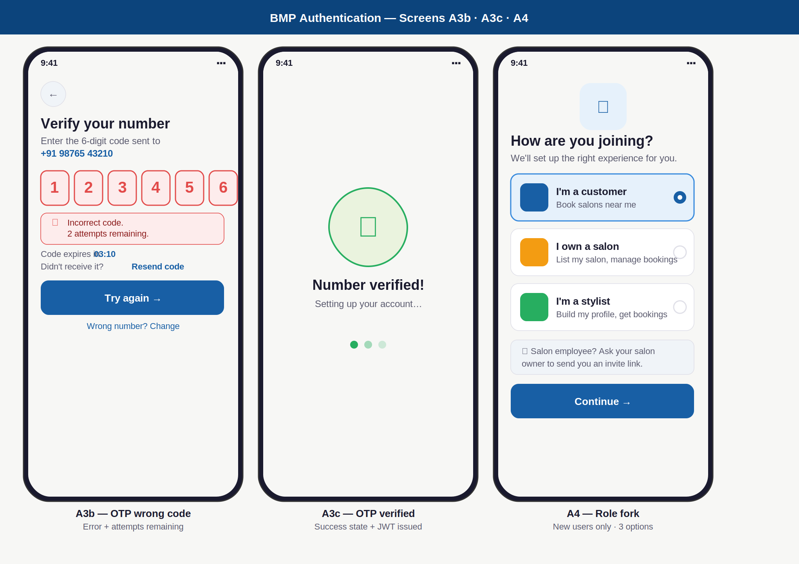

Screen annotations — A3b, A3c, A4
Screen | Elements shown | UX reasoning | Dev note
A3b Error | All 6 OTP boxes turn red (red border, red background, red text). Red error banner below boxes: "Incorrect code. 2 attempts remaining." Timer still running. Try again button active. | All boxes turn red simultaneously — the user clearly understands the entire code was wrong. "X attempts remaining" is specific and honest — generic "invalid OTP" causes unnecessary re-reads. Boxes clear automatically for re-entry. | After 3 wrong attempts: set otp_requests.locked_until = now+10min. Show lockout screen (not this screen). Reset all 6 boxes to empty on error. Do not pre-fill with wrong digits.
A3c Verified | Centred green circle with white checkmark. "Number verified!" heading. "Setting up your account…" subtext. 3 green dots in loading sequence. | A positive confirmation screen before the app does backend work (JWT generation, role check). Prevents the user from seeing a frozen screen. Green = success without needing to read text. Auto-navigates after 1 second — no user action needed. | Issue JWT here. Store refresh token with device fingerprint. Role check happens during the 1-second display. Navigate to: fork (new) or role routing (returning). No back button on this screen.
A4 Fork | Small logo. 3 role cards: Customer (blue icon, selected state with blue border), Salon owner (amber), Stylist (green). Employee notice card (grey). Continue button. | 3 options only — no "Manager" option because a manager without a salon is meaningless. Employee note explains why they cannot self-register without overwhelming them. Selected state uses border + background fill — visible without needing color alone. | Show only for first-time users (no existing user_roles record). After fork selection, create user_roles record with chosen role. This screen should not appear on subsequent logins.

Screens A5a · A5b
Customer profile · Hair preferences

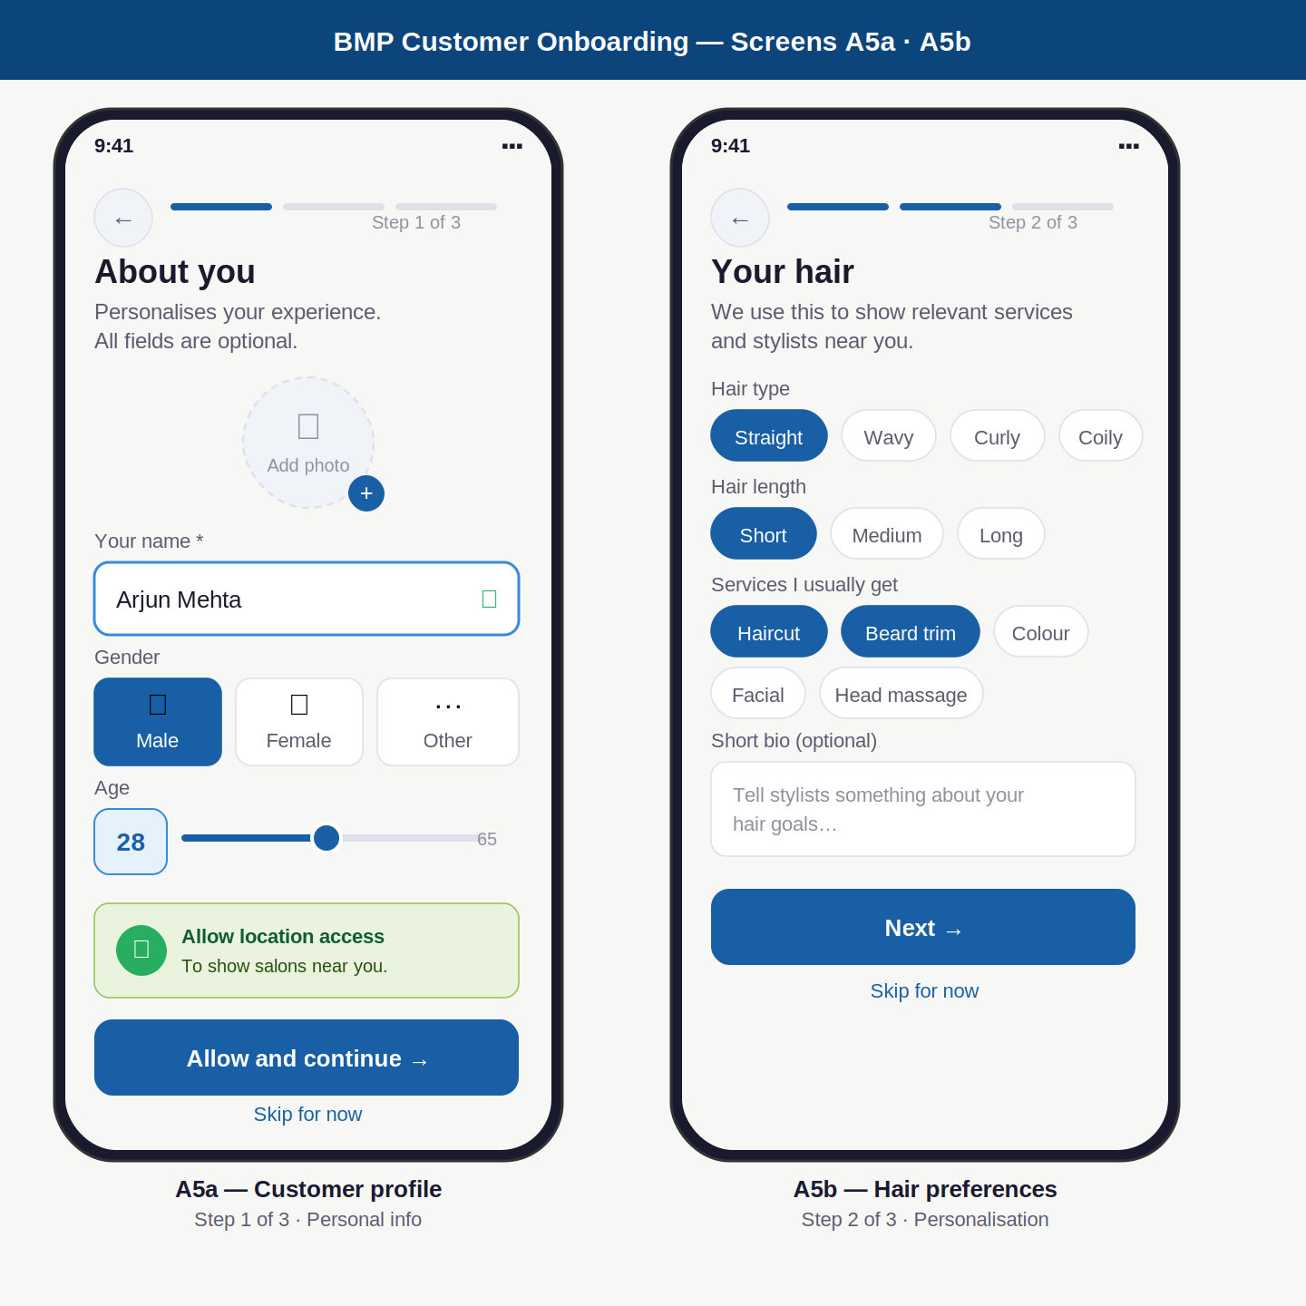

Screen annotations — A5a, A5b
Screen | Elements shown | UX reasoning | Dev note
A5a Personal | Progress bar (step 1 of 3, filled blue). Photo upload circle with dashed border and + badge. Name input (filled, green tick). Gender: 3 equal pills (Male/Female/Other). Age: number box + slider (18–65). GPS permission card in green. Allow + skip buttons. | Progress bar shows effort required upfront — reduces abandonment. Photo upload is prominent but clearly optional (no asterisk). 3 equal gender options (not male/female default with "other" as afterthought). Slider for age removes keyboard usage on mobile. GPS framed as a benefit ("to show salons near you") not a demand. | Name is the only required field. All others skippable. Gender stored as enum: male/female/other. Age stored as int. GPS permission uses expo-location. If denied: manual area search shown on home screen. Skip navigates to A5b.
A5b Hair prefs | Progress bar step 2. Hair type chips (Straight selected). Hair length chips. Services multi-select chips (Haircut + Beard trim selected). Bio text area (placeholder, optional). Next and skip buttons. | Multi-select chips are faster than dropdowns on mobile — one tap per selection. Chips show current selections clearly with blue fill. All fields are optional — this data personalises the home feed and stylist suggestions, not gatekeeps the app. Short bio lets stylists prepare before the appointment. | Store as arrays in user profile. Used to: sort nearby salons, highlight relevant services, suggest stylists with matching specialisations. Bio max 200 characters. These preferences can be changed any time in Settings > Profile.

Screens A6 · A7
Salon onboarding · Pending verification

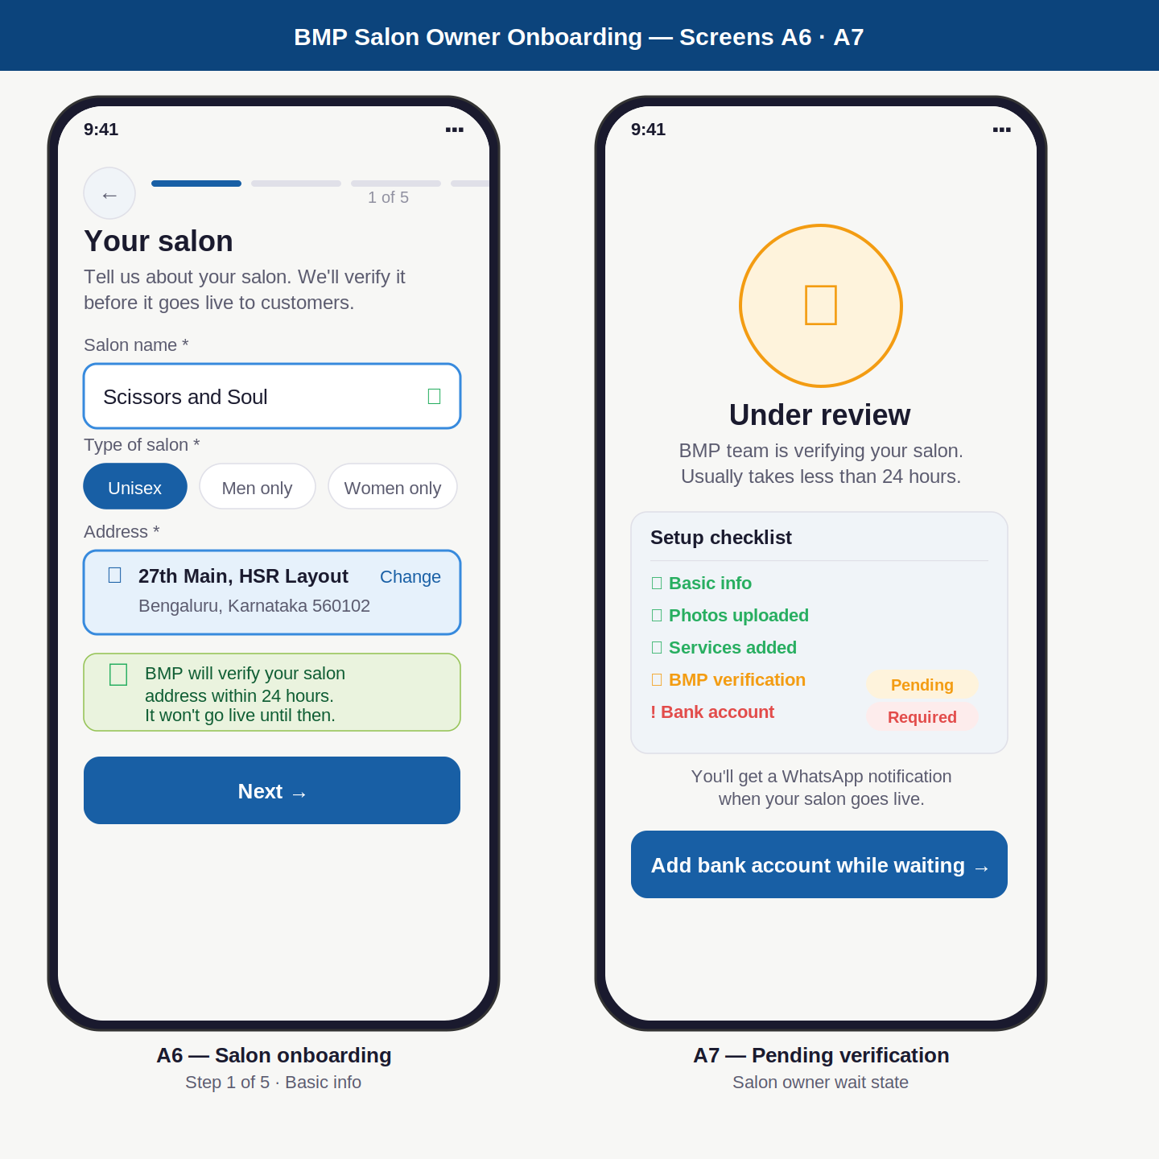

Screen annotations — A6, A7
Screen | Elements shown | UX reasoning | Dev note
A6 Salon info | 5-dot progress bar (step 1 active). Salon name input (filled, green tick). Type chips: Unisex selected. Address card (blue background, Maps pin icon, full address shown, Change link). Green info banner: "BMP verifies within 24 hours." Next button. | 5-step progress bar prepares owner for the onboarding effort — transparency reduces mid-flow abandonment. Address shown as a resolved card (not raw input) because owners are more confident seeing their address correctly geocoded. Green info banner sets expectations before they invest time in steps 2–5. | Address captured via Google Places Autocomplete API. Stored as full address string + lat/lng for PostGIS. Salon type stored as enum: unisex/men/women/kids. Progress persisted server-side — if owner closes app mid-onboarding, they resume from last completed step.
A7 Pending | Clock icon in amber circle. "Under review" heading. Checklist card: Basic info (green tick), Photos (green tick), Services (green tick), BMP verification (amber pending badge), Bank account (red required badge). WhatsApp notification note. Add bank account CTA. | The checklist keeps the owner engaged during the wait — they know exactly where things stand. Bank account CTA is shown here deliberately: it is the one productive action they can take while waiting. Red "Required" badge on bank account creates appropriate urgency. WhatsApp note reassures them they won't miss the approval. | Salon status field: pending/approved/rejected. Owner sees this screen until status = approved. BMP team approves via internal admin panel. On approval: push notification + WhatsApp sent. Payout held until bank account added even after approval.

Screens A8 · A9 · A10
Stylist · Manager invite · Role picker

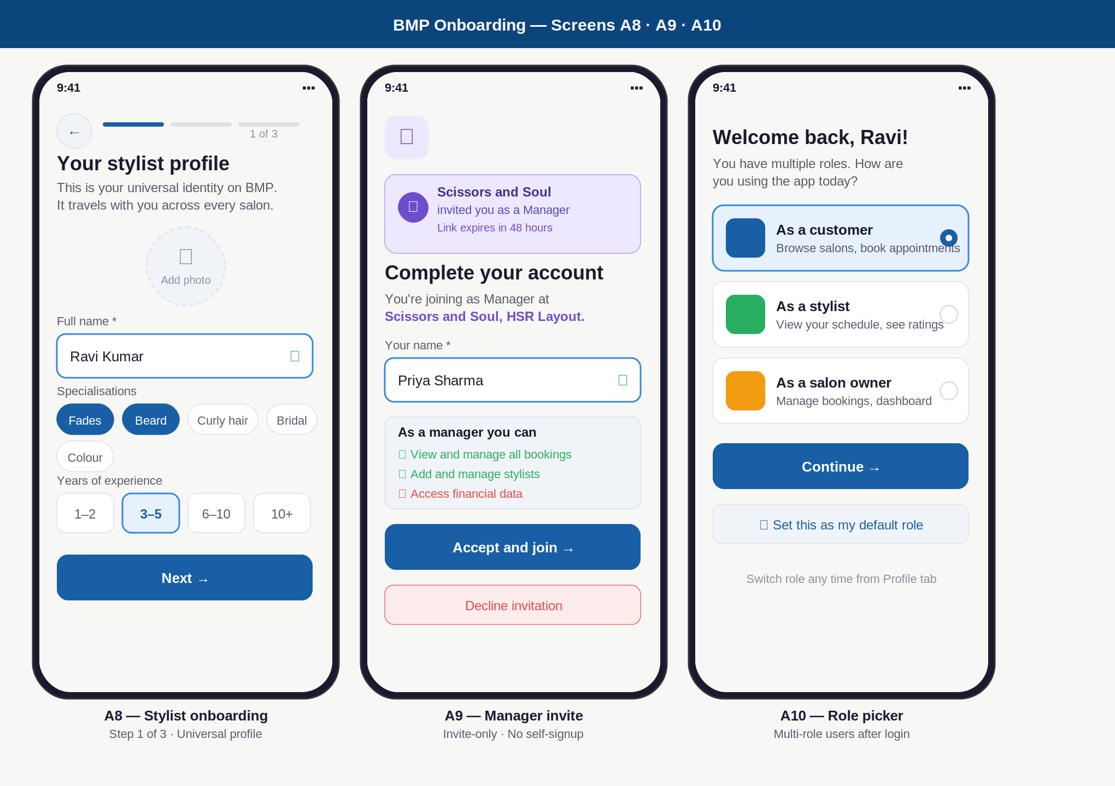

Screen annotations — A8, A9, A10
Screen | Elements shown | UX reasoning | Dev note
A8 Stylist | 3-step progress (step 1). Photo upload circle. Name input (filled). Specialisation chips: Fades + Beard selected. Experience picker: 4 options as segmented control, 3–5 years selected (blue). Next button. | Specialisation chips instead of a text field — prevents misspellings, enables filtering in search. Segmented experience picker is faster than a number input and removes the need to type. The profile is emphasised as "universal" in the subtitle — sets the right expectation that this profile travels with them. | Creates stylist record in global stylist table (not salon-specific). Profile live immediately. Cannot receive bookings until stylist_salon record created (join a salon). Specialisation tags stored as string array. Experience stored as enum.
A9 Manager | Purple invite banner showing salon name and role. "Joined as Manager" heading with purple role text. Name input (filled). Permissions summary card: green ticks for can-do, red X for cannot access financial data. Accept button (primary). Decline button (red outline). | Invite banner is the first thing visible — immediately contextualises why they are here. Permissions summary before accepting sets clear expectations: "you will not see financial data" said upfront prevents future frustration. Decline is clearly visible — no dark patterns forcing acceptance. | Invite token validated against staff_invites table. One-time use. Expires 48 hours after creation. On accept: create salon_staff record with role=manager. If user already has BMP account: link to existing user_id. If new: create user then link.
A10 Role picker | Welcome message with user name. 3 role cards with icons: Customer (selected, blue border), Stylist (unselected), Salon owner (unselected). Continue button. "Set as default role" checkbox card at bottom. | Role picker only appears for multi-role users — the majority of users never see it. Roles shown as large tappable cards — easy to distinguish at a glance. Setting a default role skips this screen on future logins. The picker is per-session: switching roles mid-session is possible from Profile tab. | After role selection, JWT scoped to chosen role: active_role field set in token payload. API gateway validates active_role on every protected route. User can switch roles without re-authenticating — new JWT issued instantly.

Design System — Auth Screens

Colours
Token | Hex value | Used for | Example
Primary navy | #0C447C | Splash background, CTA buttons background, headings | Splash screen background, "Send OTP" button
Accent blue | #185FA5 | Links, active states, progress bar fill, chip selected | Active OTP box border, selected role card border
Light blue | #E6F1FB | Active field background, chip selected background | Active OTP box fill, selected chip fill
Amber accent | #FAC775 | Splash "Pro" text, pending badges | "Professional" on splash, pending verification badge
Success green | #27AE60 | Verified tick, GPS card, completed checklist items | OTP verified checkmark, completed steps
Error red | #E24B4A | Wrong OTP state, error messages, required badges | Wrong OTP boxes, "Required" bank account badge
Text primary | #1A1A2E | All headings, filled input text | "Verify your number", name input value
Text secondary | #5A5A6E | Subtext, field labels, hints | "Enter the 6-digit code sent to…"
Background page | #F7F7F5 | App background behind all screens | The off-white surface all cards sit on

Typography
Style | Size / Weight | Used for | Example
Screen heading | 18px / 700 | Main title of each screen | "Verify your number", "How are you joining?"
Body text | 12px / 400 | Descriptions, hints, secondary information | "We'll send you a one-time code"
Input text | 13px / 400 | Text entered in input fields | Phone number, salon name, user name
Field label | 11px / 400 | Labels above input fields | "Your name", "Gender", "Salon type"
Button text | 13px / 600 | Primary and secondary buttons | "Send OTP →", "Continue →", "Accept and join →"
OTP digit | 20px / 700 | Digits inside OTP boxes | The numbers the user types into OTP boxes
Micro text | 10px / 400 | Terms, hints, step counters | "Step 1 of 3", "By continuing you agree to…"

Component states
Component | State | Visual treatment
Input field | Default | White background, #E0E0E8 border, 0.8px stroke, 8px radius
Input field | Active / focused | #E6F1FB background, #378ADD border, 1.5px stroke — blue tint signals active input clearly
Input field | Filled (valid) | #378ADD border + green tick icon at right edge — confirmation without interrupting the flow
OTP box | Empty | White background, grey border — waiting
OTP box | Filled | #E6F1FB background, #378ADD border — filled but not yet submitted
OTP box | Error | #FDECEC background, #E24B4A border, red digit — entire code wrong at once
Button | Primary active | #185FA5 background, white text — main action
Button | Disabled | #F0F4F8 background, #9090A0 text — cannot submit yet
Role card | Selected | #E6F1FB background, #378ADD border 1.5px, filled radio button
Chip | Selected | #185FA5 background, white text — active filter or selection

BMP — UX / UI Screen Designs | Authentication & Onboarding | May 2026 | Confidential

