Be My Professional
BMP
UX / UI SCREEN DESIGNS
Authentication · Signup · Role Onboarding · All States · Design System
10 screens | 5 user roles | All UI states | Annotations | Design tokens

Version 1.0 | June 2026 | Bengaluru, India | Confidential

Screens A1 · A2 · A3a
Splash screen · Phone entry · OTP entering (partial state)

BMP Auth Flow — Screens A1, A2 and A3a shown in phone frames at actual proportions
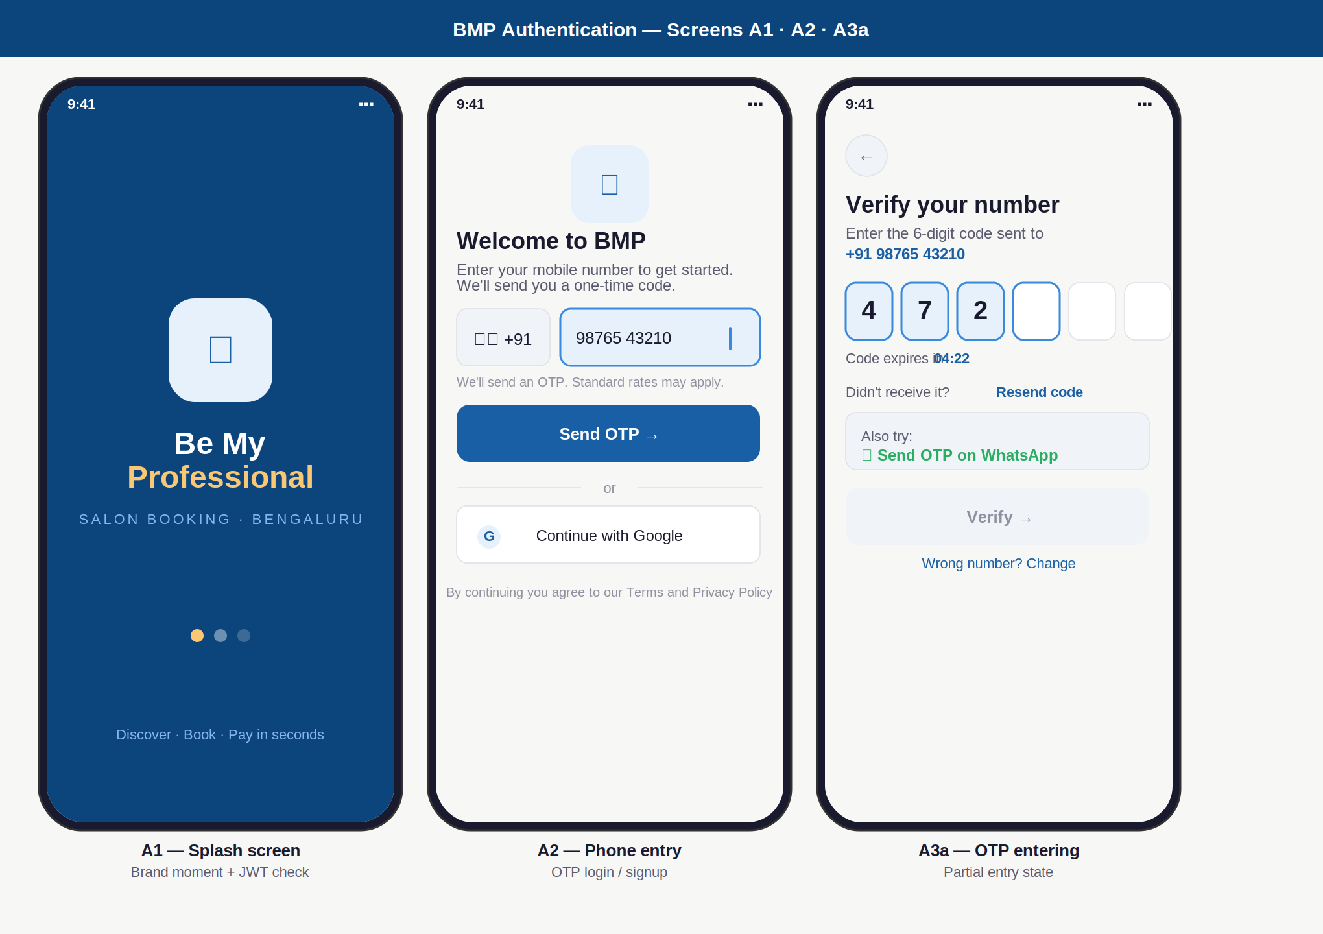

Element annotations — A1 · A2 · A3a
ID | Screen | UI elements | UX reasoning | Dev / build note
A1 | Splash | Full navy background (#0C447C). Scissors icon in light blue card. "Be My Professional" with amber "Professional". Tagline. 3 loading dots (first amber = active). | Navy background creates a distinct brand moment — the only dark screen in the app, making it memorable. Amber accent signals premium. Dots signal async work without a spinner. | JWT check fires during the 1.5s splash. Valid token → auto-navigate to home. Invalid → navigate to A2. Never show splash > 2 seconds. No back navigation on this screen.
A2 | Phone entry | Logo top-centre. +91 flag selector (fixed, left). Phone number input (right, blue border when active). "Send OTP" primary CTA. Divider. Google sign-in secondary. Terms micro-text. | Country code left-pinned — Indian users expect +91 always visible. Active state (blue border + light blue bg) makes the focused field immediately clear. Google is secondary because phone OTP has higher trust in India for financial apps. | Validate exactly 10 digits before enabling Send OTP. Auto-space as user types (98765 43210). Google OAuth flow links to same BMP backend — same JWT issued. Terms link opens in-app browser.
A3a | OTP entering | 6 individual OTP boxes. First 3 filled (blue bg + blue border). 4th active (blue border only). Last 2 empty (grey). "04:22" countdown timer. WhatsApp fallback card. Verify button disabled (grey). | Individual boxes force one digit per box and show progress visually. Verify button stays disabled until all 6 filled — eliminates premature submit errors. WhatsApp card is visible immediately (not hidden) because many Indian users receive WhatsApp faster than SMS. | Auto-submit triggers API call 300ms after 6th digit is entered. No tap needed. OTP valid 5 minutes. Max 3 resends. Lock account 10 minutes after 3 consecutive wrong attempts.

Screens A3b · A3c · A4
OTP wrong code · OTP verified · Role fork screen

BMP Auth Flow — Screens A3b, A3c and A4 — error state, success state, and role selection
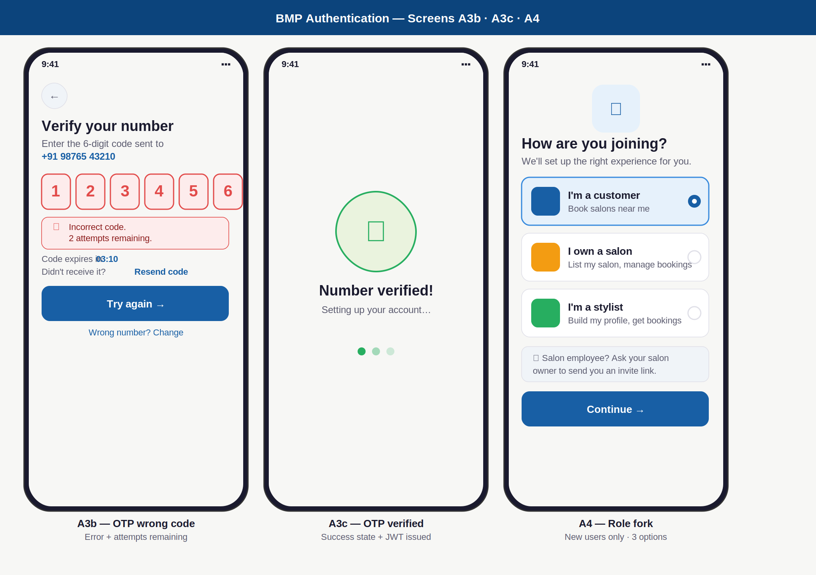

Element annotations — A3b · A3c · A4
ID | Screen | UI elements | UX reasoning | Dev / build note
A3b | OTP error | All 6 OTP boxes turn red simultaneously (red bg, red border, red text). Red error banner below boxes: icon + "Incorrect code. 2 attempts remaining." Timer continues. Try again button enabled. | All boxes turn red at once — the full code was wrong, not one digit. "2 attempts remaining" is specific and honest — generic "invalid OTP" causes users to re-read repeatedly. Boxes clear automatically for re-entry without the user having to tap delete 6 times. | "remaining" count = otp_requests.attempts column. On 3rd failure: navigate to lockout screen (10-minute countdown), not this screen. Do not pre-fill wrong digits. Clear all 6 on error.
A3c | OTP verified | Full-screen centred layout. Large green circle (60px, 2px green border) with white checkmark. "Number verified!" heading. "Setting up your account…" subtext. 3 green loading dots. | A confirmation screen before the app does backend work (JWT generation, role check). Prevents the user seeing a frozen/loading screen. Green = success without needing to read text. 1-second display before auto-navigation. | Issue JWT here. Store refresh_token with device_fingerprint. During the 1-second display: query user_roles table. Navigate to: fork (new user, no roles) or role routing (returning). No back button on this screen.
A4 | Role fork | Small logo top-centre. "How are you joining?" heading. 3 role cards: Customer (selected, blue border + radio filled), Salon owner (amber icon), Stylist (green scissors icon). Grey info box: employee note. Continue button. | 3 options only — no Manager option because a manager without a salon is meaningless. Employee note explains why without overwhelming the user. Selected state uses border + fill — colour-independent for accessibility. Continue disabled until a role is selected. | Show only for first-time users (no user_roles record). After selection: create user_roles record. Cache role choice. This screen must NOT appear on subsequent logins — check user_roles before routing.

Screens A5a · A5b
Customer profile setup · Hair preferences

BMP Customer Onboarding — Screens A5a and A5b — personal info and hair preferences
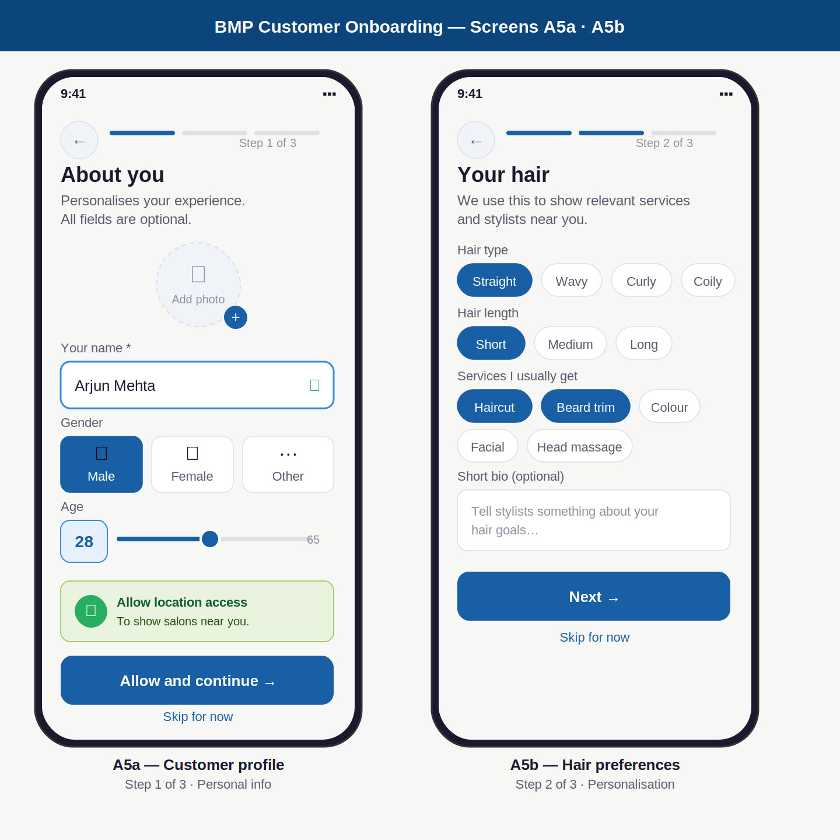

Element annotations — A5a · A5b
ID | Screen | UI elements | UX reasoning | Dev / build note
A5a | Personal info | Progress bar (3 dots, 1 filled = step 1). Photo upload circle (dashed border, camera icon, + badge). Name input (filled, green tick). Gender: 3 equal pills (Male/Female/Other). Age: value box + horizontal slider (18–65). GPS card (green tint). Allow and Skip buttons. | Progress bar shows total effort upfront — reduces abandonment. Gender pills are equal-size (not male/female default with "other" as afterthought). Slider for age removes keyboard usage entirely. GPS card framed as a benefit ("to show salons near you") not a permission demand — this framing significantly improves accept rate. | Name = only required field. Gender stored as enum: male/female/other. Age stored as int 18-65. GPS uses expo-location API. If denied: manual area entry shown on home screen instead. "Skip" creates a blank profile and goes to A5b. All fields editable later in Settings.
A5b | Hair prefs | Progress bar step 2. Hair type chips: Straight (selected), Wavy, Curly, Coily. Hair length: Short (selected), Medium, Long. Services multi-select: Haircut + Beard trim selected, others unselected. Bio text area (placeholder text). Next and Skip buttons. | Multi-select chips faster than dropdowns on mobile. Blue fill on selected chip is clear without relying on borders alone. All fields optional — this data personalises the home feed and stylist recommendations; it does not gatekeep app access. Short bio lets stylists prepare before the appointment. | Store hair_type, hair_length as enums. Services as string array. Used by recommendation engine to: sort nearby salons, highlight relevant services, suggest stylists with matching specialisations. Bio max 200 chars. Editable any time in Profile > Edit preferences.

Screens A6 · A7
Salon onboarding step 1 · Pending verification

BMP Salon Owner Onboarding — Screens A6 and A7 — basic info and verification wait state
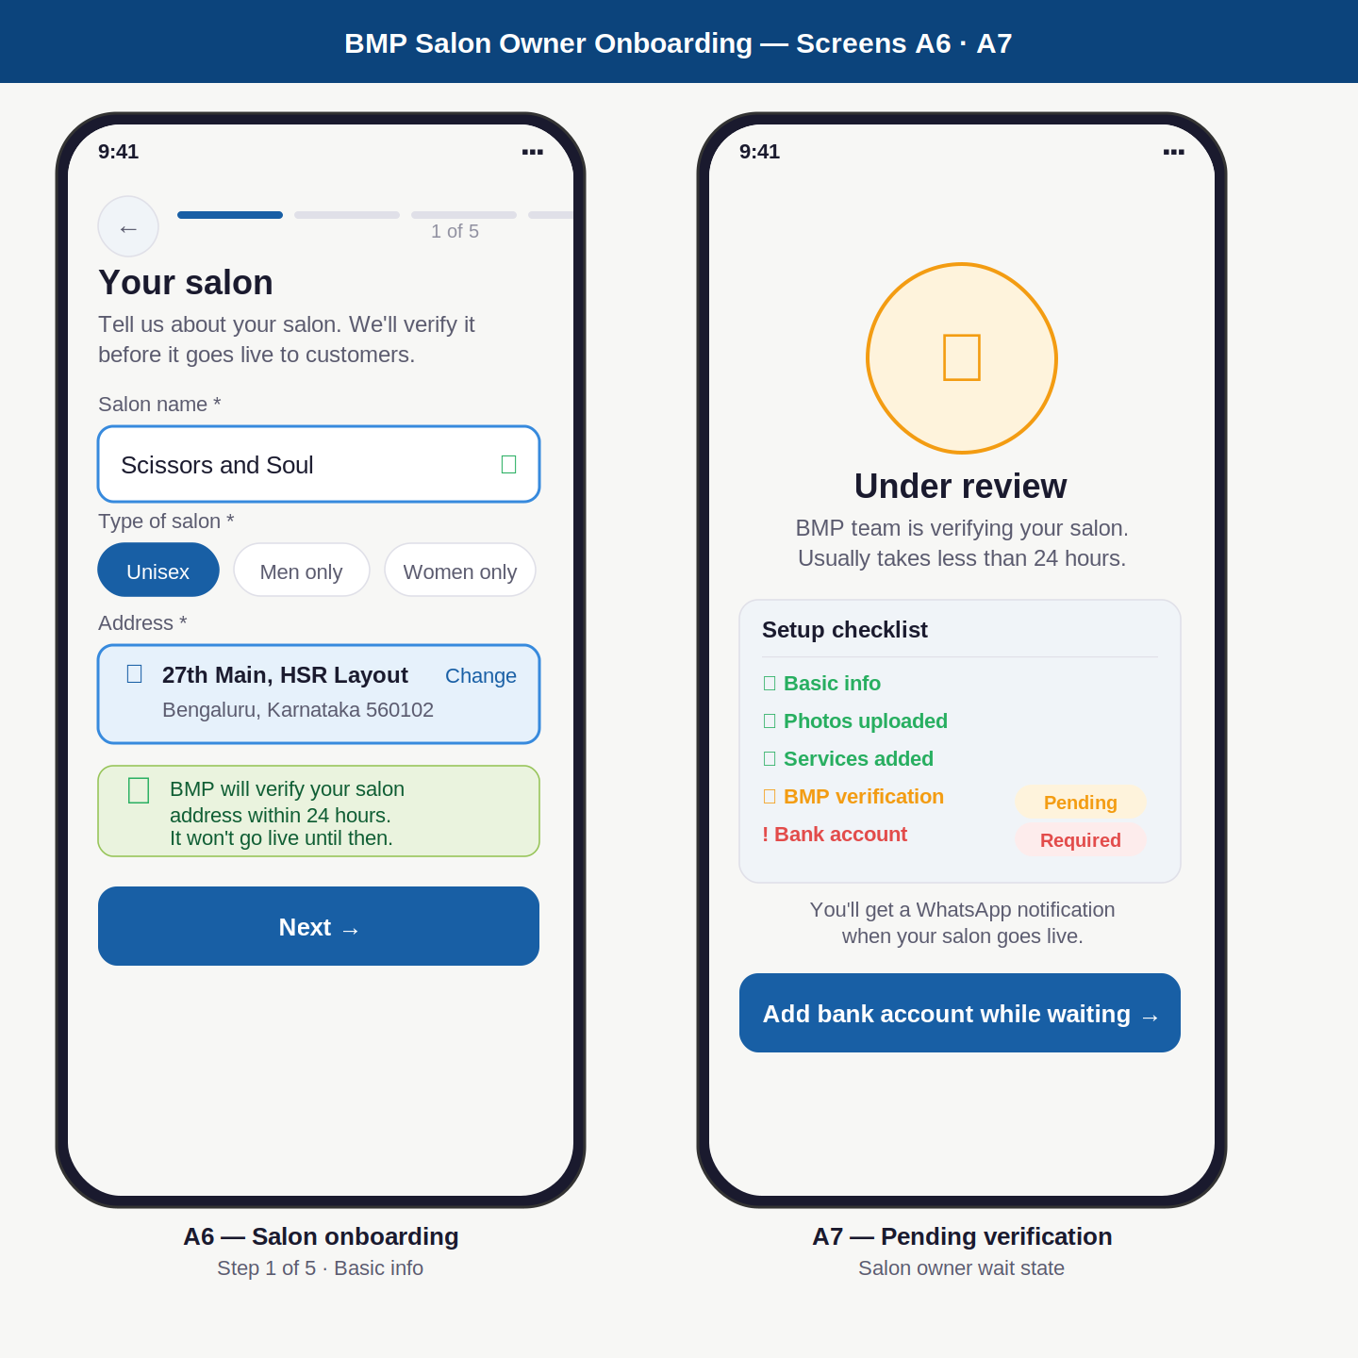

Element annotations — A6 · A7
ID | Screen | UI elements | UX reasoning | Dev / build note
A6 | Salon info step 1 | 5-dot progress bar (step 1 active, blue). Salon name input (filled, green tick). Type selector chips: Unisex selected. Address card (blue bg, pin icon, full address + "Change" link). Green info banner: "BMP verifies within 24 hours." Next button. | 5-step bar sets expectations for the full onboarding effort — reduces mid-flow abandonment. Address shown as a resolved card (not raw input) because owners feel more confident seeing their address correctly geocoded on a map before proceeding. Green banner sets the verification expectation before they invest time in steps 2–5. | Address captured via Google Places Autocomplete. Store full text + lat/lng (PostGIS GEOGRAPHY point). Salon type = enum: unisex/men/women/kids. Progress state saved server-side — if owner closes app mid-onboarding, they resume from last completed step automatically.
A7 | Pending review | Clock icon in amber circle (60px). "Under review" heading. Checklist card: Basic info ✓ (green), Photos ✓ (green), Services ✓ (green), BMP verification (amber "Pending" badge), Bank account (red "Required" badge). WhatsApp note. "Add bank account" CTA button. | Checklist keeps the owner engaged and informed during the wait — they know exactly where things stand. Bank account CTA is shown here deliberately: it is the one productive action they can take while waiting. Red "Required" badge on bank account creates appropriate urgency. WhatsApp reassures them they won't miss the approval notification. | salon.status field: pending / approved / rejected. Owner sees this screen on every login until status = approved. On approval: BMP admin triggers push + WhatsApp notification. Payouts remain held until bank_account record added even after approval. Rejection shows specific feedback.

Screens A8 · A9 · A10
Stylist onboarding · Manager invite · Role picker

BMP Role Onboarding — Screens A8, A9 and A10 — stylist profile, manager invite, multi-role picker
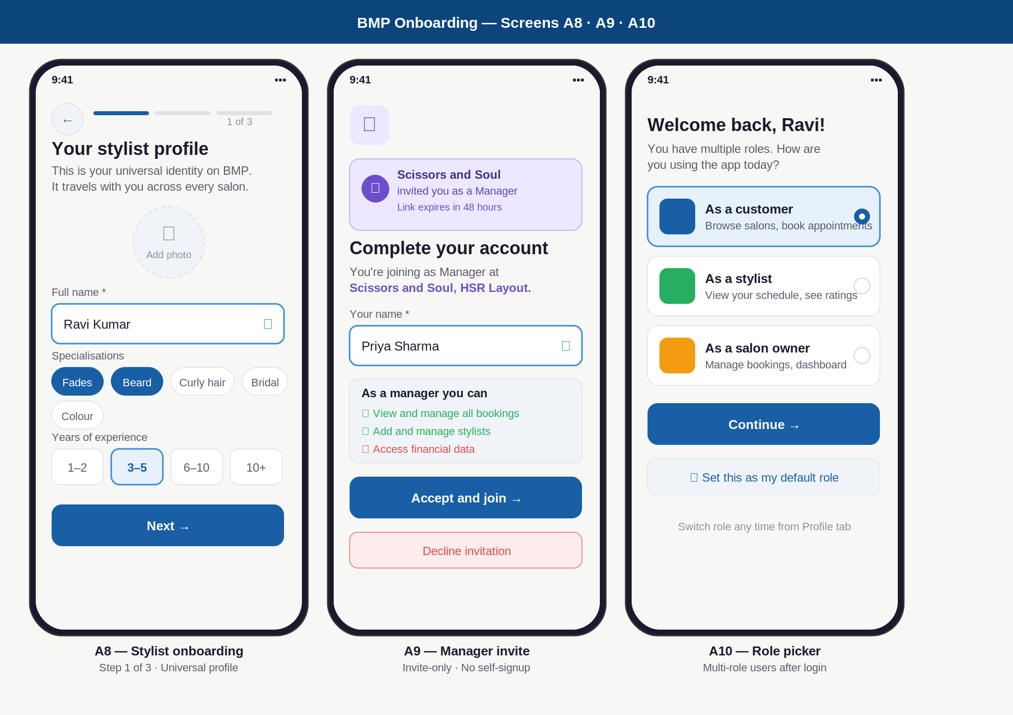

Element annotations — A8 · A9 · A10
ID | Screen | UI elements | UX reasoning | Dev / build note
A8 | Stylist profile | 3-step progress bar (step 1 active). Photo upload circle (dashed border). Name input (filled, tick). Specialisation chips: Fades + Beard selected (blue). Experience picker: 4 segments (1–2 / 3–5 / 6–10 / 10+ years), 3–5 selected. Next button. | Specialisation chips prevent misspellings and enable search filtering — a typed field would produce "fade", "Fade", "fades", "hair fades" for the same thing. Segmented experience picker removes the need for keyboard. Profile emphasised as "universal" in subtitle — sets the expectation it travels across every salon. | Creates global stylist record (not salon-specific). Profile visible immediately to salon owners. Booking capability requires stylist_salon record. Specialisations stored as string array. Experience stored as enum. Profile editable any time from My Profile screen.
A9 | Manager invite | Purple invite banner: salon name + role. "Complete your account" heading. Purple role text: "Manager at Scissors and Soul." Name input (filled). Permissions summary card: green ticks for allowed actions, red X for financial access. Accept button (primary blue). Decline (red outline). | Invite banner is the first visible element — immediately contextualises why the user is here. Permissions summary before accepting sets clear expectations: "you cannot see financial data" said upfront prevents future frustration and support tickets. Decline is clearly visible — no dark pattern forcing acceptance. | Validate invite_token against staff_invites table on screen load. Token is one-time use, expires 48h. On accept: create salon_staff record (role=manager). If user already has BMP account: link to existing user_id. If new: create user first, then link. On decline: mark invite status = declined.
A10 | Role picker | Personalised "Welcome back, Ravi!" heading. 3 large role cards: Customer (selected, blue border + filled radio), Stylist (unselected), Salon owner (unselected). "Continue" primary button. "Set as default role" checkbox card (grey bg). | Role picker only appears for multi-role users — the majority of users never see it. Large tappable cards are easy to distinguish at a glance on mobile. Setting a default role skips this screen on all future logins. The switcher is per-session — switching roles mid-session is possible from Profile tab without re-authenticating. | After role selection: JWT active_role field set to chosen role. API gateway validates active_role on every protected route. Role switch = new JWT issued instantly without re-OTP. Store preferred_role in users table. Picker not shown if preferred_role is set.

Design System — Authentication Screens

Colour palette
Token name | Hex | Where used | Example screen
Primary navy | #0C447C | Splash background, page headers, banner backgrounds | A1 full background, section banners in this document
Accent blue | #185FA5 | CTA buttons, active states, progress fill, selected chips, links | Send OTP button, active OTP box border, role card selected border
Light blue | #E6F1FB | Active field background, selected chip fill, info card bg | Active OTP box fill, selected chip background, GPS card alt
Amber accent | #FAC775 | Splash brand text, warning states | "Professional" text on A1, pending badge background
Success green | #27AE60 | Verified states, GPS card, completed checklist, form ticks | OTP verified screen, checklist done items, input validation tick
Error red | #E24B4A | Wrong OTP state, error messages, required field badges | A3b all boxes, error banner, bank account "Required" badge
Text primary | #1A1A2E | All screen headings, filled input text, role card titles | "Verify your number", name input value, "I own a salon"
Text secondary | #5A5A6E | Subtitles, field labels, hint text, body copy | "Enter the 6-digit code…", "Your name", "Also try:"
Page background | #F7F7F5 | App background behind all white screens | The off-white surface all screen cards sit on

Typography scale
Style name | Size / Weight | Used for + example
Screen heading | 18px / 700 | Main screen title: "Verify your number", "How are you joining?", "Your salon"
Section heading | 14px / 700 | Card section labels: "Setup checklist", "As a manager you can"
Body text | 12px / 400 | Descriptions and hints: "We'll send you a one-time code", "BMP verifies within 24 hours"
Input text | 13px / 400 | Text entered in fields: phone number, salon name, user name, bio
Field label | 11px / 400 | Labels above input fields: "Your name", "Type of salon", "Hair type"
Button text | 13px / 600 | Primary and secondary CTAs: "Send OTP →", "Continue →", "Accept and join →"
OTP digit | 20px / 700 | Numbers inside OTP boxes — large for easy reading and tap feedback
Micro text | 10px / 400 | Step counters, terms, hints: "Step 1 of 3", "By continuing you agree to our Terms…"

Component state reference
Component | State | Visual treatment
Input field | Default | White background · #E0E0E8 border · 0.8px stroke · 8px border-radius
Input field | Focused / active | #E6F1FB background · #378ADD border · 1.5px stroke · Blue tint clearly signals active input without needing a label
Input field | Valid / filled | #378ADD border · Green tick (✓) icon aligned to right edge · Confirmation without interrupting the user's flow
OTP box | Empty | White background · Grey border (#E0E0E8) · Placeholder underscore — waiting for input
OTP box | Filled | #E6F1FB background · #378ADD border · Black digit — shows digit entered and code not yet submitted
OTP box | Error | #FDECEC background · #E24B4A border · Red digit — entire row turns red simultaneously (full code wrong)
Primary button | Active | #185FA5 background · White bold text · 10px radius · Full width · Primary action on every screen
Primary button | Disabled | #F0F4F8 background · #9090A0 text · Cannot be tapped · Example: Verify button before all 6 OTP digits entered
Role card | Unselected | White background · #E0E0E8 border 0.8px · Unfilled radio circle · Tappable full card
Role card | Selected | #E6F1FB background · #378ADD border 1.5px · Filled blue radio circle · Colour-independent: border + fill together (accessible)
Chip | Unselected | White background · #E0E0E8 border · #5A5A6E text · 14px border-radius (pill shape)
Chip | Selected | #185FA5 background · White text · No border needed (fill is sufficient) · Multi-select chips stack into a wrapping flex row
Progress bar step | Completed | #185FA5 fill · 4px height · 2px radius · 56px wide per step (with 6px gaps)
Progress bar step | Upcoming | #E0E0E8 fill · Same dimensions · Greyed out — shows the road ahead without emphasising it

BMP — UX / UI Screen Designs | Authentication & Onboarding | June 2026 | Confidential

