DevOps With AWS Mini Project
Project Title: Containerizing and Deploying the Weather App Using Docker and AWS (ECR, ECS, Fargate)
Student Name : Devendra Ghanekar
Batch Code : Jun2026-A529
Institute : IT Vedant
Course : DevOps With AWS
Submission Date :
Project Overview

This project was completed as part of the ITVedant DevOps Fundamentals course (Docker module). The goal was to get hands-on practice with Docker containerization: installing Docker, writing Dockerfiles, building images, running containers, deploying a multi-container application with Docker Compose, and finally deploying the application on AWS using Amazon ECR, ECS and Fargate.
The project was done with my own Weather App (a frontend and a backend service) instead of the sample OpsMate service. The same steps and tasks of the project brief were followed for this application.
The project covers Docker installation and daemon management, Dockerfile creation, image build and container management, Docker networking and volumes, Docker Compose, AWS container deployment, troubleshooting and professional technical documentation. The work simulates the daily tasks of a Junior DevOps Engineer who containerizes and ships an application.
Project Objectives
- Understand Docker, containers and the difference between virtual machines and containers.
- Install and configure Docker Engine on an Ubuntu Linux server (EC2).
- Manage the Docker daemon and Docker service.
- Create Dockerfiles and build custom Docker images for the Weather App.
- Run, stop, restart, inspect and remove Docker containers.
- Configure Docker networking, port mapping and persistent volumes.
- Deploy a multi-container application using Docker Compose.
- Push Docker images to Amazon Elastic Container Registry (ECR).
- Create an ECS cluster, task definition and service using AWS Fargate.
- Verify the application from a browser and update it with a new image version.
- Monitor, troubleshoot and document the Docker implementation professionally.
Task 1: Understanding Containerization
Virtualization vs Containerization
Virtualization runs many full operating systems on one machine using a hypervisor. Containerization runs many isolated applications on one operating system kernel. Containers are lighter, start in seconds and use fewer resources.
Feature | Virtual Machine | Docker Container
Operating system | Full guest OS in every VM | Shares the host OS kernel
Size | Several GB | Few MB to few hundred MB
Startup time | Minutes | Seconds
Resource usage | High | Low
Isolation | Strong (hardware level) | Process level
Portability | Limited | Runs the same everywhere

Advantages of Containers
- Same environment in development, testing and production.
- Fast start and stop; easy to scale.
- Efficient use of CPU and memory.
- Easy to version, share and roll back using images.
- Works well with CI/CD pipelines.
Docker Architecture
Component | Description
Docker Client | The docker command line tool that sends commands to the daemon.
Docker Host / Daemon (dockerd) | The background service that builds images and runs containers.
Docker Engine | Docker client + daemon + REST API working together.
Docker Image | Read-only template that contains the app, runtime and dependencies.
Docker Container | Running instance of an image.
Docker Registry | Storage for images: Docker Hub (public) or Amazon ECR (private).

Components Needed to Containerize the Weather App
- Frontend service: React/Vite application served using Nginx.
- Backend service: Node.js API that fetches weather data.
- Database service: for stored data (used in Docker Compose).
- Dockerfile for each service, plus compose.yaml to run them together.
- Amazon ECR to store images and ECS Fargate to run them.
Containerization Workflow
Developer → Dockerfile → Docker Image → Docker Container → Application
[ Insert Screenshot: Docker-Architecture.png (architecture diagram) ]
Task 2: Installing Docker and Managing Docker Daemon
Launch and Connect to Ubuntu EC2
An Ubuntu EC2 instance was launched in the AWS console with ports 22 (SSH) and the application ports allowed in the security group. The instance was accessed using SSH.
ssh -i "C:\Users\Deva\OneDrive\Pictures\Downloads\deva.pem" ubuntu@
Install Docker
sudo apt update -y
sudo apt upgrade -y
sudo apt install docker.io -y
Manage the Docker Service
sudo systemctl status docker
sudo systemctl start docker
sudo systemctl stop docker
sudo systemctl restart docker
sudo systemctl enable docker
Run Docker Without sudo
sudo usermod -aG docker $USER
newgrp docker
Verify Installation
docker --version
docker info
docker ps
docker images
systemctl status docker
docker run hello-world
Task 3: Creating Dockerfile for the Weather App
The application runtime (Node.js) and its dependencies (listed in package.json) were identified. A project directory was created and a Dockerfile was written for each service.
mkdir Weather-Docker-Project && cd Weather-Docker-Project
Backend Dockerfile (Node.js)
FROM node:20-alpine
WORKDIR /app
COPY package*.json ./
RUN npm install
COPY . .
EXPOSE 5000
CMD ["npm", "start"]
Frontend Dockerfile (Multi-stage: Vite build + Nginx)
# Build stage
FROM node:20-alpine AS build
WORKDIR /app
COPY package*.json ./
RUN npm install
COPY . .
RUN chmod +x node_modules/.bin/*
RUN npm run build
# Production stage
FROM nginx:alpine
COPY nginx.conf /etc/nginx/conf.d/default.conf
COPY --from=build /app/dist /usr/share/nginx/html
EXPOSE 80
CMD ["nginx", "-g", "daemon off;"]
Dockerfile Instructions Explained
Instruction | Purpose
FROM | Selects the base image (small alpine images keep the size low).
WORKDIR | Sets the working folder inside the container.
COPY | Copies application files into the image.
RUN | Runs commands during build, e.g. npm install.
EXPOSE | Documents the port used by the application.
CMD | Default command to start the application.

Note: The ports and file names above are the ones used in my application; they can differ in your code. Update them as per your project.
Task 4: Building Docker Images and Running Containers
Build and Verify Images
docker build -t weather-back:v1 ./backend
docker build -t weather-front:v1 ./frontend
docker images
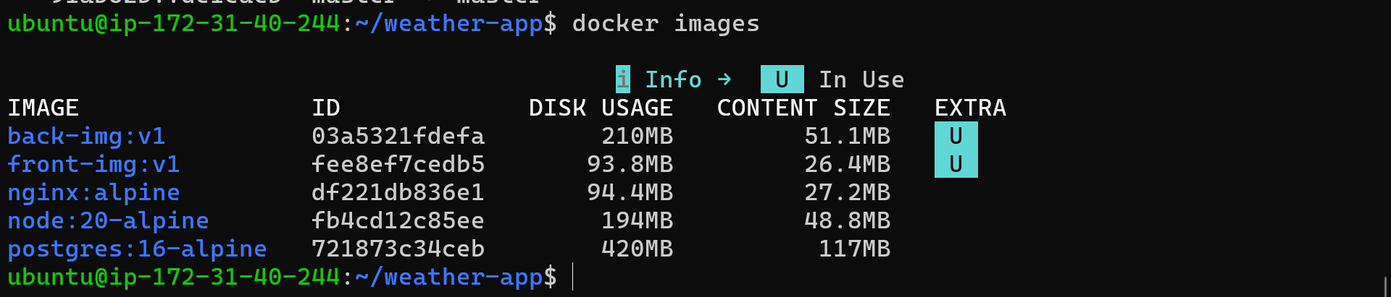
docker inspect weather-back:v1
Run Containers with Port Mapping
docker run -d --name weather-back -p 5000:5000 back-img:v1
docker run -d --name weather-front -p 80:80 front-img:v1
docker ps
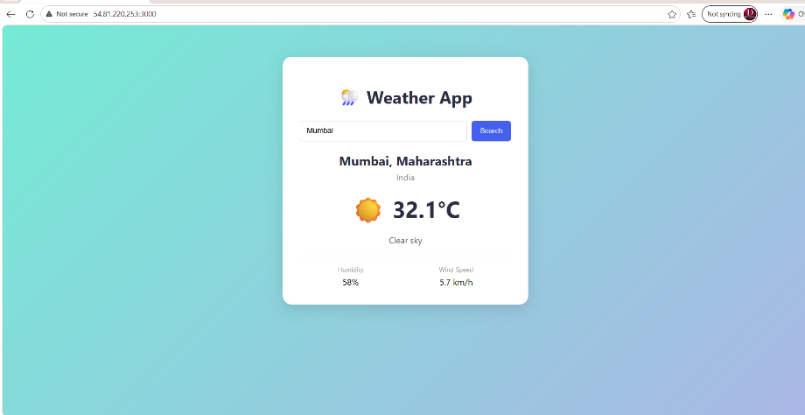
The Weather App was opened in the browser using http://<EC2-PUBLIC-IP> and worked successfully.

Manage Containers
docker logs weather-back
docker inspect weather-back
docker stop weather-back
docker start weather-back
docker restart weather-back
docker rm -f weather-back weather-front
docker rmi weather-back:v1
docker system prune -f
Command | Use
docker build | Creates an image from a Dockerfile
docker images | Lists local images
docker run | Starts a container from an image
docker ps | Lists running containers
docker logs | Shows container logs
docker inspect | Shows detailed configuration
docker stop / start / restart | Controls the container state
docker rm / rmi | Removes containers / images

Task 5: Multi-Container Deployment Using Docker Compose
A multi-container version of the Weather App was created with three services: frontend, backend and database. The services talk to each other through a custom Docker network and the database data is stored in a named volume.
compose.yaml
services:

backend:
image: back-img:v1
container_name: weather-backend
ports:
- "5000:5000"
restart: unless-stopped

frontend:
image: front-img:v1
container_name: weather-frontend
ports:
- "3000:80"
depends_on:
- backend
restart: unless-stopped

Run and Manage the Stack
docker compose up -d --build
docker compose ps
docker compose logs
docker compose logs backend
docker compose stop
docker compose start
docker compose down
Task 6: Deploying on AWS Using ECR, ECS and Fargate
Amazon ECR
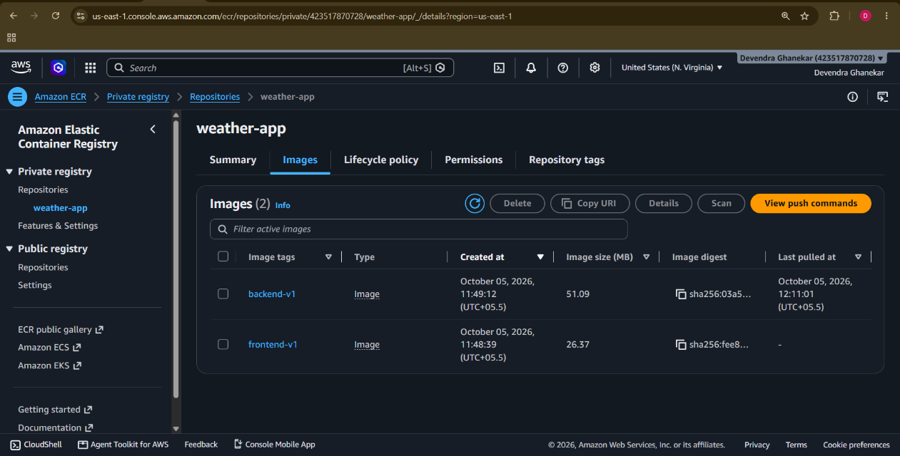

Amazon ECS with Fargate
- Created an ECS cluster (weather-cluster) with AWS Fargate as the compute option.
- Created a Task Definition (Fargate, 0.5 vCPU, 1 GB memory) and added the container using the ECR image URI.
- Set the container port, environment variables and CloudWatch logging (awslogs driver).
- Created an ECS Service with desired task count = 1.
- Selected VPC, public subnets and a security group allowing the application port (inbound).
- Enabled public IP and deployed the service on Fargate.
Application Verification
- ECS task status was RUNNING and the service status was ACTIVE.
- Container logs were checked in CloudWatch Logs.
- The public IP of the task was opened in the browser and the Weather App worked.
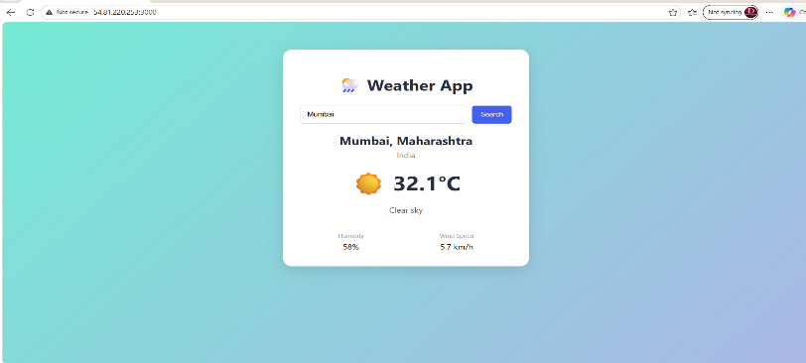

Update the Application
A small change was made in the application, a new image (v2) was built, pushed to ECR and deployed to ECS by creating a new task definition revision and updating the service (force new deployment).
docker build -t weather-front:v2 ./frontend
docker tag weather-front:v2 <ACCOUNT-ID>.dkr.ecr.us-east-1.amazonaws.com/weather-front:v2
docker push <ACCOUNT-ID>.dkr.ecr.us-east-1.amazonaws.com/weather-front:v2
aws ecs update-service --cluster weather-cluster --service weather-service --force-new-deployment
Final architecture: Developer → Dockerfile → Docker Image → Amazon ECR → ECS Task Definition → ECS Service → AWS Fargate → Weather App
Task 7: Monitoring, Troubleshooting & Documentation
The Docker implementation was analyzed. The details were also saved in docker-deployment-report.txt.
Area | Details / Command
Docker installation | docker --version, hello-world ran successfully
Docker daemon status | systemctl status docker: active (running)
Image information | docker images, docker inspect
Container information | docker ps, docker inspect
Resource usage | docker stats --no-stream
Application logs | docker logs / docker compose logs
Compose service status | docker compose ps
ECR image information | Repository weather-front / weather-back, tag v1 and v2
ECS service status | Service ACTIVE, desired count 1 = running count 1
Fargate task status | Task RUNNING, public IP reachable

Security Considerations
- Do not store passwords in the Dockerfile; use environment variables or AWS Secrets Manager.
- Add .env to .dockerignore and .gitignore.
- Use small, trusted base images (alpine) and scan images (ECR scan on push).
- Run containers as a non-root user where possible.
- Open only the required ports in security groups; keep SSH limited to my IP.
- Use IAM roles with least privilege.
Resource Optimization Suggestions
- Use multi-stage builds and alpine images to reduce image size.
- Choose the smallest Fargate CPU/memory that works.
- Use ECR lifecycle policies to delete old images.
- Set a log retention period in CloudWatch.
- Stop or delete AWS resources after evaluation to avoid charges.
Improvements Suggested
- Add an Application Load Balancer in front of ECS tasks and use HTTPS.
- Automate build and push using a CI/CD pipeline (Jenkins from my previous project).
- Use Amazon RDS instead of a database container in production.
- Add health checks and auto scaling for the ECS service.
Repository Folder Structure
Weather-Docker-Project/
|-- README.md
|-- docker-compose.yml
|
|--weather-app/
| |-- frontend/
| |-- backend/
|
|-- scripts/
| |-- install-docker.sh
| |-- build-image.sh
| |-- run-container.sh
| |-- cleanup.sh
|
|-- screenshots/
| |-- docker-installation.png
| |-- docker-daemon.png
| |-- docker-image.png
| |-- docker-container.png
| |-- application-running.png
| |-- docker-compose.png
| |-- ecr-repository.png
| |-- ecr-image.png
| |-- ecs-cluster.png
| |-- ecs-task.png
| |-- fargate-application.png
|
|-- documentation/
|-- Docker-Architecture.png
|-- Project_Report.pdf

A README.md file was prepared covering: Project Overview, Docker Architecture, Installation Steps, Dockerfile Explanation, Compose Setup, AWS Deployment Steps, Commands Used, Folder Structure, Challenges Faced and Learning Outcomes.
Challenges Faced
- ECS task stopped immediately: fixed by checking CloudWatch logs and correcting the container port and environment variables.
- Application not opening from the browser on Fargate: fixed by allowing the port in the security group and enabling public IP.
- ECR push failed with authorization error: fixed by logging in again using aws ecr get-login-password.
Conclusion
This project gave me practical experience in Docker containerization and AWS container deployment. I installed and managed Docker on Ubuntu, wrote Dockerfiles, built images, ran and managed containers, deployed a multi-container stack with Docker Compose, and deployed the Weather App on AWS using ECR, ECS and Fargate. I also updated the application with a new image version.
The project helped me understand how containers fit into a real-world DevOps workflow and strengthened my skills for a Junior DevOps Engineer role.

