Title

author

date

# 1 Feature Extraction

Lda

Figure: LDA for tongue protruding down

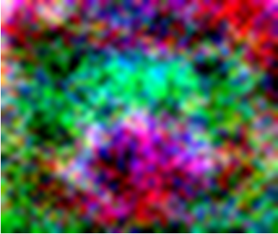

Figure: 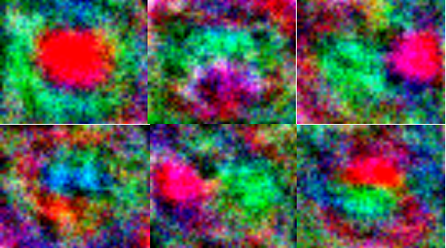LDA for 6 classes(First row: close, down, left; Second row: open, right,up)

# 2 Pre-training

## 2.1 Image Pre-processing

Resize & shuffle, normalization

## 2.1 Image Enhancement

Random brightness/saturation/contrast, Random lighting

Figure: 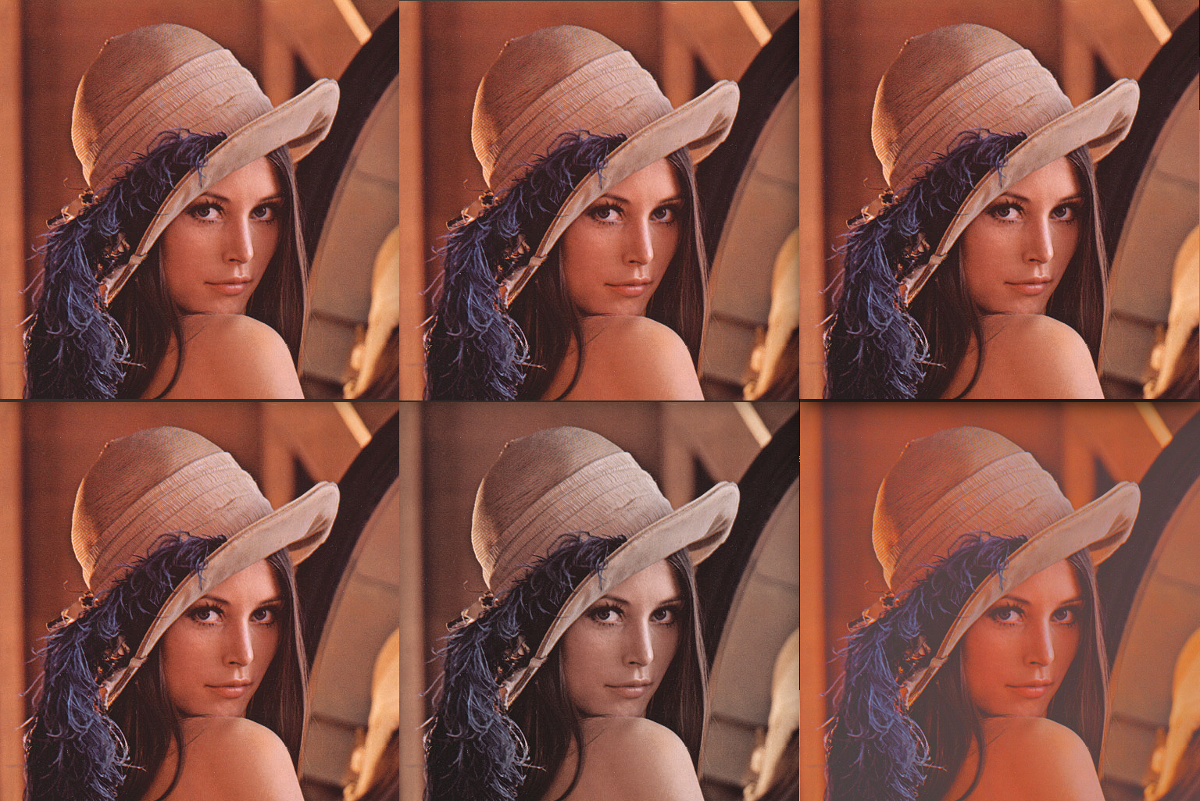6 Randomly enhanced images

Figure: 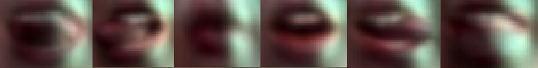Principle Component Extraction for 6 classes

# 3 Model

cnn introduction, model structure

## **3.1 Layers in CNN**

Input layer [45x37x3] will hold the raw pixel values of the image, in this case an image of width 45, height 37, and with three color channels R,G,B;

Convolutional layer will compute the output of neurons that are connected to local regions in the input, each computing a dot product between their weights and the region they are connected to in the input volume.

Figure: 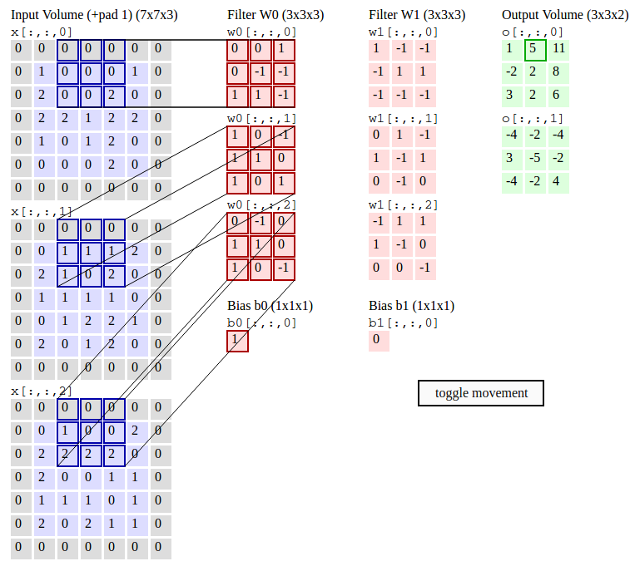Convolutional layer(image from http://cs231n.github.io/)

ReLU layer will apply an elementwise activation function with the threshold of zero;

Maxpooling layer will perform a downsampling operation along the spatial dimensions (width, height);

Figure: 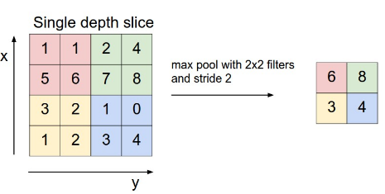Maxpooling layer(image from http://cs231n.github.io/)

Fully connected layer will compute the class scores, resulting in volume of size [1x1x6], where each of the 6 numbers correspond to a class score, such as among the 6 categories of dataset. Each neuron in this layer will be connected to all the numbers in the previous volume;

## 3.2 Model Structure

Input(45 x 37 x 3)

Convolution(3 -> 64, 12 x 4)

Maxpool(3 x 3, 2, 2, 1, 1)

ReLU

Convolution(64 -> 64, 3 x 3, 1, 1, 1, 1)

ReLU

Convolution(64 -> 64, 3 x 3, 1, 1, 1, 1)

Maxpool

ReLU

Convolution(64 -> 256, 9 x 9)

Dropout(0.5)

ReLU

Reshape(256)

Linear(256 -> 6)

Softmax

# 4 Details of Learning

Learning rate=1e-3

momentum= .1

weight decay=1e-5

learning rate decay=1e-7

hardware, sgd, batch size, epoch, time

predicted accurary

# 5 Results

with/without metalearning

Table: Confusion matrix over the blind test dataset

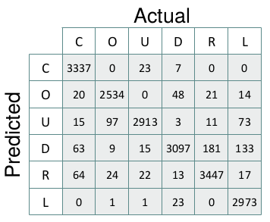

Figure: 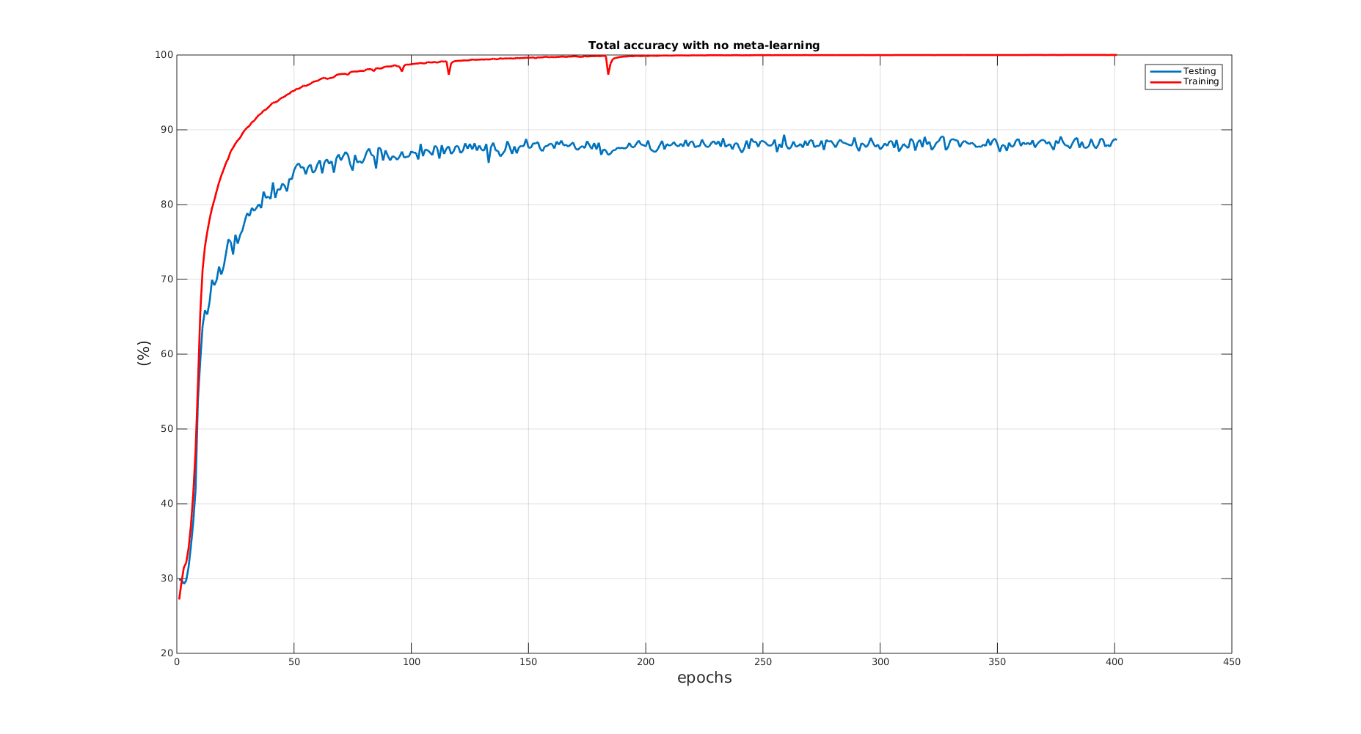total accuracy without meta learning

Figure: 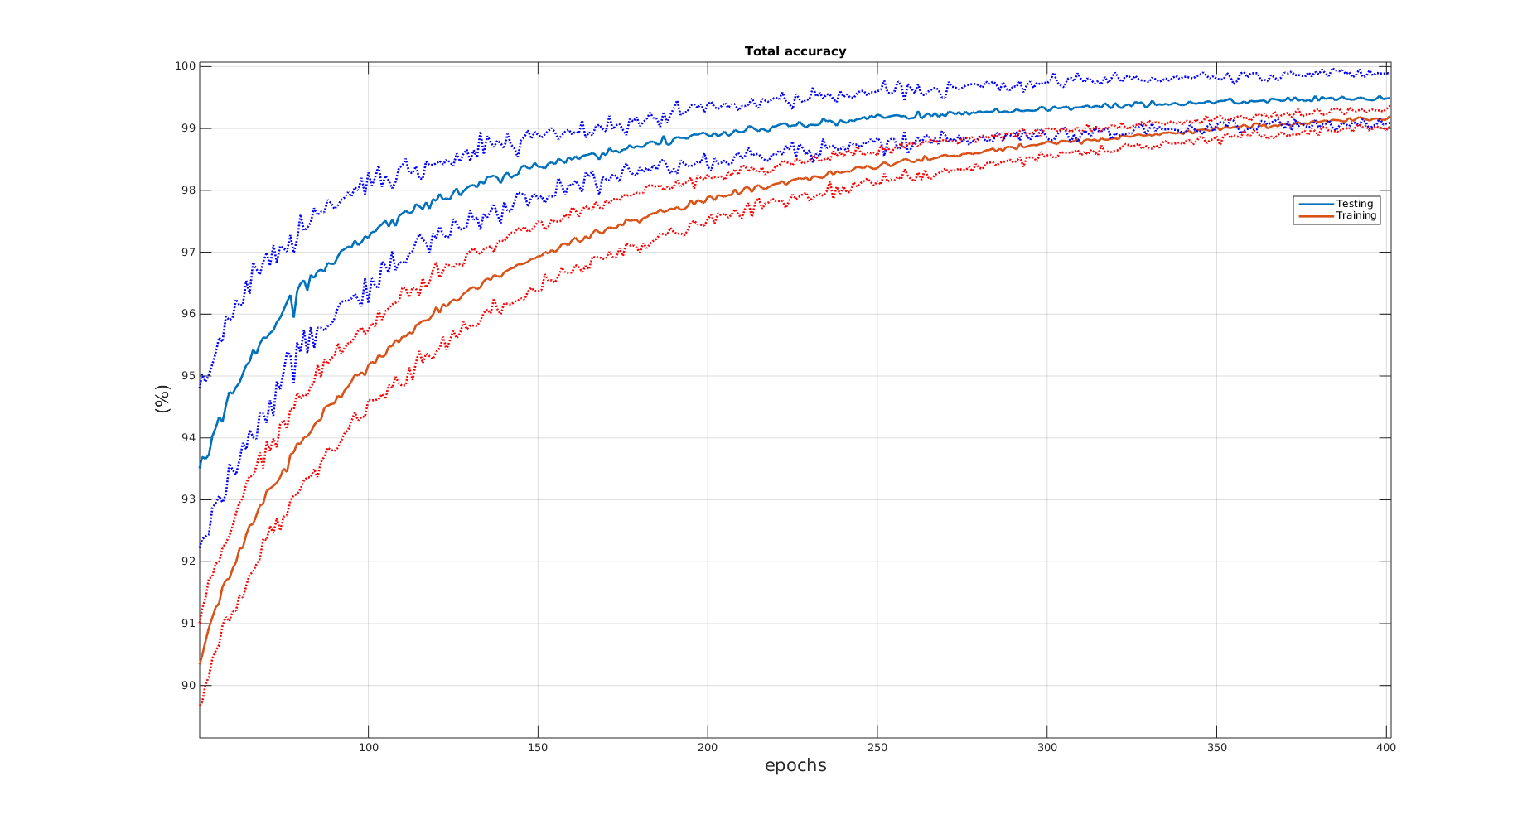total accuracy with meta learning

Figure: total accuracy with meta learning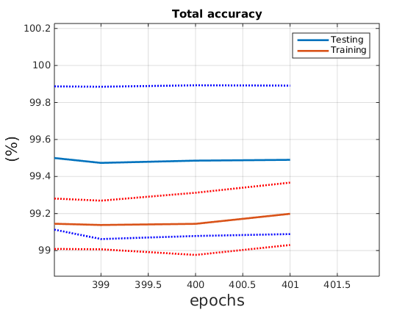

# 6 Deconvolutional Neural Nerwork

pass

# 7 Discussion

“Discuss how you would change your approach now that you have seen the other approaches and now that you know how well you did.”