Three-node vs. Five-node Replay Analysis (2025-10-13)
This document summarizes the latest replay outputs generated on 2025-10-13. Metrics were taken from the following folders:
• scenarios/paper_3node/reports/replay/three_node_run_2025-10-13_004215
• scenarios/realistic_5node/reports/replay/five_node_run_2025-10-13_022635
Aggregated statistics were recomputed into reports/replay/summary_three_vs_five_nodes_latest.csv, and supporting Excel exports reside in reports/replay/.

Headline Results
Three-node factorial workloads: automated weights averaged 0.130s (95th percentile 0.152s) versus 0.892s for the manual baseline.
Three-node matrix workloads: the spread baseline led with 2.057s, ahead of automated weights (2.913s) and manual control (3.159s).
Five-node factorial workloads: automated weights climbed to 0.466s (95th percentile 0.519s) yet remained faster than manual scheduling at 1.199s.
Five-node matrix workloads: the spread baseline ballooned to 22.91s on average, while manual orchestration contained latency to 6.03s, highlighting network overhead in the larger cluster.

Summary Table
Scenario | Strategy | Service | Samples | Mean | Median | P95
Five-node cluster | Automated weights | Factorial workloads | 21 | 0.466 | 0.475 | 0.519
Five-node cluster | Manual baseline | Factorial workloads | 21 | 1.199 | 0.957 | 2.545
Five-node cluster | Manual baseline | Matrix workloads | 21 | 6.034 | 4.813 | 15.898
Five-node cluster | Spread baseline | Factorial workloads | 105 | 1.909 | 0.939 | 5.641
Five-node cluster | Spread baseline | Matrix workloads | 95 | 22.914 | 9.663 | 79.071
Three-node cluster | Automated weights | Factorial workloads | 21 | 0.130 | 0.127 | 0.152
Three-node cluster | Automated weights | Matrix workloads | 20 | 2.913 | 2.580 | 4.298
Three-node cluster | Manual baseline | Factorial workloads | 21 | 0.892 | 0.884 | 1.000
Three-node cluster | Manual baseline | Matrix workloads | 21 | 3.159 | 3.015 | 4.016
Three-node cluster | Spread baseline | Factorial workloads | 63 | 1.039 | 0.875 | 2.151
Three-node cluster | Spread baseline | Matrix workloads | 41 | 2.057 | 1.706 | 3.099
See reports/replay/summary_three_vs_five_nodes_latest.csv for the full dataset including standard deviation values.

Key Observations
- Automated weighting continues to excel on factorial workloads even when the cluster scales out.
- Spread-based placement thrives for matrix jobs only when nodes reside in close proximity; the five-node topology amplifies migration costs.
- Tail behavior (95th percentile) spikes in the larger cluster, so SLO-driven safeguards should account for higher variance.
- Matrix data is unavailable for the five-node automated run; repeat the capture once Prometheus is confirmed healthy to complete the comparison.

Figures
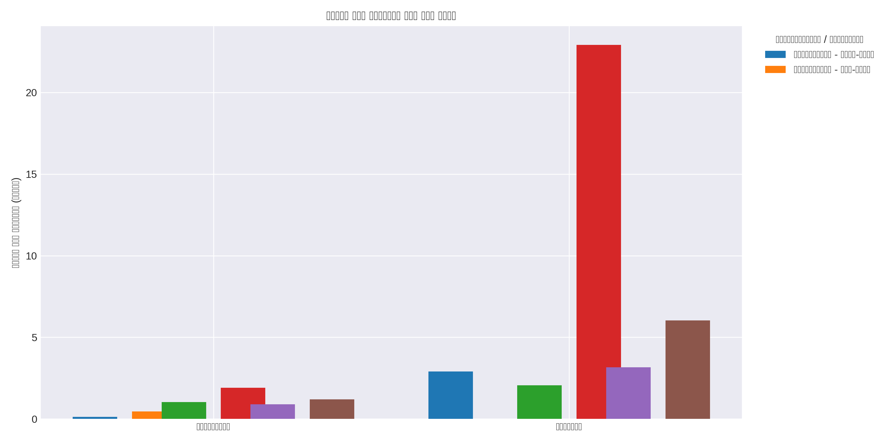
Figure: Average duration by strategy and workload (reports/replay/strategies/three_vs_five_nodes/mean_duration_by_strategy.png)
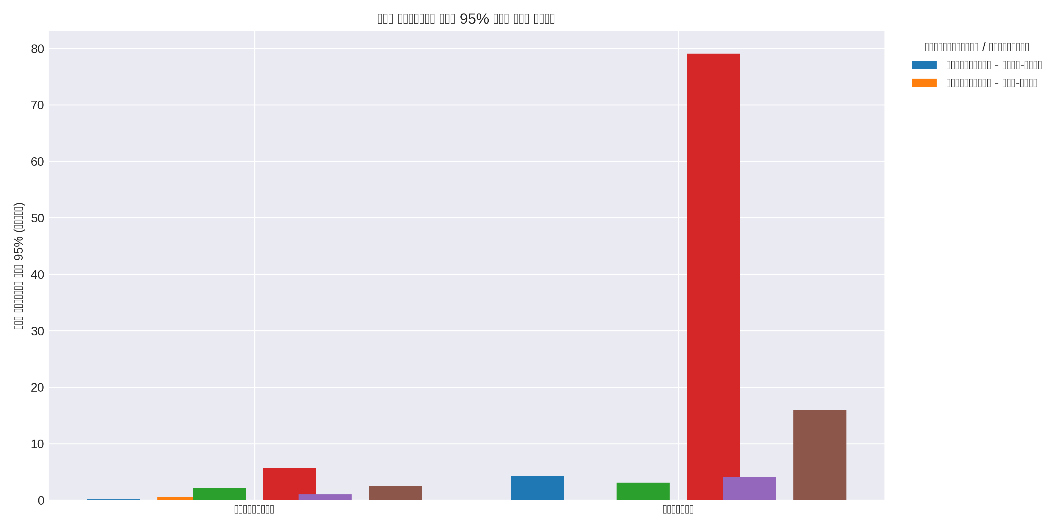
Figure: 95th percentile duration by strategy and workload (reports/replay/strategies/three_vs_five_nodes/p95_duration_by_strategy.png)
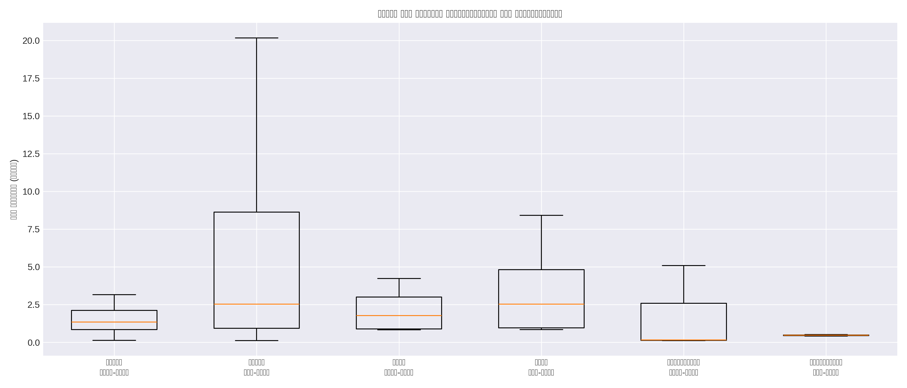
Figure: Duration distribution across strategies and scenarios (reports/replay/strategies/three_vs_five_nodes/duration_distribution_boxplot.png)
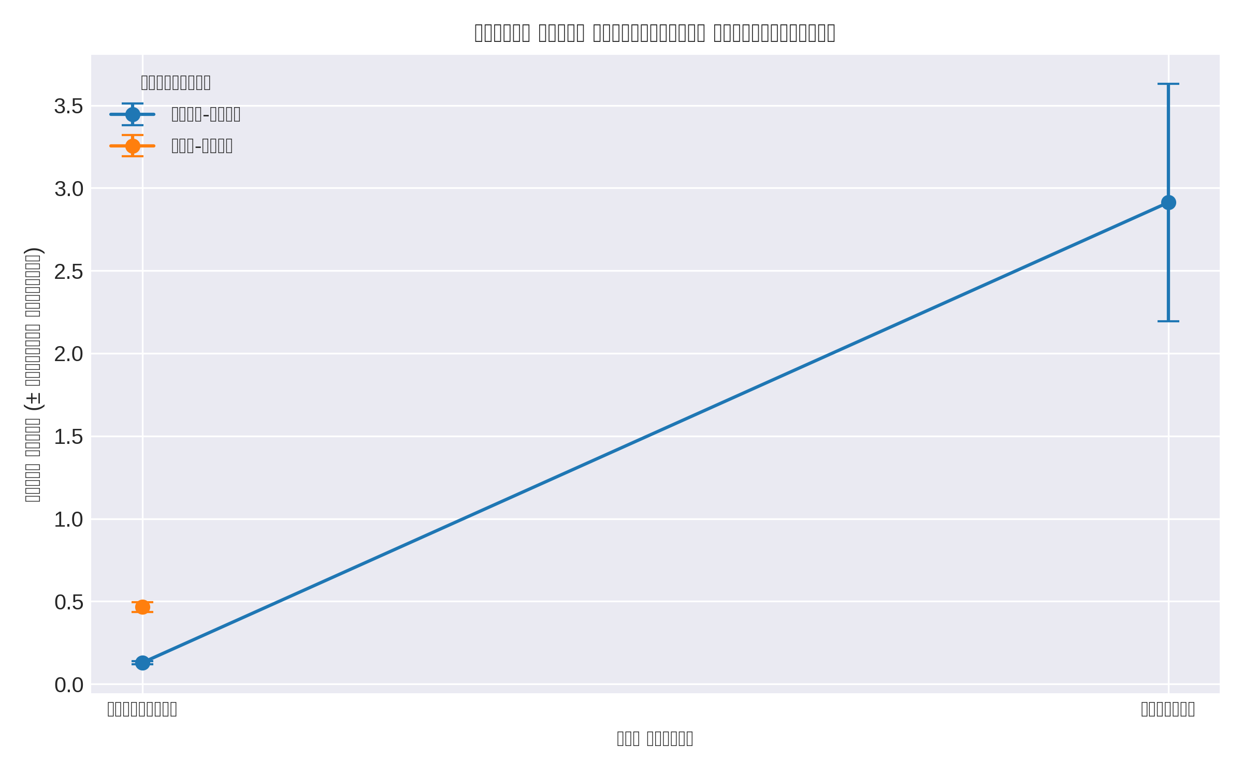
Figure: Automated weight comparison between scenarios (reports/replay/strategies/three_vs_five_nodes/auto_weights_comparison.png)

Conclusion & Next Actions
Dynamic weights are a dependable default for CPU-heavy factorial services, but matrix pipelines on distributed clusters need bandwidth-aware placement or pinning. Next actions: restore automated matrix telemetry, evaluate anti-affinity rules, and retune the weight scheduler for heterogeneous topologies.

