Performance Comparison: Three-node vs. Five-node Clusters
This report summarizes the replay results captured under two scenarios:
1. scenarios/paper_3node/reports/replay/three_node_run_2025-10-13_004215
2. scenarios/realistic_5node/reports/replay/five_node_run_2025-10-13_022635
Supporting plots are available under reports/replay/strategies/three_vs_five_nodes/. Axis labels in those charts remain in Arabic because they were generated directly from the source data.

Key Performance Highlights
In the three-node cluster, the automated weighting strategy drove factorial workloads down to an average completion time of 0.130 seconds with a 95th percentile of 0.152 seconds, compared with 0.892 seconds for the manual baseline.
Matrix workloads in the same cluster favored the spread baseline at 2.057 seconds on average, versus 2.913 for automated weights and 3.159 for manual control.
Scaling to five nodes increased the automated factorial latency to 0.466 seconds (95th percentile 0.519), yet it still remained faster than the manual baseline at 1.199 seconds.
Matrix workloads under the spread baseline ballooned to 22.91 seconds in the larger cluster, while manual orchestration held them to 6.03 seconds, underscoring the sensitivity of cross-node migrations.

Aggregated Statistics
Scenario | Strategy | Service type | Samples | Mean (s) | Median (s) | 95th pct (s)
Three-node cluster | Automated weights | Factorial workloads | 21 | 0.130 | 0.127 | 0.152
Three-node cluster | Automated weights | Matrix workloads | 20 | 2.913 | 2.580 | 4.298
Three-node cluster | Spread baseline | Factorial workloads | 63 | 1.039 | 0.875 | 2.151
Three-node cluster | Spread baseline | Matrix workloads | 41 | 2.057 | 1.706 | 3.099
Three-node cluster | Manual baseline | Factorial workloads | 21 | 0.892 | 0.884 | 1.000
Three-node cluster | Manual baseline | Matrix workloads | 21 | 3.159 | 3.015 | 4.016
Five-node cluster | Automated weights | Factorial workloads | 21 | 0.466 | 0.475 | 0.519
Five-node cluster | Spread baseline | Factorial workloads | 105 | 1.909 | 0.939 | 5.641
Five-node cluster | Spread baseline | Matrix workloads | 95 | 22.914 | 9.663 | 79.071
Five-node cluster | Manual baseline | Factorial workloads | 21 | 1.199 | 0.957 | 2.545
Five-node cluster | Manual baseline | Matrix workloads | 21 | 6.034 | 4.813 | 15.898
Full statistics are archived in reports/replay/strategies/summary_three_vs_five_nodes.csv.

Analytical Observations
- Automated weighting consistently trims factorial latency even as the cluster grows, confirming the value of telemetry-driven scheduling.
- Spread-based placement excels for matrix jobs only when nodes are co-located; wider clusters introduce network penalties that dominate runtime.
- Variance and tail latency rise sharply in the five-node case, signalling greater sensitivity to resource contention and link jitter.
- Matrix samples were not recorded for the automated strategy in the five-node replay, so the dataset should be refreshed after Prometheus is made fully available.

Supporting Figures
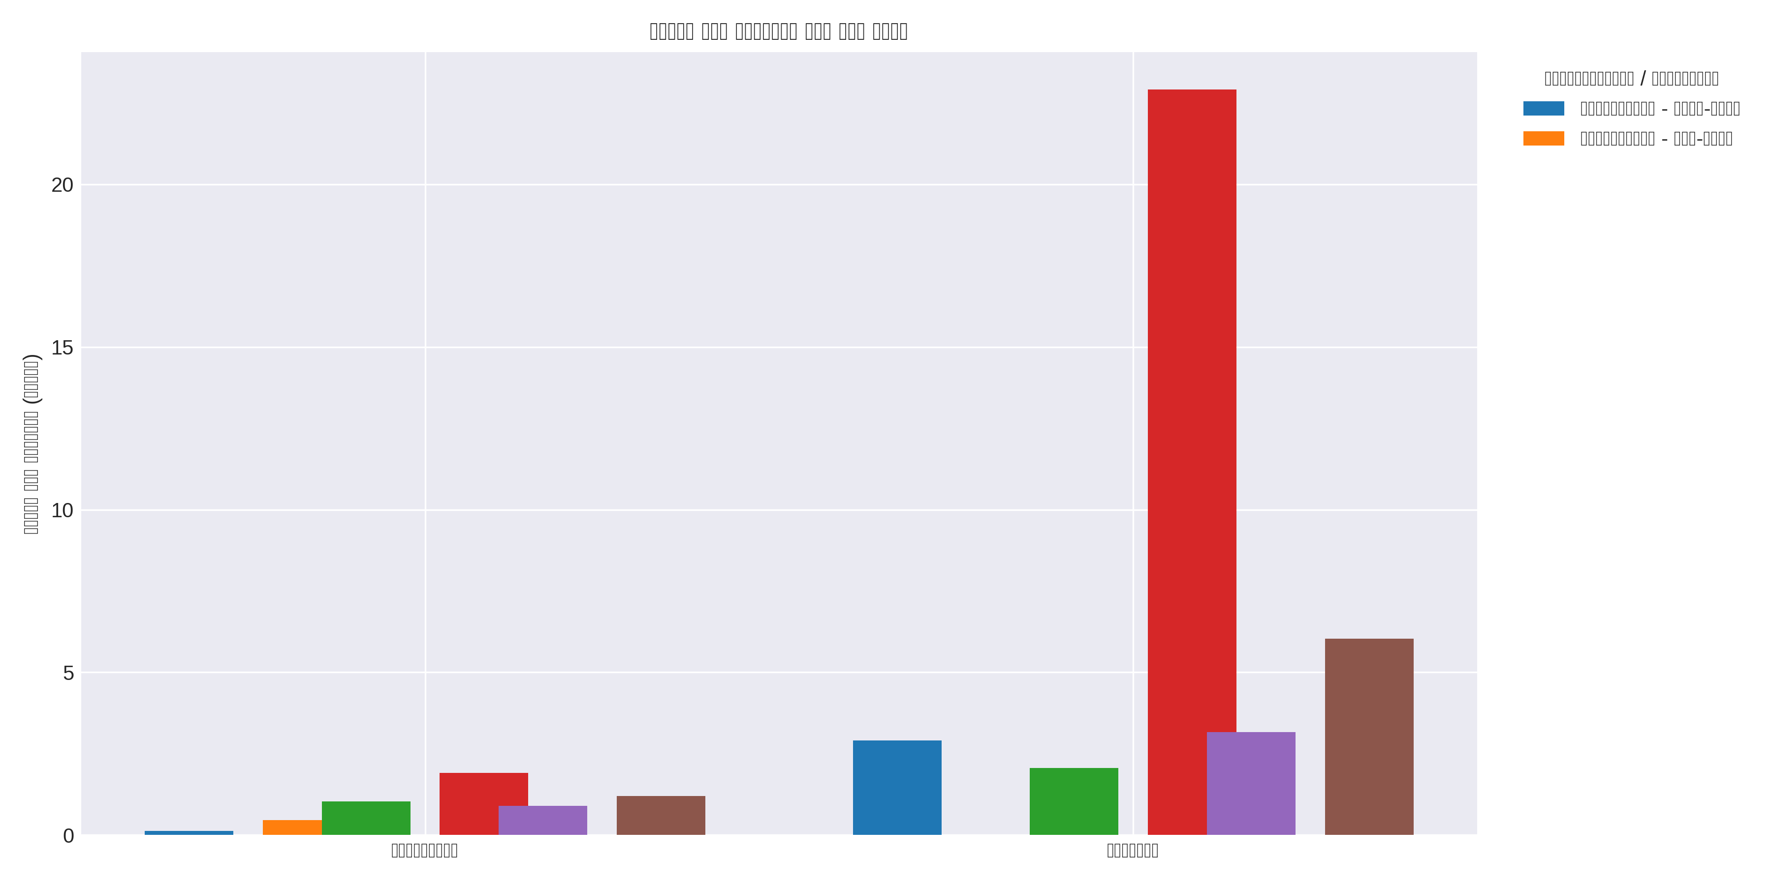
Figure: Average duration by strategy and workload (reports/replay/strategies/three_vs_five_nodes/mean_duration_by_strategy.png)
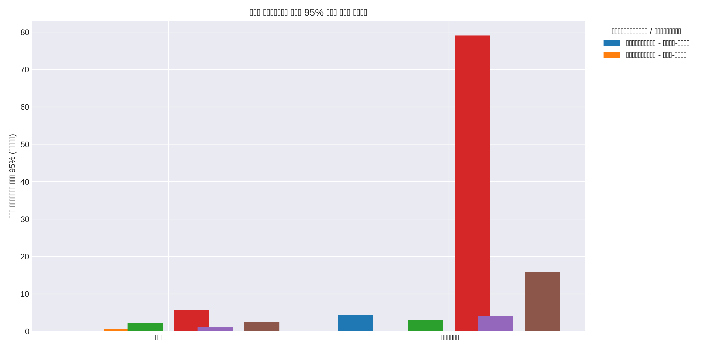
Figure: 95th percentile duration by strategy and workload (reports/replay/strategies/three_vs_five_nodes/p95_duration_by_strategy.png)
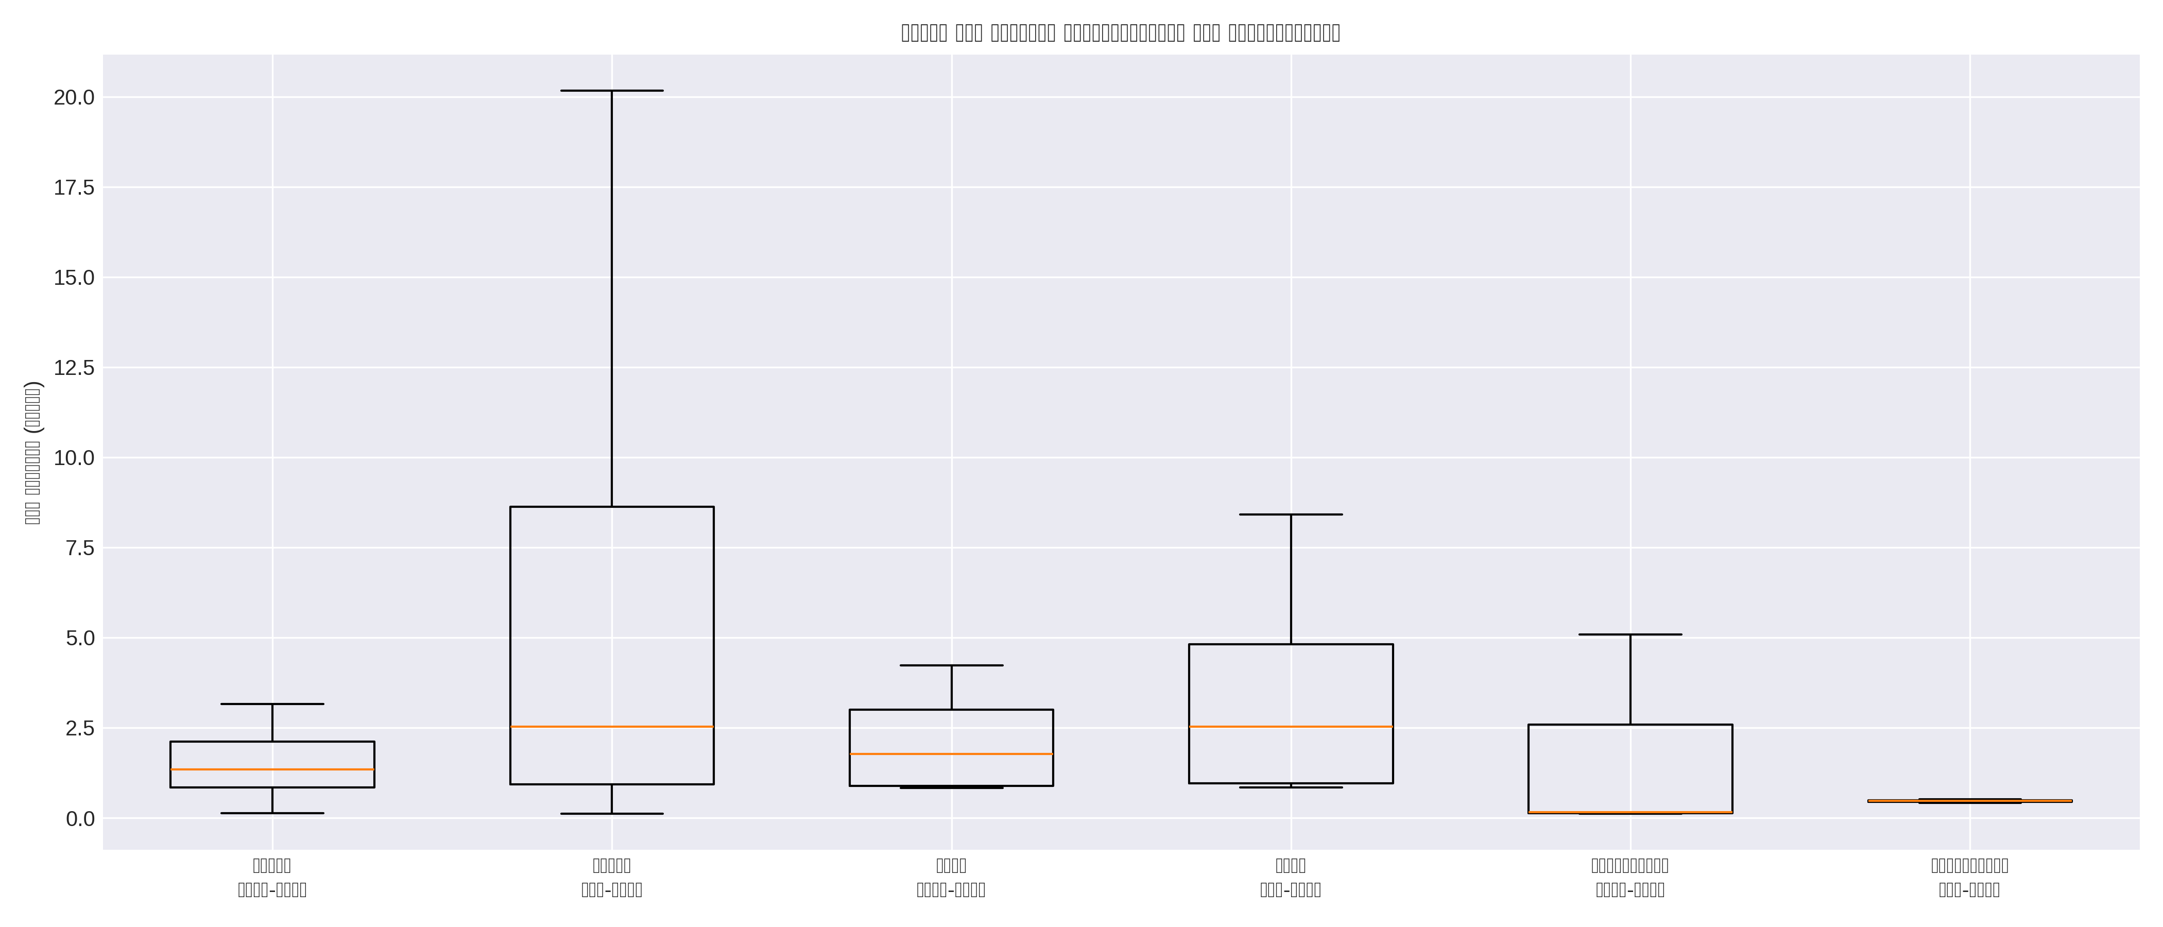
Figure: Duration distribution across strategies and scenarios (reports/replay/strategies/three_vs_five_nodes/duration_distribution_boxplot.png)
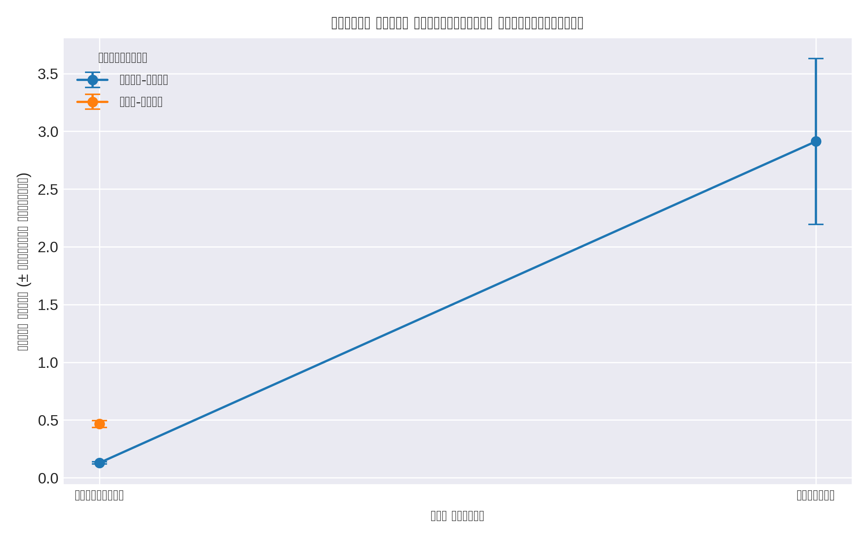
Figure: Automated weight comparison between scenarios (reports/replay/strategies/three_vs_five_nodes/auto_weights_comparison.png)

Conclusion and Next Steps
Dynamic weighting remains a strong default for factorial workloads, but matrix-heavy pipelines require additional guardrails when the cluster spans multiple nodes. Plan to rerun the automated scenario once monitoring gaps are resolved, and investigate anti-affinity or bandwidth-aware policies to stabilize matrix runtimes in larger deployments.

