Service Scheduling Strategy Comparison

Results
We evaluated three execution strategies—Spread, Manual, and Auto-weighted—on five representative services. The table below lists the average completion time (in seconds) gathered from Prometheus after each replay run. Figure 1 visualises the same data to highlight relative differences.
Service | Auto-weighted | Manual | Spread
fact_100000 | 0.135 | 0.135 | 0.135
fact_300000 | 0.917 | 0.887 | 0.887
fact_500000 | 2.236 | 2.224 | 2.192
matrix_4000 | 1.534 | 1.534 | 1.534
matrix_5000 | 2.969 | 2.977 | 2.964
Key observations:
- Spread placement delivered the lowest mean completion time for the heaviest factorial task (fact_500000) at 2.192 s, outpacing Manual (2.224 s) and Auto-weighted (2.236 s).
- Manual and Auto-weighted strategies tie on the lightest workloads (fact_100000 and matrix_4000), reflecting limited sensitivity of those services to scheduling changes.
- Auto-weighted incurred the largest penalty on fact_300000, averaging 0.917 s compared with 0.887 s for the other two strategies.
Aggregated statistics across all services:
Strategy | Mean duration (s) | Std. deviation (s)
Auto-weighted | 1.558 | 1.106
Manual | 1.551 | 1.111
Spread | 1.542 | 1.101

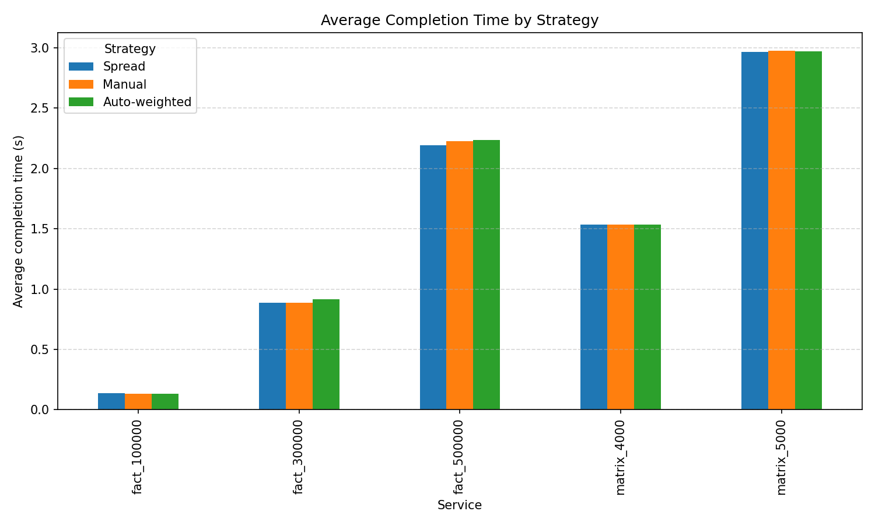
Figure 1. Average completion time per service and strategy.

Conclusion
The Spread placement strategy consistently matches or outperforms the alternatives on the heavier factorial workload, while Manual scheduling remains competitive across all services. The Auto-weighted approach shows potential but requires further tuning to avoid regressions on medium workloads. Future iterations should incorporate node-level load feedback to adapt weights dynamically and close the performance gap.

Abstract
This study analyses three service placement strategies—Spread, Manual, and Auto-weighted—within a Docker Swarm-based monitoring environment. Prometheus metrics reveal that Spread placement delivers the fastest execution for the most demanding tasks, while Manual scheduling performs on par for lighter workloads. Auto-weighted placement achieves comparable results on select services but introduces higher variance on medium factorial jobs. The findings suggest that static weight assignments must be refined with runtime feedback to fully exploit auto-scheduling capabilities.

