Three-node Cluster Replay Analysis
This report covers the latest replay outputs for the three-node cluster (run timestamp 2025-10-13_00:42:15).
Source metrics: scenarios/paper_3node/reports/replay/three_node_run_2025-10-13_004215/combined_strategy_results.csv
Aggregated statistics: scenarios/paper_3node/reports/replay/three_node_run_2025-10-13_004215/summary_three_node_en.csv
Generated figures: scenarios/paper_3node/reports/replay/three_node_run_2025-10-13_004215/plots_en/

Performance Highlights
Factorial workloads averaged 0.130s under automated weights (p95 0.152s), outperforming manual (0.892s) and spread (1.039s) baselines.
Matrix workloads favored the spread baseline with 2.057s mean (p95 3.099s), while automated and manual strategies trailed at 2.913s and 3.159s respectively.
Tail latency remains tight for factorial jobs in all strategies (sub-2s p95), whereas matrix jobs exhibit broader spread—particularly under automated control (p95 4.298s).

Summary Statistics
Strategy | Service | Samples | Mean | Median | P95
Automated | Factorial | 21 | 0.130 | 0.127 | 0.152
Automated | Matrix | 20 | 2.913 | 2.580 | 4.298
Manual | Factorial | 21 | 0.892 | 0.884 | 1.000
Manual | Matrix | 21 | 3.159 | 3.015 | 4.016
Spread | Factorial | 63 | 1.039 | 0.875 | 2.151
Spread | Matrix | 41 | 2.057 | 1.706 | 3.099
Refer to summary_three_node_en.csv for additional metrics such as standard deviation.

Key Observations
- Automated weighting keeps factorial workloads consistently low in both mean and tail latency, validating the resource-driven scheduler configuration.
- Matrix jobs benefit from explicit spread placement across the three nodes; automated placement introduces more variability, suggesting the need for matrix-specific weighting or pinning.
- No data gaps were detected in this replay, indicating that Prometheus collection was continuous throughout the sampling window.

Supporting Figures
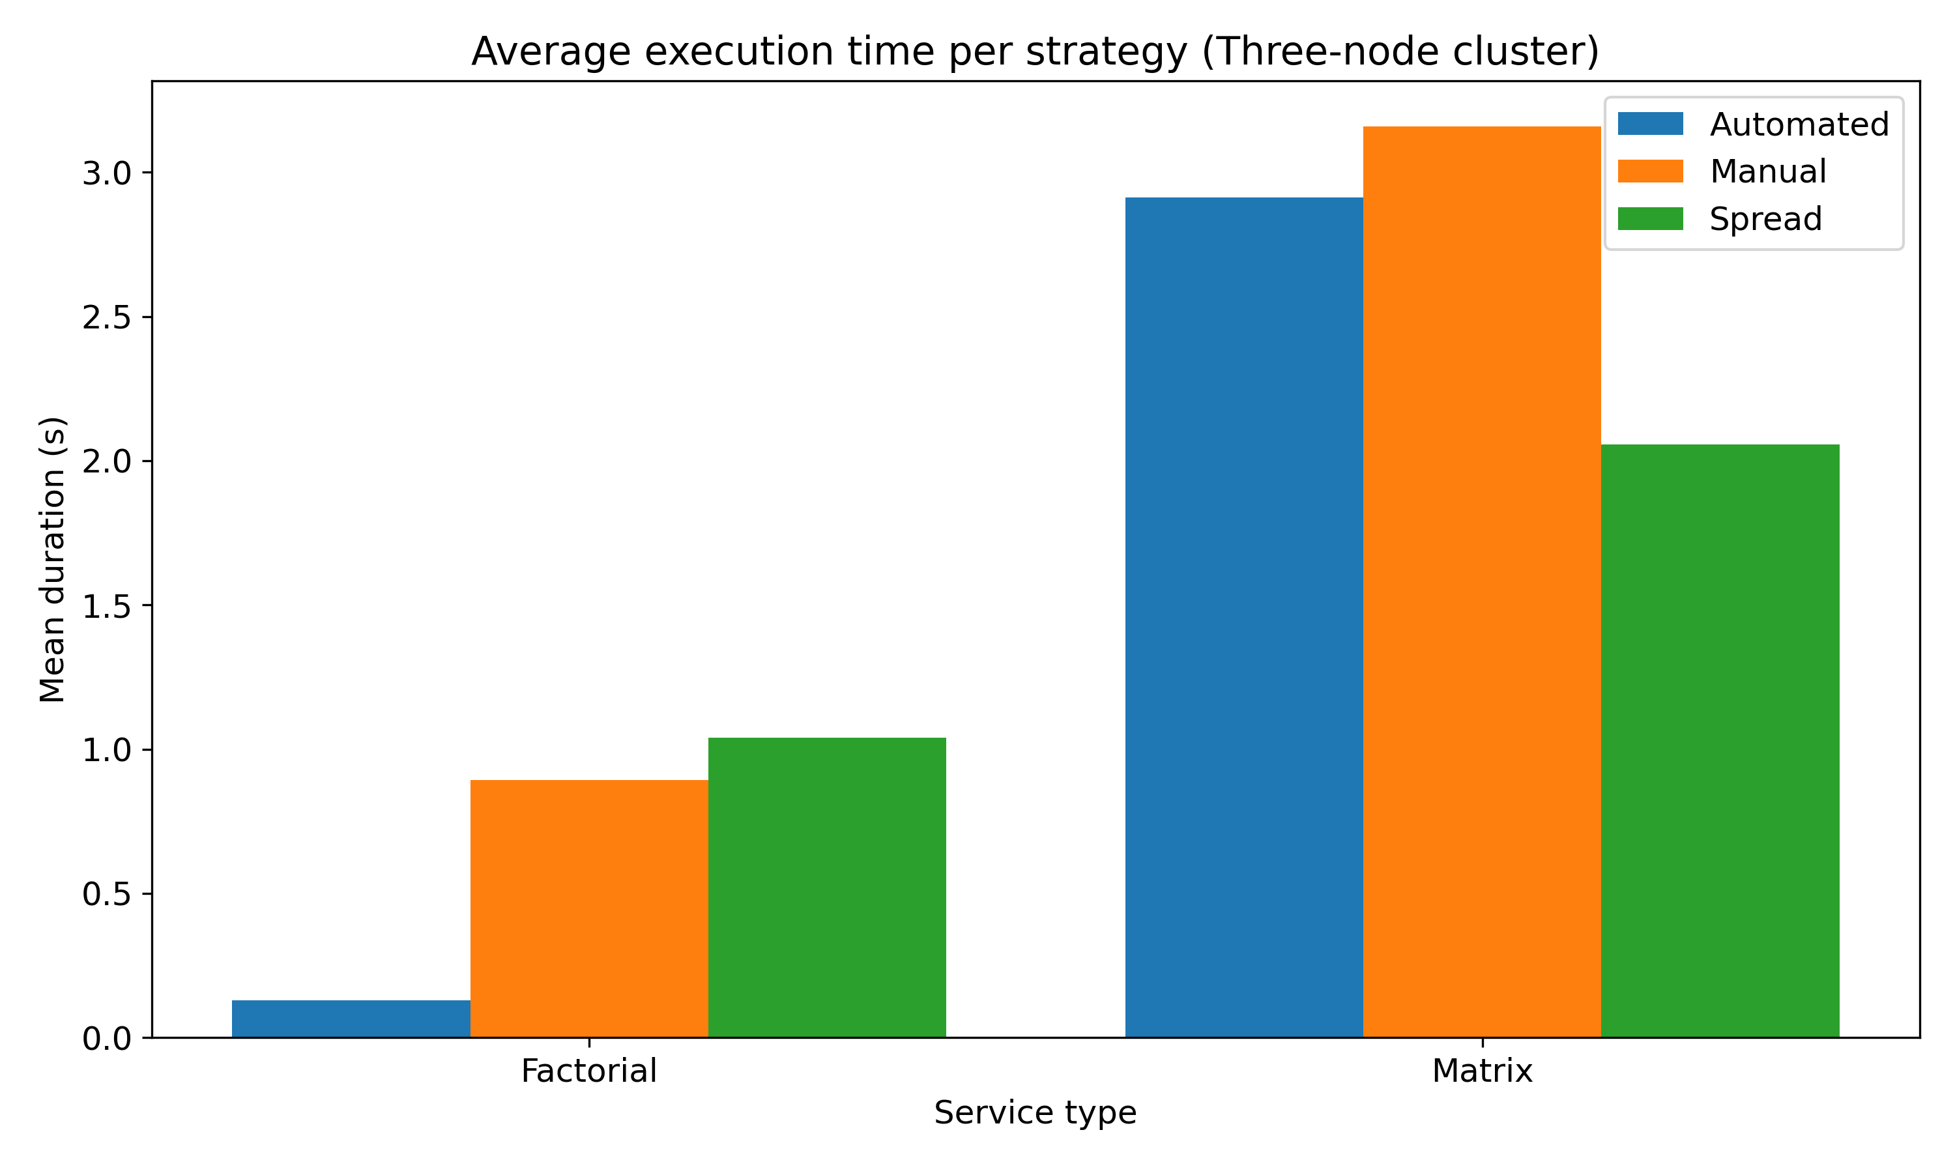
Figure: Average execution time per strategy
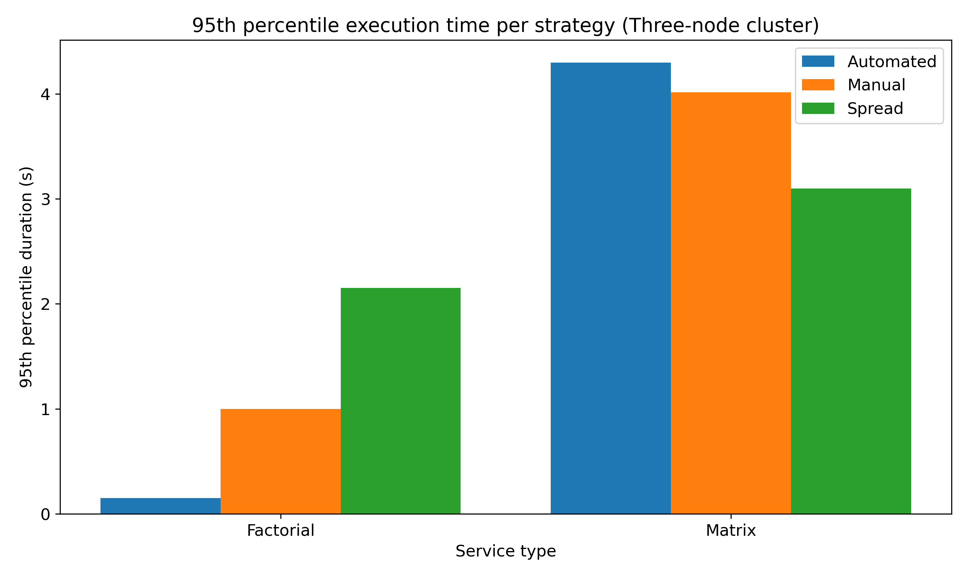
Figure: 95th percentile execution time per strategy
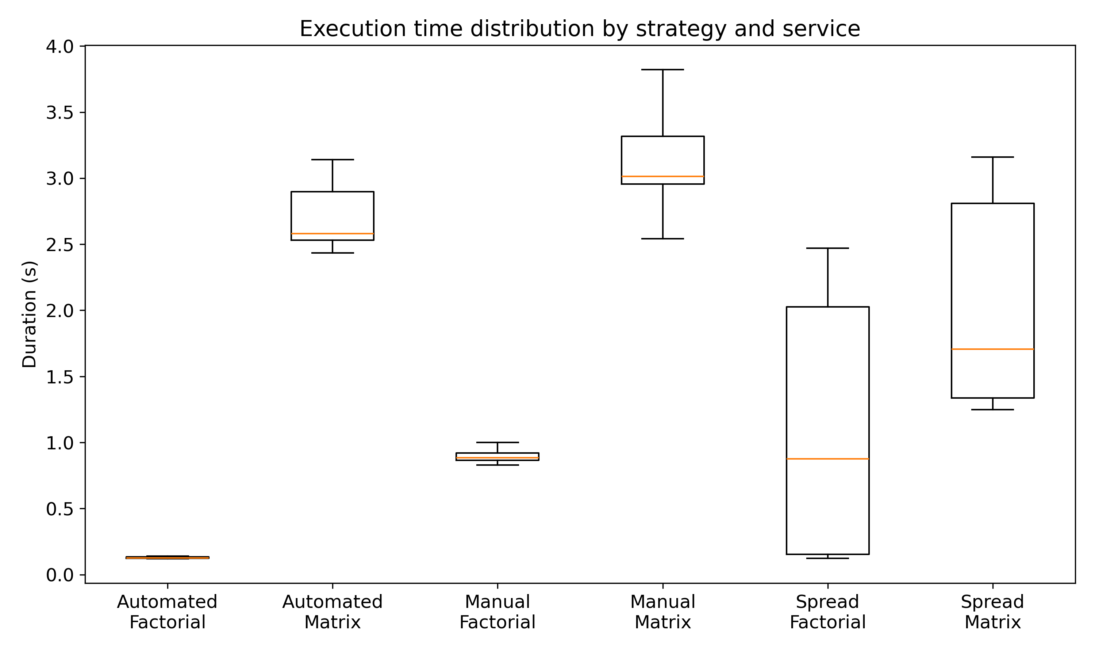
Figure: Execution time distribution by strategy/service
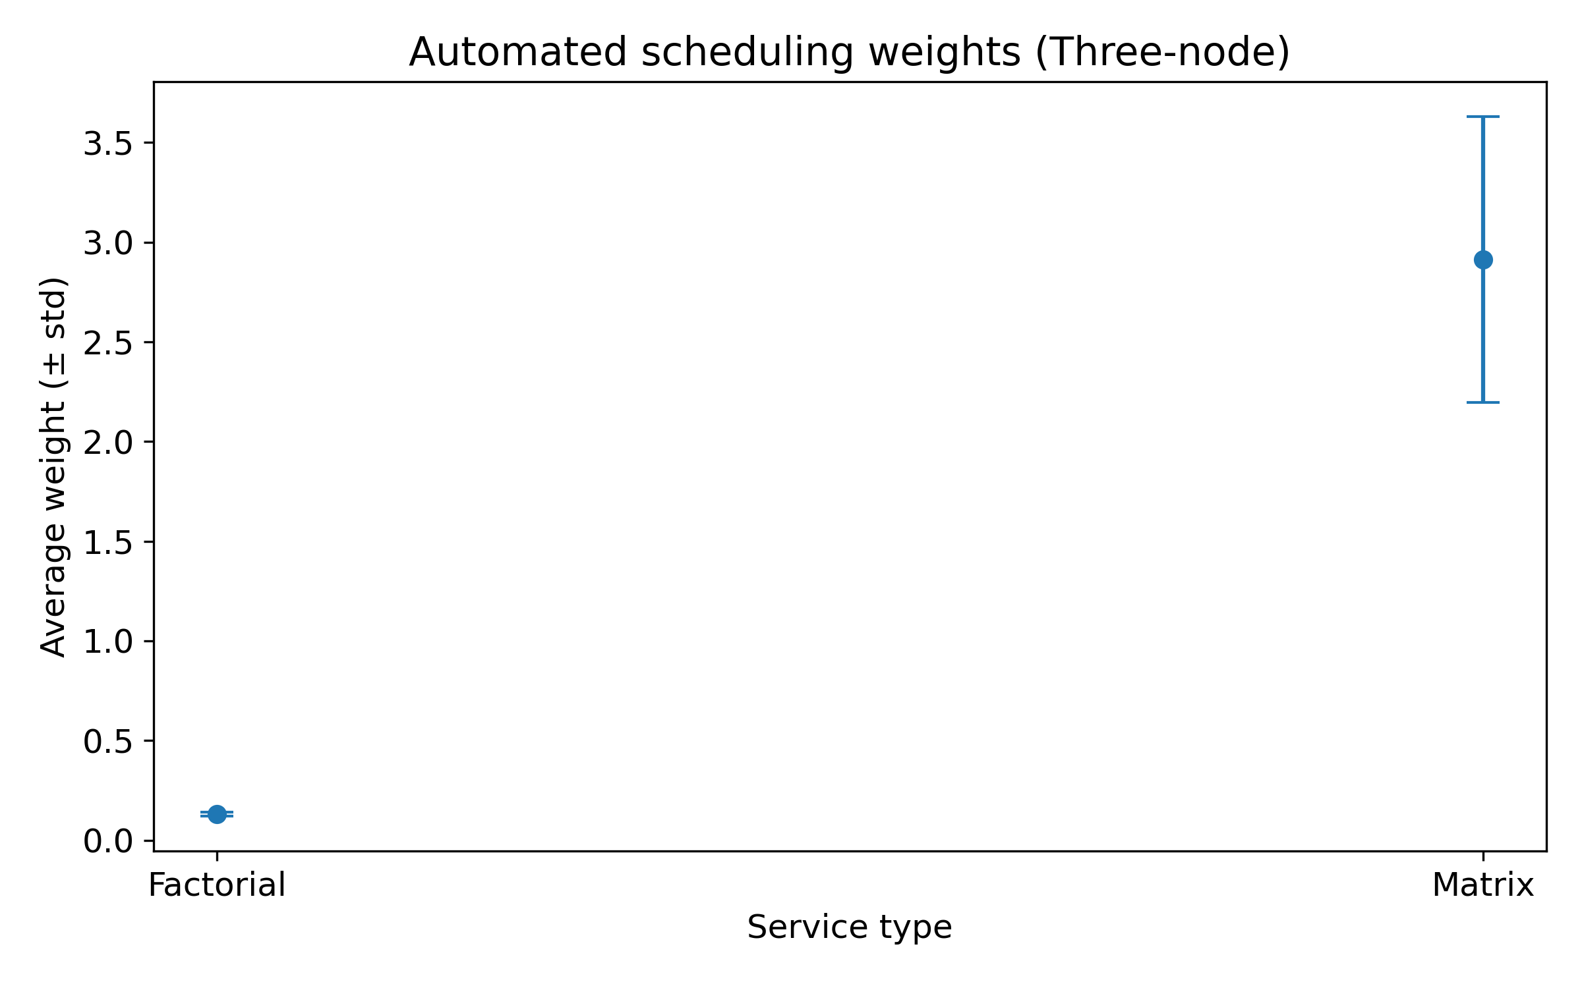
Figure: Automated weighting profile

Conclusion & Next Steps
Maintain automated weighting for factorial services as the default, while exploring strategy-specific adjustments for matrix workloads (e.g., pre-assigned node groups or tuned weights). Plan additional replay runs after tuning to validate improvements and ensure sustained Prometheus coverage.

