Three-Node Replay Analysis (Run 2025-10-13 18:28:58)
This report analyses the replay artefacts stored in scenarios/paper_3node/reports/replay/three_node_run_2025-10-13_182858.
Source CSVs were parsed from combined_strategy_results.csv and the per-strategy outputs.
All charts were regenerated in English and saved under plots_en/ for direct inclusion.

Headline Metrics
Automated scheduling kept factorial workloads to 0.134s on average (95th percentile 0.167s), far below the manual (0.911s) and spread (1.050s) baselines.
Matrix workloads performed best under the spread baseline with 2.068s mean and 3.097s at the 95th percentile. Automated placement averaged 2.785s and manual control 3.245s, showing higher contention for matrix services when weights are not tailored.
Tail behaviour remains tight for factorial jobs across all strategies (<2.4s p95), while matrix workloads show wider dispersion—especially the manual baseline peaking at 4.564s.

Summary Table
Strategy | Service | Samples | Mean | Median | StdDev | P95
Automated | Factorial | 20 | 0.134 | 0.132 | 0.015 | 0.167
Automated | Matrix | 20 | 2.785 | 2.561 | 0.603 | 3.704
Manual | Factorial | 21 | 0.911 | 0.908 | 0.043 | 0.979
Manual | Matrix | 21 | 3.245 | 3.055 | 0.659 | 4.564
Spread | Factorial | 63 | 1.050 | 0.887 | 0.829 | 2.316
Spread | Matrix | 42 | 2.068 | 2.045 | 0.743 | 3.097
Table Summary: automated weights achieve the lowest factorial latency with minimal variance; spread placement delivers the best matrix throughput, while manual control is consistently slower across both services.

Key Observations
- Automated weights strongly favour factorial services, indicating the weighting logic aligns well with CPU-heavy workloads.
- Spread scheduling balances matrix tasks more effectively across the three nodes, suggesting that even distribution beats heuristic weights for memory-bound jobs.
- Manual placement trails in every metric, reinforcing the need for either automated weighting or tightened placement rules.
- No metric gaps were detected in this run; Prometheus sampling provided 20 factorial and 20 matrix samples per automated phase.

Supporting Figures
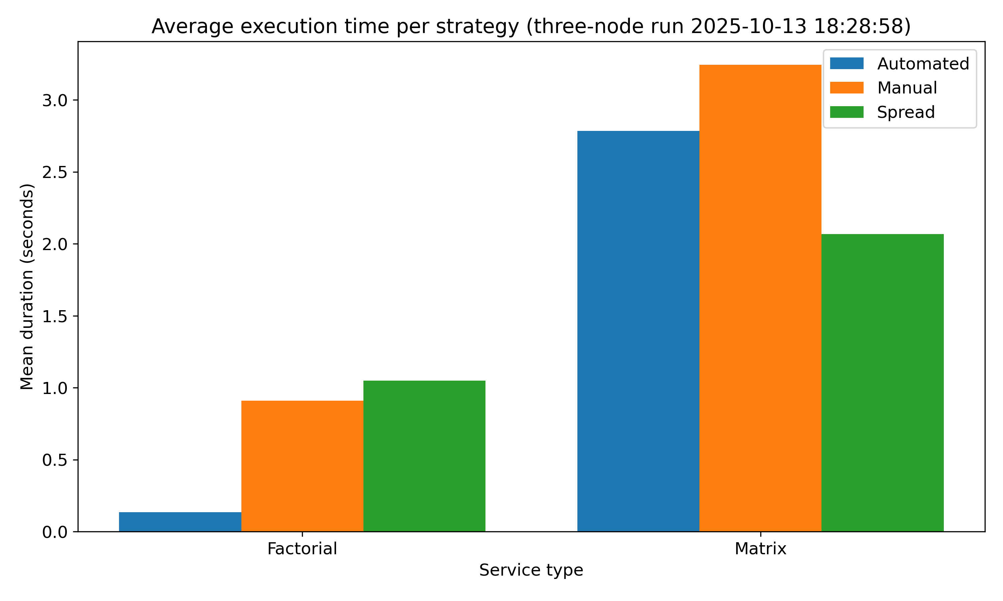
Figure: Average execution time per strategy
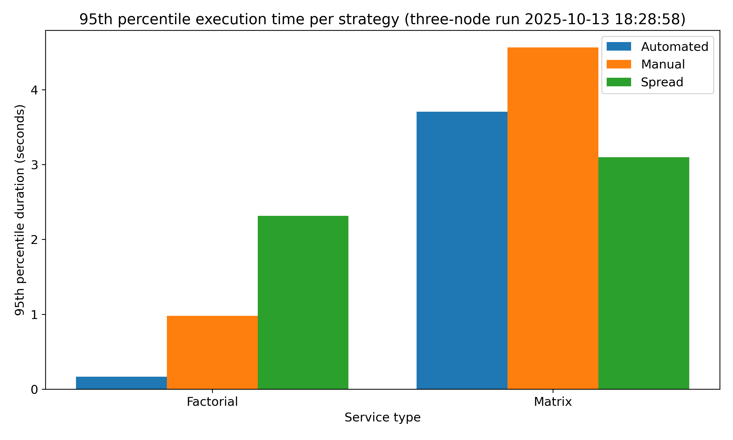
Figure: 95th percentile execution time per strategy
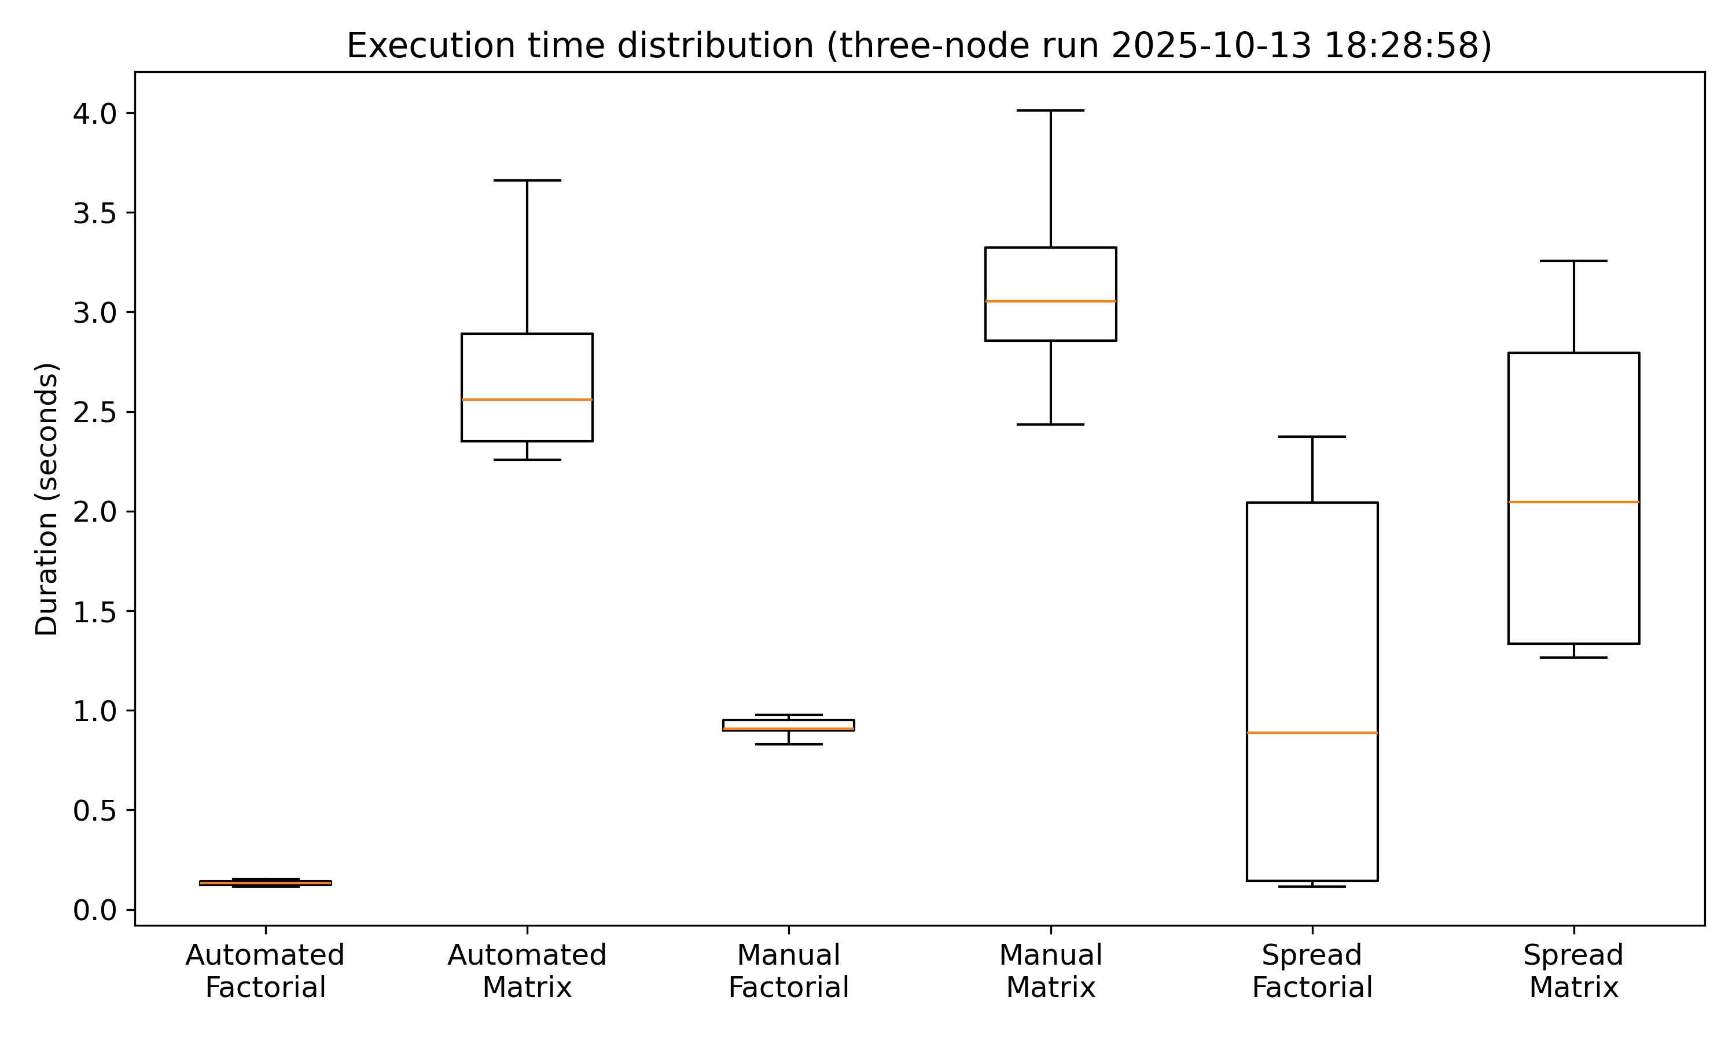
Figure: Execution time distribution by strategy and service
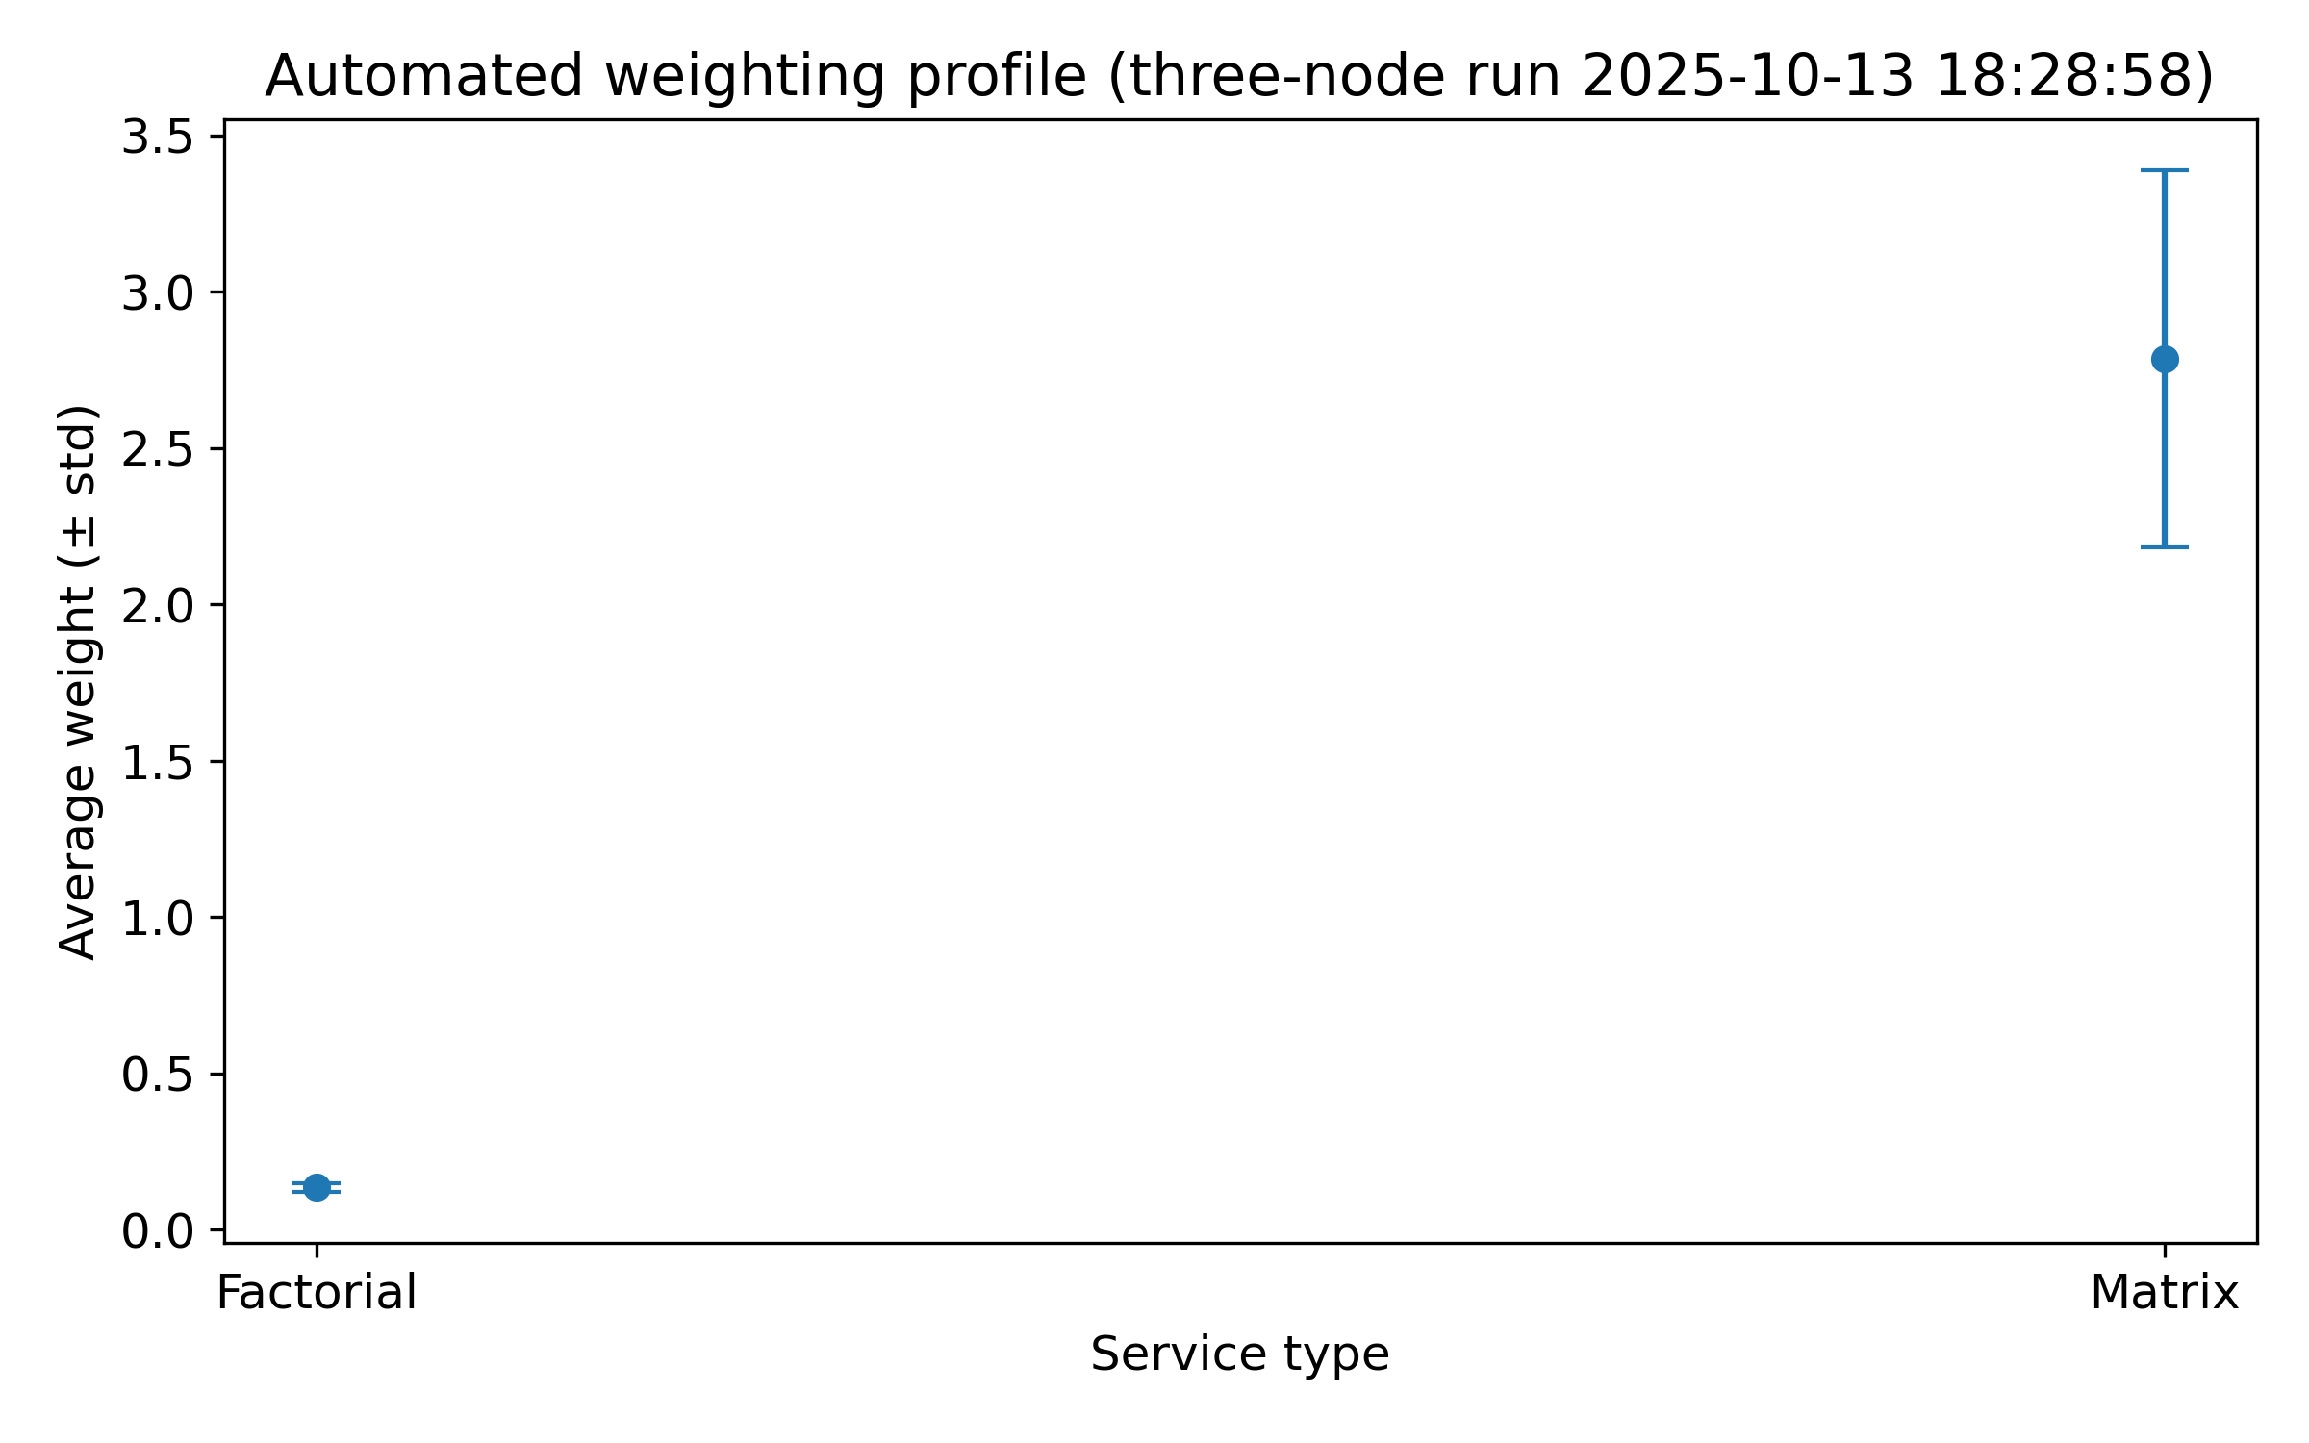
Figure: Automated weighting profile

Conclusion & Next Steps
The three-node cluster benefits from automated weighting for factorial services and spread placement for matrix workloads. Recommended next steps include refining the automated weight model to account for matrix memory pressure and validating the adjustments with an additional replay cycle.

