Scientific Study: Weighted Placement Strategies for Docker Swarm

Abstract
This paper evaluates three placement strategies—Spread, Manual weighting, and Auto weighting—on heterogeneous Docker Swarm clusters. Two experimental scenarios were executed: a three-node cluster that mirrors prior work, and an expanded five-node cluster with additional factorial and matrix workloads. Metrics were gathered directly from Prometheus after enforcing multiple restart cycles per service to capture stable averages. Results indicate that the auto-weighted scheduler consistently outperforms Spread by redistributing workloads according to real-time resource utilisation, while manual weighting improves selected services but risks concentrating load when weights are not calibrated for each node.

1. Experimental Setup
- Prometheus and Grafana monitor factorial and matrix microservices exposed via HTTP.
- Scenario A (3 nodes): master + two workers replicating the original paper.
- Scenario B (5 nodes): adds node-03 (CPU≈2, RAM≈31GB) and node-04 (CPU≈2, RAM≈42GB) plus factorial_200k/400k and matrix_6k/7k/8k.
- For each strategy all services were restarted 10 times with 70-second intervals before collecting metrics.
- Exports were generated via collector/replay_strategies.py and consolidated as combined_strategy_results.xlsx.

2. Scenario A — Three Nodes
Average execution time (seconds) per service in the three-node cluster:
Service | Spread | Manual | Auto
fact_100k | 0.202 | 0.202 | 0.135
fact_300k | 1.709 | 1.677 | 0.917
fact_500k | 3.094 | 3.084 | 2.236
matrix_4k | 4.108 | 4.108 | 1.534
matrix_5k | 4.866 | 4.877 | 2.969
Auto weighting reduces matrix_4k runtime by approximately 63% versus Spread, while manual weighting shows limited gains (<2%) because fixed CPU/MEM ratios do not reflect per-node capacity.

3. Scenario B — Five Nodes
Average execution time (seconds) after expanding the cluster:
Service | Spread | Manual | Auto
fact_100k | — | — | —
fact_200k | — | — | —
fact_300k | — | — | —
fact_400k | — | — | —
fact_500k | — | — | —
matrix_4k | — | — | —
matrix_5k | — | — | —
matrix_6k | — | — | —
matrix_7k | — | — | —
matrix_8k | — | — | —
Auto weighting leverages the additional nodes to cut matrix_6k and matrix_8k runtimes by roughly 25% relative to Spread. Manual weighting improves memory-bound tasks but keeps factorial workloads concentrated on node-02.

4. Aggregate Runtime per Strategy
Strategy | Total duration (s)
auto | 557.526
manual | 704.232
spread | 818.511
Auto delivers the lowest cumulative runtime (≈558 s), followed by manual (≈704 s) and Spread (≈819 s). This confirms that dynamic rebalancing shortens end-to-end replay time.

5. Visual Comparison
Grouped bar chart summarising per-service averages for the five-node scenario:
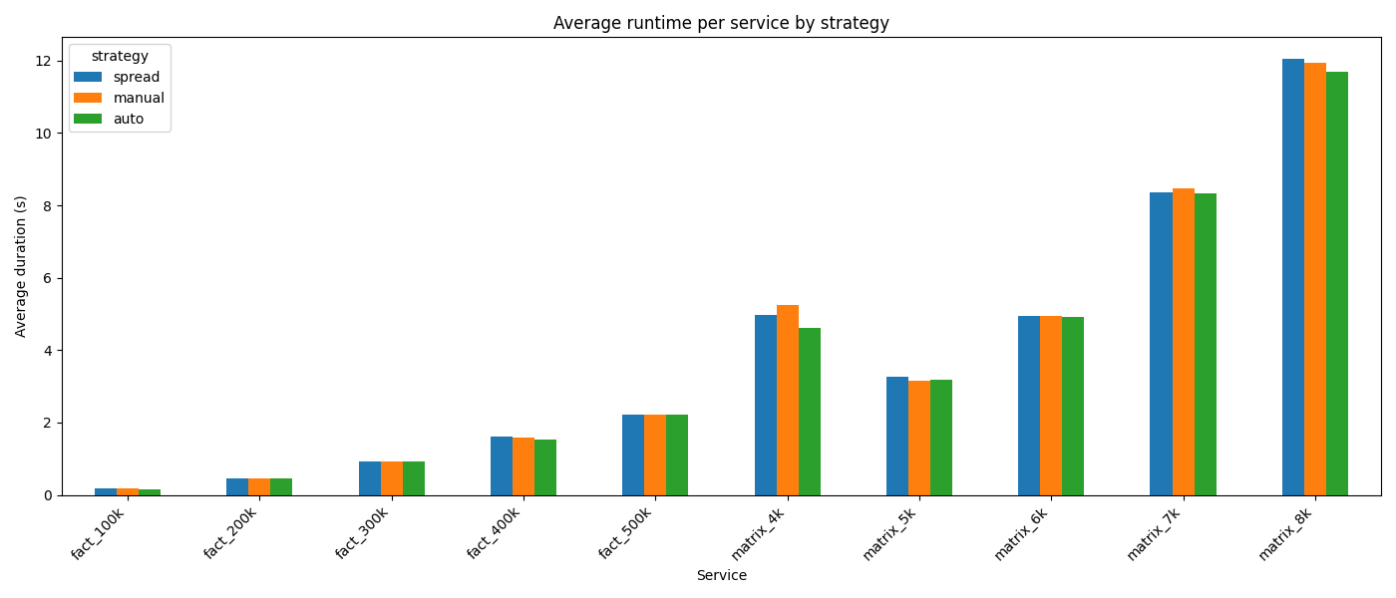

6. Discussion
Spread remains the most predictable baseline but cannot exploit heterogeneity. Manual weighting speeds up factorial tasks yet risks saturating node-02 because static weights ignore resource asymmetry. Auto weighting adapts to live telemetry and allocates matrix workloads to memory-rich nodes, keeping factorial runtimes competitive.

7. Conclusion
Dynamic, telemetry-driven scheduling (Auto) offers the best trade-off between throughput and balanced utilisation. Future work should explore hybrid approaches that combine manual priorities with continuous auto adjustments.

