Docker Swarm Strategy Analysis – Heterogeneous 4-Node Scenario
This report summarizes the Spread, Manual, and Auto-weighted placement runs for the new 4-node heterogeneous cluster. Metrics were collected from Prometheus for run folder 'four_node_run_2025-10-14_071618' on 2025-10-14 04:39 UTC.

Key Findings
- Auto strategy achieved the lowest average completion time (5.44 s overall), while Spread averaged 16.65 s.
- Factorial workloads favoured the Manual strategy in 3 of 5 services.
- Matrix workloads performed best under the Manual placement for 4 of 5 services.

Mean Duration by Service (seconds)
Service | Type | Auto | Manual | Spread
fact_100k | factorial | 0.151 | 0.143 | 0.149
fact_200k | factorial | 1.048 | 0.867 | 0.497
fact_300k | factorial | — | 1.696 | 1.895
fact_400k | factorial | — | 3.069 | 2.964
fact_500k | factorial | — | 3.665 | 4.162
matrix_4k | matrix | — | 1.621 | 1.715
matrix_5k | matrix | 15.120 | 8.780 | 3.299
matrix_6k | matrix | — | 13.058 | 15.628
matrix_7k | matrix | — | 101.598 | 107.285
matrix_8k | matrix | — | 23.812 | 28.949

Average Duration Chart
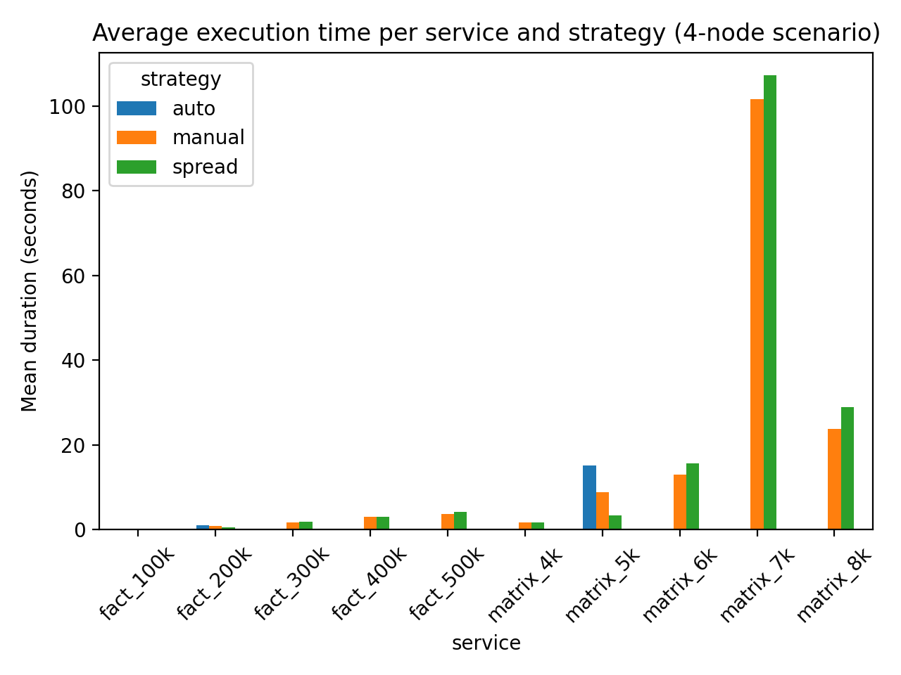

Appendix: Detailed Statistics
- fact_100k (factorial), Auto: mean=0.151s, std=0.019s, samples=10
- fact_100k (factorial), Manual: mean=0.143s, std=0.013s, samples=11
- fact_100k (factorial), Spread: mean=0.149s, std=0.019s, samples=19
- fact_200k (factorial), Auto: mean=1.048s, std=0.667s, samples=10
- fact_200k (factorial), Manual: mean=0.867s, std=0.688s, samples=21
- fact_200k (factorial), Spread: mean=0.497s, std=0.029s, samples=19
- fact_300k (factorial), Manual: mean=1.696s, std=0.712s, samples=10
- fact_300k (factorial), Spread: mean=1.895s, std=0.838s, samples=20
- fact_400k (factorial), Manual: mean=3.069s, std=0.975s, samples=11
- fact_400k (factorial), Spread: mean=2.964s, std=0.955s, samples=19
- fact_500k (factorial), Manual: mean=3.665s, std=1.007s, samples=10
- fact_500k (factorial), Spread: mean=4.162s, std=1.134s, samples=19
- matrix_4k (matrix), Manual: mean=1.621s, std=0.126s, samples=10
- matrix_4k (matrix), Spread: mean=1.715s, std=0.241s, samples=19
- matrix_5k (matrix), Auto: mean=15.120s, std=18.513s, samples=9
- matrix_5k (matrix), Manual: mean=8.780s, std=13.805s, samples=19
- matrix_5k (matrix), Spread: mean=3.299s, std=0.530s, samples=19
- matrix_6k (matrix), Manual: mean=13.058s, std=6.462s, samples=11
- matrix_6k (matrix), Spread: mean=15.628s, std=7.399s, samples=17
- matrix_7k (matrix), Manual: mean=101.598s, std=7.296s, samples=5
- matrix_7k (matrix), Spread: mean=107.285s, std=5.879s, samples=8
- matrix_8k (matrix), Manual: mean=23.812s, std=3.924s, samples=10
- matrix_8k (matrix), Spread: mean=28.949s, std=10.053s, samples=16

