Manual Weighting Strategy Report
Running ./run_manual_strategy.sh with CPU weight 0.7 and memory weight 0.3 ranked node-02 as the preferred host, pinning most workloads to that node.

Metric Summary
Service | Mean (s) | Std dev | Samples
fact_100k | 0.196 | 0.076 | 18
fact_200k | 0.460 | 0.033 | 17
fact_300k | 0.961 | 0.101 | 21
fact_400k | 1.594 | 0.087 | 17
fact_500k | 2.333 | 0.110 | 17
matrix_4k | 7.243 | 2.752 | 17
matrix_5k | 3.060 | 0.422 | 21
matrix_6k | 4.821 | 0.219 | 18
matrix_7k | 8.492 | 1.037 | 17
matrix_8k | 11.486 | 0.727 | 16
Factorial jobs improved slightly, but the majority of services now share node-02, increasing the risk of saturation.

Applied Relative Weights
Service | Relative weight | Samples
fact_100k | 0.544 | 18
fact_200k | 0.232 | 17
fact_300k | 0.111 | 21
fact_400k | 0.067 | 17
fact_500k | 0.046 | 17
matrix_4k | 0.157 | 17
matrix_5k | 0.373 | 21
matrix_6k | 0.236 | 18
matrix_7k | 0.134 | 17
matrix_8k | 0.099 | 16
The dataset confirms that fixed CPU/MEM ratios were applied to each service.

Cluster Snapshots
Primary snapshot highlighting service consolidation on node-02:
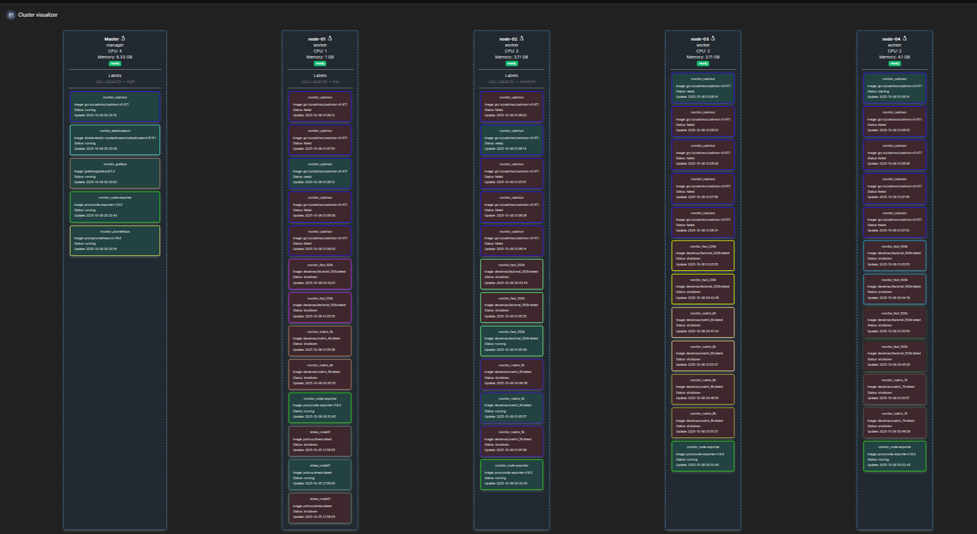
Secondary snapshot showing how other nodes retain only monitoring containers after manual placement:
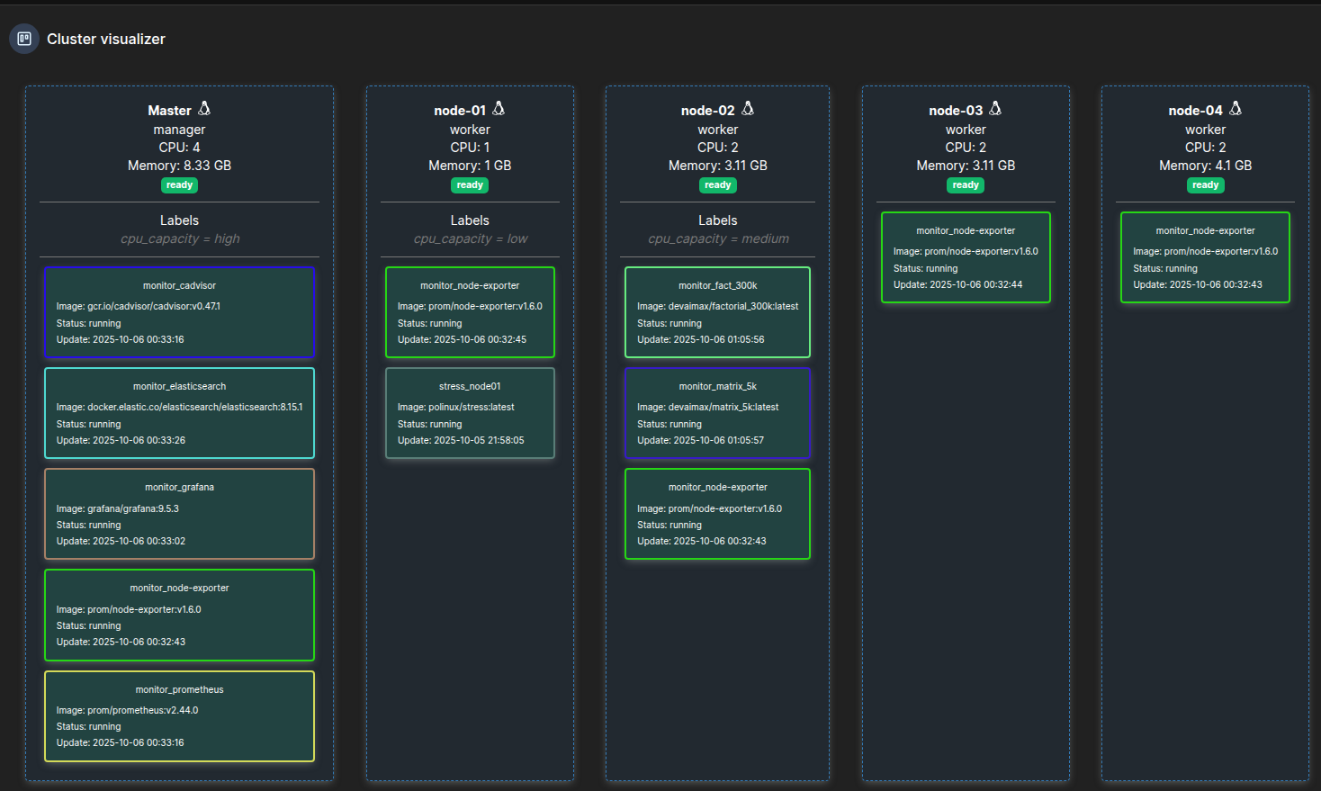
Detailed records are available in reports/replay/manual_2025-10-06_005844.xlsx.

