Docker Swarm Strategy Analysis – Paper 3-Node Scenario
Generated on 2025-10-14 02:52 UTC from run folder 'three_node_run_2025-10-14_053418'. Metrics cover factorial and matrix workloads under Spread, Manual, and Auto strategies.

Key Findings
- Spread strategy delivered the lowest average completion time across all workloads (1.36 s), while Auto was highest (1.44 s).
- Factorial services mostly favoured the Auto strategy, winning 1 out of 2 jobs.
- Matrix workloads achieved best latency under the Auto strategy in 1 of 2 services.

Mean Duration by Service (seconds)
Service | Type | Auto | Manual | Spread
fact_100000 | factorial | 0.134 | 0.141 | 0.141
fact_300000 | factorial | 0.953 | 0.935 | 0.886
matrix_4000 | matrix | 1.482 | 1.496 | 1.496
matrix_5000 | matrix | 3.186 | 3.083 | 2.932

Average Duration Chart
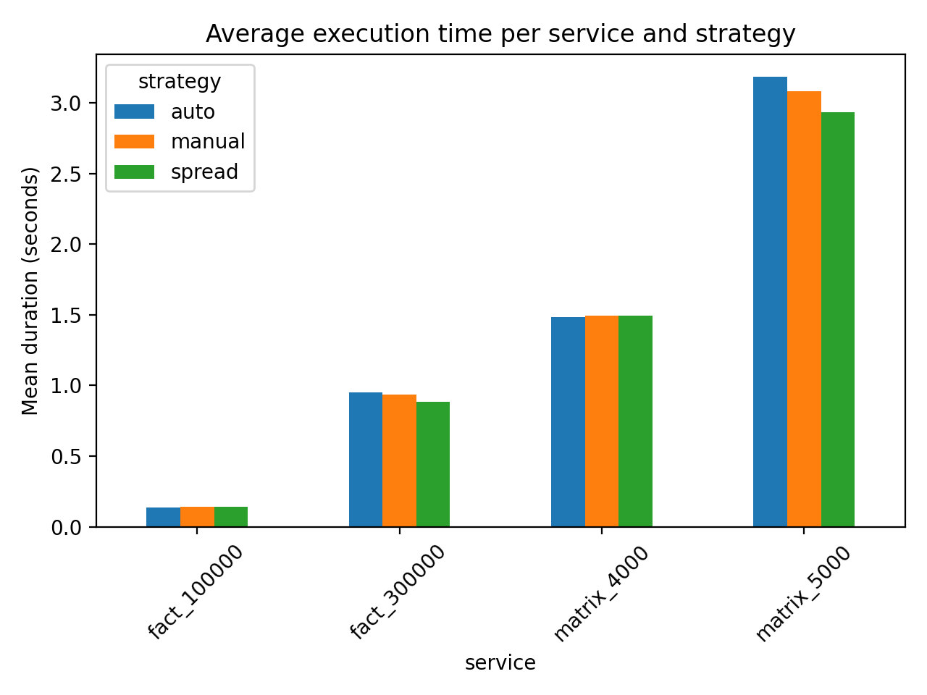

Appendix: Detailed Statistics
- fact_100000 (factorial), Auto: mean=0.134s, std=0.009s, samples=7
- fact_100000 (factorial), Manual: mean=0.141s, std=0.011s, samples=4
- fact_100000 (factorial), Spread: mean=0.141s, std=0.011s, samples=4
- fact_300000 (factorial), Auto: mean=0.953s, std=0.055s, samples=8
- fact_300000 (factorial), Manual: mean=0.935s, std=0.057s, samples=11
- fact_300000 (factorial), Spread: mean=0.886s, std=0.024s, samples=3
- matrix_4000 (matrix), Auto: mean=1.482s, std=0.125s, samples=5
- matrix_4000 (matrix), Manual: mean=1.496s, std=0.090s, samples=9
- matrix_4000 (matrix), Spread: mean=1.496s, std=0.090s, samples=9
- matrix_5000 (matrix), Auto: mean=3.186s, std=0.372s, samples=17
- matrix_5000 (matrix), Manual: mean=3.083s, std=0.279s, samples=14
- matrix_5000 (matrix), Spread: mean=2.932s, std=0.227s, samples=8

