Spread Strategy Report
Services were reset to the native Docker Swarm Spread policy and metrics were collected directly from Prometheus after a short stabilisation period. Raw samples are stored under reports/replay/2worker-node-reports/.

Metric Summary
Service | Mean (s) | Std dev | Samples
fact_100k | 0.202 | 0.029 | 12
fact_300k | 1.709 | 0.414 | 11
fact_500k | 3.094 | 0.242 | 11
matrix_4k | 4.108 | 0.592 | 11
matrix_5k | 4.866 | 0.651 | 12
These baseline numbers reflect the three-node lab before introducing any additional weighting logic.

Reference Weights
Service | Relative weight | Samples
Weights are derived from the exported dataset and are provided for reference only.

Cluster Layout
Cluster Visualizer snapshot after applying Spread:
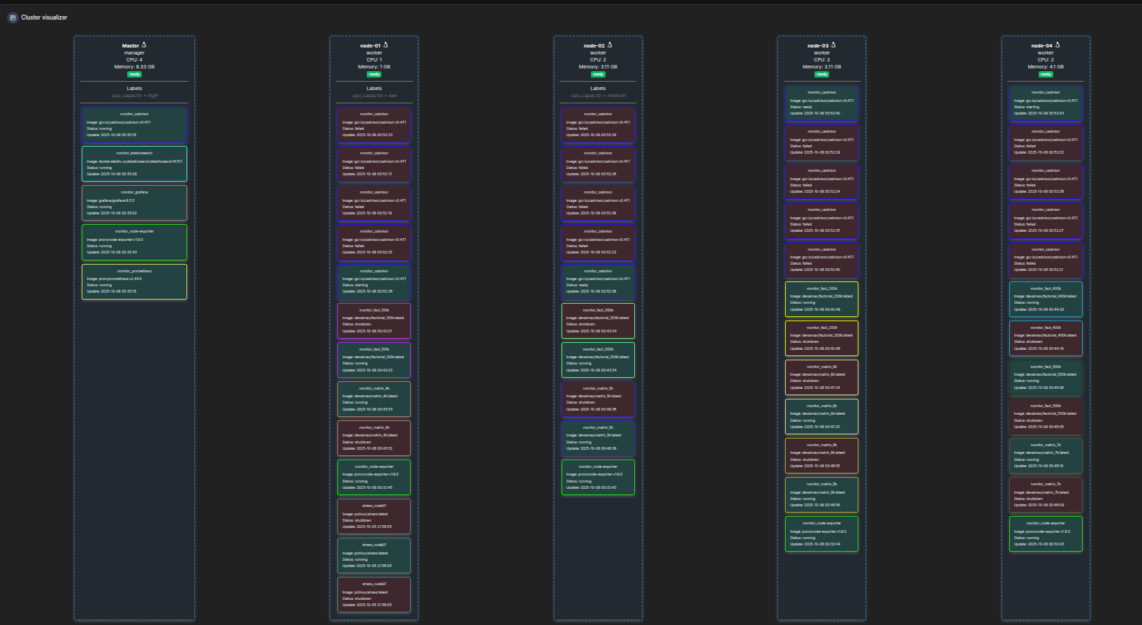
The manager hosts monitoring services while worker nodes keep a balanced mix of factorial and matrix workloads.

