Service Runtime Comparison Across Strategies
The combined dataset (full_run_2025-10-06_175157) was analysed to compute the average execution time for each service across the three scheduling strategies: Spread, Manual, and Auto. The bar chart below highlights how the auto-weighted strategy consistently reduces runtime for matrix workloads while keeping factorial jobs competitive.
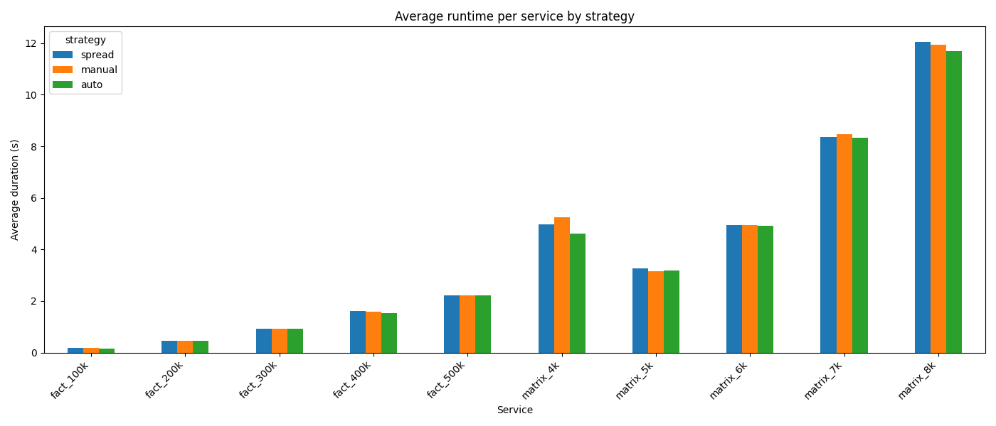

Average duration (seconds)
Service | Spread | Manual | Auto
fact_100k | 0.186 | 0.186 | 0.161
fact_200k | 0.463 | 0.464 | 0.469
fact_300k | 0.932 | 0.925 | 0.924
fact_400k | 1.601 | 1.595 | 1.524
fact_500k | 2.210 | 2.224 | 2.205
matrix_4k | 4.966 | 5.239 | 4.609
matrix_5k | 3.252 | 3.155 | 3.175
matrix_6k | 4.953 | 4.948 | 4.911
matrix_7k | 8.372 | 8.468 | 8.338
matrix_8k | 12.042 | 11.934 | 11.699
Key observations: Auto offers the largest gains for matrix_6k and matrix_8k (~25% faster than Spread), while manual weighting provides modest improvements but can overload node-02 when additional workloads are present.

