**Experiment-1**

**Aim: Introduction to packet tracer**

**Cisco Packet Tracer Overview:**

Cisco Packet Tracer Overview Cisco packet tracer is a powerful virtual network simulation tool used to learn and understand different concept in computer networks. The tool is developed by Cisco in order to allow students or user to get practical networking technology knowledge. Cisco packet tracer provide user / student to design and simulate a network by using virtual devices such as hub, router, switches etc. In cisco packet tracer, the simulation works without having any physical network.

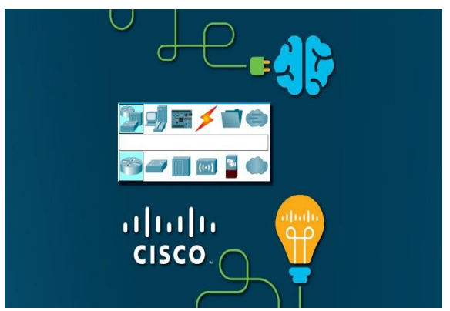

**Figure 1. Cisco Packet Tracer Interface**

**Packet tracer Workspaces:**

Cisco packet has two Workspaces: one is Physical and the other one logical. The logical view allow user to place and connect virtual network devices while the physical view gives a graphical representation of the virtual network devices. In the physical view of the devices, we can add additional modules to an available slot in the devices as we can see in the Figure 2. bellow. The good thing about this particular simulation tool is that it provides an environment where devices resemble to devices in the real world. This is very important because it give user the possibility to be familiar with devices before working with the real equipment.

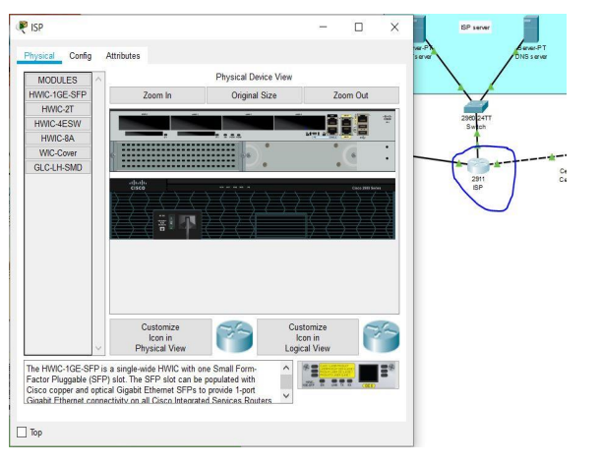

**Figure 2. Physical View of ISP Route**

**Packet tracer Mode:**

The tool also provides two modes, which are real time mode, and simulation mode. In the real time, students/ user can have a clear vison of how the devices behaves. In this mode, devices behave as real devices. In the other hand, the simulation mode helps students / user to understand the fundamental concept behind the network operations. This mode permit user to see and control time intervals, and to visualize the propagation of data across a network.

**Cisco devices configuration methods:**

Cisco packet tracer allow us to configure devices using two options: Config tab or CLI tab (command line interface). With command line interface, we configure devices using cisco command line. The advantage of using the command line interface is that, the commands we use to configure devices virtually are the same command we use with the real devices. The Figure 3 below represents a router configuration using a Command line interface (CLI). The config tab did not required any cisco commands knowledge. Configuration with config tab is done through a graphical interface. This configuration method can be use in the situation where user does not have enough time and want to configure devices quickly. This technique can help us saving time during configuration. The Figure 4 represent a router configuration with Config Tab.

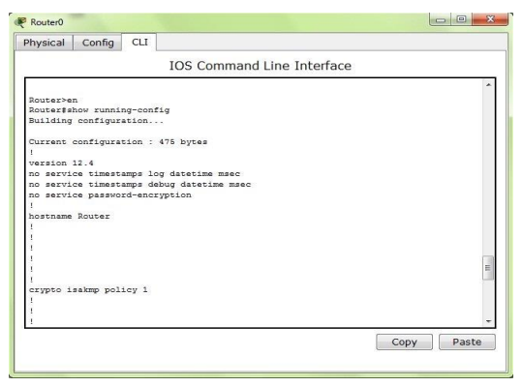

**Figure 3. Cisco Packet Tracer Command Line Interface Tab**

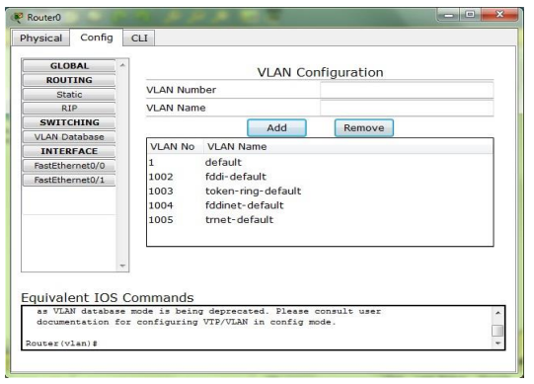

**Figure 4. Cisco Packet Tracer Config Tab**

**Cisco packet tracer supported protocols:**

Cisco packet tracer support different protocols. The table below show the lists of protocols supported by packet tracer.

**Table 2. Protocol Supported by Cisco Packet Tracer**

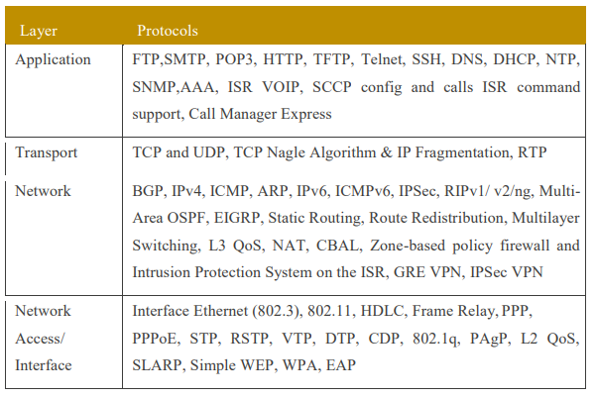

**Cisco packet tracer and Internet of Things:**

The last version of cisco packet tracer included some new feature that can help us to perform internet of things simulation. Those new feature are smart devices, sensor, actuator and microcontroller. Some of those smart devices included in packet tracer are smart windows, smart fan, smart light, alarm siren. We can also find some sensors such as water level, temperature, humidity, carbon dioxide. One most important thing with the new version is that, all the devices can be programmable using different programming languages that are python, JavaScript and blocky. In addition, they can all be connected through wired cable or through wireless. 11 There are different cabling options in the new packet tracer, which are copper straight cables, copper crossover cables, and optic Fast-Ethernet cables and IoT custom cables. Nevertheless, we can also choose the auto cabling option where the tools automatically choose the suitable cable to connect two devices.

The internet of things devices in the Cisco Packet tracer can be used to build and simulate different internet of things application such as smart home, smart industry, smart city etc. The benefit of using cisco packet tracer is that, user can interact with the devices the same way they do in the real devices. In addition, with it multiuser functionality, multiuser can work together to build virtual network through a real network. This thesis work is only focusing on using the smart devices in the new version of the packet tracer to implement a smart home or internet based home automation system The Figure 5 bellow show some different devices include in the new version of cisco packet tracer.

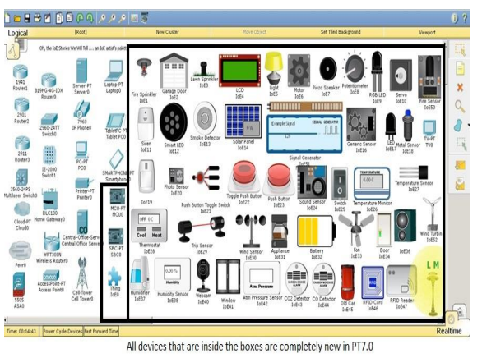

**Figure 5. Cisco Packet Tracer Smart devices**