**Experiment 1**

**AIM:**

TO study and apply network trouble shooting commands in live network environment

### Objective:

To understand and demonstrate the use of various network troubleshooting commands (IPCONFIG, PING, ARP, TRACERT) in diagnosing and resolving common network issues in a live environment.

### Materials Required:

* A computer with an active network connection (Windows, macOS, or Linux)
* Command-line interface (CLI) access (Command Prompt for Windows, Terminal for macOS/Linux)

### Theory

Network troubleshooting commands are essential tools for diagnosing and resolving network connectivity issues. Each command serves a specific purpose:

1. **IPCONFIG**: Displays the current network configuration details of a computer.
2. **PING**: Tests the reachability of a host on an IP network and measures the round-trip time for messages.
3. **ARP (Address Resolution Protocol)**: Displays and modifies the ARP table used to map IP addresses to MAC addresses.
4. **TRACERT (Traceroute)**: Traces the path packets take to reach a network host, showing each hop along the way.

### Procedure

**IPCONFIG Command:**

* Open the Command Prompt (Windows) or Terminal (macOS/Linux).
* Type ipconfig (or ifconfig on macOS/Linux) and press Enter.
* Observe the output which includes details such as IP address, subnet mask, and default gateway.
* Note: Use at least three options in this command and attach the screenshots under the title “example output”

**PING Command:**

* Type ping <hostname or IP address> and press Enter. For example, ping google.com.
* Observe the output which shows whether the destination is reachable and the time taken for each ping.
* Note: Use at least three options in this command and attach the screenshots under the title “ Output & Observation”
* Use CTR C keys to break the loop

**ARP Command:**

* Type arp -a and press Enter to display the ARP table.
* Observe the output which lists IP addresses and their corresponding MAC addresses.
* Note: To clear the ARP cache, use arp -d followed by the IP address on Windows.

**TRACERT Command:**

* Type tracert <hostname or IP address> on Windows or traceroute <hostname or IP address> on macOS/Linux and press Enter. For example, tracert google.com.
* Observe the output which shows each hop from your computer to the destination, including the round-trip time for each hop.
* Note: Use at least three options in this command and attach the screenshots under the title “output & observations”
* Use CTR C keys to break the loop

### Output & Observations

* **IPCONFIG**: Provides detailed network configuration information.(vary the space for three different Screenshots)

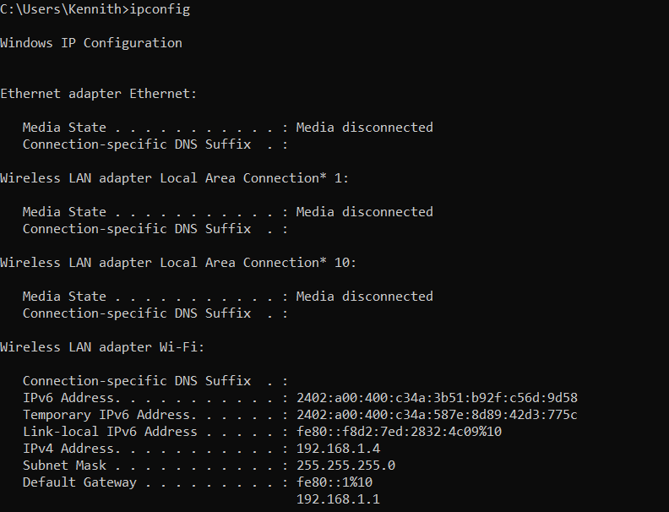

Ipconfig/all

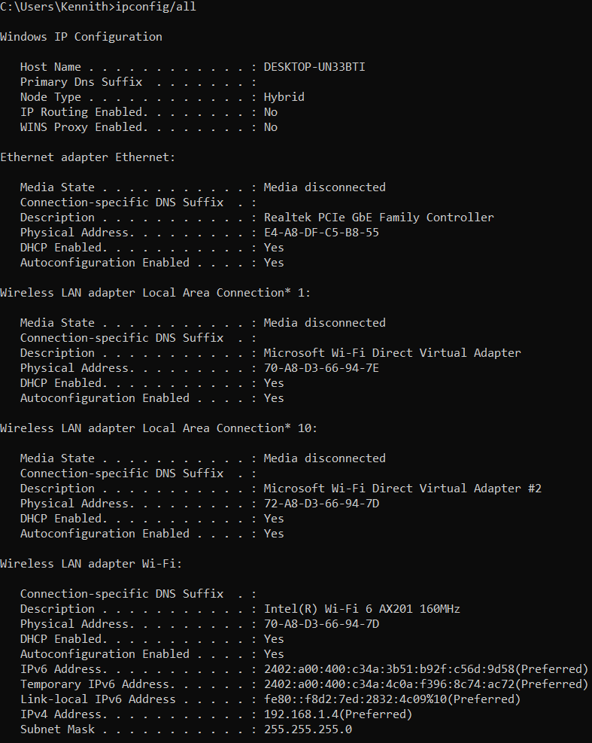

Ipconfig/flushdns

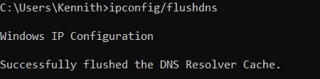

* **PING**: Confirms whether a host is reachable and measures the round-trip time.(vary the space for three different Screenshots)

**ping www.google.com**

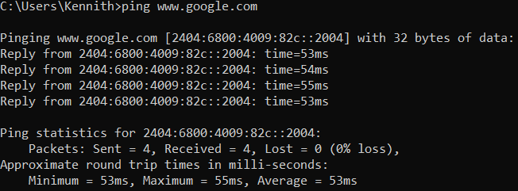

ping www.facebook.com

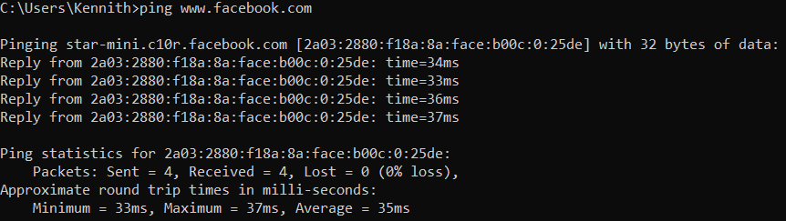

ping www.amazon.in

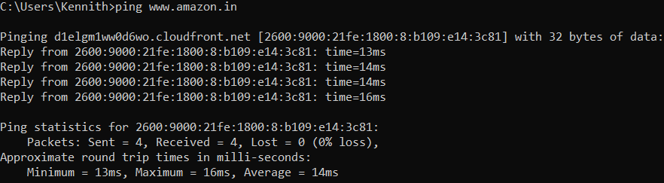

* **ARP**: Displays the mapping between IP addresses and MAC addresses.(vary the space forthree different Screenshots)
* **Arp -a**

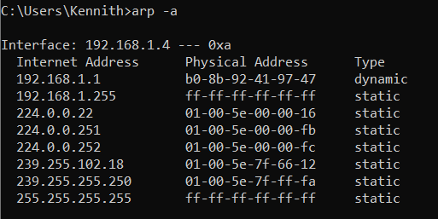

arp

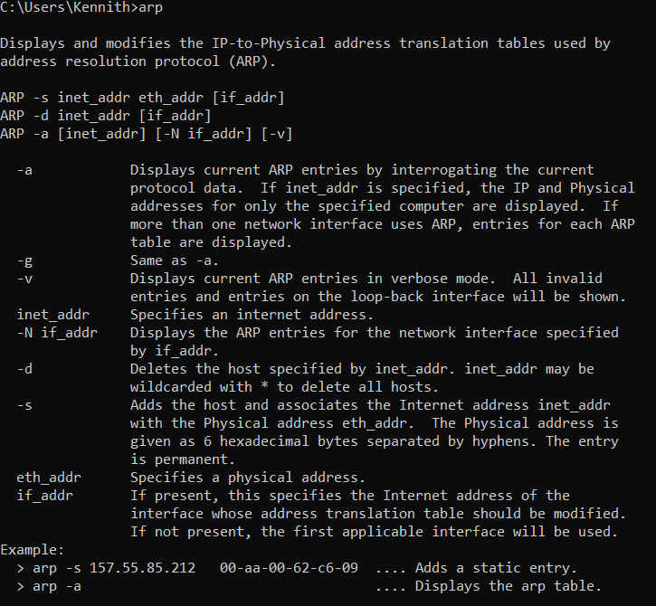

Arp -g

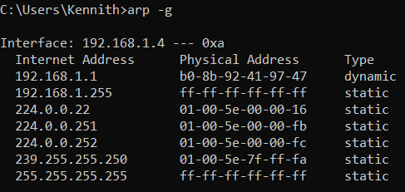

* **TRACERT**: Identifies the path packets take to reach a destination and where delays occur. (vary the space for three different Screenshots)

tracert www.google.com

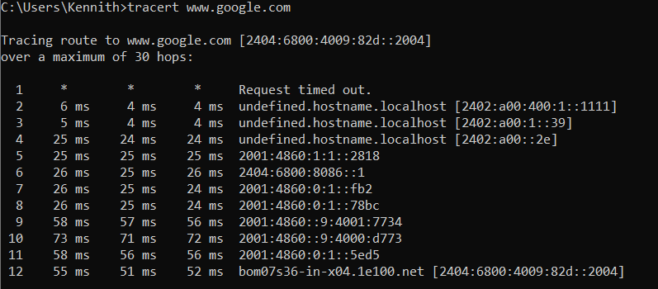

tracert www.facebook.com

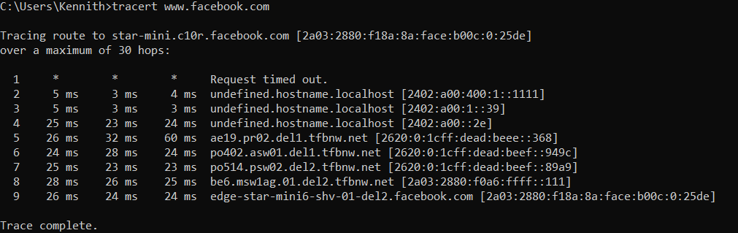

tracert www.google.com

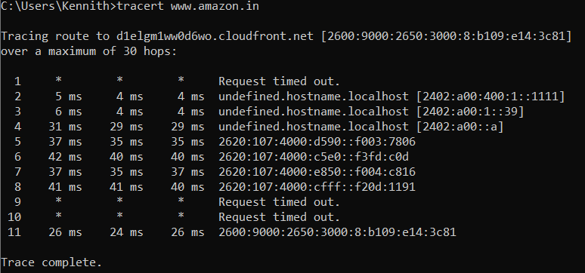

### Conclusion

The experiment demonstrates the use of network troubleshooting commands to diagnose and resolve network issues. Understanding these commands is crucial for network administration and troubleshooting.