**Experiment 2**

**AIM:**

To study and implement peer to peer and client-server network by using packet tracer

### Objective:

To create, understand and demonstrate the use of various networks like peer to peer and client-server by using packet tracer

### Materials Required:

* A computer with an active network connection (Windows, macOS, or Linux)
* Packet tracer software application installed

### Procedure

**Peer to Peer Network**

* Open Cisco packet tracer and click on end devices, select PC and place 2 of them on the front, select the copper-cross-over connection and connect the PCs using FastEthernet0 (2 green nodes will be displayed on the wire).
* Click on one of the PCs to configure, go to IP configuration in desktop tab and change the ipv4 address to 192.168.1.1. Repeat the process for 2nd PC and put the ipv4 address to 192.168.1.2.
* Now open the command prompt of the 2nd PC and type “ping 192.168.1.1” to ping with the 1st PC

**Client-Server Network**

* Open Cisco packet tracer and click on end devices, select PC and place it and select a server and place it too. Select the copper-cross-over connection and connect the PC and the server using FastEthernet0 (2 green nodes will be displayed on the wire).
* Click on the PC, go to IP configuration in desktop tab and change the ipv4 address to 192.168.1.1. Repeat the process for the server and put the ipv4 address to 192.168.1.2.
* After the configuration open the config tab in the server and in settings set the address ‘192.168.1.2.’ in the default gateway.
* Use ping command to check the connectivity between the pc and the server.
* Open the web browser in the desktop tab of the pc and type 192.168.1.2 to fetch results from the server.

**Multiple Client-server Network**

* Open Cisco packet tracer and click on end devices, select PC and place 3 of them then select a server and place it and click on switches, select the 2950-24 switch and place it too. Select the copper-straight-through connection and connect the PCs to the switch and the switch to the server using FastEthernet (2 green nodes will be displayed on each wire).
* Click on the PC, go to IP configuration in desktop tab and change the ipv4 address to 192.168.1.1. Repeat the process for the other PCs and the server
* After the configuration open the config tab in the server and in settings set the IP address of the server in the default gateway.
* Use ping command to check the connectivity between the PCs and the server.
* Open the web browser in the desktop tab of anyone of the PCs and type the IP address of the server to fetch results from the server.

### Output & Observations

* **Peer to Peer Network**

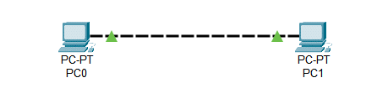

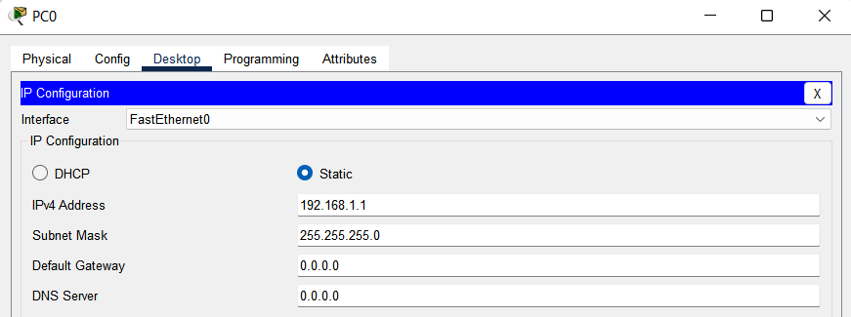

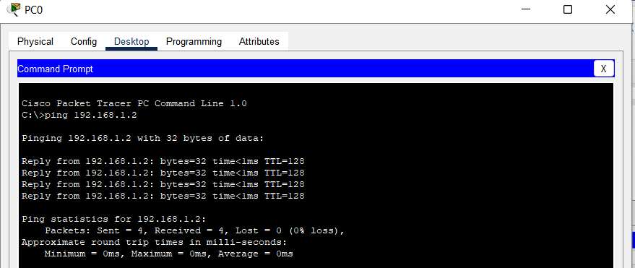

* **Client-Server Network**

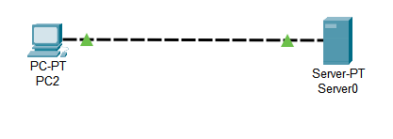

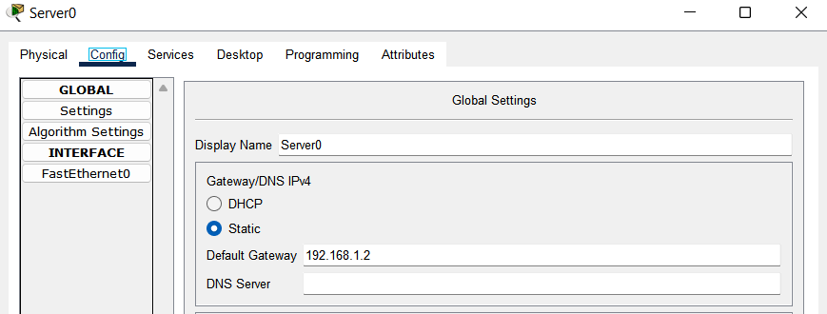

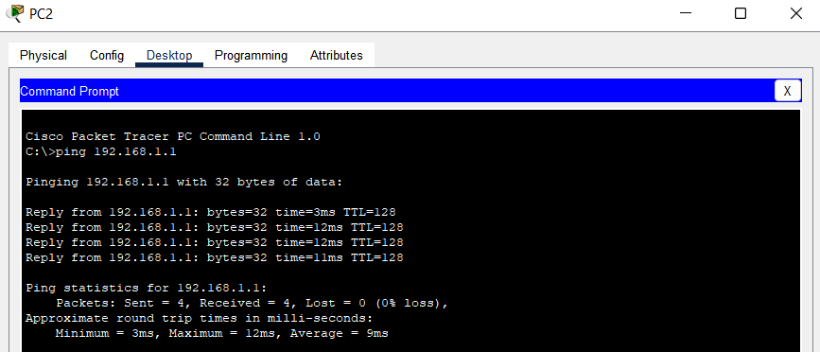

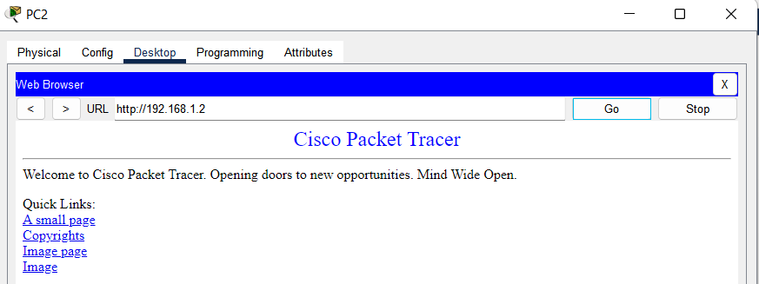

* **Multiple Client-server Network**

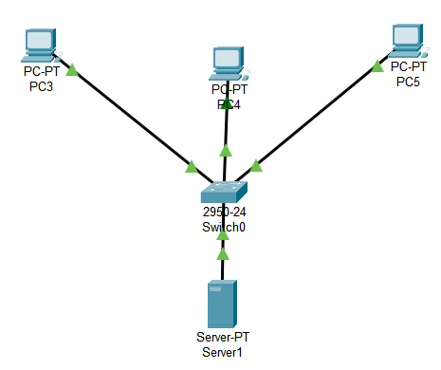



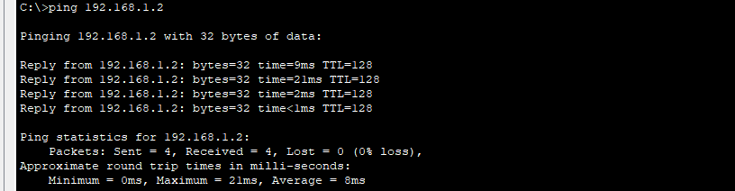

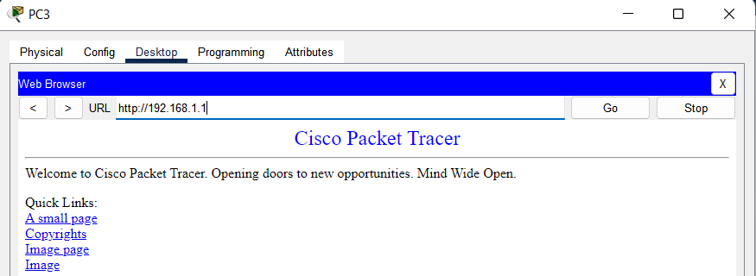

* **Conclusion**: The experiment demonstrates the use of network connectivity between different end devices. Understanding these networks is crucial for network administration and troubleshooting.