**Experiment 4**

**AIM:**

To study basic server configurations : HTTP DNS DHCP EMAIL FTP

### Objective:

To create, understand and demonstrate the use server configurations by using packet tracer.

### Materials Required:

* A computer with an active network connection (Windows, macOS, or Linux)
* Packet tracer software application installed

### Procedure, Output and Observations

**DHCP**

* Open Cisco packet tracer and click on end devices, select PC and place 5 of them on the front, then select a server and place it too
* Click on network devices, click on switches, select the 2950-24 switch and place it like shown in the image
* Click on connections, Select the copper-straight-through connection and connect the PCs to the switch and the switch to the server using FastEthernet (2 green nodes will be displayed on each wire after some time).

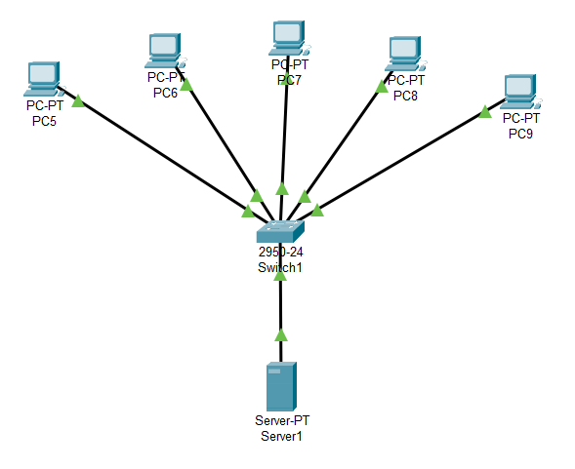

* Click on the Server, go to desktop tab, click on IP configuration and set the ipv4 and the default gateway to 192.168.1.1, the subnet mask will appear automatically.

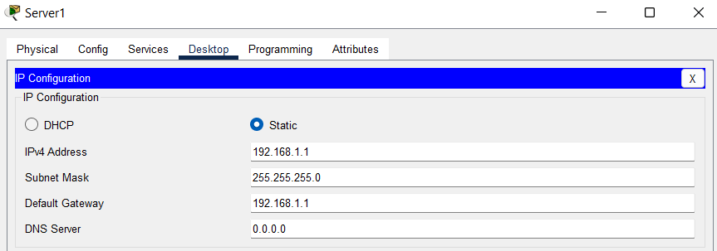

* Click on the services tab, go to DHCP and turn on the service, set a poolname for EX: newpool, set the default gateway and the DNS server to 192.168.1.1.
* Change the start ip address to 192.168.1.2 like shown

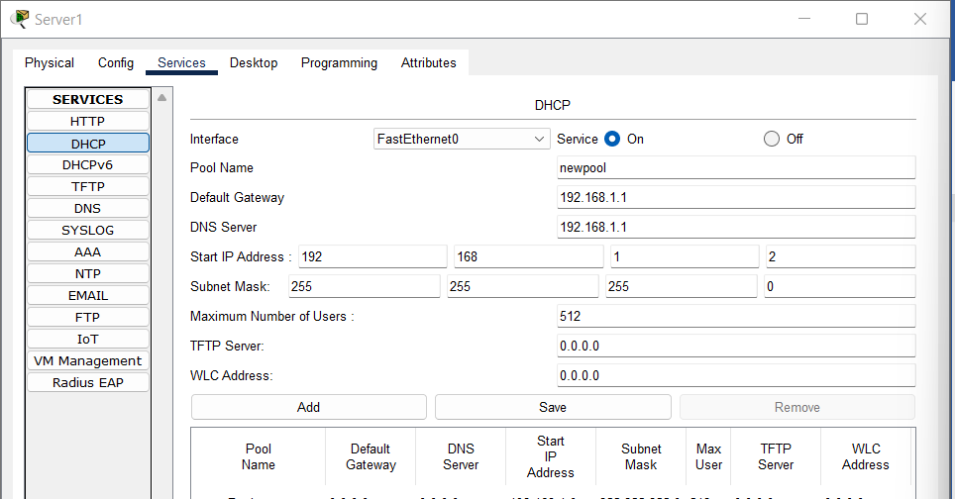

* Click add to add the newpool, it will be displayed under poolname

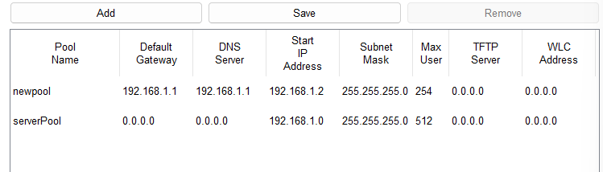

* Click on the first PC, go to desktop tab, open ip configuration and click on DHCP to automatically set the ipv4 address

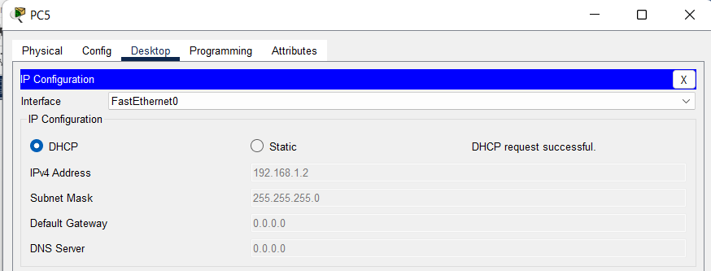

* Repeat the process for the other 4 PCs
* Click on server, go to desktop tab click on command prompt and ping with the ipv4 addresses of all the PCs

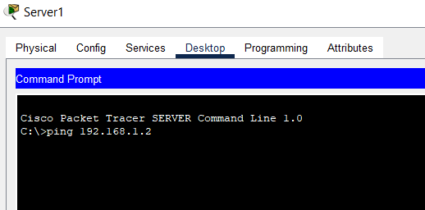

* It should show the following

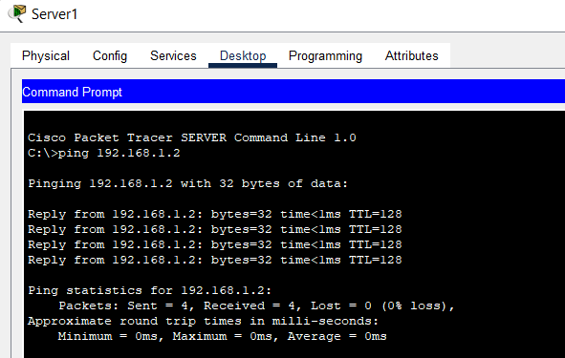

* **DNS,HTTP,FTP,EMAIL**
* Select a server, 2811 router, 2950-24 switch and 2 PCs and connect them using the copper straight through wire as Fastethernet as shown below:

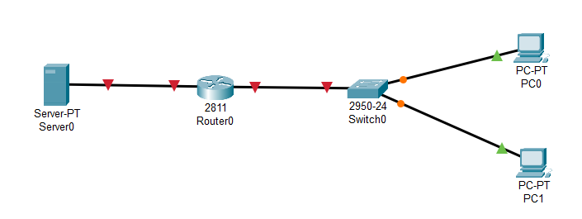

* Open IP configuration of PC 1 and configure it accordingly:

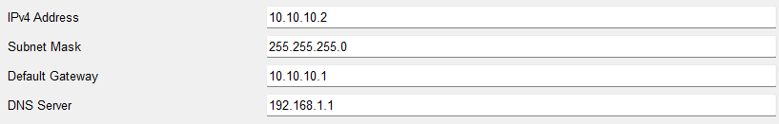

* Open IP configuration of PC 0 and configure it accordingly:

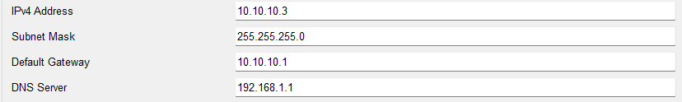

* Click on the CLI tab of router and configure it with the server and the switch

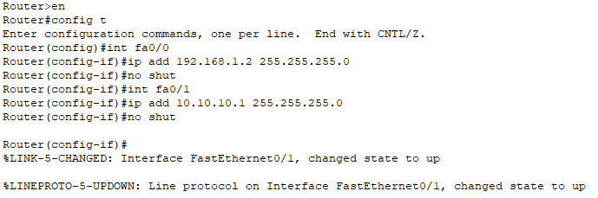

* After configurations are done, all nodes should turn green:

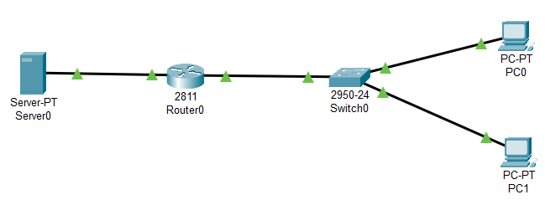

* Set the IP configurations of server as shown:

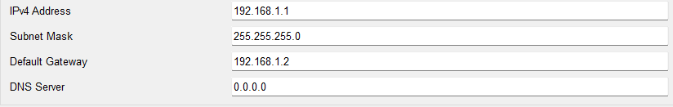

* **HTTPS**: For accessing HTTPS, simply turn on the service in the services tab of the server and open web browser in one of the PCs and search the server IP address to fetch results:

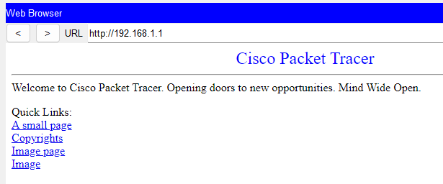

* **DNS**: For accessing DNS, go to DNS in services tab of server, turn it on, set a domain name with IP address of the server and open web browser in one of the PCs and search the domain name to fetch results:

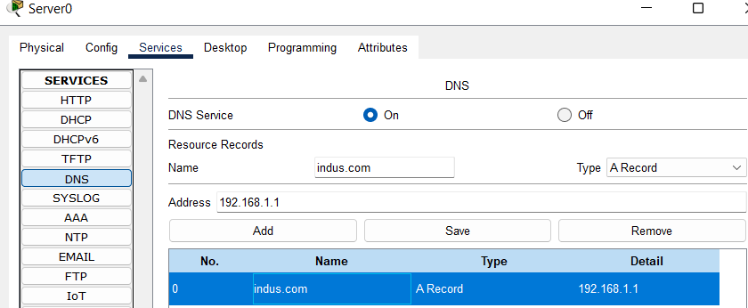

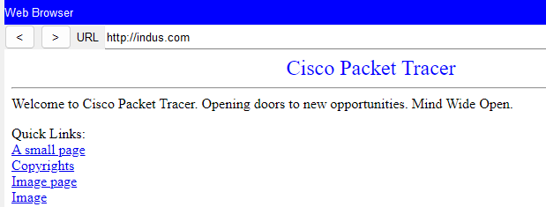

* **FTP**: For accessing FTP service, go to FTP in services tab of the server, turn it on, add a username and password with permissions(write, read, delete, rename, list). Repeat for another time to create 2 users.

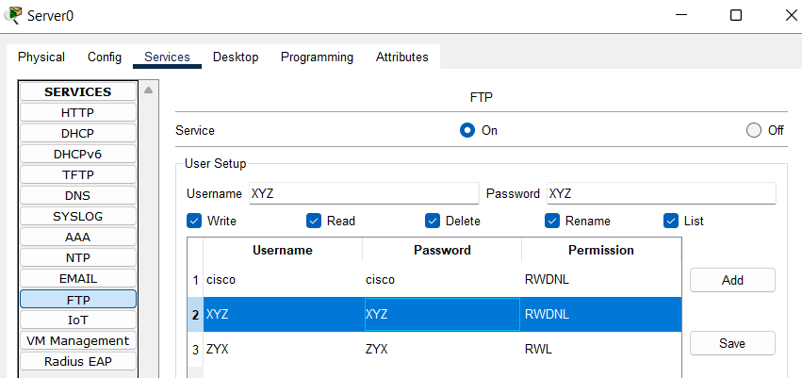

* Open the text editor and write down data in file and save it as Test.txt

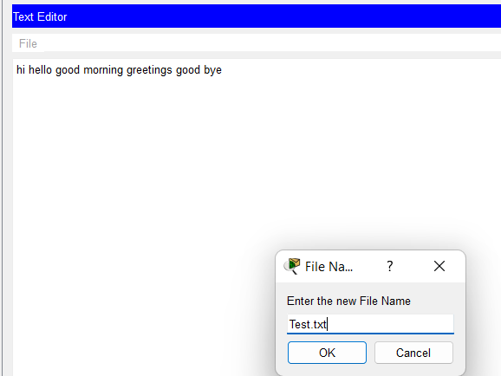

* Go to Cmd of the same PC and write following commands: ‘dir’ to check the directory, ’ftp 192.168.1.1’ to connect to FTP server, enter username and password to log in then write ‘put Test.txt’ to transfer the file.

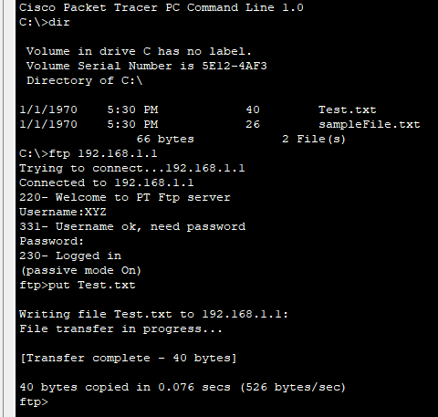

* Open cmd of the other PC and write ‘ftp 192.168.1.1’ and enter username password to log on then write ‘get Test.txt’ to receive it.

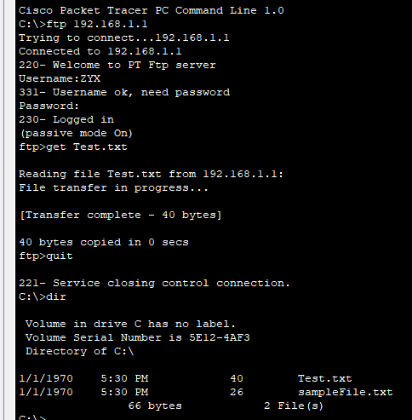

* **EMAIL:** For accessing email services, go to email via services tab of server, write a domain name and create 2 users with name and password:

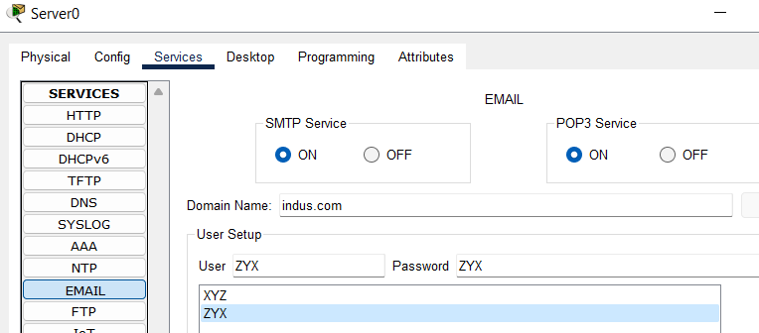

* Go to email of PC0 and PC1 and configure the details

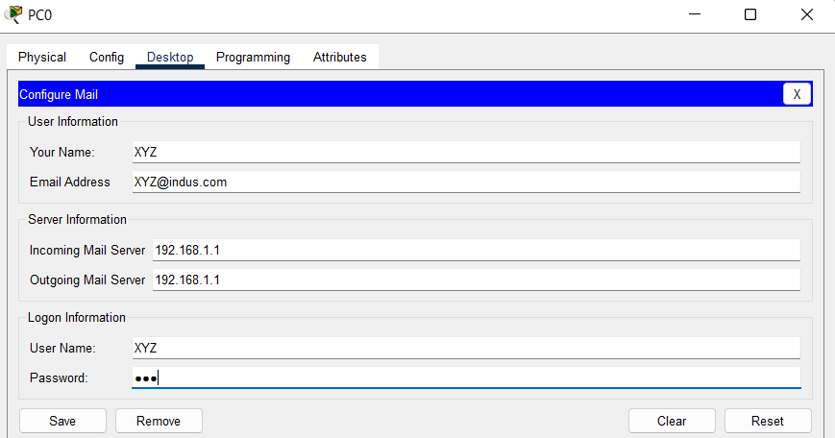

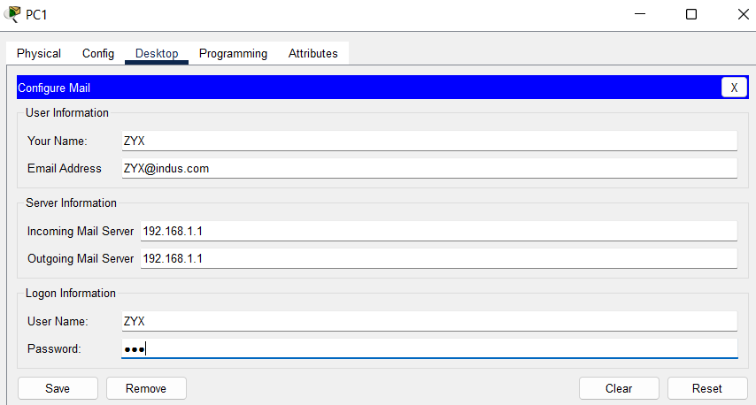

* Compose an email and send it as shown:

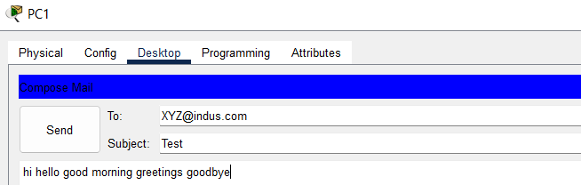

* Go to email of PC0 where email is sent and click on receive to receive the email:

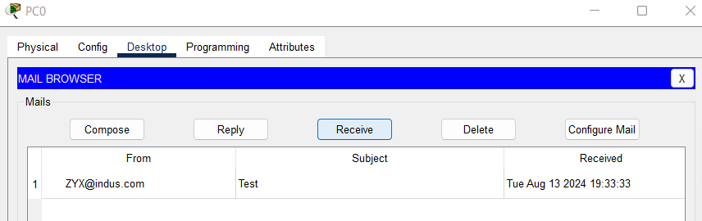

* **Conclusion**: The experiment demonstrates the use of services like HTTP,DNS,DHTP,FTP,EMAIL by configuration of server . Understanding these configurations is crucial for network administration and troubleshooting.