**Experiment 6**

**AIM:**

To study and design IP addressing for IPv4

### Objective:

Use VLSM subnetting and subnetting to design ip addresses for a company with branches in ahmedabad, delhi and chennai. ahmedabad has 3 sub branches with A-120PCs, B-170PCs, C-60PCs. Delhi has 2 sub branches A-29PCs, B-14PCs. Chennai has 3 sub branches A-14PCs, B-6PCs, C-4PCs. Use class c private address with minimum wastage.

### Materials Required:

* A computer with an active network connection (Windows, macOS, or Linux)
* Packet tracer software application installed

### Procedure, Output and Observations

**1. Calculate the Required Subnet Sizes**

Ahmedabad Branches:

* Branch B: 170 PCs → /24 (256 IP addresses)
* Branch A: 120 PCs → /25 (128 IP addresses)
* Branch C: 60 PCs → /26 (64 IP addresses)

Delhi Branches:

* Branch A: 29 PCs → /27 (32 IP addresses)
* Branch B: 14 PCs → /28 (16 IP addresses)

Chennai Branches:

* Branch A: 14 PCs → /28 (16 IP addresses)
* Branch B: 6 PCs → /29 (8 IP addresses)
* Branch C: 4 PCs → /29 (8 IP addresses)

Ahmedabad to Delhi :

* Network → /30 (4 IP addresses)

Ahmedabad to Chennai :

* Network → /30 (4 IP addresses)

Delhi to Chennai :

* Network → /30 (4 IP addresses)

**2. Allocate IP Subnets in a Continuous Manner**

Ahmedabad Branch

1. Branch B (256 IPs)
   * Network Address: 192.168.0.0/24
   * Usable IP Range: 192.168.0.1 to 192.168.0.254
   * Broadcast Address: 192.168.0.255
   * Subnet Mask:255.255.255.0
2. Branch A (128 IPs)
   * Network Address: 192.168.1.0/25
   * Usable IP Range: 192.168.1.1 to 192.168.1.126
   * Broadcast Address: 192.168.1.127
   * Subnet Mask:255.255.255.128
3. Branch C (64 IPs)
   * Network Address: 192.168.1.128/26
   * Usable IP Range: 192.168.1.129 to 192.168.1.190
   * Broadcast Address: 192.168.1.191
   * Subnet Mask:255.255.255.192

Delhi Branch

1. Branch A (32 IPs)
   * Network Address: 192.168.1.192/27
   * Usable IP Range: 192.168.1.193 to 192.168.1.222
   * Broadcast Address: 192.168.1.223
   * Subnet Mask:255.255.255.224
2. Branch B (16 IPs)
   * Network Address: 192.168.1.224/28
   * Usable IP Range: 192.168.1.225 to 192.168.1.238
   * Broadcast Address: 192.168.1.239
   * Subnet Mask:255.255.255.240

Chennai Branch

1. Branch A (16 IPs)
   * Network Address: 192.168.1.240/28
   * Usable IP Range: 192.168.1.241 to 192.168.1.254
   * Broadcast Address: 192.168.1.255
   * Subnet Mask:255.255.255.240
2. Branch B (8 IPs)
   * Network Address: 192.168.2.0/29
   * Usable IP Range: 192.168.2.1 to 192.168.2.6
   * Broadcast Address: 192.168.2.7
   * Subnet Mask:255.255.255.248
3. Branch C (8 IPs)
   * Network Address: 192.168.2.8/29
   * Usable IP Range: 192.168.2.9 to 192.168.2.14
   * Broadcast Address: 192.168.2.15
   * Subnet Mask:255.255.255.248
4. Ahmedabad to Delhi (4 Ips)
   * Network Address: 192.168.2.24/30
   * Usable IP Range: 192.168.2.25 to 192.168.2.26
   * Broadcast Address: 192.168.2.27
   * Subnet Mask:255.255.255.252
5. Ahmedabad to Chennai (4 Ips)
   * Network Address: 192.168.2.28/30
   * Usable IP Range: 192.168.2.29 to 192.168.2.30
   * Broadcast Address: 192.168.2.31
   * Subnet Mask:255.255.255.252
6. Chennai to Delhi (4 Ips)
   * Network Address: 192.168.2.32/30
   * Usable IP Range: 192.168.2.33 to 192.168.2.35
   * Broadcast Address: 192.168.2.35
   * Subnet Mask:255.255.255.252

|  |  |  |  |  |
| --- | --- | --- | --- | --- |
|  | Network ID | Broadcast ID | Host Range | Subnet Mask |
| Ahmedabad-B | 192.168.0.0/24 | 192.168.0.255/24 | 192.168.0.1/24 to 192.168.0.254/24 | 255.255.255.0 |
| Ahmedabad-A | 192.168.1.0/25 | 192.168.1.127/25 | 192.168.1.1/25 to 192.168.1.126/25 | 255.255.255.128 |
| Ahmedabad-C | 192.168.1.128/26 | 192.168.1.191/26 | 192.168.1.129/26 to 192.168.1.190/26 | 255.255.255.192 |
| Delhi-A | 192.168.1.192/27 | 192.168.1.223/27 | 192.168.1.193/27 to 192.168.1.222/27 | 255.255.255.224 |
| Delhi-B | 192.168.1.224/28 | 192.168.1.239/28 | 192.168.1.225/28 to 192.168.1.238/28 | 255.255.255.240 |
| Chennai-A | 192.168.1.240/28 | 192.168.1.255/28 | 192.168.1.241/28 to 192.168.1.254/28 | 255.255.255.240 |
| Chennai-B | 192.168.2.0/29 | 192.168.2.7/29 | 192.168.2.1/29 to 192.168.2.6/29 | 255.255.255.248 |
| Chennai-C | 192.168.2.8/29 | 192.168.2.15/29 | 192.168.2.9/29 to 192.168.2.14/29 | 255.255.255.248 |
| Ahmedabad-Delhi | 192.168.2.24/30 | 192.168.2.27/30 | 192.168.2.25/30 to 192.168.2.26/30 | 255.255.255.252 |
| Ahmedabad-Chennai | 192.168.2.28/30 | 192.168.2.31/30 | 192.168.2.29/30 to 192.168.2.30/30 | 255.255.255.252 |
| Chennai-Delhi | 192.168.2.32/30 | 192.168.2.35/30 | 192.168.2.31/30 to 192.168.2.34/30 | 255.255.255.252 |

**PERFORMING IN CISCO PACKET TRACER**

* Take 3 routers and add WIC-2T and NM-2FE2W modules in the router
* Name the routers as Ahm,Dlh and Chn. Also set the hostnames
* Connect the routers with serial DCE connection

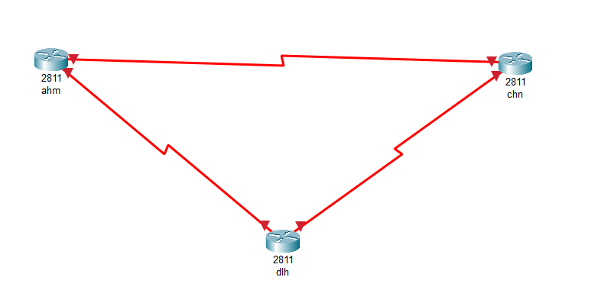

* Select 2950T-24 Switches to connect to routers for each sub branch and connect equivalent PCs to each switch

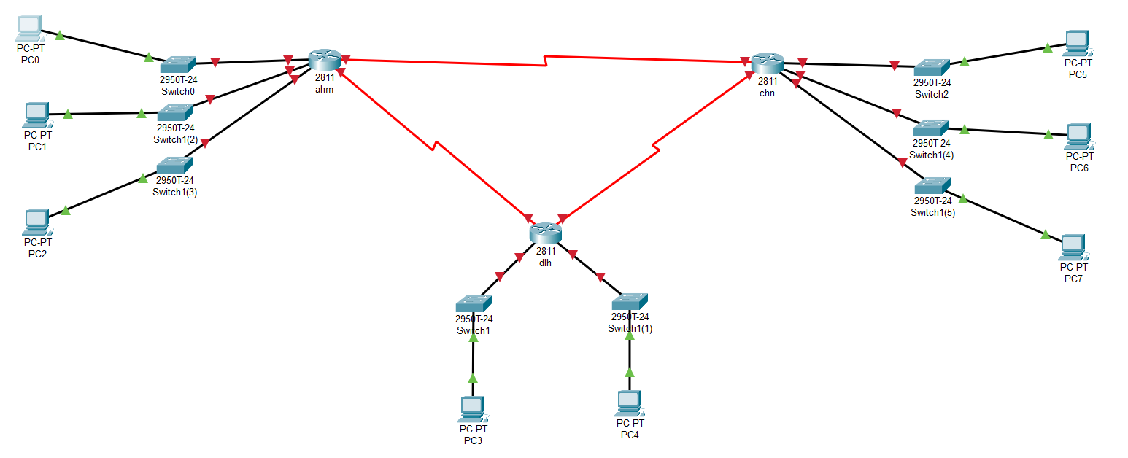

* Now we will interface the serial ports in each router and provide clock rate

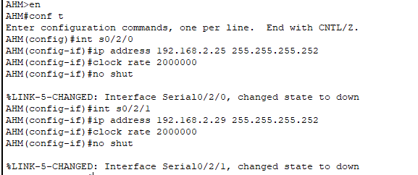

* Repeat the process for all routers and the serial port’s state will be up

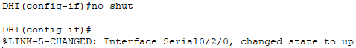

* Now we will interface the fastethernet ports in each router

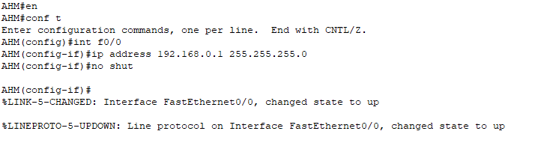

* Repeat the process for all sub branches of all other routers
* The resulting network should look like this:

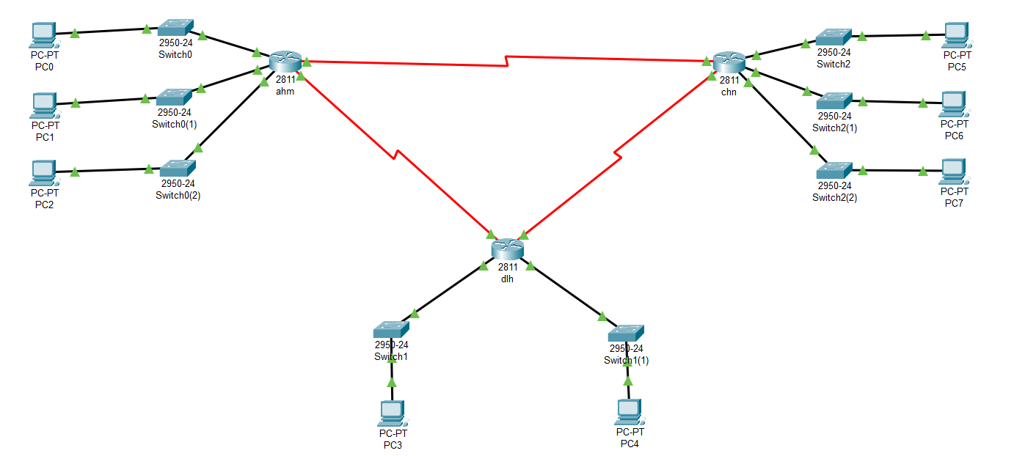

* **Conclusion**: The experiment demonstrates the design of IPv4 addressing with minimum wastage of IP addresses using VLSM and Subnetting