**Experiment 7**

**AIM:**

To configure DHCP and Static Routing in a network

### Objective:

To provide IP address to host using DHCP and statically routing it with other networks

### Materials Required:

* A computer with an active network connection (Windows, macOS, or Linux)
* Packet tracer software application installed

### Procedure, Output and Observations

**We will be using the network created in pract-6**

|  |  |  |  |  |
| --- | --- | --- | --- | --- |
|  | Network ID | Broadcast ID | Host Range | Subnet Mask |
| Ahmedabad-B | 192.168.0.0/24 | 192.168.0.255/24 | 192.168.0.1/24 to 192.168.0.254/24 | 255.255.255.0 |
| Ahmedabad-A | 192.168.1.0/25 | 192.168.1.127/25 | 192.168.1.1/25 to 192.168.1.126/25 | 255.255.255.128 |
| Ahmedabad-C | 192.168.1.128/26 | 192.168.1.191/26 | 192.168.1.129/26 to 192.168.1.190/26 | 255.255.255.192 |
| Delhi-A | 192.168.1.192/27 | 192.168.1.223/27 | 192.168.1.193/27 to 192.168.1.222/27 | 255.255.255.224 |
| Delhi-B | 192.168.1.224/28 | 192.168.1.239/28 | 192.168.1.225/28 to 192.168.1.238/28 | 255.255.255.240 |
| Chennai-A | 192.168.1.240/28 | 192.168.1.255/28 | 192.168.1.241/28 to 192.168.1.254/28 | 255.255.255.240 |
| Chennai-B | 192.168.2.0/29 | 192.168.2.7/29 | 192.168.2.1/29 to 192.168.2.6/29 | 255.255.255.248 |
| Chennai-C | 192.168.2.8/29 | 192.168.2.15/29 | 192.168.2.9/29 to 192.168.2.14/29 | 255.255.255.248 |
| Ahmedabad-Delhi | 192.168.2.24/30 | 192.168.2.27/30 | 192.168.2.25/30 to 192.168.2.26/30 | 255.255.255.252 |
| Ahmedabad-Chennai | 192.168.2.28/30 | 192.168.2.31/30 | 192.168.2.29/30 to 192.168.2.30/30 | 255.255.255.252 |
| Chennai-Delhi | 192.168.2.32/30 | 192.168.2.35/30 | 192.168.2.31/30 to 192.168.2.34/30 | 255.255.255.252 |

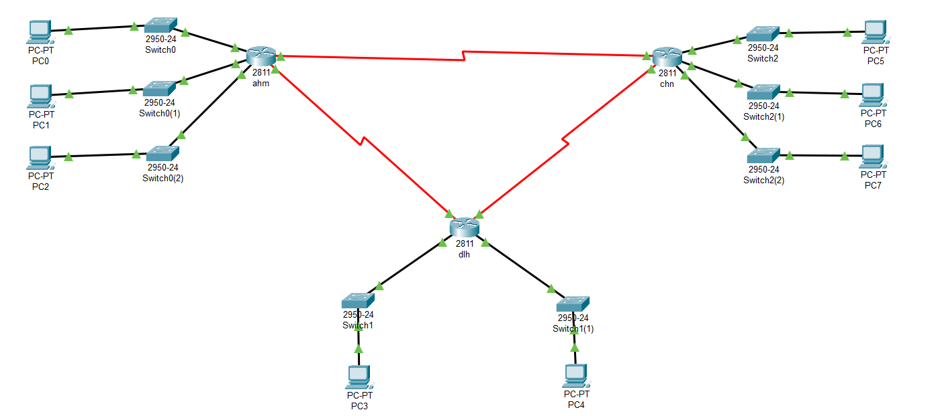

**PERFORMING IN CISCO PACKET TRACER**

* Select AHM and go to CLI and create pool for each sub branch for assigning ip address via DHCP.

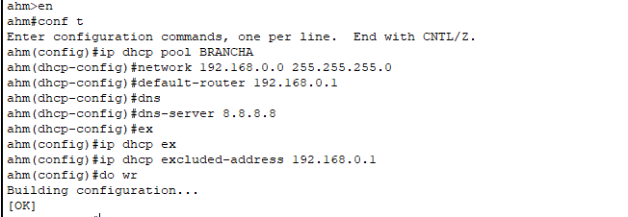

* Repeat the process for all routers
* Goto each PC and enable DHCP in IP configuration setting and DHCP request should be successful

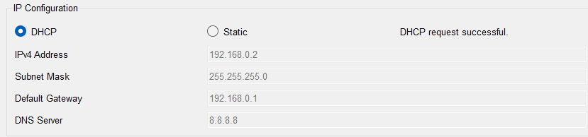

* Now we will use static routing to assign routes for sending packets
* For that we will assign routes for each and every non directly connected network. For Ex: Ahm is not connected directly to any sub branches in other city or the network between Delhi and Chennai.

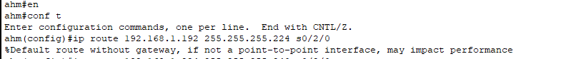



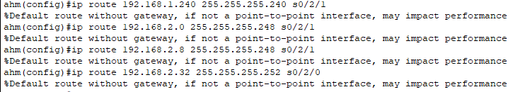

* We will repeat this process for all routers. After that we will send packets to check if the connection is routed.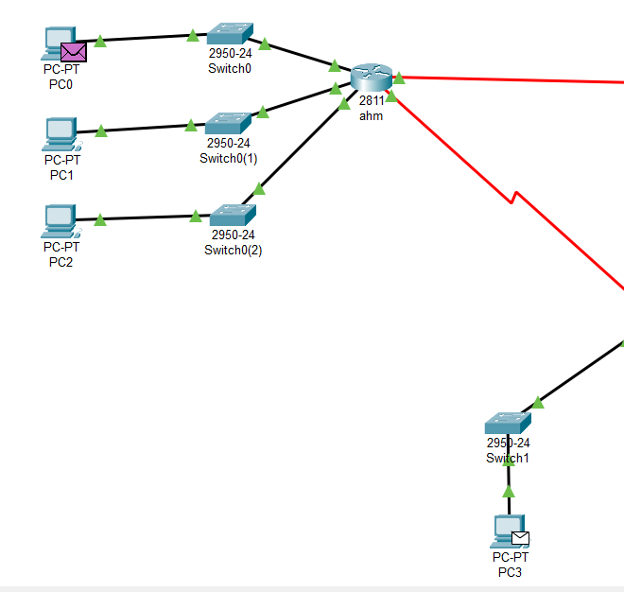



* **Conclusion**: The experiment demonstrates the use of DHCP services and Static routing to send data between different networks