**Experiment 8**

**AIM:**

To configure dynamic routing using RIP protocol in a network.

### Objective:

To route a network dynamically using RIP and checking the routes with ping command.

### Materials Required:

* A computer with an active network connection (Windows, macOS, or Linux)
* Packet tracer software application installed

### Procedure, Output and Observations

A company with branches in ahmedabad, delhi and chennai. ahmedabad has 3 sub branches with A-120PCs B-170PCs C-60PCs. Delhi has 2 sub branches A-29PCs B-14PCs. Chennai has 3 sub branches A-14PCs B-6PCs C-4PCs.

|  |  |  |  |  |
| --- | --- | --- | --- | --- |
|  | Network ID | Broadcast ID | Host Range | Subnet Mask |
| Ahmedabad-B | 192.168.0.0/24 | 192.168.0.255/24 | 192.168.0.1/24 to 192.168.0.254/24 | 255.255.255.0 |
| Ahmedabad-A | 192.168.1.0/25 | 192.168.1.127/25 | 192.168.1.1/25 to 192.168.1.126/25 | 255.255.255.128 |
| Ahmedabad-C | 192.168.1.128/26 | 192.168.1.191/26 | 192.168.1.129/26 to 192.168.1.190/26 | 255.255.255.192 |
| Delhi-A | 192.168.1.192/27 | 192.168.1.223/27 | 192.168.1.193/27 to 192.168.1.222/27 | 255.255.255.224 |
| Delhi-B | 192.168.1.224/28 | 192.168.1.239/28 | 192.168.1.225/28 to 192.168.1.238/28 | 255.255.255.240 |
| Chennai-A | 192.168.1.240/28 | 192.168.1.255/28 | 192.168.1.241/28 to 192.168.1.254/28 | 255.255.255.240 |
| Chennai-B | 192.168.2.0/29 | 192.168.2.7/29 | 192.168.2.1/29 to 192.168.2.6/29 | 255.255.255.248 |
| Chennai-C | 192.168.2.8/29 | 192.168.2.15/29 | 192.168.2.9/29 to 192.168.2.14/29 | 255.255.255.248 |
| Ahmedabad-Delhi | 192.168.2.24/30 | 192.168.2.27/30 | 192.168.2.25/30 to 192.168.2.26/30 | 255.255.255.252 |
| Ahmedabad-Chennai | 192.168.2.28/30 | 192.168.2.31/30 | 192.168.2.29/30 to 192.168.2.30/30 | 255.255.255.252 |
| Chennai-Delhi | 192.168.2.32/30 | 192.168.2.35/30 | 192.168.2.31/30 to 192.168.2.34/30 | 255.255.255.252 |

**PERFORMING IN CISCO PACKET TRACER**

* Take 3 routers and add WIC-2T and NM-2FE2W modules in the router
* Name the routers as Ahm,Dlh and Chn. Also set the hostnames
* Connect the routers with serial DCE connection

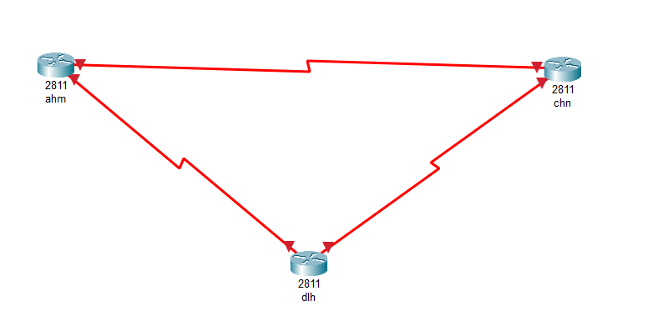

* Select 2950T-24 Switches to connect to routers for each sub branch and connect equivalent PCs to each switch

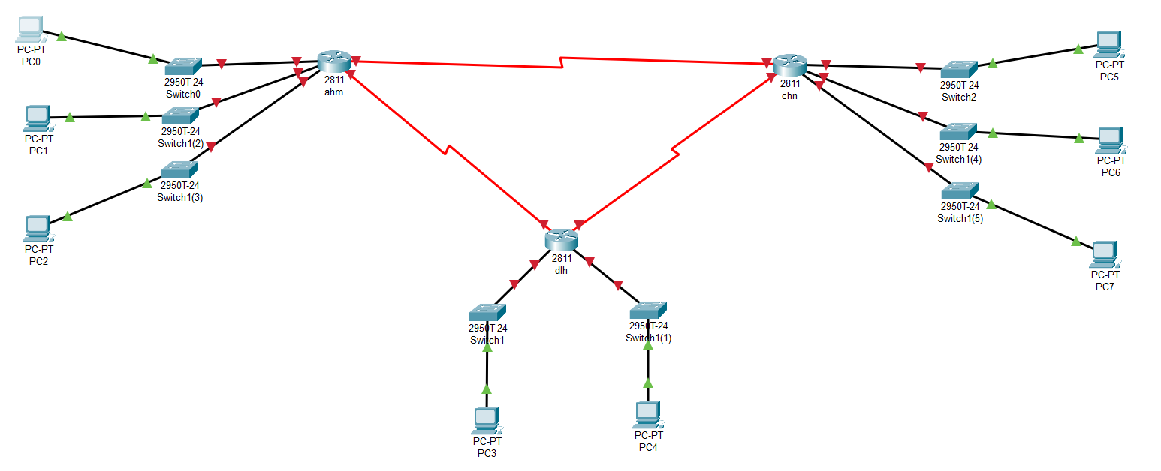

* Now we will interface the ethernet and serial ports in each router and provide clock rate
* For Ahmedabad router:

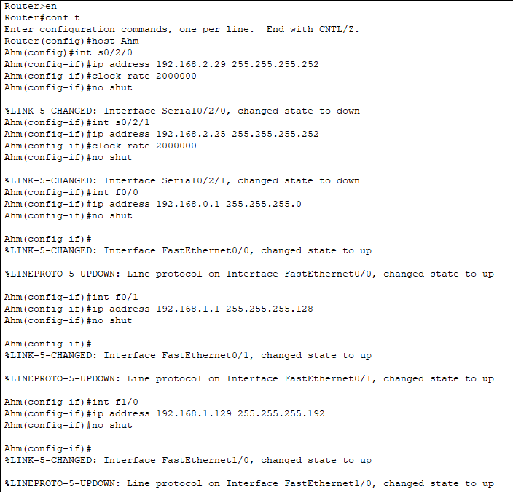

* For Delhi router:

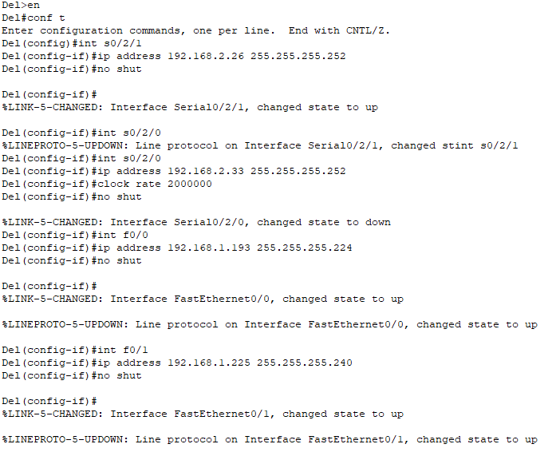

* For Chennai router:

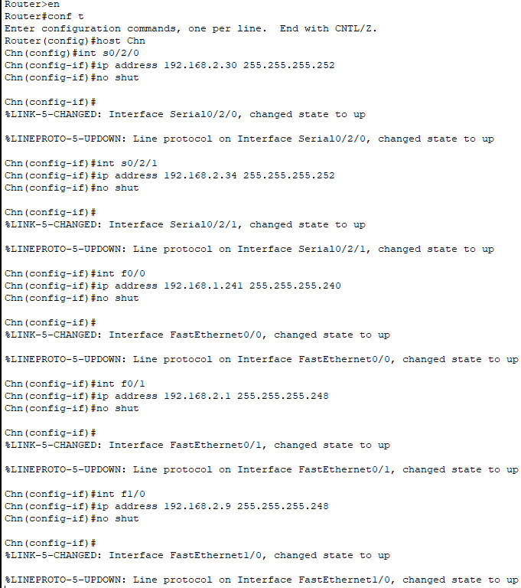

* Select AHM and go to CLI and create pool for each sub branch for assigning ip address via DHCP

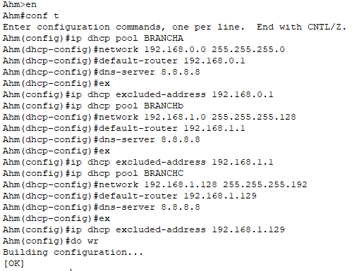

* Select DEL and go to CLI and create pool for each sub branch for assigning ip address via DHCP

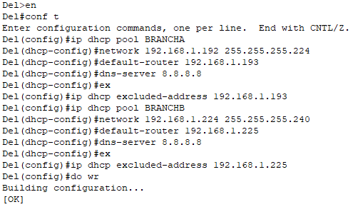

* Select CHN and go to CLI and create pool for each sub branch for assigning ip address via DHCP

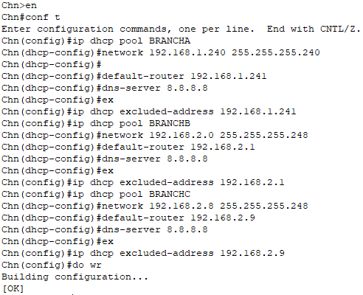

* Goto each PC and enable DHCP in IP configuration setting and DHCP request should be successful

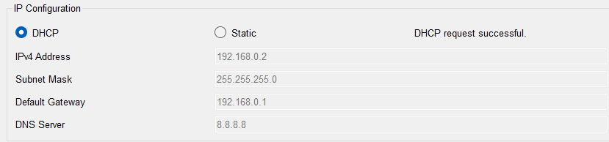

* Now we will use the router rip command and network command to add directly connected networks to dynamically route them

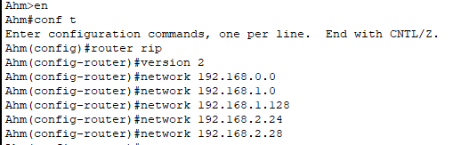

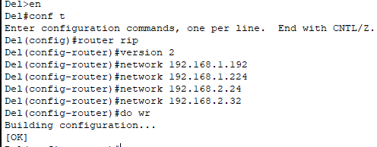

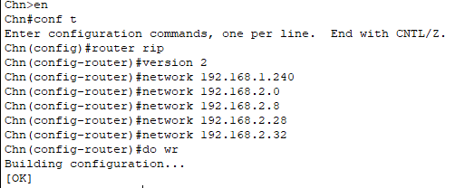

* Now we have dynamically routed the network using RIP protocol. We will test it using Ping command.
* Pinging Ahmedabad’s network with Delhi’s and chennai’s network

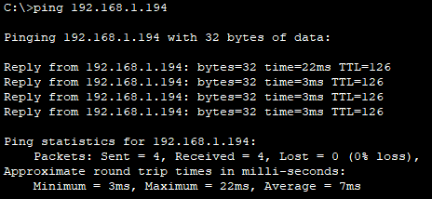

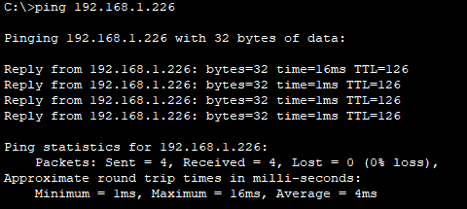

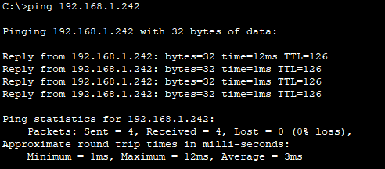

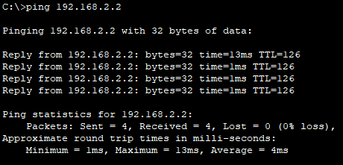

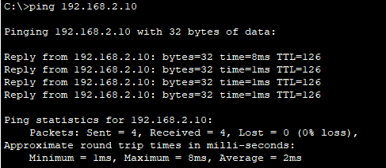

* Pinging Delhi’s network with Chennai’s network

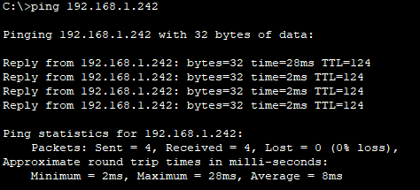

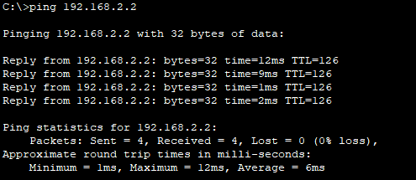

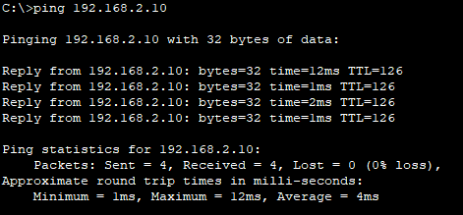

* **Conclusion**: The experiment demonstrates the use of RIP protocol and dynamic routing to send packets of data in a network