**Experiment 9A**

**AIM:**

To study and configure IOT registration server with wired network.

### Objective:

To create a wired network of home devices and server and configure IOT registration in the server.

### Materials Required:

* A computer with an active network connection (Windows, macOS, or Linux)
* Packet tracer software application installed

### Procedure, Output and Observations

* Click on end devices, go to Home tab and select motion detector and web camera and place it. Place a switch from network devices and a server from end devices.
* Click on the web camera and go to physical tab and click advanced at the bottom right corner to access the I/O config tab.
* Set the network adapter to PT-IOT-NM-1CFE
* Click on the motion detector and go to physical tab and click advanced at the bottom right corner to access the I/O config tab.
* Set the network adapter to PT-IOT-NM-1CFE
* Connect the devices with copper straight through cable as shown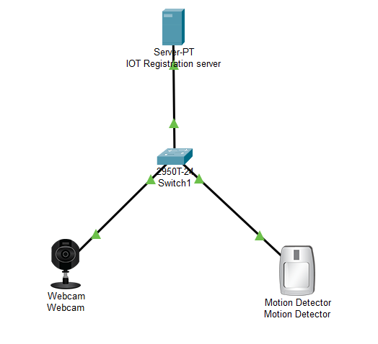
* Assign the IP addresses for server(192.168.1.1), for webcamera(192.168.1.2), for motion detector(192.168.1.3).
* Click on the server and go to services tab then IOT and turn it on

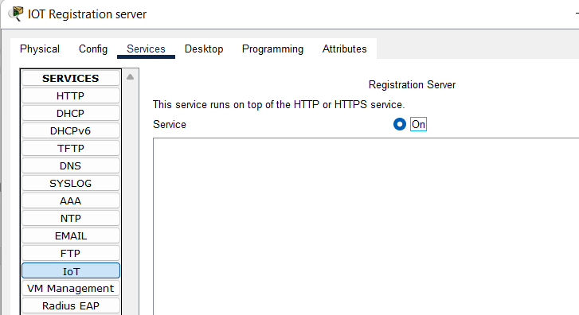

* Click on the Desktop tab, open web browser and search the assigned IP address of the server (192.168.1.1) to open the login page for Registration server.

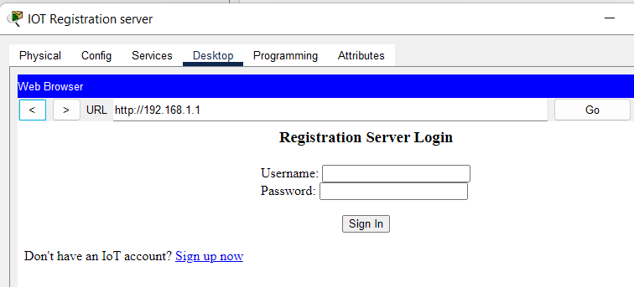

* Click on sign up now and enter the username and password of choice

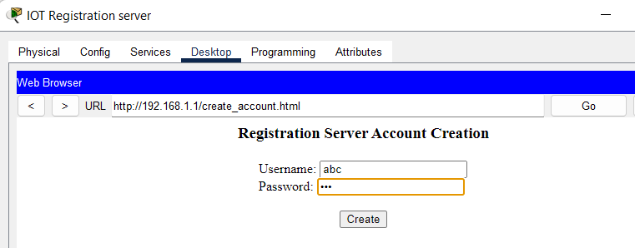

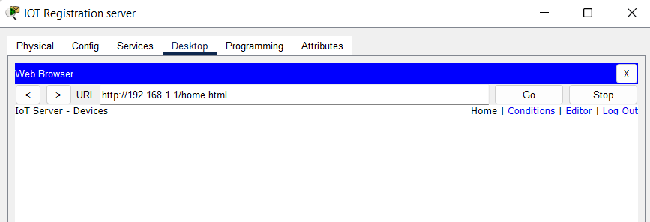

* Now to configure the IOT devices, Click on Motion detector, go to config tab, in Fastethernet section, click on remote server in IOT server and add the IP address of the server, username and password to connect.

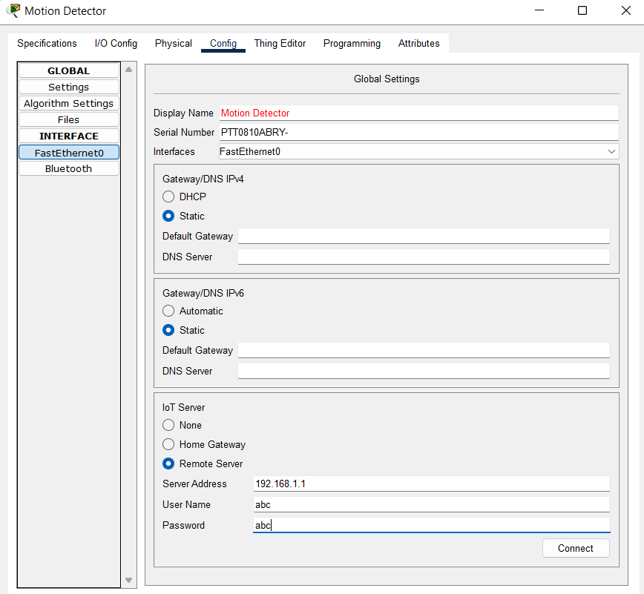

* Repeat the process for Web camera, Click on Webcamera, go to config tab, in Fastethernet section, click on remote server in IOT server and add the IP address of the server, username and password to connect.

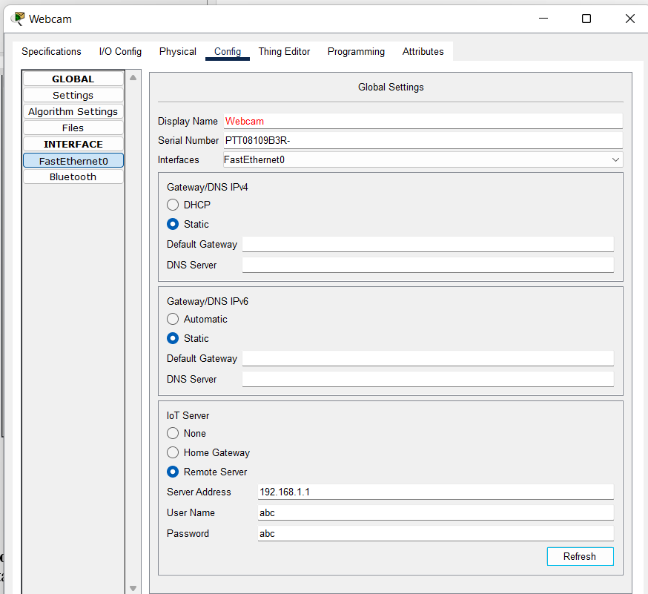

* After the connection is done, IOT registration page should be updated and will show the name of both devices.

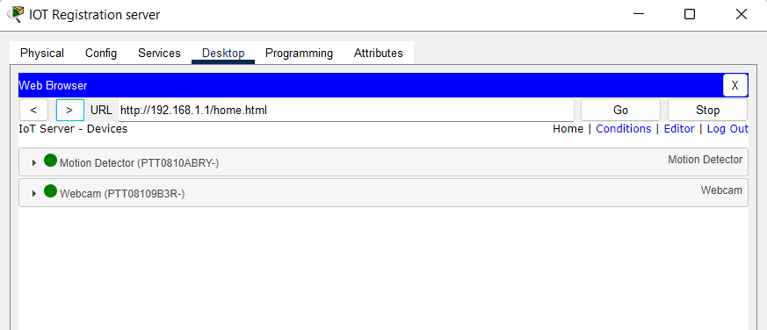

* Now to add conditions to the devices, we will open the registration server page, click on conditions, click on add to add rule.

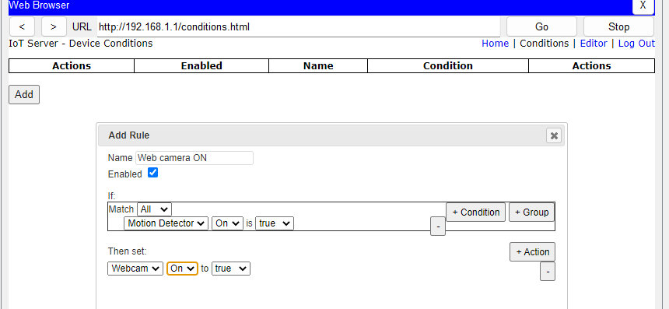

* Now to add off condition:

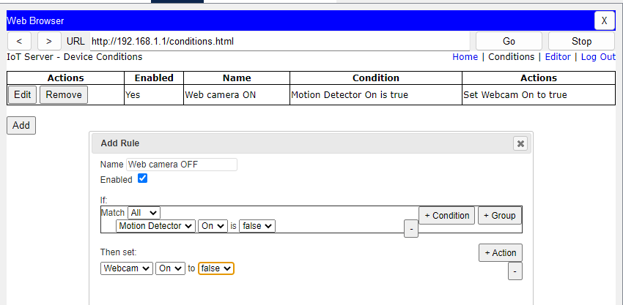

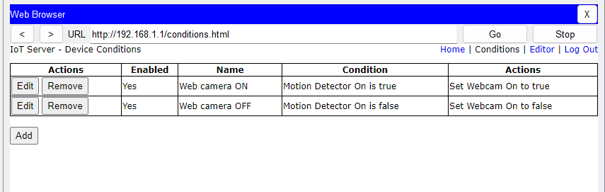

* Now to test it, hover the mouse pointer over to motion sensor while pressing alt key.

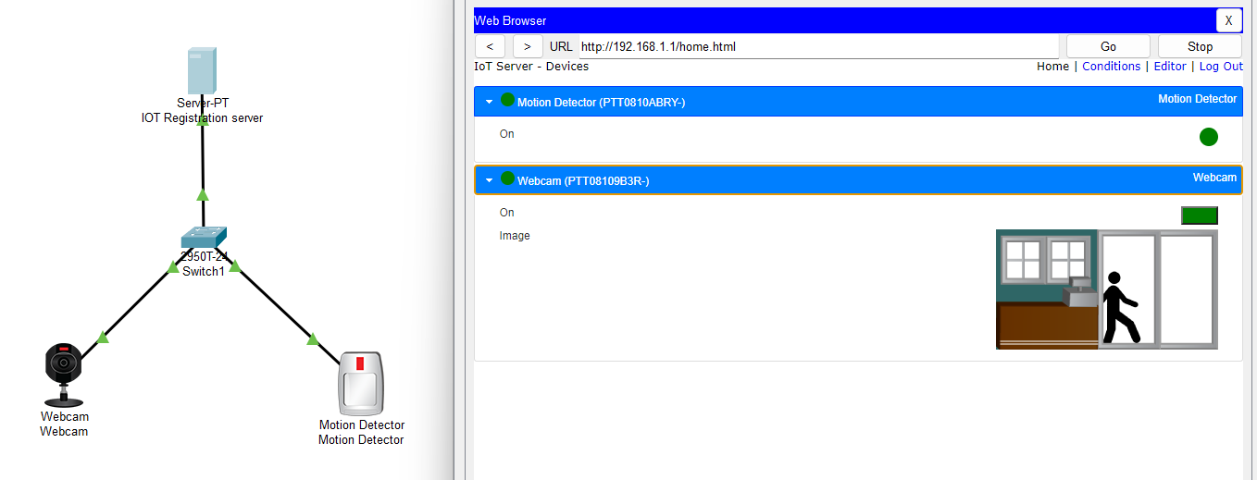

* **Conclusion**: The experiment demonstrates the use of Wired IOT registration server and its services for detecting motion and capturing it in web camera.