**Experiment 9B**

**AIM:**

To study and configure IOT registration server with wireless network.

### Objective:

To create a wireless network of home devices and server and configure IOT registration in the server.

### Materials Required:

* A computer with an active network connection (Windows, macOS, or Linux)
* Packet tracer software application installed

### Procedure, Output and Observations

* Click on end devices, go to Home tab and select motion detector and web camera and place it. Place a Home gateway by typing dlc-100 as shown

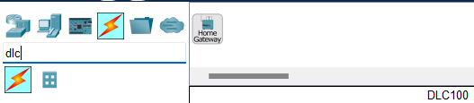

* Click on the web camera and go to physical tab and click advanced at the bottom right corner to access the I/O config tab.
* Set the network adapter to PT-IOT-NM-1W
* Click on the motion detector and go to physical tab and click advanced at the bottom right corner to access the I/O config tab.
* Set the network adapter to PT-IOT-NM-1W
* Place a tablet for monitoring.

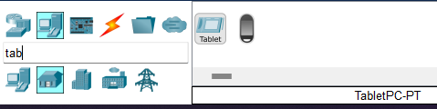

* Click on DLC-100 Home gateway, go to config tab and select wireless. Change the SSID of choice EX:MyHomegateway

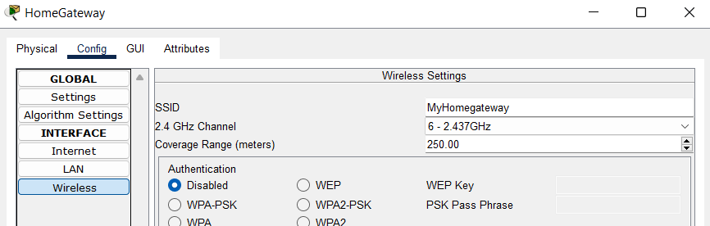

* Now to configure the IOT devices, Click on Webcamera go to config tab, in Wireless section, change the SSID to MyHomegateway.

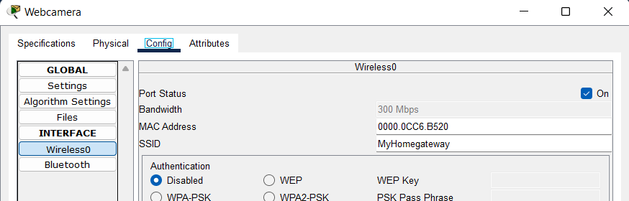

* Click on Motion detector, go to config tab, in Wireless section, change the SSID to MyHomegateway.

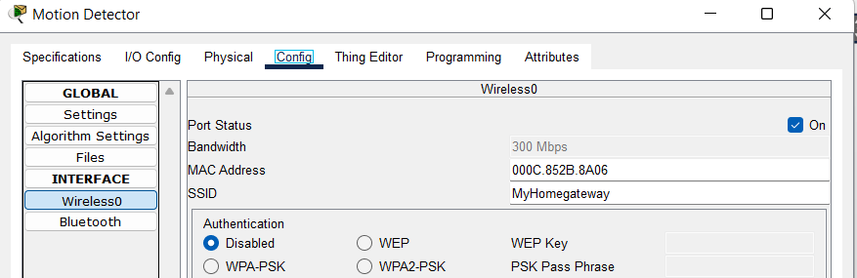

* Click on Tablet, go to config tab, in Wireless section, change the SSID to MyHomegateway.

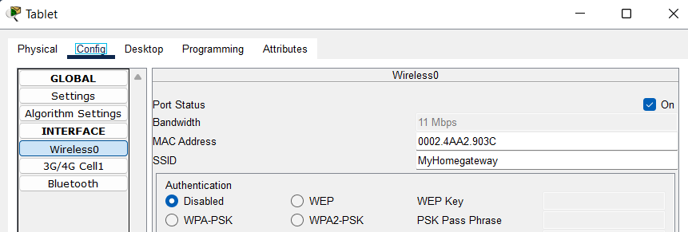

* The network should be wirelessly connected as shown

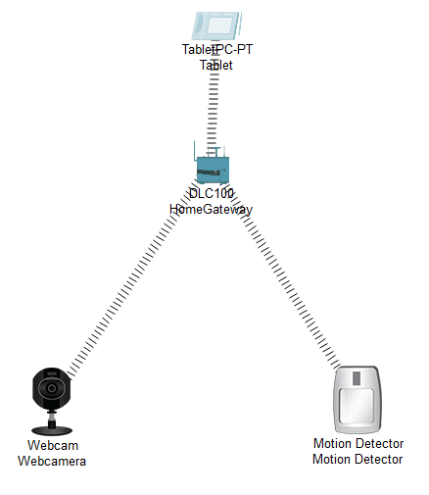

* Click on web camera go to config , go to wireless and in IOT server click on Home gateway. Click on Motion detector go to config , go to wireless and in IOT server click on Home gateway.

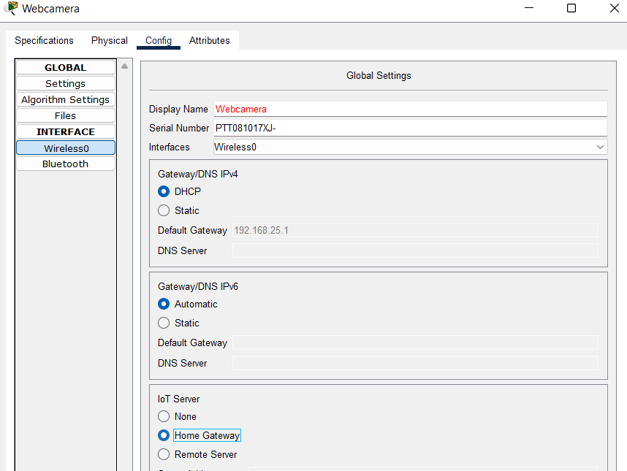

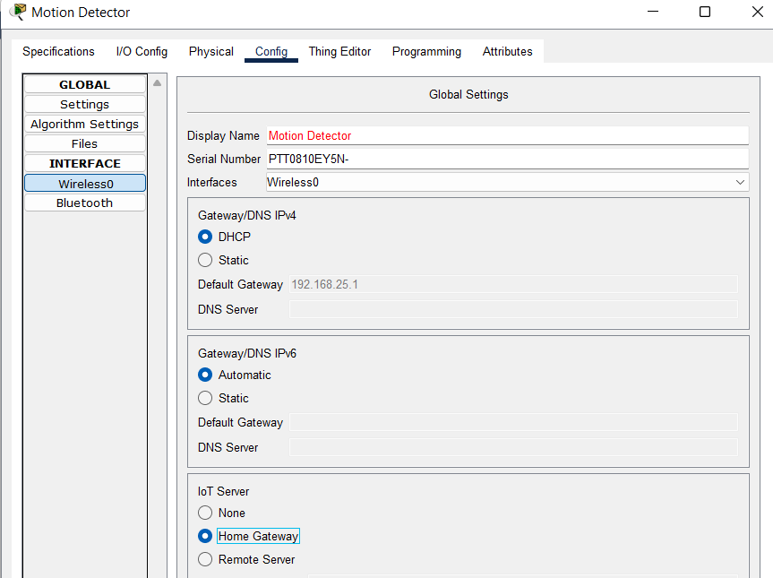

* Now go to desktop tab in tablet and click on IOT monitor

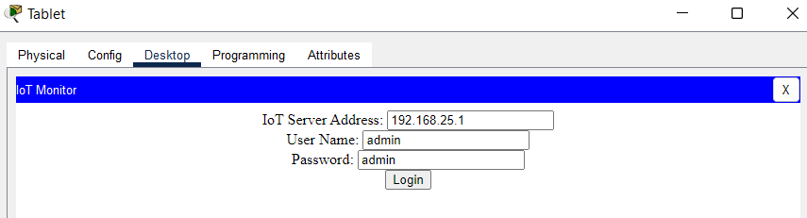

* It will auto assign the server IP, name and password. Click on login.

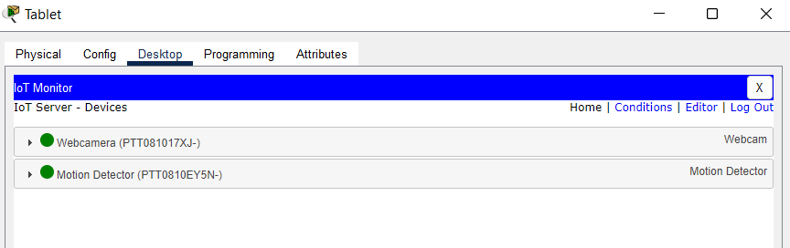

* Now to add conditions to the devices, click on conditions, click on add to add rule.

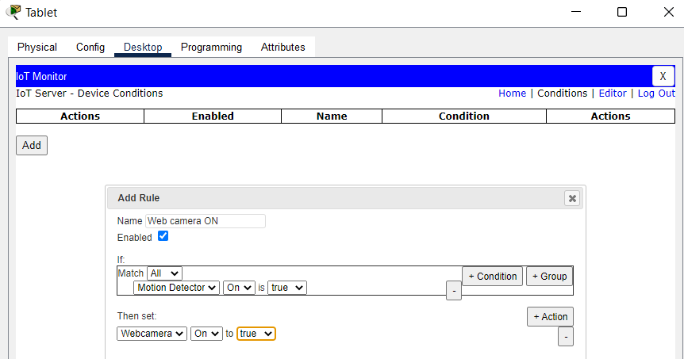

* Now to add off condition:

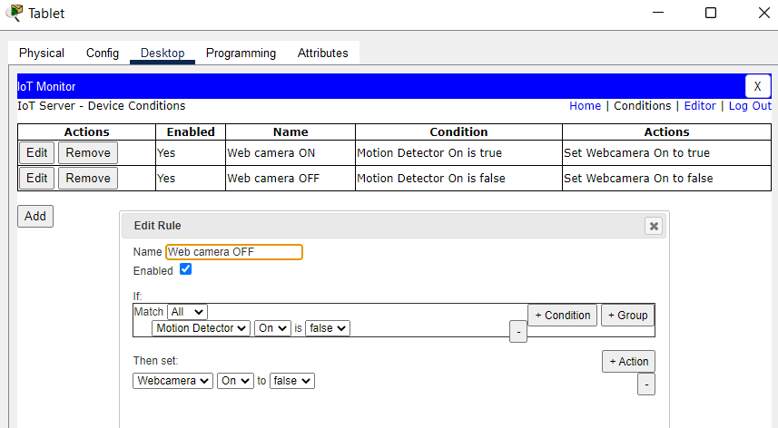

* Now to test it, hover the mouse pointer over to motion sensor while pressing alt key.

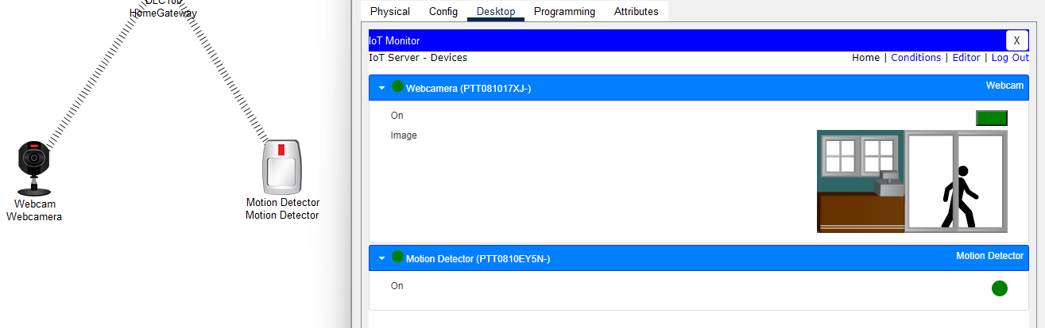

* **Conclusion**: The experiment demonstrates the use of Wireless IOT registration server and its services for detecting motion and capturing it in web camera.