AGENTIC COMMERCE GATEWAY
Software Requirements Specification (SRS)
Make any merchant AI-sellable, profitable, and safe.
Version 1.0
September 2026
MVP / Hackathon Build Specification

Document Control
Field | Value
Document | Software Requirements Specification
Product | Agentic Commerce Gateway (working name)
Version | 1.0
Status | Finalized MVP baseline
Primary demonstration domain | Electronics
Merchant targets | Shopify, WooCommerce, and custom e-commerce merchants
MVP catalog ingestion | CSV / JSON upload
Payment environment | Razorpay Test Mode — actual test checkout/payment
Merchant client | Flutter responsive web/PWA; Android/iOS-ready codebase
Primary backend | FastAPI + PostgreSQL + pgvector + Redis
AI orchestration | LangGraph for AI workflows only; deterministic transaction state outside LangGraph

Core architectural invariant
LLMs may interpret, recommend, rank, negotiate, and propose actions. They never move money directly. Every financial action passes through deterministic policy evaluation, approval rules when required, a transaction state machine, and the Razorpay adapter.

Contents
1. Introduction and Product Context
2. Stakeholders, Actors, Assumptions and Scope
3. System Architecture
4. Detailed MVP Feature Specification
5. Agent Architecture and Responsibilities
6. Merchant Negotiation and Bulk-Order Automation
7. Functional Requirements
8. Business Rules and Policy Model
9. Transaction Assurance and Failure Recovery
10. External API and Protocol Readiness
11. Data Requirements and Logical Model
12. Merchant Application and UX Requirements
13. Analytics, Explainability and Audit
14. Non-Functional Requirements
15. Technology Stack and Deployment Architecture
16. Testing and Acceptance Criteria
17. Out of Scope and Roadmap
18. Requirements Traceability Matrix
Appendix A. Example Electronics Demo Flow
Appendix B. Core State Definitions

1. Introduction and Product Context

1.1 Purpose
This SRS defines the finalized MVP requirements for an Agentic Commerce Gateway that enables merchants to expose AI-readable product catalogs, accept discovery and negotiation requests from external AI buyers, grow conversion through personalized recommendations and bounded negotiation, execute real Razorpay test-mode payments, and maintain a deterministic, auditable control layer around every financial action.

1.2 Problem Statement
Merchants increasingly need to sell not only to human shoppers but also to autonomous AI buyers. Existing merchant catalogs, product attributes, pricing, checkout flows, and operational policies are typically designed for websites and human interpretation. They are not consistently structured for AI agents to discover products, compare alternatives, negotiate terms, create bundles, complete payments, or recover safely from transaction failures. At the same time, autonomous selling creates new risks: discounts can exceed merchant limits, inventory can change mid-negotiation, duplicate checkout requests can cause repeated money movement, and payment/order states can diverge. The system addresses these issues through agent-readable commerce data, specialized AI agents, deterministic merchant policy enforcement, bounded autonomy, human approval for exceptional deals, and transaction assurance.

1.3 Product Vision
Vision
Create a merchant-side commerce layer that makes any supported merchant AI-sellable, profitable, and safe: discoverable by external AI buyers, capable of autonomous recommendation and negotiation, controlled by merchant-defined limits, and able to execute and reconcile Razorpay transactions with a complete audit trail.

1.4 MVP Goals
- Convert merchant CSV/JSON product exports into a normalized, agent-readable catalog for an electronics demonstration store.
- Expose universal commerce endpoints that external AI agents can use for capability discovery, product discovery, negotiation, quoting, checkout, and order status.
- Improve expected conversion probability using conversation-aware recommendations, upsells, cross-sells, dynamic bundles, and bounded negotiation.
- Automate merchant-side negotiation within explicit limits and return a final permissible acceptance point when a buyer asks for terms beyond policy.
- Detect high-value/bulk opportunities and selectively involve the merchant with decision-ready economics and a temporary quote-specific discount override.
- Execute actual Razorpay test-mode orders/checkouts/payments and verify state server-side.
- Handle all five agreed failure classes safely: webhook loss after capture, inventory unavailability, payment failure, duplicate request, and policy violation.
- Provide merchant-facing explainability, audit timelines, readiness scoring, and exact AI revenue attribution.

1.5 Product Positioning
This system is not a consumer shopping chatbot and is not merely an AI checkout wrapper. It is a merchant control plane and agentic commerce gateway. The external buyer may be any compatible AI agent or the built-in demo buyer simulator; the merchant retains control over pricing, margins, inventory, delivery constraints, negotiation limits, approvals, and payment execution.
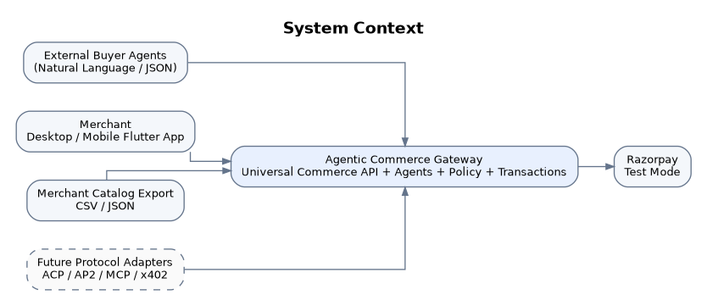
Figure 1. System context: the merchant-side gateway mediates buyer agents, merchant controls, catalog data, and Razorpay.

2. Stakeholders, Actors, Assumptions and Scope

2.1 Primary Stakeholders and Actors
Actor | Description | Primary objectives
Merchant Owner | Controls store policies and sees all operational and financial data. | Increase conversion/revenue while preserving margin and control.
Merchant Operator | Handles catalog, approvals, negotiations, and transaction exceptions within assigned role. | Operate day-to-day commerce workflows safely.
External Buyer Agent | Calls public commerce endpoints using natural-language or structured intent. | Discover, compare, negotiate, and purchase products.
Buyer Simulator | Demo surface implemented in the Flutter application. | Exercise the complete agentic commerce flow without an external integration.
Commerce Orchestrator | Coordinates agent workflow and dependencies. | Route requests to the correct agents without owning financial state.
Razorpay | Test-mode payment provider. | Create orders, run checkout, report payment state, and send webhooks.

2.2 Supported Merchant Types
The product is designed for Shopify, WooCommerce, and custom e-commerce merchants. In the MVP, direct store connectors are intentionally deferred: merchants import CSV or JSON exports into the platform. The internal schema and service boundaries must be designed so platform connectors can be added later without changing the core commerce logic.

2.3 Demonstration Domain
Electronics is the reference domain for the MVP. Example product categories include headphones, monitors, keyboards, chargers, adapters, laptops, and accessories. Electronics is used because product compatibility, specification matching, bundles, upgrades, delivery constraints, and bulk procurement are easy to demonstrate and evaluate.

2.4 Key Assumptions
- Merchant product data includes enough pricing/cost information to calculate margins for negotiation rules; missing cost data reduces readiness and can disable margin-dependent automation.
- Conversation memory is scoped to a buyer session/user context for MVP personalization; long-term behavioral profiling is not required.
- Buyer-side spending mandates/authorization policies are out of scope for MVP; merchant-side policies are authoritative for seller behavior.
- Razorpay credentials are test-mode credentials and remain server-side.
- Only one universal commerce interface is fully functional in MVP; protocol-specific adapters are architectural extension points.
- Conversion probability in MVP may be heuristic/model-derived rather than trained from a large historical merchant dataset.

2.5 In-Scope MVP
- Merchant authentication and workspace
- CSV/JSON catalog import, validation, normalization, enrichment, embeddings and readiness scoring
- Natural-language and JSON buyer intent
- Multi-agent discovery/recommendation
- Conversation-aware personalization
- Upsell, cross-sell and dynamic bundle generation
- Expected-conversion optimization
- Advanced buyer <-> merchant negotiation
- Merchant-side autonomous negotiation boundary and final acceptance point
- Bulk/high-value opportunity detection and merchant override
- Deterministic policy engine and responsive approvals
- Quote expiry and inventory reservation
- Razorpay test-mode checkout/payment, signature verification and webhooks
- Transaction state machine, idempotency and reconciliation
- Five defined failure recovery flows
- Universal commerce API
- Merchant-facing dashboard, analytics, audit, explainability and revenue attribution

3. System Architecture

3.1 Architectural Principles
- AI reasoning is separated from financial control.
- Agent orchestration and transaction orchestration are separate systems.
- All critical money-moving transitions are deterministic, persisted, idempotent, and auditable.
- Policies are code/rule-based and cannot be overridden by LLM output.
- Core commerce logic uses a universal internal schema; protocol adapters translate external formats at the edge.
- Failures in non-critical AI features such as upselling must not prevent a valid base checkout.
- Merchant autonomy is policy-bounded: low-risk actions execute automatically; high-value/exceptional opportunities can escalate to a human.
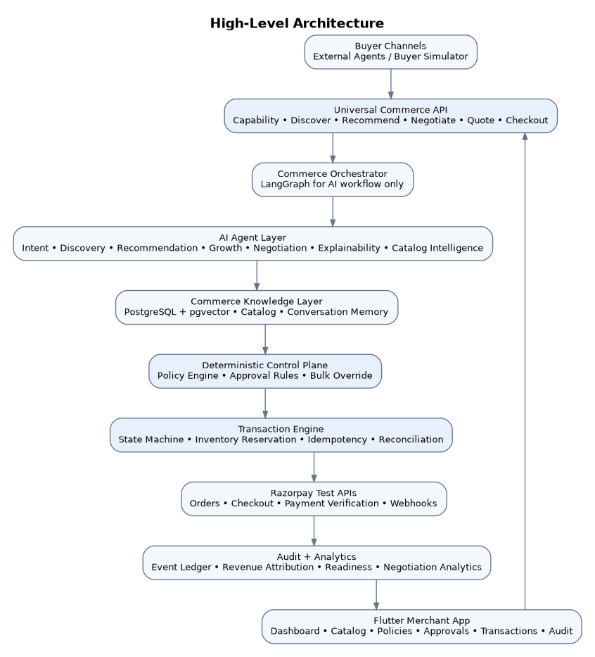
Figure 2. High-level architecture and separation between AI orchestration, deterministic control, transactions, payments, and merchant UI.

3.2 Component Responsibilities
Component | Responsibility
Flutter Merchant Application | Responsive merchant dashboard/PWA, mobile approvals, catalog management, policies, negotiations, transaction timelines, analytics, and buyer simulator.
Universal Commerce API | External agent-facing endpoints and normalized request/response contracts.
Protocol Gateway | Authentication, capability discovery, versioning, rate limiting, adapter translation.
Commerce Orchestrator | Coordinates AI workflows such as intent -> discovery -> recommendation -> growth -> negotiation.
Agent Layer | Specialized AI reasoning and catalog intelligence.
Commerce Knowledge Layer | Normalized product data, embeddings, inventory, pricing, delivery, session conversation memory.
Policy Engine | Deterministic ALLOW / DENY / REQUIRE_APPROVAL decisions.
Approval Service | Responsive approval workflow and quote-specific policy overrides.
Transaction Engine | Persistent payment/order state machine, idempotency, inventory reservations, retries, reconciliation.
Razorpay Adapter | Server-side Razorpay test-mode integration and webhook handling.
Audit/Analytics | Append-only event ledger, decision explanations, readiness metrics, revenue attribution, negotiation analytics.

4. Detailed MVP Feature Specification

F-01 Agent-Readable Catalog
Import CSV/JSON, validate and normalize disparate merchant product records into a universal internal schema with structured identity, pricing, cost, stock, variants, compatibility, delivery, return/warranty, images, and agent metadata. Generate semantic embeddings and serve the normalized data through discovery APIs.
Acceptance summary: Merchant uploads a 100-product electronics catalog; valid records become searchable by semantic intent while invalid rows produce actionable import errors.

F-02 AI Commerce Readiness Score
Score the merchant from 0–100 using catalog completeness, semantic quality, inventory freshness, price freshness, shipping readiness, refund/return readiness, payment readiness, agent discoverability, policy configuration, and protocol compatibility. Each deduction must be explainable and linked to an improvement action.
Acceptance summary: Dashboard shows the weighted score, component scores, deductions, and concrete remediation steps.

F-03 Multi-Agent Product Discovery
Accept natural-language or structured JSON intent, derive hard constraints and soft preferences, use conversation history, semantic retrieval and deterministic filtering, then rank compatible in-stock products with merchant-facing explanations.
Acceptance summary: A request for wireless headphones under ₹8,000 for gaming/office calls returns only compliant in-stock candidates with match reasons.

F-04 Personalized Upsell/Cross-Sell
Use conversation context and current cart/intent to propose relevant upgrades, accessories, and complementary products. Recommendations must respect budget, compatibility, inventory and merchant policies.
Acceptance summary: A compatible Bluetooth adapter may be suggested when it increases conversion likelihood; an incompatible accessory is never offered.

F-05 Merchant <-> Buyer-Agent Negotiation
Support negotiation over price, quantities, bundles, alternatives, shipping/delivery, upgrades/downgrades, and discount. The Merchant Negotiation Agent autonomously counters within rules, applies a bounded rescue discount when abandonment risk is high, and exposes a final permissible acceptance point when the buyer exceeds limits.
Acceptance summary: Negotiation never crosses the computed merchant floor and records every round.

F-06 Merchant Policy Engine
Allow merchant configuration of max automatic discount, absolute discount/floor, minimum margin, auto-transaction amount, approval threshold, allowed products/categories, negotiation rounds, inventory limits/reservation TTL, bundle limits, estimated delivery constraints, and rescue-discount settings.
Acceptance summary: Every commercial proposal receives deterministic ALLOW, DENY, or REQUIRE_APPROVAL.

F-07 Responsive Approval Center
When a deal exceeds automatic limits or a strategically valuable bulk order is detected, show the merchant decision-ready economics on desktop/mobile. Merchant can approve, reject, modify, or create a custom quote-specific override.
Acceptance summary: Approval updates the workflow in real time and does not alter the global policy unless explicitly edited elsewhere.

F-08 Transaction Assurance
Use a persistent transaction state machine with quote expiry, inventory reservation/revalidation, Razorpay order/checkout/payment, signature verification, webhook deduplication, idempotency, reconciliation, and safe retry behavior.
Acceptance summary: No duplicate charge occurs from repeated checkout or a lost webhook after payment capture.

F-09 Universal Commerce Interface
Expose a versioned, functional API for capabilities, discovery, recommendation, negotiation, quote, checkout and order status. Keep ACP/AP2/MCP/x402 as adapters mapped to the same internal schema.
Acceptance summary: An external test client can complete the full flow without using the Flutter UI.

F-10 Revenue Intelligence
Track gross revenue, AI-influenced revenue, exact net AI incremental revenue, upsell/cross-sell revenue, negotiation revenue, AOV, conversion estimates, negotiation outcomes, rescue discounts, lost-revenue signals and catalog discoverability.
Acceptance summary: A completed order shows baseline revenue, add-on revenue, discount cost, final value and net AI incremental revenue.
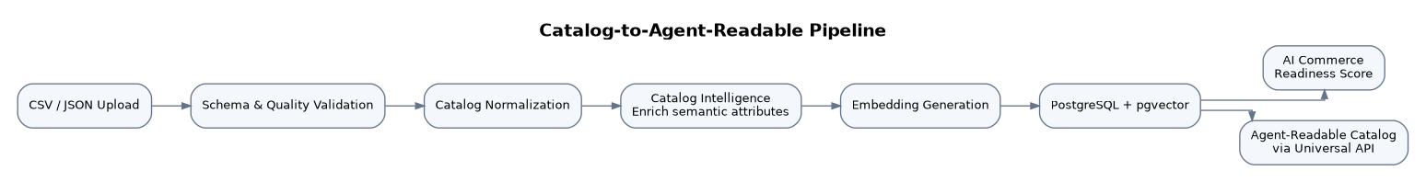
Figure 3. Catalog ingestion and transformation into agent-readable commerce data.
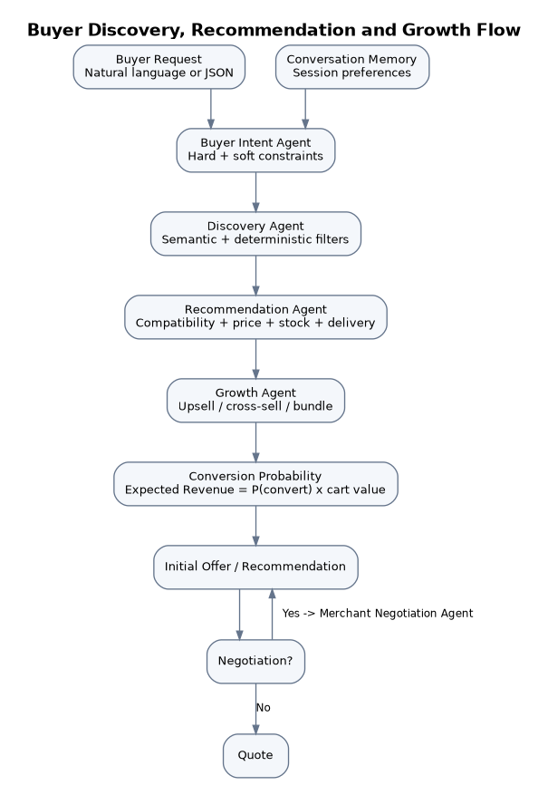
Figure 4. Discovery, recommendation and growth flow using buyer intent and session conversation memory.

5. Agent Architecture and Responsibilities
Agent | Primary responsibility | May move money? | Key outputs
Catalog Intelligence Agent | Normalize/enrich product data and flag missing agent-readable attributes. | No | Normalized fields, quality issues, enrichment suggestions.
Buyer Intent Agent | Convert natural language/JSON into hard constraints, soft preferences, and session context. | No | Universal commerce intent.
Discovery Agent | Retrieve candidates using embeddings plus deterministic catalog filters. | No | Candidate product set.
Recommendation Agent | Rank candidates for compatibility, price, stock, delivery, and intent match. | No | Ranked products + match rationale.
Growth Agent | Generate upsell, cross-sell, bundle and cart options optimized primarily for conversion probability. | No | Growth proposal + expected conversion/revenue.
Merchant Negotiation Agent | Counter, accept, propose final permissible terms, apply rescue rules, and detect strategic bulk opportunities. | No | Negotiation proposal.
Explainability Agent | Translate decisions, scores and policy outcomes into merchant-facing explanations. | No | Human-readable explanation.
Transaction Assurance Agent | Detect payment/order mismatches and recommend/trigger deterministic reconciliation workflows. | No | Reconciliation action request.
Commerce Orchestrator | Coordinate the above agents and persist AI workflow state. | No | Workflow routing and aggregated result.

5.1 Agent Output Contract
All agent outputs that can influence commerce must be structured and validated by Pydantic models. Free-form text may be used for explanations but not as the source of truth for pricing, discount, quantities, policy decisions, order state, or money movement.
NegotiationProposal {
quote_id?
product_lines[]
proposed_total
discount_percent
delivery_estimate
rationale
predicted_conversion
requires_policy_evaluation = true
}

5.2 Optimization Objective
The Growth and Negotiation layers primarily optimize conversion probability, not maximum cart value. A useful MVP objective is Expected Revenue = P(conversion) x Cart Value, subject to merchant constraints. This allows the system to prefer a slightly lower but substantially more convertible offer over a high-value offer likely to be abandoned.

6. Merchant Negotiation and Bulk-Order Automation

6.1 Negotiation Boundary Model
The merchant configures at least two negotiation boundaries: an automatic range that the agent may use without human intervention and an absolute merchant boundary that the platform may not cross without a temporary merchant-approved quote-specific override. The effective last point of acceptance is the strictest result of the discount floor, minimum-margin floor, product/category overrides, delivery constraints, and inventory constraints.
Rule | Example | Behavior
Automatic discount limit | 5% | Agent may accept/counter automatically up to this limit.
Absolute discount limit | 10% | Default final boundary unless a merchant approves a temporary exception.
Minimum margin | 20% | Any price causing margin below 20% is invalid.
Rescue discount | <=5% when abandonment probability >75% | May be applied only if final price remains policy-compliant.
Maximum rounds | 3 | Agent ends negotiation or returns final permissible terms after limit.
Delivery constraint | <=7 days | Agent may not promise an ETA beyond verified fulfillment capability.

6.2 Final Point of Acceptance
When the buyer requests a price/term beyond the allowed boundary, the agent must not merely reject. It computes and returns the closest valid final offer and labels it as the final authorized acceptance point for the current policy context. This allows automated closure while preserving merchant control.

6.3 Bulk Opportunity Detection
Bulk order detection combines quantity and order-value thresholds with order economics. The orchestrator should escalate only strategically meaningful opportunities rather than notifying the merchant for every large cart. The notification must include buyer offer, standard value, requested discount, resulting margin, expected profit, inventory, delivery estimate, conversion probability, and an AI-recommended discount range.

6.4 Quote-Specific Override
A merchant-approved special discount or price is stored as a temporary override bound to a specific quote/negotiation, approver, and expiry. It must not mutate the merchant’s global policy. Once expired or consumed, the standard policy applies again.
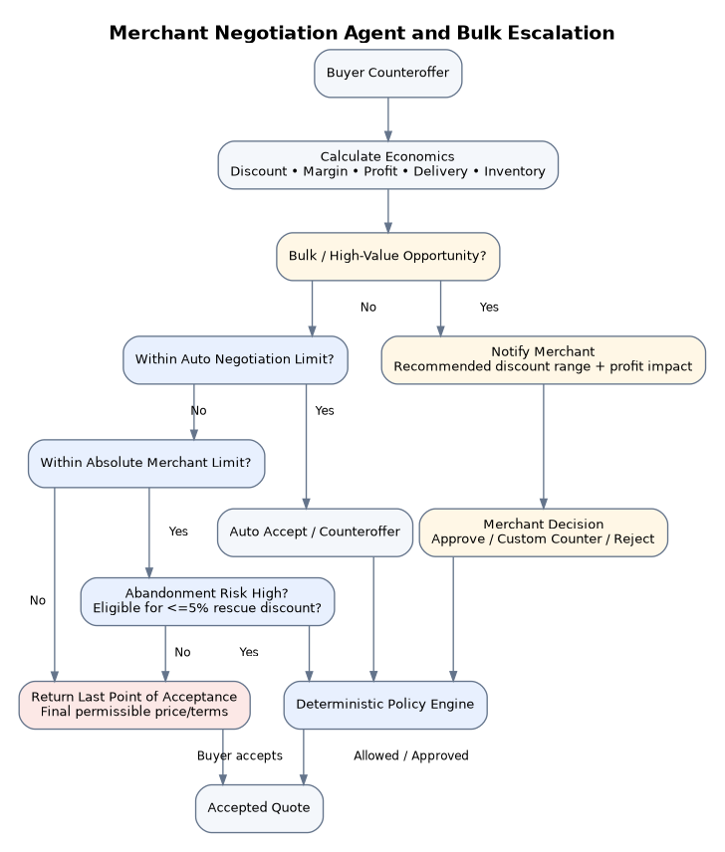
Figure 5. Merchant Negotiation Agent: autonomous range, final acceptance point, rescue discount, and bulk-order escalation.

7. Functional Requirements
FR-001 — Merchant authentication and workspace
The system shall authenticate merchant users and scope all catalog, policy, transaction, approval, analytics and audit data to a merchant workspace.
Acceptance: A logged-in user can access only resources authorized for that merchant/role.
FR-002 — Catalog upload
The merchant shall upload CSV or JSON catalogs.
Acceptance: Valid files are accepted; unsupported/invalid files receive row/field-level errors.
FR-003 — Catalog validation
The system shall validate required identifiers, names, prices, stock, categories, variants, duplicates and numeric constraints.
Acceptance: Import summary reports accepted, rejected, duplicate and warning counts.
FR-004 — Catalog normalization
The system shall convert imported records into the universal product schema.
Acceptance: Equivalent fields from different exports map to the same internal representation.
FR-005 — Catalog intelligence
The system shall flag missing semantic, compatibility, cost/margin, shipping, return, variant, and cross-sell data.
Acceptance: Each issue is actionable and associated with affected products.
FR-006 — Embeddings
The platform shall generate embeddings for searchable product content.
Acceptance: Semantic search can retrieve relevant products even without exact keyword match.
FR-007 — Readiness score
The platform shall calculate a weighted 0–100 AI Commerce Readiness Score.
Acceptance: Score contains component values, deductions and remediation guidance.
FR-008 — Capability discovery
External agents shall retrieve supported commerce capabilities and API version.
Acceptance: GET capabilities returns machine-readable supported operations.
FR-009 — Conversational intent
The system shall accept natural-language buyer requests.
Acceptance: Intent output includes category, hard constraints, soft preferences and session context.
FR-010 — Structured intent
The system shall accept structured JSON buyer intents.
Acceptance: Natural-language and JSON paths produce the same internal intent schema.
FR-011 — Conversation memory
The platform shall use session-scoped conversation history for personalization.
Acceptance: Later turns honor previously stated preferences unless explicitly changed.
FR-012 — Hard constraints
The system shall enforce hard buyer constraints during candidate filtering.
Acceptance: A candidate violating a budget/category/mandatory attribute is excluded.
FR-013 — Semantic discovery
The system shall combine semantic retrieval with deterministic product filters.
Acceptance: Results are relevant and satisfy stock/price/category constraints.
FR-014 — Product ranking
The system shall rank valid candidates by intent match, compatibility, price, stock, delivery and other weighted preferences.
Acceptance: Returned products contain a match score and explanation.
FR-015 — Explainable recommendations
The merchant shall see why a product was selected or rejected.
Acceptance: Explanation references concrete intent/catalog facts rather than generic prose.
FR-016 — Upsell
The Growth Agent shall propose relevant higher-value alternatives when likely to improve conversion.
Acceptance: Upsell remains within buyer hard constraints and merchant policy.
FR-017 — Cross-sell
The Growth Agent shall propose compatible complementary items.
Acceptance: Incompatible or unavailable accessories are excluded.
FR-018 — Dynamic bundles
The system shall construct intent-specific multi-product bundles.
Acceptance: Bundle respects max product count, compatibility, stock, margin, and budget constraints.
FR-019 — Conversion probability
The platform shall estimate relative conversion likelihood for candidate offers.
Acceptance: The score is stored with its method/version and can be compared across offers.
FR-020 — Expected revenue optimization
The Growth Agent shall compare offers using conversion probability and cart value.
Acceptance: Selected proposal maximizes the configured objective subject to constraints.
FR-021 — Advanced negotiation
The Merchant Negotiation Agent shall negotiate price, quantity, bundle, alternatives, delivery and discounts.
Acceptance: Each round is persisted with buyer offer, merchant response and reason.
FR-022 — Automatic negotiation limit
The agent shall operate autonomously within merchant-defined automatic limits.
Acceptance: No approval is required for an offer that remains fully inside auto-policy.
FR-023 — Final acceptance point
If the buyer requests terms beyond the permitted boundary, the system shall compute and communicate the closest valid final offer.
Acceptance: Final offer never violates the effective price/margin/policy floor.
FR-024 — Rescue discount
The system may apply up to a configured maximum of 5% rescue discount when abandonment risk is above threshold and all other policy checks pass.
Acceptance: Audit records trigger probability, discount, resulting margin and rationale.
FR-025 — Negotiation round limit
The system shall enforce a configured maximum negotiation round count.
Acceptance: Further counters end or escalate according to policy.
FR-026 — Bulk order detection
The orchestrator shall detect high-quantity/high-value strategic offers.
Acceptance: Qualified bulk opportunity generates an opportunity score and merchant notification.
FR-027 — Bulk economics
Bulk alerts shall show standard order value, buyer offer, requested discount, margin, expected profit, stock, delivery and predicted conversion.
Acceptance: Merchant can make a decision without reconstructing the economics manually.
FR-028 — Quote-specific override
Merchant may approve a temporary special price/discount for a specific bulk negotiation.
Acceptance: Override is scoped, audited and expires; global policy is unchanged.
FR-029 — Merchant policy configuration
Merchant shall configure discount, margin, amount, approval, product/category, inventory, bundle, delivery, negotiation and rescue rules.
Acceptance: Saved policy is versioned and effective timestamp is recorded.
FR-030 — Deterministic policy evaluation
Every money-affecting proposal shall receive ALLOW, DENY or REQUIRE_APPROVAL from non-LLM code.
Acceptance: LLM output cannot override the result.
FR-031 — Autonomous actions
Policy-compliant low-risk actions shall execute without human approval.
Acceptance: System proceeds automatically through quote/checkout preparation when allowed.
FR-032 — Human approval
High-risk/exception actions shall enter AWAITING_APPROVAL.
Acceptance: Transaction cannot cross the approval gate before an authorized decision.
FR-033 — Responsive approval center
Approvals shall be usable on desktop and mobile web.
Acceptance: Merchant can approve/reject/modify from responsive Flutter interface.
FR-034 — Approval explanation
Approval view shall show requested action, pricing, discount, margin, conversion estimate, policy reason and recommendation.
Acceptance: Merchant sees the cause and economic consequence of escalation.
FR-035 — Quote generation
Accepted negotiation output shall become a persisted quote.
Acceptance: Quote includes line items, quantities, final price, discount, ETA, expiry, merchant and buyer session.
FR-036 — Quote expiry
Quotes shall expire after a configurable TTL.
Acceptance: Expired quote cannot proceed to payment without revalidation/requote.
FR-037 — Inventory reservation
Accepted quotes shall reserve stock for a configured duration.
Acceptance: Reserved stock is unavailable to competing checkout and auto-releases on expiry/failure.
FR-038 — Pre-payment revalidation
Before Razorpay order creation the system shall revalidate stock, price, quote, expiry and policy.
Acceptance: Any mismatch blocks payment creation.
FR-039 — Razorpay order/checkout
The transaction service shall create an actual Razorpay test order and provide a test-mode checkout flow.
Acceptance: A buyer can complete a Razorpay test payment.
FR-040 — Server-side payment verification
Backend shall verify Razorpay payment signature/state before confirming the order.
Acceptance: Client callback alone cannot mark payment captured.
FR-041 — Webhook processing
The system shall verify, deduplicate and persist Razorpay webhook events.
Acceptance: Duplicate webhook has no duplicate state transition.
FR-042 — Transaction state machine
All transaction/order states shall follow defined legal transitions.
Acceptance: Invalid transitions are rejected and logged.
FR-043 — Idempotent checkout
Checkout shall use idempotency keys based on commerce intent/quote/attempt.
Acceptance: Repeated request returns existing workflow rather than creating duplicate money movement.
FR-044 — Reconciliation
Transaction Assurance shall compare internal state with Razorpay state and repair known safe mismatches.
Acceptance: Captured-but-pending state can be corrected without a second charge.
FR-045 — Payment failure recovery
Failed payment shall be recorded, explained, and eligible for controlled retry.
Acceptance: Retry cannot reuse an invalid/expired quote without revalidation.
FR-046 — Inventory failure recovery
Unavailable inventory before payment shall block payment and trigger alternative discovery when possible.
Acceptance: No payment is initiated for unavailable stock.
FR-047 — Policy violation recovery
Out-of-policy negotiation shall return DENY/REQUIRE_APPROVAL or closest permissible final terms.
Acceptance: No silent bypass occurs.
FR-048 — Audit trail
Every significant buyer, agent, policy, approval, transaction and reconciliation event shall be appended to an audit timeline.
Acceptance: Merchant can reconstruct the complete decision path for an order.
FR-049 — Decision explanation
AI-influenced decisions shall store input factors, agent, recommendation, policy context, confidence/score and reason.
Acceptance: Merchant-facing explanation is available from related transaction/negotiation.
FR-050 — Revenue attribution
Completed orders shall calculate baseline revenue, upsell/cross-sell revenue, discount cost, final value and net AI incremental revenue.
Acceptance: Dashboard metrics reconcile to order-level attribution.
FR-051 — Merchant dashboard
Dashboard shall display revenue, AI revenue, AOV, readiness, searches, negotiations, approvals, transactions, failures and audit indicators.
Acceptance: All specified KPI categories are visible and drillable.
FR-052 — Negotiation analytics
Track negotiation starts, completion, abandonment, average rounds/discount, rescue discounts, bulk revenue and conversion.
Acceptance: Analytics can filter by date/product/category.
FR-053 — Agent search analytics
Track searches, candidate products, rejections, recommendations, offers and orders.
Acceptance: Merchant sees common rejection reasons and discoverability gaps.
FR-054 — Universal API
Expose versioned endpoints for capabilities, discovery, recommendation, negotiation, quote, checkout and order status.
Acceptance: External test client completes end-to-end flow.
FR-055 — Protocol adapter boundary
Core commerce logic shall not depend on ACP/AP2/MCP/x402 request formats.
Acceptance: A new adapter maps external request to universal schema without changing policy/transaction logic.
FR-056 — Merchant secrets
Razorpay test keys and webhook secret shall be stored server-side and never returned to browser clients.
Acceptance: Secrets are masked in UI/logs and not present in frontend bundle.

8. Business Rules and Policy Model
Policy category | Required fields / examples
Negotiation | auto_discount_max, absolute_discount_max or min_price, max_rounds, rescue_enabled, rescue_discount_max (<=5%), abandonment_threshold
Margin | minimum_margin_percent; product/category/SKU overrides
Transaction | auto_transaction_limit, human_approval_threshold
Catalog scope | allowed/blocked products and categories
Inventory | minimum_available, reserve_on_accept, reservation_ttl_minutes
Bundle | enabled, max_products, compatibility requirement
Delivery | max_estimated_days, verified ETA requirement, express-shipping rules
Bulk opportunity | min_quantity, min_order_value, opportunity-score threshold, optional category overrides
Overrides | quote-scoped special price/discount, approver, reason, expiry

8.1 Effective Negotiation Floor
The final permissible offer is computed from all applicable constraints. Conceptually: effective minimum selling price = max(discount-based floor, minimum-margin floor, product/SKU minimum price, delivery/operational floor). If a merchant authorizes a quote-specific override, the override becomes an additional temporary policy input rather than a replacement for transaction safety checks.

8.2 Policy Precedence
- Quote-specific approved override (most specific, temporary)
- SKU policy
- Product policy
- Category policy
- Merchant-wide policy (least specific)

8.3 Recommended Merchant Modes
Mode | Typical behavior
Conservative | Low automatic discount; earlier approval; bulk deals usually escalated.
Balanced (default) | Moderate autonomy; rescue discount up to configured 5%; strategic bulk opportunities escalated.
Aggressive Growth | Higher automatic discount subject to margin; fewer escalations; conversion optimization favored.
Custom | Merchant directly configures all relevant limits.

9. Transaction Assurance and Failure Recovery

9.1 Transaction Lifecycle
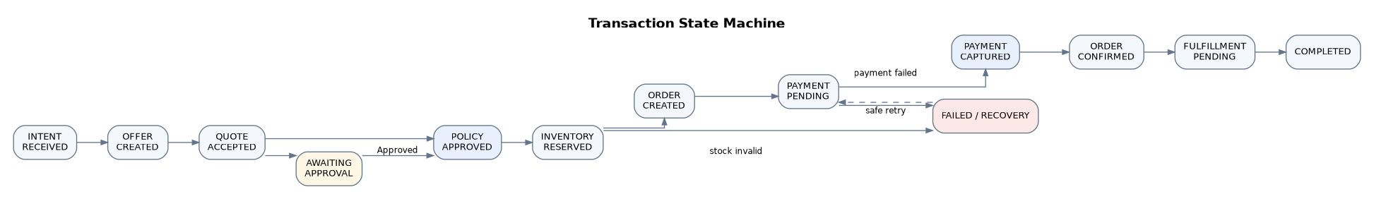
Figure 6. Deterministic transaction state machine. AI workflow state does not replace this state machine.

9.2 Required Identifiers
commerce_intent_id
buyer_session_id
negotiation_id
quote_id
inventory_reservation_id
internal_order_id
checkout_attempt_id
idempotency_key
razorpay_order_id
razorpay_payment_id

9.3 Failure Cases
Failure | Required system response
Payment captured but webhook lost | Detect internal/Razorpay mismatch, retrieve/verify payment, reconcile order to captured/confirmed, never retry charge.
Inventory unavailable | Block payment before order creation, release invalid reservation, return alternative recommendation if possible.
Payment failure | Persist failure reason, remain unpaid, release/retain reservation according to retry window, permit controlled retry only after revalidation.
Duplicate checkout request | Resolve idempotency key and return existing transaction/order instead of creating another payment workflow.
Merchant policy violation | Return DENY, REQUIRE_APPROVAL, or final permissible terms; no silent bypass.

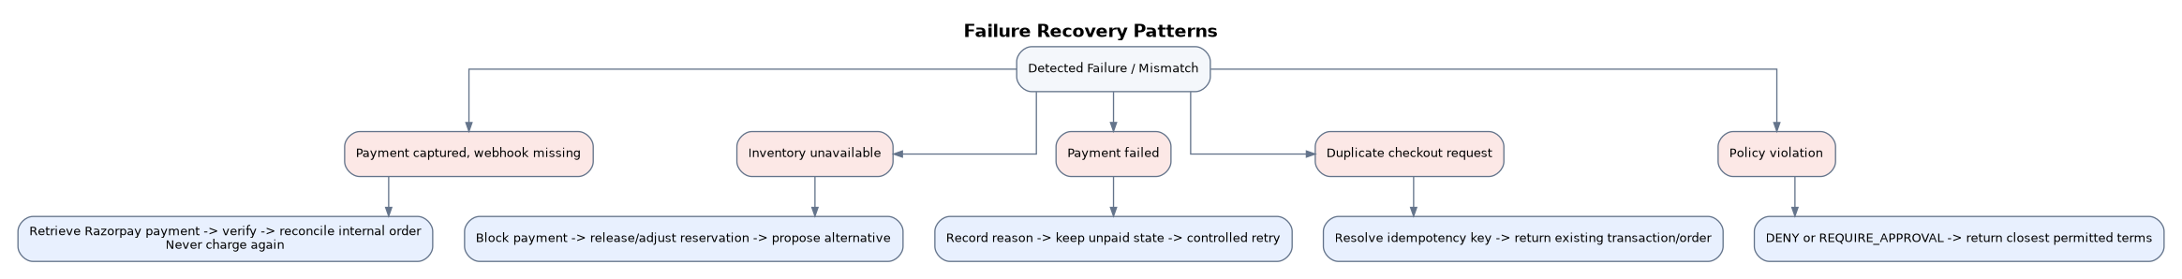
Figure 7. Required failure-recovery patterns for the five MVP scenarios.

10. External API and Protocol Readiness

10.1 MVP External Commerce Endpoints
Method | Endpoint | Purpose
GET | /api/v1/commerce/capabilities | Return merchant commerce capabilities and schema/protocol version.
POST | /api/v1/commerce/discover | Submit natural-language or structured intent and retrieve compliant products.
POST | /api/v1/commerce/recommend | Request ranked recommendation and optional growth proposal.
POST | /api/v1/commerce/negotiate | Submit buyer offer/counteroffer; receive merchant agent response or approval-pending state.
POST | /api/v1/commerce/quote | Create/finalize a quote from accepted terms.
POST | /api/v1/commerce/checkout | Create/reuse idempotent checkout workflow and Razorpay test order.
GET | /api/v1/orders/{order_id} | Retrieve canonical order/transaction state.

10.2 Merchant/Admin Endpoints
/api/v1/catalog/import
/api/v1/catalog/products
/api/v1/catalog/readiness
/api/v1/policies
/api/v1/approvals
/api/v1/transactions
/api/v1/transactions/{id}/timeline
/api/v1/analytics/revenue
/api/v1/analytics/discovery
/api/v1/analytics/negotiations
/api/v1/analytics/lost-revenue

10.3 Universal Internal Commerce Schema
External request formats must map to internal domain objects such as CommerceIntent, ProductCandidate, Offer, NegotiationRound, Quote, PolicyDecision, Approval, Order, PaymentTransaction and AuditEvent. The internal schema is versioned and is the only format consumed by core commerce services.
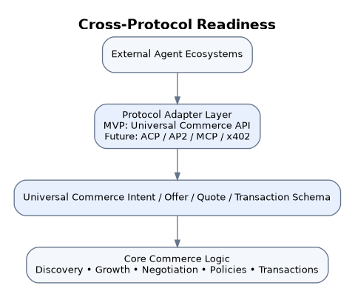
Figure 8. Cross-protocol readiness: adapters translate at the edge; core commerce logic remains protocol-neutral.

11. Data Requirements and Logical Model
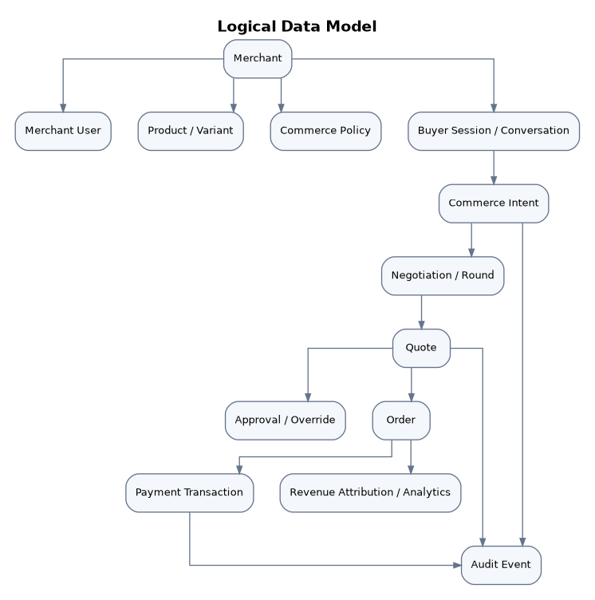
Figure 9. Logical data model and principal entity relationships.

11.1 Core Entities
Entity | Key attributes
Merchant | id, store_type, profile, timezone, readiness score, status
MerchantUser | id, merchant_id, role, auth identifiers
Product / Variant | ids, SKU, name, category, attributes, price, cost, stock, compatibility, delivery, returns, embeddings
CommercePolicy | version, scope, negotiation limits, margin rules, approval rules, inventory/delivery/bundle rules
BuyerSession | session id, merchant id, conversation history, extracted preferences
CommerceIntent | hard constraints, soft preferences, raw input, normalized intent
Negotiation | status, rounds, buyer offers, merchant responses, predicted conversion, final boundary
Quote | lines, totals, discounts, delivery, expiry, policy version, override reference
Approval / Override | type, request reason, economics, decision, approver, expiry
Order | internal id, merchant, buyer session, quote, canonical state, totals
PaymentTransaction | Razorpay ids, amount, status, signature verification, webhook/reconciliation metadata
AuditEvent | append-only event type, actor, timestamp, references, before/after metadata, explanation
RevenueAttribution | baseline, upsell, cross-sell, discount cost, final revenue, AI incremental revenue

11.2 Data Retention
Transaction and audit data require long-lived retention appropriate for operational traceability. Conversation/session memory should be shorter-lived and deletable. Quote/reservation data can expire quickly but their consequential audit events must remain. Exact production retention periods are deployment policy and can be finalized after compliance review.

12. Merchant Application and UX Requirements

12.1 Flutter Application
The merchant control plane shall be implemented in Flutter/Dart as a responsive web application/PWA optimized for desktop and mobile browser use, with the architecture remaining compatible with native Android/iOS packaging. A separate native mobile app is not required for the MVP.

12.2 Primary Screens
Screen | Required content
Authentication / Onboarding | Login; merchant/store type; Razorpay test configuration; initial catalog import.
Dashboard | Gross revenue, AI revenue, incremental revenue, AOV, readiness, searches, negotiations, approvals, failures.
Catalog | Import, product list/detail, data-quality issues, semantic/compatibility fields.
Readiness | Overall score, component metrics, deductions, recommended actions.
Buyer Simulator | Conversational buyer prompt and structured intent testing; visible agent responses.
Negotiation Center | Active/completed negotiations, rounds, final boundary, rescue discounts, bulk opportunities.
Approval Center | Responsive decision cards with economics, reasons and approve/reject/custom offer controls.
Policies | Merchant modes and custom thresholds; product/category/SKU overrides.
Transactions | Order/payment status, Razorpay references, failure/reconciliation state.
Audit Timeline | Chronological agent, policy, approval, payment and recovery events.
Analytics | Revenue attribution, conversion estimates, negotiation metrics, discovery rejection reasons.

12.3 Mobile Approval UX
Mobile approval cards must present sufficient context to make a financial decision without opening a desktop dashboard: buyer/order summary, quantity, original and proposed price, discount, resulting margin, minimum margin, expected profit, conversion estimate, delivery estimate, inventory, escalation reason, and AI recommendation.

13. Analytics, Explainability and Audit

13.1 Revenue Attribution
For each completed order, store the baseline intended product/cart value, upsell revenue, cross-sell revenue, negotiated discount cost, final transaction value, and net AI incremental revenue. The dashboard must aggregate these without double-counting.

13.2 Negotiation Analytics
- Negotiations started/completed/abandoned
- Average negotiation rounds
- Average and median discount
- Rescue-discount frequency and conversion
- Bulk opportunities surfaced, approved, rejected and converted
- Revenue/profit from bulk orders
- Conversion estimate before and after negotiation

13.3 Discovery Analytics
- Buyer searches/intents
- Products considered/shortlisted/recommended
- Offer and checkout creation rates
- Common product rejection reasons: too expensive, unavailable, missing attributes, delivery too slow, compatibility mismatch
- Agent discoverability gaps by category/product

13.4 Explainability
Explainability is merchant-facing in MVP. For any product choice, discount, bundle, negotiation, escalation, or reconciliation action, the merchant should be able to inspect the relevant inputs, constraints, policy decision, model/heuristic score, expected impact, and final action.

14. Non-Functional Requirements
NFR-001 — Security
All production traffic shall use HTTPS; credentials/secrets are encrypted at rest and never exposed to browser clients or LLM prompts.
NFR-002 — Payment isolation
Only deterministic backend transaction services may call Razorpay money-moving operations; AI agents only propose structured actions.
NFR-003 — Authorization
Role-based access control shall protect merchant owner/operator/viewer capabilities and all merchant-scoped resources.
NFR-004 — Reliability
Critical workflows shall use idempotency, persistent state, webhook deduplication, database transactions and recoverable retries.
NFR-005 — Availability
MVP target is 99% service availability; production target should be 99.9%+ after hardening.
NFR-006 — Performance
Normal REST p95 <500 ms where feasible; semantic discovery target <2 s; AI recommendation/negotiation target <5 s typical; policy evaluation target <100 ms.
NFR-007 — Scalability
API nodes, AI workers, catalog jobs and webhook processors should scale horizontally; API tier should remain stateless where practical.
NFR-008 — Consistency
Payment/order/policy state requires strong transactional consistency; analytics and non-critical AI enrichment may use eventual consistency.
NFR-009 — Auditability
Commercial actions must be traceable from buyer intent through AI proposal, policy decision, approval, payment and final order.
NFR-010 — Explainability
Every AI-influenced commerce decision affecting product, price, discount, bundle, negotiation or approval shall retain a merchant-readable explanation.
NFR-011 — Observability
Collect structured logs, metrics, traces, agent execution times, LLM usage, errors, payment/webhook events and reconciliation outcomes.
NFR-012 — Failure isolation
Failure in optional AI growth features must not corrupt or block a valid core purchase when a safe fallback exists.
NFR-013 — Graceful degradation
If AI is unavailable, existing quote retrieval, policy enforcement, payment status, transaction reconciliation and core catalog data remain usable.
NFR-014 — Determinism
Policy decisions, price/margin arithmetic, idempotency and transaction state transitions shall be deterministic code, not LLM judgement.
NFR-015 — Maintainability
Backend uses modular domains: auth, merchant, catalog, agents, commerce, policies, negotiation, inventory, payments, transactions, approvals, analytics, audit, protocols.
NFR-016 — Extensibility
New commerce protocol adapters or payment providers can be added without rewriting core discovery, negotiation, policy or transaction logic.
NFR-017 — Interoperability
APIs and internal schemas are JSON-based, versioned and documented via OpenAPI.
NFR-018 — Responsive UX
Merchant dashboard and approvals shall remain usable across desktop, tablet and mobile browser widths.
NFR-019 — Accessibility
Target WCAG 2.1 AA practices for contrast, keyboard navigation, labels, focus and status messaging.
NFR-020 — Privacy
Conversation memory is scoped, minimized and deletable; sensitive personal data should not be retained unless necessary for the commerce workflow.
NFR-021 — Testability
Policy logic, pricing/margin calculations, negotiation floors, state transitions, idempotency, webhooks and revenue attribution must be unit/integration testable without LLM dependency.
NFR-022 — Versioning
Version API contracts, universal schema, policy definitions, agent prompts/workflows and scoring methodology.
NFR-023 — Cost control
Use deterministic retrieval/scoring and smaller models where sufficient; reserve stronger reasoning models for negotiation or complex interpretation.
NFR-024 — Timeouts
Every agent invocation shall have configured timeout/fallback behavior so one agent cannot indefinitely block the commerce workflow.
NFR-025 — Secret/log hygiene
Razorpay secrets, auth tokens and sensitive customer data must be redacted from logs, traces and AI context unless explicitly required and protected.

15. Technology Stack and Deployment Architecture
Layer | Finalized / Recommended technology | Purpose
Merchant frontend | Flutter + Dart | Responsive web/PWA; mobile approvals; Android/iOS-ready.
State management | Riverpod | Predictable app/server-driven state.
Routing | go_router | Declarative navigation.
Networking | Dio | REST calls, interceptors, auth/error handling.
Models | freezed + json_serializable | Immutable typed models and serialization.
Charts | fl_chart | Dashboard and analytics visualization.
Realtime | WebSockets / web_socket_channel | Approval, payment and transaction updates.
Backend | Python + FastAPI + Pydantic v2 | Versioned APIs, validation, async integration.
ORM/migrations | SQLAlchemy + Alembic | Persistence and schema migrations.
AI orchestration | LangGraph | Agent reasoning workflow only.
LLM abstraction | Provider interface | Avoid provider lock-in; use one primary provider for MVP.
Primary database | PostgreSQL | Transactional commerce data.
Vector search | pgvector | Semantic product retrieval and similarity.
Cache/TTL | Redis | Quote TTL, inventory reservation, rate limiting, transient state.
Background jobs | Celery + Redis | Catalog enrichment, embeddings, readiness/analytics, reconciliation jobs.
Payments | Razorpay Test Mode APIs | Actual test order/checkout/payment flow.
Object storage | Cloudflare R2 or S3 | Uploaded catalog files and future assets.
Observability | OpenTelemetry + Sentry + structured logs | Tracing, errors and operational diagnostics.
Testing | pytest/httpx; Flutter test; integration/E2E | Unit, API, transaction and UI validation.
Suggested deployment | Flutter web static hosting; FastAPI on Railway/Render; PostgreSQL on Neon; Redis on Upstash | Fast hackathon deployment with replaceable managed services.

15.1 Backend Module Boundaries
backend/
auth/
merchants/
catalog/
commerce/
agents/
negotiation/
policies/
approvals/
inventory/
transactions/
payments/razorpay/
analytics/
audit/
protocols/
shared/

15.2 Flutter Feature Structure
lib/
core/
api/ auth/ config/ networking/ router/ theme/ widgets/
features/
onboarding/ dashboard/ catalog/ readiness/ buyer_simulator/
negotiations/ approvals/ policies/ transactions/ analytics/ audit/

16. Testing and Acceptance Criteria

16.1 Required MVP End-to-End Demo
1. Merchant logs in, configures Razorpay test credentials and imports an electronics CSV/JSON catalog.
2. System validates/normalizes products, generates embeddings and displays AI Commerce Readiness Score with actionable issues.
3. Buyer simulator or external API submits a conversational/JSON request for an electronics product.
4. Intent, discovery and recommendation agents return ranked compliant products using session preferences.
5. Growth Agent proposes a relevant upsell/cross-sell or bundle and stores conversion estimates.
6. Buyer negotiates; Merchant Negotiation Agent counters autonomously within policy and demonstrates the final acceptance point behavior.
7. A second scenario demonstrates a bulk/high-value order; merchant receives mobile-friendly economics and approves a quote-specific special discount.
8. Accepted quote reserves inventory and executes an actual Razorpay test-mode checkout/payment.
9. Backend verifies the payment, transitions order state, and displays audit timeline and revenue attribution.
10. At least one failure scenario is demonstrated live; all five must have automated tests.

16.2 Critical Automated Test Groups
Area | Minimum tests
Policy engine | Boundary values for discount, minimum margin, amount thresholds, precedence, approval and quote override expiry.
Negotiation | Auto range, absolute floor, rescue discount eligibility, max rounds, bulk escalation, final acceptance point.
Inventory | Reservation, TTL expiry, revalidation, concurrent reservation conflict.
Idempotency | Repeated checkout/request/webhook does not duplicate order/payment transition.
Razorpay webhooks | Valid signature, invalid signature, duplicate webhook, out-of-order event.
Reconciliation | Captured payment with missing webhook repairs internal state safely.
Revenue attribution | Baseline + add-ons − discount cost = expected incremental revenue.
API contracts | Natural language/JSON intent normalization; versioned response schemas.
Flutter UX | Responsive approval controls, error states, realtime updates.

17. Out of Scope and Roadmap

17.1 Explicitly Out of Scope for MVP
- Direct Shopify/WooCommerce API connectors; MVP uses CSV/JSON exports.
- Buyer-side mandate/spending-limit enforcement.
- Production/real-money Razorpay settlement processing.
- Fully implemented ACP/AP2/MCP/x402 protocol stacks.
- Trained merchant-specific conversion model based on large historical datasets.
- Long-term cross-session behavioral customer profiling.
- Automated ERP/warehouse fulfillment integration.
- Native mobile app publication to app stores.
- Enterprise multi-tenant billing and production compliance certification.

17.2 Phase-2 Roadmap
- Native Shopify/WooCommerce connectors and continuous inventory/price sync
- Protocol-specific adapter implementations
- Production-grade buyer identity/mandate support
- Historical conversion model and experimentation engine
- Agent search optimization/AEO tooling
- Merchant trust/risk scoring for external agents
- Multi-payment-provider abstraction
- Advanced fraud/dispute/settlement agents
- ERP/fulfillment integrations
- Native mobile push approval experience

18. Requirements Traceability Matrix
Feature | Functional requirements | Supporting NFRs
F-01 Agent-readable catalog | FR-002–FR-006 | NFR-015, NFR-017, NFR-021
F-02 Readiness score | FR-005, FR-007 | NFR-010, NFR-022
F-03 Multi-agent discovery | FR-008–FR-015 | NFR-006, NFR-012, NFR-023, NFR-024
F-04 Upsell/cross-sell | FR-016–FR-020 | NFR-010, NFR-012, NFR-023
F-05 Negotiation | FR-021–FR-028 | NFR-009, NFR-010, NFR-014, NFR-021
F-06 Policy engine | FR-029–FR-031 | NFR-002, NFR-014, NFR-021
F-07 Approval center | FR-032–FR-034 | NFR-003, NFR-018, NFR-019
F-08 Transaction assurance | FR-035–FR-047 | NFR-001–NFR-004, NFR-008, NFR-011, NFR-021
F-09 Universal interface | FR-008, FR-054–FR-055 | NFR-016, NFR-017, NFR-022
F-10 Revenue intelligence | FR-048–FR-053 | NFR-009–NFR-011, NFR-021

Appendix A. Example Electronics Demo Flow

A.1 Individual Purchase
Buyer: "I need wireless headphones under ₹8,000 for gaming and office meetings. Battery life is important. I do not like heavy headphones."
Intent -> category=headphones, budget<=8000, wireless=true, use_cases=[gaming, office], soft=[battery high, low weight].
Discovery -> filters stock/budget/category, semantic-retrieves candidates.
Recommendation -> ranks candidates and explains match.
Growth -> proposes compatible accessory/bundle if conversion estimate improves.
Negotiation -> buyer counters; agent respects auto limit and margin floor; may use <=5% rescue discount if abandonment risk is high.
Quote -> accepted terms persisted with ETA and expiry.
Checkout -> inventory reserve -> Razorpay test order -> test payment -> signature verification -> order confirmation.
Analytics -> baseline, add-on revenue, discount cost, final value, net AI incremental revenue.

A.2 Bulk Order
Buyer: "I need 30 monitors for our office. Can you do ₹11,000 each and deliver within 5 days?"
Orchestrator detects quantity/value threshold -> Bulk Opportunity.
System computes standard value, requested discount, margin, expected profit, stock, delivery feasibility, conversion estimate.
Merchant receives responsive approval card -> chooses AI-recommended ₹11,100/unit special price.
System creates quote-specific override with approver + expiry.
Merchant Negotiation Agent resumes -> sends final bulk offer -> buyer accepts -> quote/checkout flow proceeds.

Appendix B. Core State Definitions
State | Meaning
INTENT_RECEIVED | A normalized buyer commerce intent exists.
OFFER_CREATED | Product/bundle offer has been generated.
NEGOTIATING | Buyer and Merchant Negotiation Agent are exchanging terms.
QUOTE_ACCEPTED | Buyer has accepted a concrete quote.
AWAITING_APPROVAL | Required merchant approval is pending.
POLICY_APPROVED | All applicable deterministic policy checks/approvals have passed.
INVENTORY_RESERVED | Required stock is temporarily reserved.
ORDER_CREATED | Internal and Razorpay test order references exist.
PAYMENT_PENDING | Checkout is active or payment result not yet verified.
PAYMENT_CAPTURED | Server-side verification/Razorpay state confirms captured test payment.
PAYMENT_FAILED | Payment failed and workflow is eligible for defined recovery.
ORDER_CONFIRMED | Merchant order state is consistent with captured payment.
FULFILLMENT_PENDING | Order awaits merchant fulfillment.
COMPLETED | Commerce workflow completed successfully.
FAILED | Workflow reached a terminal/non-recoverable failure requiring intervention or closure.

Final MVP Baseline
Baseline locked by this SRS
The MVP is a Flutter-based merchant control application plus a FastAPI commerce platform. It targets Shopify, WooCommerce and custom e-commerce merchants through CSV/JSON catalog import; uses electronics as the demo domain; exposes a functional universal commerce API; employs specialized AI agents for intent, discovery, recommendation, growth, merchant negotiation and explainability; enforces deterministic merchant policies; supports autonomous negotiation with a final acceptance point and merchant escalation for strategic bulk deals; performs actual Razorpay test-mode checkout/payment; handles the five agreed failure scenarios; and proves business impact through readiness, conversion, negotiation and exact AI revenue attribution metrics.

