INTERNSHIP REPORT
Full Stack Development

A Summer Internship Report submitted in partial fulfillment
of the requirements for the award of degree of

MASTER OF COMPUTER APPLICATIONS
Submitted
By
Vinnakota Devaki
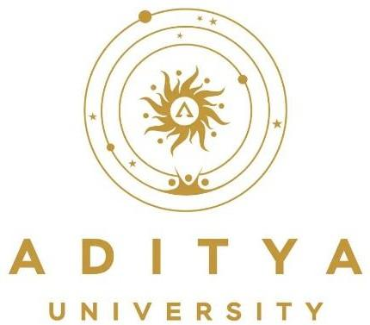
24M11MC186

DEPARTMENT OF COMPUTER APPLICATIONS
ADITYA UNIVERSITY
A.Y. 2025-26

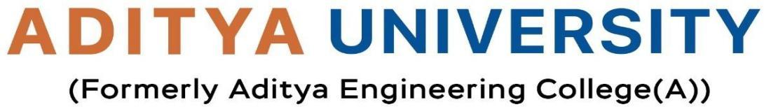
DEPARTMENT OF COMPUTER APPLICATIONS

CERTIFICATE

This is to certify that the internship report entitled “Data Science & Big Data Analytics” is being submitted by Vinnakota Devaki- 24M11MC186 in partial fulfillment of the requirements for the award of the degree of Master of Computer Applications in the Department of Computer Applications for the academic year 2024–2025. This report is based on the internship carried out at Blackbuck Engineers, and it reflects the student’s own work, conducted under our guidance and supervision.

Guide/Supervisor Name Head of the Department

Mr. K. NAGA BABU | Dr. M. VAMSIKRISHNA
Assistant Professor | Professor

DECLARATION

I hereby declare that the internship report entitled “Data Science & Big Data Analytics” is a genuine and original work submitted to Aditya University, Surampalem, in partial fulfillment of the requirements for the award of the Master of Computer Applications (MCA) degree. I further declare that this report has not been submitted, either in full or in part, for the award of any degree or diploma at this or any other educational institution.

By
Vinnakota Devaki
(24M11MC186)

INTERNSHIP CERTIFICATE

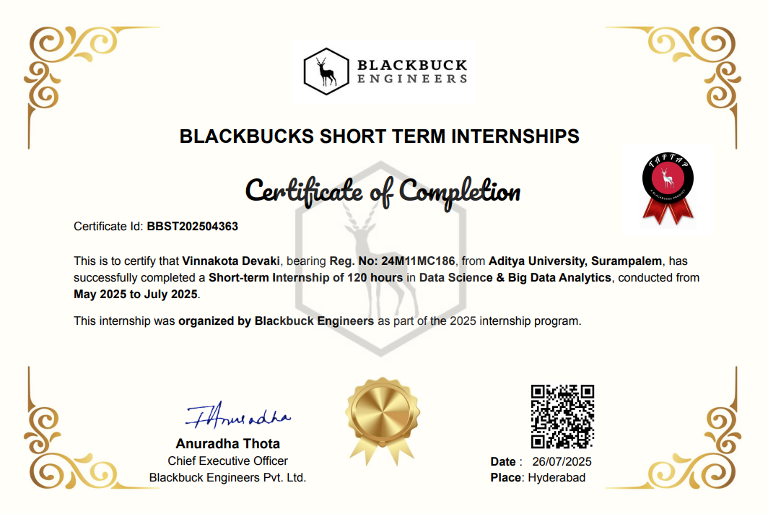

ACKNOWLEDGEMENT

First and foremost, I would like to express my heartfelt gratitude to Anuradha Thota, Chief Executive Officer of Blackbuck Engineers, for providing me the opportunity to undertake a short-term internship in Data Science & Big Data Analytics as part of the 2025 internship program. I am also thankful to all the team members at Blackbuck Engineers for their guidance, cooperation, and the professional yet friendly work environment that made this learning experience both enriching and enjoyable.
I extend my sincere thanks to Mr. Ritik Patidar, Assistant Professor and Internship Coordinator, for his support in coordinating the internship process and ensuring the smooth submission and evaluation of reports.
I am deeply grateful to Dr. M. Vamsikrishna, Head of the Department, for his continuous encouragement and for facilitating the necessary resources and infrastructure for the successful execution of my internship.
I also wish to express my appreciation to Naga Babu Sir, my project guide, for his valuable insights, constructive feedback, and unwavering support throughout the internship journey.
I am thankful to the respected leadership of Aditya University for their unconditional support and for providing world-class infrastructure and state-of-the-art laboratories. My sincere thanks to:
- Dr. Satish Reddy N, Pro Chancellor
- Dr. M. Sreenivasa Reddy, Deputy Pro Chancellor
- Dr. MB. Srinivas, Vice Chancellor
- Dr. S. Rama Sree, Pro-Vice Chancellor (Academics)
- Dr. Ramesh A, Pro-Vice Chancellor (Engineering & Sciences)
- Dr. Suresh G, Registrar
- Dr. M. Venkata Rajesh, Associate Dean of Academics

Lastly, I would like to thank all the faculty members, lab technicians, non-teaching staff, and my friends who directly or indirectly helped and supported me in successfully completing my internship project on time.
SUMMER INTERNSHIP ABSTRACT

As part of the 2025 Summer Internship Program organized by Blackbuck Engineers, I successfully completed a 120-hour internship in Data Science & Big Data Analytics from May 2025 to July 2025. The internship focused on foundational and advanced concepts in data handling, statistical analysis, machine learning, and big data technologies.
During the internship, I gained hands-on experience with tools and platforms such as Python, Pandas, NumPy, Matplotlib, Scikit-learn, and Apache Hadoop, among others. I worked on data preprocessing, exploratory data analysis, model building, and performance evaluation. The program also emphasized the importance of scalable data solutions and real-time analytics in modern business environments.
This internship has significantly enhanced my technical skills, analytical thinking, and understanding of data-driven decision-making, preparing me for future roles in the field of data science.

About Organization

Founded in May 2013, Blackbuck Engineers Pvt. Ltd. is a forward-thinking company dedicated to empowering students and professionals in the field of technology. Their mission is to build and empower people in technology by leveraging collaborative talent, experience, and energy to drive meaningful change.

Vision and Mission
Vision: To unleash the highest human potential by closing the gap between academic learning and industry expectations.
Mission: To create structured programs that combine cutting-edge pedagogy with hands-on experience, enabling learners to become future leaders in technology.

What They Offer
- LIVE Digital Learning Platform: Designed to groom students into future CEOs with a structured curriculum and world-class faculty.
- Internships and Job Opportunities: Students can access high-paying jobs, attend mock interviews, and build strong professional networks.
- Incubation and Innovation Centers: These centers work on real industry projects, allowing students to gain practical experience in research and development.

Community and Culture
Blackbuck Engineers fosters a vibrant student community across India, encouraging collaboration, learning, and personal growth.
Their motto, #AageKiPhikrNahi, reflects a commitment to worry-free, future-ready education and career development

SUMMER INTERNSHIP OVERVIEW
As part of the 2025 Summer Internship Program organized by Blackbuck Engineers Pvt. Ltd., I successfully completed a 120-hour short-term internship in Data Science & Big Data Analytics from May 2025 to July 2025. This program was designed to provide hands-on experience and practical exposure to emerging technologies in the field of data science.
Objectives
- To understand the core principles of data science and big data analytics.
- To gain practical experience with data preprocessing, visualization, and model building.
- To explore scalable data solutions and real-time analytics using industry-relevant tools.
Tools & Technologies Used
- Programming Languages: Python
- Libraries: Pandas, NumPy, Matplotlib, Scikit-learn
- Big Data Platforms: Apache Hadoop, Spark (if applicable)
- Development Tools: Jupyter Notebook, VS Code
Activities Undertaken
- Data collection and cleaning
- Exploratory data analysis (EDA)
- Building and evaluating machine learning models
- Understanding big data architecture and processing pipelines
- Participating in team discussions and project reviews
Learning Outcomes
- Strengthened understanding of data-driven decision-making
- Improved proficiency in Python and data science libraries
- Exposure to real-world datasets and problem-solving techniques
- Enhanced ability to work collaboratively in a professional environment
- This internship has been a pivotal step in my academic and professional journey, equipping me with the skills and confidence to pursue advanced roles in data science and analytics.

INDEX
S.No | Contents | Page No
1 | CERTIFICATE | 2
2 | DECLARATION | 3
3 | ACKNOWLEDGEMENT | 4
4 | SUMMER INTERNSHIP ABSTRACT | 6 - 9
5 | Week 1 Report | 11
6 | Week 2 Report | 12
7 | Week 3 Report | 13
8 | Week 4 Report | 14
9 | Week 5 Report | 15
10 | Week 6 Report | 16
11 | Overall Outcomes | 17

Week 1 Report:
 | DATE | DAY | NAMEOFTHETOPIC/MODULECOMPLETED
 | 19-05-2025 | Monday | Introduction to Data Science & Big Data
 | 20-05-2025 | Tuesday | Data Science Lifecycle & Business Analytics
 | 21-05-2025 | Wednesday | Onboarding Session – Tools (Python, Excel, Jupyter)
 | 22-05-2025 | Thursday | Domain Test – Python Basics
 | 23-05-2025 | Friday | MET Test – Analytical Problem Solving
 | 24-05-2025 | Saturday | Prerequisite Videos & Revision

Overview:

- Learned fundamentals of data science, lifecycle stages, and big data challenges.
- Understood business analytics applications and industry expectations.
- Onboarded with tools like Python, Excel, and Jupyter Notebook.
- Attempted domain test on Python basics (functions, loops).
- MET test helped identify strengths in analytical problem-solving.
.
Conclusion:
Week 1 provided a strong foundation in data science concepts and tools. Through onboarding and initial assessments, I gained clarity on the internship structure and prepared for hands-on sessions.

Week 2 Report:

 | DATE | DAY | NAMEOFTHETOPIC/MODULECOMPLETED
 | 26-05-2025 | Monday | Placement Test – Excel Basics
 | 27-05-2025 | Tuesday | Excel Data Cleaning & Pivot Tables
 | 28-05-2025 | Wednesday | Formula Automation (VLOOKUP, IF)
 | 29-05-2025 | Thursday | Assessment 1 – E-commerce Dataset
 | 30-05-2025 | Friday | Assignment – Sales Analysis
 | 31-05-2025 | Saturday | Visualization in Excel (Charts, Graphs)

Overview:

- Practiced Excel automation techniques for data cleaning and transformation.
- Learned pivot tables, VLOOKUP, and formula-based workflows.
- Completed assessment on cleaning e-commerce dataset.
- Created interactive charts for sales analysis.

Conclusion:
This week strengthened my foundation in Excel for data analysis. I learned to automate workflows and visualize datasets effectively.

Week 3 Report:

 | DATE | DAY | NAMEOFTHETOPIC/MODULECOMPLETED
 | 02-06-2025 | Monday | Placement Test – Python Basics
 | 03-06-2025 | Tuesday | Python Setup & Jupyter Notebook
 | 04-06-2025 | Wednesday | Control Flow & Functions
 | 05-06-2025 | Thursday | Assessment – Python Loops
 | 06-06-2025 | Friday | Assignment – Data Cleaning Scripts
 | 07-06-2025 | Saturday | Python-SQL Integration

Overview:

- Learned Python basics including data types, control flow, and functions.
- Practiced coding in Jupyter Notebook.
- Built scripts for cleaning datasets.
- Integrated Python with SQL for database queries.

Conclusion:
This week focused on Python fundamentals and integration with databases. This helped me transition from Excel to Python-based analytics.

Week 4 Report:

 | DATE | DAY | NAMEOFTHETOPIC/MODULECOMPLETED
 | 09-06-2025 | Monday | Pandas DataFrames & Filtering
 | 10-06-2025 | Tuesday | Handling Missing Data
 | 11-06-2025 | Wednesday | Grouping & Joining Data
 | 12-06-2025 | Thursday | Assessment – Warehouse Dataset
 | 13-06-2025 | Friday | Matplotlib & Seaborn Basics
 | 14-06-2025 | Saturday | Advanced Charts & Dashboards

Overview:
- Learned Pandas for data wrangling and cleaning.
- Handled missing values and duplicates.
- Practiced grouping and joining datasets.
- Built visualizations using Matplotlib and Seaborn.

Conclusion:
This Week enhanced my ability to clean, transform, and visualize data effectively.

Week 5 Report:

5th Week | DATE | DAY | NAMEOFTHETOPIC/MODULECOMPLETED
5th Week | 16-06-2025 | Monday | Hadoop Ecosystem & HDFS
5th Week | 17-06-2025 | Tuesday | MapReduce Concepts
5th Week | 18-06-2025 | Wednesday | Spark Basics
5th Week | 19-06-2025 | Thursday | Data Ingestion – Flume & Sqoop
5th Week | 20-06-2025 | Friday | Hive & Pig Basics
5th Week | 21-06-2025 | Saturday | Assessment – Big Data Workflow

Overview:

- Learned Hadoop ecosystem and distributed storage (HDFS).
- Understood MapReduce and Spark basics.
- Practiced data ingestion using Flume and Sqoop.
- Explored Hive and Pig for querying big data.

Conclusion:
This Week introduced me to big data fundamentals and tools, preparing me for large - scale analytics.

Week 6 Report:

 | DATE | DAY | NAMEOFTHETOPIC/MODULECOMPLETED
 | 23-06-2025 | Monday | Machine Learning – Regression & Classification
 | 24-06-2025 | Tuesday | Clustering & Model Evaluation
 | 25-06-2025 | Wednesday | Cross-validation & Overfitting
 | 26-06-2025 | Thursday | Real-world Case Study – Sales Forecasting
 | 27-06-2025 | Friday | Customer Segmentation Project
 | 28-06-2025 | Saturday | Capstone Review & Future Trends

Overview:
- Learned supervised learning techniques (regression and classification) and applied them to sample datasets.
- Practiced clustering methods for grouping customer data.
- Understood model evaluation, cross-validation, and how to avoid overfitting.
- Applied knowledge to real-world case studies such as sales forecasting and customer segmentation.
- Automated analytics workflows using Python and Excel integration.
- Reviewed capstone project outcomes and explored future trends in AI, cloud computing, and ethical analytics.
Conclusion:
Week 6 consolidated all the concepts learned during the internship. By completing the capstone project and final assessments, I demonstrated proficiency in the data science lifecycle, big data tools, and predictive modelling techniques. This final week marked the successful completion of my internship journey with Blackbuck Engineers, equipping me with industry-ready skills and confidence to apply data-driven solutions in real-world scenarios.

OVERALL OUTCOMES
- Foundational Knowledge: Developed a strong understanding of climate science, sustainability concepts, and the importance of green skills in today’s world.
- Technical Skills: Acquired hands-on experience in using AI and data analytics for environmental challenges, such as building and optimizing the EcoSort AI-powered smart recycling system and creating professional dashboards in Tableau.
- Project Management: Practiced end-to-end project management, including ideation, planning, technical development, documentation, quality assurance, and final submission.
- Real-World Application: Successfully transformed sustainability theory into practice with the EcoSort project, integrating community engagement and advocacy.
- Professional Development: Earned the AI Skills Passport certification, developed a professional portfolio, and enhanced LinkedIn/profile presence.
- Career Advancement: Explored career pathways in green technologies, engaged with the sustainability professional community, and planned future learning and entrepreneurship opportunities.
- Impact and Reflection: Engaged in self-reflection to identify strengths and areas for growth, giving me clear direction for future roles in climate tech, data analytics, and sustainable development sectors.
This experience has prepared me to contribute to India’s green economy and the UN Sustainable Development Goals, laying a solid foundation for my future career in technology-driven sustainability.

