End-to-End Analysis of Fitbit User Activity and Sleep Data
Analyzing fitness tracker data to uncover activity patterns, sleep behavior, and wellness insights using Excel, SQL, and Tableau.
- Data is taken from: FitBit Fitness Tracker Data
- We are taking two files which are :
1. dailyactivity_merged.csv
2.sleepday_merged.csv
- This are the overview of the dailyactivity_merged.csv
-There are 35 unique users in the dataset.( Using excel formula (=COUNTA(UNIQUE(A2:A458)) ,OUTPUT :35)
-The activity data covers March and April 2016.
-The Id column uniquely identifies each Fitbit user.
-The ActivityDate column records the date of the activity.
-The TotalSteps column represents the total number of steps taken by a user in a day.
-The TotalDistance column represents the total distance traveled by a user in a day.
-The TrackerDistance column represents the distance automatically tracked by the Fitbit device.
-The dataset also contains activity intensity metrics such as very active, fairly active, lightly active, and sedentary minutes.
-The Calories column represents the total calories burned by a user in a day.
  - Overview of the sleepday_merged.csv
- There are 24 unique users in the dataset
- The data covers April and May 2016.
- The Id column uniquely identifies each user.
- The SleepDay column records the date and timestamp of the sleep log.
- The TotalSleepRecords column tracks how many times a user slept in a 24-hour period (including main sleep and naps).
- The TotalMinutesAsleep column represents the exact time the user spent sleeping.
- The TotalTimeInBed column tracks the total time spent in bed (sleeping + resting/scrolling).
- Data cleaning in excel
-No duplicates found in dailyactivity file
-checked for duplicates in sleepday file, found 3 duplicates (data section and remove duplicates)
- Missing values were checked in both files using Excel filters and the COUNTBLANK() function. No missing values were identified in the dailyActivity_merged dataset.
- Data formatting in excel
- Changed Id datatype into whole number and with decimal point as 0
- Changed activitydate to shortdate for both the datasets
- Data import into SQL
- After completing data cleaning in Excel, the cleaned CSV files were uploaded into BigQuery.
- Data types were verified after importing to ensure dates and numerical values were correctly recognized.
- Analyze the dataset
How many unique users are present in the activity dataset?
To identify the number of Fitbit users included in the analysis.
select
count(distinct id) as unique_users
from
`firstproject-492514.fit.dailyactivity_cleaned`

- What is the average number of steps taken by users per day?
To understand the overall daily activity pattern of users.

select
ActivityDate,
round(avg(totalsteps),2) as avg_steps
from
`firstproject-492514.fit.dailyactivity_cleaned`
group by
ActivityDate;

Which date recorded the highest average number of steps?
To identify the day with the highest overall user activity.

select
ActivityDate,
round(avg(totalsteps),2) as avg_steps
from
`firstproject-492514.fit.dailyactivity_cleaned`
group by
ActivityDate
order by
avg_steps desc
limit 1

- Which user recorded the highest total number of steps?
To identify the most active Fitbit user based on total steps.
select
Id,
sum(TotalSteps) as total_steps
from
`firstproject-492514.fit.dailyactivity_cleaned`
group by
Id
order by total_steps desc
limit 1;

- Do users who are more active tend to sleep longer?
To analyze the relationship between physical activity and sleep duration.

select dc.Id,
round(avg(TotalSteps),2) as activity,
round(avg(TotalMinutesAsleep),2) as sleep
from
`firstproject-492514.fit.dailyactivity_cleaned`as dc
join
`firstproject-492514.fit.sleepday_cleaned` as sc
on
dc.Id= sc.Id
and dc.ActivityDate=sc.SleepDay
group by
dc.Id

- How many users achieve the recommended 7 hours or more of sleep on average?
To identify users meeting the recommended sleep duration.
select count(*)
from (select avg(TotalMinutesAsleep) as average
from `firstproject-492514.fit.sleepday_cleaned`
group by Id
having average >=420);

- Which users are more active than the average Fitbit user?
To compare individual users' activity levels against the overall user average.
select
Id,
avg(TotalSteps) as avg_steps
from
`firstproject-492514.fit.dailyactivity_cleaned`
group by
Id
having avg_steps > (
select avg(totalsteps) as average
from
`firstproject-492514.fit.dailyactivity_cleaned`
)

- Which users spend the most time being sedentary?
To identify users with higher inactive time.

select id,
round(avg(SedentaryMinutes),2) as avg_sedentary_minutes
from
`firstproject-492514.fit.dailyactivity_cleaned`
group by
id
order by
avg_sedentary_minutes desc

- Categorize users based on their activity level.
To classify users into low, moderate, and high activity groups.
select
id,
round(avg(totalsteps)) as avg_steps,
case
when avg(totalsteps) < 5000 then 'Low activity'
when avg(totalsteps) between 5000 and 10000 then 'Moderate activity'
else 'High activity'
end as cat
from
`firstproject-492514.fit.dailyactivity_cleaned`
group by ID;

- Which user has the highest sleep efficiency?
To identify users who spend the highest percentage of their time in bed actually sleeping.

SELECT
Id,
ROUND(AVG((TotalMinutesAsleep / TotalTimeInBed) * 100),2) AS avg_sleep_efficiency
FROM
`firstproject-492514.fit.sleepday_cleaned`
GROUP BY ID
ORDER BY avg_sleep_efficiency DESC
LIMIT 1;

- Tableau Visualizations
- How active are Fitbit users over time?
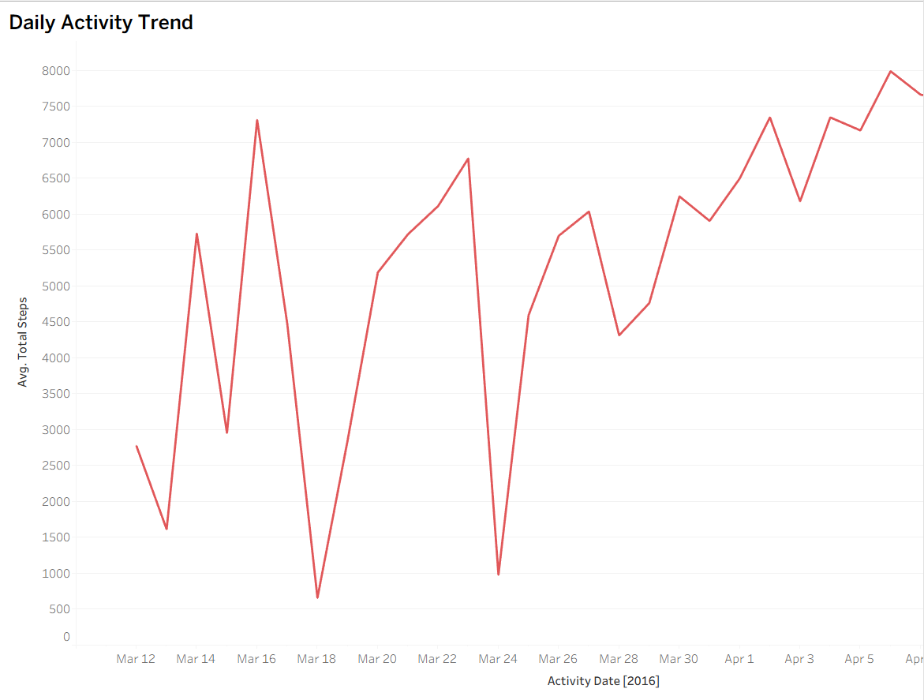

- Does logging more steps lead to better sleep?
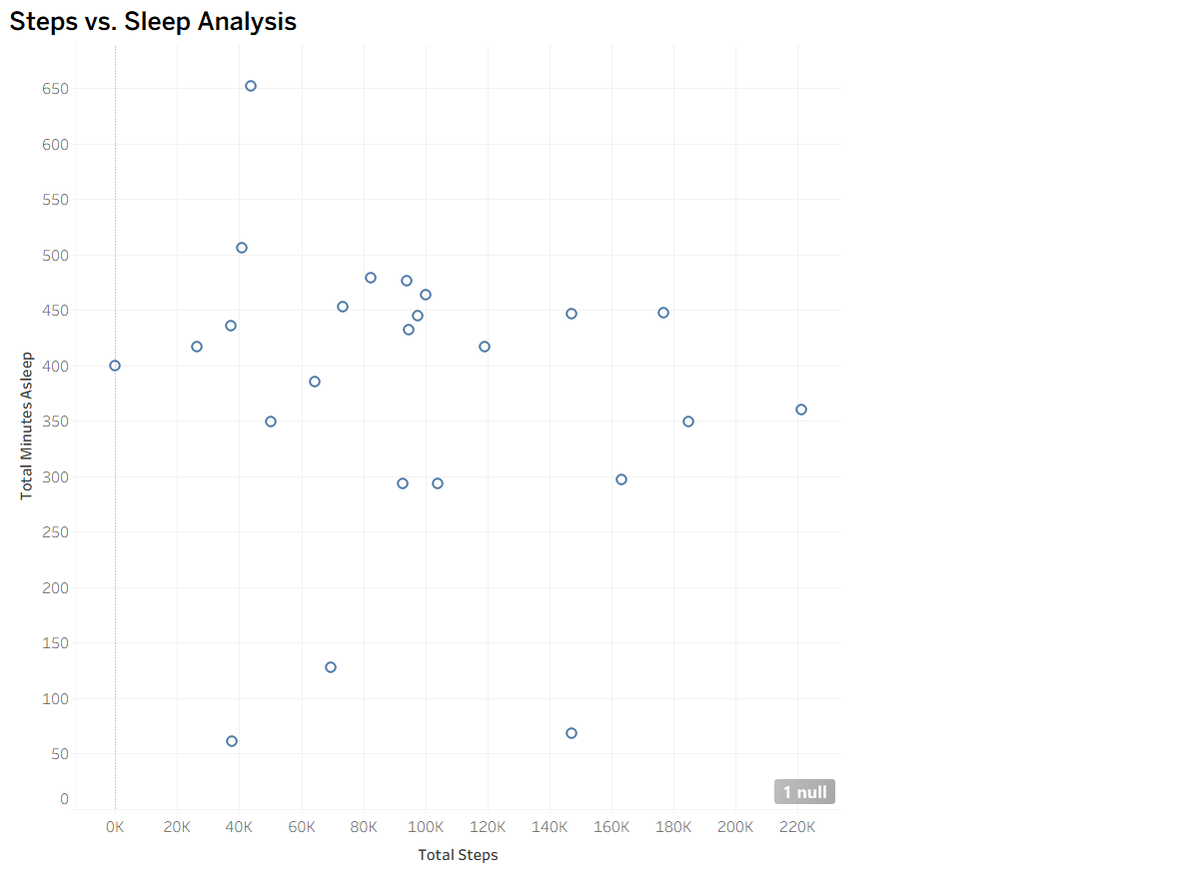

- How are users distributed across activity levels?
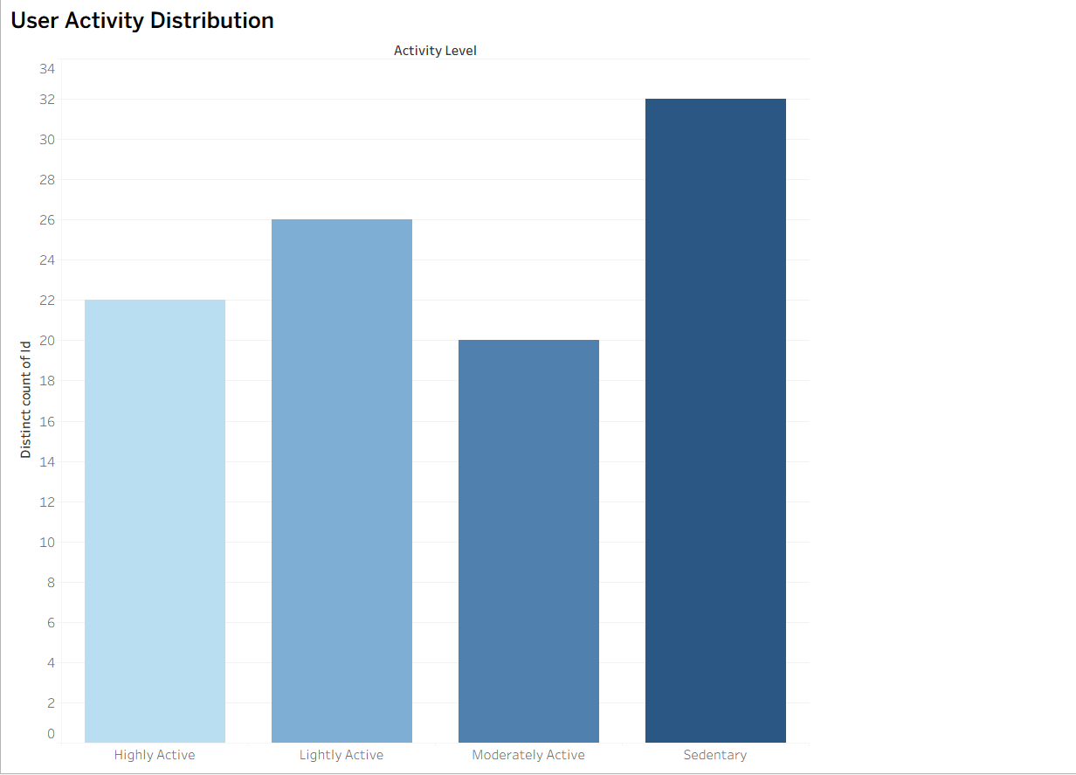

- Which users spend the most time being sedentary?

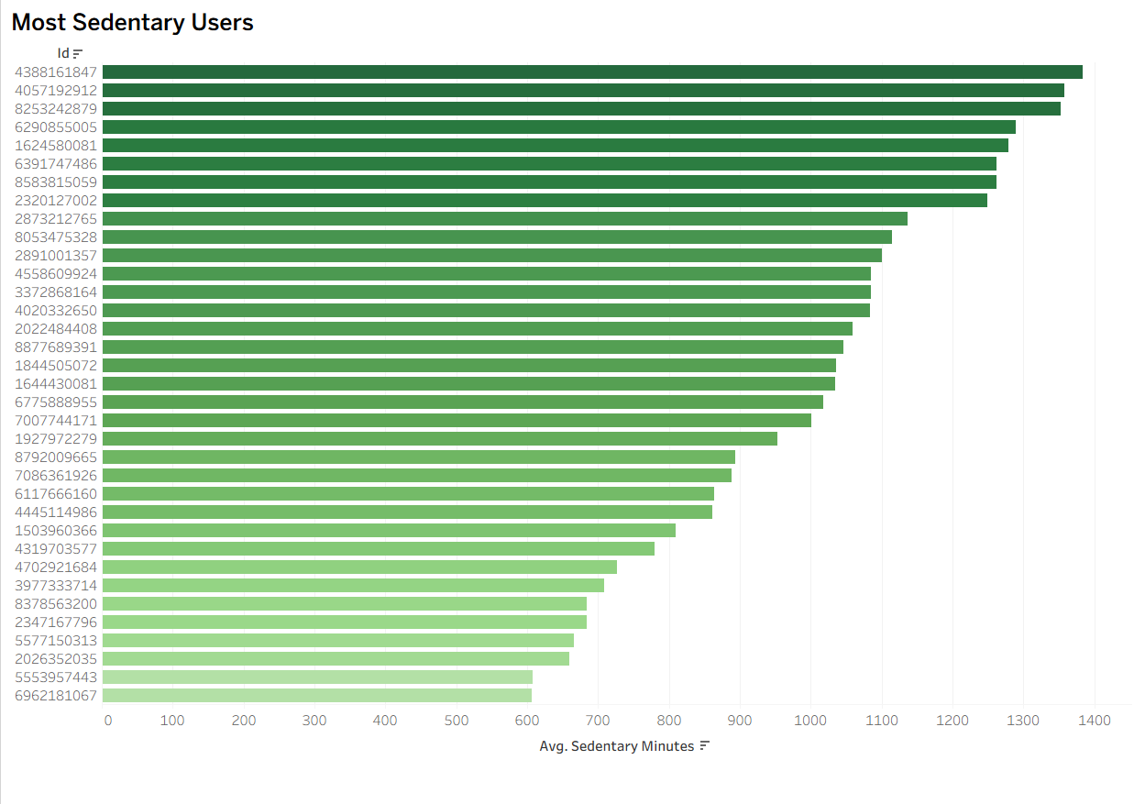

Final Dashboard
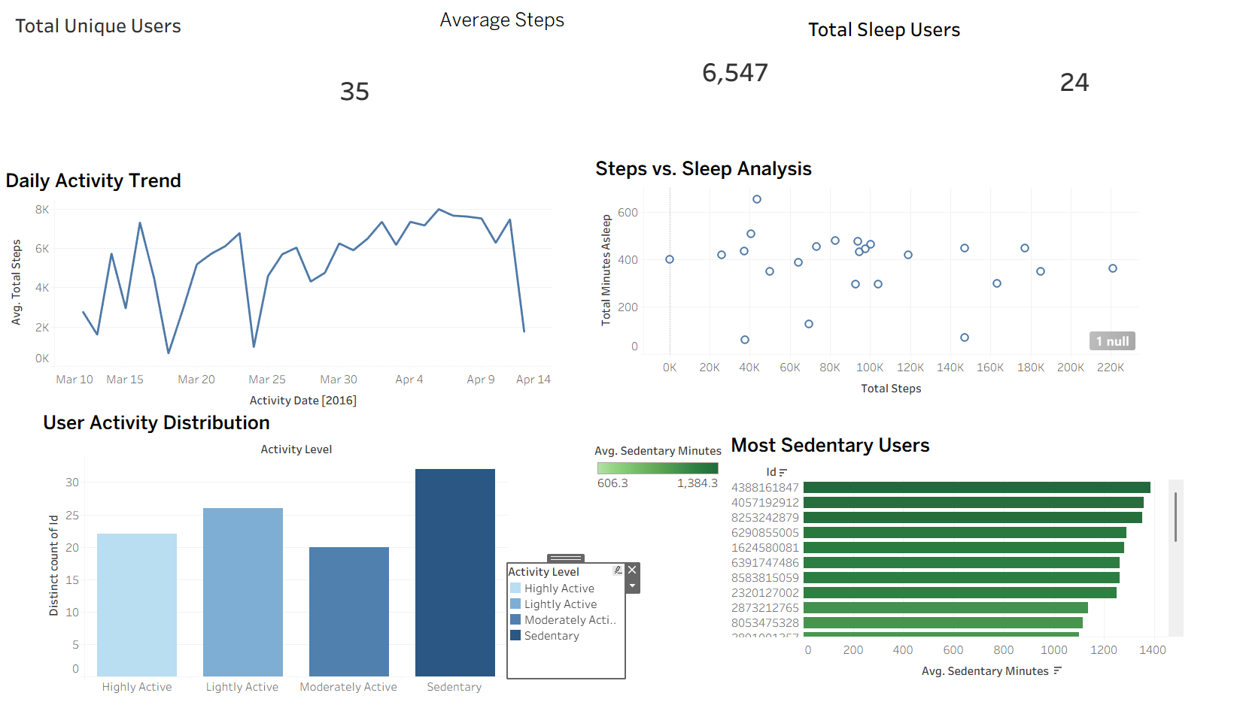

Conclusion:
This project successfully analyzed Fitbit user activity and sleep behavior using Excel, SQL (BigQuery), and Tableau. The analysis identified activity trends, sedentary behavior, sleep efficiency, and user classifications while demonstrating the complete data analytics workflow from data cleaning to visualization.

