Help Desk Module – Test Signoff by IT

Test Version Control:
Tested Date | Tested By | Module | Version
17/10/25 | Asif A | Help Desk | 1.0

Summary of Bugs:
- Categories must be clubbed, as we are able to see lot of Categories and 1 subcategory for each category. it must be under each category; many subcategories must be there.
- SLA Time is different in 2 different places
- Feedback is yet to be configured
- Dashboard for Helpdesk to be configured
- Request for closure is not working; the system automatically closes the issue without the confirmation from the Ticket Raiser.

Test Cases which are followed in the Help desk module Unit Testing:
- Act as an Employee raise a Helpdesk ticket
- Act as an Assignee of the ticket and check for the notification
- Act as an Assignee and reassign the ticket to a new Assignee
- Act as a New Assignee and ask for a Clarification on the Ticket
- Ast as an Employee who created the ticket and check for the comments / Notifications for the same
- Act as an Employee Give back the comments
- Act as a Reassigned Employee and check for the comments / notifications
- Act on the ticket and request for the closure
- Act as an Employee and check for the Notification for the request for a Closure
- Act as an Employee and Respond No to the ticket Closure.
- Act as a Reassigned Employee and Respond to the ticket
- Again, Request for closure to the same ticket
- Act as an Employee and respond to the closure of the ticket
- Check for the SLA breaches is the ticket getting escalated in the Given Time
- Check the SLA configuration with the DCT template
- Feedback form must be sent to the employee post closure of the ticket – Non Mandatory
- Dashboard for the Helpdesk Module

Test Case Results:
- Act as an Employee raise a Helpdesk ticket
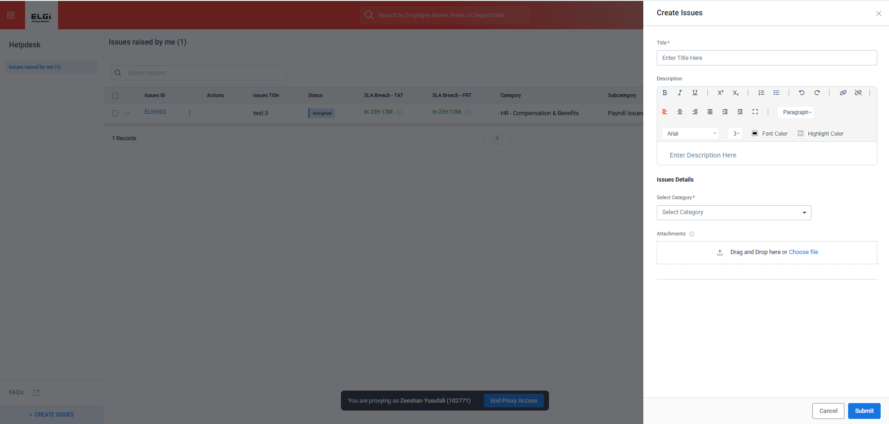
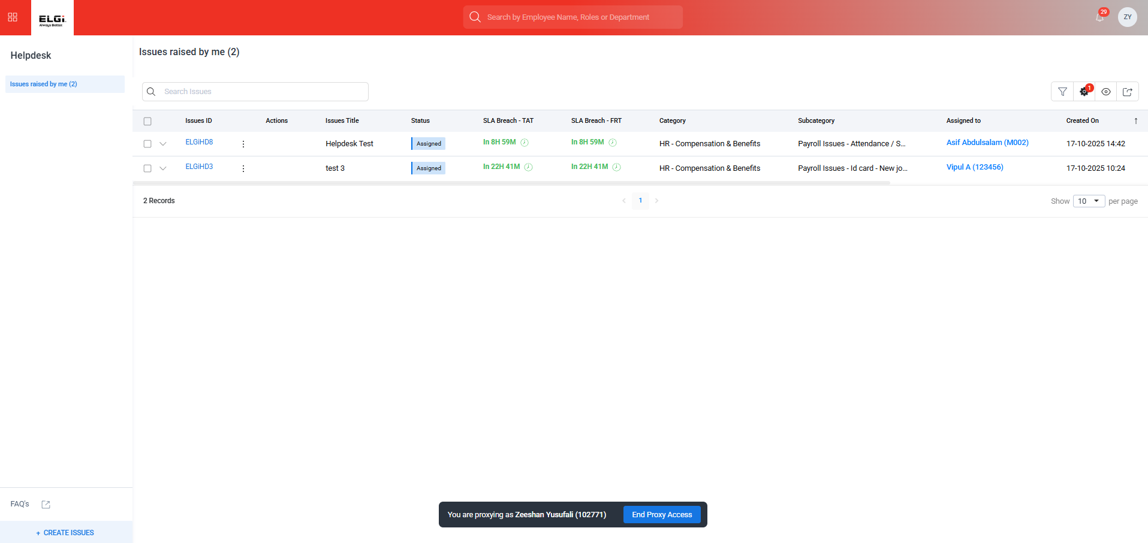

- Act as an Assignee of the ticket and check for the notification
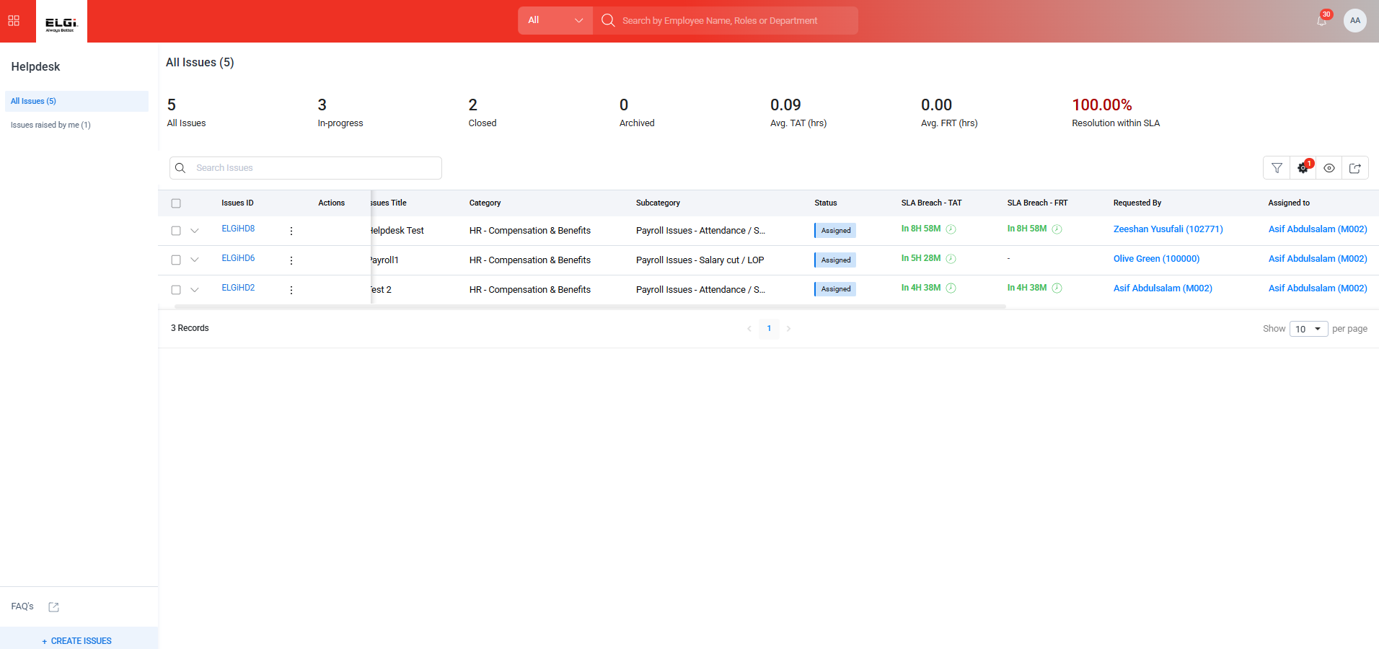
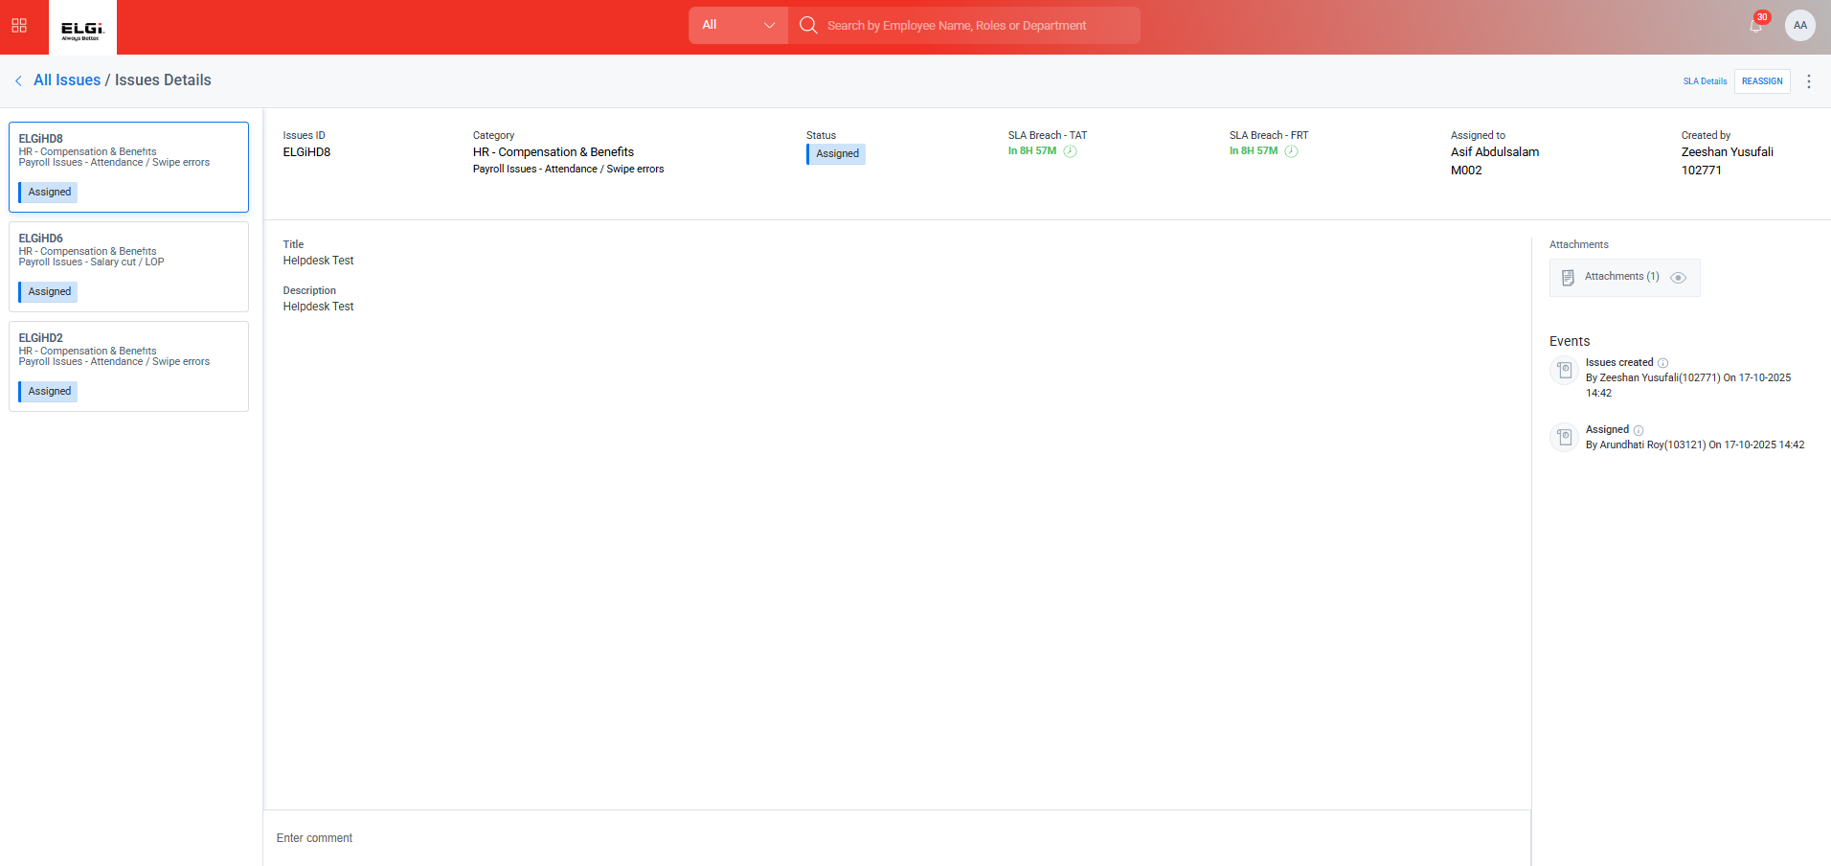
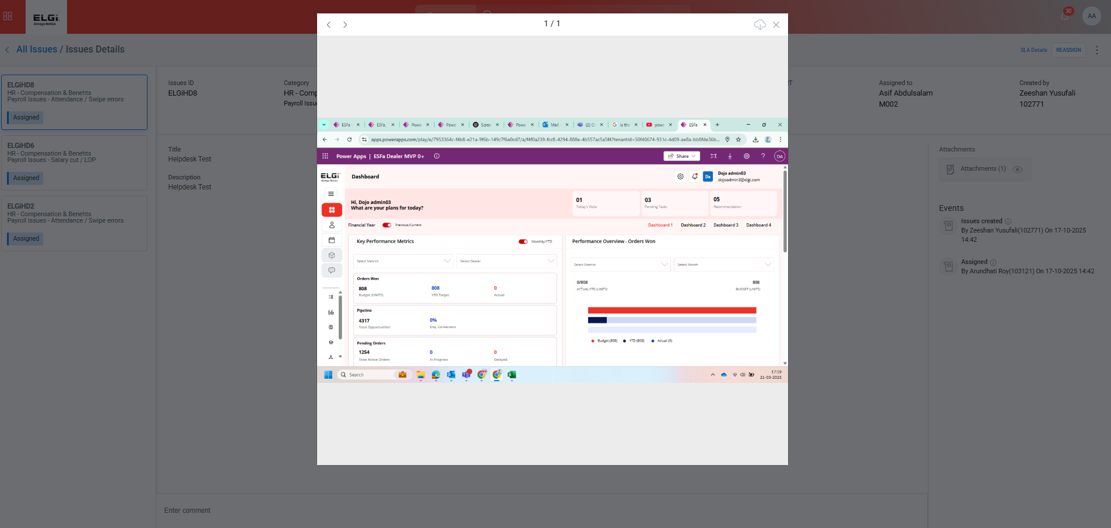

- Act as an Assignee and reassign the ticket to a new Assignee
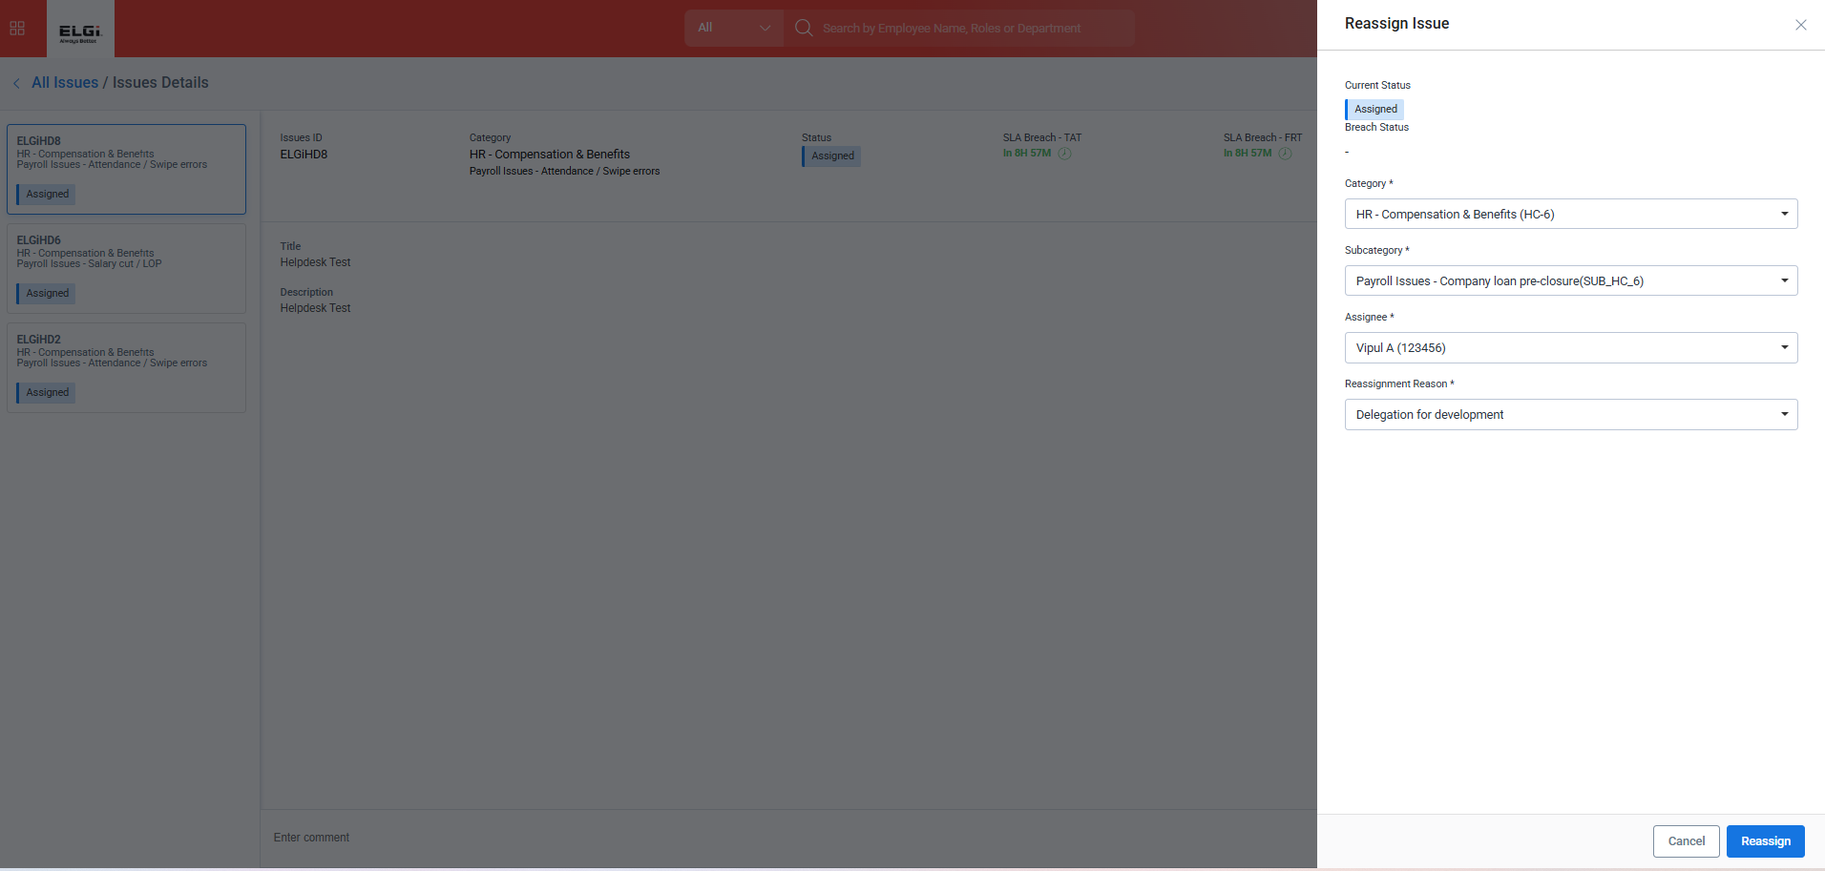
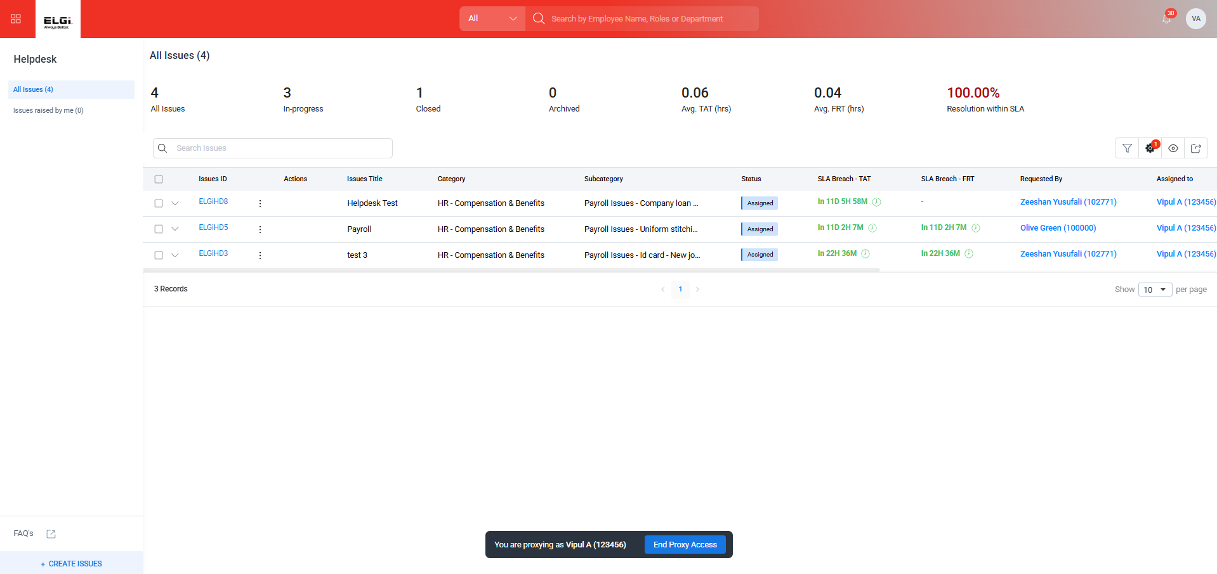
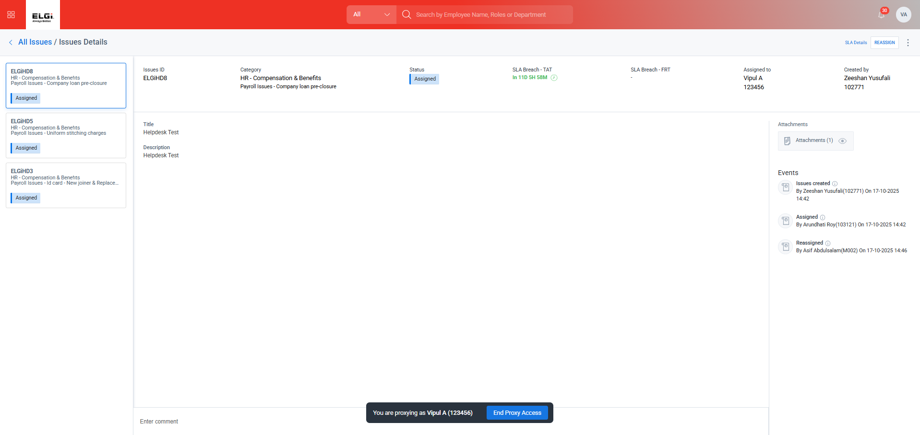
- Act as a New Assignee and ask for a Clarification on the Ticket
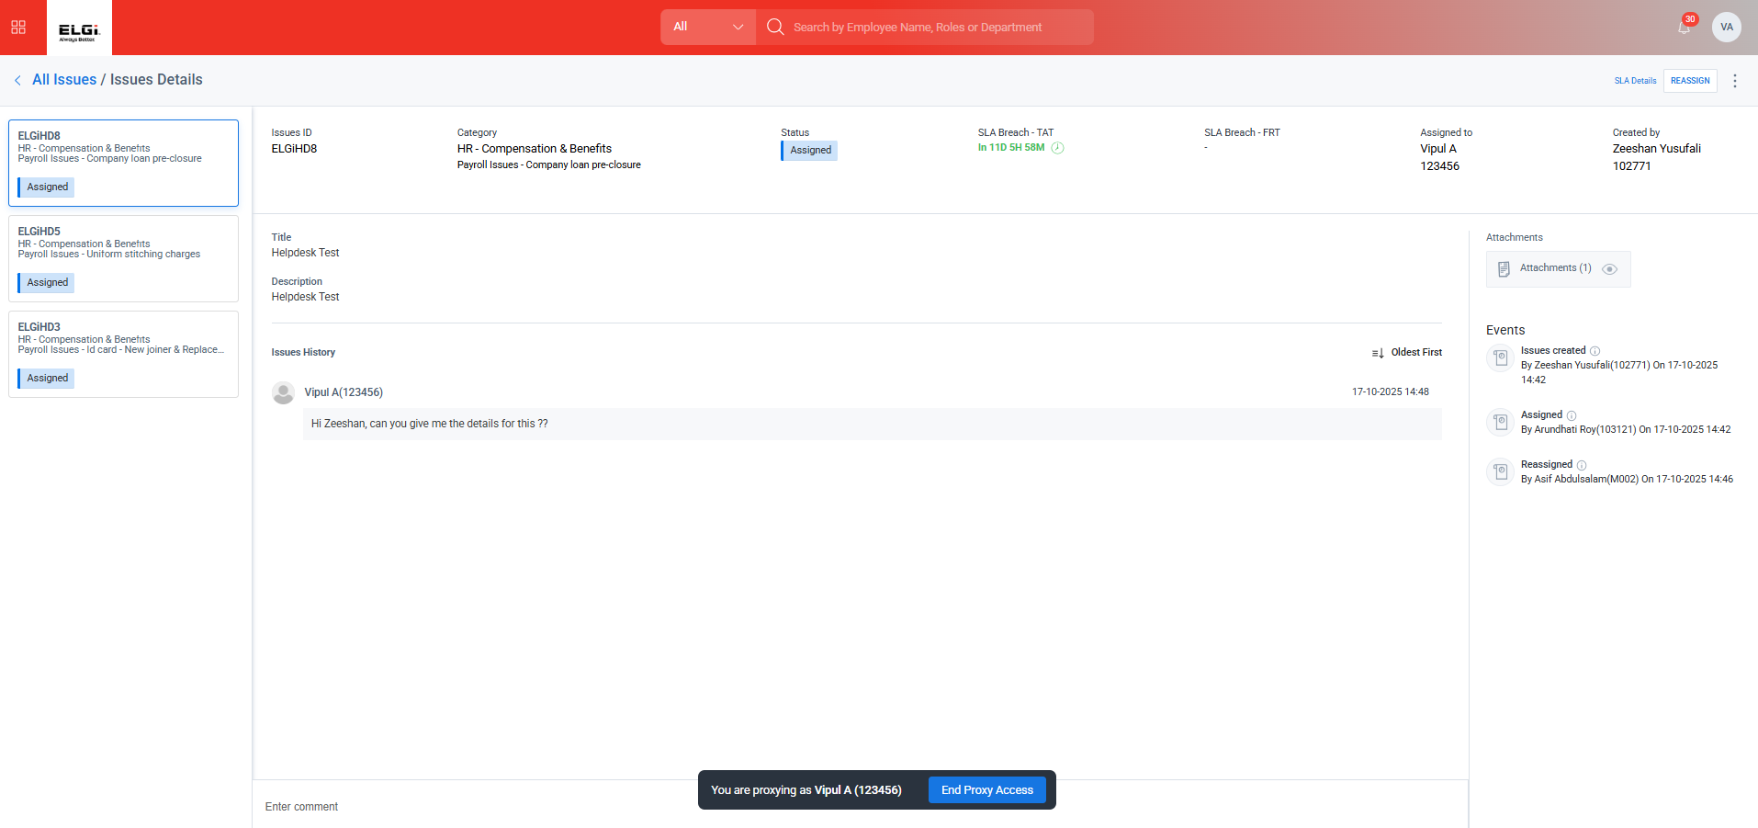
- Ast as an Employee who created the ticket and check for the comments / Notifications for the same
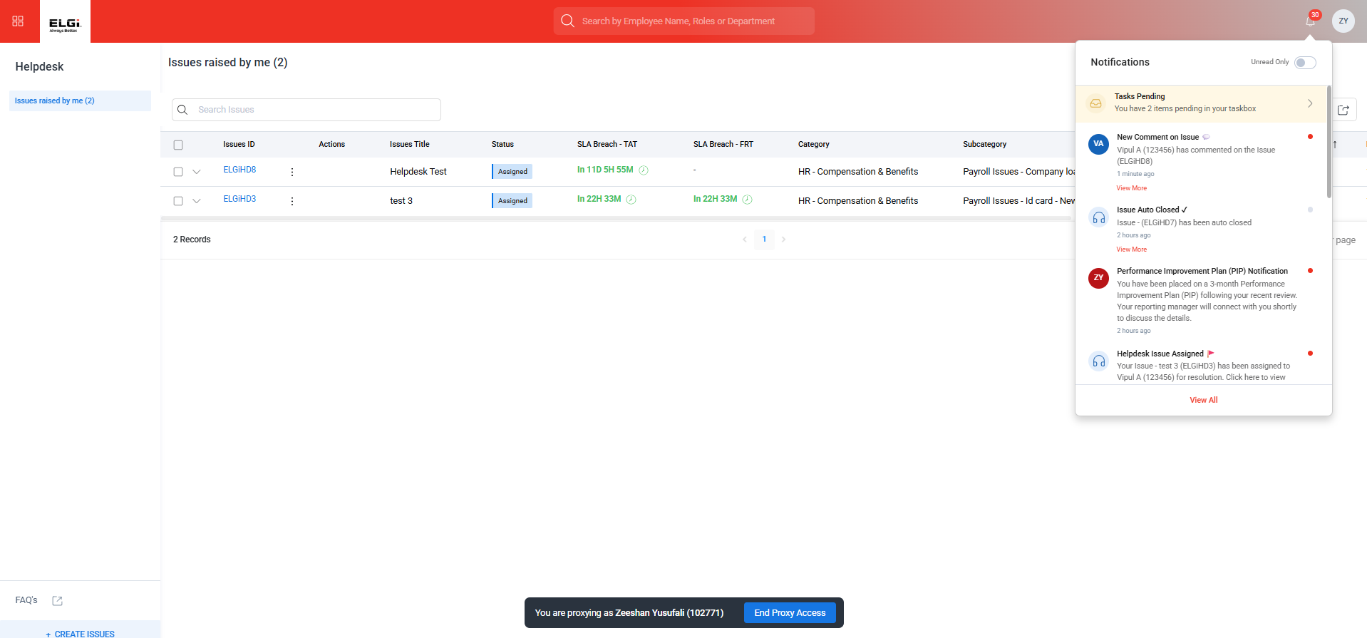

- Act as an Employee Give back the comments
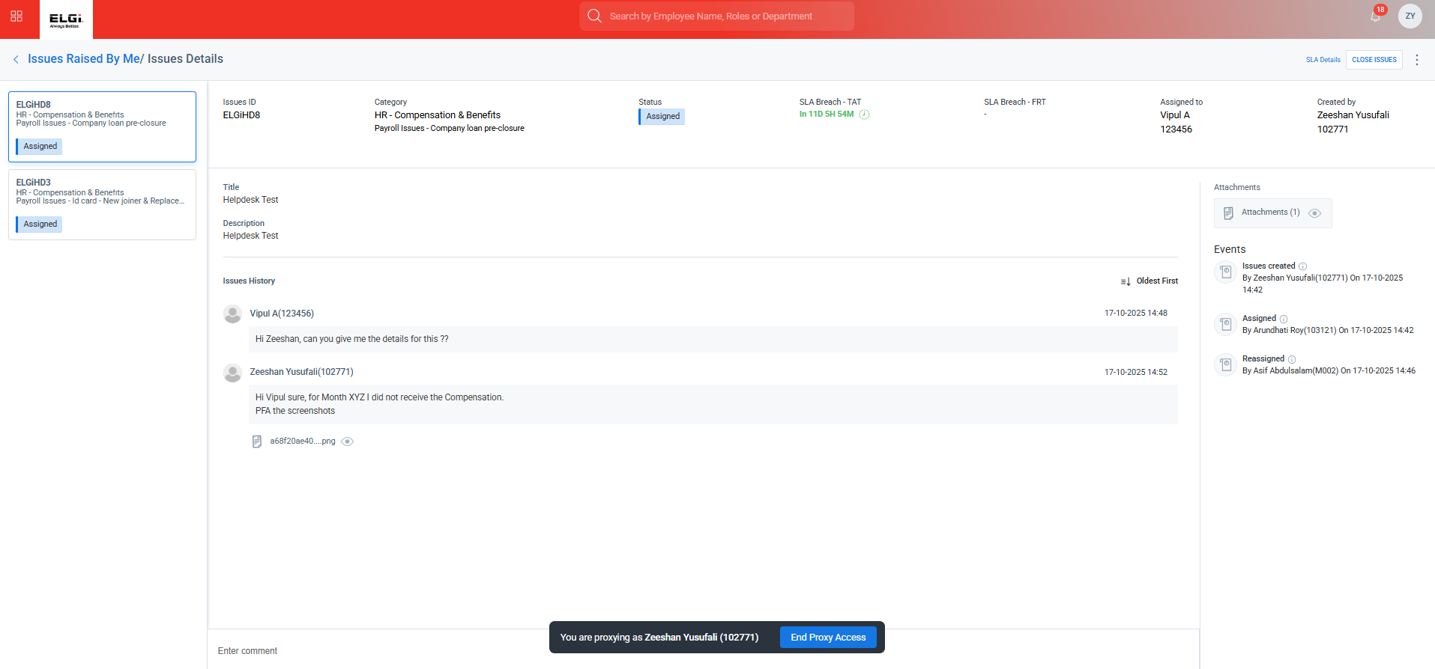

- Act as a Reassigned Employee and check for the comments / notifications
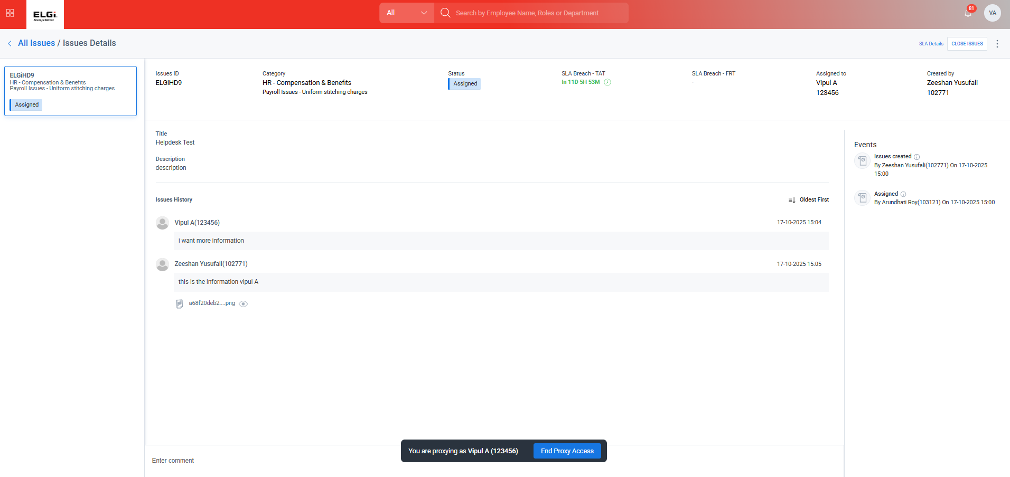

- Act on the ticket and request for the closure
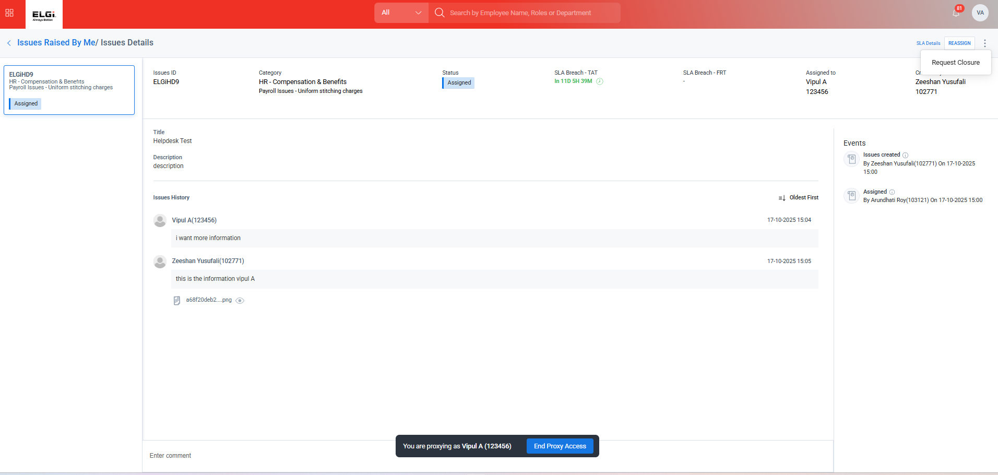
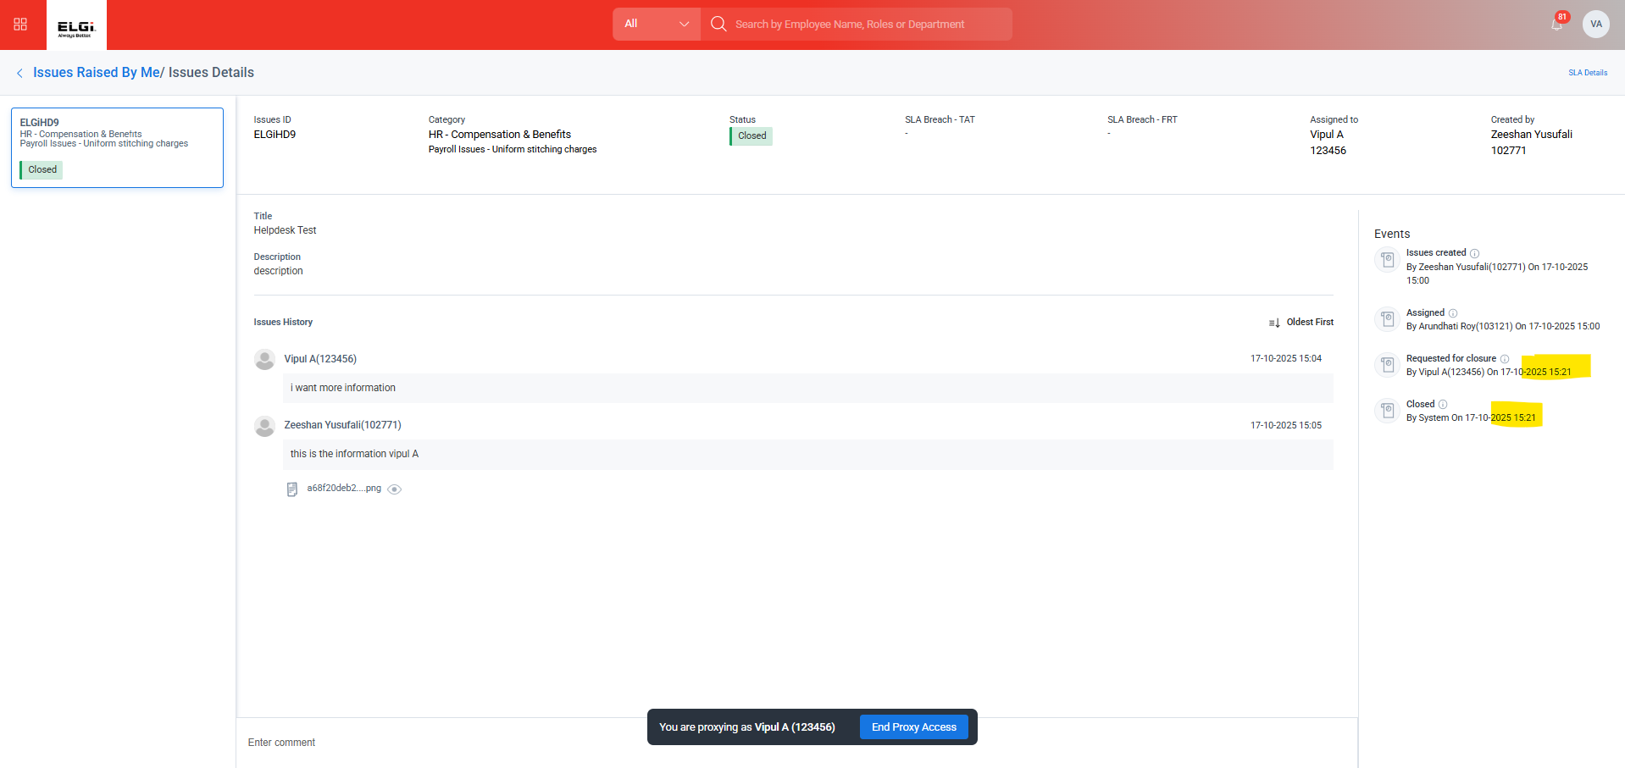
- Act as an Employee and check for the Notification for the request for a Closure
- Fail there is no Request for Closure
- Act as an Employee and Respond No to the ticket Closure.
- Fail there is no Request for Closure
- Act as a Reassigned Employee and Respond to the ticket
- Fail there is no Request for Closure
- Again, Request for closure to the same ticket
- Fail there is no Request for Closure
- Act as an Employee and respond to the closure of the ticket
- Fail there is no Request for Closure
- Check for the SLA breaches is the ticket getting escalated in the Given Time
- Couldn’t Test as the SLA is 24 hours.
- 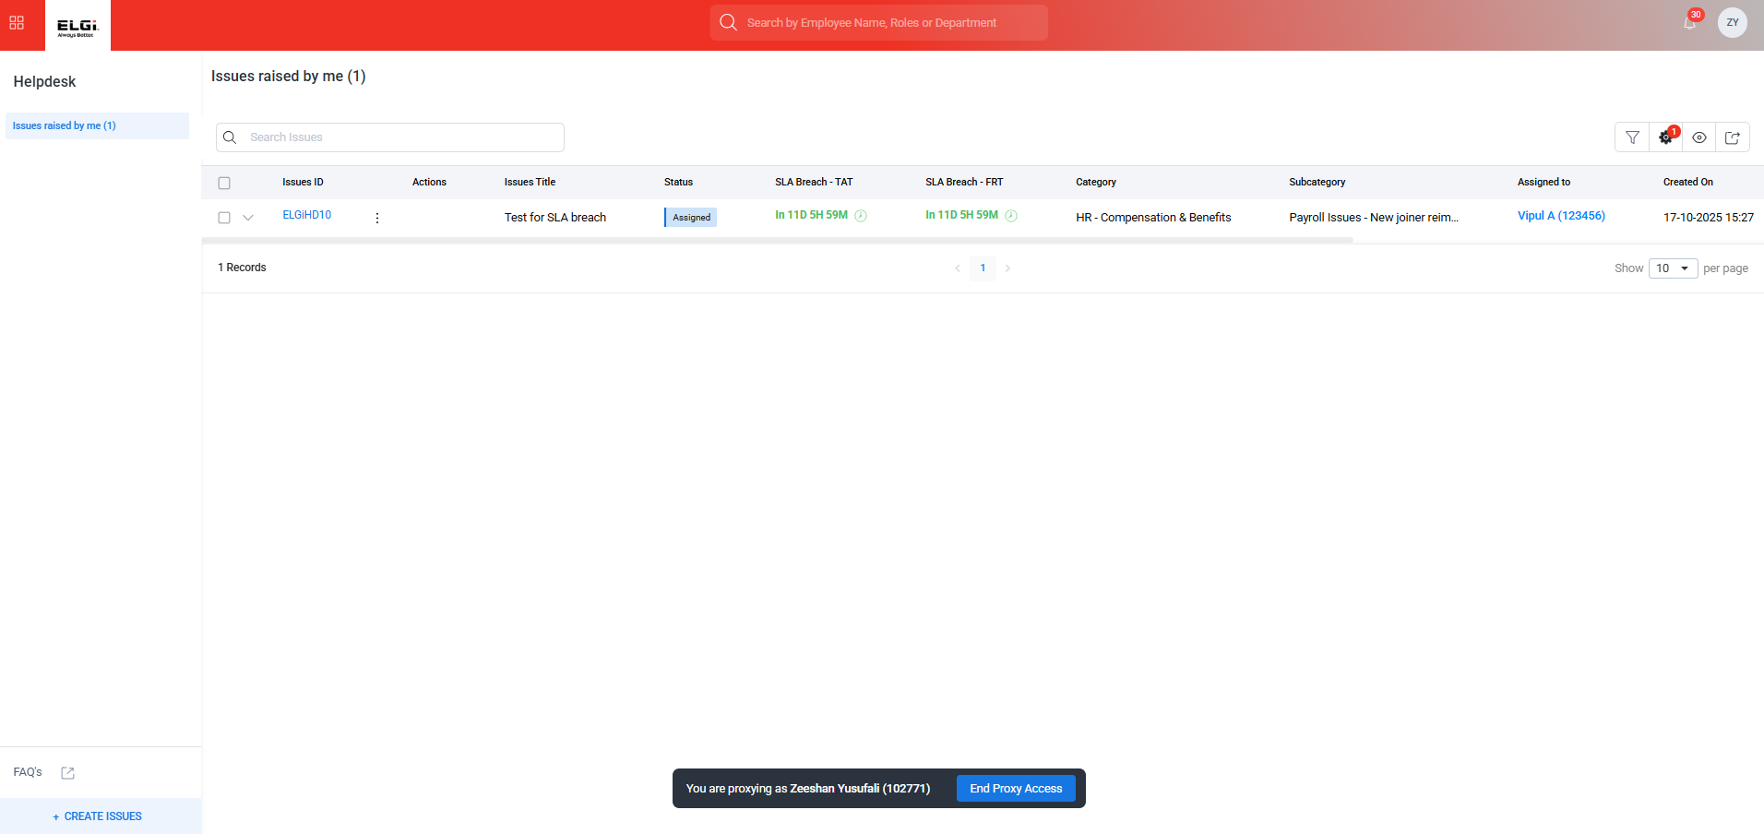
- Will test the SLA with this particular ticket
- Check the SLA configuration with the DCT template
- Feedback form must be sent to the employee post closure of the ticket – Non Mandatory-
- Not Yet Configured
- Dashboard for the Helpdesk Module
- Not Yet Confirmed

