Low-Level Design (LLD) — Customer Master Sync Module
Attribute | Value
Module | Customer Master Sync
Menu path | ADMINISTRATION → SYSTEM CONFIGURATION → Customer Master Sync
Landing page | customers.php
Application | Complaint Management Portal
Stack | Core PHP + PostgreSQL (PDO)
Document version | 1.0
Access | System Admin only (require_system_admin)

────────────────────────────────

1. Module Overview

1.1 Purpose
The Customer Master Sync module allows admins to maintain a controlled list of customer codes in customer_master_sync. Codes are selected from customer_master, and customer name is auto-resolved/read-only for display.

1.2 Scope
• Add, edit, list, view, soft-delete sync records
• Validate selected customer code exists in source master
• Ensure unique active customer code in sync table
• Reset assigned users (user_master.customer_code) when sync code is deleted or changed
────────────────────────────────

2. Functional Requirements
• FR-01: Admin can view paginated/searchable sync list
• FR-02: Admin can add a sync entry by selecting customer code
• FR-03: Customer name auto-populates from selected code and is read-only
• FR-04: Admin can edit selected customer code
• FR-05: Admin can view sync record details
• FR-06: Admin can soft-delete sync records
• FR-07: On delete, assigned users must be unassigned (customer_code = NULL)
• FR-08: On code change during edit, users mapped to old code must be unassigned
────────────────────────────────

3. User Roles & Access
• Only System Admin can access:
• API access is guarded through admin_api_require_system_admin($obconn).
────────────────────────────────

4. Business Rules
• BR-01: customer_code is required.
• BR-02: customer_code max length is 9.
• BR-03: customer_code must exist in customer_master.cuno.
• BR-04: Active uniqueness in sync table is case/trim-insensitive.
• BR-05: Delete is soft delete (deleted_at set).
• BR-06: When a sync code is removed or replaced, users with that old code are reset to NULL.
────────────────────────────────

5. Database Design

5.1 Sync table
• Table: customer_master_sync
• Fields:

5.2 Constraints
• Unique index on active rows:

5.3 Reference source
• Source customer list is read from customer_master:
────────────────────────────────

6. Component Architecture
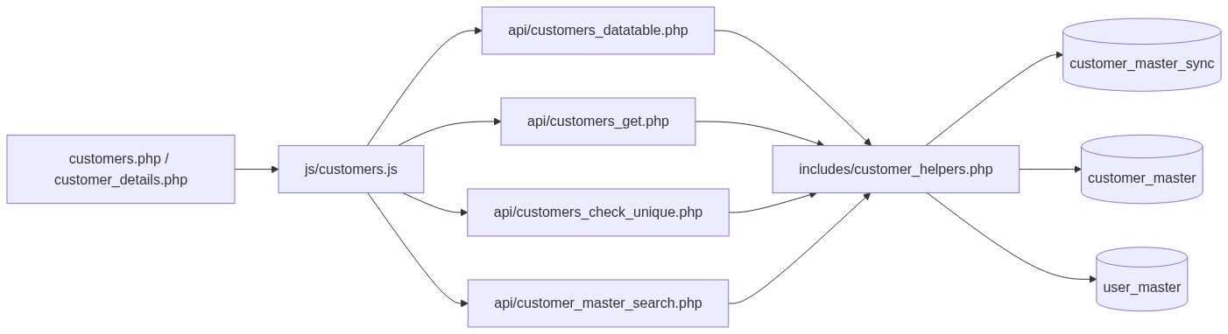
Figure 1 — Component architecture
────────────────────────────────

7. Page-Level Flow

7.1 List + form page (customers.php)
• Shows flash/success/error messages
• Contains Add/Edit form panel
• Contains DataTable list
• Performs server-side add/update on POST

7.2 Details page (customer_details.php)
• Decodes id from base64 query param
• Loads active sync record by id
• Shows code/name and audit fields

7.3 Delete page (delete_customer.php)
• Validates record exists and active
• Calls helper soft-delete flow
• Redirects with flash message
────────────────────────────────

8. API Design
• api/customers_datatable.php
• api/customers_get.php
• api/customers_check_unique.php
• api/customer_master_search.php
────────────────────────────────

9. Validation

9.1 Client-side (js/customers.js)
• validate.js enforces required customer_code
• async uniqueness call before submit
• Select2 invalid state styling

9.2 Server-side (includes/customer_helpers.php, customers.php)
• required and length checks
• code existence check in customer_master
• uniqueness check in customer_master_sync
────────────────────────────────

10. Search, Pagination, Sorting
• Implemented using DataTables server-side mode
• Uses helper dt_parse_request(...)
• Search filters on:
────────────────────────────────

11. Soft Delete & User Unassignment
When deleting a sync record:
1. Load sync record and capture its customer_code
2. Soft-delete sync row
3. Update user_master and set customer_code = NULL for users assigned to that code
4. Commit transaction
Same reset logic runs on update when old code changes to a new code.
────────────────────────────────

12. Transaction Handling
• customer_soft_delete(...) uses transaction:
• customer_update(...) uses transaction:
────────────────────────────────

13. Security Considerations
• System Admin gate on pages and APIs
• Parameterized SQL everywhere (PDO prepared statements)
• Output escaping via htmlspecialchars(...)
• ID obfuscation in details/delete links via base64
────────────────────────────────

14. Error Handling
• Invalid id/code -> friendly error message
• Missing/deleted record -> guarded and redirected
• DB exceptions -> generic failure messages
• API errors return JSON with proper HTTP codes/messages
────────────────────────────────

15. Integration with User Management
User module uses sync table as source for Customer Code assignment:
• api/user_customer_search.php uses user_customer_code_search(...)
• helper reads from customer_master_sync (active only)
• display names may still resolve via customer_master join for label text
────────────────────────────────

16. Key Files
• customers.php
• customer_details.php
• delete_customer.php
• includes/customer_helpers.php
• js/customers.js
• api/customers_datatable.php
• api/customers_get.php
• api/customers_check_unique.php
• api/customer_master_search.php
• sql/create_customer_master_sync.sql
────────────────────────────────

17. Test Scenarios
• Add new sync record with valid code
• Prevent duplicate active code
• Edit code and verify old code users are unassigned
• Delete code and verify assigned users are unassigned
• Verify list pagination/search/sort
• Verify details page for valid/invalid id
• Verify non-admin access denied
────────────────────────────────

18. Future Enhancements
• Add audit trail table for before/after sync changes
• Add bulk sync upload from source master
• Add “active assignment count” in list view before delete

