Low-Level Design (LLD) — Users Module
Attribute | Value
Module | Users (User Master Administration)
Menu path | ADMINISTRATION → Users
Landing page | users.php
Application | Complaint / Dealer Portal
Stack (target) | Core PHP + MySQL (PDO)
Stack (current repo) | Core PHP + PostgreSQL via PDO
Document version | 1.1
Access | System Admin only (role id 6) — no RBAC module slug

â”€â”€â”€â”€â”€â”€â”€â”€â”€â”€â”€â”€â”€â”€â”€â”€â”€â”€â”€â”€â”€â”€â”€â”€â”€â”€â”€â”€â”€â”€â”€â”€

1. Module Overview

1.1 Purpose
System Administrators manage portal accounts in user_master: create/edit users, assign roles, link Sales Coordinators where required, assign a Customer Code from customer_master_sync, set credentials, enforce uniqueness and email quality rules, soft-delete accounts, and revoke active sessions via session_version when password, role, or email changes.

1.2 Scope
In scope | Out of scope
List / Add / Edit / Details / Soft-delete | Self-service change password (Auth module)
Role + Sales Coordinator linkage | Role master CRUD (Roles module)
Unique username / email / mobile / customer_code | Lockout counters (Auth; columns shared)
Customer Code assignment via Select2 from customer_master_sync | Customer Master Sync CRUD (separate module)
Disposable email block | Password history on admin-set password
session_version bump on critical edits

1.3 High-level architecture
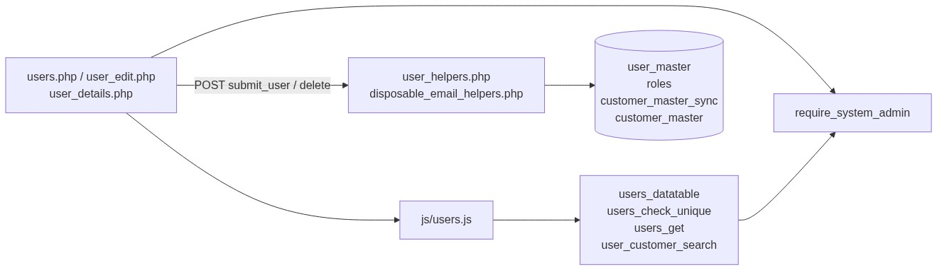
Figure 1 â€” High-level architecture
â”€â”€â”€â”€â”€â”€â”€â”€â”€â”€â”€â”€â”€â”€â”€â”€â”€â”€â”€â”€â”€â”€â”€â”€â”€â”€â”€â”€â”€â”€â”€â”€

2. Functional Requirements
ID | Requirement | Priority
FR-01 | System Admin can open Users list (DataTables) | Must
FR-02 | Create user with role, identity, password, customer code, optional SC | Must
FR-03 | Edit user on user_edit.php (password optional) | Must
FR-04 | Soft-delete user; hide from list | Must
FR-05 | Unique username, email, mobile among active users | Must
FR-06 | Roles 1/2/3 require valid Sales Coordinator | Must
FR-07 | Block disposable/open email domains | Must
FR-08 | Password strength on create; on edit if non-blank | Must
FR-09 | Bump session_version on password/role/email change and soft-delete | Must
FR-10 | Client uniqueness check for email/mobile/customer_code before submit | Should
FR-11 | View read-only details (including Customer Code) | Should
FR-12 | Customer Code required; unique among active users | Must
FR-13 | Customer Code Select2 dropdown sourced from customer_master_sync | Must
FR-14 | Customer Code shown in Users grid (resolved as cuno - cuname) | Must

â”€â”€â”€â”€â”€â”€â”€â”€â”€â”€â”€â”€â”€â”€â”€â”€â”€â”€â”€â”€â”€â”€â”€â”€â”€â”€â”€â”€â”€â”€â”€â”€

3. User Roles & Permissions

3.1 RBAC module slug
None. Users administration is gated by System Admin (SYSTEM_ADMIN_ROLE = 6), not a permission slug.

3.2 Permission matrix
Capability | Gate
All Users pages | require_system_admin($obconn)
Users APIs (datatable, unique) | admin_api_require_system_admin
Denied | Access denied. System Admin privileges required.

Admin pages (users.php, user_edit.php, user_details.php, delete_user.php) are listed in rbac_admin_pages() and skip module RBAC; System Admin check is authoritative.

3.3 Page / API mapping
Resource | Gate
users.php, user_edit.php, user_details.php, delete_user.php | System Admin
api/users_datatable.php | System Admin API
api/users_check_unique.php | System Admin API (POST)
api/users_get.php | Gap: no admin guard in file today

3.4 After-market list scope
N/A for Users UI. Sales Coordinator linkage on users feeds sales_coordinator_access_helpers.php for after-market record scoping elsewhere.
â”€â”€â”€â”€â”€â”€â”€â”€â”€â”€â”€â”€â”€â”€â”€â”€â”€â”€â”€â”€â”€â”€â”€â”€â”€â”€â”€â”€â”€â”€â”€â”€

4. Business Rules
ID | Rule
BR-01 | Soft-deleted users excluded from list, get, uniqueness, SC options.
BR-02 | Role must be active in roles.
BR-03 | Roles requiring SC: 1, 2, 3 (Dealer User / Dealer Engineer / ELGi Engineer).
BR-04 | SC must be active user whose role name is Sales Coordinator.
BR-05 | If role does not require SC → store sales_coordinator_id = NULL.
BR-06 | Username / email / customer_code unique case-insensitive among non-deleted.
BR-07 | Mobile unique among non-deleted (TRIM).
BR-07a | Customer Code required; must exist in customer_master_sync (active).
BR-07b | Customer Code max 9 characters (matches customer_master.cuno CHAR(9)).
BR-07c | When a customer_master_sync record is deleted, users with that code are reset to customer_code = NULL.
BR-08 | Password required on create; blank on edit keeps existing hash.
BR-09 | No password-history check on admin create/update.
BR-10 | Disposable email domains blocked (exact + subdomain).
BR-11 | Update bumps session_version if password or role or email changed.
BR-12 | Soft-delete sets deleted_at + bumps session_version.
BR-13 | Username / name / mobile / SC-only updates do not bump session_version.
BR-14 | Create sets created_by = current_username().
BR-15 | URL ids are base64_encode((string) id).

â”€â”€â”€â”€â”€â”€â”€â”€â”€â”€â”€â”€â”€â”€â”€â”€â”€â”€â”€â”€â”€â”€â”€â”€â”€â”€â”€â”€â”€â”€â”€â”€

5. Database Design

5.1 ER diagram
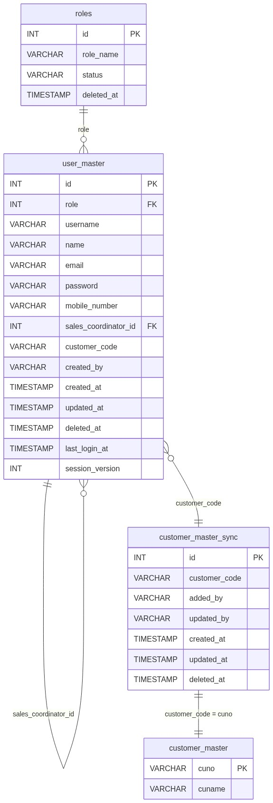
Figure 2 â€” Entity relationship diagram

5.2 Table: user_master (Users-relevant)
Column | MySQL type | Notes
id | INT UNSIGNED AUTO_INCREMENT | PK
role | INT | → roles.id
username | VARCHAR(100) | Unique among active
name | VARCHAR(255)
email | VARCHAR(255) | Unique among active
password | VARCHAR(255) | PASSWORD_DEFAULT hash
mobile_number | VARCHAR(10) | 10-digit
sales_coordinator_id | INT NULL | Self-FK
created_by | VARCHAR(100) | Creator username
created_at | TIMESTAMP
updated_at | TIMESTAMP NULL
deleted_at | TIMESTAMP NULL | Soft-delete
last_login_at | TIMESTAMP NULL | Display only
session_version | INT NOT NULL DEFAULT 1 | Revocation

5.3 Related tables
Table | Role
roles | Active role dropdown (LIFO)
user_master (SC rows) | Sales Coordinator options
Auth tables | Lockout / history used by Auth, not Users CRUD

5.4 Reference / lookup sources
Source | Usage
role_active_options_lifo() | Role <select>
user_sales_coordinator_* | SC <select>
disposable_email_blocked_domains() | Client + server blocklist
window.USER_ROLES_REQUIRING_SALES_COORDINATOR | Client SC toggle

â”€â”€â”€â”€â”€â”€â”€â”€â”€â”€â”€â”€â”€â”€â”€â”€â”€â”€â”€â”€â”€â”€â”€â”€â”€â”€â”€â”€â”€â”€â”€â”€

6. API / Backend Design

6.1 Page endpoints
Endpoint | Method | Auth | Description
users.php | GET | System Admin | List + Add panel
users.php | POST submit_user | System Admin | Create (or update if record_id)
user_edit.php?id= | GET/POST | System Admin | Edit
user_details.php?id= | GET | System Admin | Details
delete_user.php?id= | GET | System Admin | Soft-delete

6.2 JSON APIs

POST api/users_datatable.php
DataTables server-side. Search: username/name/email/mobile + role name.
{
"draw": 1,
"recordsTotal": 10,
"recordsFiltered": 2,
"data": [{ "id": "#1", "role": "...", "username": "...", "actions": "<html>" }]
}

POST api/users_check_unique.php
Body: record_id, email, mobile_number, customer_code.
{ "valid": true, "errors": {} }
or
{ "valid": false, "errors": { "email": ["Email address already exists"], "customer_code": ["Customer Code already exists."] } }
Checks email, mobile, and customer_code uniqueness. Username checked server-side on POST.

GET api/users_get.php?id=
Returns user fields for edit (no password). Includes customer_code and customer_code_text (resolved label).

6.3 Supporting lookup APIs

GET api/user_customer_search.php?q=
Select2 source. Searches customer_master_sync (active, non-deleted) joined with customer_master for name. Returns [{ id, text }].

6.4 Core PHP responsibilities
File | Role
includes/user_helpers.php | from_post, validate, insert/update, uniqueness, SC, actions
includes/user_form_fields.php | Shared form markup
includes/disposable_email_helpers.php | Domain blocklist
includes/admin_access_helpers.php | System Admin gate
includes/password_reset_helpers.php | Strength rules (reuse)
includes/login_helpers.php | login_bump_session_version_by_id
includes/role_helpers.php | Active roles

â”€â”€â”€â”€â”€â”€â”€â”€â”€â”€â”€â”€â”€â”€â”€â”€â”€â”€â”€â”€â”€â”€â”€â”€â”€â”€â”€â”€â”€â”€â”€â”€

7. Validation Rules

7.1 Server-side (user_validate + uniqueness)
Field / rule | Message
Role | Role is required.
Username | Required; [A-Za-z0-9_]; max 100
Name | Required; letters/spaces/./'/-; max 255
Email | Required; format; not disposable; max 255
Disposable | Open or disposable email addresses are not allowed...
Mobile | Required; /^[1-9]\d{9}$/
Password | Strength rules (create / edit if set)
SC | Required for roles 1–3; must be valid SC user
Unique | Username / email / mobile already exists messages

7.2 Client-side (js/users.js)
â€¢ validate.js constraints + live input filtering
â€¢ Pre-submit POST api/users_check_unique.php for email/mobile/customer_code
â€¢ Customer Code Select2 with async search from api/user_customer_search.php
â€¢ SC show/hide from USER_ROLES_REQUIRING_SALES_COORDINATOR
â€¢ Disposable check via BLOCKED_EMAIL_DOMAINS
â”€â”€â”€â”€â”€â”€â”€â”€â”€â”€â”€â”€â”€â”€â”€â”€â”€â”€â”€â”€â”€â”€â”€â”€â”€â”€â”€â”€â”€â”€â”€â”€

8. UI Screen Specifications

8.1 Listing — users.php
Element | Spec
Subtitle | Manage application users, roles, and credentials.
CTA | Add User / Cancel
Grid | ID, Role, Username, Name, Customer Code, Email, Mobile, Last Login, Created At, Action
Empty | No users found. / No matching users found.
Actions | View / Edit / Delete

8.2 Form panel
Fields: Role*, Sales Coordinator (conditional), Customer Code (Select2), Username*, Name*, Email*, Mobile*, Password* (optional on edit).
Customer Code uses Select2 (api/user_customer_search.php) showing cuno - cuname. Required field.
Hints: create strength text; edit “Leave blank to keep the current password.”

8.3 Details — user_details.php
Account Information + Activity (created/last login); Customer Code (resolved label); SC when applicable.

8.4 Modals
None for CRUD (inline panel + dedicated edit page). Delete uses browser confirm('Delete this user?').
â”€â”€â”€â”€â”€â”€â”€â”€â”€â”€â”€â”€â”€â”€â”€â”€â”€â”€â”€â”€â”€â”€â”€â”€â”€â”€â”€â”€â”€â”€â”€â”€

9. Database Flow

9.1 Create
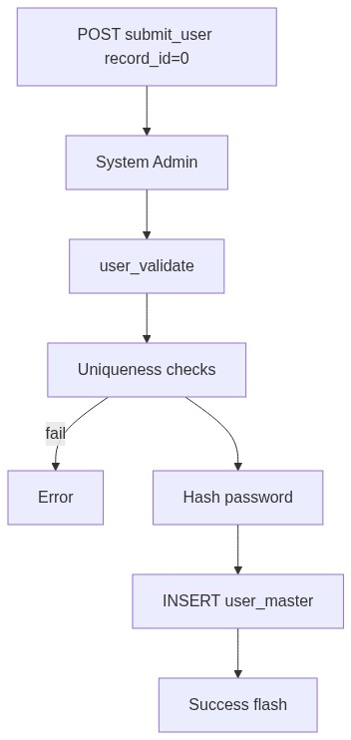
Figure 3 â€” Create database flow

9.2 Soft-delete
UPDATE user_master
SET deleted_at = CURRENT_TIMESTAMP,
updated_at = CURRENT_TIMESTAMP,
session_version = COALESCE(session_version, 1) + 1
WHERE id = :id AND deleted_at IS NULL;

9.3 List query pattern
SELECT um.*, r.role_name
FROM user_master um
LEFT JOIN roles r ON r.id = um.role
WHERE um.deleted_at IS NULL
AND /* optional search */
ORDER BY um.id DESC
LIMIT :limit OFFSET :offset;
â”€â”€â”€â”€â”€â”€â”€â”€â”€â”€â”€â”€â”€â”€â”€â”€â”€â”€â”€â”€â”€â”€â”€â”€â”€â”€â”€â”€â”€â”€â”€â”€

10. Sequence Diagram

10.1 Create user
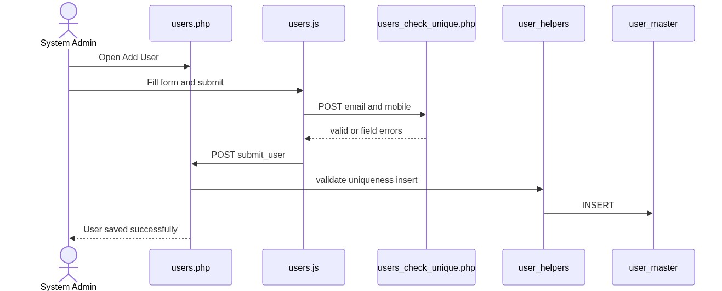
Figure 4 â€” Sequence: Create / update on Spare Parts page

10.2 Edit with session revoke
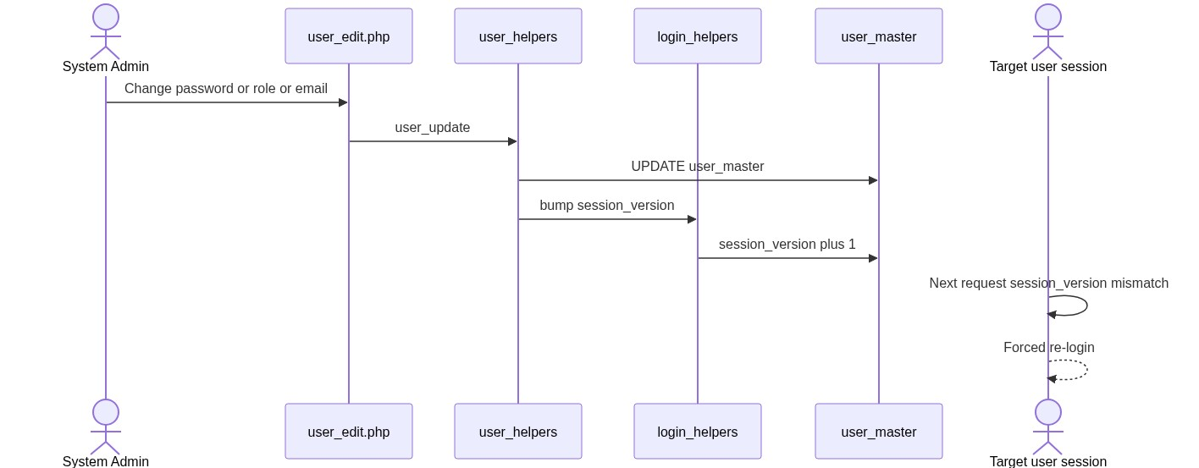
Figure 5 â€” Sequence: Add Spare Parts from IB / SL row
â”€â”€â”€â”€â”€â”€â”€â”€â”€â”€â”€â”€â”€â”€â”€â”€â”€â”€â”€â”€â”€â”€â”€â”€â”€â”€â”€â”€â”€â”€â”€â”€

11. Activity Diagram
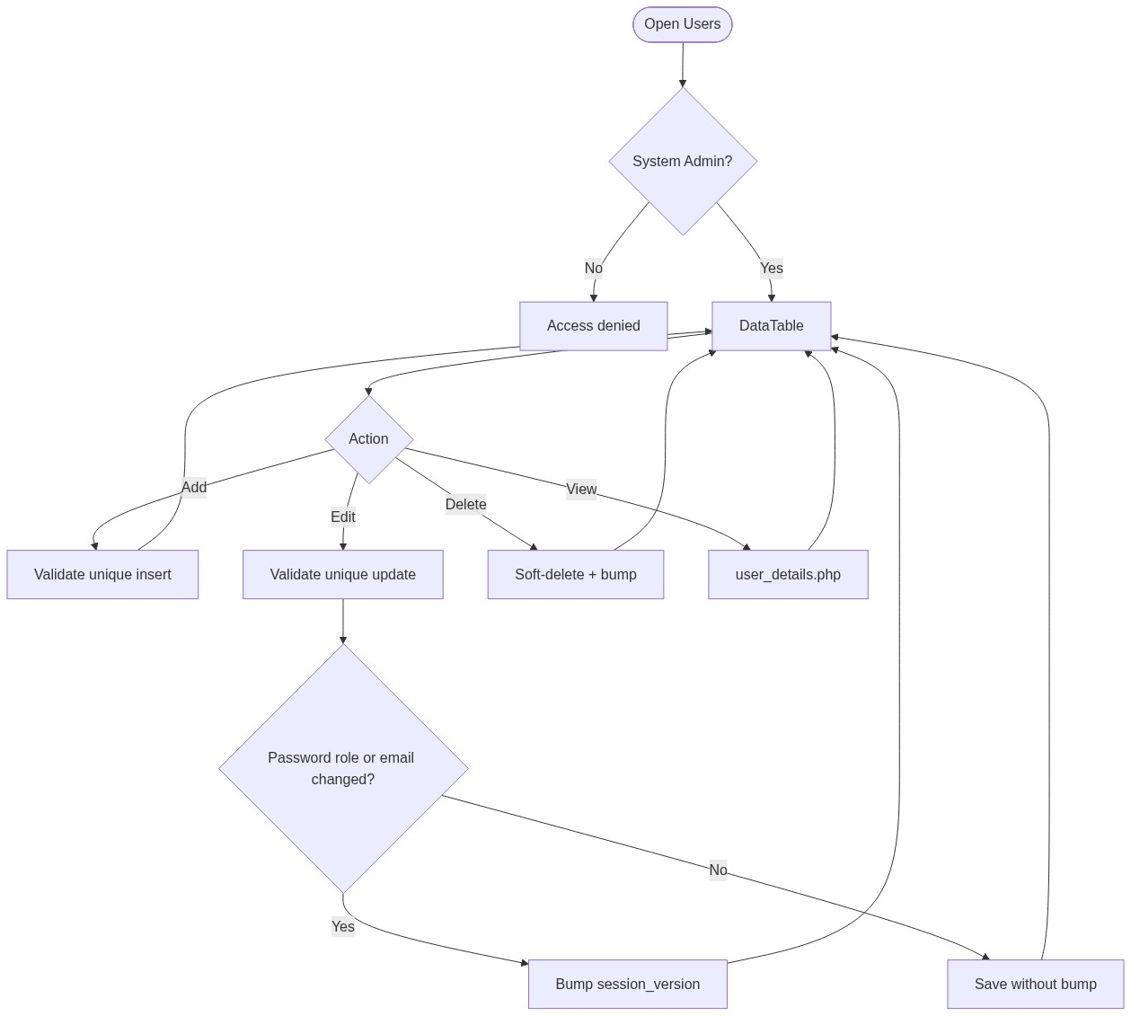
Figure 6 â€” Activity diagram
â”€â”€â”€â”€â”€â”€â”€â”€â”€â”€â”€â”€â”€â”€â”€â”€â”€â”€â”€â”€â”€â”€â”€â”€â”€â”€â”€â”€â”€â”€â”€â”€

12. Class / Module Diagram
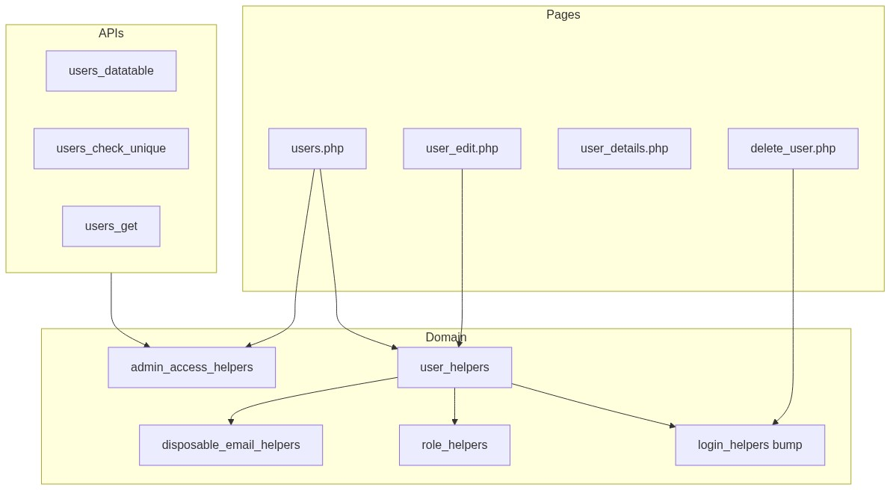
Figure 7 â€” Class / module diagram

12.1 Key functions
Function | Role
user_from_post / user_validate | Parse + validate
user_insert / user_update | Persist
user_username_exists / user_email_exists / user_mobile_exists | Uniqueness
user_roles_requiring_sales_coordinator | Roles 1–3
user_sales_coordinator_* | SC options/validate
disposable_email_is_blocked | Email quality
login_bump_session_version_by_id | Session revoke
require_system_admin | Access gate

â”€â”€â”€â”€â”€â”€â”€â”€â”€â”€â”€â”€â”€â”€â”€â”€â”€â”€â”€â”€â”€â”€â”€â”€â”€â”€â”€â”€â”€â”€â”€â”€

13. Folder Structure
ComplaintManagement/
├── users.php
├── user_edit.php
├── user_details.php
├── delete_user.php
├── api/
│ ├── users_datatable.php
│ ├── users_check_unique.php
│ ├── users_get.php
│ └── user_customer_search.php
├── includes/
│ ├── user_helpers.php
│ ├── user_form_fields.php
│ ├── disposable_email_helpers.php
│ ├── admin_access_helpers.php
│ ├── admin_api_guard.php
│ ├── login_helpers.php
│ └── role_helpers.php
├── js/
│ └── users.js
├── sql/
│ ├── add_user_master_session_version.sql
│ └── add_user_master_customer_code.sql
└── docs/
└── LLD_Users_Module.md
â”€â”€â”€â”€â”€â”€â”€â”€â”€â”€â”€â”€â”€â”€â”€â”€â”€â”€â”€â”€â”€â”€â”€â”€â”€â”€â”€â”€â”€â”€â”€â”€

14. Error Handling
Layer | Pattern
Page POST | $error_message / $success_message or session flash
Delete | Session flash → users.php
APIs | JSON errors + HTTP 403/400/404/405
Client unique fail | Unable to verify email and mobile number. Please try again.

14.1 Common messages
Message | When
User saved successfully. | Create
User updated successfully. | Update
User deleted successfully. | Soft-delete
Failed to save user. / Failed to update user. / Failed to delete user. | Persist fail
User not found or already deleted. | Missing target
Access denied. System Admin privileges required. | Non-admin
Your account details were updated. Please log in again. | Target session after bump

â”€â”€â”€â”€â”€â”€â”€â”€â”€â”€â”€â”€â”€â”€â”€â”€â”€â”€â”€â”€â”€â”€â”€â”€â”€â”€â”€â”€â”€â”€â”€â”€

15. Security Considerations
Area | Control
Authorization | System Admin hard-gate
Soft-delete | Excluded from active queries
Session revoke | session_version on password/role/email/delete
Passwords | Hashed; never returned by APIs
Email quality | Disposable domain blocklist
XSS | Escaped DataTable/form output
Unique check | POST-only (no email/mobile in query string)
Gaps | users_get.php lacks admin guard; admin-set passwords skip history check; base64 ids not signed

â”€â”€â”€â”€â”€â”€â”€â”€â”€â”€â”€â”€â”€â”€â”€â”€â”€â”€â”€â”€â”€â”€â”€â”€â”€â”€â”€â”€â”€â”€â”€â”€

16. Audit Logs

16.1 Built-in field-level audit
Field | Behavior
created_by / created_at | On create
updated_at | On update / soft-delete
deleted_at | Soft-delete
session_version | Critical change / delete
Dedicated audit table | Not implemented

â”€â”€â”€â”€â”€â”€â”€â”€â”€â”€â”€â”€â”€â”€â”€â”€â”€â”€â”€â”€â”€â”€â”€â”€â”€â”€â”€â”€â”€â”€â”€â”€

17. Test Cases

17.1 Functional
ID | Scenario | Expected
TC-01 | Non-admin opens Users | Denied
TC-02 | Create role 1/2/3 without SC | Validation error
TC-03 | Create with duplicate email/mobile/username | Rejected
TC-04 | Disposable email | Rejected
TC-05 | Weak password | Rejected
TC-06 | Edit blank password | Keeps hash
TC-07 | Change email/role/password | session_version bump; target re-login
TC-08 | Change name only | No bump
TC-09 | Soft-delete | Hidden from list; session bumped
TC-10 | DataTable search by role name | Filtered
TC-11 | Edit user whose SC inactive | Selected SC still shown (prepended)
TC-12 | Create with duplicate customer_code | Rejected (unique)
TC-13 | Create with customer_code not in sync | Rejected (invalid)
TC-14 | Delete sync record | User customer_code set to NULL
TC-15 | Customer Code shown in grid | Resolved as cuno - cuname

â”€â”€â”€â”€â”€â”€â”€â”€â”€â”€â”€â”€â”€â”€â”€â”€â”€â”€â”€â”€â”€â”€â”€â”€â”€â”€â”€â”€â”€â”€â”€â”€

18. Assumptions & Dependencies

18.1 Assumptions
1. Role id 6 is System Admin.
2. Active role named Sales Coordinator exists for SC options.
3. Legacy role ids 1–3 still define SC requirement.
4. Auth module enforces session_version on subsequent requests.
5. Document target stack Core PHP + MySQL; repo runs PostgreSQL.

18.2 Dependencies
Dependency | Purpose
roles master | Role dropdown
Auth / login helpers | Session version bump
Disposable email helper | Domain block
Password strength helper | Shared rules
jQuery + DataTables + validate.js | UI

â”€â”€â”€â”€â”€â”€â”€â”€â”€â”€â”€â”€â”€â”€â”€â”€â”€â”€â”€â”€â”€â”€â”€â”€â”€â”€â”€â”€â”€â”€â”€â”€

Appendix A — Success flashes
Event | Message
Create | User saved successfully.
Update | User updated successfully.
Delete | User deleted successfully.

â”€â”€â”€â”€â”€â”€â”€â”€â”€â”€â”€â”€â”€â”€â”€â”€â”€â”€â”€â”€â”€â”€â”€â”€â”€â”€â”€â”€â”€â”€â”€â”€

Appendix B — Select2 control map
Control | Source API | Display format
#userCustomerCodeSelect | api/user_customer_search.php | cuno - cuname

Role (#userRoleSelect) and Sales Coordinator (#salesCoordinatorSelect) are native HTML selects.
â”€â”€â”€â”€â”€â”€â”€â”€â”€â”€â”€â”€â”€â”€â”€â”€â”€â”€â”€â”€â”€â”€â”€â”€â”€â”€â”€â”€â”€â”€â”€â”€

Appendix C — session_version bump matrix
Action | Bumps?
Soft-delete | Yes
Password change | Yes
Role change | Yes
Email change | Yes
Username / name / mobile / SC only | No
Create | No

â”€â”€â”€â”€â”€â”€â”€â”€â”€â”€â”€â”€â”€â”€â”€â”€â”€â”€â”€â”€â”€â”€â”€â”€â”€â”€â”€â”€â”€â”€â”€â”€

Appendix D — Role constants (reference)
Constant | Id | Notes
Dealer User | 1 | Requires SC
Dealer Engineer | 2 | Requires SC
ELGi Engineer | 3 | Requires SC
Sales Coordinator | 4
Management | 5
System Admin | 6 | Users module access
CCS Admin | 7

â”€â”€â”€â”€â”€â”€â”€â”€â”€â”€â”€â”€â”€â”€â”€â”€â”€â”€â”€â”€â”€â”€â”€â”€â”€â”€â”€â”€â”€â”€â”€â”€
End of LLD — Users Module

