Low-Level Design (LLD) — Despatch Details Module
Attribute | Value
Module | Despatch Details (List / View of Despatched Invoices)
Menu path | ORDERS → Despatch Details
Landing page | despatch_details.php (sidebar)
Alternate page | dispatch_details.php (orphaned; column keys align better with API)
Application | Complaint / Dealer Portal
Stack (target) | Core PHP + MySQL (PDO)
Stack (current repo) | Core PHP + PostgreSQL via PDO ($dpconn dealerportal)
Document version | 1.0
Access | RBAC module slug despatch-details / permission list (view / export-excel reserved)

â”€â”€â”€â”€â”€â”€â”€â”€â”€â”€â”€â”€â”€â”€â”€â”€â”€â”€â”€â”€â”€â”€â”€â”€â”€â”€â”€â”€â”€â”€â”€â”€

1. Module Overview

1.1 Purpose
Authenticated users with Despatch Details permissions browse despatched invoice/shipment rows from Dealerportal despatch, enriched with LR packing data (lr_details) and product-group description (dpst_master). The list is server-side DataTables via orderRequest.php → orderClass::getDespatchDetails(). The module is read-only; it does not create despatch records.

1.2 Scope
In scope | Out of scope
Despatch list (DataTables) | Order Booking create
LR join / packing / weight display | Recent Orders Re-Push
RBAC list / view / export flags | Pending Orders list
Dashboard “Dispatched” KPI gate (related) | Writing to despatch / ERP
Related LR Details sibling module (noted) | Working invoice/detail pages (targets missing)

1.3 High-level architecture
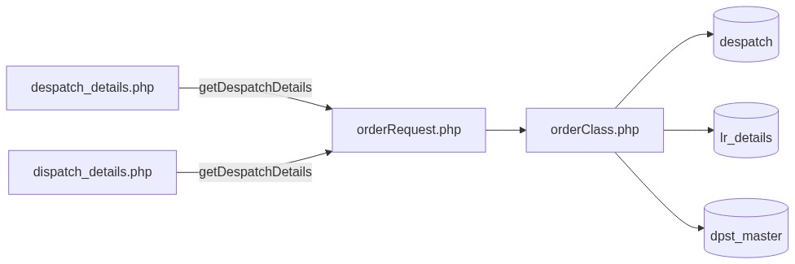
Figure 1 — High-level architecture
â”€â”€â”€â”€â”€â”€â”€â”€â”€â”€â”€â”€â”€â”€â”€â”€â”€â”€â”€â”€â”€â”€â”€â”€â”€â”€â”€â”€â”€â”€â”€â”€

2. Functional Requirements
ID | Requirement | Priority
FR-01 | User with despatch-details/list can open Despatch Details list | Must
FR-02 | Server-side DataTables list from despatch | Must
FR-03 | Exclude cmp = 600 and excluded dpst codes | Must
FR-04 | Scope rows to session customer cuno | Must
FR-05 | Show AO / invoice / transporter / LR / packing / weight / action | Must
FR-06 | Join LR details for packing and transporter | Should
FR-07 | Global search on invoice / AO / customer / dpst | Should
FR-08 | View permission controls detail links | Should
FR-09 | Export Excel when permitted | Could (wrong target today)
FR-10 | Deduplicate logical despatch keys | Should

â”€â”€â”€â”€â”€â”€â”€â”€â”€â”€â”€â”€â”€â”€â”€â”€â”€â”€â”€â”€â”€â”€â”€â”€â”€â”€â”€â”€â”€â”€â”€â”€

3. User Roles & Permissions

3.1 RBAC module slug
Resource | Module | Permission
despatch_details.php / menu | despatch-details | list
View-link strip (client) | despatch-details | view
Export button visibility | despatch-details | export-excel
Dashboard Dispatched KPI gate | despatch-details | list

Unauthenticated → login.php. No list → access_denied.php.

3.2 Page / API mapping
Resource | Gate
despatch_details.php | list
dispatch_details.php | list (not in sidebar)
POST orderRequest.php getDespatchDetails | Session only — no module RBAC
POST orderRequest.php getLrDetails | Session only (LR module)

3.3 Scoping notes
Layer | Scope
Despatch list API | Always cuno = customer_number_vayu (fallback '10001')
Admin/Management seeAll | Not implemented on despatch list (unlike Recent Orders)
Sales coordinator widen | Used in dashboard scope helpers; not in getDespatchDetails

â”€â”€â”€â”€â”€â”€â”€â”€â”€â”€â”€â”€â”€â”€â”€â”€â”€â”€â”€â”€â”€â”€â”€â”€â”€â”€â”€â”€â”€â”€â”€â”€

4. Business Rules
ID | Rule
BR-01 | Despatch list row = despatch with cmp != 600 and dpst not in excluded set.
BR-02 | Excluded dpst: SLS500, SLS01, SO0600, SAL01.
BR-03 | Customer scope: cuno = session customer_number_vayu (or '10001').
BR-04 | Dedupe via DISTINCT ON (invdate, cmp, ordno, invref, invno).
BR-05 | LR join on invref + invno + cmp = company.
BR-06 | Packing string built from cases / boxes / bundles / carton / special cases.
BR-07 | Read-only module — no insert/update/delete of despatch in this UI.
BR-08 | Soft-delete / deleted_at not used on this path.
BR-09 | Cross-module “Despatched” status (Recent/Pending) = despatch match on cuno + TRIM(ordno) + cmp != 600 (no dpst exclusion in those helpers).
BR-10 | Dashboard pipeline “Dispatched” = booking AOs found in despatch.
BR-11 | Action links currently target invoice.php — file missing in repo.
BR-12 | Primary page column keys may not match API keys (known UI↔API mismatch).
BR-13 | Export button points to exportOrders.php (Acknowledgement-shaped) — not despatch data.
BR-14 | No date-range filter on list (DataTables search only).

â”€â”€â”€â”€â”€â”€â”€â”€â”€â”€â”€â”€â”€â”€â”€â”€â”€â”€â”€â”€â”€â”€â”€â”€â”€â”€â”€â”€â”€â”€â”€â”€

5. Database Design

5.1 Logical model
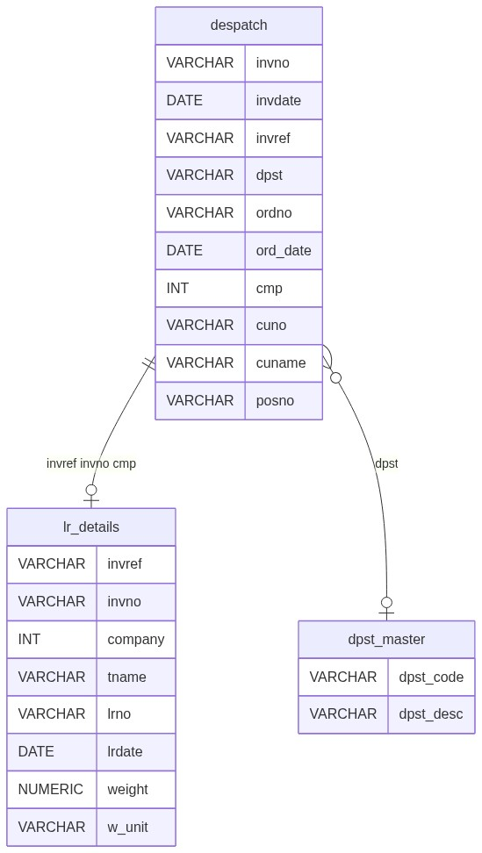
Figure 2 — Entity relationship diagram

5.2 Tables
Table | Conn | Role
despatch | $dpconn | Primary list source
lr_details | $dpconn | LR / packing / transporter join
dpst_master | $dpconn | DPST description
lrdetails | $dpconn | Separate LR list API table name (sibling module)

5.3 List query pattern
SELECT DISTINCT ON (a.invdate, a.cmp, a.ordno, a.invref, a.invno)
a.*, b.tname, b.lrno, /* packing fields */, d.dpst_desc
FROM despatch a
LEFT JOIN lr_details b
ON a.invref = b.invref AND a.invno = b.invno AND a.cmp = b.company
LEFT JOIN dpst_master d
ON d.dpst_code::text = a.dpst
WHERE a.cmp != 600
AND a.dpst NOT IN ('SLS500','SLS01','SO0600','SAL01')
AND a.cuno = :cuno
AND /* optional ILIKE search */
ORDER BY a.invdate DESC, /* cmp should lead with DISTINCT ON */, a.ordno, a.invref, a.invno
LIMIT :length OFFSET :start;
â”€â”€â”€â”€â”€â”€â”€â”€â”€â”€â”€â”€â”€â”€â”€â”€â”€â”€â”€â”€â”€â”€â”€â”€â”€â”€â”€â”€â”€â”€â”€â”€

6. API / Backend Design

6.1 Page endpoints
Endpoint | Method | Auth | Description
despatch_details.php | GET | despatch-details/list | Primary list (sidebar)
dispatch_details.php | GET | list (orphan) | Alternate list UI

6.2 AJAX — POST orderRequest.php
Action | Description
getDespatchDetails | DataTables JSON for despatch list
getLrDetails | LR Details sibling list JSON

6.3 Response shape (API keys)
Typical row keys: cuno, dpst, ordno, invno, invdt, transporter, lrno, packing, weight, action.
Primary page may expect different keys (ao_number, order_ref_number, invoice_date, …) — mismatch.

6.4 Core PHP responsibilities
File | Role
despatch_details.php | Primary list + RBAC flags + DataTable
dispatch_details.php | Alternate list (better key alignment)
orderRequest.php / orderClass.php | getDespatchDetails, status helpers
includes/rbac_access_helpers.php | Page/menu AuthZ
includes/dashboard_helpers.php | Dispatched KPI / weekly alert
lr_details.php | Sibling LR module

â”€â”€â”€â”€â”€â”€â”€â”€â”€â”€â”€â”€â”€â”€â”€â”€â”€â”€â”€â”€â”€â”€â”€â”€â”€â”€â”€â”€â”€â”€â”€â”€

7. Validation Rules

7.1 Server-side
Field / rule | Behavior
Session + list | Redirect login / access_denied
DataTables params | start / length cast to int; search bound
Customer bind | Always session cuno (or default)
CSRF | Not implemented

7.2 Client-side
â€¢ DataTables serverSide; pageLength 10; scrollX; processing
â€¢ Export button d-none without export-excel
â€¢ drawCallback strips order_data.php links when no view (API actually emits invoice.php — gate ineffective)
â€¢ No Select2 filters; no date pickers
â€¢ No validate.js form (read-only)
â”€â”€â”€â”€â”€â”€â”€â”€â”€â”€â”€â”€â”€â”€â”€â”€â”€â”€â”€â”€â”€â”€â”€â”€â”€â”€â”€â”€â”€â”€â”€â”€

8. UI Screen Specifications

8.1 Primary list — despatch_details.php
Element | Spec
Layout | Bootstrap card + #orderTable (OA-style)
Table | DataTables serverSide
Intended columns | AO, Order Ref, Invoice Date, Transporter, LR No, Packaging, Weight, Action
API columns | ordno, invno, invdt, transporter, lrno, packing, weight, action (+ cuno/dpst)
Export | Excel button (wrong exporter target)
Select2 | Not used
Modals | None
CSS | order_acknowledge_style.css / orderbook_style.css (dispatch_details.css unused)

8.2 Alternate — dispatch_details.php
Column keys align more closely with API; not linked in sidebar.

8.3 Detail navigation
Action HTML links to invoice.php?invno=&invref= — file not in repo (dead link).
â”€â”€â”€â”€â”€â”€â”€â”€â”€â”€â”€â”€â”€â”€â”€â”€â”€â”€â”€â”€â”€â”€â”€â”€â”€â”€â”€â”€â”€â”€â”€â”€

9. Database Flow

9.1 List load
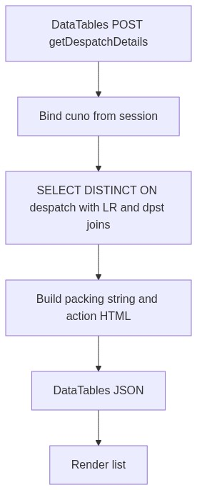
Figure 3 — List load database flow

9.2 Cross-module status use
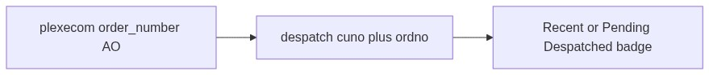
Figure 4 — Cross-module Despatched status use
â”€â”€â”€â”€â”€â”€â”€â”€â”€â”€â”€â”€â”€â”€â”€â”€â”€â”€â”€â”€â”€â”€â”€â”€â”€â”€â”€â”€â”€â”€â”€â”€

10. Sequence Diagram

10.1 List DataTables
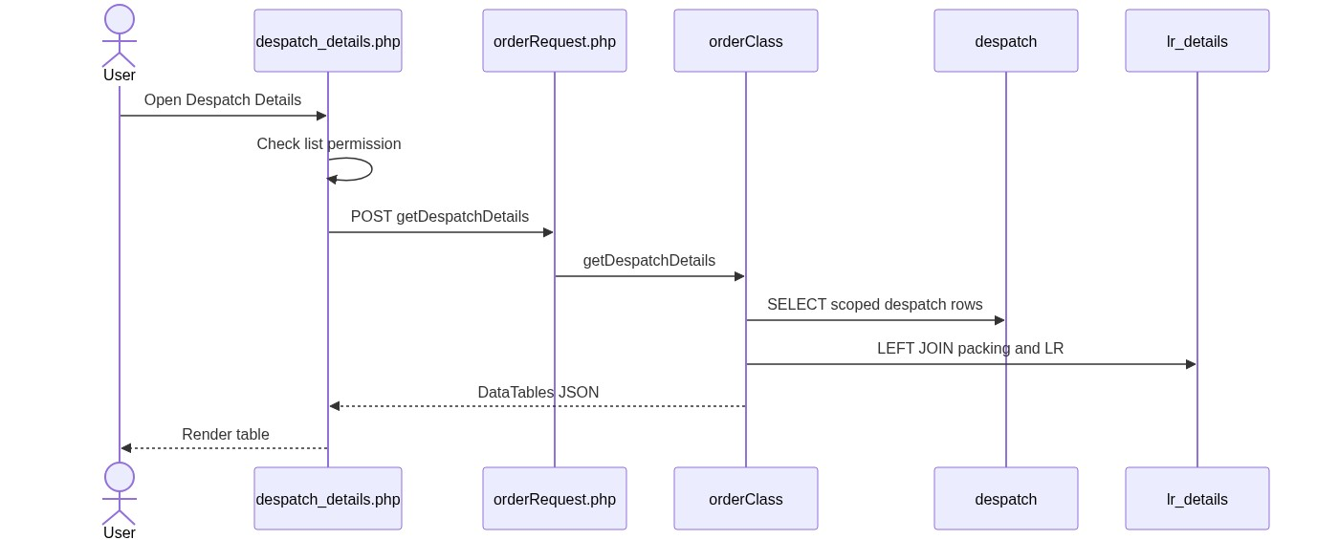
Figure 5 — Sequence: List DataTables

10.2 Open action link (intended)
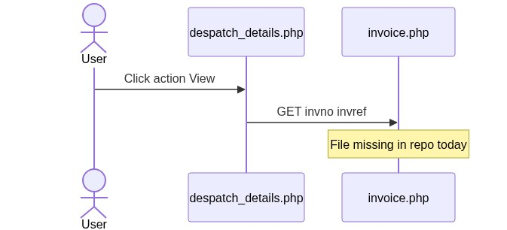
Figure 6 — Sequence: Open action link
â”€â”€â”€â”€â”€â”€â”€â”€â”€â”€â”€â”€â”€â”€â”€â”€â”€â”€â”€â”€â”€â”€â”€â”€â”€â”€â”€â”€â”€â”€â”€â”€

11. Activity Diagram
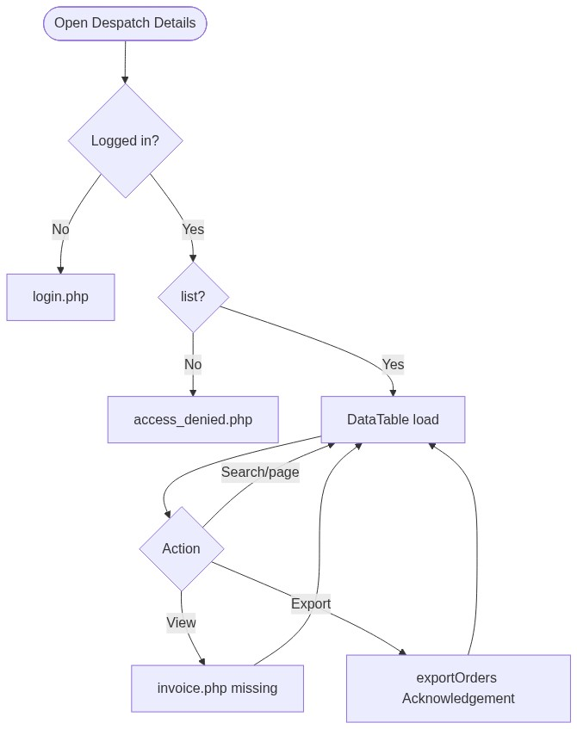
Figure 7 — Activity diagram
â”€â”€â”€â”€â”€â”€â”€â”€â”€â”€â”€â”€â”€â”€â”€â”€â”€â”€â”€â”€â”€â”€â”€â”€â”€â”€â”€â”€â”€â”€â”€â”€

12. Class / Module Diagram
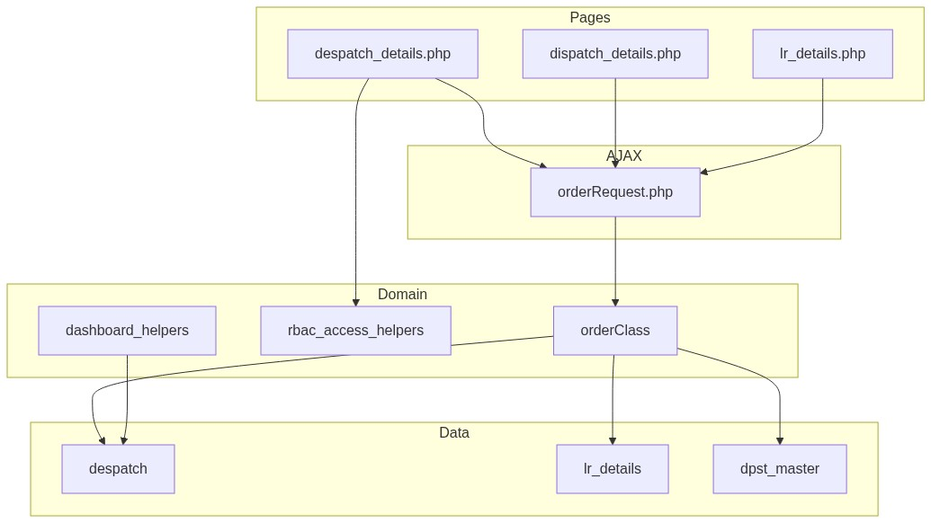
Figure 8 — Class / module diagram

12.1 Key functions
Function | Role
getDespatchDetails | Server-side despatch list JSON
getLrDetails | Sibling LR list JSON
resolveRecentOrderStatus / Label | Cross-module Despatched badge
dashboard_count_recent_orders_with_invoice | Pipeline Dispatched KPI
dashboard_fetch_dispatched_count | “Dispatches this week” alert
dashboard_order_module_permissions | Maps dispatched UI to despatch-details/list
rbac_user_can / rbac_can_access_menu | Page/menu gating

â”€â”€â”€â”€â”€â”€â”€â”€â”€â”€â”€â”€â”€â”€â”€â”€â”€â”€â”€â”€â”€â”€â”€â”€â”€â”€â”€â”€â”€â”€â”€â”€

13. Folder Structure
ComplaintManagement/
├── despatch_details.php
├── dispatch_details.php
├── lr_details.php
├── orderRequest.php
├── orderClass.php
├── exportOrders.php
├── access_denied.php
├── includes/
│ ├── rbac_access_helpers.php
│ ├── dashboard_helpers.php
│ └── dashboard_scope_helpers.php
├── css/
│ ├── order_acknowledge_style.css
│ ├── orderbook_style.css
│ └── dispatch_details.css
└── docs/
└── LLD_Despatch_Details_Module.md
Missing referenced targets: invoice.php, despatchview1.php, lrview.php.
â”€â”€â”€â”€â”€â”€â”€â”€â”€â”€â”€â”€â”€â”€â”€â”€â”€â”€â”€â”€â”€â”€â”€â”€â”€â”€â”€â”€â”€â”€â”€â”€

14. Error Handling
Layer | Pattern
Unauthenticated | Redirect login.php
No list | access_denied.php
AJAX SQL/exception | JSON { draw:0, data:[], error: message } (often empty table)
Success flashes | None (read-only)
Dead view links | Browser 404 / missing page

14.1 User-visible messages
Message / UI | When
Access denied page | Missing list
Empty DataTable | No rows / query error swallowed
Broken View | Missing invoice.php

â”€â”€â”€â”€â”€â”€â”€â”€â”€â”€â”€â”€â”€â”€â”€â”€â”€â”€â”€â”€â”€â”€â”€â”€â”€â”€â”€â”€â”€â”€â”€â”€

15. Security Considerations
Area | Control
Page AuthZ | RBAC despatch-details/list
AJAX AuthZ gap | orderRequest lacks module permission check
Customer fallback | Missing session customer → '10001'
No seeAll | Admins still customer-scoped on list API
View gate ineffective | Strips wrong href pattern vs API links
Export wrong data | exportOrders.php is OA-shaped; no despatch RBAC
XSS risk | Action/packing HTML built from ERP fields without full escaping
DISTINCT ON / ORDER BY | May omit cmp leading expression → query failure
CSRF | Not implemented on AJAX
Dead detail targets | Missing invoice/view PHP files

â”€â”€â”€â”€â”€â”€â”€â”€â”€â”€â”€â”€â”€â”€â”€â”€â”€â”€â”€â”€â”€â”€â”€â”€â”€â”€â”€â”€â”€â”€â”€â”€

16. Audit Logs

16.1 Built-in field-level audit
Item | Behavior
Despatch list audit table | Not implemented
Module nature | Read-only ERP despatch / LR aggregation
Despatch creation audit | Owned by ERP / warehouse systems outside this UI

â”€â”€â”€â”€â”€â”€â”€â”€â”€â”€â”€â”€â”€â”€â”€â”€â”€â”€â”€â”€â”€â”€â”€â”€â”€â”€â”€â”€â”€â”€â”€â”€

17. Test Cases

17.1 Functional
ID | Scenario | Expected
TC-01 | Guest opens Despatch Details | Redirect login
TC-02 | User without list | access_denied.php
TC-03 | User with list | DataTable requests getDespatchDetails
TC-04 | Session with valid cuno | Only that customer’s rows
TC-05 | cmp = 600 or excluded dpst | Not listed
TC-06 | Search by invno / ordno | Filtered rows
TC-07 | Primary page column keys vs API | Gap: fields may appear blank
TC-08 | Click View action | Gap: invoice.php missing
TC-09 | User without export-excel | Export button hidden
TC-10 | Click Export | Downloads Acknowledgement-shaped export (wrong)
TC-11 | Admin without customer_number_vayu | Falls back to 10001
TC-12 | Dashboard Dispatched KPI without list perm | KPI gated off
TC-13 | Recent Orders despatch match | Shows Despatched badge
TC-14 | Open dispatch_details.php | Alternate UI may show API fields correctly

â”€â”€â”€â”€â”€â”€â”€â”€â”€â”€â”€â”€â”€â”€â”€â”€â”€â”€â”€â”€â”€â”€â”€â”€â”€â”€â”€â”€â”€â”€â”€â”€

18. Assumptions & Dependencies

18.1 Assumptions
1. despatch-details/list is assigned to roles that may see despatches.
2. ERP writes despatch / lr_details; portal does not create them here.
3. Live menu path is despatch_details.php despite column-key mismatch with API.
4. dispatch_details.php remains an alternate until primary page is aligned or removed.
5. Document target stack Core PHP + MySQL; repo runs PostgreSQL (DISTINCT ON, ILIKE).
6. Detail/invoice PHP pages may be restored later; currently missing.
7. Dashboard “Dispatched” remains AO∩despatch unless product aligns definitions with list filters.

18.2 Dependencies
Dependency | Purpose
RBAC / Assign Permissions | despatch-details grants
$dpconn / despatch | List source
lr_details / dpst_master | Enrichment
orderClass / orderRequest | Shared order AJAX surface
DataTables + jQuery | List UX
Recent Orders / Pending / Dashboard | Consumers of despatch for status/KPIs
LR Details module | Sibling ORDERS menu item

â”€â”€â”€â”€â”€â”€â”€â”€â”€â”€â”€â”€â”€â”€â”€â”€â”€â”€â”€â”€â”€â”€â”€â”€â”€â”€â”€â”€â”€â”€â”€â”€

Appendix A — API vs primary UI column keys
Primary UI expectation | API key
ao_number | ordno
order_ref_number | (not mapped 1:1; invref related)
invoice_date | invdt
transporter | transporter
lr_no | lrno
packaging_details | packing
weight | weight
action | action

â”€â”€â”€â”€â”€â”€â”€â”€â”€â”€â”€â”€â”€â”€â”€â”€â”€â”€â”€â”€â”€â”€â”€â”€â”€â”€â”€â”€â”€â”€â”€â”€

Appendix B — Select2 control map
N/A. Despatch Details list does not use Select2 filters.
â”€â”€â”€â”€â”€â”€â”€â”€â”€â”€â”€â”€â”€â”€â”€â”€â”€â”€â”€â”€â”€â”€â”€â”€â”€â”€â”€â”€â”€â”€â”€â”€

Appendix C — RBAC permission matrix
Permission | Effect
list | Open Despatch Details / menu / dashboard Dispatched gate
view | Intended to control detail links (currently ineffective)
export-excel | Show Export button (wrong exporter)

â”€â”€â”€â”€â”€â”€â”€â”€â”€â”€â”€â”€â”€â”€â”€â”€â”€â”€â”€â”€â”€â”€â”€â”€â”€â”€â”€â”€â”€â”€â”€â”€

Appendix D — Inclusion filters
Filter | Value
Company | cmp != 600
DPST exclude | SLS500, SLS01, SO0600, SAL01
Customer | cuno = session customer
Dedupe | DISTINCT ON (invdate, cmp, ordno, invref, invno)

â”€â”€â”€â”€â”€â”€â”€â”€â”€â”€â”€â”€â”€â”€â”€â”€â”€â”€â”€â”€â”€â”€â”€â”€â”€â”€â”€â”€â”€â”€â”€â”€

Appendix E — Pipeline position
Order Booking → plexecom (AO empty)
↓
Acknowledgement / AO populated
↓
Pending Orders (open LN lines)
↓
Despatch Details (this module) ← despatch + LR
↓
Recent Orders status badge: Despatched
â”€â”€â”€â”€â”€â”€â”€â”€â”€â”€â”€â”€â”€â”€â”€â”€â”€â”€â”€â”€â”€â”€â”€â”€â”€â”€â”€â”€â”€â”€â”€â”€

Appendix F — Known defects checklist
Defect | Impact
UI↔API column key mismatch | Blank/wrong columns on sidebar page
Missing invoice.php | Dead View links
Export → OA exporter | Wrong data downloaded
No API RBAC | AuthZ gap
No admin seeAll | Admins limited to one cuno / default
DISTINCT ON vs ORDER BY | Possible empty error responses
view strips wrong href | View permission unused

â”€â”€â”€â”€â”€â”€â”€â”€â”€â”€â”€â”€â”€â”€â”€â”€â”€â”€â”€â”€â”€â”€â”€â”€â”€â”€â”€â”€â”€â”€â”€â”€
End of LLD — Despatch Details Module

