Low-Level Design (LLD) — Complaint Entry Module
Attribute | Value
Module | Complaint Entry
Menu path | SUPPORT → Complaint Entry
Application | Complaint / Dealer Portal
Stack (target) | Core PHP + MySQL (PDO)
Stack (current repo) | Core PHP + PostgreSQL via PDO (pdo_obconn.php) — schema maps 1:1 to MySQL
Document version | 1.0
Related modules | Assigned Complaint List, Service Update, Complaint Categories, RBAC

Boundary: Complaint Entry (complaint-entry / new_complaint.php) is separate from Assigned Complaint List (assigned-complaint-list / dse_lse_complaint_list.php) and Service Update. This LLD covers entry create, history listing, assign, closure, and soft-delete on the entry page.
â”€â”€â”€â”€â”€â”€â”€â”€â”€â”€â”€â”€â”€â”€â”€â”€â”€â”€â”€â”€â”€â”€â”€â”€â”€â”€â”€â”€â”€â”€â”€â”€

1. Module Overview

1.1 Purpose
Complaint Entry lets authorized users register a customer complaint against a Fab Number (must exist in LN invoice data), capture customer/address details, categorize the issue, optionally assign an engineer at create time, and manage the complaint lifecycle from the entry history grid (assign, closure, view, delete).

1.2 Scope
In scope | Out of scope
Create complaint (POST on new_complaint.php) | Editing core complaint master fields after create
Complaint History DataTable + status cards | Assigned Complaint List / Service Update flows (separate module)
Manual assign (Open → In Progress) | Complaint attachments
Closure (Pending With HO → Resolved / Re-Open) | Installed Base / Service Log CRUD
Soft-delete | Hard delete
FAB + pincode prefill | Order / dealer fields on create form

1.3 High-level architecture
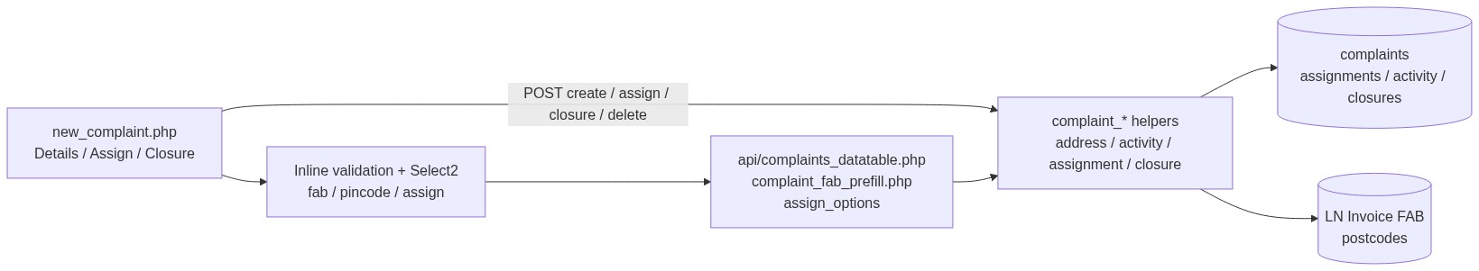
Figure 1 â€” High-level architecture
â”€â”€â”€â”€â”€â”€â”€â”€â”€â”€â”€â”€â”€â”€â”€â”€â”€â”€â”€â”€â”€â”€â”€â”€â”€â”€â”€â”€â”€â”€â”€â”€

2. Functional Requirements
ID | Requirement | Priority
FR-01 | Users with view can open entry page, history, and details (from=entry) | Must
FR-02 | Users with add can create a complaint | Must
FR-03 | FAB must exist in LN invoice data | Must
FR-04 | Address required; city/district/state from pincode Select2 | Must
FR-05 | Complaint category required from active categories | Must
FR-06 | Optional assign at create if user has assign-complaint | Must
FR-07 | Manual assign from Open complaints | Must
FR-08 | Soft-delete with delete permission (UI hidden for Resolved) | Must
FR-09 | Closure for CCS Admin + complaint-closure when Pending With HO and service update exists | Must
FR-10 | Closure Yes → Resolved; No → reassign + Re-Open (needs reassign-complaint) | Must
FR-11 | Listing scoped by role; status cards filter history | Must
FR-12 | FAB prefill from prior complaint under scope | Should
FR-13 | Activity log for Created / Assignment / Reassignment / Closure / Deleted | Must
FR-14 | Assignment / closure emails via helpers | Should

â”€â”€â”€â”€â”€â”€â”€â”€â”€â”€â”€â”€â”€â”€â”€â”€â”€â”€â”€â”€â”€â”€â”€â”€â”€â”€â”€â”€â”€â”€â”€â”€

3. User Roles & Permissions

3.1 RBAC module slug
complaint-entry
Display name: Complaint Entry
Enforced via role permissions (included in modules that enforce role_permissions for System Admin).

3.2 Permission matrix
Permission slug | Capability
view | Entry page, history, details
add | Create complaint; FAB prefill API
delete | Soft-delete
assign-complaint | Assign at create / Assign modal
reassign-complaint | Reassign on Closure = No
complaint-closure | Closure actions (also requires CCS Admin helper)

3.3 Page / API mapping
Resource | Module | Permission / gate
new_complaint.php | complaint-entry | view
complaint_details.php (from ≠ list) | complaint-entry | view
delete_complaint.php | complaint-entry | delete
api/complaints_datatable.php | complaint-entry | view
api/complaint_fab_prefill.php | complaint-entry | add
assign_complaint.php | In-script | assign-complaint
closure_complaint.php | In-script | CCS Admin and complaint-closure
api/complaint_assign_options.php | Custom | assign / reassign / closure permission
api/postcode_search.php | Session | (no module map)
api/ln_invoice_fabno_search.php | Session | (no module map)

complaint_entry_action_permissions() exposes: view, add, delete, assign, reassign, closure.

3.4 After-market / list scope (complaint entry)
Role class | List / FAB-prefill scope
System Admin / Management / CCS Admin | All non-deleted complaints
Sales Coordinator | Scoped creators / assignees (sales-coordinator helpers)
Other | Creator username or currently assigned to user

“Added By” column shown for System Admin / Management / CCS Admin only.
â”€â”€â”€â”€â”€â”€â”€â”€â”€â”€â”€â”€â”€â”€â”€â”€â”€â”€â”€â”€â”€â”€â”€â”€â”€â”€â”€â”€â”€â”€â”€â”€

4. Business Rules
ID | Rule
BR-01 | Soft-deleted rows excluded (deleted_at IS NULL).
BR-02 | Status codes: 1 Open, 2 In Progress, 3 Pending With HO, 4 Re-Open, 5 Resolved.
BR-03 | Create without assignee → Open; with assignee → In Progress + complaint_assignments row.
BR-04 | FAB must exist in LN invoice (ln_invoice_fabno_exists).
BR-05 | Category must be active in complaint_categories.
BR-06 | Customer name: alphabetic characters and spaces only.
BR-07 | Remarks (assignment) max 500 characters.
BR-08 | Dealer creator may assign only to self.
BR-09 | Assignee must be an active user in the configured “ELGi Engineer” role filter (role id from helper).
BR-10 | Manual assign only when status = Open.
BR-11 | Closure only when Pending With HO and ≥1 complaint_service_updates row.
BR-12 | Closure Yes → Resolved + feedback 1–10; Closure No → reassignment + Re-Open.
BR-13 | Delete UI hidden for Resolved; soft-delete only.
BR-14 | No post-create edit of core complaint fields on entry module.
BR-15 | No order_id / dealer_name on create form.

â”€â”€â”€â”€â”€â”€â”€â”€â”€â”€â”€â”€â”€â”€â”€â”€â”€â”€â”€â”€â”€â”€â”€â”€â”€â”€â”€â”€â”€â”€â”€â”€

5. Database Design
Note: Current production uses PostgreSQL. Types below are MySQL-equivalent.

5.1 ER diagram
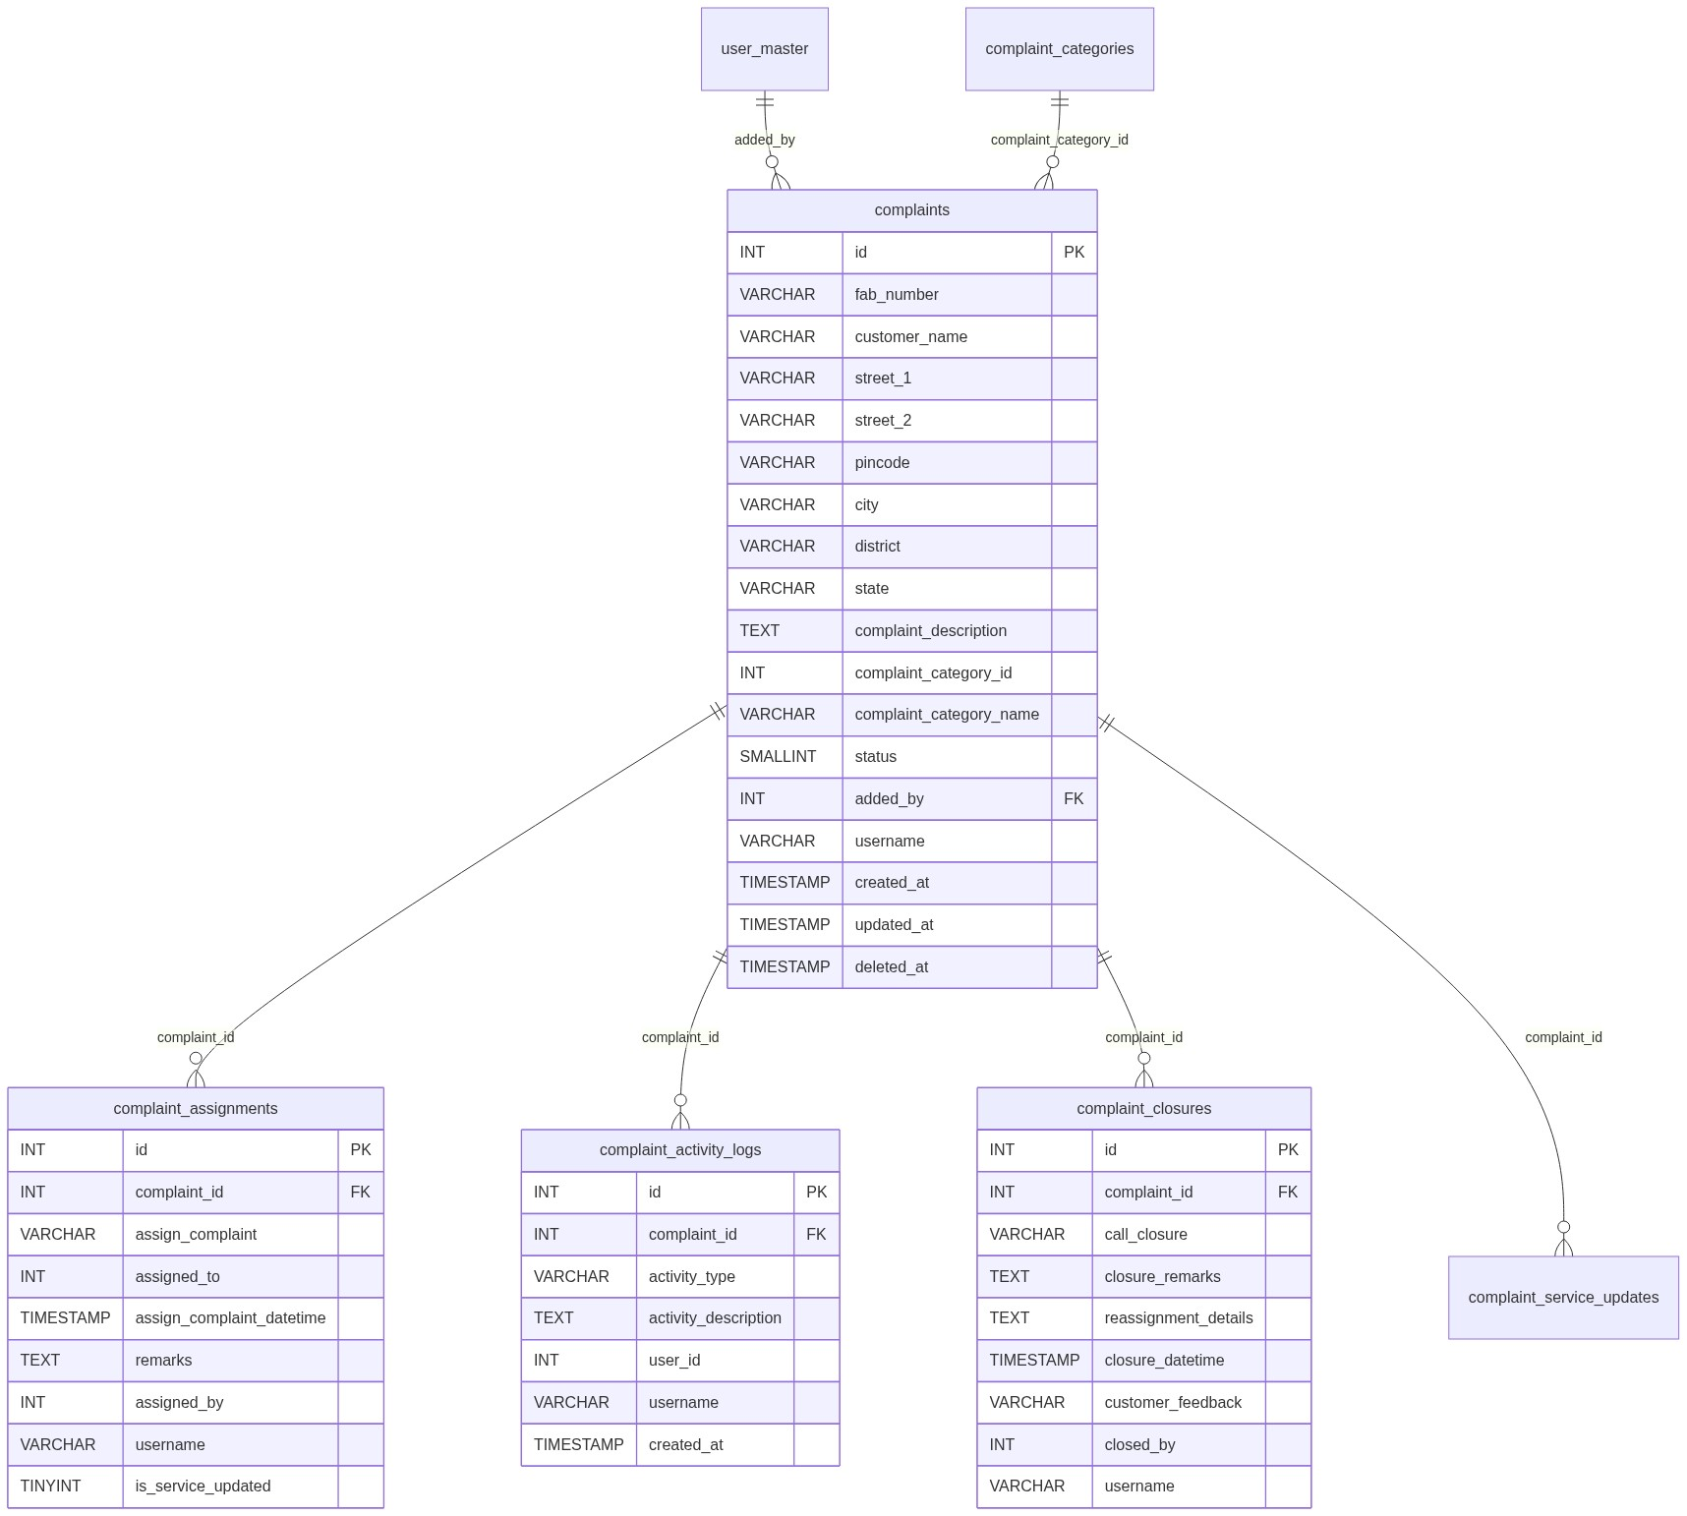
Figure 2 â€” Entity relationship diagram

5.2 Table: complaints
Column | MySQL type | Null | Default | Description
id | INT UNSIGNED AUTO_INCREMENT | NO | — | PK
fab_number | VARCHAR(100) | NO | — | LN FAB
customer_name | VARCHAR(255) | NO | —
customer_address | TEXT | YES | NULL | Legacy
street_1 | VARCHAR(255) | NO | —
street_2 | VARCHAR(255) | YES | NULL
pincode | CHAR(6) / VARCHAR(10) | NO | —
city | VARCHAR(100) | NO | —
district | VARCHAR(100) | NO | —
state | VARCHAR(100) | NO | —
complaint_description | TEXT | YES | NULL | Client required
complaint_category_id | INT UNSIGNED | YES | NULL | Category FK-ish
complaint_category_name | VARCHAR(100) | YES | NULL | Snapshot
status | SMALLINT | NO | 1 | Lifecycle
added_by | INT UNSIGNED | NO | — | Creator user id
username | VARCHAR(100) | YES | NULL | Creator username
created_at | TIMESTAMP | NO | CURRENT_TIMESTAMP
updated_at | TIMESTAMP | YES | NULL | Closure / updates
deleted_at | TIMESTAMP | YES | NULL | Soft-delete

Create INSERT columns:
fab_number, customer_name, street_1, street_2, pincode, city, district, state, complaint_description, complaint_category_id, complaint_category_name, status, added_by, username.

5.3 Related tables
Table | Relationship | Notes
complaint_assignments | Assignment history | Display name + assigned_to
complaint_activity_logs | Audit trail | Created / Assignment / Reassignment / Closure / Deleted
complaint_closures | Closure records | Yes/No + feedback / reassignment
complaint_service_updates | Prerequisite for closure | Written by Assigned List / Service Update
complaint_categories | Category master | Active options
postcodes | Pincode lookup | Logical
LN invoice ($dpconn) | FAB existence | External

5.4 Reference / lookup sources
Source | Usage
api/ln_invoice_fabno_search.php | FAB Select2
api/postcode_search.php → postcodes | Pincode → city/district/state
complaint_categories | Category Select2
api/complaint_assign_options.php | Assignee options
api/complaint_fab_prefill.php | Prior complaint address by FAB

â”€â”€â”€â”€â”€â”€â”€â”€â”€â”€â”€â”€â”€â”€â”€â”€â”€â”€â”€â”€â”€â”€â”€â”€â”€â”€â”€â”€â”€â”€â”€â”€

6. API / Backend Design

6.1 Page endpoints (HTML / form POST)
Endpoint | Method | Auth | Description
new_complaint.php | GET | view | Form + history
new_complaint.php | POST submit_complaint | add (+ assign if filled) | Create
complaint_details.php?id=&from=entry | GET | view | Details
assign_complaint.php | POST | assign-complaint | Manual assign
closure_complaint.php | POST | CCS + complaint-closure | Closure / reassign
delete_complaint.php?id= | GET | delete | Soft-delete (base64 id)

Create is not a JSON API — form POST to new_complaint.php.

6.2 JSON APIs

POST api/complaints_datatable.php
Scoped Complaint History DataTables (status filter / search / complaint_id deep-link).

GET api/complaint_fab_prefill.php?fab_number=
Returns prior complaint customer/address fields under list scope (privileged roles: any FAB history).
Errors: Unauthorized.

GET/POST api/complaint_assign_options.php
Dynamic assignee options for assign/closure modals.

6.3 Supporting lookup APIs
API | Purpose
api/postcode_search.php | Pincode Select2
api/ln_invoice_fabno_search.php | FAB Select2

6.4 Core PHP module responsibilities
Module / file | Responsibility
new_complaint.php | Create orchestration, UI
includes/complaint_address_helpers.php | Address from_post / validate
includes/complaint_category_helpers.php | Category options / resolve
includes/complaint_activity_helpers.php | Activity insert
includes/complaint_assignment_helpers.php | Assign rules / insert
includes/complaint_assignment_mail_helpers.php | Assignment emails
includes/complaint_closure_helpers.php | Closure rules / persist
includes/complaint_status.php / cards | Status labels / filters
includes/complaint_datatable_helpers.php | DataTable parse / search
includes/ln_invoice_helpers.php | FAB exists / search
includes/rbac_* | Guards

â”€â”€â”€â”€â”€â”€â”€â”€â”€â”€â”€â”€â”€â”€â”€â”€â”€â”€â”€â”€â”€â”€â”€â”€â”€â”€â”€â”€â”€â”€â”€â”€

7. Validation Rules

7.1 Server-side (create)
Rule | Error message
No add permission | Access denied. You do not have permission to add complaints.
Assign without permission | Access denied. You do not have permission to assign complaints.
Street 1 / Pincode / City / District / State | Address helper messages (required, lengths, 6-digit pincode)
FAB empty | Fab Number is required.
FAB not in LN | Selected Fab Number was not found in invoice details.
Customer | Customer Name is required. / alphabetic + spaces only
Category | Complaint Category is required.
Remarks | Remarks cannot exceed 500 characters.
Dealer self-assign | Selected Dealer User is not allowed for this complaint.
Engineer assignee | Selected assignee must be an active ELGi Engineer.
Persist | Failed to submit complaint.

Assign / closure / delete messages as listed in module inventory (Open-only assign; Pending With HO + service update for closure; etc.).

7.2 Client-side
Area | Script | Notes
Create form | Inline initComplaintFormValidation in new_complaint.php | Authoritative (not complaint_form_validation.js)
Fields | FAB, customer, street, pincode, city/district/state, description, category, remarks | Description required on client
Assign modal | Inline | Engineer required; remarks ≤ 500
Closure modal | Inline + rating JS | Yes/No, remarks, feedback 1–10, reassign when No

â”€â”€â”€â”€â”€â”€â”€â”€â”€â”€â”€â”€â”€â”€â”€â”€â”€â”€â”€â”€â”€â”€â”€â”€â”€â”€â”€â”€â”€â”€â”€â”€

8. UI Screen Specifications

8.1 Listing — Complaint History (new_complaint.php)
Element | Spec
Status cards | Open / In Progress / Pending With HO / Re-Open / Resolved
DataTable | ID, Fab, Customer, Category, Address, optional Added By, Status, Created At, Action
Actions | Assign / Closure / View / Delete (permission + status gated)
Empty | No complaints found. / No matching complaints found.
Deep-link | ?status_filter= / ?complaint_id=

8.2 Form panel — New Complaint
Section 1 — Customer Information
Fab Number* (Select2), Customer Name*, Street 1*, Street 2, Pincode* (Select2), City/District/State* (readonly auto)
Section 2 — Complaint Details
Complaint Category* (static Select2), Complaint Description*
Section 3 — Assignment (if assign-complaint)
Assign To (Select2), Remarks
Buttons: New Complaint / Cancel · Submit Complaint

8.3 Details — complaint_details.php?from=entry
Read-only complaint + activity / assignment / closure / service-update sections as applicable. Back to entry.

8.4 Modals (from listing)
Modal | Purpose
Assign | Open complaints → engineer + remarks
Closure | Pending With HO → Yes (resolve + feedback) / No (reassign)

â”€â”€â”€â”€â”€â”€â”€â”€â”€â”€â”€â”€â”€â”€â”€â”€â”€â”€â”€â”€â”€â”€â”€â”€â”€â”€â”€â”€â”€â”€â”€â”€

9. Database Flow

9.1 Create
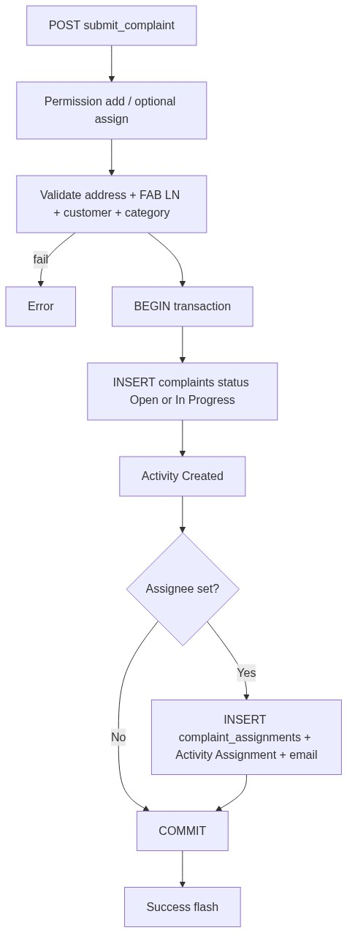
Figure 3 â€” Create database flow

9.2 Soft-delete
-- Activity Deleted then:
UPDATE complaints
SET deleted_at = CURRENT_TIMESTAMP
WHERE id = :id AND deleted_at IS NULL;
Confirm: Delete this complaint?

9.3 List query pattern
SELECT ... FROM complaints c
WHERE /* complaint_entry_list_scope: deleted_at IS NULL [AND username/assignee ...] */
AND /* optional status_filter / search */
ORDER BY {col} {ASC|DESC}
LIMIT :limit OFFSET :offset;
â”€â”€â”€â”€â”€â”€â”€â”€â”€â”€â”€â”€â”€â”€â”€â”€â”€â”€â”€â”€â”€â”€â”€â”€â”€â”€â”€â”€â”€â”€â”€â”€

10. Sequence Diagram

10.1 Create complaint (optionally assigned)
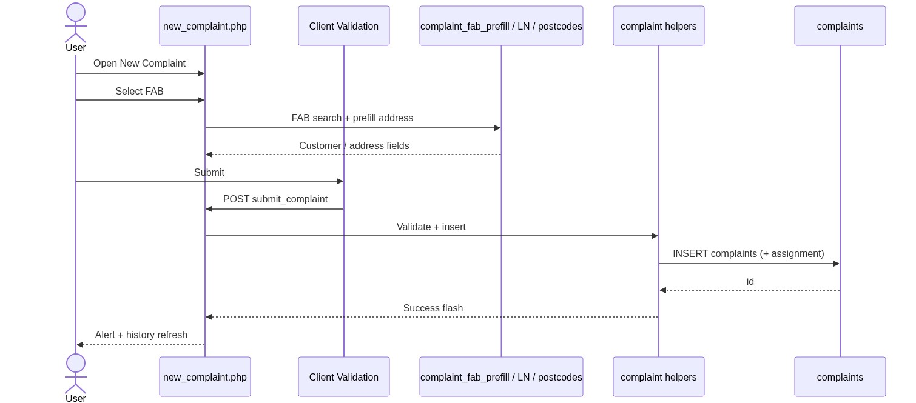
Figure 4 â€” Sequence: Create / update on Spare Parts page

10.2 Assign from Complaint History
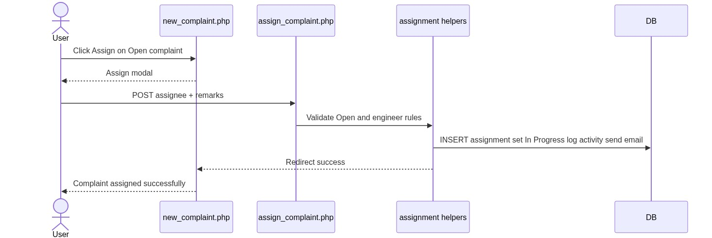
Figure 5 â€” Sequence: Add Spare Parts from IB / SL row
â”€â”€â”€â”€â”€â”€â”€â”€â”€â”€â”€â”€â”€â”€â”€â”€â”€â”€â”€â”€â”€â”€â”€â”€â”€â”€â”€â”€â”€â”€â”€â”€

11. Activity Diagram
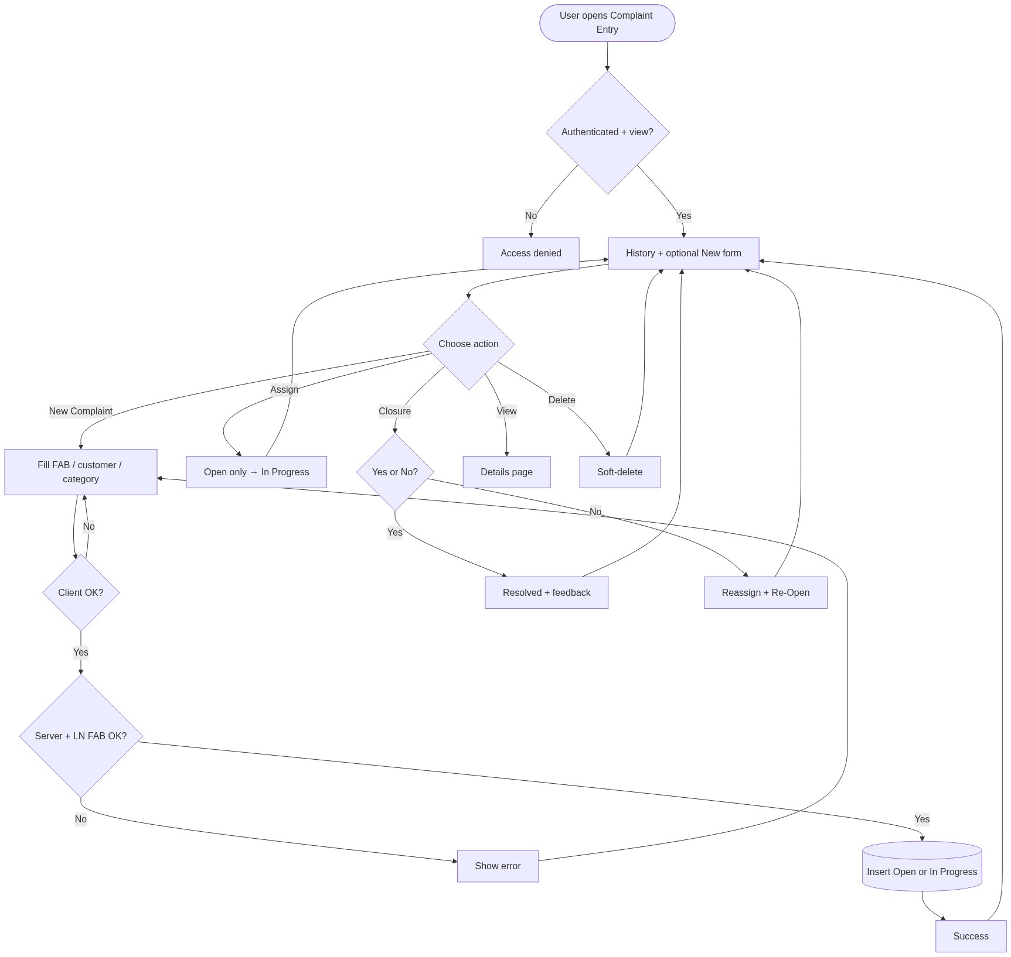
Figure 6 â€” Activity diagram
â”€â”€â”€â”€â”€â”€â”€â”€â”€â”€â”€â”€â”€â”€â”€â”€â”€â”€â”€â”€â”€â”€â”€â”€â”€â”€â”€â”€â”€â”€â”€â”€

12. Class / Module Diagram
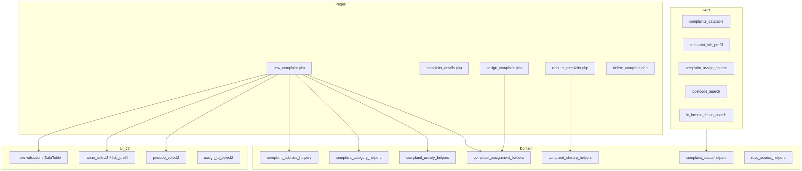
Figure 7 â€” Class / module diagram

12.1 Key functions
Function / area | Role
Address helpers | Parse/validate street/pincode/city
Category helpers | Active options + name snapshot
Activity helpers | Insert Created / Assignment / Closure / Deleted
Assignment helpers | Insert assignment, dealer/engineer rules
Closure helpers | Yes/No close, reassign, eligibility
Status helpers | Labels, cards, filters
complaint_entry_action_permissions() | UI action flags
complaint_entry_list_scope() | List / prefill ACL
LN invoice helpers | FAB exists / search

â”€â”€â”€â”€â”€â”€â”€â”€â”€â”€â”€â”€â”€â”€â”€â”€â”€â”€â”€â”€â”€â”€â”€â”€â”€â”€â”€â”€â”€â”€â”€â”€

13. Folder Structure
ComplaintManagement/
├── new_complaint.php
├── complaint_details.php
├── assign_complaint.php
├── closure_complaint.php
├── delete_complaint.php
├── api/
│ ├── complaints_datatable.php
│ ├── complaint_fab_prefill.php
│ ├── complaint_assign_options.php
│ ├── postcode_search.php
│ └── ln_invoice_fabno_search.php
├── includes/
│ ├── complaint_address_helpers.php
│ ├── complaint_category_helpers.php
│ ├── complaint_activity_helpers.php
│ ├── complaint_assignment_helpers.php
│ ├── complaint_assignment_mail_helpers.php
│ ├── complaint_closure_helpers.php
│ ├── complaint_status.php
│ ├── complaint_status_cards.php
│ ├── complaint_datatable_helpers.php
│ ├── ln_invoice_helpers.php
│ └── rbac_*.php
├── js/
│ ├── complaint_fab_prefill.js
│ ├── fabno_select2.js
│ ├── pincode_select2.js
│ ├── assign_to_select2.js
│ ├── static_select2.js
│ └── closure_customer_feedback_rating.js
├── css/
│ ├── new_complaint.css
│ ├── complaint_form.css
│ ├── complaint_buttons.css
│ └── complaint_status_cards.css
└── docs/
└── LLD_Complaint_Entry_Module.md
â”€â”€â”€â”€â”€â”€â”€â”€â”€â”€â”€â”€â”€â”€â”€â”€â”€â”€â”€â”€â”€â”€â”€â”€â”€â”€â”€â”€â”€â”€â”€â”€

14. Error Handling
Layer | Pattern
Page POST | $error_message / $success_message
Redirect flows | $_SESSION['success_message'] / error_message
JSON APIs | 401 / 403 + {"error":"..."}
Client | validate.js messages on form/modals

14.1 Common messages
Message | When
Access denied. You do not have permission to add complaints. | Create without add
Access denied. You do not have permission to assign complaints. | Assign without permission
Selected Fab Number was not found in invoice details. | LN miss
Complaint not found. / ... or already deleted. | Missing target
Manual assign is only allowed for open complaints. | Wrong status
Closure is only allowed for complaints pending with HO. | Wrong status
Service update is required before complaint closure. | Prerequisite
Access denied. Complaint closure is available to CCS Admin users with the required permission only. | Closure gate
Failed to submit complaint. / Failed to assign complaint. / Failed to save complaint closure. / Failed to delete complaint. | Persist failures

â”€â”€â”€â”€â”€â”€â”€â”€â”€â”€â”€â”€â”€â”€â”€â”€â”€â”€â”€â”€â”€â”€â”€â”€â”€â”€â”€â”€â”€â”€â”€â”€

15. Security Considerations
Area | Control
SQL Injection | PDO prepared statements
XSS | Escaped output on listing/details
CSRF | Session POST; recommend CSRF tokens
Authentication | Portal session
Authorization | RBAC + list scope + status gates
IDOR | Details/delete/assign scoped; base64 IDs obfuscation only
Soft-delete | Filter deleted_at IS NULL
FAB integrity | Must exist in LN invoice source

â”€â”€â”€â”€â”€â”€â”€â”€â”€â”€â”€â”€â”€â”€â”€â”€â”€â”€â”€â”€â”€â”€â”€â”€â”€â”€â”€â”€â”€â”€â”€â”€

16. Audit Logs

16.1 Built-in field-level audit
Entity | Fields
complaints | added_by, username, created_at, updated_at, deleted_at
complaint_assignments | assigned_by, username, created_at
complaint_activity_logs | user_id, username, activity_type, activity_description, created_at
complaint_closures | closed_by, username, created_at, closure_datetime

Activity types: Created, Assignment, Reassignment, Closure, Deleted.
No separate generic audit table beyond activity logs.
â”€â”€â”€â”€â”€â”€â”€â”€â”€â”€â”€â”€â”€â”€â”€â”€â”€â”€â”€â”€â”€â”€â”€â”€â”€â”€â”€â”€â”€â”€â”€â”€

17. Test Cases

17.1 Functional
ID | Scenario | Expected
TC-01 | User with view opens entry | History loads under scope
TC-02 | Create without assign | Open; success “submitted”
TC-03 | Create with assign | In Progress + assignment row + email
TC-04 | FAB not in LN | Invoice not found error
TC-05 | Invalid customer name / pincode | Validation errors
TC-06 | Missing category | Validation error
TC-07 | FAB prefill | Address fields populated
TC-08 | Pincode select | City/district/state auto-fill
TC-09 | Assign Open complaint | In Progress
TC-10 | Assign non-Open | Rejected
TC-11 | Closure without service update | Rejected
TC-12 | Closure Yes | Resolved + feedback
TC-13 | Closure No | Re-Open + reassignment
TC-14 | Soft-delete | deleted_at set; gone from list
TC-15 | Delete Resolved | Action hidden / blocked
TC-16 | Status card filter | Filtered DataTable
TC-17 | Dealer self-assign only | Other assignees rejected
TC-18 | Non-privileged list | Sees own / assigned only

â”€â”€â”€â”€â”€â”€â”€â”€â”€â”€â”€â”€â”€â”€â”€â”€â”€â”€â”€â”€â”€â”€â”€â”€â”€â”€â”€â”€â”€â”€â”€â”€

18. Assumptions & Dependencies

18.1 Assumptions
1. Users authenticate via portal session (user_master).
2. RBAC permissions for complaint-entry are seeded for applicable roles.
3. LN invoice FAB master is available via $dpconn helpers.
4. postcodes and complaint_categories are maintained.
5. Service Update (Assigned List) produces complaint_service_updates before closure.
6. Document target stack is Core PHP + MySQL; repo currently runs PostgreSQL.

18.2 Dependencies
Dependency | Purpose
PHP PDO + MySQL (or PostgreSQL) | Persistence
Session + RBAC | AuthZ
LN invoice helpers / dealerportal | FAB validation
postcodes | Address autofill
Complaint categories master | Category Select2
Mail helpers | Assignment / closure notifications
jQuery + Select2 + DataTables + Bootstrap + validate.js | UI
Assigned Complaint List / Service Update | Closure prerequisite

â”€â”€â”€â”€â”€â”€â”€â”€â”€â”€â”€â”€â”€â”€â”€â”€â”€â”€â”€â”€â”€â”€â”€â”€â”€â”€â”€â”€â”€â”€â”€â”€

Appendix A — Success flash query flags
Event | Message
Create unassigned | Complaint submitted successfully.
Create + assign | Complaint submitted and assigned successfully.
Assign | Complaint assigned successfully.
Closure Yes | Complaint closed successfully.
Closure No | Complaint closed with No. Reassigned successfully.
Delete | Complaint deleted successfully.

(No dedicated query-string flags on create; session / in-page flashes used. Success alerts fade ~3s.)
â”€â”€â”€â”€â”€â”€â”€â”€â”€â”€â”€â”€â”€â”€â”€â”€â”€â”€â”€â”€â”€â”€â”€â”€â”€â”€â”€â”€â”€â”€â”€â”€

Appendix B — Select2 control map
Control | Init | API / mode
Fab Number | initFabnoSelect2 | api/ln_invoice_fabno_search.php (+ complaint_fab_prefill.js)
Pincode | initPincodeSelect2 | api/postcode_search.php
Complaint Category | initStaticSelect2 | Static active categories
Assign To | initAssignToSelect2 | Static / api/complaint_assign_options.php

â”€â”€â”€â”€â”€â”€â”€â”€â”€â”€â”€â”€â”€â”€â”€â”€â”€â”€â”€â”€â”€â”€â”€â”€â”€â”€â”€â”€â”€â”€â”€â”€
End of LLD — Complaint Entry Module

