Low-Level Design (LLD) — Installed Base Capture Module
Attribute | Value
Module | Installed Base Capture
Application | Complaint / Dealer Portal (After Market)
Stack (target) | Core PHP + MySQL (PDO)
Stack (current repo) | Core PHP + PostgreSQL via PDO (pdo_obconn.php) — schema maps 1:1 to MySQL
Document version | 1.0
Related modules | Service Log Capture, Spare Parts Consumption, Complaints, RBAC

────────────────────────────────

1. Module Overview

1.1 Purpose
Installed Base Capture records the physical machine / customer install footprint after sale: Fab Number (FAB), customer & address, dealer, machine model, invoice & commissioning dates, running hours, and industry segment. It is the parent master for after-market Service Log and Spare Parts Consumption records.

1.2 Scope
In scope | Out of scope
Create / update / soft-delete installed base | Hard delete / cascade delete of child records
Server-side DataTable listing with role scope | Standalone order booking (Order ID UI is hidden; saved as 0)
FAB ownership & uniqueness rules | Full LN ERP sync (uses invoice lookup helpers only)
Prefill from FAB / complaint | Changing RBAC admin UI
Launch Service Log / Spare Parts from IB row | Pricing / inventory of spare kits

1.3 High-level architecture
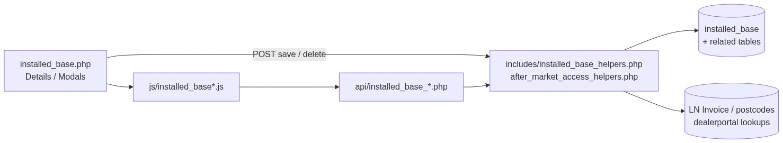
Figure 1 — High-level architecture
────────────────────────────────

2. Functional Requirements
ID | Requirement | Priority
FR-01 | Authenticated users with view can open listing and details | Must
FR-02 | Users with add can create a new installed base record | Must
FR-03 | Users with edit can update records they are allowed to use | Must
FR-04 | Users with delete can soft-delete allowed records | Must
FR-05 | Listing is server-side searchable/sortable (DataTables) | Must
FR-06 | FAB Number is required and must exist in invoice (LN) data on save | Must
FR-07 | FAB cannot be claimed if owned by another user | Must
FR-08 | Same FAB for current owner upserts (create vs update resolution) | Must
FR-09 | Invoice date is resolved from LN invoice by FAB (form value overridden) | Must
FR-10 | Address city/district/state auto-fill from pincode Select2 | Must
FR-11 | Machine model selectable via Select2; locked when FAB already has IB / on edit | Must
FR-12 | Users with add-service-log-capture can open Add Service Log from a row | Must
FR-13 | Users with add-spare-parts-consumption can open Add Spare Parts from a row | Must
FR-14 | Details page shows IB + linked service logs + spare parts | Must
FR-15 | Deep-link open form with FAB / complaint_id for complaint flow | Should
FR-16 | Soft-deleted records excluded from all active queries | Must
FR-17 | List visibility follows after-market scope (admin / sales coordinator / owner) | Must

────────────────────────────────

3. User Roles & Permissions

3.1 RBAC module slug
installed-base-capture

3.2 Permission matrix
Permission slug | Capability
view | List, details, get, datatable, FAB prefill/availability, link search
add | Create new installed base
edit | Update existing installed base
delete | Soft-delete
add-service-log-capture | Row action + service-log modal from IB
add-spare-parts-consumption | Row action + spare-parts modal from IB

3.3 Page / API mapping
Resource | Required permission
installed_base.php | view
installed_base_details.php | view
delete_installed_base.php | delete
api/installed_base_datatable.php | view
api/installed_base_get.php | view
api/installed_base_fab_prefill.php | view
api/installed_base_fab_availability.php | view
api/installed_base_link_search.php | view
api/installed_base_service_log_prefill.php | Service Log add (+ after-market helper)
api/installed_base_service_log_draft_create.php | Service Log add
api/installed_base_spare_parts_prefill.php | Spare Parts add or IB add-spare-parts-consumption

3.4 After-market list scope
Role class | List scope (deleted_at IS NULL always)
System Admin / CCS Admin / Management | All active records
Sales Coordinator | Records whose username is in assigned dealers/engineers
Other roles | username = current user

3.5 FAB ownership (stricter than list scope)
A user owns a record if created_by = current_user_id OR username = current_username.
• Privileged list access does not allow claiming another user’s FAB.
• Message: This FAB Number is already assigned to another user and cannot be used.
────────────────────────────────

4. Business Rules
ID | Rule
BR-01 | Active FAB uniqueness is case-insensitive on TRIM(fab_number) among deleted_at IS NULL rows (ownership-aware upsert).
BR-02 | On save, FAB must resolve in LN invoice helpers; else error: Selected Fab Number was not found in invoice details.
BR-03 | invoice_date is always overwritten from LN resolve helper, not free-typed.
BR-04 | running_hours required, numeric, strictly > 0.
BR-05 | On insert, dealer_name = current_assignee_name() (display name or username).
BR-06 | On update, empty dealer in POST keeps existing dealer_name.
BR-07 | order_ref_id / order_id currently persisted as 0 (Order Select2 hidden).
BR-08 | Industry segment must exist in System Config Master (industry_segment).
BR-09 | Soft-delete sets deleted_at + updated_at; no cascade to service_logs / spare_parts_consumption.
BR-10 | Service Log / Spare Parts require an accessible non-deleted IB parent.
BR-11 | Machine model Select2 disabled when FAB already maps to IB (prefill) or when editing.
BR-12 | Customer name: alphabetic characters and spaces only.
BR-13 | Mobile: 10 digits, first digit 1–9. Pincode: exactly 6 digits.
BR-14 | Remarks optional, max 1000 characters.

────────────────────────────────

5. Database Design
Note: Current production uses PostgreSQL. Types below are MySQL-equivalent for the requested stack. Map TIMESTAMP ↔ PostgreSQL timestamp, DECIMAL ↔ numeric, INT AUTO_INCREMENT ↔ SERIAL/BIGSERIAL.

5.1 ER diagram
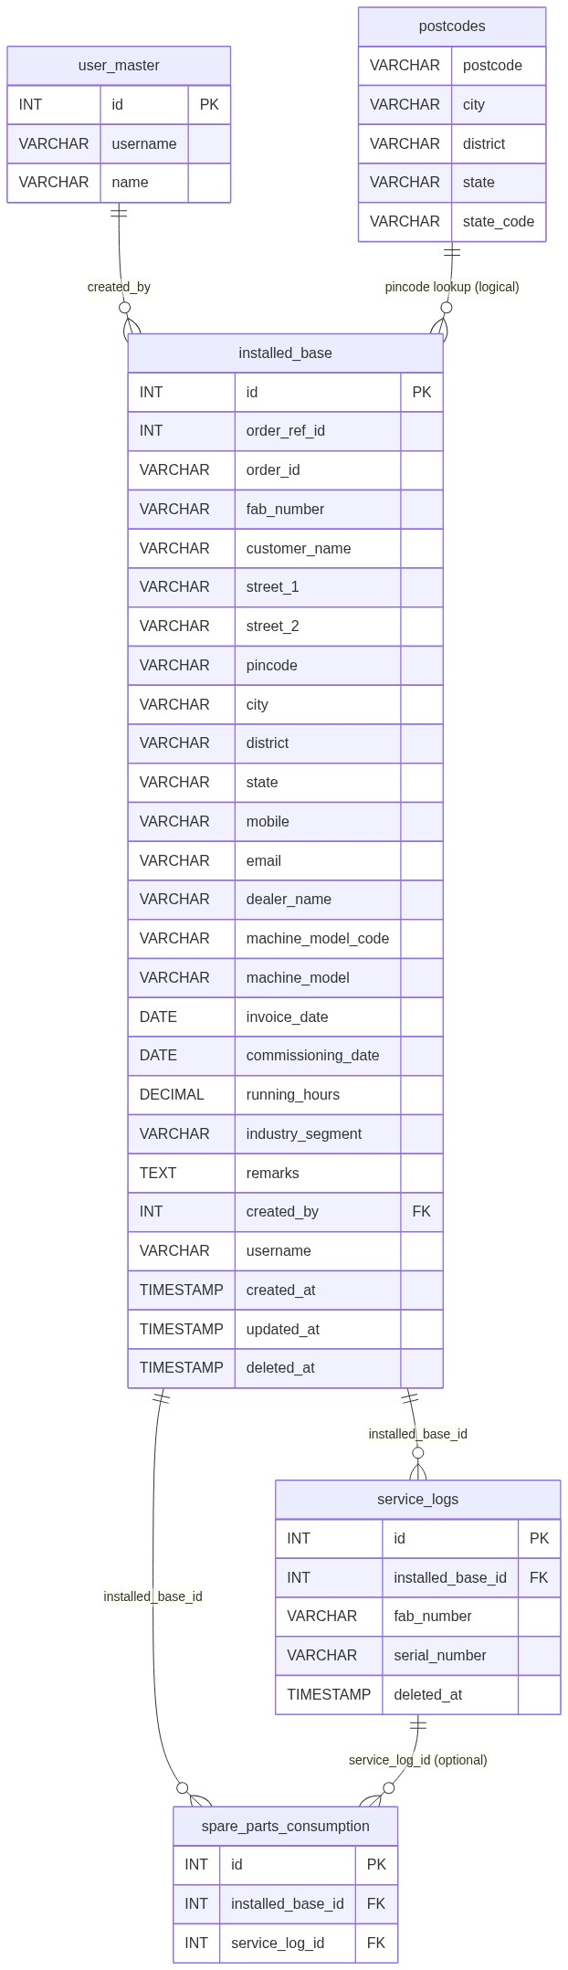
Figure 2 — Entity relationship diagram

5.2 Table: installed_base
Column | MySQL type | Null | Default | Description
id | INT UNSIGNED AUTO_INCREMENT | NO | — | PK
order_ref_id | INT | YES | 0 | Legacy; currently saved as 0
order_id | VARCHAR(50) | YES | '0' | Legacy; currently saved as '0'
fab_number | VARCHAR(100) | NO | — | Business key (FAB)
customer_name | VARCHAR(150) | NO | —
street_1 | VARCHAR(255) | NO | —
street_2 | VARCHAR(255) | YES | NULL
pincode | CHAR(6) | NO | —
city | VARCHAR(100) | NO | — | Auto from postcodes
district | VARCHAR(100) | NO | — | Auto from postcodes
state | VARCHAR(100) | NO | — | Auto from postcodes
mobile | VARCHAR(15) | NO | — | 10-digit
email | VARCHAR(150) | NO | —
dealer_name | VARCHAR(150) | NO | — | Set on insert from assignee
machine_model_code | VARCHAR(100) | NO | —
machine_model | VARCHAR(255) | NO | — | Description / label
invoice_date | DATE | NO | — | From LN invoice resolve
commissioning_date | DATE | NO | —
running_hours | DECIMAL(12,2) | NO | — | Must be > 0
industry_segment | VARCHAR(150) | NO | — | SCM option name
remarks | VARCHAR(1000) | YES | NULL
created_by | INT UNSIGNED | NO | — | FK → user_master.id
username | VARCHAR(100) | NO | — | Owner username for scope
created_at | TIMESTAMP | NO | CURRENT_TIMESTAMP
updated_at | TIMESTAMP | YES | NULL | On update / soft-delete
deleted_at | TIMESTAMP | YES | NULL | Soft-delete marker
address | VARCHAR(500) | YES | NULL | Legacy; display/search fallback only

Constraints (recommended):
PRIMARY KEY (id),
KEY idx_ib_fab (fab_number),
KEY idx_ib_username (username),
KEY idx_ib_deleted (deleted_at),
KEY idx_ib_created_by (created_by),
-- Optional unique among active rows (MySQL 8+ functional / generated column, or app-enforced):
-- UNIQUE KEY uq_ib_fab_active (fab_number, (IF(deleted_at IS NULL, 1, NULL)))

5.3 Related tables (logical FKs)
Child table | FK column | Parent | Notes
service_logs | installed_base_id | installed_base.id | Soft-delete independent
spare_parts_consumption | installed_base_id | installed_base.id | Optional service_log_id
user_master | — | referenced by created_by | “Added By” on details
postcodes | postcode | logical | Select2 lookup only
complaints | — | prefill source | By complaint_id or FAB
Dealerportal pendingordersnew | — | external DB | Order search (hidden UI)

5.4 Reference / lookup sources
Source | Usage
postcodes | Pincode → city, district, state, state_code
System Config Master industry_segment | Dropdown options
LN invoice helpers (ln_invoice_*) | FAB search + invoice date
Machine model search API | Code + description

────────────────────────────────

6. API / Backend Design

6.1 Page endpoints (HTML / form POST)
Endpoint | Method | Auth | Description
installed_base.php | GET | Session + view | Listing + form panel
installed_base.php | POST (submit_installed_base) | add / edit | Create or update
installed_base_details.php?id= | GET | view + record ACL | Details (id base64-encoded)
delete_installed_base.php?id= | GET | delete + record ACL | Soft-delete (id base64)

POST installed_base.php — request fields
Field | Required | Notes
record_id | No | 0 = new; >0 = edit candidate
fab_number | Yes
customer_name, street_1, pincode, city, district, state | Yes
street_2 | No
mobile, email | Yes
dealer_name | Yes (update) | Forced on insert
machine_model_code, machine_model | Yes
invoice_date, commissioning_date | Yes | Invoice overwritten from LN
running_hours | Yes | > 0
industry_segment | Yes
remarks | No | Max 1000
return_complaint_id | No | Complaint return flow
order_id / order_ref_id | No | Persisted as 0

POST success redirects
Condition | Redirect / flash
Insert | installed_base.php?ib_saved=1
Update | installed_base.php?ib_updated=1
Complaint return | Complaint list + session success

6.2 JSON APIs

GET api/installed_base_datatable.php
DataTables server-side. Scoped by after_market_list_scope.
Response (shape):
{
"draw": 1,
"recordsTotal": 100,
"recordsFiltered": 12,
"data": [
{
"id": 1,
"fab_number": "FAB001",
"customer_name": "Acme",
"dealer_name": "Dealer A",
"machine_model": "MODEL - Desc",
"commissioning_date": "01 Jan 2026",
"created_at": "01 Jan 2026 10:00",
"action": "<html actions>"
}
]
}

GET api/installed_base_get.php?id={id}
Success: full form payload (dates as YYYY-MM-DD, invoice refreshed from LN when FAB present).
Errors: 400 invalid id; 404 not found / no ACL.

GET api/installed_base_fab_prefill.php
Param | Description
fab_number | FAB to resolve
complaint_id | Optional complaint source
record_id | Optional edit context

Blocked:
{
"found": false,
"blocked": true,
"available": false,
"has_installed_base": false,
"message": "This FAB Number is already assigned to another user and cannot be used."
}
Found (partial): found, available, has_installed_base, customer/address fields, and when has_installed_base: machine model, commissioning, running hours, industry, remarks.

GET|POST api/installed_base_fab_availability.php
{ "available": true, "existing_id": 12, "message": "" }

GET api/installed_base_link_search.php?q=
Select2 results for Service Log “link to IB”:
{
"results": [
{
"id": 1,
"text": "#1 - FAB001 - Acme",
"installed_base_id": 1,
"fab_number": "FAB001",
"machine_model": "...",
"machine_model_code": "...",
"running_hours": "1200"
}
]
}

GET api/installed_base_service_log_prefill.php?id=
Prefills Add Service Log modal (IB label, FAB, machine model, running hours, next serial peek).

POST api/installed_base_service_log_draft_create.php
Creates draft service log from IB modal.

GET api/installed_base_spare_parts_prefill.php?id=
Prefills Add Spare Parts modal; prefers latest scoped service log for serial/warranty fields; running_hours from IB.

6.3 Supporting lookup APIs
API | Purpose
api/postcode_search.php?q= | Pincode Select2 → postcodes
api/ln_invoice_fabno_search.php | FAB Select2
api/machine_model_search.php | Machine model Select2
api/order_search.php | Order Select2 (UI hidden)
api/service_log_create.php | Submit service log from IB modal
api/spare_parts_create.php | Create spare parts from IB modal

6.4 Core PHP module responsibilities
Module / file | Responsibility
includes/installed_base_helpers.php | from_post, validate, insert/update, FAB ownership, UI action HTML
includes/after_market_access_helpers.php | Scope, ACL, action permissions
includes/complaint_address_helpers.php | Address parse + validate
includes/ln_invoice_helpers.php | Invoice date by FAB
includes/rbac_* | Session page/API guards

────────────────────────────────

7. Validation Rules

7.1 Server-side (installed_base_validate + address helpers)
Field | Rule | Error message
Fab Number | Required | Fab Number is required.
Fab Number | Ownership | This FAB Number is already assigned to another user and cannot be used.
Fab Number | Must exist in LN | Selected Fab Number was not found in invoice details.
Customer Name | Required | Customer Name is required.
Customer Name | /^[A-Za-z]+(?:\s+[A-Za-z]+)*$/ | Customer Name can contain only alphabetic characters and spaces.
Street 1 | Required | Street 1 is required.
Pincode | Required, 6 digits | Pincode is required. / Pincode must be a 6-digit number.
City / District / State | Required | `City | District | State is required.`
Mobile | Required, /^[1-9]\d{9}$/ | Mobile is required. / Mobile must be a valid 10-digit number.
Email | Required, valid email | Email is required. / Email must be a valid email address.
Dealer Name | Required | Dealer Name is required.
Machine Model | Code + description | Machine Model is required.
Invoice Date | Required (then LN overwrite) | Invoice Date is required.
Commissioning Date | Required | Commissioning Date is required.
Running Hours | Required, numeric > 0 | Running Hours is required. / Running Hours must be greater than 0.
Industry Segment | Required + SCM exists | Industry Segment is required. / Invalid Industry Segment selected.
Remarks | Max 1000 | Remarks cannot exceed 1000 characters.

7.2 Client-side (js/installed_base_validation.js + validate.js)
• Mirrors server presence/format rules (validate.js constraint messages).
• Pre-submit AJAX: api/installed_base_fab_availability.php.
• Disabled machine-model Select2 posts via hidden #machineModelCodeLocked.
• HTML5 / Select2 invalid class + .validation-msg[data-field].
────────────────────────────────

8. UI Screen Specifications

8.1 Listing — installed_base.php
Element | Spec
Title | Installed Base Capture
Primary CTA | New Record (if add) → opens slide-in #installedBaseFormCard
Grid | DataTable: ID, Fab Number, Customer, Dealer, Machine Model, Commissioning, Created At, Action
Empty | No installed base records found.
Flash | Query flags ib_saved, ib_updated, service_log_added, service_log_draft_added, spare_parts_added + session flashes
Row actions | View, Edit, Add Service Log, Add Spare Parts, Delete (permission-gated)

8.2 Form panel (3 sections)
Section 1 — Order & Machine
Field | Control | Notes
Order ID | Select2 | Hidden (d-none)
Fab Number | Select2 | Required
Machine Model | Select2 | Required; may lock
Invoice Date | date | Required; overwritten from LN
Commissioning Date | date | Required
Running Hours | number | Required > 0

Section 2 — Customer
Field | Control | Notes
Customer Name | text | Required
Dealer Name | text | Required; default on create
Street 1 / 2 | text | Street 1 required
Pincode | Select2 | Fills city/district/state
City, District, State | text readonly | Auto
Mobile, Email | text | Required

Section 3 — Business
Field | Control | Notes
Industry Segment | static Select2 | SCM options
Remarks | textarea | Optional

Hidden: record_id, return_complaint_id.
Deep link: ?open_form=1&fab_number=&complaint_id=.

8.3 Details — installed_base_details.php
• Header badges: service log / draft / spare parts counts.
• Read-only IB sections (Order & Machine / Customer / Business / Added By).
• Embedded linked Service Log and Spare Parts sections.
• Back to listing.

8.4 Modals (from listing)
Modal | Include / JS
Add Service Log | includes/installed_base_service_log_modal.php + js/installed_base_service_log_modal.js (+ draft JS)
Add Spare Parts | includes/service_log_spare_parts_modal.php + js/service_log_spare_parts_modal.js (data-prefill="installed_base")

────────────────────────────────

9. Database Flow

9.1 Create
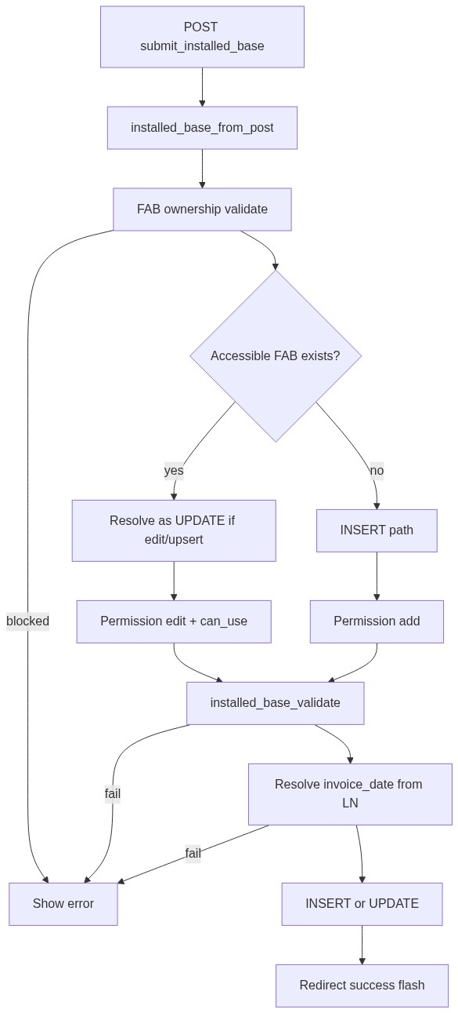
Figure 3 — Create / update database flow

9.2 Soft-delete
UPDATE installed_base
SET deleted_at = CURRENT_TIMESTAMP,
updated_at = CURRENT_TIMESTAMP
WHERE id = :id
AND deleted_at IS NULL;

9.3 List query pattern
SELECT ... FROM installed_base
WHERE /* after_market_list_scope: deleted_at IS NULL [AND username ...] */
AND /* optional DataTables search */
ORDER BY {col} {ASC|DESC}
LIMIT :limit OFFSET :offset;
────────────────────────────────

10. Sequence Diagram

10.1 Create / update installed base
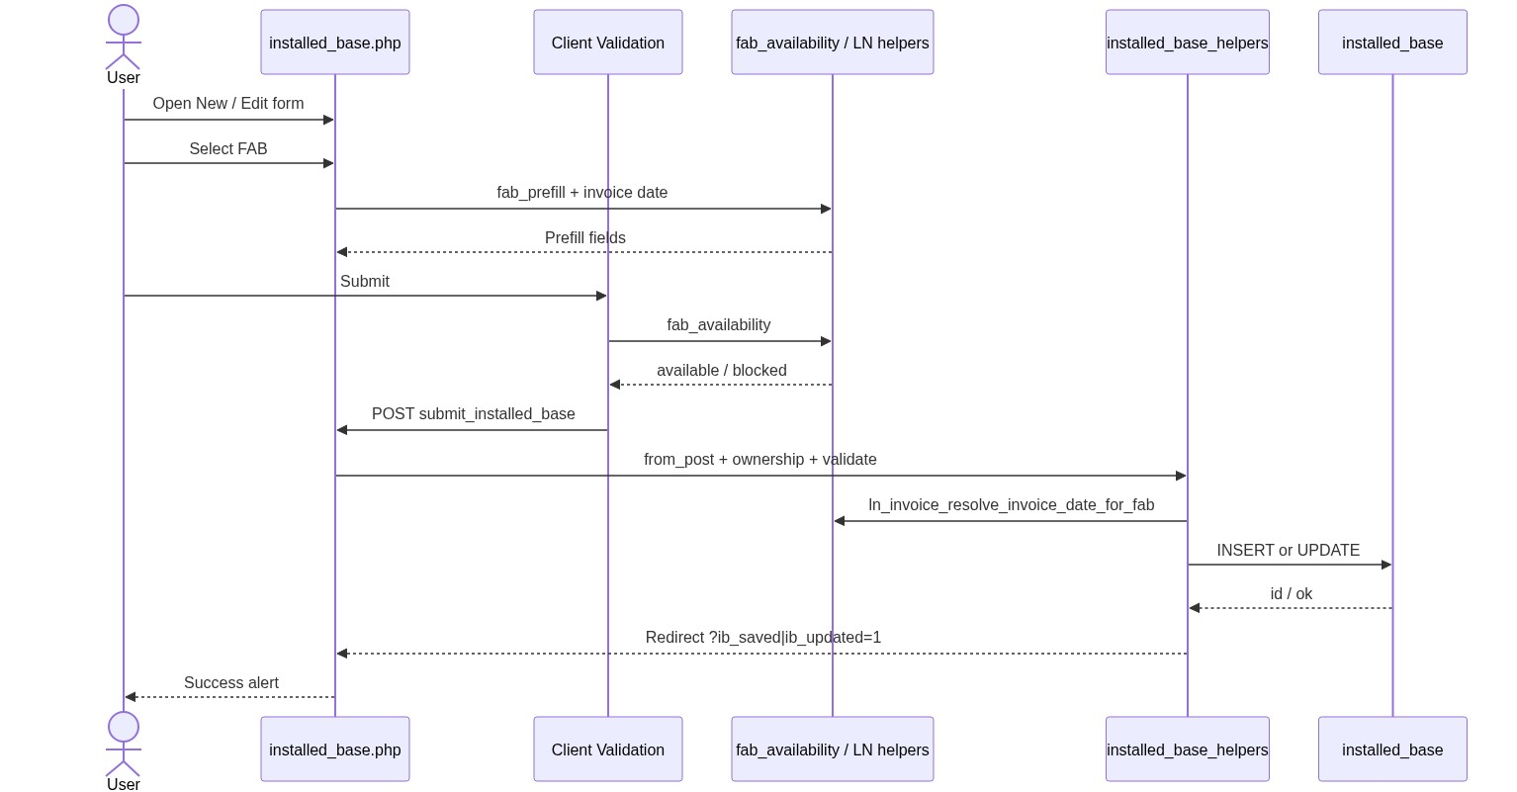
Figure 4 — Sequence: Create / update installed base

10.2 Add Spare Parts from Installed Base row
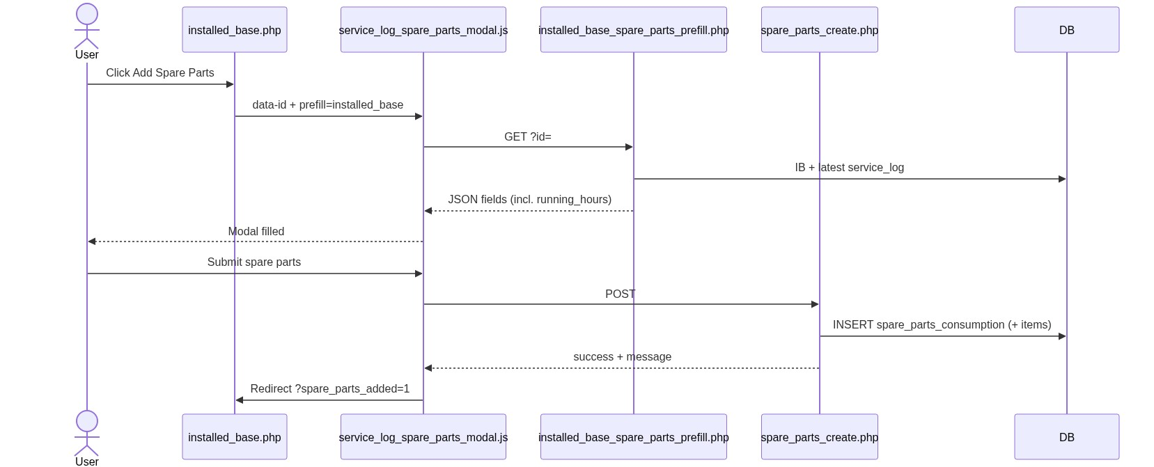
Figure 5 — Sequence: Add Spare Parts from Installed Base
────────────────────────────────

11. Activity Diagram
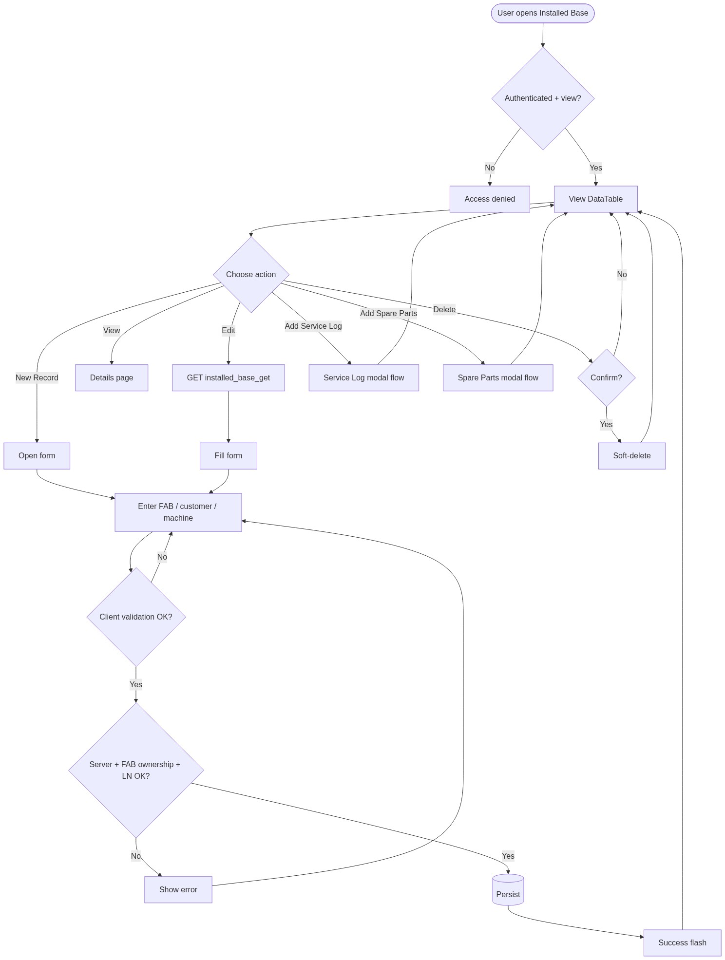
Figure 6 — Activity diagram
────────────────────────────────

12. Class / Module Diagram
Core PHP is procedural; treat helpers as modules.
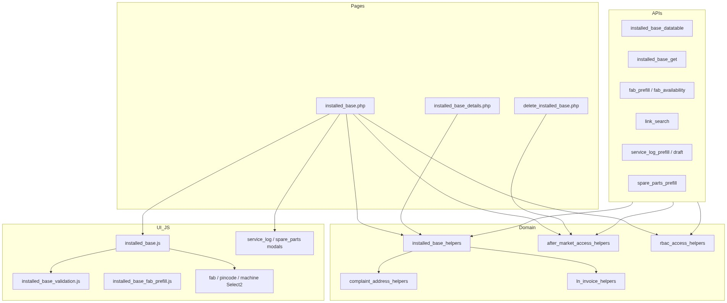
Figure 7 — Class / module diagram

12.1 Key functions (installed_base_helpers.php)
Function | Role
installed_base_from_post() | Map POST → data array
installed_base_validate() | Server validation
installed_base_insert_record() | INSERT
installed_base_update_record() | UPDATE
installed_base_validate_fab_for_current_user() | Ownership gate
installed_base_find_accessible_id_by_fab() | Upsert target resolve
installed_base_current_user_owns_record() | Owner check
installed_base_action_html() / permissions | Row actions
installed_base_fab_prefill_row() | Prefill source row

────────────────────────────────

13. Folder Structure
Existing project layout (not strict MVC; page + api/ + includes/ + js/):
ComplaintManagement/
├── installed_base.php # List + create/update UI
├── installed_base_details.php # Read-only details
├── delete_installed_base.php # Soft-delete
├── pdo_obconn.php # PDO connections
├── sidebar.php # AFTER MARKET menu
├── api/
│ ├── installed_base_datatable.php
│ ├── installed_base_get.php
│ ├── installed_base_fab_prefill.php
│ ├── installed_base_fab_availability.php
│ ├── installed_base_link_search.php
│ ├── installed_base_service_log_prefill.php
│ ├── installed_base_service_log_draft_create.php
│ ├── installed_base_spare_parts_prefill.php
│ ├── postcode_search.php
│ ├── machine_model_search.php
│ ├── order_search.php
│ └── ln_invoice_fabno_search.php
├── includes/
│ ├── installed_base_helpers.php
│ ├── installed_base_record_details_section.php
│ ├── installed_base_service_log_modal.php
│ ├── service_log_spare_parts_modal.php
│ ├── after_market_access_helpers.php
│ ├── complaint_address_helpers.php
│ ├── ln_invoice_helpers.php
│ ├── rbac_access_helpers.php
│ └── rbac_page_guard.php
├── js/
│ ├── installed_base.js
│ ├── installed_base_validation.js
│ ├── installed_base_fab_prefill.js
│ ├── installed_base_fabno_select2.js
│ ├── installed_base_order_select2.js
│ ├── installed_base_machine_model_select2.js
│ ├── installed_base_service_log_modal.js
│ ├── installed_base_service_log_draft.js
│ ├── service_log_spare_parts_modal.js
│ ├── pincode_select2.js
│ ├── fabno_select2.js
│ └── static_select2.js
└── docs/
└── LLD_Installed_Base_Capture_Module.md
Suggested MVC mapping (if refactoring later):
Layer | Maps to
Controller | installed_base.php, api/installed_base_*.php
Model / Service | includes/installed_base_helpers.php
View | PHP templates + Bootstrap form/modal partials
Assets | js/installed_base*.js

────────────────────────────────

14. Error Handling
Layer | Pattern
Page POST | $error_message alert on same page; no silent fail
Delete / ACL | $_SESSION['error_message'] + redirect listing
JSON APIs | HTTP 400 / 401 / 403 / 404 / 422 + {"error":"..."}
Client AJAX | alert() or in-page Bootstrap alert helpers
DB exceptions | PDO ERRMODE_EXCEPTION; catch at page/API boundary with user-safe message
Soft-delete miss | Treat as not found / already deleted

Common messages
Message | When
Access denied. You do not have permission for this action. | RBAC / ACL
Unable to resolve logged-in user. | Missing session user id
Record not found or already deleted. | Update target missing
Failed to save installed base record. | Persist failure
Unable to load record. | Edit GET fail (JS fallback)

────────────────────────────────

15. Security Considerations
Area | Control
SQL Injection | Prepared statements (PDO bindValue) for all IB queries
XSS | htmlspecialchars(..., ENT_QUOTES, 'UTF-8') on output; JSON APIs return data consumed via textContent / careful HTML action builders
CSRF | Session-authenticated POST; recommend adding CSRF tokens on submit_installed_base and mutating APIs if not already global
Authentication | session_start + login session checks / session_check patterns
Authorization | RBAC module permissions + after_market_user_can_access_record + FAB ownership
IDOR | Details/delete/get scoped by ACL; IDs for delete/details often base64-encoded (obfuscation only — ACL is authoritative)
Soft-delete | All reads filter deleted_at IS NULL
Mass assignment | Explicit from_post whitelist; order fields forced to 0
Sensitive headers | Align with app-wide security headers / cookie flags

────────────────────────────────

16. Audit Logs

16.1 Built-in field-level audit
Field | Behavior
created_by | Set on insert (user_master.id)
username | Set on insert (scope / ownership)
created_at | DB default
updated_at | Set on update and soft-delete
deleted_at | Soft-delete timestamp
updated_by | Not implemented

Details “Added By”: COALESCE(user_master.name, user_master.username, installed_base.username).

16.2 Recommended audit enhancement (future)
Table installed_base_audit_log:
Column | Type | Notes
id | PK
installed_base_id | INT
action | ENUM(create,update,soft_delete)
actor_user_id | INT
actor_username | VARCHAR
before_json | JSON | Nullable on create
after_json | JSON | Nullable on delete
ip_address | VARCHAR(45)
created_at | TIMESTAMP

No dedicated IB audit table exists in the current codebase.
────────────────────────────────

17. Test Cases

17.1 Functional
ID | Scenario | Expected
TC-01 | User with view opens listing | DataTable loads scoped rows
TC-02 | User without add | New Record hidden; POST add denied
TC-03 | Create with valid FAB + fields | Redirect ib_saved=1; row appears
TC-04 | Create with FAB owned by other user | Error ownership message; no insert
TC-05 | Create with FAB not in LN invoice | Invoice not found error
TC-06 | Edit own record | ib_updated=1; values persist
TC-07 | Soft-delete | Row disappears from list; deleted_at set
TC-08 | Details for accessible id | Shows IB + children counts/sections
TC-09 | Details for inaccessible id | Denied / not found
TC-10 | Pincode select | City/district/state auto-fill
TC-11 | Running hours 0 or blank | Validation error
TC-12 | Invalid mobile / email / customer name | Validation errors
TC-13 | Add Service Log from row (permitted) | Modal prefills; save redirects success
TC-14 | Add Spare Parts from row | Modal prefills running hours from IB; success flash
TC-15 | Sales coordinator scope | Sees only assigned usernames’ records
TC-16 | Admin list | Sees all active; still cannot claim others’ FAB
TC-17 | Deep-link open_form + complaint_id | Form opens with prefill
TC-18 | DataTable search by FAB/customer | Filtered results

17.2 Security / negative
ID | Scenario | Expected
TC-S1 | Unauthenticated API call | 401 / redirect login
TC-S2 | Tamper record_id to another user’s IB | ACL / ownership deny
TC-S3 | SQL payload in search q | No injection; safe bind
TC-S4 | Script tags in remarks | Stored escaped on render
TC-S5 | Delete without delete permission | Denied

17.3 Regression
ID | Scenario | Expected
TC-R1 | Machine model lock on edit | Select2 disabled; value still submitted
TC-R2 | Order ID hidden | Saved order fields remain 0
TC-R3 | Soft-deleted FAB | Can be reused per ownership rules for new insert (if no active row)

────────────────────────────────

18. Assumptions & Dependencies

18.1 Assumptions
1. Users are authenticated via existing portal session (user_master).
2. RBAC permissions for installed-base-capture are seeded for applicable roles.
3. FAB numbers exist in LN invoice source before IB save.
4. postcodes master is populated for India (6-digit) pincodes.
5. Industry segments are maintained in System Config Master.
6. Soft-deleted children are filtered independently; deleting IB does not auto-delete children.
7. Order linkage is intentionally disabled in UI; design retains columns for compatibility.
8. Document target stack is Core PHP + MySQL; this repository currently runs PostgreSQL with equivalent PDO SQL.

18.2 Dependencies
Dependency | Purpose
PHP PDO + MySQL (or PostgreSQL) | Persistence
Session + RBAC helpers | AuthZ
jQuery + Select2 + DataTables + Bootstrap | UI
validate.js | Client validation
ln_invoice_helpers + dealerportal connection | FAB / invoice
postcodes table | Address autofill
Service Log / Spare Parts modules | Child capture flows
Complaints module | Optional prefill / return deep-links
current_username_helpers | Actor identity & dealer default

18.3 Non-functional targets
NFR | Guidance
Maintainability | Keep domain logic in helpers; thin pages/APIs
Performance | Indexed fab_number, username, deleted_at; DataTables LIMIT/OFFSET
Observability | Prefer structured audit log (section 16.2) for compliance
Compatibility | Preserve soft-delete and FAB ownership semantics when porting PG → MySQL

────────────────────────────────

Appendix A — Success flash query flags
Query flag | Message
ib_saved=1 | Installed base record saved successfully.
ib_updated=1 | Installed base record updated successfully.
service_log_added=1 | Service Log Capture added successfully.
service_log_draft_added=1 | Service log saved as draft successfully.
spare_parts_added=1 | Spare Parts Consumption added successfully.

Appendix B — Select2 control map
Control ID | API
fabNumberSelect | api/ln_invoice_fabno_search.php
machineModelSelect | api/machine_model_search.php
installedBasePincodeSelect | api/postcode_search.php
orderIdSelect | api/order_search.php (hidden)
industrySegmentSelect | Static SCM options
installedBaseLinkSelect (Service Log page) | api/installed_base_link_search.php

────────────────────────────────
End of LLD — Installed Base Capture Module

