Low-Level Design (LLD) — LR Details Module
Attribute | Value
Module | LR Details (Lorry Receipt List / View)
Menu path | ORDERS → LR Details
Landing page | lr_details.php
Application | Complaint / Dealer Portal
Stack (target) | Core PHP + MySQL (PDO)
Stack (current repo) | Core PHP + PostgreSQL via PDO ($dpconn dealerportal)
Document version | 1.0
Access | RBAC module slug lr-details / permission list

â”€â”€â”€â”€â”€â”€â”€â”€â”€â”€â”€â”€â”€â”€â”€â”€â”€â”€â”€â”€â”€â”€â”€â”€â”€â”€â”€â”€â”€â”€â”€â”€

1. Module Overview

1.1 Purpose
Authenticated users with LR Details permissions browse Lorry Receipt (LR) rows from Dealerportal table lrdetails, enriched with product-group description from dpst_master. The list is server-side DataTables via orderRequest.php → orderClass::getLrDetails(). The module is read-only; detail/view PHP targets referenced by the API are currently missing from the repo.

1.2 Scope
In scope | Out of scope
LR list (DataTables) | Creating / updating LR in ERP
Product group / AO / invoice / transporter / LR no+date | Despatch Details primary UI
RBAC lr-details/list | Writing packing into despatch
Sibling relationship to Despatch (noted) | Dashboard KPI implementation (uses lr_details join on despatch)
Intended detail links (lrview.php) | Working detail pages (targets missing)

1.3 High-level architecture
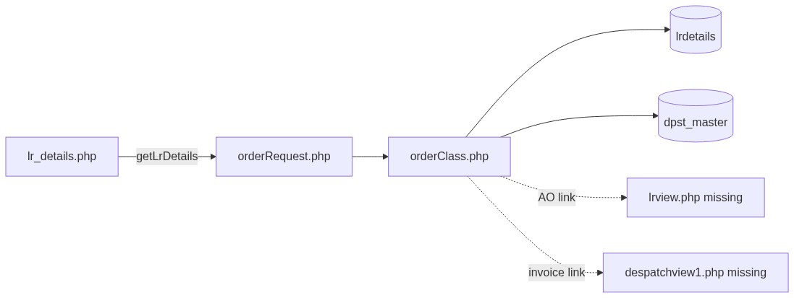
Figure 1 — High-level architecture
â”€â”€â”€â”€â”€â”€â”€â”€â”€â”€â”€â”€â”€â”€â”€â”€â”€â”€â”€â”€â”€â”€â”€â”€â”€â”€â”€â”€â”€â”€â”€â”€

2. Functional Requirements
ID | Requirement | Priority
FR-01 | User with lr-details/list can open LR Details list | Must
FR-02 | Server-side DataTables list from lrdetails | Must
FR-03 | Scope rows to session customer cuno | Must
FR-04 | Exclude divcode = '6' | Must
FR-05 | Show product group, AO, invoice, despatch date, transporter, LR no, LR date | Must
FR-06 | Join dpst_master for product-group description | Should
FR-07 | Global search on dpst / AO / invoice / LR / transporter | Should
FR-08 | Open LR detail by AO (lrview.php) | Should (target missing)
FR-09 | Open despatch/invoice view from invoice link | Could (target missing)
FR-10 | Deduplicate logical LR keys | Should

â”€â”€â”€â”€â”€â”€â”€â”€â”€â”€â”€â”€â”€â”€â”€â”€â”€â”€â”€â”€â”€â”€â”€â”€â”€â”€â”€â”€â”€â”€â”€â”€

3. User Roles & Permissions

3.1 RBAC module slug
Resource | Module | Permission
lr_details.php / menu | lr-details | list

Unauthenticated → login.php. No list → access_denied.php.
Sidebar: rbac_can_access_menu($obconn, 'lr_details.php').

3.2 Page / API mapping
Resource | Gate
lr_details.php | list
POST orderRequest.php getLrDetails | Session only — no module RBAC

rbac_api_access_rules() does not list orderRequest.php.

3.3 Scoping notes
Layer | Scope
LR list API | Always cuno = customer_number_vayu (fallback '10001')
Admin/Management seeAll | Not implemented
Sales coordinator widen | Dashboard helpers only — not on LR API

â”€â”€â”€â”€â”€â”€â”€â”€â”€â”€â”€â”€â”€â”€â”€â”€â”€â”€â”€â”€â”€â”€â”€â”€â”€â”€â”€â”€â”€â”€â”€â”€

4. Business Rules
ID | Rule
BR-01 | LR list row = lrdetails with divcode <> '6' and matching cuno.
BR-02 | Customer scope: cuno = session customer_number_vayu (or '10001').
BR-03 | Product group from dpst (+ dpst_desc via join).
BR-04 | Deduplication via DISTINCT on (ordno, invno, invdate, invref).
BR-05 | Sort by invdate DESC.
BR-06 | Read-only module — no insert/update/delete of LR in this UI.
BR-07 | Soft-delete / deleted_at not used on this path.
BR-08 | AO link targets lrview.php?ordno= — file missing.
BR-09 | Invoice link targets despatchview1.php?invref=&invno= — file missing.
BR-10 | LR list uses table lrdetails; Despatch/Dashboard join uses lr_details — different sources.
BR-11 | No date-range filter (DataTables global search only).
BR-12 | No modals on LR page.
BR-13 | UI column keys currently mismatch API JSON keys (known defect).
BR-14 | No status workflow column — presence in lrdetails with filters = listed.

â”€â”€â”€â”€â”€â”€â”€â”€â”€â”€â”€â”€â”€â”€â”€â”€â”€â”€â”€â”€â”€â”€â”€â”€â”€â”€â”€â”€â”€â”€â”€â”€

5. Database Design

5.1 Logical model
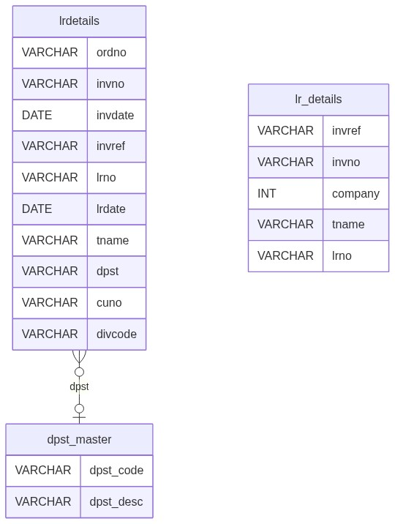
Figure 2 — Entity relationship diagram
Note: lr_details (underscore) is used by Despatch/Dashboard, not by this list API.

5.2 Tables
Table | Conn | Role
lrdetails | $dpconn | Primary LR list source
dpst_master | $dpconn | Product group description
lr_details | $dpconn | Used by Despatch Details / dashboard — sibling data path

5.3 List query pattern
SELECT DISTINCT
l.ordno, l.invno, l.invdate, l.invref, l.lrno, l.lrdate,
l.tname, l.dpst, d.dpst_desc
FROM lrdetails l
LEFT JOIN dpst_master d
ON TRIM(l.dpst) = TRIM(d.dpst_code::text)
WHERE l.cuno = :cuno
AND l.divcode <> '6'
AND /* optional ILIKE search */
ORDER BY l.invdate DESC
LIMIT :length OFFSET :start;
â”€â”€â”€â”€â”€â”€â”€â”€â”€â”€â”€â”€â”€â”€â”€â”€â”€â”€â”€â”€â”€â”€â”€â”€â”€â”€â”€â”€â”€â”€â”€â”€

6. API / Backend Design

6.1 Page endpoints
Endpoint | Method | Auth | Description
lr_details.php | GET | lr-details/list | LR list

6.2 AJAX — POST orderRequest.php
Action | Description
getLrDetails | DataTables JSON for LR list

6.3 Response shape (API keys)
API key | Content
dpst / dpst_desc | Product group
ordno | AO number (HTML link to lrview.php)
invoice | Invoice number (HTML link to despatchview1.php)
invdate | Despatch / invoice date
tname | Transporter
lrno | LR number
lrdate | LR date

6.4 Core PHP responsibilities
File | Role
lr_details.php | List UI + RBAC + DataTable init
orderRequest.php | Action router
orderClass.php | getLrDetails()
includes/rbac_access_helpers.php | Page/menu AuthZ
despatch_details.php / dashboard helpers | Sibling consumers of lr_details

â”€â”€â”€â”€â”€â”€â”€â”€â”€â”€â”€â”€â”€â”€â”€â”€â”€â”€â”€â”€â”€â”€â”€â”€â”€â”€â”€â”€â”€â”€â”€â”€

7. Validation Rules

7.1 Server-side
Field / rule | Behavior
Session + list | Redirect login / access_denied
DataTables params | draw / start / length cast; search bound as %…%
Customer bind | Always session cuno (or default)
CSRF | Not implemented

7.2 Client-side
â€¢ DataTables serverSide #LrTable; pageLength 10; scrollX
â€¢ No Select2 widgets (Select2 CSS may be linked unused)
â€¢ No date pickers / custom filters
â€¢ No validate.js form (read-only)
â”€â”€â”€â”€â”€â”€â”€â”€â”€â”€â”€â”€â”€â”€â”€â”€â”€â”€â”€â”€â”€â”€â”€â”€â”€â”€â”€â”€â”€â”€â”€â”€

8. UI Screen Specifications

8.1 List — lr_details.php
Element | Spec
Table | #LrTable DataTables serverSide
Intended columns | Product Group, AO Number, Invoice No, Despatch Date, Transporter, LR Number, LR Date
Page length | 10
Search | DataTables global search
Modals | None
Select2 | Not used
Layout | Similar to orphaned dispatch_details.php style

8.2 UI ↔ API column mismatch (critical)
UI columns.data | API key | Result
dpst | dpst | OK
ordno | ordno | OK (HTML)
invno | invoice | Blank / wrong
invdt | invdate | Blank / wrong
transporter | tname | Blank / wrong
lrno | lrno | OK
packing | lrdate | Wrong cell
weight | (not returned) | Blank; 8th col vs 7 headers

8.3 Detail navigation (intended)
Link | Target | Status
AO | lrview.php?ordno= | Missing file
Invoice | despatchview1.php?invref=&invno= | Missing file

â”€â”€â”€â”€â”€â”€â”€â”€â”€â”€â”€â”€â”€â”€â”€â”€â”€â”€â”€â”€â”€â”€â”€â”€â”€â”€â”€â”€â”€â”€â”€â”€

9. Database Flow

9.1 List load
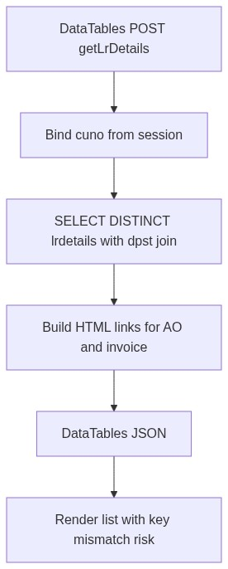
Figure 3 — List load database flow

9.2 Sibling data path (Despatch)
Figure 4 — Sibling Despatch lr_details path
â”€â”€â”€â”€â”€â”€â”€â”€â”€â”€â”€â”€â”€â”€â”€â”€â”€â”€â”€â”€â”€â”€â”€â”€â”€â”€â”€â”€â”€â”€â”€â”€

10. Sequence Diagram

10.1 List DataTables
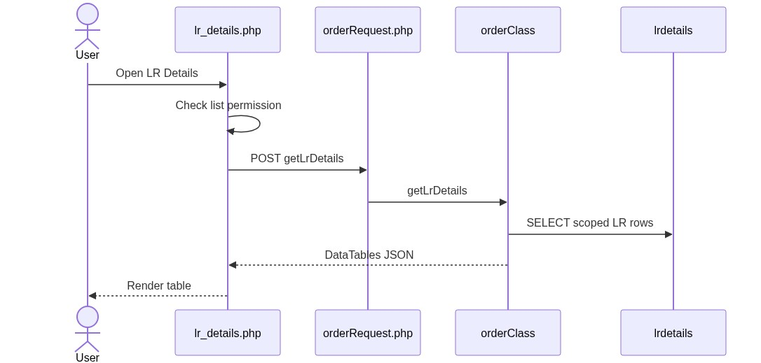
Figure 5 — Sequence: List DataTables

10.2 Open AO link (intended)
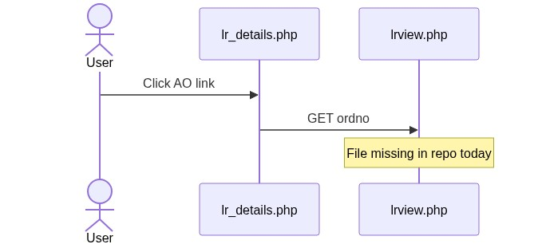
Figure 6 — Sequence: Open AO link
â”€â”€â”€â”€â”€â”€â”€â”€â”€â”€â”€â”€â”€â”€â”€â”€â”€â”€â”€â”€â”€â”€â”€â”€â”€â”€â”€â”€â”€â”€â”€â”€

11. Activity Diagram
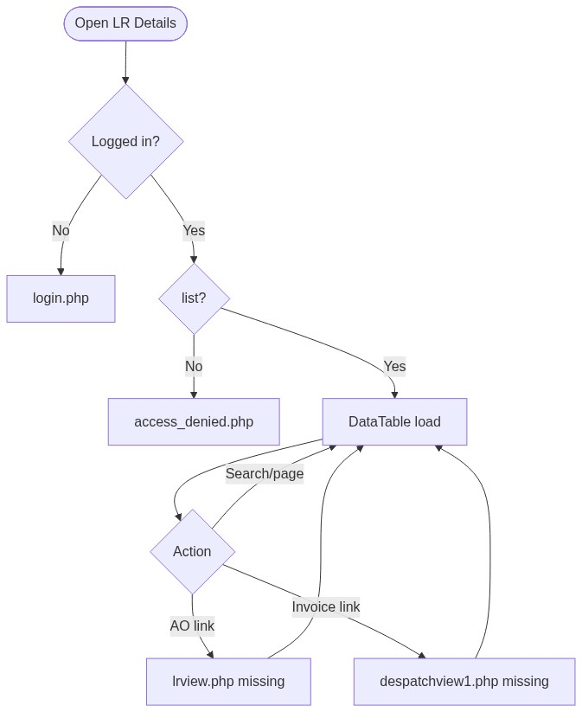
Figure 7 — Activity diagram
â”€â”€â”€â”€â”€â”€â”€â”€â”€â”€â”€â”€â”€â”€â”€â”€â”€â”€â”€â”€â”€â”€â”€â”€â”€â”€â”€â”€â”€â”€â”€â”€

12. Class / Module Diagram
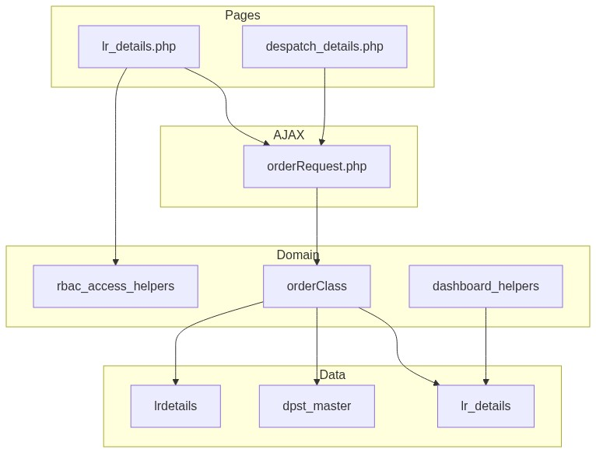
Figure 8 — Class / module diagram

12.1 Key functions
Function | Role
getLrDetails | Server-side LR list JSON
getDespatchDetails | Sibling despatch list (joins lr_details)
orderClass constructor | Sets customer_code (+ '10001' fallback)
rbac_user_can / rbac_can_access_menu | Page/menu gating
dashboard_fetch_dispatched_count | Uses despatch + lr_details (not this list)

â”€â”€â”€â”€â”€â”€â”€â”€â”€â”€â”€â”€â”€â”€â”€â”€â”€â”€â”€â”€â”€â”€â”€â”€â”€â”€â”€â”€â”€â”€â”€â”€

13. Folder Structure
ComplaintManagement/
├── lr_details.php
├── despatch_details.php
├── orderRequest.php
├── orderClass.php
├── access_denied.php
├── includes/
│ ├── rbac_access_helpers.php
│ └── dashboard_helpers.php
├── css/
│ ├── orderbook_style.css
│ └── select2_change.css
└── docs/
└── LLD_LR_Details_Module.md
Missing referenced targets: lrview.php, despatchview1.php.
â”€â”€â”€â”€â”€â”€â”€â”€â”€â”€â”€â”€â”€â”€â”€â”€â”€â”€â”€â”€â”€â”€â”€â”€â”€â”€â”€â”€â”€â”€â”€â”€

14. Error Handling
Layer | Pattern
Unauthenticated | Redirect login.php
No list | access_denied.php
AJAX | DataTables JSON (method echoes JSON; router may also echo null)
Success flashes | None (read-only)
Dead view links | Browser 404 / missing page

14.1 User-visible messages
Message / UI | When
Access denied page | Missing list
Empty / wrong DataTable cells | Column key mismatch or no rows
Broken AO / invoice links | Missing view PHP files

â”€â”€â”€â”€â”€â”€â”€â”€â”€â”€â”€â”€â”€â”€â”€â”€â”€â”€â”€â”€â”€â”€â”€â”€â”€â”€â”€â”€â”€â”€â”€â”€

15. Security Considerations
Area | Control
Page AuthZ | RBAC lr-details/list
AJAX AuthZ gap | orderRequest lacks module permission check
Customer fallback | Missing session customer → '10001'
No seeAll | Admins still customer-scoped on list API
XSS risk | AO/invoice HTML embeds ERP fields; URL params urlencoded, display may not be fully escaped
Dual table names | Easy to query lr_details vs lrdetails incorrectly
CSRF | Not implemented on AJAX
Dead detail targets | Missing lrview.php / despatchview1.php
display_errors | Enabled in orderClass.php (information leakage risk)

â”€â”€â”€â”€â”€â”€â”€â”€â”€â”€â”€â”€â”€â”€â”€â”€â”€â”€â”€â”€â”€â”€â”€â”€â”€â”€â”€â”€â”€â”€â”€â”€

16. Audit Logs

16.1 Built-in field-level audit
Item | Behavior
LR list audit table | Not implemented
Module nature | Read-only ERP LR aggregation
LR creation audit | Owned by ERP / warehouse systems outside this UI

â”€â”€â”€â”€â”€â”€â”€â”€â”€â”€â”€â”€â”€â”€â”€â”€â”€â”€â”€â”€â”€â”€â”€â”€â”€â”€â”€â”€â”€â”€â”€â”€

17. Test Cases

17.1 Functional
ID | Scenario | Expected
TC-01 | Guest opens LR Details | Redirect login
TC-02 | User without list | access_denied.php
TC-03 | User with list | DataTable requests getLrDetails
TC-04 | Session with valid cuno | Only that customer’s LR rows
TC-05 | divcode = '6' | Excluded
TC-06 | Search by AO / LR / transporter | Filtered rows
TC-07 | UI column keys vs API | Gap: blank/wrong cells for several columns
TC-08 | Click AO link | Gap: lrview.php missing
TC-09 | Click invoice link | Gap: despatchview1.php missing
TC-10 | Admin without customer_number_vayu | Falls back to 10001
TC-11 | User without list but hits AJAX | Gap: may still get data if session valid
TC-12 | Despatch list packing fields | Come from lr_details, not this module’s lrdetails query

â”€â”€â”€â”€â”€â”€â”€â”€â”€â”€â”€â”€â”€â”€â”€â”€â”€â”€â”€â”€â”€â”€â”€â”€â”€â”€â”€â”€â”€â”€â”€â”€

18. Assumptions & Dependencies

18.1 Assumptions
1. lr-details/list is assigned to roles that may see LRs.
2. ERP writes lrdetails; portal does not create LR rows here.
3. Live menu path is lr_details.php despite UI↔API column mismatch.
4. lrdetails and lr_details may both exist in dealerportal with related but not identical data.
5. Detail view PHP pages may be restored later; currently missing.
6. Document target stack Core PHP + MySQL; repo runs PostgreSQL (ILIKE, DISTINCT).
7. Aligning DataTables columns.data to API keys (invoice, invdate, tname, lrdate) is required for a usable list.

18.2 Dependencies
Dependency | Purpose
RBAC / Assign Permissions | lr-details grants
$dpconn / lrdetails | List source
dpst_master | Product group label
orderClass / orderRequest | Shared order AJAX surface
DataTables + jQuery | List UX
Despatch Details / Dashboard | Sibling consumers of lr_details

â”€â”€â”€â”€â”€â”€â”€â”€â”€â”€â”€â”€â”€â”€â”€â”€â”€â”€â”€â”€â”€â”€â”€â”€â”€â”€â”€â”€â”€â”€â”€â”€

Appendix A — API vs UI column keys
UI expectation | API key
Product Group | dpst (dpst_desc also returned)
AO Number | ordno
Invoice No | invoice (UI looks for invno)
Despatch Date | invdate (UI looks for invdt)
Transporter | tname (UI looks for transporter)
LR Number | lrno
LR Date | lrdate (UI looks for packing)
Weight | Not returned (UI still defines weight)

â”€â”€â”€â”€â”€â”€â”€â”€â”€â”€â”€â”€â”€â”€â”€â”€â”€â”€â”€â”€â”€â”€â”€â”€â”€â”€â”€â”€â”€â”€â”€â”€

Appendix B — Select2 control map
N/A. Select2 CSS may be included; no Select2 controls on LR Details list.
â”€â”€â”€â”€â”€â”€â”€â”€â”€â”€â”€â”€â”€â”€â”€â”€â”€â”€â”€â”€â”€â”€â”€â”€â”€â”€â”€â”€â”€â”€â”€â”€

Appendix C — RBAC permission matrix
Permission | Effect
list | Open LR Details page and sidebar link

No separate view / export-excel flags on the live LR page today.
â”€â”€â”€â”€â”€â”€â”€â”€â”€â”€â”€â”€â”€â”€â”€â”€â”€â”€â”€â”€â”€â”€â”€â”€â”€â”€â”€â”€â”€â”€â”€â”€

Appendix D — Inclusion filters
Filter | Value
Customer | cuno = session customer
Division | divcode <> '6'
Dedup | DISTINCT on ordno/invno/invdate/invref
Sort | invdate DESC

â”€â”€â”€â”€â”€â”€â”€â”€â”€â”€â”€â”€â”€â”€â”€â”€â”€â”€â”€â”€â”€â”€â”€â”€â”€â”€â”€â”€â”€â”€â”€â”€

Appendix E — ORDERS menu position
ORDERS
├── Recent Orders
├── Despatch Details → despatch JOIN lr_details
└── LR Details → lrdetails list (this module)
â”€â”€â”€â”€â”€â”€â”€â”€â”€â”€â”€â”€â”€â”€â”€â”€â”€â”€â”€â”€â”€â”€â”€â”€â”€â”€â”€â”€â”€â”€â”€â”€

Appendix F — Known defects checklist
Defect | Impact
UI↔API column key mismatch | Blank/wrong columns
Missing lrview.php | Dead AO links
Missing despatchview1.php | Dead invoice links
No API RBAC | AuthZ gap
No admin seeAll | Admins limited to one cuno / default
Dual table names | Confusion with Despatch join source
Extra weight column def | Header/column count mismatch

â”€â”€â”€â”€â”€â”€â”€â”€â”€â”€â”€â”€â”€â”€â”€â”€â”€â”€â”€â”€â”€â”€â”€â”€â”€â”€â”€â”€â”€â”€â”€â”€
End of LLD — LR Details Module

