Low-Level Design (LLD) — Order Acknowledgement Module
Attribute | Value
Module | Order Acknowledgement (AO List / View)
Menu path | ORDER BOOKING → Order Acknowledgement
Landing page | order_acknowledgement.php
Detail page | order_data.php
Application | Complaint / Dealer Portal
Stack (target) | Core PHP + MySQL (PDO)
Stack (current repo) | Core PHP + PostgreSQL via PDO ($obconn, $dpconn)
Document version | 1.0
Access | RBAC module slug order-acknowledgement / permission list (view eye: view)

â”€â”€â”€â”€â”€â”€â”€â”€â”€â”€â”€â”€â”€â”€â”€â”€â”€â”€â”€â”€â”€â”€â”€â”€â”€â”€â”€â”€â”€â”€â”€â”€

1. Module Overview

1.1 Purpose
Authenticated users with Order Acknowledgement permissions browse ERP-acknowledged orders (AO) from maintdealer and open a read-only detail view. The list is server-side DataTables via orderRequest.php → orderClass::getOrderAcknowledgeList(). Optional Ref No is resolved from booking table plexecom_customer_units by matching order_number to AO ordno.

1.2 Scope
In scope | Out of scope
AO list (DataTables) | Order Booking create / cart submit
AO detail view (order_data.php) | Pending Orders list UI
RBAC list / view (export-excel reserved) | Despatch Details UI
Ref No bridge from booking order_number | Creating / updating AO in ERP
Dashboard “Acknowledged” KPI gate (related) | Excel export (button commented out)

1.3 High-level architecture
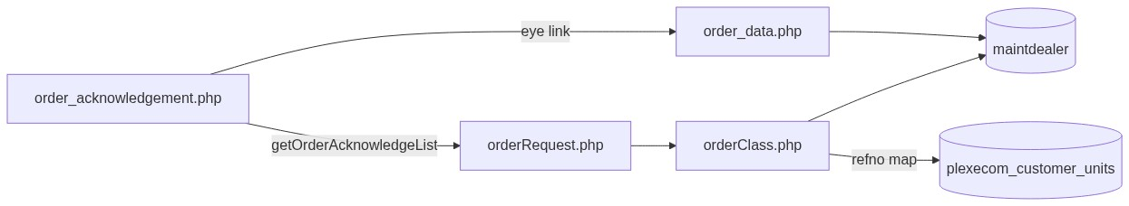
Figure 1 — High-level architecture
â”€â”€â”€â”€â”€â”€â”€â”€â”€â”€â”€â”€â”€â”€â”€â”€â”€â”€â”€â”€â”€â”€â”€â”€â”€â”€â”€â”€â”€â”€â”€â”€

2. Functional Requirements
ID | Requirement | Priority
FR-01 | User with order-acknowledgement/list can open AO list | Must
FR-02 | Server-side DataTables list of AO rows | Must
FR-03 | Show Ref No, PO Number, AO Number, AO Date, Action | Must
FR-04 | View permission controls eye link visibility | Should
FR-05 | Open detail in new tab via order_data.php | Must
FR-06 | Resolve booking Ref No from order_number match | Should
FR-07 | Scope list to current customer / user context | Must
FR-08 | Global search by AO number | Should
FR-09 | Export Excel when permitted | Could (UI commented out)

â”€â”€â”€â”€â”€â”€â”€â”€â”€â”€â”€â”€â”€â”€â”€â”€â”€â”€â”€â”€â”€â”€â”€â”€â”€â”€â”€â”€â”€â”€â”€â”€

3. User Roles & Permissions

3.1 RBAC module slug
Resource | Module | Permission
order_acknowledgement.php | order-acknowledgement | list
Eye / view link | order-acknowledgement | view
Export (reserved) | order-acknowledgement | export-excel

Gate on list page: rbac_user_can(..., 'list') → else access_denied.php. Unauthenticated → login.php.
Sidebar: rbac_can_access_menu($obconn, 'order_acknowledgement.php').

3.2 Page / API mapping
Resource | Gate
order_acknowledgement.php | list
POST orderRequest.php getOrderAcknowledgeList | Session only — no module RBAC
order_data.php | Not in rbac_page_access_rules — any logged-in user with URL

3.3 Client-side view gating
$canViewOrderAck passed to JS; eye links removed when view is false (client-side only — not a server gate on order_data.php).

3.4 Scoping notes
Layer | Scope
List SQL | maintdealer.cuno = :uname where uname is session usr_name
Ref map | plexecom_customer_units.cuno = customer_number_vayu (or fallback)
Dashboard AO count | Admin/Management see-all; others customer-scoped
Contrast | Recent Orders may see-all for admin; AO list has no see-all

â”€â”€â”€â”€â”€â”€â”€â”€â”€â”€â”€â”€â”€â”€â”€â”€â”€â”€â”€â”€â”€â”€â”€â”€â”€â”€â”€â”€â”€â”€â”€â”€

4. Business Rules
ID | Rule
BR-01 | AO list row = distinct maintdealer order with company != 600.
BR-02 | AO identity = ERP ordno; AO date = ord_date; PO = purno.
BR-03 | List excludes company = 600.
BR-04 | Ref No = booking refno where TRIM(order_number) matches AO ordno (latest by indent_date).
BR-05 | Read-only module — no create/update/delete of AO in this UI.
BR-06 | Detail URL: order_data.php?order={ordno}&cuno={cuno}&reference=order_acknowledgement.
BR-07 | Sidebar highlights AO when reference=order_acknowledgement.
BR-08 | Dashboard “Acknowledged” uses plexecom_customer_units.order_number non-empty — different definition than AO list (maintdealer).
BR-09 | No date-range filter on AO list.
BR-10 | Export Excel button is commented out (permission still evaluated).
BR-11 | Soft-delete / deleted_at not used on this path.
BR-12 | Legacy getAcknowledgeLine ( tbl_vayu_orders_line ) is unused by current list UI.

â”€â”€â”€â”€â”€â”€â”€â”€â”€â”€â”€â”€â”€â”€â”€â”€â”€â”€â”€â”€â”€â”€â”€â”€â”€â”€â”€â”€â”€â”€â”€â”€

5. Database Design

5.1 Logical model
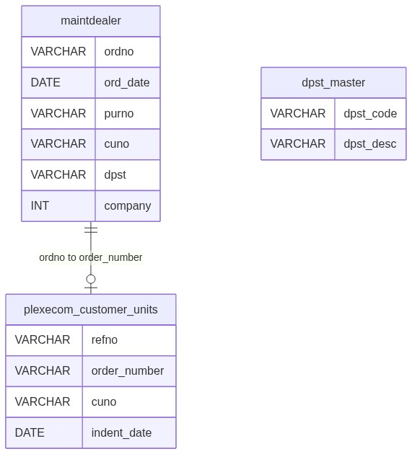
Figure 2 — Entity relationship diagram

5.2 Tables
Table | Conn | Role
maintdealer | $dpconn | AO list + detail header/lines
dpst_master | $dpconn | Optional dpst description join
customer_master | $dpconn | Detail header join
cust_delivery_address | $dpconn | Detail delivery when del_add length = 3
plexecom_customer_units | $obconn | Ref No bridge via order_number

5.3 List query pattern
SELECT DISTINCT m.cuno, m.ordno, m.ord_date, m.purno, m.dpst, d.dpst_desc
FROM maintdealer m
LEFT JOIN dpst_master d ON trim(m.dpst) = d.dpst_code::text
WHERE company != 600
AND cuno = :uname
ORDER BY m.ord_date DESC
LIMIT :length OFFSET :start;

5.4 Ref No map pattern
-- Conceptual: DISTINCT ON (order_number) refno
-- WHERE TRIM(order_number) IN (:aos) AND cuno = :customer_code
-- ORDER BY order_number, indent_date DESC
â”€â”€â”€â”€â”€â”€â”€â”€â”€â”€â”€â”€â”€â”€â”€â”€â”€â”€â”€â”€â”€â”€â”€â”€â”€â”€â”€â”€â”€â”€â”€â”€

6. API / Backend Design

6.1 Page endpoints
Endpoint | Method | Auth | Description
order_acknowledgement.php | GET | order-acknowledgement/list | AO list
order_data.php | GET order, cuno, reference | Session only (gap) | AO detail

6.2 AJAX
Endpoint | Action | Description
POST orderRequest.php | getOrderAcknowledgeList | DataTables JSON
POST orderRequest.php | getAcknowledgeLine | Legacy line HTML — unused by list

6.3 Core PHP responsibilities
File | Role
order_acknowledgement.php | Page + RBAC flags + DataTable init
order_data.php | Read-only AO detail
orderRequest.php | Action router
orderClass.php | getOrderAcknowledgeList, fetchPendingOrderRefMap
includes/rbac_access_helpers.php | Page/menu AuthZ
css/order_acknowledge_style.css | List styling

â”€â”€â”€â”€â”€â”€â”€â”€â”€â”€â”€â”€â”€â”€â”€â”€â”€â”€â”€â”€â”€â”€â”€â”€â”€â”€â”€â”€â”€â”€â”€â”€

7. Validation Rules

7.1 Server-side
Field / rule | Behavior
Session user | Empty → login.php
list permission | Fail → access_denied.php
DataTables params | start / length / search string
Detail order / cuno | Prepared queries; no module view check

7.2 Client-side
â€¢ DataTables serverSide; pageLength 10; scrollX
â€¢ Remove view links when $canViewOrderAck is false
â€¢ No Select2 filters; no date pickers on list
â€¢ No validate.js form (read-only)

7.3 Known search gap
Count query may apply ordno ILIKE :search, but main data SQL historically omits the same $where — search may not filter displayed rows.
â”€â”€â”€â”€â”€â”€â”€â”€â”€â”€â”€â”€â”€â”€â”€â”€â”€â”€â”€â”€â”€â”€â”€â”€â”€â”€â”€â”€â”€â”€â”€â”€

8. UI Screen Specifications

8.1 List — order_acknowledgement.php
Element | Spec
Table | #orderTable DataTables serverSide
Columns | Ref No, PO Number, AO Number, AO Date, Action
Action | Eye link → detail (if view)
Export | Excel button commented out
Page length | 10
Select2 | Loaded globally; not used on this list
Modals | None

8.2 Detail — order_data.php
Element | Spec
Header | AO / customer fields from maintdealer ⋈ customer_master
Delivery | cust_delivery_address when applicable
Lines | Positions: item, UOM, qty, price, dates
Navigation | reference=order_acknowledgement keeps AO menu active

8.3 Libraries
DataTables 1.13.x + Bootstrap 5 + jQuery; shared orderbook_style.css.
â”€â”€â”€â”€â”€â”€â”€â”€â”€â”€â”€â”€â”€â”€â”€â”€â”€â”€â”€â”€â”€â”€â”€â”€â”€â”€â”€â”€â”€â”€â”€â”€

9. Database Flow

9.1 List load
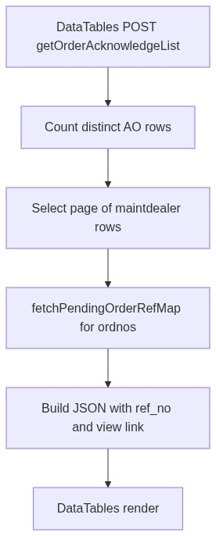
Figure 3 — List load database flow

9.2 Detail load
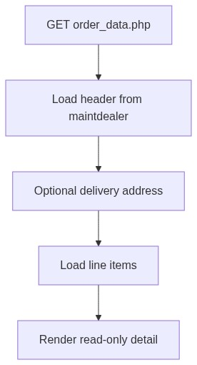
Figure 4 — Detail load database flow
â”€â”€â”€â”€â”€â”€â”€â”€â”€â”€â”€â”€â”€â”€â”€â”€â”€â”€â”€â”€â”€â”€â”€â”€â”€â”€â”€â”€â”€â”€â”€â”€

10. Sequence Diagram

10.1 List DataTables
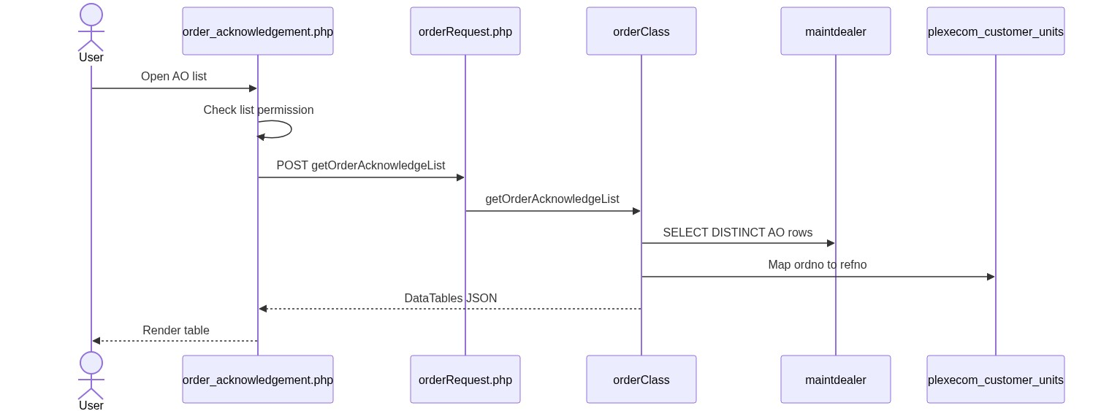
Figure 5 — Sequence: List DataTables

10.2 Open detail
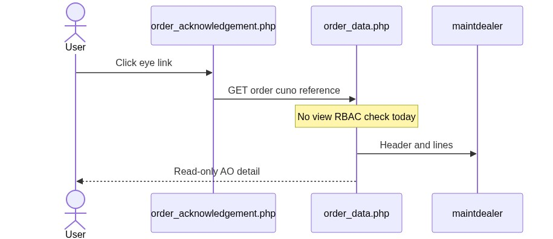
Figure 6 — Sequence: Open detail
â”€â”€â”€â”€â”€â”€â”€â”€â”€â”€â”€â”€â”€â”€â”€â”€â”€â”€â”€â”€â”€â”€â”€â”€â”€â”€â”€â”€â”€â”€â”€â”€

11. Activity Diagram
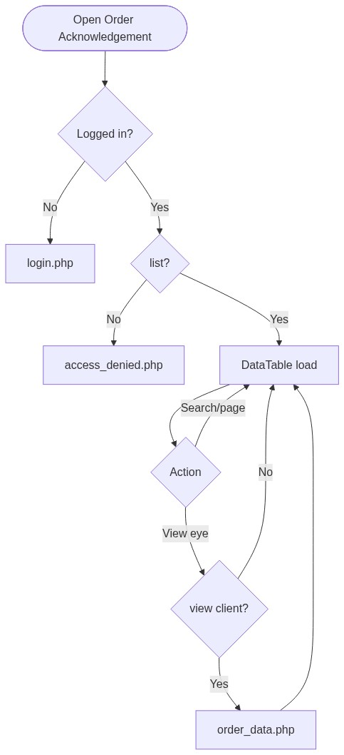
Figure 7 — Activity diagram
â”€â”€â”€â”€â”€â”€â”€â”€â”€â”€â”€â”€â”€â”€â”€â”€â”€â”€â”€â”€â”€â”€â”€â”€â”€â”€â”€â”€â”€â”€â”€â”€

12. Class / Module Diagram
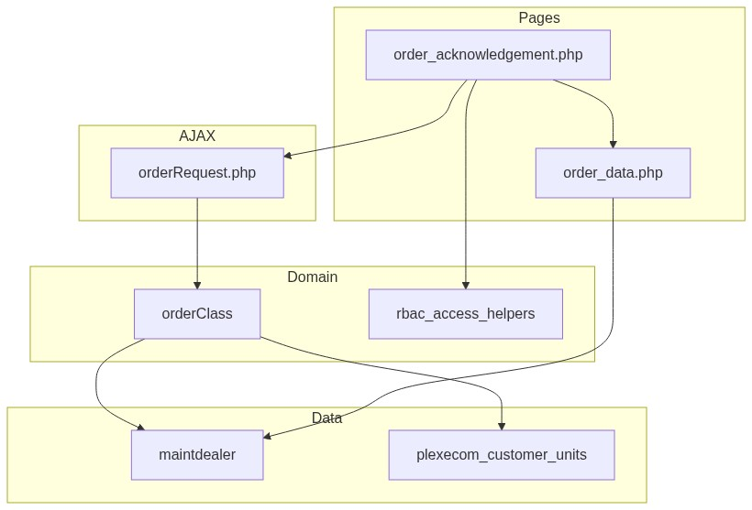
Figure 8 — Class / module diagram

12.1 Key functions
Function | Role
getOrderAcknowledgeList | Server-side AO list JSON
fetchPendingOrderRefMap | AO ordno → booking refno
getAcknowledgeLine | Legacy line HTML (unused by list)
rbac_user_can | list / view / export-excel flags
Dashboard helpers | “Acknowledged” KPI from booking order_number

â”€â”€â”€â”€â”€â”€â”€â”€â”€â”€â”€â”€â”€â”€â”€â”€â”€â”€â”€â”€â”€â”€â”€â”€â”€â”€â”€â”€â”€â”€â”€â”€

13. Folder Structure
ComplaintManagement/
├── order_acknowledgement.php
├── order_data.php
├── orderRequest.php
├── orderClass.php
├── exportOrders.php
├── access_denied.php
├── includes/
│ ├── rbac_access_helpers.php
│ └── dashboard_helpers.php
├── css/
│ ├── order_acknowledge_style.css
│ └── orderbook_style.css
└── docs/
└── LLD_Order_Acknowledgement_Module.md
â”€â”€â”€â”€â”€â”€â”€â”€â”€â”€â”€â”€â”€â”€â”€â”€â”€â”€â”€â”€â”€â”€â”€â”€â”€â”€â”€â”€â”€â”€â”€â”€

14. Error Handling
Layer | Pattern
Unauthenticated | Redirect login.php
No list | access_denied.php
AJAX | DataTables JSON (empty / error shapes per orderClass)
Detail missing | Page renders empty / limited data (no flash)
Success flashes | None (read-only)

14.1 User-visible messages
Message / UI | When
Access denied page | Missing list
Empty DataTable | No AO rows for scoped customer
No session flash | N/A for this module

â”€â”€â”€â”€â”€â”€â”€â”€â”€â”€â”€â”€â”€â”€â”€â”€â”€â”€â”€â”€â”€â”€â”€â”€â”€â”€â”€â”€â”€â”€â”€â”€

15. Security Considerations
Area | Control
Page AuthZ | RBAC order-acknowledgement/list
View link | Client strip if no view
AJAX AuthZ gap | orderRequest lacks module permission check
Detail IDOR gap | order_data.php not module-gated
Scoping mismatch | List uses usr_name as cuno; ref map uses customer_number_vayu
Customer fallback | Missing session customer → '10001' in class paths
Search integrity | $where may not apply to data SQL
Ref No mapping bug | Per-row array_column misuse can yield wrong/empty ref
CSRF | Not implemented on AJAX
Export | Commented out; legacy export lacks RBAC / wrong table

â”€â”€â”€â”€â”€â”€â”€â”€â”€â”€â”€â”€â”€â”€â”€â”€â”€â”€â”€â”€â”€â”€â”€â”€â”€â”€â”€â”€â”€â”€â”€â”€

16. Audit Logs

16.1 Built-in field-level audit
Item | Behavior
AO list/view audit table | Not implemented
Module nature | Read-only aggregation of ERP + booking bridge
AO creation audit | Owned by ERP / booking acknowledgement process outside this UI

â”€â”€â”€â”€â”€â”€â”€â”€â”€â”€â”€â”€â”€â”€â”€â”€â”€â”€â”€â”€â”€â”€â”€â”€â”€â”€â”€â”€â”€â”€â”€â”€

17. Test Cases

17.1 Functional
ID | Scenario | Expected
TC-01 | Guest opens AO page | Redirect login
TC-02 | User without list | access_denied.php
TC-03 | User with list | DataTable loads AO rows
TC-04 | User without view | Eye links hidden
TC-05 | Click eye with view | Opens order_data.php with AO detail
TC-06 | AO matched to booking order_number | Ref No shown when map works
TC-07 | company = 600 rows | Excluded from list
TC-08 | Search by AO number | Should filter (verify data SQL applies search)
TC-09 | Pagination | LIMIT/OFFSET page of 10
TC-10 | Username ≠ customer number | List may be empty / mis-scoped
TC-11 | Direct order_data.php URL without view | Gap: may still open if logged in
TC-12 | Dashboard Acknowledged vs AO list | Counts may differ (plexecom vs maintdealer)

â”€â”€â”€â”€â”€â”€â”€â”€â”€â”€â”€â”€â”€â”€â”€â”€â”€â”€â”€â”€â”€â”€â”€â”€â”€â”€â”€â”€â”€â”€â”€â”€

18. Assumptions & Dependencies

18.1 Assumptions
1. order-acknowledgement/list (and optionally view) are assigned to roles that may see AO.
2. ERP writes AO rows into maintdealer; portal does not create them in this module.
3. Booking acknowledgement populates plexecom_customer_units.order_number for Ref No bridging.
4. Live list path is getOrderAcknowledgeList over maintdealer, not tbl_vayu_orders.
5. Document target stack Core PHP + MySQL; repo runs PostgreSQL (ILIKE, DISTINCT ON).
6. Export Excel remains out of active UI until re-enabled and secured.

18.2 Dependencies
Dependency | Purpose
RBAC / Assign Permissions | order-acknowledgement grants
$dpconn / maintdealer | AO list and detail
$obconn / plexecom_customer_units | Ref No bridge
orderClass / orderRequest | Shared order AJAX surface
DataTables + jQuery | List UX
Order Booking / ERP | Upstream AO creation
Dashboard helpers | Related KPI (different definition)

â”€â”€â”€â”€â”€â”€â”€â”€â”€â”€â”€â”€â”€â”€â”€â”€â”€â”€â”€â”€â”€â”€â”€â”€â”€â”€â”€â”€â”€â”€â”€â”€

Appendix A — Column map (list)
UI column | Source
Ref No | plexecom_customer_units.refno via order_number = ordno
PO Number | maintdealer.purno
AO Number | maintdealer.ordno
AO Date | maintdealer.ord_date
Action | Eye → order_data.php

â”€â”€â”€â”€â”€â”€â”€â”€â”€â”€â”€â”€â”€â”€â”€â”€â”€â”€â”€â”€â”€â”€â”€â”€â”€â”€â”€â”€â”€â”€â”€â”€

Appendix B — Select2 control map
N/A on list. Select2 is loaded globally but not used on Order Acknowledgement. No date filter controls.
â”€â”€â”€â”€â”€â”€â”€â”€â”€â”€â”€â”€â”€â”€â”€â”€â”€â”€â”€â”€â”€â”€â”€â”€â”€â”€â”€â”€â”€â”€â”€â”€

Appendix C — RBAC permission matrix
Permission | Effect
list | Open AO list page
view | Show eye / open detail (client-enforced today)
export-excel | Reserved; Export button commented out

â”€â”€â”€â”€â”€â”€â”€â”€â”€â”€â”€â”€â”€â”€â”€â”€â”€â”€â”€â”€â”€â”€â”€â”€â”€â”€â”€â”€â”€â”€â”€â”€

Appendix D — Acknowledged definition matrix
Surface | Definition
AO list (this module) | Row in maintdealer with company != 600
Dashboard / pipeline “Acknowledged” | plexecom_customer_units.order_number non-empty
Recent Orders “AO” badge | order_number set and not yet despatched

â”€â”€â”€â”€â”€â”€â”€â”€â”€â”€â”€â”€â”€â”€â”€â”€â”€â”€â”€â”€â”€â”€â”€â”€â”€â”€â”€â”€â”€â”€â”€â”€

Appendix E — Pipeline position
Order Booking (plexecom, order_number empty)
↓ ERP acknowledgement
Order Acknowledgement list (maintdealer.ordno)
↕ optional refno via order_number
Pending / Despatch (separate modules)
â”€â”€â”€â”€â”€â”€â”€â”€â”€â”€â”€â”€â”€â”€â”€â”€â”€â”€â”€â”€â”€â”€â”€â”€â”€â”€â”€â”€â”€â”€â”€â”€
End of LLD — Order Acknowledgement Module

