Low-Level Design (LLD) — Pending Orders Module
Attribute | Value
Module | Pending Orders (List / View)
Menu path | ORDER BOOKING → Pending Orders
Landing page | pending_order.php (live)
Alternate page | pending_order_new.php (not in sidebar)
Detail pages | order_data.php / order_data_new.php
Application | Complaint / Dealer Portal
Stack (target) | Core PHP + MySQL (PDO)
Stack (current repo) | Core PHP + PostgreSQL via PDO ($obconn, $dpconn)
Document version | 1.0
Access | RBAC module slug pending-order / permission list (view eye: view)

â”€â”€â”€â”€â”€â”€â”€â”€â”€â”€â”€â”€â”€â”€â”€â”€â”€â”€â”€â”€â”€â”€â”€â”€â”€â”€â”€â”€â”€â”€â”€â”€

1. Module Overview

1.1 Purpose
Authenticated users with Pending Orders permissions browse open LN pending order lines from Dealerportal pendingordersnew and open a read-only detail view. The live list is server-side DataTables via orderRequest.php → orderClass::getPendingOrderList() (line-level). An alternate header-level UI (pending_order_new.php / getPendingOrderListNew) exists but is not linked in the sidebar.

1.2 Scope
In scope | Out of scope
Pending list (live line-level UI) | Order Booking create / cart submit
Alternate header-level list (documented) | Order Acknowledgement list UI
Detail view links (order_data*) | Despatch Details UI
Price breakup AJAX (new UI; button disabled) | Dashboard “Pending” KPI definition (different)
RBAC list / view (export reserved) | Re-Push (Recent Orders, not pending list)

1.3 High-level architecture
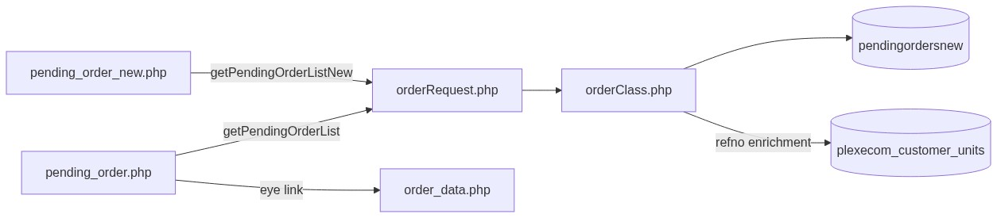
Figure 1 — High-level architecture
â”€â”€â”€â”€â”€â”€â”€â”€â”€â”€â”€â”€â”€â”€â”€â”€â”€â”€â”€â”€â”€â”€â”€â”€â”€â”€â”€â”€â”€â”€â”€â”€

2. Functional Requirements
ID | Requirement | Priority
FR-01 | User with pending-order/list can open Pending Orders list | Must
FR-02 | Server-side DataTables list from pendingordersnew | Must
FR-03 | Show Ref No, PO, AO, Delivery Date, Status, Action (live UI) | Must
FR-04 | View permission controls eye link visibility | Should
FR-05 | Open detail in new tab via order_data.php | Must
FR-06 | Scope list to current customer / user context | Must
FR-07 | Global search by AO / PO / indent | Should
FR-08 | Exclude company = 600 | Must
FR-09 | Export Excel when permitted | Could (UI commented out)
FR-10 | Header-level list + price breakup (alternate UI) | Could

â”€â”€â”€â”€â”€â”€â”€â”€â”€â”€â”€â”€â”€â”€â”€â”€â”€â”€â”€â”€â”€â”€â”€â”€â”€â”€â”€â”€â”€â”€â”€â”€

3. User Roles & Permissions

3.1 RBAC module slug
Resource | Module | Permission
pending_order.php | pending-order | list
Eye / view link | pending-order | view
Export (reserved) | pending-order | export-excel

Gate on live list: rbac_user_can(..., 'list') → else access_denied.php. Unauthenticated → login.php.
Sidebar: rbac_can_access_menu($obconn, 'pending_order.php').

3.2 Page / API mapping
Resource | Gate
pending_order.php | list
pending_order_new.php | Not in page RBAC map (alternate)
POST orderRequest.php pending actions | Session only — no module RBAC
order_data.php / order_data_new.php | Session only (gap)
Invoice pages | No auth/customer check documented

3.3 Client-side view gating
$canView… style flags strip eye links in DataTables drawCallback when view is false (client-side only).

3.4 Scoping notes
Layer | Scope
Live old list SQL | pendingordersnew.cuno = userId (usr_name) — mismatch risk
New list / price breakup | cuno = customer_number_vayu (fallback '10001')
Admin see-all | Forced off / commented out on pending lists
Dashboard pipeline Pending | Admin/Management see-all; else customer-scoped plexecom

â”€â”€â”€â”€â”€â”€â”€â”€â”€â”€â”€â”€â”€â”€â”€â”€â”€â”€â”€â”€â”€â”€â”€â”€â”€â”€â”€â”€â”€â”€â”€â”€

4. Business Rules
ID | Rule
BR-01 | Pending list row = exists in pendingordersnew with company != 600.
BR-02 | Live UI is line-level (one DataTable row per line / position).
BR-03 | Alternate UI is header-level (GROUP BY cuno, ordno).
BR-04 | AO identity = ordno; PO = pono; delivery date = delydt.
BR-05 | Ref No enriched from plexecom_customer_units via order_number / pono lookups.
BR-06 | Status badge computed (Pending / AO / Despatched) — not a column on pendingordersnew.
BR-07 | Read-only list — no create/update/delete of pending rows in this UI.
BR-08 | Detail URL (live): order_data.php?order={ordno}&cuno={cuno}&reference=pending_order.
BR-09 | Detail pages query maintdealer (ack-style), not pendingordersnew.
BR-10 | No date-range filter on pending list UIs.
BR-11 | Export Excel button commented out.
BR-12 | Price breakup modal on new UI; action button commented out in row HTML.
BR-13 | Dashboard “Pending” = empty plexecom_customer_units.order_number — different from this list.
BR-14 | Re-Push is on Recent Orders (empty AO), not on Pending Orders list.
BR-15 | Soft-delete / deleted_at not used on pendingordersnew.

â”€â”€â”€â”€â”€â”€â”€â”€â”€â”€â”€â”€â”€â”€â”€â”€â”€â”€â”€â”€â”€â”€â”€â”€â”€â”€â”€â”€â”€â”€â”€â”€

5. Database Design

5.1 Logical model
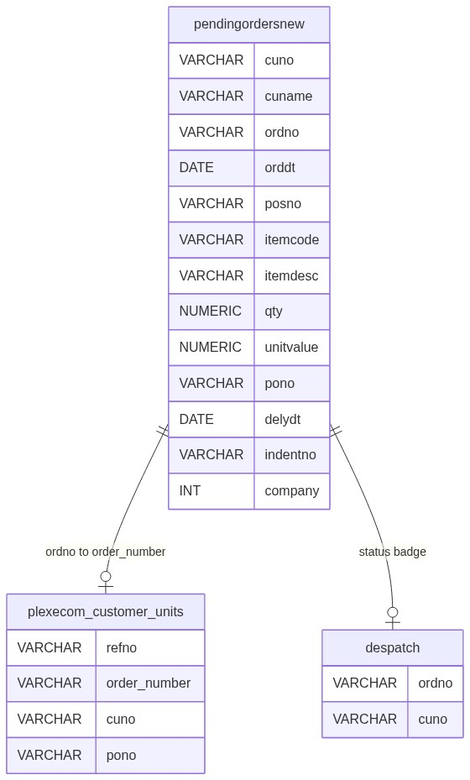
Figure 2 — Entity relationship diagram

5.2 Tables
Table | Conn | Role
pendingordersnew | $dpconn | Primary pending list source
dpst_master | $dpconn | Description join (live list)
tbl_commitment | $dpconn | Commitment date (selected; may not show)
plexecom_customer_units | $obconn | Ref No / address / terms enrichment
despatch | $dpconn | Despatched status badge
maintdealer | $dpconn | Detail pages (shared with AO)

5.3 Live list filter pattern
SELECT ...
FROM pendingordersnew p
-- joins ...
WHERE p.company != 600
AND p.cuno = :uname
AND /* optional search ILIKE on ordno/pono/indentno */
ORDER BY ...
LIMIT :length OFFSET :start;

5.4 Two “Pending” definitions
Surface | Definition
Pending Orders module | Rows in pendingordersnew (company != 600)
Dashboard / Recent “Pending” | plexecom_customer_units.order_number empty

â”€â”€â”€â”€â”€â”€â”€â”€â”€â”€â”€â”€â”€â”€â”€â”€â”€â”€â”€â”€â”€â”€â”€â”€â”€â”€â”€â”€â”€â”€â”€â”€

6. API / Backend Design

6.1 Page endpoints
Endpoint | Method | Auth | Description
pending_order.php | GET | pending-order/list | Live line-level list
pending_order_new.php | GET | Session (not in RBAC map) | Alternate header list
order_data.php | GET | Session | Detail (live link)
order_data_new.php | GET | Session | Detail (new UI link)
Invoice pages | GET | Ungated | PDF / invoice helpers

6.2 AJAX — POST orderRequest.php
Action | Description
getPendingOrderList | Live DataTables JSON (line-level)
getPendingOrderListNew | Alternate DataTables JSON (header-level)
getPendingOrderPriceBreakup | GST/freight for one AO
rePushOrder | Recent Orders only — not pending list UI

6.3 Core PHP responsibilities
File | Role
pending_order.php | Live list + RBAC + DataTable
pending_order_new.php | Alternate header list
orderRequest.php / orderClass.php | Pending list + breakup APIs
order_data.php / order_data_new.php | Read-only detail
includes/pending_order_invoice_helpers.php | Invoice/PDF
includes/rbac_access_helpers.php | Page/menu AuthZ

â”€â”€â”€â”€â”€â”€â”€â”€â”€â”€â”€â”€â”€â”€â”€â”€â”€â”€â”€â”€â”€â”€â”€â”€â”€â”€â”€â”€â”€â”€â”€â”€

7. Validation Rules

7.1 Server-side
Field / rule | Behavior
Session user | Empty → login.php
list permission (live page) | Fail → access_denied.php
DataTables params | start / length / search
Price breakup | Requires ordno; scoped to customer_code
Detail order / cuno | Query string; no module view check

7.2 Client-side
â€¢ DataTables serverSide; processing indicator
â€¢ Eye links stripped when no view
â€¢ Price breakup failures → alert()
â€¢ No Select2 filters; no date pickers on list
â€¢ No validate.js form (read-only)
â”€â”€â”€â”€â”€â”€â”€â”€â”€â”€â”€â”€â”€â”€â”€â”€â”€â”€â”€â”€â”€â”€â”€â”€â”€â”€â”€â”€â”€â”€â”€â”€

8. UI Screen Specifications

8.1 Live list — pending_order.php
Element | Spec
Table | DataTables serverSide
Grain | Line-level
Columns | Ref No, PO, AO, Delivery Date, Status, Action
Action | Eye → order_data.php
Search | ordno, pono, indentno
Export | Commented out
Select2 | Not used
CSS | order_acknowledge_style.css + orderbook_style.css (pending_order.css unused)

8.2 Alternate list — pending_order_new.php
Element | Spec
Grain | Header per AO (GROUP BY)
Columns | Order Number, AO, Order Date, Customer, PO, invoice/payment/delivery fields, Action
Detail | order_data_new.php
Modal | Price breakup (button disabled in row actions)
Sidebar | Not linked

8.3 Detail
Shared ack-style detail from maintdealer (+ customer / delivery / lines). reference=pending_order keeps menu context.
â”€â”€â”€â”€â”€â”€â”€â”€â”€â”€â”€â”€â”€â”€â”€â”€â”€â”€â”€â”€â”€â”€â”€â”€â”€â”€â”€â”€â”€â”€â”€â”€

9. Database Flow

9.1 Live list load
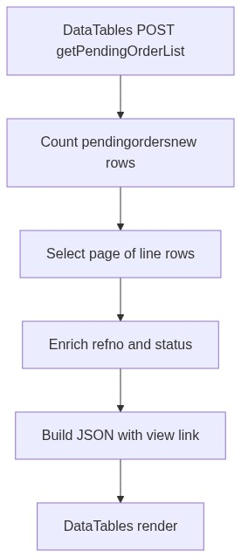
Figure 3 — Live list load database flow

9.2 Alternate header load
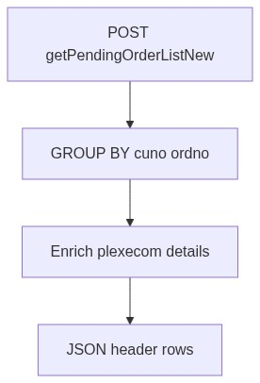
Figure 4 — Alternate header load database flow
â”€â”€â”€â”€â”€â”€â”€â”€â”€â”€â”€â”€â”€â”€â”€â”€â”€â”€â”€â”€â”€â”€â”€â”€â”€â”€â”€â”€â”€â”€â”€â”€

10. Sequence Diagram

10.1 Live list DataTables
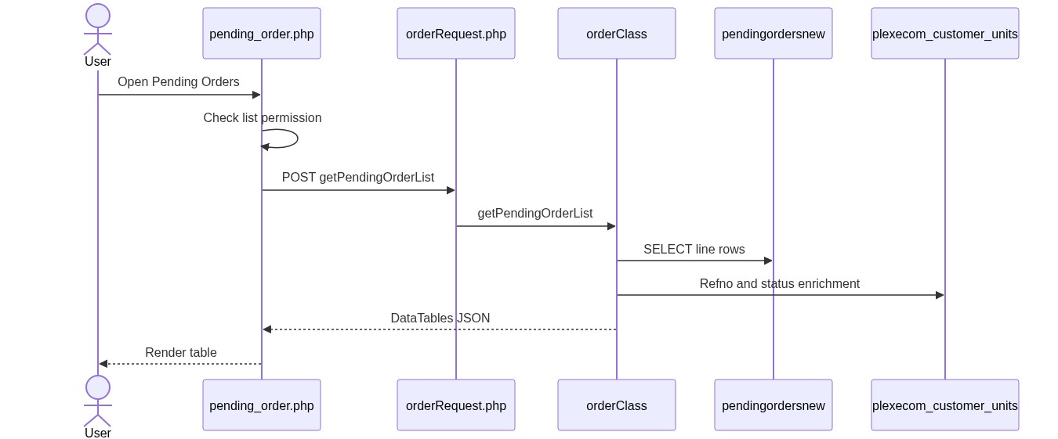
Figure 5 — Sequence: Live list DataTables

10.2 Open detail
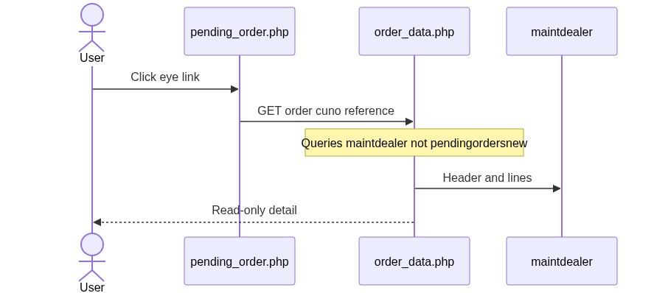
Figure 6 — Sequence: Open detail
â”€â”€â”€â”€â”€â”€â”€â”€â”€â”€â”€â”€â”€â”€â”€â”€â”€â”€â”€â”€â”€â”€â”€â”€â”€â”€â”€â”€â”€â”€â”€â”€

11. Activity Diagram
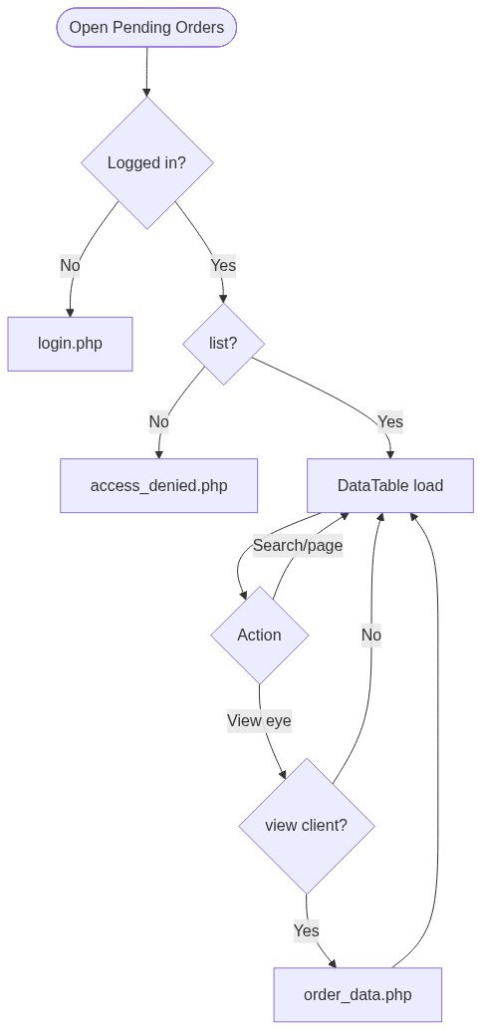
Figure 7 — Activity diagram
â”€â”€â”€â”€â”€â”€â”€â”€â”€â”€â”€â”€â”€â”€â”€â”€â”€â”€â”€â”€â”€â”€â”€â”€â”€â”€â”€â”€â”€â”€â”€â”€

12. Class / Module Diagram
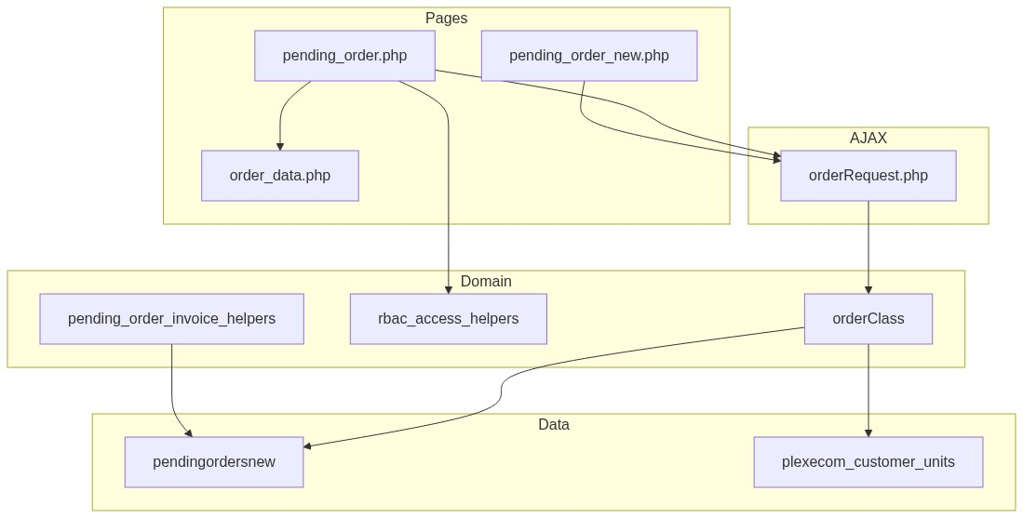
Figure 8 — Class / module diagram

12.1 Key functions
Function | Role
getPendingOrderList | Live line-level DataTable JSON
getPendingOrderListNew | Header-level DataTable JSON
getPendingOrderPriceBreakup | AO GST/freight breakup
fetchPendingOrderRefMap / fetchPendingOrderPlexecomDetails | Enrichment
resolveRecentOrderStatus | Status badge labels
rePushOrder | Recent Orders re-push (related, not list UI)
pending_invoice_fetch / PDF helpers | Invoice generation

â”€â”€â”€â”€â”€â”€â”€â”€â”€â”€â”€â”€â”€â”€â”€â”€â”€â”€â”€â”€â”€â”€â”€â”€â”€â”€â”€â”€â”€â”€â”€â”€

13. Folder Structure
ComplaintManagement/
├── pending_order.php
├── pending_order_new.php
├── order_data.php
├── order_data_new.php
├── pending_order_invoice.php
├── generate_pending_order_invoice.php
├── orderRequest.php
├── orderClass.php
├── includes/
│ ├── rbac_access_helpers.php
│ ├── dashboard_helpers.php
│ └── pending_order_invoice_helpers.php
├── css/
│ ├── order_acknowledge_style.css
│ ├── orderbook_style.css
│ └── pending_order.css
└── docs/
└── LLD_Pending_Orders_Module.md
â”€â”€â”€â”€â”€â”€â”€â”€â”€â”€â”€â”€â”€â”€â”€â”€â”€â”€â”€â”€â”€â”€â”€â”€â”€â”€â”€â”€â”€â”€â”€â”€

14. Error Handling
Layer | Pattern
Unauthenticated | Redirect login.php
No list (live) | access_denied.php
AJAX | DataTables JSON / {error} / status: false
Price breakup fail | Client alert()
Success flashes | None (read-only list)

14.1 User-visible messages
Message / UI | When
Access denied page | Missing list
Empty DataTable | No pending rows for scope
Price breakup alerts | Breakup AJAX fail (new UI)

â”€â”€â”€â”€â”€â”€â”€â”€â”€â”€â”€â”€â”€â”€â”€â”€â”€â”€â”€â”€â”€â”€â”€â”€â”€â”€â”€â”€â”€â”€â”€â”€

15. Security Considerations
Area | Control
Page AuthZ (live) | RBAC pending-order/list
View link | Client strip if no view
AJAX AuthZ gap | orderRequest lacks module permission check
Scoping bug (live) | List may bind cuno to usr_name instead of customer_number_vayu
Alternate page | Not in RBAC page map / not in sidebar
Detail IDOR gap | order_data* not module-gated; uses maintdealer
Invoice ungated | Ordno fetch without auth/customer check; sample defaults risk
Customer fallback | Missing session customer → '10001'
Admin see-all | Disabled on pending lists
CSRF | Not implemented on AJAX
Export | Commented out

â”€â”€â”€â”€â”€â”€â”€â”€â”€â”€â”€â”€â”€â”€â”€â”€â”€â”€â”€â”€â”€â”€â”€â”€â”€â”€â”€â”€â”€â”€â”€â”€

16. Audit Logs

16.1 Built-in field-level audit
Item | Behavior
Pending list/view audit table | Not implemented
Module nature | Read-only view of LN pending + enrichment
Re-Push / EDI timestamps | Owned by Recent Orders / ediprocessdt path

â”€â”€â”€â”€â”€â”€â”€â”€â”€â”€â”€â”€â”€â”€â”€â”€â”€â”€â”€â”€â”€â”€â”€â”€â”€â”€â”€â”€â”€â”€â”€â”€

17. Test Cases

17.1 Functional
ID | Scenario | Expected
TC-01 | Guest opens pending_order.php | Redirect login
TC-02 | User without list | access_denied.php
TC-03 | User with list | Line-level DataTable loads
TC-04 | User without view | Eye links hidden
TC-05 | Click eye | Opens order_data.php (may show maintdealer data)
TC-06 | company = 600 rows | Excluded
TC-07 | Search by AO / PO / indent | Filtered rows
TC-08 | Username ≠ customer number | Live list may empty / mis-scope
TC-09 | Open pending_order_new.php | Header-level list (if reachable)
TC-10 | Dashboard Pending vs list | Counts/datasets may differ
TC-11 | Re-Push from pending list | Not available (Recent Orders only)
TC-12 | Direct invoice URL | Gap: may generate without RBAC
TC-13 | Direct order_data.php without view | Gap: may open if logged in

â”€â”€â”€â”€â”€â”€â”€â”€â”€â”€â”€â”€â”€â”€â”€â”€â”€â”€â”€â”€â”€â”€â”€â”€â”€â”€â”€â”€â”€â”€â”€â”€

18. Assumptions & Dependencies

18.1 Assumptions
1. pending-order/list (and optionally view) are assigned to roles that may see pending orders.
2. LN / ERP populates pendingordersnew; portal does not insert pending lines in this UI.
3. Live production menu path is pending_order.php + getPendingOrderList.
4. pending_order_new.php is an alternate/experimental path until promoted to sidebar.
5. Dashboard “Pending” KPI remains booking-AO-empty unless product decides to align definitions.
6. Document target stack Core PHP + MySQL; repo runs PostgreSQL (ILIKE, GROUP BY).
7. Detail pages remaining on maintdealer is a known shared-pattern limitation.

18.2 Dependencies
Dependency | Purpose
RBAC / Assign Permissions | pending-order grants
$dpconn / pendingordersnew | List source
$obconn / plexecom_customer_units | Ref No / terms enrichment
orderClass / orderRequest | Shared order AJAX surface
DataTables + jQuery | List UX
Order Acknowledgement detail pages | Shared order_data*
Dashboard / Recent Orders | Related but different “Pending” meaning

â”€â”€â”€â”€â”€â”€â”€â”€â”€â”€â”€â”€â”€â”€â”€â”€â”€â”€â”€â”€â”€â”€â”€â”€â”€â”€â”€â”€â”€â”€â”€â”€

Appendix A — Live list column map
UI column | Source / notes
Ref No | plexecom enrichment / pono lookup
PO Number | pendingordersnew.pono
AO Number | pendingordersnew.ordno
Delivery Date | pendingordersnew.delydt
Status | Computed badge (Pending / AO / Despatched)
Action | Eye → order_data.php

â”€â”€â”€â”€â”€â”€â”€â”€â”€â”€â”€â”€â”€â”€â”€â”€â”€â”€â”€â”€â”€â”€â”€â”€â”€â”€â”€â”€â”€â”€â”€â”€

Appendix B — Select2 control map
N/A on pending list pages. Select2 may load globally; not used for pending filters.
â”€â”€â”€â”€â”€â”€â”€â”€â”€â”€â”€â”€â”€â”€â”€â”€â”€â”€â”€â”€â”€â”€â”€â”€â”€â”€â”€â”€â”€â”€â”€â”€

Appendix C — RBAC permission matrix
Permission | Effect
list | Open live Pending Orders page
view | Show eye / open detail (client-enforced today)
export-excel | Reserved; Export button commented out

â”€â”€â”€â”€â”€â”€â”€â”€â”€â”€â”€â”€â”€â”€â”€â”€â”€â”€â”€â”€â”€â”€â”€â”€â”€â”€â”€â”€â”€â”€â”€â”€

Appendix D — Old vs new UI
Aspect | Live (pending_order.php) | Alternate (pending_order_new.php)
Sidebar | Yes | No
API | getPendingOrderList | getPendingOrderListNew
Grain | Line | Header (GROUP BY ordno)
Detail | order_data.php | order_data_new.php
Modal | None | Price breakup (button disabled)
Scope key | Often usr_name | customer_code

â”€â”€â”€â”€â”€â”€â”€â”€â”€â”€â”€â”€â”€â”€â”€â”€â”€â”€â”€â”€â”€â”€â”€â”€â”€â”€â”€â”€â”€â”€â”€â”€

Appendix E — Pipeline position
Order Booking (plexecom, order_number empty) ← Dashboard "Pending"
↓ ERP AO
Order Acknowledgement (maintdealer)
↓ open LN lines
Pending Orders list (pendingordersnew) ← This module
↓ despatch
Despatch Details
â”€â”€â”€â”€â”€â”€â”€â”€â”€â”€â”€â”€â”€â”€â”€â”€â”€â”€â”€â”€â”€â”€â”€â”€â”€â”€â”€â”€â”€â”€â”€â”€

Appendix F — Related but out-of-list actions
Action | Where
Re-Push order | recent_orders.php → rePushOrder
Dashboard Quick Action | Link to pending_order.php
Installed Base order search | May query pendingordersnew

â”€â”€â”€â”€â”€â”€â”€â”€â”€â”€â”€â”€â”€â”€â”€â”€â”€â”€â”€â”€â”€â”€â”€â”€â”€â”€â”€â”€â”€â”€â”€â”€
End of LLD — Pending Orders Module

