Low-Level Design (LLD) — Recent Orders Module
Attribute | Value
Module | Recent Orders (List / Details / Re-Push)
Menu path | ORDER BOOKING → Recent Orders
Landing page | recent_orders.php
Details page | recent_order_details.php
Application | Complaint / Dealer Portal
Stack (target) | Core PHP + MySQL (PDO)
Stack (current repo) | Core PHP + PostgreSQL via PDO ($obconn, $dpconn)
Document version | 1.0
Access | RBAC module slug recent-orders / permission list (details: view)

â”€â”€â”€â”€â”€â”€â”€â”€â”€â”€â”€â”€â”€â”€â”€â”€â”€â”€â”€â”€â”€â”€â”€â”€â”€â”€â”€â”€â”€â”€â”€â”€

1. Module Overview

1.1 Purpose
Authenticated users with Recent Orders permissions browse booked dealer orders from plexecom_customer_units (one logical order per refno), view full details, and optionally Re-Push Pending orders to ION/LN. Booking success redirects here with ?order_no={refno} to highlight the new order via DataTables search. Dashboard embeds a short Recent Orders preview using the same AJAX APIs.

1.2 Scope
In scope | Out of scope
Recent Orders DataTables list | Order Booking cart/create UI
Order details by refno | Pending Orders list (pendingordersnew)
Status badges: Pending / AO / Despatched | Order Acknowledgement list (maintdealer)
Re-Push for eligible Pending orders | Despatch Details UI
Booking success ?order_no= deep-link | Excel export (button commented out)
Dashboard preview consumer | Line modal as primary list action (legacy)

1.3 High-level architecture
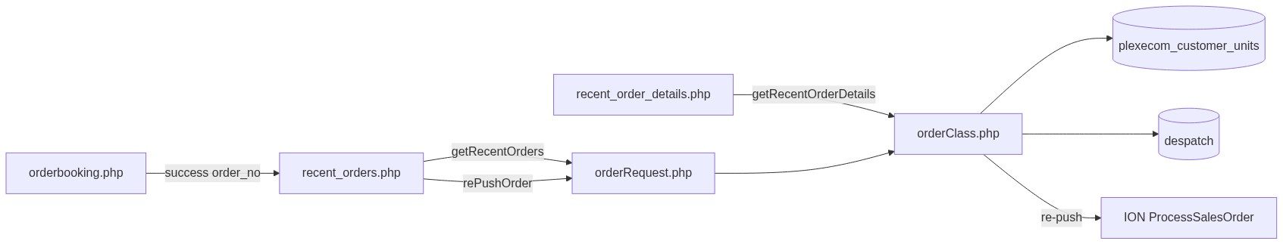
Figure 1 — High-level architecture
â”€â”€â”€â”€â”€â”€â”€â”€â”€â”€â”€â”€â”€â”€â”€â”€â”€â”€â”€â”€â”€â”€â”€â”€â”€â”€â”€â”€â”€â”€â”€â”€

2. Functional Requirements
ID | Requirement | Priority
FR-01 | User with recent-orders/list can open Recent Orders list | Must
FR-02 | Server-side DataTables list grouped by refno | Must
FR-03 | Show Ref No, AO, category, terms, PO, transporter, status, date, actions | Must
FR-04 | Added By column for Admin / Management / CCS Admin | Should
FR-05 | Status badge Pending / AO / Despatched | Must
FR-06 | Eye link to details when view permitted | Must
FR-07 | Details page by ?refno= with header + lines + totals | Must
FR-08 | Re-Push button for eligible Pending orders | Must
FR-09 | Honor ?order_no= from booking success (search highlight) | Should
FR-10 | Scope non–seeAll users to session customer | Must
FR-11 | Export Excel when permitted | Could (UI commented out)

â”€â”€â”€â”€â”€â”€â”€â”€â”€â”€â”€â”€â”€â”€â”€â”€â”€â”€â”€â”€â”€â”€â”€â”€â”€â”€â”€â”€â”€â”€â”€â”€

3. User Roles & Permissions

3.1 RBAC module slug
Resource | Module | Permission
recent_orders.php | recent-orders | list
recent_order_details.php | recent-orders | view
Export (reserved) | recent-orders | export-excel
Dashboard Recent block | recent-orders | list

Unauthenticated → login.php. No list → access_denied.php. Details use rbac_page_guard.php.

3.2 Page / API mapping
Resource | Gate
recent_orders.php | list
recent_order_details.php | view
POST orderRequest.php (getRecentOrders, getRecentOrderLine, rePushOrder) | Session only — no module RBAC

3.3 seeAll / Added By matrix
Role | seeAll (all dealers) | Added By column
System Admin | Yes | Yes
Management | Yes | Yes
CCS Admin | No (own cuno) | Yes
Others | Own cuno | No

seeAll = is_system_admin() || is_management_user()
scope = seeAll ? 1=1 : a.cuno = session customer_number_vayu
â”€â”€â”€â”€â”€â”€â”€â”€â”€â”€â”€â”€â”€â”€â”€â”€â”€â”€â”€â”€â”€â”€â”€â”€â”€â”€â”€â”€â”€â”€â”€â”€

4. Business Rules
ID | Rule
BR-01 | Logical order key = refno; list uses DISTINCT ON (refno).
BR-02 | Source table = plexecom_customer_units (booked lines from Order Booking).
BR-03 | Status Pending when order_number empty (or empty cuno).
BR-04 | Status Despatched when despatch has matching (cuno, ordno) with cmp != 600.
BR-05 | Status AO when AO exists on plexecom with company != 600 and not despatched.
BR-06 | Eye action opens recent_order_details.php?refno=... (not modal on current list).
BR-07 | Re-Push UI shown only if: empty AO, status Pending, placed ≥ 30 minutes ago.
BR-08 | Re-Push server: reject if AO already set (ao_generated); must be Pending; 5-minute cooldown from ediprocessdt.
BR-09 | Re-Push success updates ediprocessdt = CURRENT_TIMESTAMP for refno.
BR-10 | Non–seeAll re-push must match session customer cuno.
BR-11 | ?order_no= triggers client DataTables search for that refno.
BR-12 | Payment term display often defaults to 100% Advance in UI enrichment.
BR-13 | No soft-delete filter on plexecom rows in this path.
BR-14 | Line modal #lineModal / getRecentOrderLine remains for Dashboard / legacy.
BR-15 | Export Excel button commented out.

â”€â”€â”€â”€â”€â”€â”€â”€â”€â”€â”€â”€â”€â”€â”€â”€â”€â”€â”€â”€â”€â”€â”€â”€â”€â”€â”€â”€â”€â”€â”€â”€

5. Database Design

5.1 Logical model
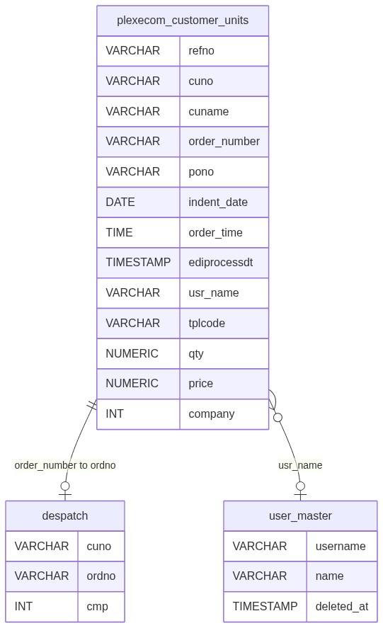
Figure 2 — Entity relationship diagram

5.2 Tables
Table | Conn | Role
plexecom_customer_units | $obconn | Primary list / details / re-push source
tbl_vayu_delivery_term | $obconn | Delivery term label
tbl_vayu_order_category | $obconn | Category label
spp_payterm_master | $obconn | Payment description
transporter_master | $obconn | Transporter name
user_master | $obconn | Added By (non-deleted)
area | $obconn | Details enrichment
despatch | $dpconn | Despatched status
customer_address | $dpconn | Re-push / address helpers

5.3 List query pattern
SELECT DISTINCT ON (a.refno) a.*, /* joins for labels */
FROM plexecom_customer_units a
-- LEFT JOINs ...
WHERE /* seeAll or a.cuno = :customer */
AND /* optional ILIKE search */
ORDER BY a.refno, /* then DataTables sort via outer query / mapped columns */
LIMIT :length OFFSET :start;
â”€â”€â”€â”€â”€â”€â”€â”€â”€â”€â”€â”€â”€â”€â”€â”€â”€â”€â”€â”€â”€â”€â”€â”€â”€â”€â”€â”€â”€â”€â”€â”€

6. API / Backend Design

6.1 Page endpoints
Endpoint | Method | Auth | Description
recent_orders.php | GET ?order_no= | recent-orders/list | List + deep-link search
recent_order_details.php | GET ?refno= | recent-orders/view | Full details

6.2 AJAX — POST orderRequest.php
Action | Description
getRecentOrders | DataTables JSON (list + dashboard)
getRecentOrderLine | HTML lines for modal (dashboard/legacy)
rePushOrder | Rebuild XML, post ION, bump ediprocessdt

6.3 Core PHP responsibilities
File | Role
recent_orders.php | List UI, RBAC flags, DataTable, re-push JS
recent_order_details.php | Details UI via getRecentOrderDetails
orderRequest.php / orderClass.php | List, lines, status, re-push, ION
includes/rbac_access_helpers.php | Page/menu AuthZ
includes/admin_access_helpers.php | seeAll / Added By role checks
css/recent_order_details.css | Details styling

â”€â”€â”€â”€â”€â”€â”€â”€â”€â”€â”€â”€â”€â”€â”€â”€â”€â”€â”€â”€â”€â”€â”€â”€â”€â”€â”€â”€â”€â”€â”€â”€

7. Validation Rules

7.1 Server-side
Field / rule | Behavior
Session + list/view | Redirect login / access_denied / page guard
DataTables params | start / length / search / order
Re-Push refno | Required
Re-Push AO already set | status: ao_generated
Re-Push not Pending | Reject
Re-Push cooldown | Block if within 5 minutes of ediprocessdt
Re-Push scope | Non–seeAll: cuno must match session customer
Details refno | Load fail → error card (customer scope commented out — gap)

7.2 Client-side
â€¢ DataTables serverSide; pageLength 10; scrollX
â€¢ ?order_no= → table.search(...).draw()
â€¢ Re-Push: confirm/alert; cooldown UI via data-repush-until
â€¢ Eye links / re-push visibility driven by server-rendered HTML + RBAC flags
â€¢ No Select2 filters on list
â”€â”€â”€â”€â”€â”€â”€â”€â”€â”€â”€â”€â”€â”€â”€â”€â”€â”€â”€â”€â”€â”€â”€â”€â”€â”€â”€â”€â”€â”€â”€â”€

8. UI Screen Specifications

8.1 List — recent_orders.php
Element | Spec
Table | DataTables serverSide
Columns | Ref No, Order/AO No, Category, Delivery Term, PO, Payment Term, Transporter, Added By (conditional), Status, Order Date, Action
Default sort | Order Date descending
Action | Eye → details; Re-Push when eligible
Export | Commented out
Modal | #lineModal present (legacy; list uses details page)
Select2 | Not used

8.2 Details — recent_order_details.php
Element | Spec
Header | Customer, PO, dates, terms, addresses, status
Lines | Item code/desc, qty, price, UOM, tax fields
Totals | Line aggregates / freight as implemented
Delivery type | Dealer vs end-customer from email / delivery_code
Fail | Inline error + link back to list

8.3 Libraries
DataTables + Bootstrap 5 + jQuery; order_acknowledge_style.css / orderbook_style.css / recent_order_details.css.
â”€â”€â”€â”€â”€â”€â”€â”€â”€â”€â”€â”€â”€â”€â”€â”€â”€â”€â”€â”€â”€â”€â”€â”€â”€â”€â”€â”€â”€â”€â”€â”€

9. Database Flow

9.1 List load
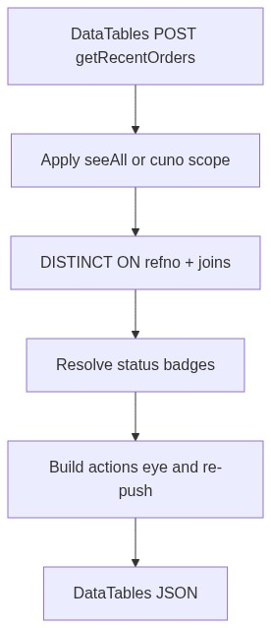
Figure 3 — List load database flow

9.2 Re-Push
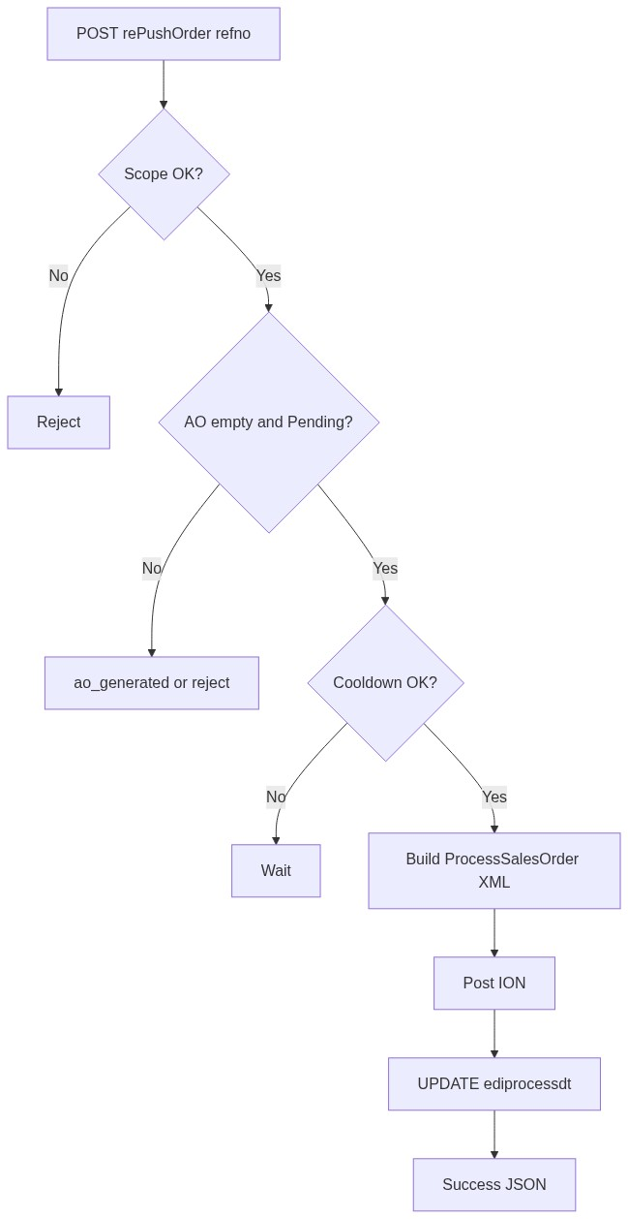
Figure 4 — Re-Push database flow
â”€â”€â”€â”€â”€â”€â”€â”€â”€â”€â”€â”€â”€â”€â”€â”€â”€â”€â”€â”€â”€â”€â”€â”€â”€â”€â”€â”€â”€â”€â”€â”€

10. Sequence Diagram

10.1 List + booking deep-link
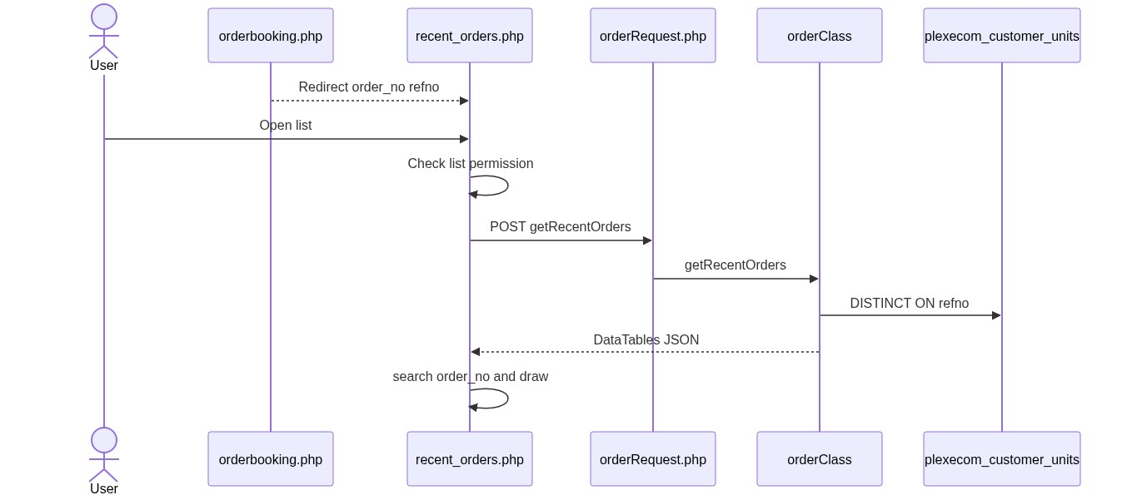
Figure 5 — Sequence: List and booking deep-link

10.2 Re-Push
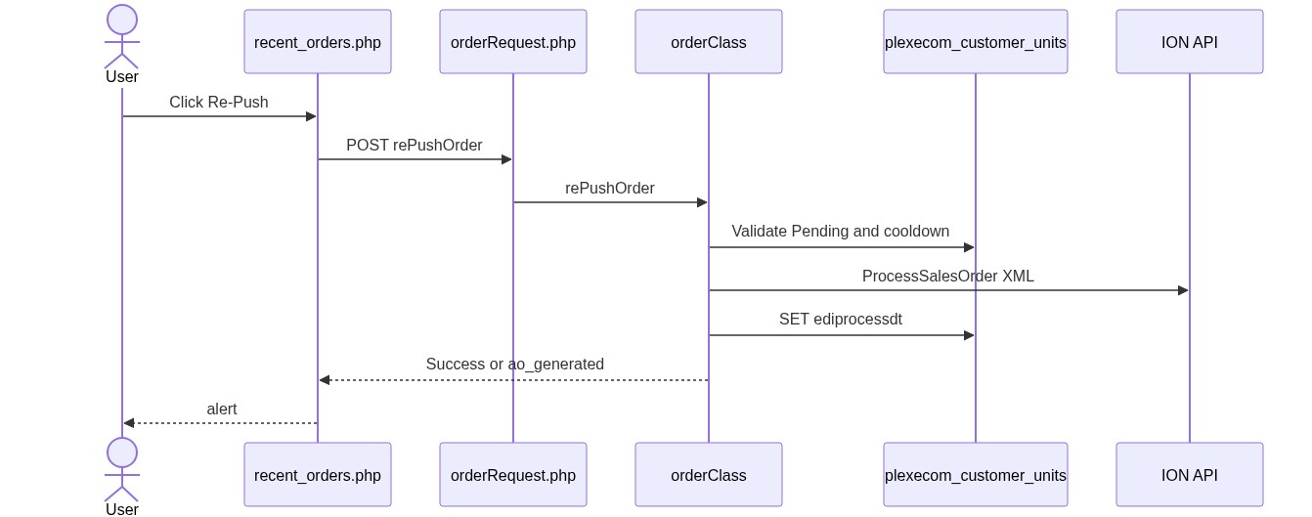
Figure 6 — Sequence: Re-Push
â”€â”€â”€â”€â”€â”€â”€â”€â”€â”€â”€â”€â”€â”€â”€â”€â”€â”€â”€â”€â”€â”€â”€â”€â”€â”€â”€â”€â”€â”€â”€â”€

11. Activity Diagram
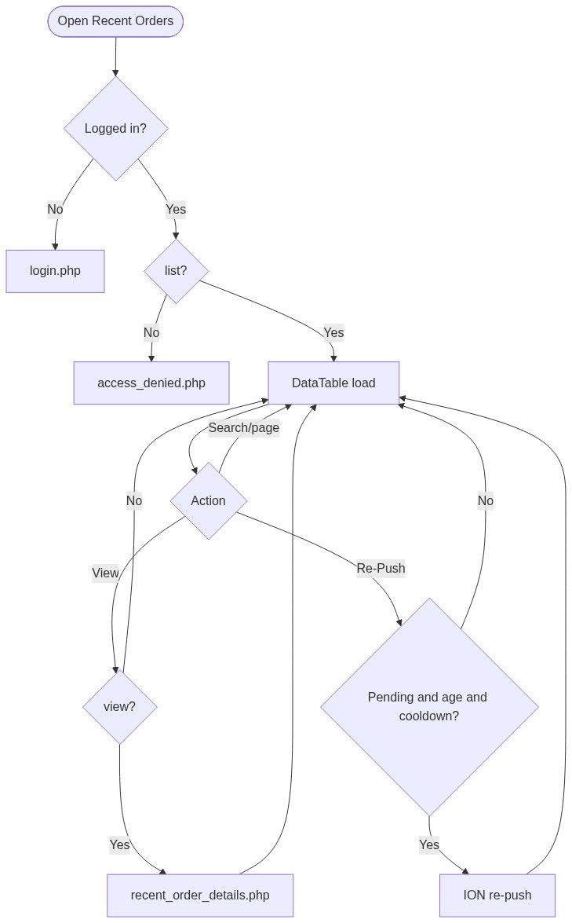
Figure 7 — Activity diagram
â”€â”€â”€â”€â”€â”€â”€â”€â”€â”€â”€â”€â”€â”€â”€â”€â”€â”€â”€â”€â”€â”€â”€â”€â”€â”€â”€â”€â”€â”€â”€â”€

12. Class / Module Diagram
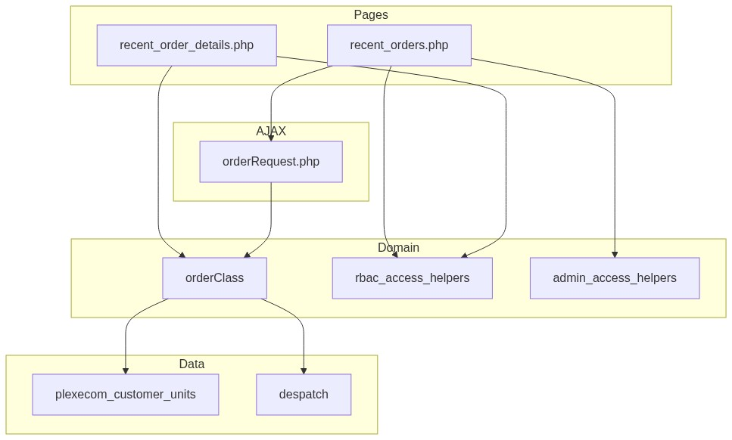
Figure 8 — Class / module diagram

12.1 Key functions
Function | Role
getRecentOrders | DataTables JSON + actions
getRecentOrderDetails | Details payload
getRecentOrderLine | Modal HTML lines
resolveRecentOrderStatus / Label | Pending / AO / Despatched
canShowRecentOrderRepush | 30-min UI gate
resolveRecentOrderRepushCooldownUntil | 5-min cooldown
rePushOrder | ION re-submit + ediprocessdt
buildProcessSalesOrderXmlForRepush | BOD XML rebuild
sendIonSalesOrderMessage / getBearerTokenLN | ION transport

â”€â”€â”€â”€â”€â”€â”€â”€â”€â”€â”€â”€â”€â”€â”€â”€â”€â”€â”€â”€â”€â”€â”€â”€â”€â”€â”€â”€â”€â”€â”€â”€

13. Folder Structure
ComplaintManagement/
├── recent_orders.php
├── recent_order_details.php
├── orderbooking.php
├── orderRequest.php
├── orderClass.php
├── access_denied.php
├── includes/
│ ├── rbac_access_helpers.php
│ ├── rbac_page_guard.php
│ ├── admin_access_helpers.php
│ └── dashboard_helpers.php
├── css/
│ ├── recent_order_details.css
│ ├── order_acknowledge_style.css
│ └── orderbook_style.css
├── dashboard_data.php
└── docs/
└── LLD_Recent_Orders_Module.md
â”€â”€â”€â”€â”€â”€â”€â”€â”€â”€â”€â”€â”€â”€â”€â”€â”€â”€â”€â”€â”€â”€â”€â”€â”€â”€â”€â”€â”€â”€â”€â”€

14. Error Handling
Layer | Pattern
Unauthenticated | Redirect login.php
No list / view | access_denied.php / page guard
AJAX | JSON status/message; re-push alert()
Details load fail | Inline error card + back link
Booking land | SuccessModal then redirect (no session flash on list)

14.1 Common messages / statuses
Message / status | When
Access denied | Missing list
ao_generated | Re-Push when AO already exists
Cooldown / wait | Within 5 minutes of last ediprocessdt
Success alert | Re-Push OK
Coming Soon | Dashboard stub rePushOrder()

â”€â”€â”€â”€â”€â”€â”€â”€â”€â”€â”€â”€â”€â”€â”€â”€â”€â”€â”€â”€â”€â”€â”€â”€â”€â”€â”€â”€â”€â”€â”€â”€

15. Security Considerations
Area | Control
Page AuthZ | RBAC list / view
AJAX AuthZ gap | orderRequest lacks recent-orders checks
Details IDOR gap | getRecentOrderDetails customer scope commented out
Line modal XSS / scope | getRecentOrderLine unscoped; raw field concat
Re-Push API gap | Does not enforce 30-minute age (UI does)
Customer fallback | Missing customer_number_vayu → '10001'
CCS Admin | Added By yes; seeAll no
CSRF | Not implemented on AJAX
Export | Commented out; not Recent-Orders-specific
EDI credentials | Env / ION token path (shared with booking)

â”€â”€â”€â”€â”€â”€â”€â”€â”€â”€â”€â”€â”€â”€â”€â”€â”€â”€â”€â”€â”€â”€â”€â”€â”€â”€â”€â”€â”€â”€â”€â”€

16. Audit Logs

16.1 Built-in field-level audit
Item | Behavior
ediprocessdt | Updated on successful Re-Push
Booking create fields | Set at Order Booking insert
Dedicated Recent Orders audit table | Not implemented
ION submission trail | External system + local timestamp only

â”€â”€â”€â”€â”€â”€â”€â”€â”€â”€â”€â”€â”€â”€â”€â”€â”€â”€â”€â”€â”€â”€â”€â”€â”€â”€â”€â”€â”€â”€â”€â”€

17. Test Cases

17.1 Functional
ID | Scenario | Expected
TC-01 | Guest opens Recent Orders | Redirect login
TC-02 | User without list | access_denied.php
TC-03 | User with list | DataTable loads by refno
TC-04 | Booking success redirect with order_no | List searches that refno
TC-05 | Empty order_number | Status Pending
TC-06 | AO set, no despatch | Status AO
TC-07 | Despatch match | Status Despatched
TC-08 | Admin/Management | seeAll + Added By
TC-09 | CCS Admin | Own cuno + Added By
TC-10 | Dealer without view | No eye / details denied
TC-11 | Re-Push before 30 minutes | Button hidden
TC-12 | Re-Push within 5-min cooldown | Blocked
TC-13 | Re-Push after AO exists | ao_generated
TC-14 | Eligible Re-Push | ION call + ediprocessdt update
TC-15 | Direct details other dealer refno | Gap: may load despite scope
TC-16 | AJAX without list permission | Gap: may still return data if session valid

â”€â”€â”€â”€â”€â”€â”€â”€â”€â”€â”€â”€â”€â”€â”€â”€â”€â”€â”€â”€â”€â”€â”€â”€â”€â”€â”€â”€â”€â”€â”€â”€

18. Assumptions & Dependencies

18.1 Assumptions
1. recent-orders/list and view are assigned to appropriate roles.
2. Order Booking writes all lines for an order under one refno.
3. ERP acknowledgement populates order_number; despatch writes despatch rows.
4. Live list primary navigation is eye → details page (modal is secondary/legacy).
5. Document target stack Core PHP + MySQL; repo runs PostgreSQL (DISTINCT ON, ILIKE).
6. Re-Push ION endpoint/credentials are configured in environment.

18.2 Dependencies
Dependency | Purpose
RBAC / Assign Permissions | recent-orders grants
Order Booking | Creates rows; redirects with order_no
$obconn / plexecom_customer_units | List and details
$dpconn / despatch | Despatched status
ION / LN | Re-Push ProcessSalesOrder
DataTables + jQuery | List UX
Dashboard | Preview consumer of same APIs

â”€â”€â”€â”€â”€â”€â”€â”€â”€â”€â”€â”€â”€â”€â”€â”€â”€â”€â”€â”€â”€â”€â”€â”€â”€â”€â”€â”€â”€â”€â”€â”€

Appendix A — List column map
UI column | Source / notes
Ref No | refno
Order / AO No | order_number
Category | tbl_vayu_order_category
Delivery Term | tbl_vayu_delivery_term
PO Number | pono
Payment Term | pay master / default Advance
Transporter | transporter_master
Added By | user_master (conditional)
Status | Computed badge
Order Date | indent_date / order_date + time
Action | Eye + Re-Push

â”€â”€â”€â”€â”€â”€â”€â”€â”€â”€â”€â”€â”€â”€â”€â”€â”€â”€â”€â”€â”€â”€â”€â”€â”€â”€â”€â”€â”€â”€â”€â”€

Appendix B — Select2 control map
N/A. Recent Orders list does not use Select2 filters.
â”€â”€â”€â”€â”€â”€â”€â”€â”€â”€â”€â”€â”€â”€â”€â”€â”€â”€â”€â”€â”€â”€â”€â”€â”€â”€â”€â”€â”€â”€â”€â”€

Appendix C — Status resolution matrix
Condition | Badge
Empty order_number | Pending
Despatch row for cuno+ordno (cmp != 600) | Despatched
AO on plexecom (company != 600) | AO
Else | Pending

â”€â”€â”€â”€â”€â”€â”€â”€â”€â”€â”€â”€â”€â”€â”€â”€â”€â”€â”€â”€â”€â”€â”€â”€â”€â”€â”€â”€â”€â”€â”€â”€

Appendix D — Re-Push rules
Gate | Where | Value
Empty AO + Pending | UI + server | Required
Placed ≥ 30 minutes | UI only | Required to show button
Cooldown from ediprocessdt | Server + UI | 5 minutes
Customer scope | Server | Non–seeAll must match cuno
Success side-effect | Server | Update ediprocessdt

â”€â”€â”€â”€â”€â”€â”€â”€â”€â”€â”€â”€â”€â”€â”€â”€â”€â”€â”€â”€â”€â”€â”€â”€â”€â”€â”€â”€â”€â”€â”€â”€

Appendix E — RBAC permission matrix
Permission | Effect
list | Open Recent Orders list / dashboard preview
view | Open recent_order_details.php
export-excel | Reserved; Export button commented out

â”€â”€â”€â”€â”€â”€â”€â”€â”€â”€â”€â”€â”€â”€â”€â”€â”€â”€â”€â”€â”€â”€â”€â”€â”€â”€â”€â”€â”€â”€â”€â”€

Appendix F — Pipeline position
Order Booking → plexecom_customer_units (refno, AO empty)
↓
Recent Orders list (this module) — status Pending
↓ AO populated
Status AO (+ Order Acknowledgement list elsewhere)
↓ despatch match
Status Despatched
Re-Push applies while still Pending (empty AO) after age/cooldown gates.
â”€â”€â”€â”€â”€â”€â”€â”€â”€â”€â”€â”€â”€â”€â”€â”€â”€â”€â”€â”€â”€â”€â”€â”€â”€â”€â”€â”€â”€â”€â”€â”€
End of LLD — Recent Orders Module

