

- - Proposal For “”--

Content:

- Introduction

- Statement of Work

- Scope

- Project Description

5)Technical Description

- Roles and Skills

- Our Development Model / Process

- Test Objectives

- Support Methodology

- QA Methodology

- Technical Documentation

- Delivery Time

- Cost estimation

- Payment terms & conditions

- Company Information

1. INTRODUCTION:
Infograins is a metropolitan area-based web and Mobile application development agency that specializes in the design, development, and search engine optimization (SEO) of government and non-profit Organization websites, easy-to-use (user-friendly) content management systems (CMS) and Mobile application (Iphone & android). Our goal is to help organizations cost-effectively meet and exceed their website and mobile application goals and objectives. Founded in 2012, Infograins Software Solutions was created to offer innovative web solutions, mobile applications development and internet marketing services to growing and mid-sized business. Since the beginning, the company successfully serving to our UAE, USA, India, Australia and UK clients.
- Our Corporate Capabilities:
Web Design, Development, Usability:
Perhaps our greatest strength is identifying, understanding, and cultivating the target web visitor segments. Our approach to user interface (UI) design incorporates human factors engineering, ergonomics, accessibility, Section 508compliance and web usability. We believe that user-focused design is extremely important to a successful interface. It takes quite a bit of thinking and effort to make complicated things simple, easy, intuitive, and meaningful. We take an outside-in perspective to create excellent user experiences for both web and mobile visitors.
Content Management System (CMS):
We believe that database-driven content management systems (CMS) represent one of the greatest breakthroughs in the development and proliferation of the World Wide Web. We focus on designing and delivering easy-to-use, search engine friendly content management systems that empower our clients to take control of their content and outreach programs.
Mobile Design, Development (Android & iOS)
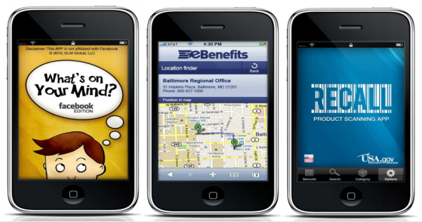

Search Engine Optimization (SEO)
Social Media Integration
Support & Services
Full List of Corporate Capabilities
- Web design ,development
- Mobile Design, development
- Search engine optimization (SEO)
- Web usability testing, analysis, implementation
- Dynamic database applications (My-SQL) development
- Website optimization (including photo, image, animation, graphics optimization)
- E-commerce solutions (shopping carts, secure checkout, payment gateways)
- SSL Integration and authentication
- Dashboard design and implementation
- Content management system design, development, customization, implementation
- Web content development, copy writing, editing, content management, archival
- Systems training and support (via telephone, e-mail, web conference, and in-person)
- Intra-net design, development, implementation, support
- Social media integration and platform development
- Multimedia library implementation and integration
- Drupal/Magneto/Joomla/WordPress/X- Cart/OsCommerce/etc..development, implementation, modification, and maintenance
- PHP
- Android/Android
- MySQL
- JavaScript
- j Query
- HTML/CSS
- C#
- VB
- ASP.NET
- SharePoint
- Site Core
- Visual Studio
- .NET
- SQL Server
- 3D animation
- WordPress
- Photography, photo editing, photo manipulation
- Videography, video editing, video production
- Illustration
- Web analytics
2. STATEMENT OF WORK: This will be Platform website and mobile(android)for E-Commerce App,buying and selling of product.where the.firstly new user register by himself and select the Product according to categories wise,Purchase the product. seller upload the product by the Google link and excel format and also (seller)purchase the product. There is seller and customer bargaining the product.admin will manage the whole system.
SCOPE: The scope of the Project purchase the product by the application without the need of going physically to anywhere,Delivery times will be improve and make the Quality of product.
4. PROJECT DESCRIPTION :-There will be 3 user in this application
1.Customer
2.Seller(Manager)
3.Super Admin
1.1User side flow
Login:Login with the email and password
Registration:New user will register yourself
- First name
- Last name
- Email
- Mobile number
- Password
- Confirm password
- Edit Profile:user can edit the profile
- Profile image
- Mobile number
- change password
- Forgot password:in case user forgot password,link will sent on the Registered email.
- Search:Search the Product according to categories and Retailers name
- Categories:Select the Categories
- Fashion:user can select the product
- Product1
- Product2
- Select a Product
- Product details:
- Product image
- Product name
- Product Price
- Add Product
- Checkout
- Payment Gateway:user select the Payment method
- Paypal
- Card
- Review and Ratings
- View Product details
- Payment history
- Chat : customer and seller for bargaining.
- About us
- Contact us
- Logout
2.1. Seller(Manager):Seller register form Website
Login:Login with the Registered emails and password
Registration:new seller Register by himself
- First name
- Last name
- Mobile Number
- Email
- Password
- Confirm Password
- Edit Profile:Seller can edit the Profile
- Profile image
- Mobile number
- Change Password
- Forgot password:In case Seller forgot the password link send on the Registered email id.
- Upload Catalogue:Seller can upload the catalogue by
  - Google lick(.catalogue)
  - Excel format
- Upload Product
- Seller identity:According to the seller confirmation
Note: If seller do not want to show his name on portal then his name will be hidden
Chat:Seller and Customer for bargaining(optional)
Note:If seller want bargain option then it will be active.
Order details:Seller view order details
- View Order
Distance:seller and customer for delivery propose for Product.
Delivery type:
- Today
- Note:who order on same day by 7 pm in the evening.
- Delivery charge:distance(KM)*Price of Product
Note:it will auto calculated in the prize of product according to the distance
Seller:seller can also the purchase the Product
Payment Gateway:Seller pay the Payment
- Paypal
- Card
Dashboard:
- Catalogue
- Sell product:show all Product list
- Purchase Product:show all purchase item
- Payment:view Payment(order wise)
  - Weekly
  - Monthly
  - Yearly
- About us
- Services
- FAQ
- Contact us
- Logout
3.1Super Admin: Admin login with the email and Password
- Edit Profile: admin can edit the Profile
- Profile image
- change password
- Manage: admin will manage
- View all Registered customer
- Delete Registered Customer
- View All Registered Seller(Manager)
- Edit
- update
- Delete
- Advertisement:add the image for advertisement
- Discount:for sale
- Note:Accordingly product selected by seller and Cutomer.
- Rent Product:Product for rent(Seller and customer)
- About us
- Contact us
- FAQ
- Terms and conditions
- Privacy
- CMS
- Logout
5.Technical Description: Server Side (Back end ) :- We use server side technology which produce a response for client side request to the website. We use server side like Apache Server, MySQL, PHP.
Client Side (Front end) :- We use client side technology which request to the server for specific action perform using HTML, CSS, JavaScript, J Query, Bootstrap etc.
2.Android:- we will use Java technology for back end technology, screens will be designed and send for the approval before working on it.
Both Front-end and Back-end developers collaborate parallel for the development of application. Android code standard will be used with the latest version of Android Studio IDE 3.0.1. Application will support all the resolutions Small, Medium, Large and Extra Large and will be developed for Android OS 4.4 Kit-kat and above.
6. Roles and Skills:- This project will be develop under the experienced resources, they are

Roles | Name | Year of Experience | Skills | Contact Email
Project Manager | Ajay Shukla | 8 Years | PHP, Java, Swift, Ionic | ajay@infograins.com
Web Designer | Hukum Khede | 4 Years | Html5, CSS3, Bootstrap, JavaScript | hukum@infograins.com
Web Developer | Hemant Anjana | 4 Years | PHP, WordPress, Codeignitor | hemantanjana@infograins.com
Andriod Developer | Rajni Raghuwanshi | 4 year | Andriod studio,Java | rajniraghuwanshi@infograins.com
Q.A | Krishna Thakur | 5 Years | Manual and Automation | krishna@infograins.com

7. OUR DEVELOPMENT MODEL / PROCESS:
Our process is very client interactive. At each phase we interact with client for the betterment of the project. Our Process has 5 phases:--
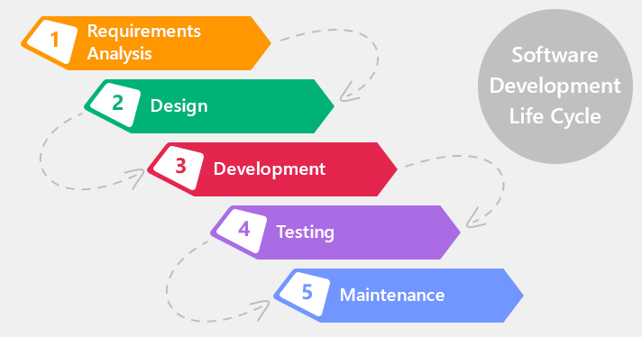

- Analysis
- Designing
- Developing
- Testing
- Deployment and Maintenance
Analysis:--
We start the process with analysis , In this we analyses and understand the client's problem and perspective. In these we send a document of Project Planning to client for his approval. This document describe the project as per our understanding and if client want any changes in the document they can correct and suggest us.
Designing:--In designing phase , We create the UI / UX design in PSD(Photoshop document) and UI flow. We also send these designs to client for their approval and any changes to this are also invited.
Development:--
In these phase we do coding and develop application. In these phase also we interact with client on weekly basis to give the status of development
Testing:--
In testing we test the developed application according to user's perspective. After assuring the quality of software , It is ready for deployment.
Deployment / Maintenance:--
In these phase , we deploy the application on server. We also provide Maintenance to the application for a particular time period after the deployment.
8. TEST OBJECTIVES:
Installation Testing
System Integration Test (SIT)
Network testing
User Acceptance Test (UAT)
Test Approach
There are 2 categories of testing, Functional Testing and Technical Testing.
- Functional Testing
- Technical Testing
Types of Testing: Detail description of testing are as follows.

- Functional Testing:
Testing Type | Descriptions
UR – User Requirements and Procedures |  | Checking the Functional requirement and procedures and process
ER – Error Response |  | Check every error and do proper validation and verification
FN – Function |  | INFOGRAINS will done all functional testing to determine the effectiveness of every function
II – Interface & Inter system |  | Checking the all interface and Inter system functionality
RN – Regression Testing |  | Will be properly done for all functionality
TR – Transaction Flow |  | Will do proper transaction flow of every flow of the function within the project.

- Technical Testing: The following testing types are part of Technical Testing and those applicable in the SIT are marked as “Yes”.

Testing Type | Descriptions
IN – Installation Verification | YES
BO- Batch Cycle and Operations | YES
SA – Security Acceptance | YES

9.SUPPORT METHODOLOGY:
Scope of Support:
Our Support services include:
- Bug fixes
- Technical, Functional and Operational support
- Root cause analysis
- Enhancements
- MIS Reports
- Support Documentation
All these services are effectively delivered remotely through continuous interactions with the customer to get an insight into the problem space. Internal processes for providing support services to meet stringent service levels.
Mode of communication:
- IM
- Phone Call
- Email

Support Process:
The Support Process will start after the delivery of the Source code of the project to Customer for the Time period of three month. INFOGRAINS will assign the Support task for the every team member of Support Team. (Mention Below). Process we follow:
- Assigned Team for Support.
- Mentioning the task for Every Team members.
- Analysis of Task done for Every Team member.
- Setting up the priority for every Task.
- INFOGRAINS will properly looking for the every milestone delivery.
- We will use Project Management System for tracking of every project.
Critical Issues(Show Stoppers):INFOGRAINS help Customer to solve out any critical issue raised by the customer at any point. Any of the Critical Issues arise than client has to inform INFOGRAINS by Call or by the Email.

Support Hours:
INFOGRAINS provide 2-3 hours per day (Monday – Friday) support services. give time period will be change as per the issue raised.
Support Options:
- On call Support
- Off-site using INTERNET and network facilities
- Direct login to client environment through VNC or team viewer client
- Easy to maintain and provide application support
Warranty Support:
Warranty Support would be of three month only for the bug fixing
10. QA METHODOLOGY:
Our singular focus on quality management and testing combined with our expertise in the development life cycle enables us to deliver practical services that drive improvement to the way you build and manage your enterprise applications and IT infrastructure. We engage QA team right from the start of the project to ensure the quality of the solutions we offer. It helps us to identify the variation from the specification at the initial stage that eventually save efforts and cost. We offer all Quality Assurance and Testing services with help of our experience and expertise by understanding the client and investment Planning, prepare quality standard, test scenario.

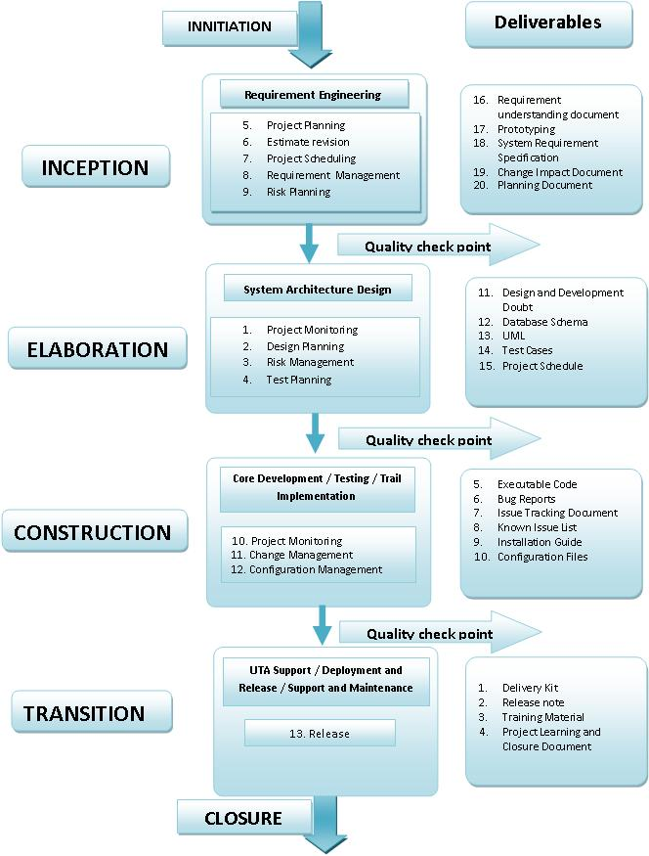

11. TECHNICAL DOCUMENTATION:-
- System design documents
- Class diagram
- Test Cases document
- User Manual & Help documents
12. DELIVERY TIME :-With the agreed upon Scope for the above Proposal For “E commerce app”info grains software solution Pvt. Ltd. agrees to deliver the complete project in working days from the date of start.
13. COST ESTIMATION:- Based on the nature of the project and above solutions the estimated cost to develop this website will be: --
Maintenance: - We will decide in final discussion.

14. PAYMENT TERMS & CONDITION:-
We shall change the terms if required in any condition.
- 30% as an upfront
- 50% will be break down in two different milestones
- 20% once application will successfully upload to Play store

15. Company Informations:- For more details you can contact us to our contact number.
Company Name | Infograins Software Solutions Pvt. Ltd.
Address | Krishna Tower, 208, 2nd Floor, OPP. Scheme-140, Main Rd, Pipliyahana, Indore, Madhya
Contact Number | 0731-4258071
Contact Email | info@infograins.com

