Opdracht 12-5 Pevsner

# crustacyanin

Crustacyanin is a carrier protein that binds the chromophore astaxanthin.

Structure

The chromophore is bound to a large protein complex,

this large protein complex is know as alpha-crustacyanin and is found in the protein family lopcalin.

Alpha-crustacyanin is an aggregate of 16 crustacyanin monomers. Each of these monomers have bound to

a molecule of astaxanthin. These 16 monomers are arranged in 8 crustacyanin dimers. These dimers are called beta-crustacyanin.

## Colour change:

As previously explained, a crustacyanin monomers has an imbeded chromophore, one end of the chromophore is hidden in the crustacyanin, but another protrudes. When two monomers join, they will cap the others protruding chromophore. This binding changes the molecular structure, which will result in a change in optical properties. When bound as a dimer, the chromophores will emit a blueish-green colour, when unbound the colour will shift to orange-red.

When the lobster is cooked, proteins will denature and this will result in the denaturation of the dimers, which will change the optical properties of the chromophore change the colour to orange-red.

Specific colour change is due to a reduced energy gap between ground and exited states. On molecular level keto groups are needed at position 4 and 4’, and methyl groups are needed at position C20 and C20’. Only E isomers are bound to crustacyanin. Binding between crustacyanin and chromophore is non-covalant.

## Physical properties

Crustacyanin constists of five types of subunits: A1, A2, A3, C1 and C2.

Subunit A1 and C1 has a length of 181 amino acids, whereas A2 is shorter with 174 amino acids.

## Searching

Using uniprot:

Searching UniProtKB with the following query:

*Alpha-crustacyanin*

*Beta-crustacyanin*

*astaxanthin crustacyanin*

Will find 3 proteins:

Crustacyanin-A1

Link: https://www.uniprot.org/uniprot/P58989

subunit has a length of 181 proteins

Using MINT a [pubmed paper was found](https://www.ncbi.nlm.nih.gov/pmc/articles/PMC125020/)

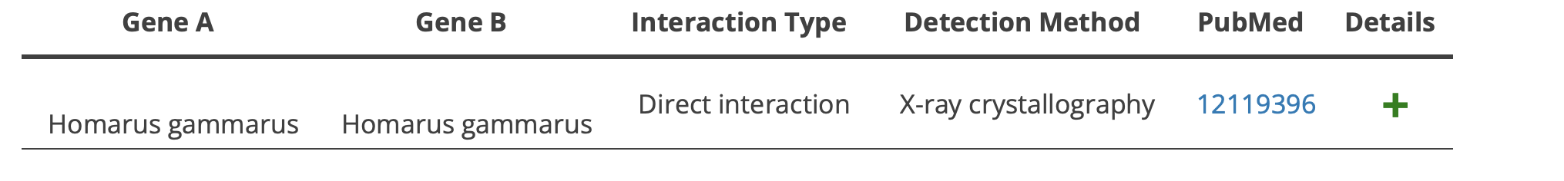

## Binding:

Subunit A1 and A3 interact via a loop region, connecting the strands G and H of each subunit. Both these Subunits will bind to an astaxanthin molecule. Underlying left image shows the two subunits. Binding of astaxanthin occurs at G and H. Right image shows Astaxanthin molecules inside the two subunits.

Subunit A1 and A3 have a 35% sequence identity, as visible in the underlying image.

Astaxanthin Binding sites have many conserved amino acid residues.