Session 2025-2026

Vision: To be a well-known centre for pursuing computer education through innovative pedagogy, value-based education and industry collaboration | Mission: To establish learning ambience for ushering in computer engineering professionals in core and multidisciplinary area by developing Problem-solving skills through emerging technologies.
Program Educational Objectives of the program (PEO): (broad statements that describe the professional and career accomplishments)
PEO1 | Preparation | P: Preparation | Pep-CL abbreviation pronounce as Pep-si-lL easy to recall
PEO2 | Core Competence | E: Environment  (Learning Environment) | Pep-CL abbreviation pronounce as Pep-si-lL easy to recall
PEO3 | Breadth | P: Professionalism | Pep-CL abbreviation pronounce as Pep-si-lL easy to recall
PEO4 | Professionalism | C: Core Competence | Pep-CL abbreviation pronounce as Pep-si-lL easy to recall
PEO5 | Learning  Environment | L: Breadth (Learning in  diverse areas) | Pep-CL abbreviation pronounce as Pep-si-lL easy to recall

Program Outcomes (PO): (statements that describe what a student should be able to do and know by the end of a program)

Keywords of POs:
Engineering knowledge, Problem analysis, Design/development of solutions, Conduct Investigations of Complex Problems, Engineering Tool Usage, The Engineer and The World, Ethics, Individual and Collaborative Team work, Communication, Project Management and Finance, Life-Long Learning
PSO Keywords: Cutting edge technologies, Research
“I am an engineer, and I know how to apply engineering knowledge to investigate, analyse and design solutions to complex problems using tools for entire world following all ethics in a collaborative way with proper management skills throughout my life.” to contribute to the development of cutting-edge technologies and Research.

Integrity: I will adhere to the Laboratory Code of Conduct and ethics in its entirety.

Name and Signature of Student and Date
(Signature and Date in Handwritten)
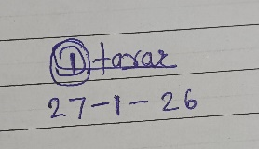

Session | 2025-26 (EVEN) |  | Course Name | JAVA FSD Lab
Semester | IV |  | Course Code | 23ADS1407
Roll No | 03 |  | Name of Student | Deval Tarar
Practical Number |  | 02
Course Outcome |  | To understand and implement various concept of class and object.
Aim |  | Write a program to demonstrate concept of class,method in java.
Problem Definition |  | In object-oriented programming, a real-world entity can be represented using a class, and the behavior of that entity is defined using methods.  The problem is to design a Java program that defines a class with data members and methods, creates an object of that class, and invokes its methods to display output.
Theory  (100 words) |  | A class in Java is a blueprint or template used to create objects. It defines the properties (data members) and behaviors (member functions) that the objects of that class will have. A class does not occupy memory until an object is created from it. It helps in achieving data abstraction and encapsulation by binding data and methods together into a single unit. Multiple objects can be created from a single class, and all objects share the same structure but have different values. Classes make programs organized, reusable, and easier to understand.
Procedure and Execution  (100 Words) |  | Algorithm:  . Start the program.  . Create a class Ycce with required data members.  . Define a method showDetails() to display student details.  . In main() method, create objects of class Ycce.  . Assign values to object data members.  . Call showDetails() method using objects.  . End the program.

Code:
public class Main{

String collegeName = “YCCE”;
String department = "IT";
String studentName;
int year;

void showDetails() {
System.out.println("College Name: “ + collegeName);
System.out.println("Department : “ + department);
System.out.println("Student Name: “ + studentName);
System.out.println("Year : + year);
}

public static void main(String[] args) {

// Student 1
Ycce s1= new Ycce();
s1.studentName = "Deval";
s1.year = 1;

// Student 2
Ycce s2 = new Ycce();
s2.studentName = "Priya";
s2.year = 2;

// Student 3
Ycce s3 = new Ycce();
s3.studentName = "Riya”;
s3. year = 3;

s1.showDetails();
s2.showDetails();
s3.showDetails();
}
}

Output:

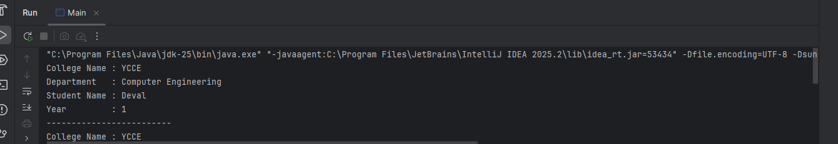

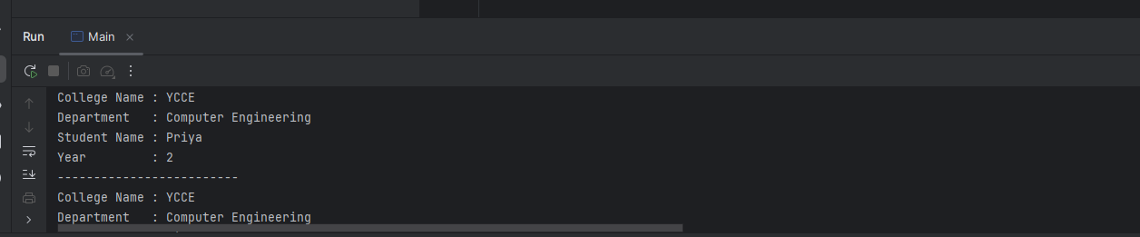

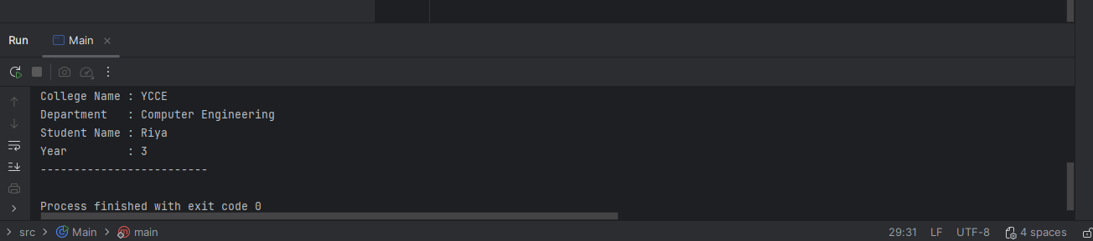

Output Analysis | The output shows that the program creates multiple objects of the Ycce class and displays their details using the showDetails() method. For each object, the college name and department remain the same, while the student name and year change according to the values assigned to that object. The details of three students—Deval, Priya, and Riya—are printed sequentially with their respective years of study. This output verifies that each object holds its own data and that the method works correctly for different objects, thereby demonstrating the concepts of class, object, and method in Java.
Link of student Github profile where lab assignment has
been uploaded
Conclusion | The program successfully demonstrates the use of class, object, and method in Java by creating multiple objects and displaying their details using a common method.

Plag Report (Similarity index < 12%) | 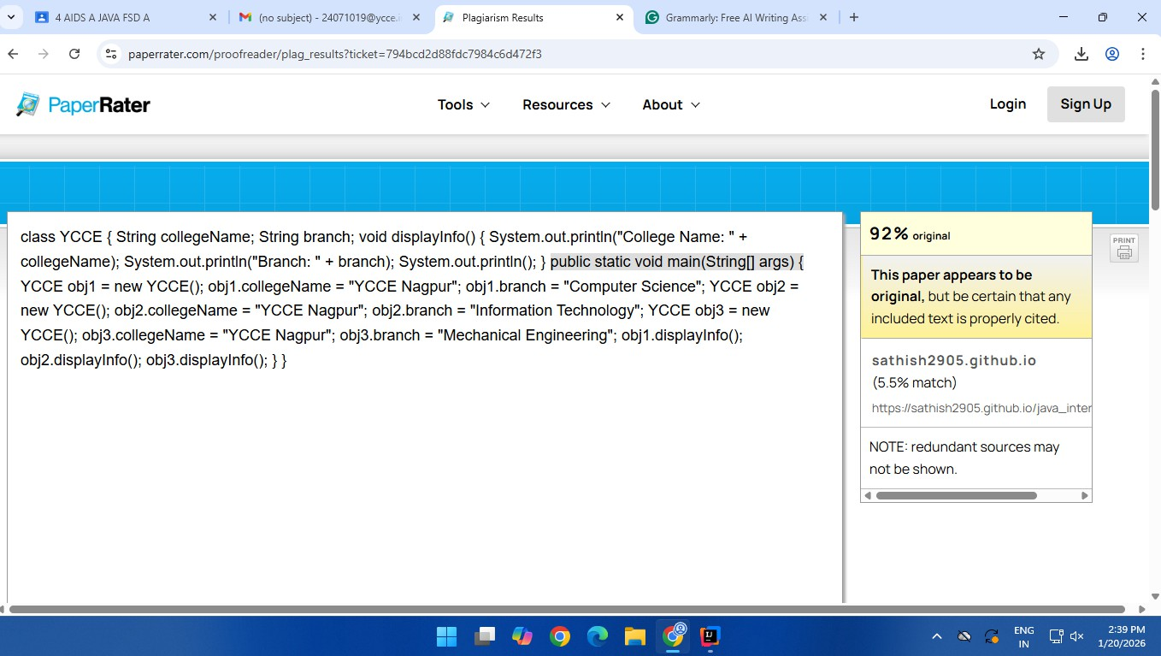
Date | 20-01-2026

Paste here Faculty signed observation page.

